Supplementary Materials

This file includes:

Figs. S1 to S5

Supplementary table 1-4

Supplementary Text

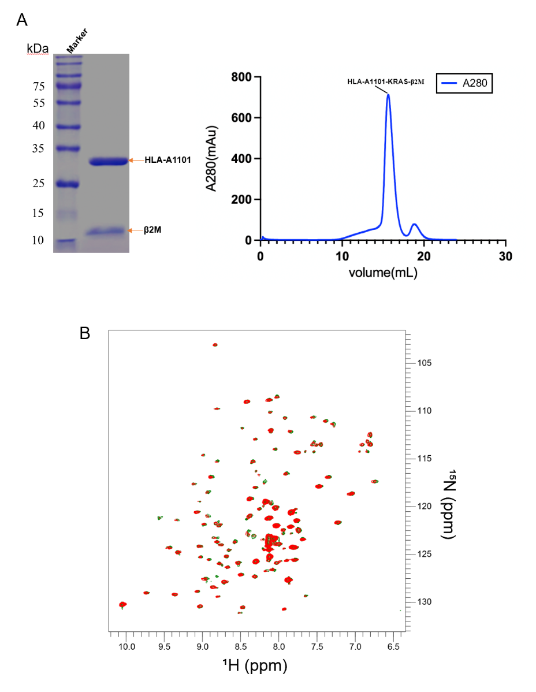
Fig. S1. Purification and NMR characterization of pMHC complex
- Size exclusion profile of pMHC complex using a Superdex-200 10/300GL Cytiva column in FPLC Buffer (20mM Phosphate Buffer/pH7.2, 150mM NaCl). The purified KRAS-HLA complex was verified with SDS-PAGE.
- Conformational analysis of β₂-microglobulin by NMR. The 2D TROSY-HSQC NMR spectra comparison of β2M in presence of WT (Red) peptides and G12D peptides (Green).

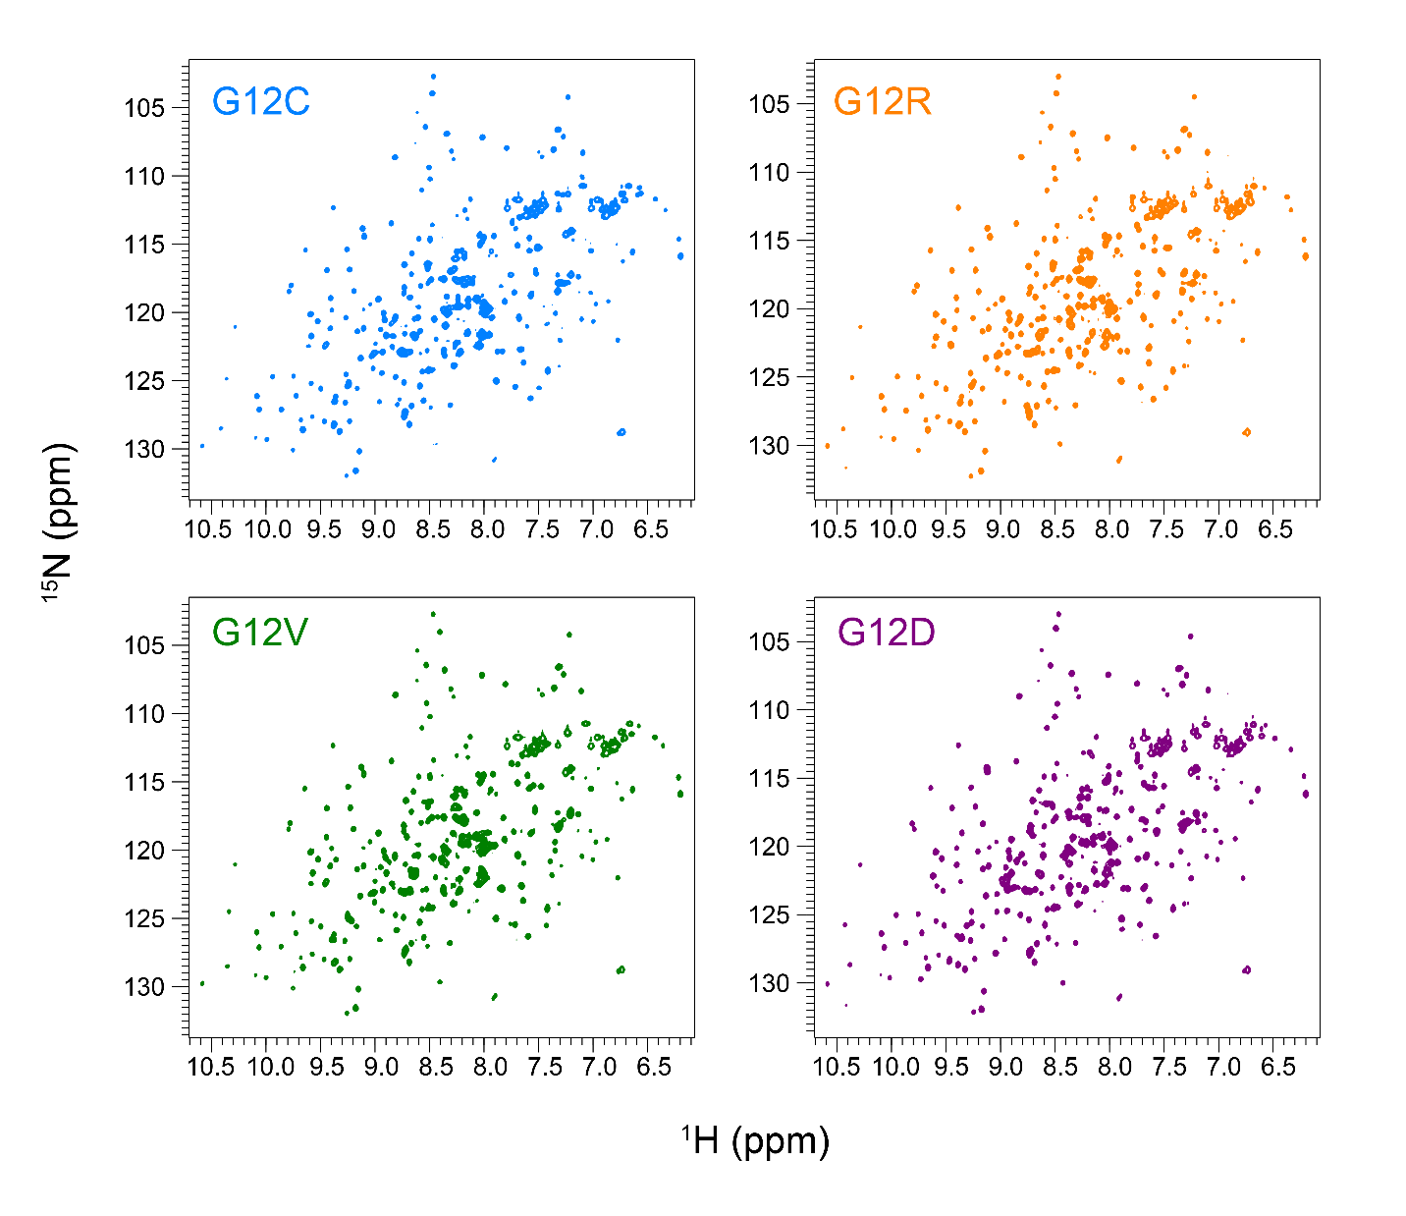
Fig. S2. Comparative NMR analysis of KRAS G12 mutant complexes
TROSY-HSQC spectral series of HLA-A*11:01 bound to: (A) G12C (cyan), (B) G12R (orange), (C) G12V (green), (D) G12D (purple). Reference spectrum (WT, red) overlaid for comparison.

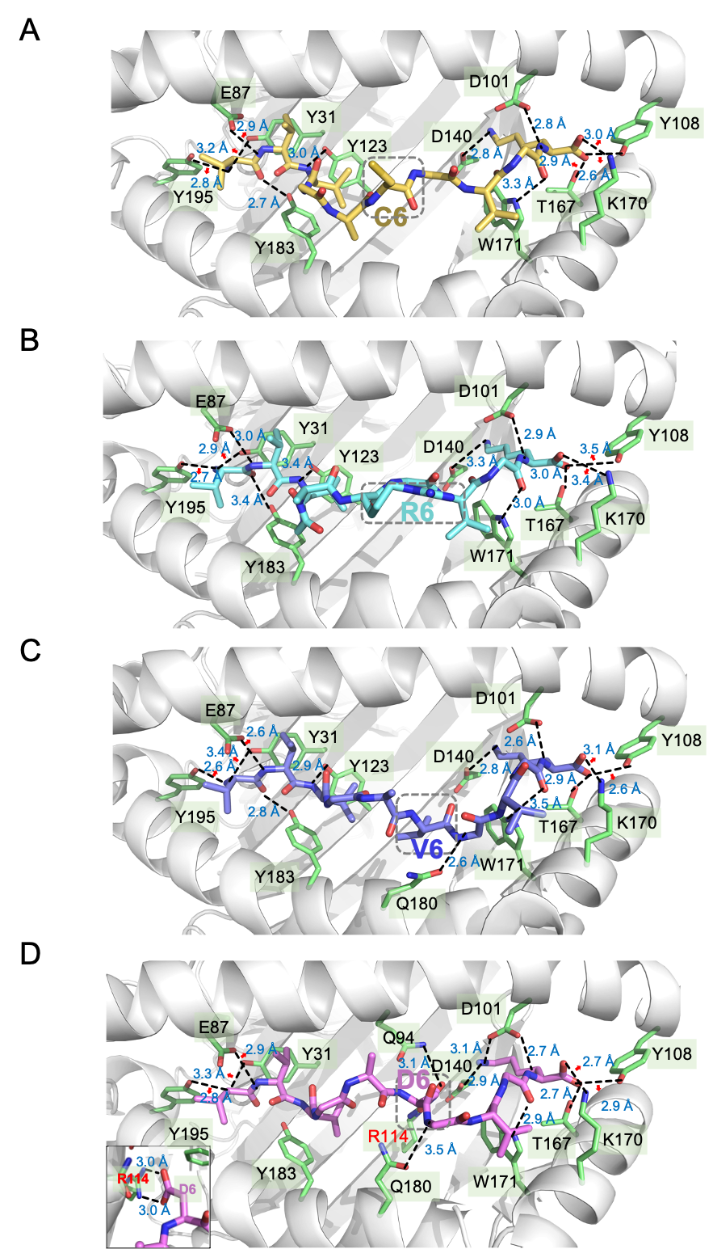

Fig. S3. Structural determinants of KRAS variant recognition
High-resolution crystal structures showing critical interaction networks between HLA-A*11:01, directed to Fig 3. (A) G12C; (B) G12R; (C) G12V; (D) G12D, and the lower-left corner panel shows the binding interface of D6.

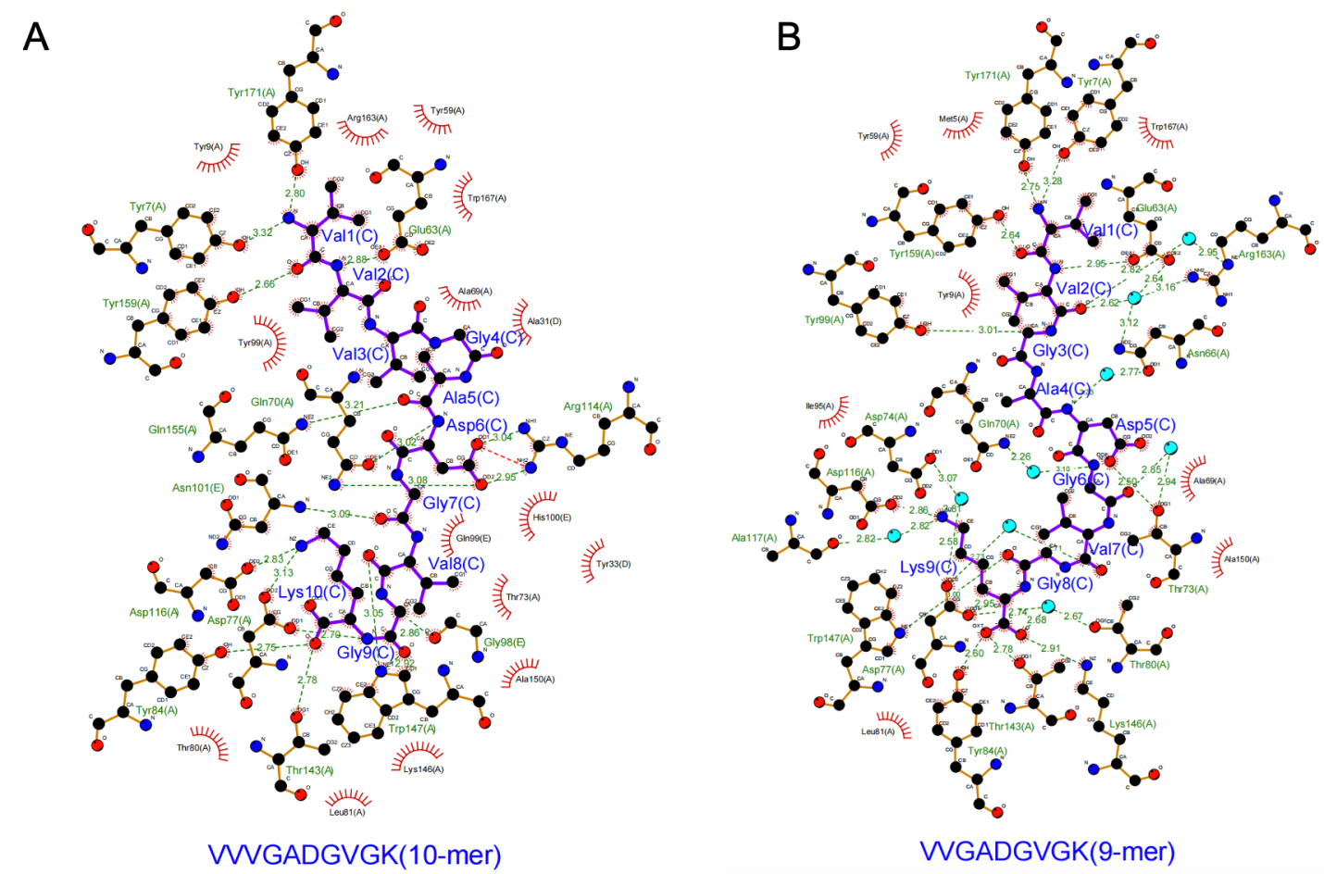

Fig. S4 Structural presentation of G12D peptide binding sites
(A) Two-dimensional representation of the G12D-10mer (VVVGADGVGK) peptide binding site.
(B) Two-dimensional representation of the G12D-9mer (VVGADGVGK) peptide binding site.

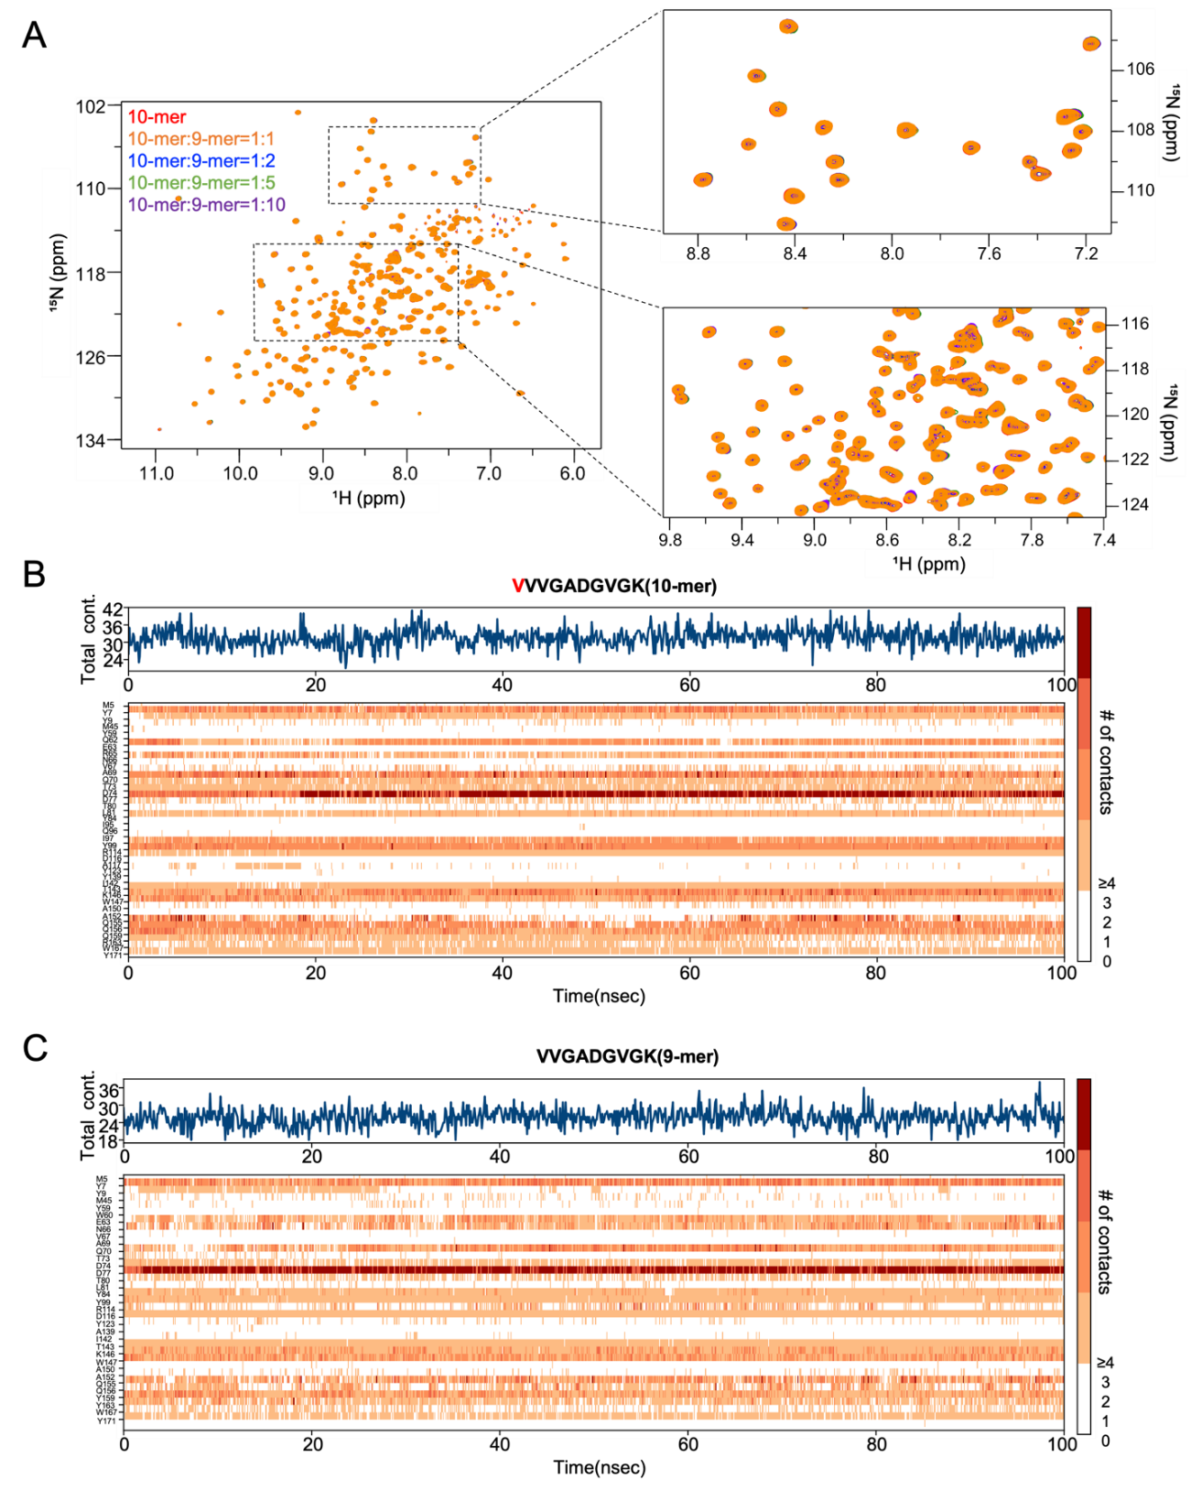

Fig. S5. Competitive binding analysis and interaction dynamics of G12D peptides with MHC
(A) NMR-based detection of competitive binding between G12D-9mer and G12D-10mer peptides.
(B) Interaction timeline of MHC with G12D-10mer peptide. Top: Total specific contacts (H-bonds, hydrophobic, ionic, water bridges) per frame. Bottom: Interacting MHC residues (color intensity reflects contact frequency; scale at right).
(C) Interaction timeline of MHC with G12D-9mer peptide (same visualization as B).
Supplementary table 1 Data collection and refinement statistics of the complex structure of MHC-G12C
Parameter | MHC-G12C_10mer
PDB code | 8K4T
Data collection
Space group | P1
Cell dimensions
a, b, c (Å) | 48.71, 63.58, 75.51
α, β, γ (°) | 105.86, 92.66, 97.70
Resolution (Å) | 40.78-2.30 (2.38-2.30)*
R_{sym} or R_{merge} (%) | 3.5 (49.3)
Mn(I) half-set correlation CC(1/2) (%) | 99.9 (87.8)
Total number of observations | 200263 (21663)
Total number unique | 129724 (12209)
I / σI | 13.7 (1.7)
Completeness (%) | 97.3 (96.0)
Redundancy | 3.5 (3.4)
Wilson B-factor (Å²) | 45.1
Refinement
No. reflections | 37332 (3630)
R_{work} / R_{free} (%) | 25.8 (31.6)
No. atoms
Chain A | 2238
Chain B | 812
Chain C | 61
Chain D | 2244
Chain E | 797
Chain F | 61
B-factors (Å²)
Chain A | 54.80
Chain B | 54.69
Chain C | 56.46
Chain D | 59.86
Chain E | 62.73
Chain F | 59.95
R.m.s. deviations
Bond lengths (Å) | 0.002
Bond angles (°) | 0.53
Ramachandran plot
Most favored (%) | 97.20
Additional allowed (%) | 2.80
*Values in parentheses are for highest-resolution shell.

Supplementary table 2 Data collection and refinement statistics of the complex structure of MHC-G12R
Parameter | MHC-G12R_10mer
PDB code | 8K4V
Data collection
Space group | P2₁2₁2
Cell dimensions
a, b, c (Å) | 118.65, 121.60, 155.81
α, β, γ (°) | 90.00, 90.00, 90.00
Resolution (Å) | 47.93-3.09 (3.22-3.09)*
R_{sym} or R_{merge} (%) | 104.4 (456.2)
Mn(I) half-set correlation CC(1/2) (%) | 95.5 (48.3)
Total number of observations | 541207 (59739)
Total number unique | 41754 (4607)
I / σI | 13.0 (1.3)
Completeness (%) | 95.5 (48.3)
Redundancy | 3.5 (3.4)
Wilson B-factor (Å²) | 40.40
Refinement
No. reflections | 41449 (4023)
R_{work} / R_{free} (%) | 29.6 (34.7)
No. atoms
Chain A | 2250
Chain B | 836
Chain C | 66
Chain D | 2250
Chain E | 836
Chain F | 50
Chain G | 2250
Chain H | 836
Chain I | 50
Chain J | 2250
Chain K | 836
Chain L | 50
B-factors (Å²)
Chain A | 54.06
Chain B | 49.03
Chain C | 64.19
Chain D | 49.64
Chain E | 44.93
Chain F | 49.59
Chain G | 50.90
Chain H | 45.47

Supplementary table 2 Data collection and refinement statistics of the complex structure of MHC-G12R (Continued)
Parameter |  | MHC-G12R_10mer
Refinement
B-factors (Å²)
Chain I | 41.01
Chain J | 69.80
Chain K | 65.44
Chain L | 86.18
R.m.s. deviations
Bond lengths (Å) | 0.003
Bond angles (°) | 0.58
Ramachandran plot
Most favored (%) | 97.54
Additional allowed (%) | 2.33
*Values in parentheses are for highest-resolution shell.

Supplementary table 3 Data collection and refinement statistics of the complex structure of MHC-G12V
Parameter | MHC-G12V_10mer
PDB code | 8K50
Data collection
Space group | P2₁2₁2₁
Cell dimensions
a, b, c (Å) | 116.29, 121.85, 133.38
α, β, γ (°) | 90.00, 90.00, 90.00
Resolution (Å) | 48.83-2.80 (2.89-2.80)*
R_{sym} or R_{merge} (%) | 15.8 (97.3)
Mn(I) half-set correlation CC(1/2) (%) | 99.8 (91.2)
Total number of observations | 624770 (61050)
Total number unique | 47584 (4600)
I / σI | 15.7 (3.0)
Completeness (%) | 99.9 (99.6)
Redundancy | 13.1 (13.3)
Wilson B-factor (Å²) | 43.70
Refinement
No. reflections | 47394 (4672)
R_{work} / R_{free} (%) | 22.4 (27.8)
No. atoms
Chain A | 2240
Chain B | 832
Chain C | 62
Chain D | 2241
Chain E | 836
Chain F | 62
Chain G | 2244
Chain H | 836
Chain I | 50
Chain J | 2241
Chain K | 836
Chain L | 50
B-factors (Å²)
Chain A | 48.96
Chain B | 42.42
Chain C | 48.07
Chain D | 60.94
Chain E | 53.57
Chain F | 64.78
Chain G | 50.87
Chain H | 45.15

Supplementary table 3 Data collection and refinement statistics of the complex structure of MHC-G12V (Continued)
Parameter |  | MHC-G12V_10mer
Refinement
B-factors (Å²)
Chain I | 53.22
Chain J | 58.37
Chain K | 50.34
Chain L | 63.28
R.m.s. deviations
Bond lengths (Å) | 0.003
Bond angles (°) | 0.53
Ramachandran plot
Most favored (%) | 97.21
Additional allowed (%) | 2.59
*Values in parentheses are for highest-resolution shell.

Supplementary table 4 Data collection and refinement statistics of the complex structure of MHC-G12D_9mer
Parameter | MHC-G12D_9mer
PDB code | 9UV8
Data collection
Space group | P12₁1
Cell dimensions
a, b, c (Å) | 56.25, 80.00, 57.69
α, β, γ (°) | 90.00, 116.40, 90.00
Resolution (Å) | 51.67-1.79 (1.88-1.79)*
R_{sym} or R_{merge} (%) | 8.9 (55.6)
Mn(I) half-set correlation CC(1/2) (%) | 99.7 (69.3)
Total number of observations | 200263 (21663)
Total number unique | 42599 (5880)
I / σI | 13.9 (2.6)
Completeness (%) | 98.3 (93.4)
Redundancy | 4.7 (3.7)
Wilson B-factor (Å²) | 15.31
Refinement
No. reflections | 42435 (3904)
R_{work} / R_{free} (%) | 19.3 (23.4)
No. atoms
Chain A | 2244
Chain B | 828
Chain C | 56
Solvent | 326
B-factors (Å²)
Chain A | 19.41
Chain B | 24.96
Chain C | 20.23
Solvent | 30.25
R.m.s. deviations
Bond lengths (Å) | 0.009
Bond angles (°) | 1.35
Ramachandran plot
Most favored (%) | 99.2
Additional allowed (%) | 0.80
*Values in parentheses are for highest-resolution shell.

