Fig S1. Data preprocessing. (A) PCA plot before batch removal.(B) box-and-line plot before batch removal.(C) PCA plot after batch removal; and d: box-and-line plot after batch removal.

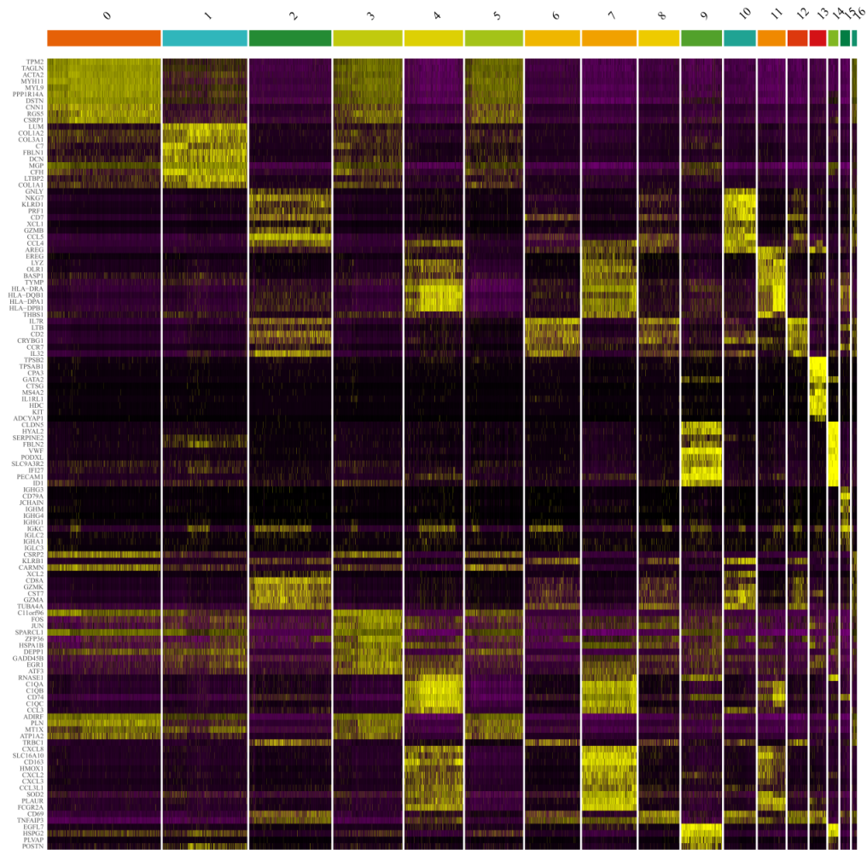
FigS2 Heatmap of the expression of the top 10 genes per cluster.

