Supplementary information

Natural Gamma-Ray Logging and Astronomical Tuning
High-resolution natural gamma-ray (GR) logging data from boreholes and outcrops are essential tools in cyclostratigraphy. These datasets facilitate the detection of Milankovitch cycles, quantification of sedimentation rates, and calibration of chronostratigraphic frameworks (Hinnov, 2013; Li et al., 2018). For clastic shelf sediments, GR logging is particularly effective as a proxy for establishing orbital-scale chronologies when integrated with other chronostratigraphic controls (Xu et al., 2020).
In this study, we utilized high-resolution GR logs from drill core WK23-1 to develop an astronomical timescale across the Triassic–Jurassic boundary. Cyclostratigraphic analysis was performed using the Acycle v2.8 software (Li et al., 2019). The GR data were recorded at 0.1 m intervals along the core, providing a continuous and detailed record of radioactive element concentrations within the strata.
Our analytical workflow involved several steps. First, the collected GR data were interpolated to a constant 0.1 m spacing to ensure a uniformly sampled depth sequence. A 122.15-meter local regression smoothing (LOWESS) filter (Cleveland, 1979) was applied to detrend the data, removing long-period variations and enhancing the visibility of potential orbital cycles. We then used the Multi-taper method (Thomson, 1982) to perform spectral analysis, identifying statistically significant periodicities within the detrended GR data. To estimate the optimal sedimentation rate (Fig. S1A), we conducted correlation coefficient (COCO) and evolutionary COCO (eCOCO) analyses (Li et al., 2018), comparing the observed periodicities to theoretical orbital cycles. The final step involved tuning the filtered GR series to the astronomical target curves using the 'Age Scale' function in Acycle, specifically targeting the clearly expressed 405-kyr eccentricity cycle. This astronomical tuning converted the depth-domain GR data into a floating astronomical timescale.

Cleveland, W.S., 1979. Robust locally weighted regression and smoothing scatterplots. J. Am. Stat. Assoc. 74, 829–836. http://doi.org/10.1080/01621459.1979.10481038
Hinnov, L.A., 2013. Cyclostratigraphy and its revolutionizing applications in the earth and planetary sciences. Geol. Soc. Am. Bull. 125, 1703–1734. http://doi.org/10.1130/b30934.1
Li, M., Hinnov, L.A., Kump, L.R., 2019. Acycle: Time-series analysis software for paleoclimate research and education. Comput. Geosci. 127: 12–22. https://doi.org/10.1016/j.cageo.2019.02.011
Li, M., Kump, L.R., Hinnov, L.A., Mann, M.E., 2018. Tracking variable sedimentation rates and astronomical forcing in Phanerozoic paleoclimate proxy series with evolutionary correlation coeﬃcients and hypothesis testing. Earth Planet. Sci. Lett. 501, 165–179. https://doi.org/10.1016/j.epsl.2018.08.041
Thomson, D.J., 1982. Spectrum estimation and harmonic analysis. Proc. IEEE 70, 1055–1096. http://doi.org/10.1109/PROC.1982.12433
Xu, Y., Jiang, R., Deng, Y., Kemp, D.B., Yang, Z., Huang, C., Zhu, Z., 2020. A robust geochronology of the Yangtze River Delta based on magnetostratigraphy and cyclostratigraphy of sediment core ZKA2. Paleogeogr. Paleoclimatol. Paleoecol. 541, 109532. https://doi.org/10.1016/j.palaeo.2019.109532

Fig. S1.
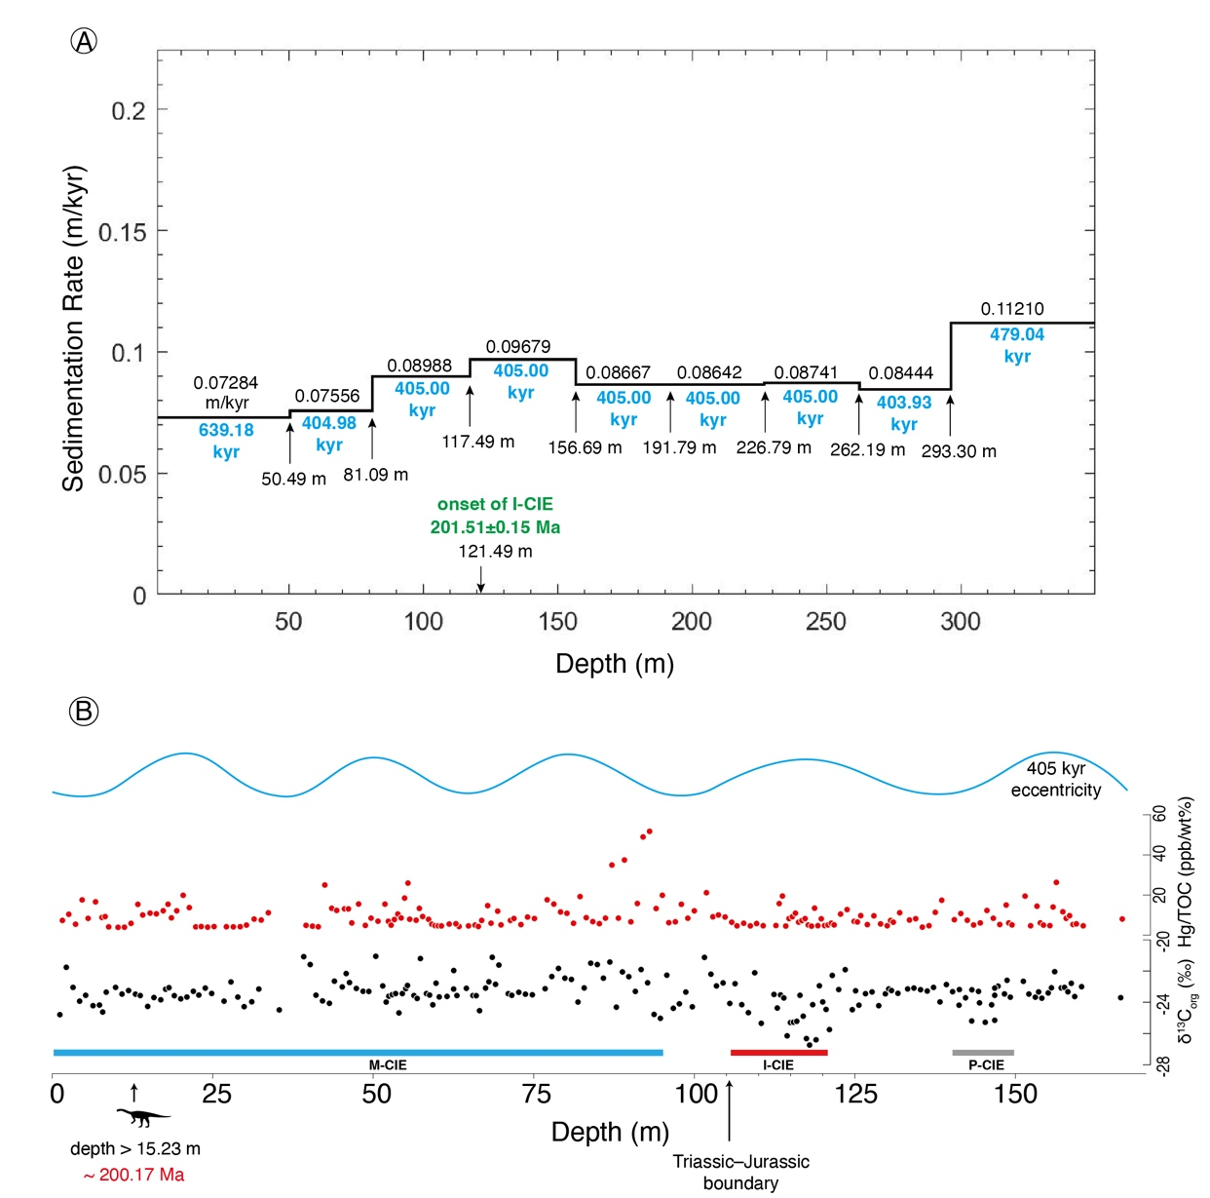
Modeled sedimentation rate for the entire core (0 to 358.84 m) (A), and high-resolution records of δ¹³C_{org} and Hg/TOC ratios for the upper half core (0 to 160 m) with the placement of dinosaur occurrence and Triassic–Jurassic boundary (B).

Fig. S2.
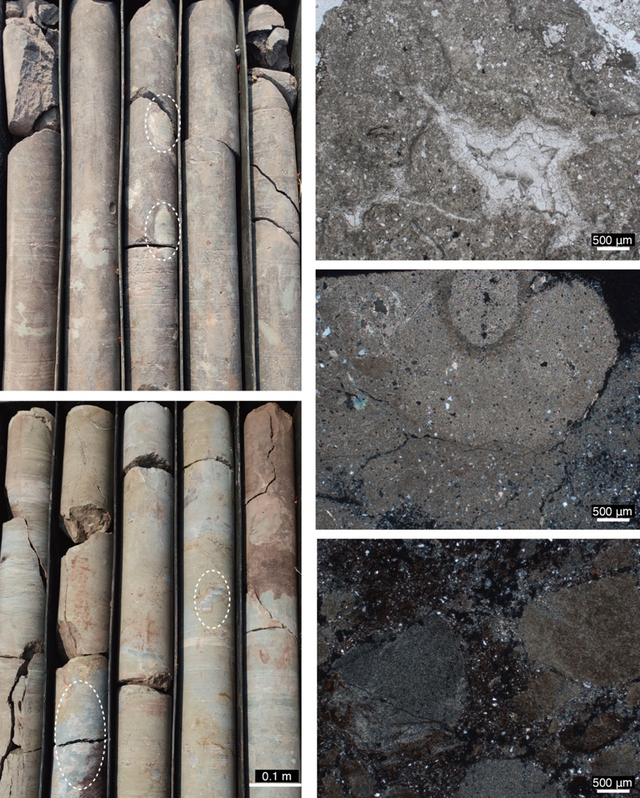
Representative carbonate nodules or concretions in the drill core WK23-1: photos from the core (left half panel) and photomicrographs for the thin-sections (right half panel).

