Supplementary Information

Interfacial Stress Decoupling enables Ultra-Stable Palladium-based Hydrogen Sensing

Rui Gao,^{1,2,3} Guozhu Zhang,^{1,2,3*} Xiaoyuan Wang,^{1,2,3} Yujing Xu,^{1,2,3} Chao Zhang,^{1,2,3} Linfeng Li, ^{1,2,3} Zeyu Wang, ^{1,2,3} Bowei Zhang, ^{1,2,3} Kazuki Nagashima,^{4,5} Takeshi Yanagida ^{6,7} and Fu-Zhen Xuan^{1,2,3*}

¹ Shanghai Key Laboratory of Intelligent Sensing and Detection Technology, Shanghai, PR China.
² School of Mechanical and Power Engineering and, East China University of Science and Technology, Shanghai, PR China.
³ Key Laboratory of Pressure Systems and Safety of Ministry of Education, East China University of Science and Technology, Shanghai, PR China
⁴ Graduate School of Chemical Science and Engineering, Hokkaido University, N13W8 Kita, Sapporo, Hokkaido 060-8628, Japan
⁵ Research Institute for Electronic Science, Hokkaido University, N21W10 Kita, Sapporo, Hokkaido 001-0021, Japan
⁶ Department of Applied Chemistry, Graduate School of Engineering, The University of Tokyo, 7-3-1 Hongo, Bunkyo, Tokyo 113-8656, Japan
⁷ Institute for Materials Chemistry and Engineering, Kyushu University, 6-1 Kasuga-Koen, Kasuga, Fukuoka 816-8580, Japan

Table of contents
I. Structure of dithiol organic molecules
II. Fabrication process of H₂ gas sensor 5
III. SEM and XPS characterizations 7
IV. Electrical properties of H₂ gas sensor 10
VI. DFT calculations and H₂ absorption modeling 17
1. Calculation of energy diagram and Density of states 17
2. Calculation of binding strength and facture properties 21
3. H₂ absorption modeling 24
VII. Construction of smart H₂ leak monitoring system 26
1. Circuit diagrams design of H₂ gas sensor platform. 26
2. Portable H₂ leak monitoring platform. 29

I. Structure of dithiol organic molecules
The molecular structure of the SAM layer consists primarily of branched carbon chains and functional groups. These branched molecules interact with the surface through their branching parts, forming a self-assembled monolayer (SAM). SAM layers are highly versatile, including both aliphatic dithiol and aromatic dithiol, and their properties can be tailored by selecting different branching structures and functional groups. This type of structure is commonly used in specific applications, such as improving wettability or enhancing adhesion. In this study, a dithiol-based (–SH terminated) SAM layer was embedded between the Pd sensitive layer and the underlying electrode. The strong sulfur-metal coordination and flexible carbon backbone significantly improved mechanical toughness and interface stability. Moreover, this design enhanced the spatial exposure of the Pd film, accelerating the H₂ adsorption/desorption kinetics, and increased the sensor's sensitivity by an order of magnitude at room temperature.
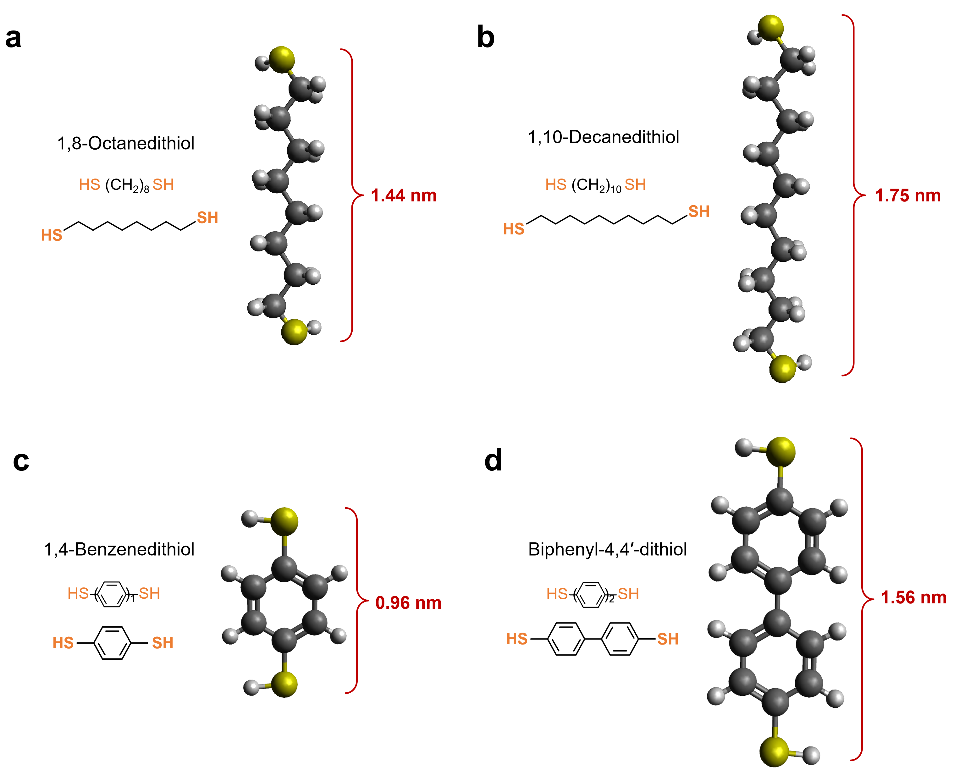
Supplementary Fig. 1 | Structure of dithiol organic molecules: (a) 1,8-Octanedithiol. (b) 1,10-Decanedithiol. (c) 1,4-Benzenedithiol. (d) Biphenyl-4,4′-dithiol.

II. Fabrication process of H₂ gas sensor
The fabrication process begins with the patterning of gold electrodes on a Si/SiO₂ substrate, using photolithography. Subsequently, Cr/Au electrodes are deposited via radio-frequency magnetron sputtering (RF). Next, the patterning of SiO₂ insulation layer is carried out using photolithography, followed by the deposition of SiO₂ layer using RF sputtering. Afterward, photolithography is used to define the palladium (Pd) sensitive layer pattern, and the wafer is then immersed in a precursor solution to grow SAM buffer layer. Here, four types of dithiol molecules, including 1,8-octanedithiol, 1,10-decanedithiol, 1,4-benzenedithiol, and biphenyl l-4,4′-dithiol are chosen for SAM layer integration. As the SAM layers are successfully grown on the Au electrode film, Pd sensing layer with controlled thickness are deposited via RF sputtering. Finally, the Pt electrode pattern is defined on the Pd-sensitive layer using photolithography, and Ti/Pt layer are deposited via RF sputtering, completing the fabrication of the hydrogen sensor.

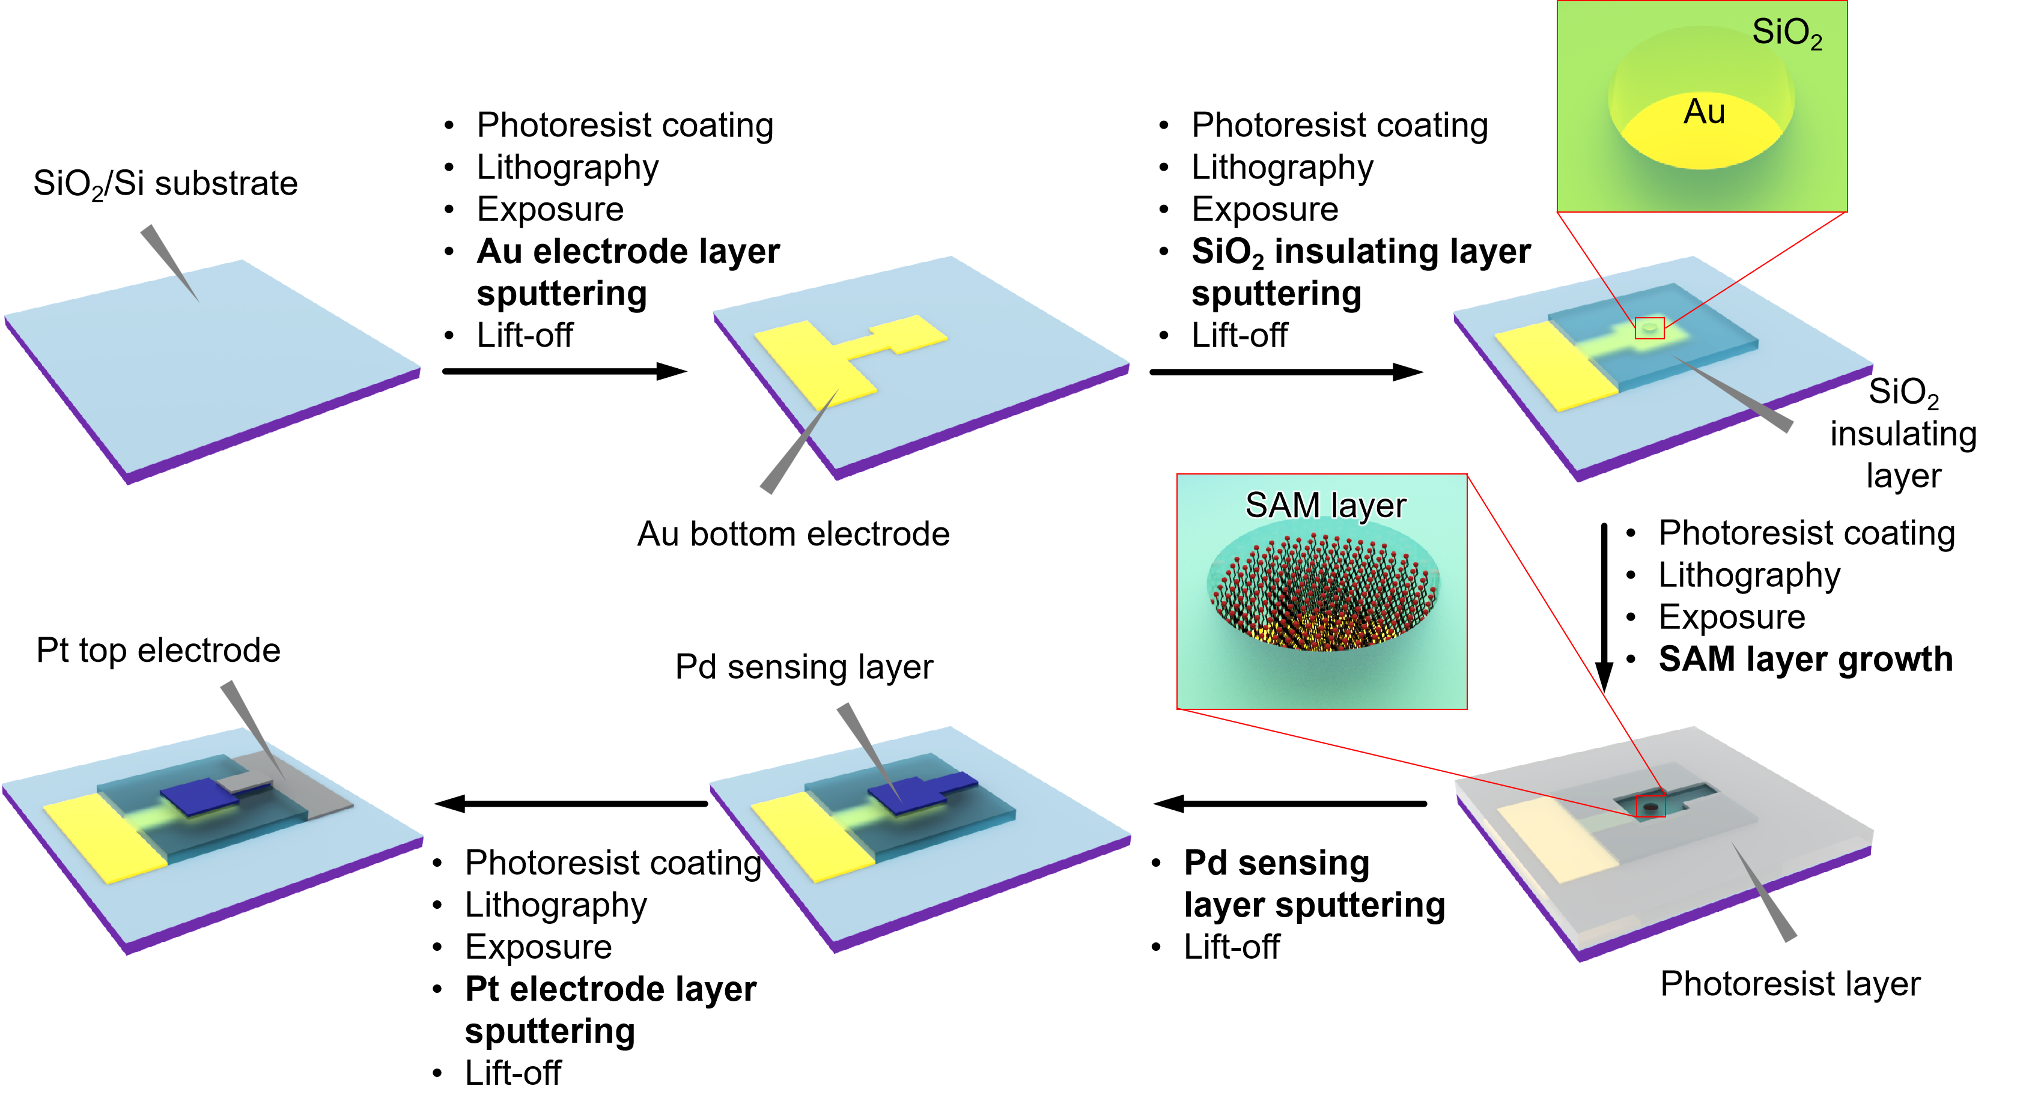
Supplementary Fig. 2 | Fabrication processes of floating-structured H₂ gas sensor.

Supplementary Fig. 3 | Fabrication process of planar-structured H₂ gas sensor.

III. SEM and XPS characterizations
To elucidate the effects of 1,10-decanedithiol on the gold electrode and palladium sensing layer, scanning electron microscopy (SEM) and X-ray photoelectron spectroscopy (XPS) were employed to characterize the film morphology and surface chemical composition. Silicon wafers coated with a 300 nm thermal SiO₂ layer were used as substrates. A 200 nm Au layer followed by an 80 nm Pd layer was deposited sequentially via radio-frequency (RF) magnetron sputtering. The resulting Au/Pd-coated substrates were immersed in a 7.5 mM solution of 1,10-decanedithiol for 24 hours to facilitate the formation of a SAM structure.

Supplementary Fig. 4 | SEM images of as-deposited Au film and 1,10-decanedithiol SAM layer grown on Au film.

Supplementary Fig. 5 | SEM images of as-deposited Pd film and 1,10-decanedithiol SAM layer grown on Pd film.

Supplementary Fig. 6 | XPS analysis of 1,10-decanedithiol SAM layer grown on Au film. 1,10-decanedithiol concentration 7.5mM, growth time 24h.

Supplementary Fig. 7 | XPS analysis of 1,10-decanedithiol SAM layer grown on Pd film. 1,10-decanedithiol concentration 7.5mM, growth time 24h.

IV. Electrical properties of H₂ gas sensor
To evaluate the influence of sensor architecture and SAM composition on electrical conductivity, current–voltage (I–V) characteristics were measured across six distinct H₂ sensor configurations: a planar structure, a floating structure, and floating structures functionalized with SAM of 1,8-octanedithiol, 1,10-decanedithiol, 1,4-phenylenedithiol, and biphenyl-4,4′-dithiol. The floating architecture demonstrated substantially improved electrical conductivity compared to the planar configuration. Consistent with these observations, resistance measurements across the six sensor types further validated the conductivity enhancement enabled by the floating structure.

Supplementary Fig. 8 | (a) I–V characteristic curves of planar- and floating-structured sensor devices. (b) Sensor resistances extracted from I-V curves.

V. H₂ sensing performance of sensor device
To further investigate the effect of 1,10-decanedithiol concentration on the gas-sensing performance of the sensor, we tested the response and recovery characteristics at concentrations ranging from 0 to 20 mM. The results indicated that a 7.5 mM concentration of 1,10-decanedithiol yielded the best performance. Next, we examined the impact of the thickness of the Pd sensing layer on the gas-sensing performance. Pd film thickness was controlled by setting the sputtering time (5min, 10min, 20min and 30min). The optimal sensing performance was achieved with an 82 nm (observed via SEM) thick Pd layer. Additionally, we tested the gas-sensing performance over four consecutive cycles for different sensor structures, including planar and floating-structured (without SAM, and with SAM of 1,8-octanedithiol, 1,10-decanedithiol, 1,4-phenylendithiol, and biphenyl-4,4′-dithiol) devices. All gas-sensing measurements were conducted using a Keithley 4200A-SCS system, with resistance changes monitored at room temperature (25ºC) and a relative humidity of 40-60%.

Supplementary Fig. 9 | Dynamic response-recovery curves of planar- and floating-structured sensors: (a) Planar structure sensor. (b) Floating-structured sensors incorporated without SAM layer.

Supplementary Fig. 10 | Dynamic response-recovery curves of floating-structured sensors embedded with different SAM layers: (a) 1,8-octanedithiol, (b) 1,10-decanedithiol, (c) 1,4-benzenedithiol, (d) biphenyl-4,4′-dithiol.

Supplementary Fig. 11 | Effect of growth concentration of the 1,10-decanedithiol SAM layer on H₂ sensing performance. (a) Response curves of sensor devices embedded with different concentration of the 1,10-decanedithiol SAM layer. (b) Sensitivity and (c) response/recovery time extracted from (a).

Supplementary Fig. 12 | Effect of Pd thickness on the H₂ sensing performance. (a) Response curves of sensor devices deposited with different thickness of Pd film. (b) Sensitivity and (c) response/recovery time extracted from (a).

VI. DFT calculations and H₂ absorption modeling

Calculation of energy diagram and Density of states
The study used VASP to perform density functional theory calculations with projector augmented wave^{1, 2}. The electron spin-polarization was included in all calculations. The Perdew-Burke-Ernzerhof functional was employed for exchange-correlation effects³, while DFT+D3 was used for handling weak interactions⁴. The cut-off energy for the plane-wave basis was 450 eV. K-points were 2*2*1 in the Brillouin zone. 15 Å of layer vacuum was applied at Z-axis of slab models to avoid the Periodic effect. Energy and maximum stress were converged to 10⁻⁵ eV and 0.02 eV/Å, respectively.

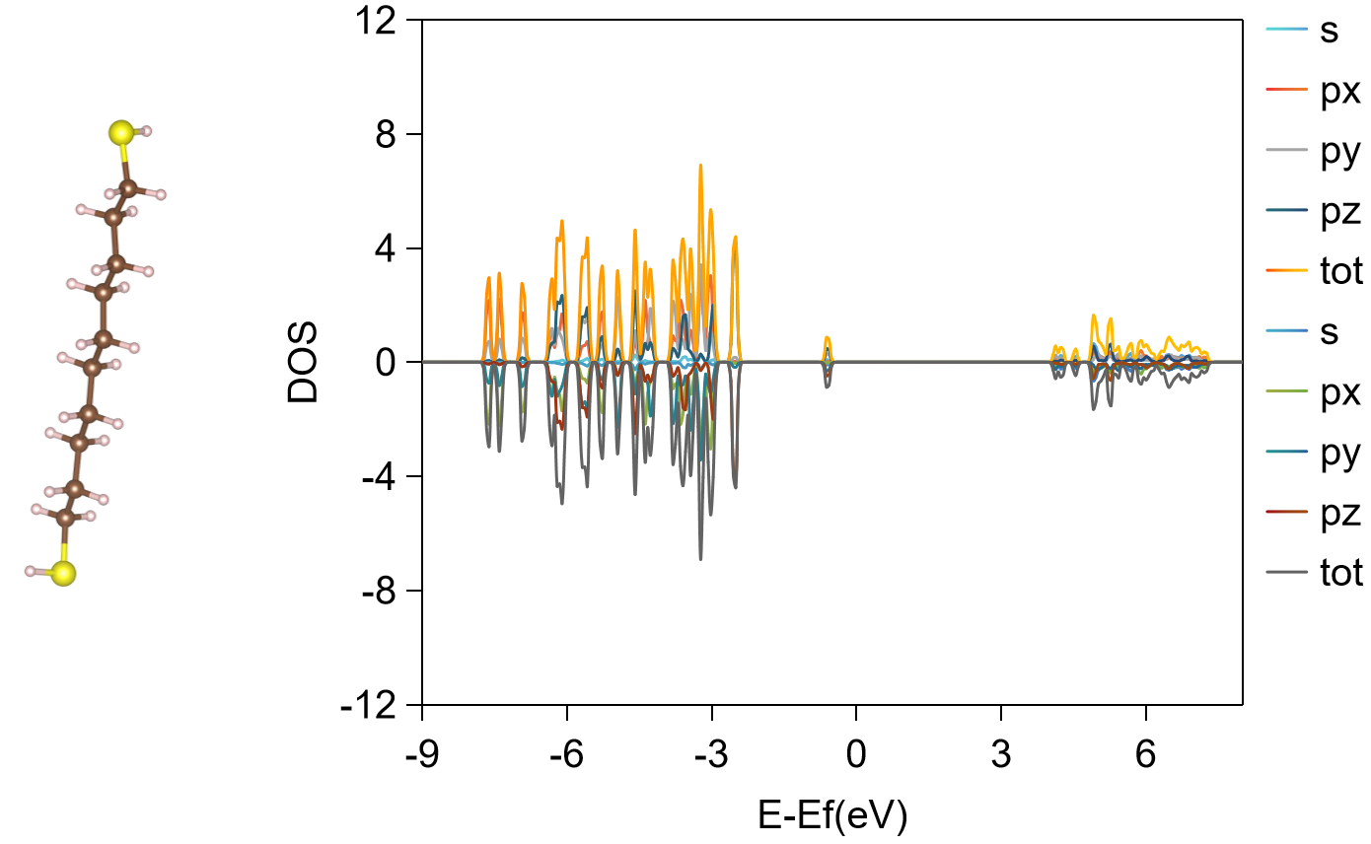
Supplementary Fig. 13 | DOS of 1,10-decanedithiol molecule.

Supplementary Fig. 14 | Density of states (DOS) of uncompressed Pd-SAM-Au system.

Supplementary Fig. 15 | DOS of Pd-SAM-Au system under compressive strain at (a) ε=1%, (b) ε=2%, (c) ε=5%, (d) ε=10%.

Calculation of binding strength and facture properties
Density functional theory (DFT) calculations were performed using the Vienna Ab initio Simulation Package (VASP)⁵. The generalized gradient approximation (GGA)³ in the Perdew-Burke-Ernzerhof (PBE) form was applied. The projector augmented wave (PAW)² method was used to describe the electron-ion interactions. A plane-wave (PW) basis set with a cutoff energy of 500 eV was employed. The Monkhorst-Pack⁶ scheme was used for the Brillouin zone sampling, and a k-point grid of 5×5×1 was applied to the surface model. Energy convergence for structural optimization was set to below 10⁻⁵ eV, and forces on all atoms were less than 0.01 eV/Å. A Fermi-Dirac smearing of 0.2 eV was applied. The vacuum layer in the surface model was at least 15 Å. Organic sulfur compounds, primarily alkyl thiols, tend to react with metal surface atoms through their thiol functional groups, releasing hydrogen gas. To explore the bonding strength and mechanical properties of the 1,10-decanedithiol (C10) SAM layer with the metal interface, the most stable structural models were constructed and tested, namely Au-SAM, Pd-Au, Pd-SAM, and Pd-SAMs-Au. The periodic nature of DFT calculations ensures that both ends of the SAM layer contain at least five atomic layers, providing a bulk-like environment at both ends of the SAM layer.

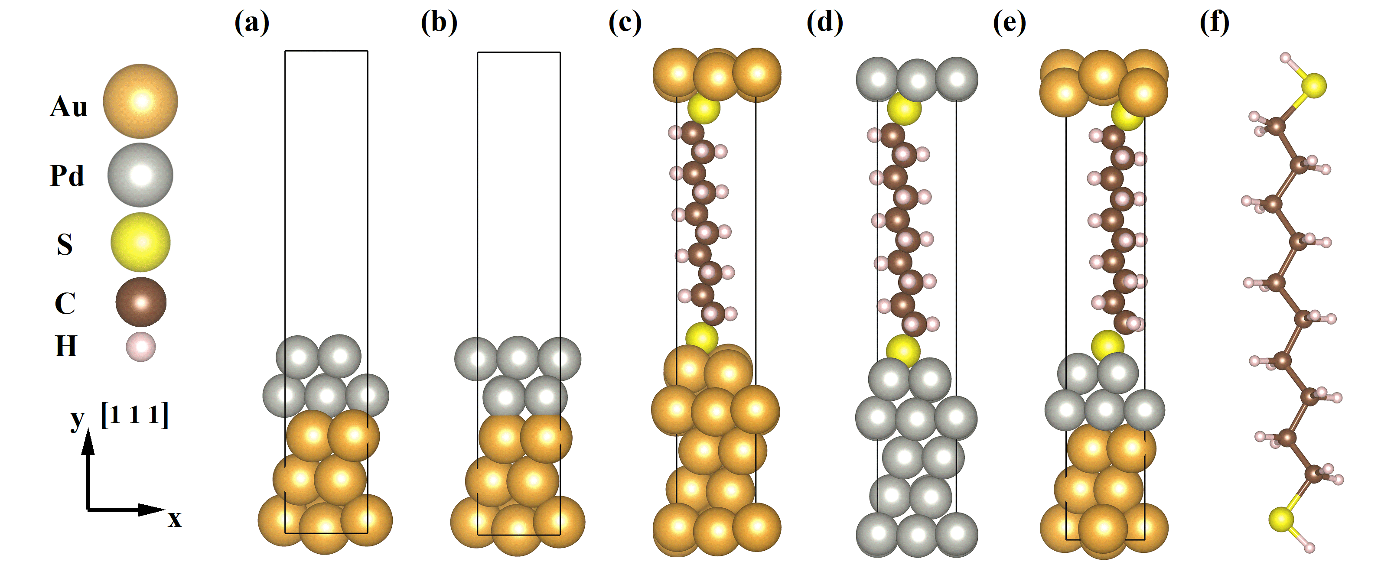
Supplementary Fig. 16 | DFT-optimized structural models: (a) Pd-Au vacancy interface, (b) Pd-Au top-site interface, (c) Au-SAM, (d) Pd-SAM, (e) Pd-SAM-Au and (f) ball-and-stick model of 1,10-decanedithiol.

To investigate the interface binding strength, we calculated the interface binding energy for the Pd-Au and Pd-SAM-Au structures. The interface binding energy, ,is evaluated by
Where corresponds the total energy of the interface system, , and ​denote the potential energy of the Pd bulk, Au bulk, and the energy of the SAM layer, and A denotes the interface area. The interfacial binding energy has been used to characterize the stability of interfaces⁷. To further investigate the mechanical properties of the interfaces, axial tensile strain⁸ was performed on both the Pd-Au and Pd-SAMs-Au models. Tensile strain was gradually applied in the z-direction to both interface structures until fracture occurred.

Supplementary Fig. 17 | Stress-strain curves for Pd-Au vacancy interface, Au-SAM, Pd-SAM, and Pd-SAM-Au.

H₂ absorption modeling
To understanding the influence of the SAM interlayer on hydrogen absorption kinetics during gas sensing, we model the correlation between the real-time hydrogen-to-palladium ratio, n(t), in bulk Pd and the sensor sensitivity. The equivalent circuit representing the hydrogen sensing mechanism in the SAM-integrated H₂ sensor is illustrated in Fig. 18. As hydrogen uptake increases, portions of pure Pd are converted to PdH_{x}, with the corresponding resistance, R_{PdHx}, directly related to n(t). Consequently, the electrical resistance of the sensor before and after hydrogen exposure can be expressed as follows:
(1)
(2)
(3)
Here, L and S denote the thickness and area of the Pd sensing film, respectively. R_{SAM} and R_{SAM-H} represent the resistance of the Pd–SAM–Au interlayer before and after H₂ absorption. Owing to the excellent electrical conductivity of the Pd–SAM–Au interlayer, which remains stable even under strain, the resistance variation between R_{SAM} and R_{SAM-H} is negligible compared to that of the Pd sensing film. Thus, R_{SAM} ≈ R_{SAM-H} can be assumed. The thickness of the resulting Pd hydride layer, L_{PdHx}, is dependent on the time-dependent H/Pd ratio, n(t)
(4)
Based on these relationships, the electrical resistance of the sensor film during H₂ exposure can be expressed as:
(5)
The sensor sensitivity (S) can thus be defined as:
(6)
During the hydrogen bulk diffusion regime, temporal evolution of the n(t) can be described as ⁹:
(7)
(8)

By combing with eq. (6) and eq. (7), the average hydrogen absorption rate can be determined by fitting the experimental gas sensing response curves in the H₂ absorption-controlled non-linear regime, as shown in Supplementary Fig. 19 and Fig. 20.

Supplementary Fig. 18 | Sensing process modeling of floating-structure H₂ gas sensor and its schematic equivalent circuit.

Supplementary Fig. 19 | Dynamic H₂ sensing response curve of the floating-structure H₂ sensor incorporated without the 1,10-decanedithiol SAM layer, along with the identified absorption- and adsorption-controlled regimes.

Supplementary Fig. 20 | Dynamic H₂ sensing response curve of the floating-structure H₂ sensor incorporated with the 1,10-decanedithiol SAM layer, along with the identified absorption- and adsorption-controlled regimes.

VII. Construction of smart H₂ leak monitoring system

Circuit diagrams design of H₂ gas sensor platform.
The circuit diagram of each component of the Floating-Structure hydrogen sensor prototype is shown in Figure 9. The core of the system is a 32-bit ARM-based MCU^{①}, operating at a frequency of 240 MHz, which is responsible for data acquisition and external communication. The signal amplification module^{②} uses a two-stage instrumentation amplifier to amplify the differential output voltage of the Wheatstone bridge. The cascaded operational amplifier configuration provides higher gain, while the filtering module ensures signal stability. The amplified signal is sent to a high-resolution ADC module^{③}, which converts it into a digital signal. The selection of the ADC is based on the required resolution and sampling rate to ensure an accurate representation of the gas sensor's response. The sensor chip is integrated into one arm of the Wheatstone bridge^{④}, while the remaining three arms are composed of high-precision resistors (RL1, RL2, and RL3), whose resistance values closely match the baseline resistance (Rsen) of the sensor. The prototype integrates a battery, switch, and voltage conversion chip^{⑤}, which regulates and controls the circuit's power supply.
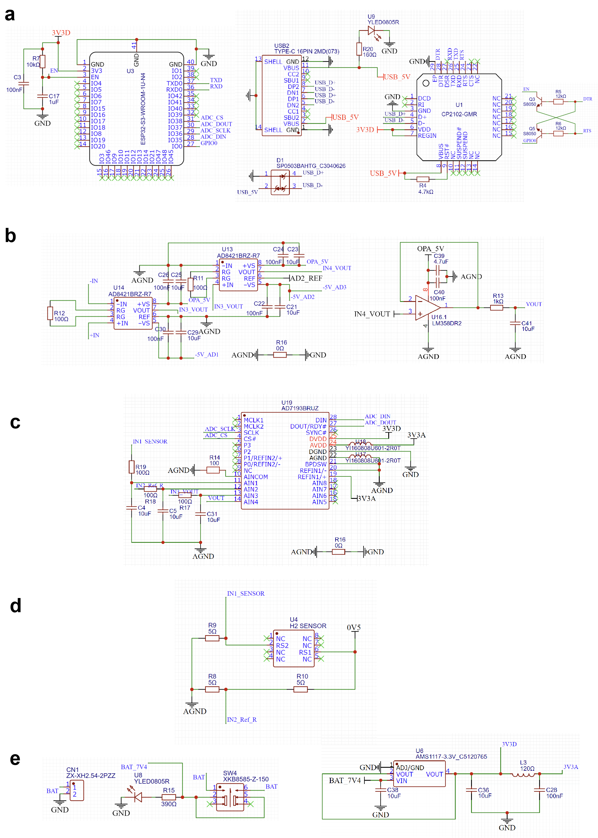
Supplementary Fig. 21 | Prototype of the hydrogen gas sensor and circuit diagram of its components. (a) MCU and external communication module. (b) Front-end signal amplification and filtering module. (c) Analog-to-Digital Converter. (d) Wheatstone Bridge Circuit. e, Battery, switch, and voltage conversion chip.

Supplementary Fig. 22| Sensor response to H₂ concentrations ranging from 1 to 1000 ppm using the integrated detection module.

Portable H₂ leak monitoring platform.
Based on the aforementioned circuit design schematic, we have developed an integrated portable H₂ leakage monitoring system. The system primarily comprises an MCU module, a MEMS H₂ sensor testing unit, a data acquisition module, a pump-suction module, a power management unit, and a button interface. The structural design and physical prototype of the device are illustrated as follows.

Supplementary Fig. 23 | Portable H₂ leak monitoring platform. (a) 3D structure of designed portable H₂ leak monitoring platform. (b) Integrated H₂ leak monitoring platform. (c) Working condition of H₂ leak monitoring platform. (d) UI of dynamic H₂ detection in hydrogen leak monitoring system.
References
1. Kresse, G.; Furthmüller, J., Efficient iterative schemes for ab initio total-energy calculations using a plane-wave basis set. Physical Review B 1996, 54 (16), 11169.
2. Blöchl, P. E., Projector augmented-wave method. Physical Review B 1994, 50 (24), 17953.
3. Perdew, J. P.; Burke, K.; Ernzerhof, M., Generalized gradient approximation made simple. Physical Review Letters 1996, 77 (18), 3865.
4. Grimme, S.; Antony, J.; Ehrlich, S.; Krieg, H., A consistent and accurate ab initio parametrization of density functional dispersion correction (DFT-D) for the 94 elements H-Pu. The Journal of Chemical Physics 2010, 132 (15).
5. Kresse, G.; Furthmüller, J., Efficiency of ab-initio total energy calculations for metals and semiconductors using a plane-wave basis set. Computational Materials Science 1996, 6 (1), 15-50.
6. Monkhorst, H. J.; Pack, J. D., Special points for Brillouin-zone integrations. Physical Review B 1976, 13 (12), 5188.
7. Sun, J. P.; Dai, J.; Song, Y.; Wang, Y.; Yang, R., Affinity of the interface between hydroxyapatite (0001) and titanium (0001) surfaces: a first-principles investigation. ACS Applied Materials & Interfaces 2014, 6 (23), 20738-20751.
8. Guo, X.; Shang, F., Reinvestigation of the tensile strength and fracture property of Ni (1 1 1)/α-Al2O3 (0 0 0 1) interfaces by first-principle calculations. Computational Materials Science 2011, 50 (5), 1711-1716.
9. Delmelle, R.;Proost, J., An in situ study of the hydriding kinetics of Pd thin films. Physical Chemistry Chemical Physics 2011, 13 (23), 11412-11421.

