Supplementary Figure

Similarity in filter properties related to similarity in filter output-connection patterns: analysis using convolutional neural networks

Hiroshi Tamura^{1, 2*}
¹Graduate School of Frontier Biosciences, The University of Osaka, Suita, Osaka 565-0871, Japan

²Center for Information and Neural Networks, Suita, Osaka 565-0871, Japan

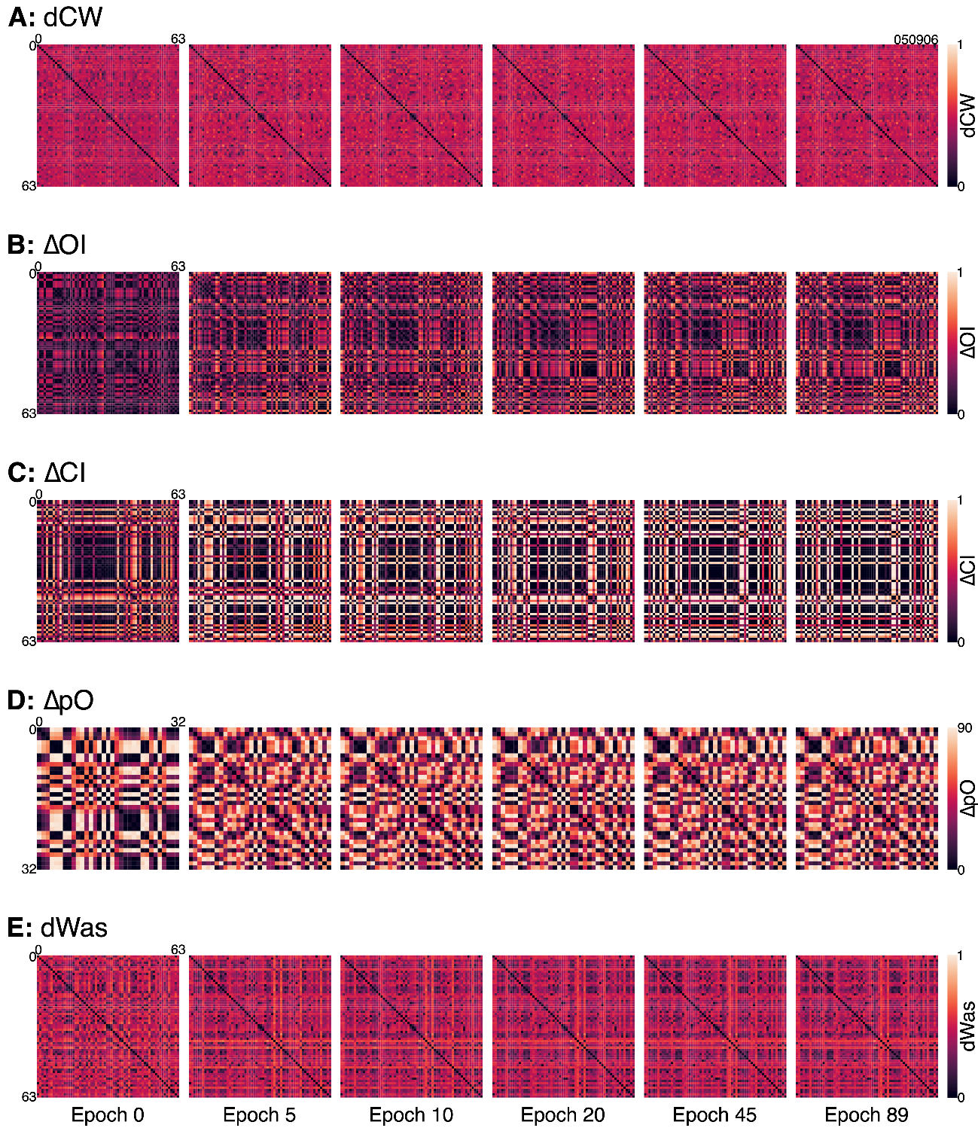

Supplementary Figure 1. Matrices of connection weight distance (dCW, A), absolute difference in orientation index (𝛥OI, B), absolute difference in color index (𝛥CI, C), absolute difference in preferred orientation (𝛥pO, D), and distance in amplitude spectrum of filter weights (dWas, E) at epochs 0, 5, 10, 20, 45, and 89 of filters in the first convolutional layer (conv1) of a representative model instance of a convolutional neural network (AlexNet). The matrices are color coded. Analysis of 𝛥pO was limited to orientation-selective conv1 filters (OI ≥ 0.5, n = 33) at the final epoch (epoch 89). The remaining analyses used all 64 conv1 filters.

