Supplementary Information
Single Nanoplastics Detection and Nano-Chemical Analysis of Surface Degradation in Commercial Bottled Water
Clementina Vitali^{1,2}, Michel W.F. Nielen^{1,2}, Hans-Gerd Janssen^{1,3}°, Anna K. Undas², and Francesco Simone Ruggeri^{1,4}*
1 Wageningen University, Laboratory of Organic Chemistry, Stippeneng 4, 6708 WE, Wageningen, NL
2 Wageningen Food Safety Research, Wageningen University & Research, Akkermaalsbos 2, 6708 WB Wageningen, NL
3 Unilever Foods Innovation Centre – Hive, Bronland 14, 6708 WH Wageningen, NL
4 Wageningen University, Physical Chemistry and Soft Matter, Stippeneng 4, 6708 WE, Wageningen, NL
* Corresponding author:
Email: simone.ruggeri@wur.nl
Table of Contents
Supplementary Notes 3
SI Notes 1 – Total fluorescence analysis 3
SI Notes 2 – Comparison of Zinc Sulfide and Zinc Selenide substrates for MPs/NPs analysis 4
SI Notes 3 – ATR-FTIR bulk analysis of commercial PET and Bio-HDPE bottles 5
Supplementary Figures 6
Figure S1. Roughness analysis of bare substrates. 6
Figure S2. Impurity analysis on bare substrates. 7
Figure S3. ATR-FTIR spectra of microplastic standards. 8
Figure S4. AFM-IR and nano-polarimetry analysis of standard PE MP. 9
Figure S5. ATR-FTIR bulk analysis of commercial PET and Bio-HDPE bottles. 10
Figure S6. Physicochemical analysis of nanoparticles isolated from bottled water. 11
Figure S7. Nile Red Characterization. 12
Supplementary Tables 13
Table S1. Poly(ethylene terephthalate) peak assignment. 13
Table S2. Poly(lactic acid) peak assignment 14
Table S3. Poly(hydroxy butyrate) peak assignment. 15
Table S4. Polyethylene peak assignment. 16
Table S5. Polypropylene peak assignment. 17
Table S6. Polystyrene peak assignment. 18
Table S7. Nile Red peak assignment. 19

Supplementary Notes

SI Notes 1 – Total fluorescence analysis
Fluorescence images were captured using an Olympus BX51 microscope, fitted with 4x, 10x, 20x, and 40x Olympus objectives, an Olympus SC50 RGB camera, an Olympus U-RFL-T UV lamp, and a bandpass filter with excitation wavelengths of 460-490 nm and emission wavelengths greater than 515 nm. The images were collected by built-in software cellSens and processed in ImageJ (version 1.54) by subtracting the background (rolling ball radius of 25 px) and applying a median filer (radius of 5 px).
The threshold on the Z axis (grey value) to distinguish fluorescent particles from background noise was calculated by multiplying the background mean grey value by a factor of 5. The particles analysis was further refined by excluding particles with a maximum diameter on the XY plane smaller than the value obtained by multiplying the pixel size by a factor of 3. The grey values of each pixel belonging to the detected particles were summed to obtain the total fluorescence measurement.

SI Notes 2 – Comparison of Zinc Sulfide and Zinc Selenide substrates for MPs/NPs analysis
Zinc Sulfide (ZnS) and Zinc Selenide (ZnSe) IR transparent windows (Crystran Limited, Poole, United Kingdom) were characterized and compared to select the most suitable substrate for the infrared nanospectroscopy analysis of MPs and NPs.
Roughness. The roughness of the surface of ZnS and ZnSe substrates was assessed at different scales. Atomic Force Microscopy (AFM) maps were acquired with a MultiMode 8 AFM and its built-in software Nanoscope (version 9.7, Bruker) operating in Peak Force tapping mode and equipped with ScanAsyst-air silicon tip with a nominal radius of ~2 nm and an elastic constant of about 0.4 N m⁻¹. AFM morphology maps of 5 × 5 µm, 10 × 10 µm, and 50 × 50 µm were acquired in triplicates with a resolution of 2.5 nm px⁻¹, 5 nm px⁻¹, and 20 nm px⁻¹ respectively. Further studies were performed on three separate windows by acquiring on each of them triplicates of 10 × 10 µm AFM maps with a resolution of 5 nm px⁻¹. Image flattening (first or second order) and root mean square (RMS) roughness measurement were performed in MountainsSPIP (version 10, Digital Surf, France) software.
Fig. S1 illustrates representative AFM maps at the three different scales for both ZnS (Fig. S1A) and ZnSe (Fig. S1B). Mean values of RMS (n = 3) are reported as well (Fig. S1C-D). Overall, ZnSe showed lower RSM values compared to ZnS. A reduced roughness represents an advantage for particles analysis as the size detection limit is calculated by multiplying the RMS by a factor of 3. Accordingly, RMS values obtained at the 10 × 10 µm scale for ZnS (7 ± 2 nm, mean ± SD, n = 9) and ZnSe (1.8 ± 0.4 nm, mean ± SD, n = 9) were used to establish the thresholds for particle analysis.
Particle analysis. For both ZnS and ZnSe particle analysis was performed on three separate windows by acquiring on each of them triplicates of 10 × 10 µm AFM maps with a resolution of 5 nm px⁻¹. Particle analysis was performed in MountainsSPIP (Digital Surf, France) software. The threshold on the Z axis (height) to distinguish particles from background noise was calculated by multiplying the RMS by a factor of 3. The particles analysis was further refined by excluding particles with a convoluted maximum diameter on the XY plane smaller than the value obtained by multiplying the pixel size by a factor of 3 and excluding particles with a roundness lower than 0.3.
Threshold values for height, lateral resolution, and roundness obtained for ZnS and ZnSe are reported in Fig. S2. Furthermore, Fig. S2 illustrates the particle size distributions of residual impurities detected on the surface of ZnS and ZnSe substrates. For ZnS, the heights of residual particles are distributed around an average of 25 ± 15 nm (average of the means ± SD, n = 9) and the major diameters on the XY plane (convoluted values) around an average of 50 ± 90 nm (average of the means ± SD, n = 9; Fig. S2). The upper 95% confidence interval, useful to statistically discriminate residual impurities from analyte deposited on the substrate at a later stage, is estimated as 30 nm for particle height and 137 nm for the convoluted maximum diameter. For ZnSe, the heights of residual particles are distributed around an average of 20 ± 10 nm (average of the means ± SD, n = 9) and the convoluted major diameters around an average of 50 ± 30 nm (average of the means ± SD, n = 9; Fig. S2). The upper 95% confidence interval is estimated to be 39 nm for particle height and 95 nm for the convoluted maximum diameter.
ZnSe was selected for the infrared nanospectroscopy analysis of NPs due to the narrower size distribution of residual impurities which enables effective statistical discrimination between impurities and analytes.

SI Notes 3 – ATR-FTIR bulk analysis of commercial PET and Bio-HDPE bottles
Attenuated Total Reflection infrared spectroscopy (ATR-FTIR) analysis of the PET and Bio-HDPE bottles and their caps were performed using a Bruker Tensor27 spectrometer equipped with a diamond ATR element. Spectra were collected by built-in software OPUS (version 7.8, Bruker, USA). ATR-FTIR spectra of the bottles and their caps were acquired pressing the inner surface of the samples against the ATR element. Each sample was analysed in triplicate measuring different areas, for each replicate 5 spectra (with 256 co-averages) were acquired with a resolution of 4 cm⁻¹. All spectra were processed using OriginPro 2020 (OriginLab Corp., USA) software: the spectra were smoothed applying a Savitzky–Golay filter (second order, 11 pts), baselined, averaged, and normalized.
Resulting spectra are reported in Fig.S5.

Supplementary Figures
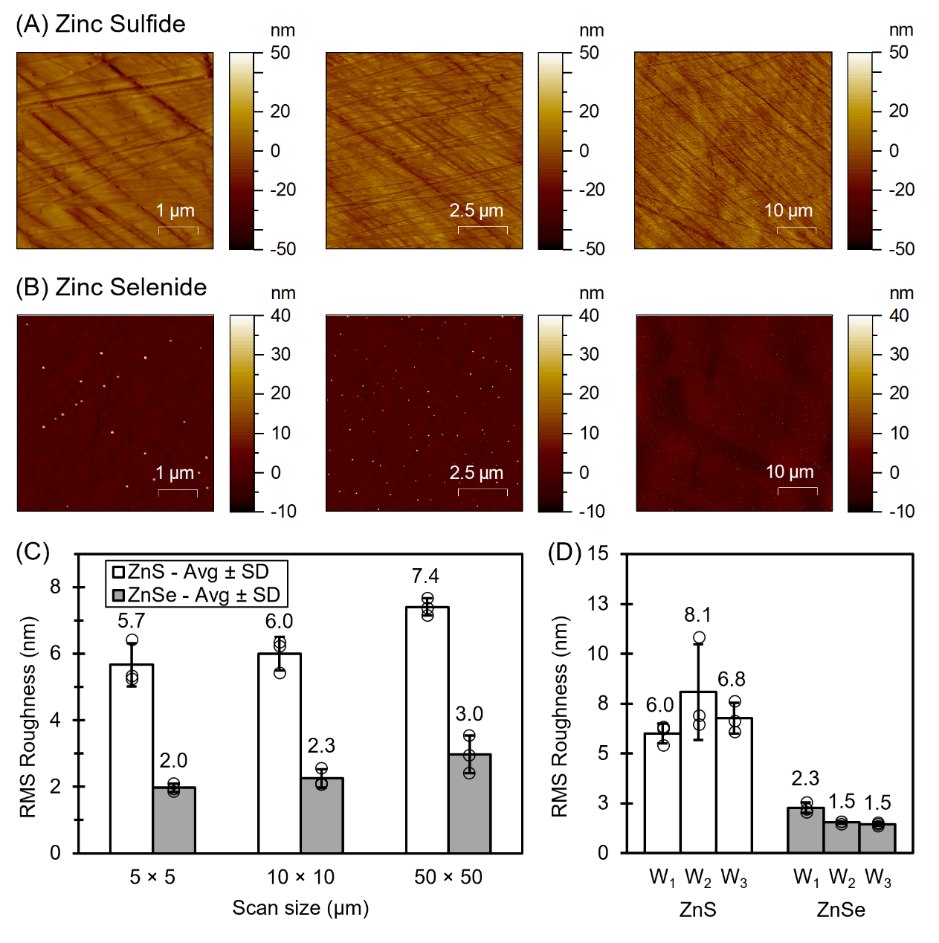
Figure S1. Roughness analysis of bare substrates. Representative AFM morphology maps of (A) Zinc Sulfide (ZnS) and (B) Zinc Selenide (ZnSe) substrates. (C) Root mean square (RMS) roughness measurement at increasing scales, data labels refer to mean values and error bars to standard deviation (n = 3). (D) RMS roughness measurement performed on three separate windows (W) for each material, data labels refer to mean values and error bars to standard deviation (n = 3).

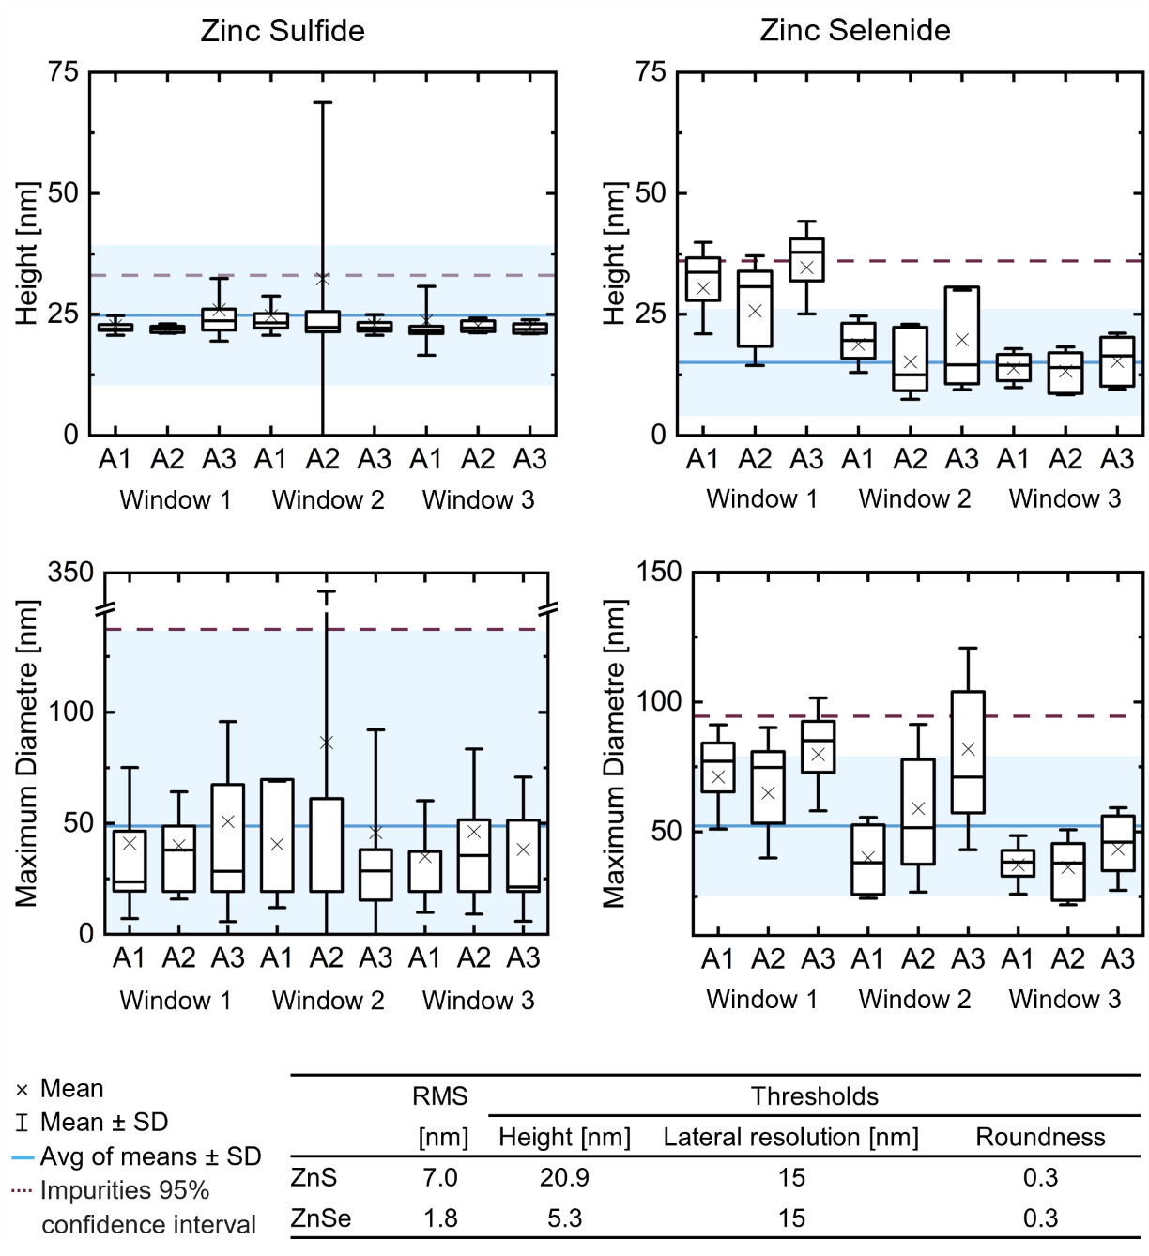
Figure S2. Impurity analysis on bare substrates. Particle analysis of residual impurities on the surface of Zinc Sulfide (ZnS) and Zinc Selenide (ZnSe) substrates. Including height and convoluted maximum diameter distribution of impurities detected by AFM analysis of nine 10×10 μm areas (A) randomly selected on 3 separate windows (W). Thresholds for the particle analysis are reported as well.

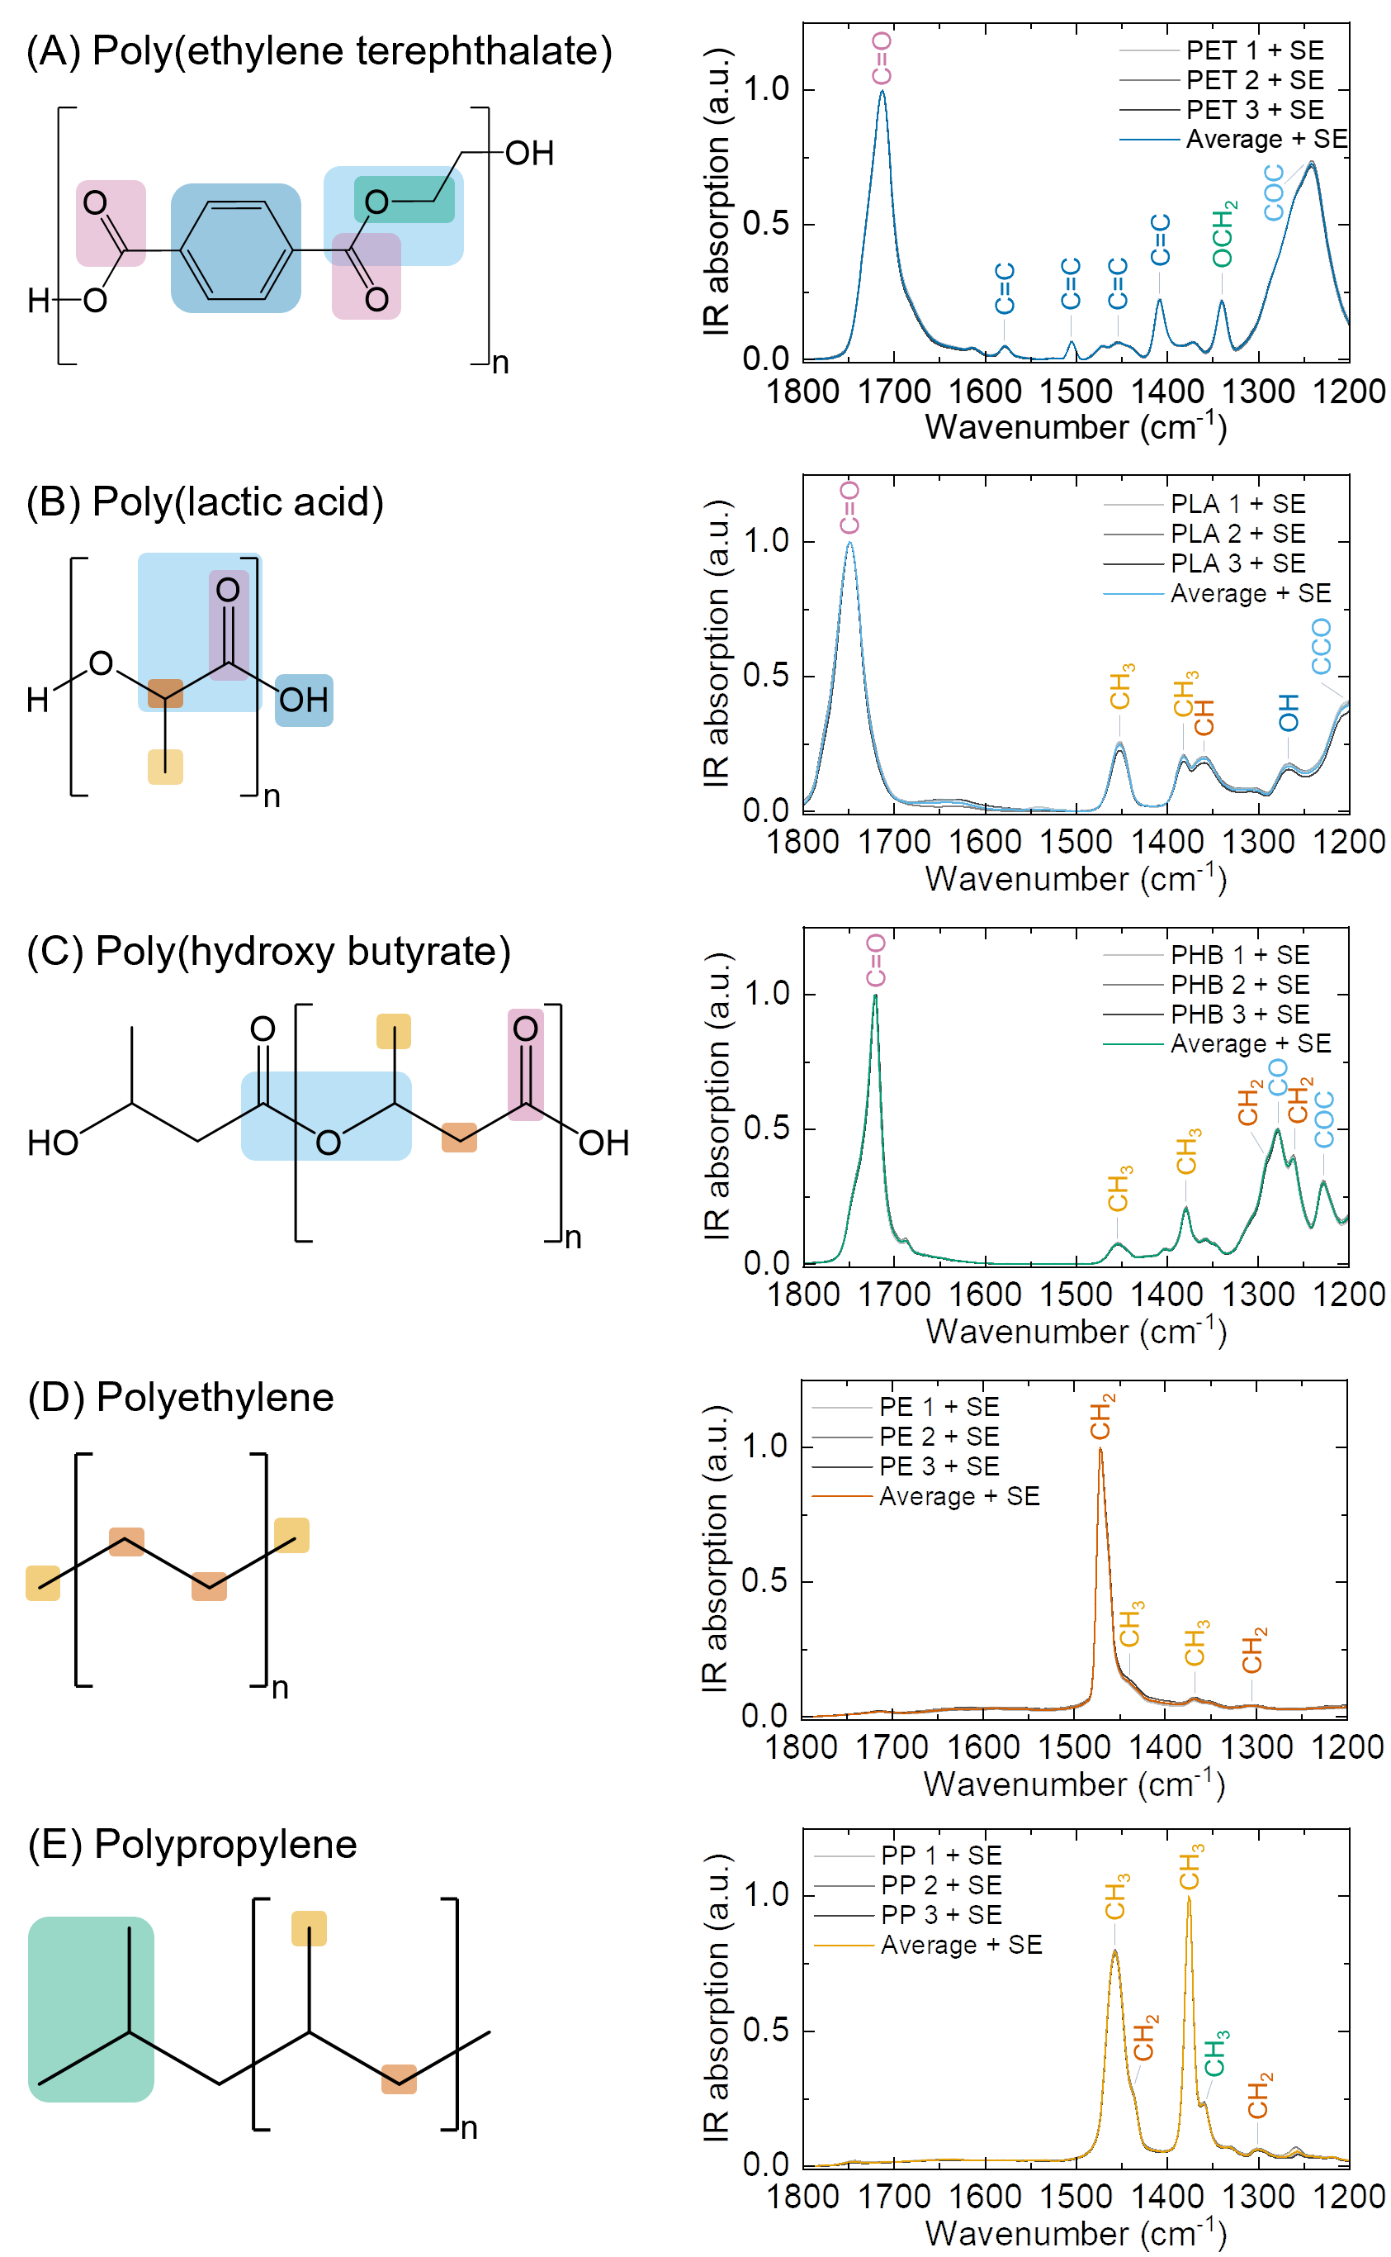
Figure S3. ATR-FTIR spectra of microplastic standards. Chemical structures and attenuated total reflection infrared spectroscopy (ATR-FTIR) spectra of microplastic (MP) standards relevant for the analysis of MPs and nanoplastics (NPs) in bottled water. Average ± standard error (SE) of N = 3 independent measurements plotted in varying grayscale intensity, each with n = 5 spectra with 256 co-averaging. Peak assignment and relative functional groups are color coded.
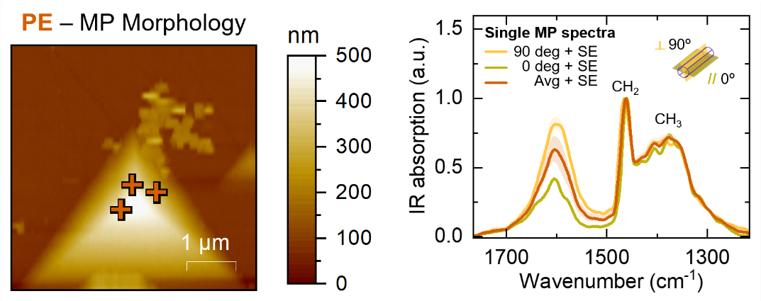
Figure S4. AFM-IR and nano-polarimetry analysis of standard PE MP. AFM-IR physicochemical characterization of PE standards via AFM morphology mapping and nano-localised IR spectra. Average (Avg) ± Standard Error (SE), N = 3 independent measurements, each with n = 5 spectra at 90° and n = 5 spectra at 0° polarisation. Crosses on the AFM maps indicate the location of acquisition of the AFM-IR spectra.

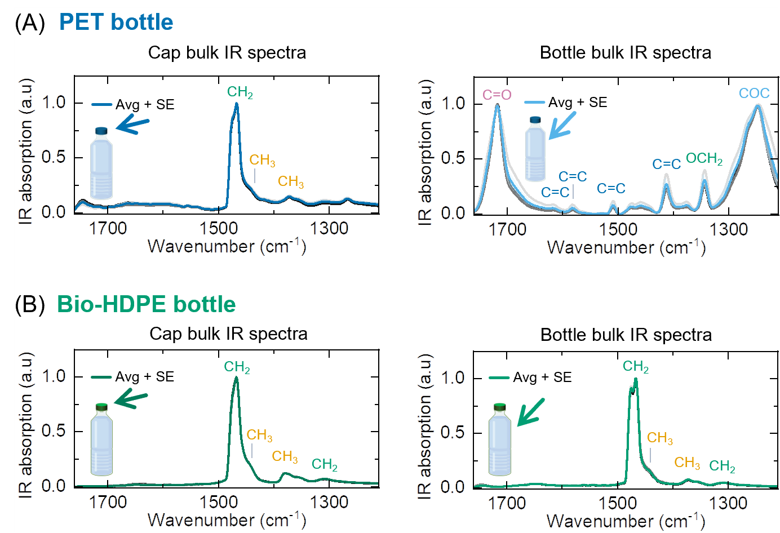
Figure S5. ATR-FTIR bulk analysis of commercial PET and Bio-HDPE bottles. AFM-IR physicochemical characterization of PE standards via AFM morphology mapping and nano-localised IR spectra. Average (Avg) ± standard error (SE) of N = 3 independent measurements plotted in varying grayscale intensity, each with n = 5 spectra with 256 co-averaging.

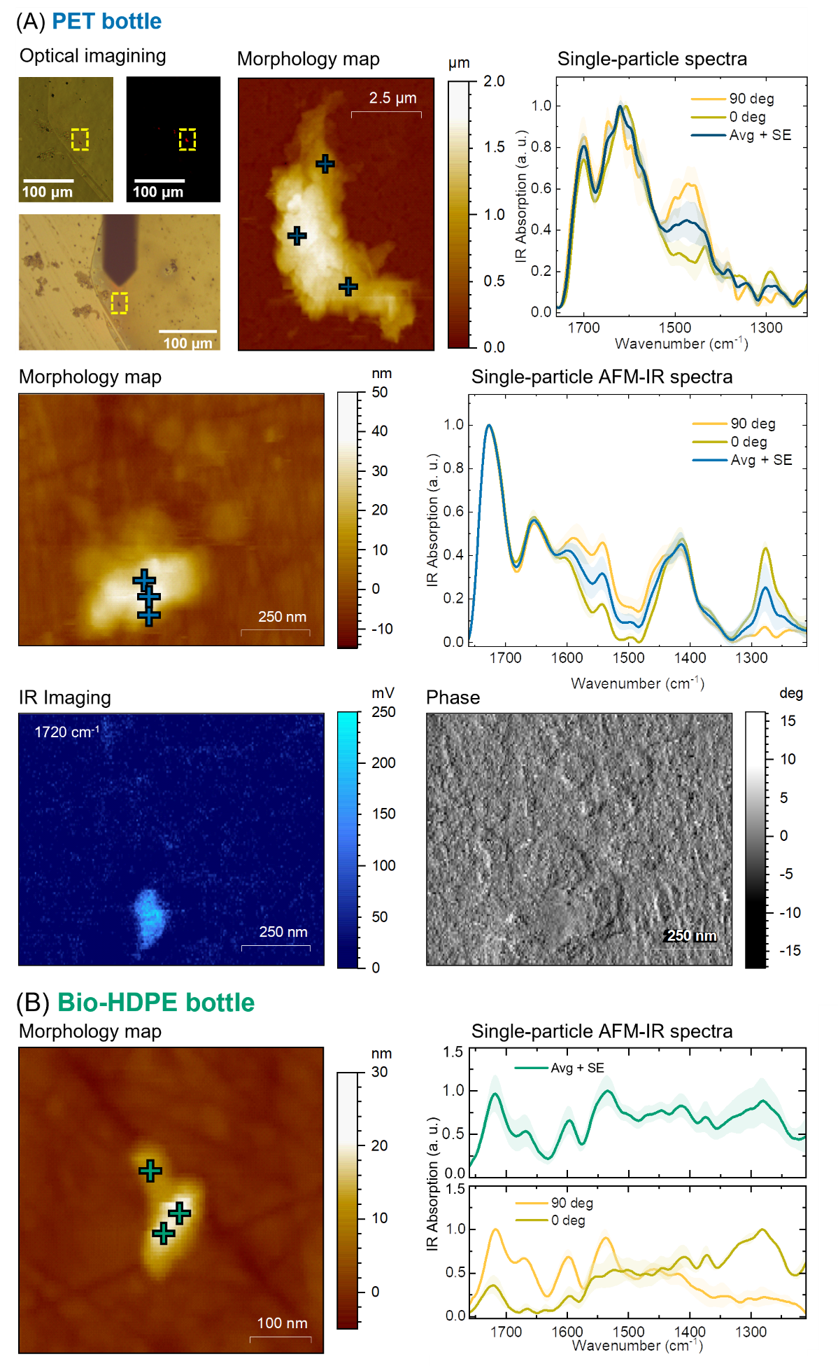
Figure S6. Physicochemical analysis of nanoparticles isolated from bottled water. Average (Avg) ± Standard Error (SE), N = 3 independent measurements, each with n = 5 spectra at 90° and n = 5 spectra at 0° polarisation. Crosses on the AFM maps indicate the location of acquisition of the AFM-IR spectra.
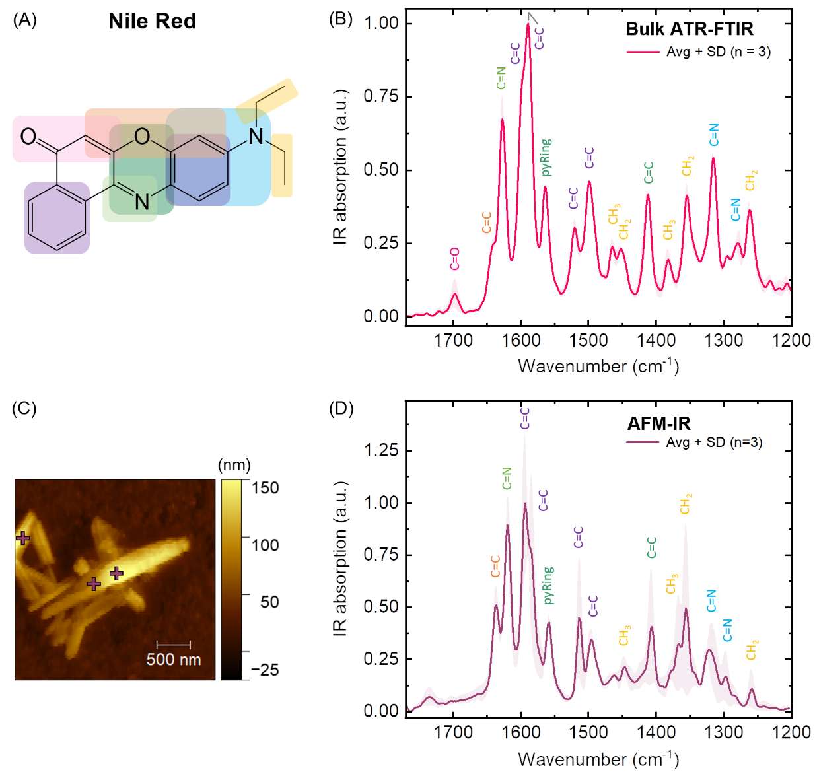
Figure S7. Nile Red Characterization. (A) Chemical structures. (B) Attenuated total reflection infrared spectroscopy (ATR-FTIR) spectra of Nile red. Peak assignment and relative functional groups are color coded. Avg, average; SD, standard deviation. (C) AFM morphology map of Nile Red crystal. (D) Infrared nanospectroscopy (AFM-IR) spectrum of Nile Red crystal. Average (Avg) ± Standard Error (SE), N = 3 independent measurements, each with n = 3 spectra. Crosses on the AFM maps indicate the location of acquisition of the AFM-IR spectra.

Supplementary Tables
Table S1. Poly(ethylene terephthalate) peak assignment. Peak assignment for the attenuated total reflection infrared spectroscopy (ATR- FTIR) spectrum of Poly(ethylene terephthalate) microplastics.

Exact peak position  [cm⁻¹] | Group | Assignment | Expected peak position  [cm⁻¹] | IR band  [cm⁻¹]
1712 | Aryl carbonyl | νC=O | 1717^{c} / 1725e | 1715 – 1660ª
1613 | Aryl | νC=C | ~1600ª / 1615^{f} | 1625 – 1590ª
1579 | Aryl | νC=C | 1578e / ~1580ª | 1590 – 1575ª
1504 | Aryl | νC=C | 1506^{d} | 1525 – 1470ª
1469 | Aryl | νC=C | 1471e | 1470 – 1430ª
1455 | Aryl | νC=C | 1450^{f} | 1465 – 1530ª
1406 | Aryl | νC=C | 1408e/ 1410^{f} | 1420 – 1400ª
1372 | Ester | γ_{w}OCH₂ | 1370^{d} | 1385 – 1335ª
1341 | Ester | γ_{t}OCH₂ | 1341^{d} | 1325 – 1340ª
1241 | Ester | νC-O-C as | 1245^{c} / 1238e | 1310 – 1250ª
γ_{t} twisting; γ_{w}, wagging; δ bending; ν stretching; as asymmetric; sym symmetric; i.p. in plane.
- Socrates, G. (2004) Infrared and Raman Characteristic Group Frequencies – Tables and Charts. Wiley
- Larkin, PJ. (2011) Infrared and Raman Spectroscopy. Principles and Spectral Interpretation. Elsevier
- Smith B. C (2022) Spectroscopy 37:10, 25-28
- Donelli I. (2010) Polym Degrad Stab, 95:9, 1542-1550
- El-Saftawy A.A. (2014) Radiation Physics and Chemistry 102, 96–102
- Holland B.J. (2001) Polymer 43, 1834-1847

Table S2. Poly(lactic acid) peak assignment Peak assignment for the attenuated total reflection infrared spectroscopy (ATR- FTIR) spectrum of Poly(lactic acid) microplastics.

Exact peak position  [cm⁻¹] | Group | Assignment | Expected peak position  [cm⁻¹] | IR band  [cm⁻¹]
1748 | Carbonyl | νC=O | 1752^{c} / 1754^{d} | 1750 – 1735^{a,b}
1453 | Methyl | δCH₃ as | 1450^{c} / 1354^{d} | 1465 – 1440ª
1381 | Methyl | δCH₃ sym | 1380^{c} / 1383^{d} | 1390 – 1370^{a,b}
1360 | Methine | δCH | 1356^{c} / 1365^{d} | 1360 – 1320ª
1270 | α-Hydroxy ester | δOH | 1265^{c} | 1300 – 1260ª
1209 | Aliphatic ester | νC-CO | 1210^{c} | 1325 – 1115ª
δ bending; ν stretching; as asymmetric; sym symmetric.
- Socrates, G. (2004) Infrared and Raman Characteristic Group Frequencies – Tables and Charts. Wiley
- Larkin, PJ. (2011) Infrared and Raman Spectroscopy. Principles and Spectral Interpretation. Elsevier [pp. 67; 75-76]
- Furukawa T. (2005) Macromolecules, 38:15, 6445–6454
- Cai Y. (2013) J Polym Environ 21:108-114

Table S3. Poly(hydroxy butyrate) peak assignment. Peak assignment for the attenuated total reflection infrared spectroscopy (ATR- FTIR) spectrum of Poly(hydroxy butyrate) microplastics.

Exact peak position  [cm⁻¹] | Group | Assignment | Expected peak position  [cm⁻¹] | IR band  [cm⁻¹]
1722 | Carbonyl | νC=O | 1723^{b} | 1740 – 1700ª
1454 | Methyl | δCH₃ as | 1380^{c} | 1470 – 1440ª
1405 | Carboxyl  Carboxyl | δCH₂CO  νC-O | - | 1410 – 1405ª  1440 – 1 395ª
1380 | Methyl | δCH₃ sym | 1380^{c} | 1380 – 1370ª
1355 | Methylene | γ_{w}CH₂ | 1356^{c} | 1385 – 1335ª
1293 | Methylene | δCH₂ | 1294^{b} / 1289^{c} | 1345 – 1180ª
1281 | Carboxyl | νC-O | 1280^{b} / 1276^{c} | 1320 – 1210ª
1261 | Methylene | γ_{t}CH₂ | 1263^{b} / 1260^{c} | 1285 – 1215ª
1228 | Ester | νC-O-C as | 1230^{b} / 1227^{c} | 1275 – 1185ª
γ_{r}, rocking; γ_{t}, twisting; γ_{w}, wagging; δ bending; ν stretching; as asymmetric; sym symmetric.
- Socrates, G. (2004) Infrared and Raman Characteristic Group Frequencies – Tables and Charts. Wiley
- Padermshoke A. (2005) Spectrochimica Acta Part A 61, 541–550
- Furukawa T. (2005) Macromolecules, 38:15, 6445–6454

Table S4. Polyethylene peak assignment. Peak assignment for the attenuated total reflection infrared spectroscopy (ATR- FTIR) spectrum of Polyethylene microplastics.

Exact peak position [cm⁻¹] | Assignment | Expected peak position  [cm⁻¹] | IR band  [cm⁻¹]
1470 | γ_{s}CH₂ | 1460 ± 15^{b} | 1480 – 1440ª
1461 | δCH₂ | -
1437 | δCH₃ as | - | 1465 – 1435ª
1368 | δCH₃ sym | - | 1390 – 1360ª
1351 | γ_{w}CH₂ | - | 1360 – 1320ª
1304 | γ_{t} –(CH₂)_{n}– | - | 1305 – 1295ª
γ_{s}, scissoring; γ_{t}, twisting; γ_{w}, wagging; δ, bending; ν stretching; as asymmetric; sym symmetric.
- Socrates, G. (2004) Infrared and Raman Characteristic Group Frequencies – Tables and Charts. Wiley
- Smith B. C. (2021) Spectroscopy 36:7 17-22

Table S5. Polypropylene peak assignment. Peak assignment for the attenuated total reflection infrared spectroscopy (ATR- FTIR) spectrum of Polypropylene microplastics.

Exact peak position [cm⁻¹] | Group | Assignment | Expected peak position [cm⁻¹] | IR band  [cm⁻¹]
1456 | Methyl | δCH₃ as | 1455 ± 15^{b} | 1465 – 1440ª
1441 | Methylene | γ_{s}CH₂ | - | 1480 – 1440ª
1374 | Methyl | δ_{s}CH₃ | 1375 ± 10^{b} | 1390 – 1370ª
1359 | Isopropyl | δ_{s}CH₃ | - | 1400 – 1360ª
1305 | Methylene | γ_{t}CH₂ | - | 1305 – 1295ª
γ_{s}, scissoring; γ_{t}, twisting; δ, bending; ν stretching; as asymmetric, sym symmetric.
- Socrates, G. (2004) Infrared and Raman Characteristic Group Frequencies – Tables and Charts. Wiley
- Smith B. C. (2021) Spectroscopy 36:11, 22–25

Table S6. Polystyrene peak assignment. Peak assignment for the attenuated total reflection infrared spectroscopy (ATR- FTIR) spectrum of Polystyrene microplastics.

Exact peak position  [cm⁻¹] | Group | Assignment | Expected peak position  [cm⁻¹] | IR band  [cm⁻¹]
1745 | Aryl | δCH o.p. | 1741^{b} | 2000 – 1660ª
1600 | Aryl | νC=C | 1601^{b} | 1600 – 1430ª
1582 | Aryl | νC=C | 1580ª | 1590 – 1575ª
1492 | Aryl | νC=C | 1493^{b} | 1525 – 1470ª
1452 | Methylene  Aryl | δCH₂  νC=C | 1451 | 1480 – 1440ª  1470 – 1430ª
1372 | Ethyl | δCH₃ sym | - | 1385 – 1370ª
1326 | Methine | δCH | - | 1360 – 1320ª
1310 | Ethyl | γ_{w},CH₂ | - | 1365 – 1295ª
γ_{t} twisting; γ_{w}, wagging; δ bending; ν stretching; as asymmetric; sym symmetric; o.p. out of plane.
- Socrates, G. (2004) Infrared and Raman Characteristic Group Frequencies – Tables and Charts. Wiley
- Nishikita, T. (2003) Infrared and Raman analysis of polymers. Marcel Dekker, Inc.

Table S7. Nile Red peak assignment. Peak assignment for the attenuated total reflection infrared spectroscopy (ATR- FTIR) spectrum of Nile Red.

Exact peak position  [cm⁻¹] | Group | Assignment | IR band  [cm⁻¹]
1698 | α,β-unsaturated ketone | νC=O | 1700 - 1660
1642 | Vinyl ether | νC=C | 1660 - 1630
1627 | Imine | νC=N | 1690 - 1630
1595 | Aryl | νC=C | 1625 - 1590
1589 | Aryl | νC=C | 1590 - 1575
1564 | Pyridine | νRing | 1590 - 1565
1519 | Aryl | νC=C | 1525 - 1470
1499 | Aryl | νC=C | 1525 - 1470
1464 | Ethyl | δCH₃ asym | 1475 - 1445
1452 | Ethyl | δCH₂ | 1470 - 1440
1413 | Pyridine | νC=C | 1450 - 1410
1382 | Ethyl | δCH₃ sym | 1390 - 1360
1353 | Ethyl | γ_{w}CH₂ | 1360 - 1320
1316 | Tertiary aromatic amine | νC-N | 1380 - 1265
1276 | Tertiary aromatic amines | νC-N | 1380 - 1265
1261 | Ethyl | γ_{t}CH₂ | 1285 - 1215
γ_{t} twisting; γ_{w}, wagging; δ bending; ν stretching; as asymmetric; sym symmetric; i.p. in plane.
Ref: Socrates, G. (2004) Infrared and Raman Characteristic Group Frequencies – Tables and Charts. Wiley

