Additional file 1
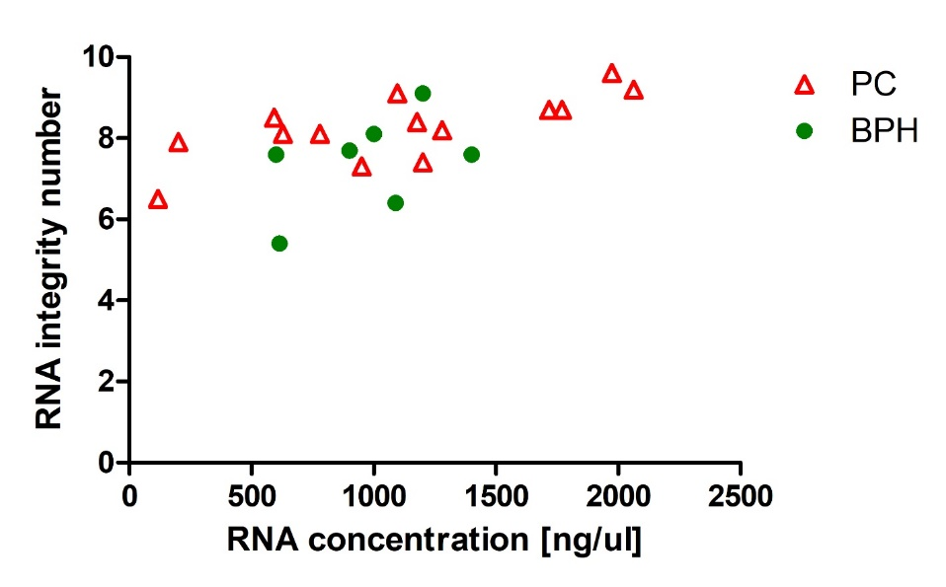
Supplementary Figure 1. Scatter plot showing RNA integrity number and RNA concentration of the samples used in Nanostring profiling.

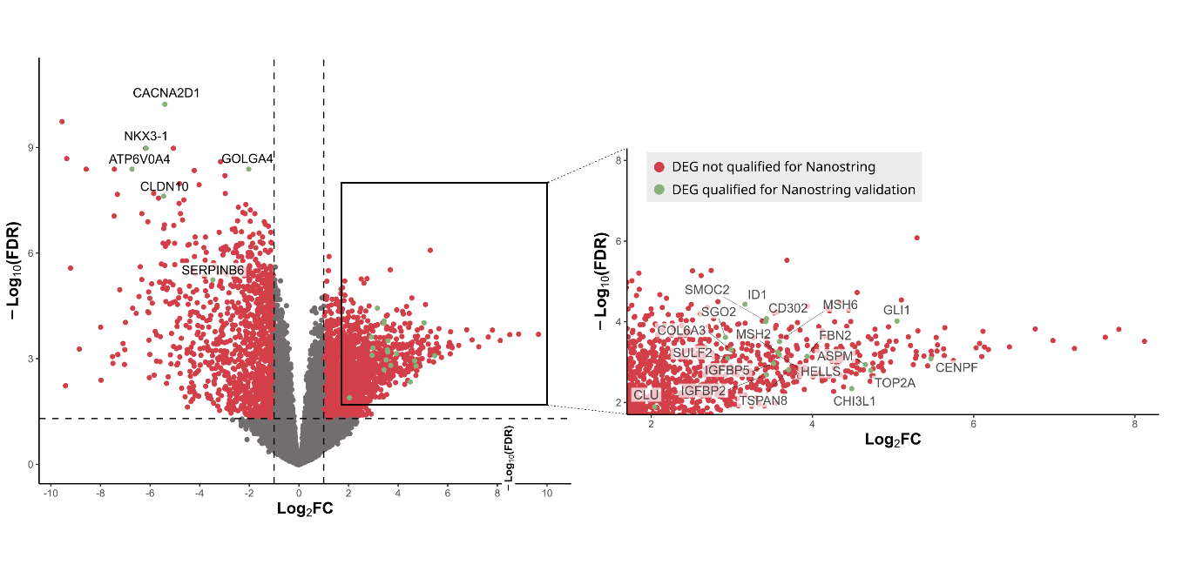
Supplementary Figure 2. Unfiltered differentially expressed genes (DEGs) between prostate cancer (PC) and benign prostate hyperplasia (BPH). Volcano plot showing 2923 differentially expressed genes (DEGs) in PC vs. BPH (-1>log₂FC>1, FDR>0.05) out of 12 185 identified genes. After additional filtering (mean normalized counts per million (CPM) >10 in each group) DEGs in green were selected for validation by targeted mRNA profiling (NanoString technology) based on the highest differences in expression and presence of mRNA in both samples (PC and BPH). For clarity, an enlarged section of the volcano plot shows the DEGs upregulated in PC.
A)
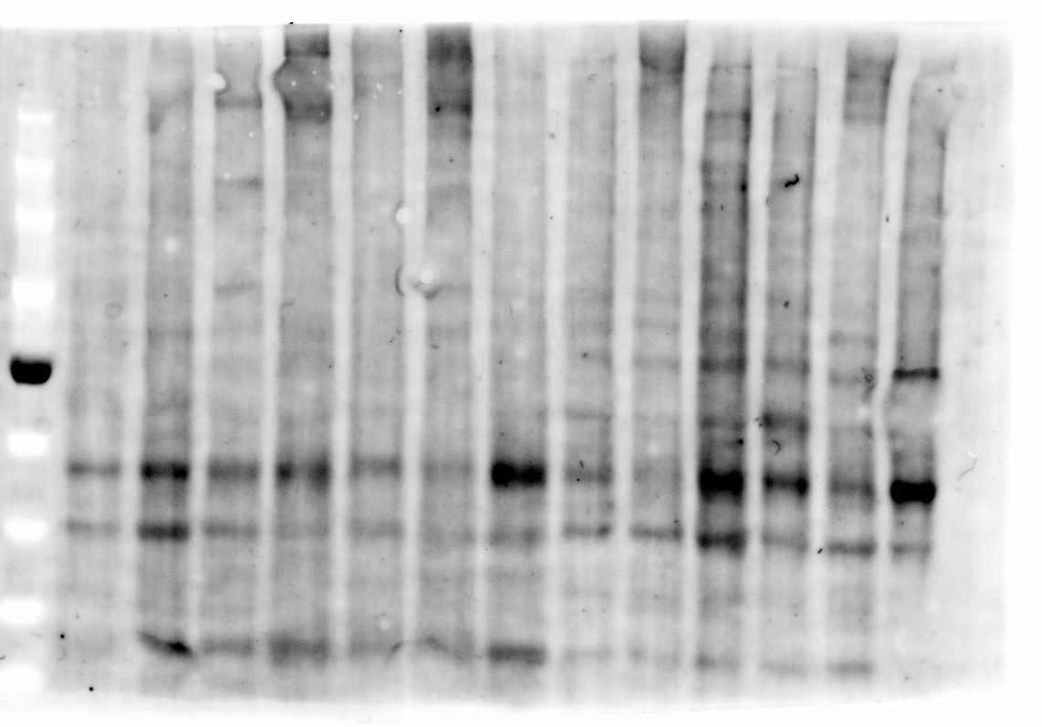
B)

C)
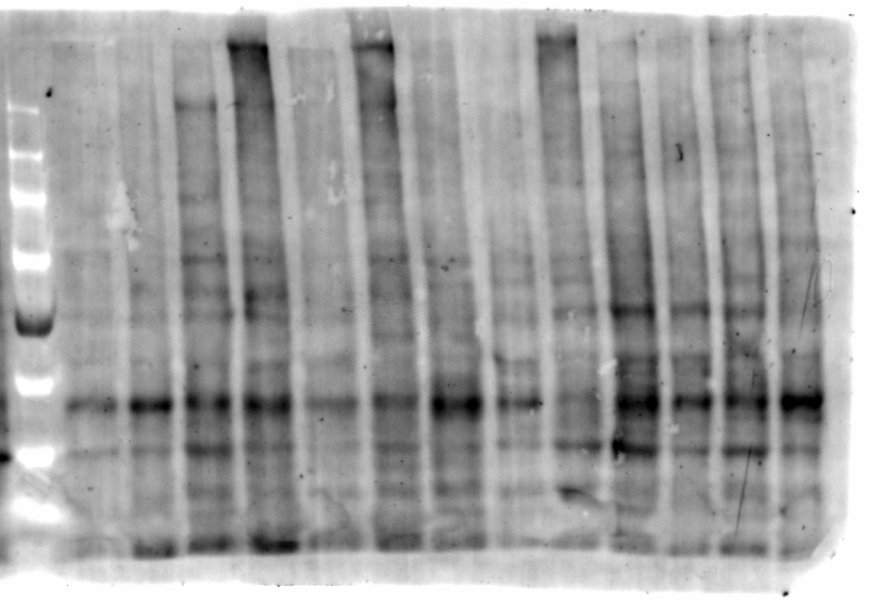
Supplementary Figure 3. A) Full-length blot presented in Fig.3A, and B) corresponding Stain-Free loading control. C) Blot replicate used together with A) for densitometric analysis presented in Fig. 3B. and D) corresponding Stain-Free loading control.

