Supplementary Material for “The future of European outdoor summer sports through the lens of 50 years of the Tour de France“ by I. Cvijanovic et al.

Supplementary Figures

Fig. S1: As in Fig. 1 but for 1100 h local time.

Fig. S2: As in Fig. S1 but for 1400 h local time.

Fig. S3: As in Fig. S1 but for 1600 h local time.

Fig. S4: As in Fig. S1 but for 1700 h local time.

Fig. S5: As in Fig. S1 but for 1800 h local time.

Fig. S6: WBGT values at 1500 h local time from 1973 to 2023 for every day in July but for Marseille (a), Nice (b), Montpellier (c), Grenoble (d), Lyon (e) and Pau (f). Shading indicates WBGT safety thresholds according to the UCI’s high temperature protocol: 18°C - 22.9°C moderate low-risk area (orange); 23°C - 27.9°C moderate high-risk area (light red); > 28°C high-risk area (purple). Official ISO WBGT safety threshold of 25°C for high exertion (metabolic rate above 520 W, acclimatized) is shown with dashed red line.
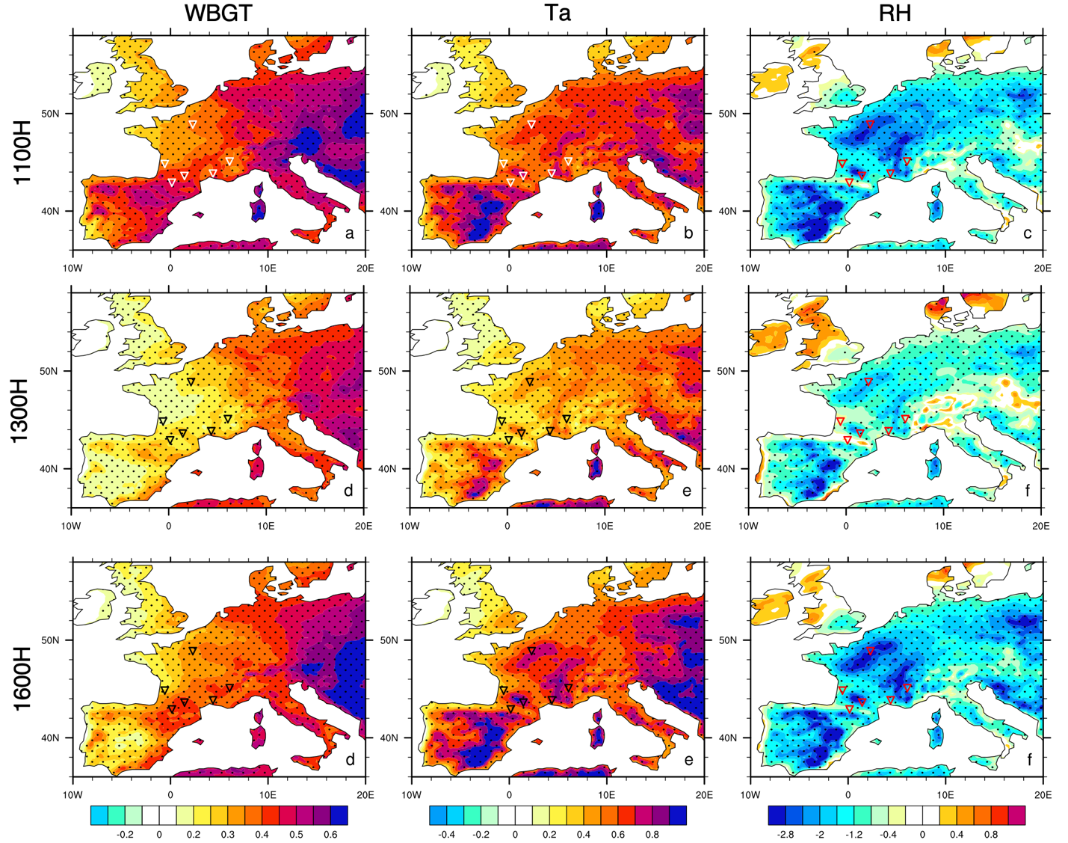
Fig. S7: Trends in July WBGT (a-d), air temperature T_{a} (e-h) and relative humidity RH (i-l) at 1100, 1300 and 1600 h local time over a period from 1974 to 2023. Dotted regions indicate trends that are significant at 95% confidence level.
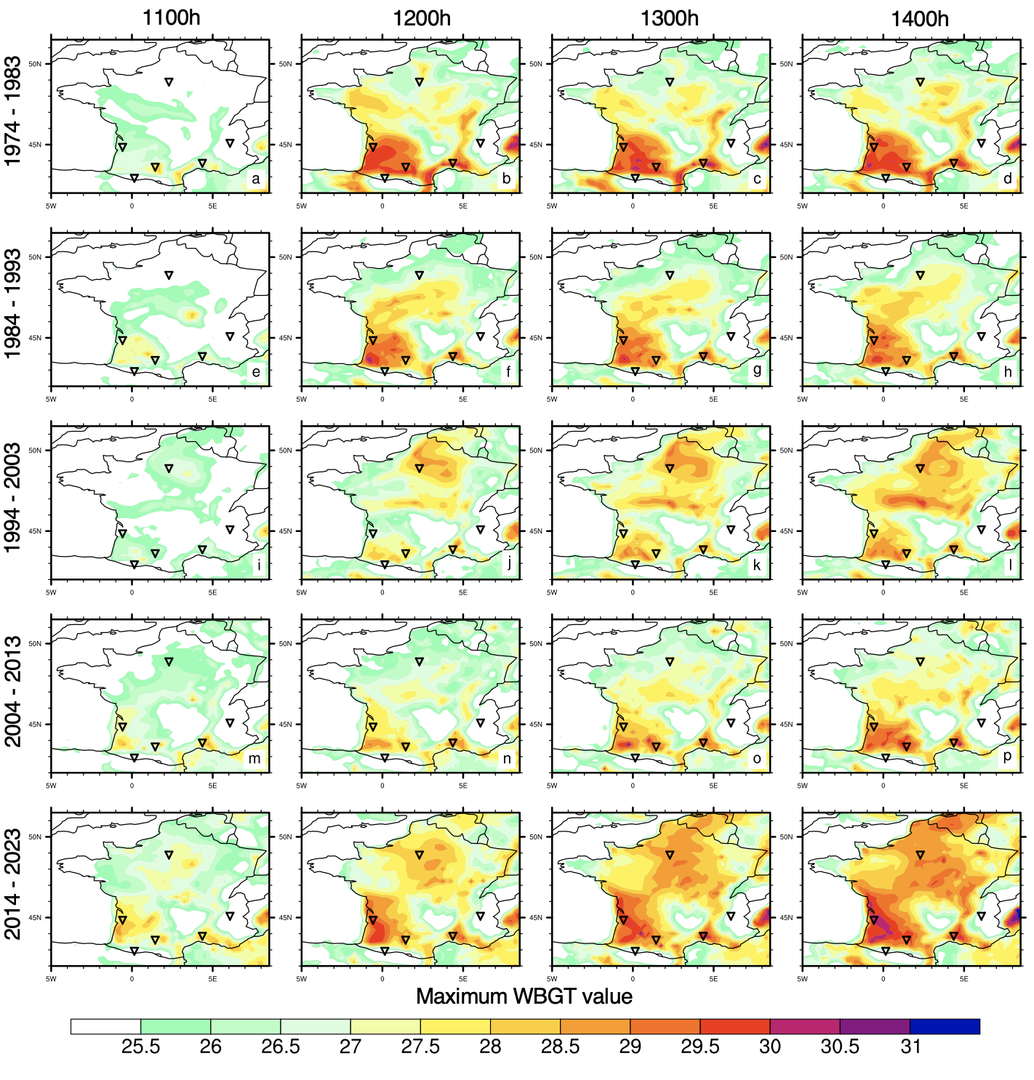 Fig. S8: Maximum WBGT value [°C] at 1100, 1200, 1300 and 1400 h local time, for each decade since 1974: a-d) 1974-1983; e-h) 1984-1993; i-l) 1994-2003; m-p) 2004-2013 and q-t) 2014-2023.
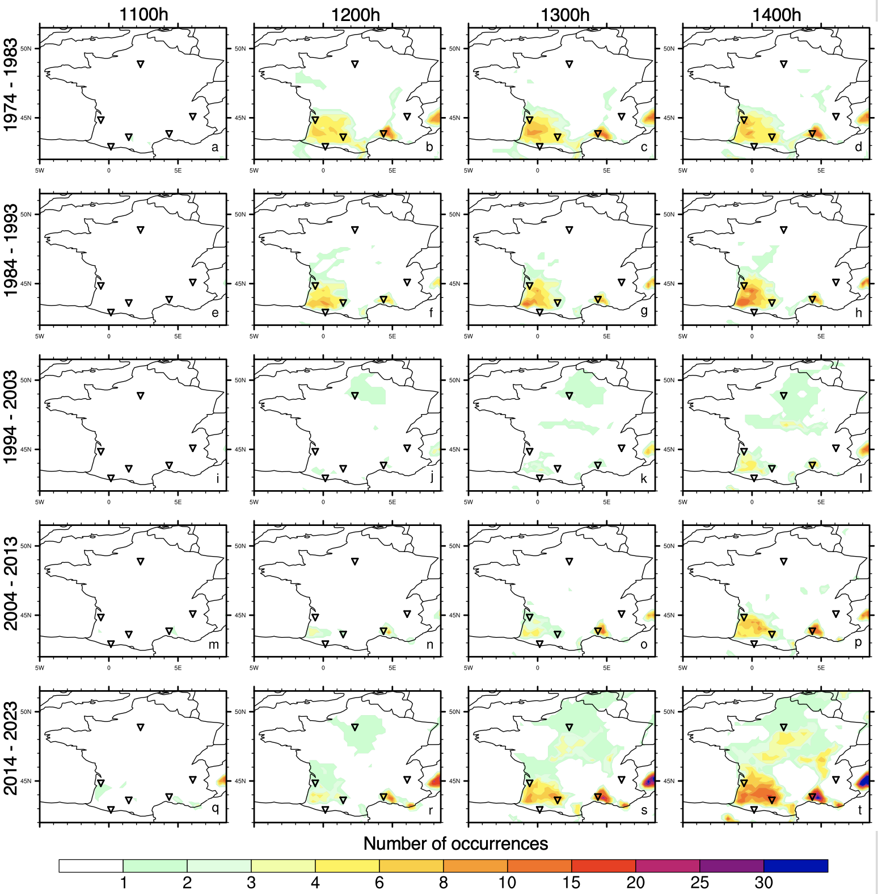
Fig. S9: Number of occurrences of crossing the UCI’s high risk WBGT threshold of 28 °C at 1100, 1200, 1300 and 1400 h local time, for each decade since 1974: a-d) 1974-1983; e-h) 1984-1993; i-l) 1994-2003; m-p) 2004-2013 and q-t) 2014-2023.

