Supplementary tables and figures

Supplementary Table 1. Prevalence of pathogens among 30 participants reporting diarrhoea at ART initiation (baseline)
 | Number and percentage positive
Adenovirus 40/41 | 0 | (0%)
Campylobacter | 6 | (20%)
C. difficile | 4 | (13%)
Cryptosporidium | 6 | (20%)
E. coli O157 | 2 | (7%)
E. histolytica | 0 | (0%)
ETEC LT/ST | 3 | (10%)
Giardia | 2 | (7%)
Norovirus | 6 | (20%)
Rotavirus A | 0 | (0%)
Salmonella | 4 | (13%)
Shigella | 17 | (57%)
STEC | 1 | (3%)
V. cholerae | 0 | (0%)
Y. enterocolitica | 0 | (0%)

Supplementary Table 2. Adjusted associations between number/groups of pathogens and mortality
 | Adjusted HR (95% CI) | p-value | Interaction p-value
Model 1: Number of pathogens (continuous) | 1.05 (0.88, 1.24) | 0.61
Model 2: Number of pathogens (categorial)
0 | 1.00 | 0.66
1 | 0.71 (0.32, 1.58)
2+ | 0.90 (0.39, 2.05)
Model 3: Any pathogen (binary) | 0.80 (0.39, 1.67) | 0.56
Model 4: Beneficial/harmful
Any harmful pathogen | 3.17 (1.32, 7.62) | 0.01
Any beneficial pathogen | 0.43 (0.20, 0.95) | 0.04
Any other pathogen | 1.01 (0.51, 2.01) | 0.97
Model 5: Beneficial/harmful with adjustment for systemic biomarkers
Any harmful pathogen | 4.45 (1.73, 11.44) | 0.002
Any beneficial pathogen | 0.13 (0.04, 0.43) | 0.001
Any other pathogen | 0.93 (0.43, 2.02) | 0.86
Model 6: Beneficial/harmful with adjustment for systemic and gut biomarkers
Any harmful pathogen | 3.37 (0.54, 21.06) | 0.19
Any beneficial pathogen | 0.17 (0.03, 1.03) | 0.054
Any other pathogen | 1.12 (0.40, 3.14) | 0.83
Model 7: Model 6 + interactions
Any harmful pathogen | 5.28 (1.95, 14.22) | 0.001
Any beneficial pathogen, CD4 <50 | 0.38 (0.12, 1.13) | 0.08 | 0.02
Any beneficial pathogen, CD4 ≥50 | 0.02 (0.002, 0.24) | 0.002
Any other pathogen, standard | 1.08 (0.41, 2.82) | 0.88 | 0.19
Any other pathogen, enhanced | 0.38 (0.11, 1.27) | 0.12
Note: hazard ratios from Cox models adjusted for site, CD4, age, stage at enrolment, BMI, viral load, sex, and enhanced prophylaxis randomisation. Models with systemic biomarkers also adjust for CRP, IFNγ, IL-23, IL-2, IL-6, IP10, RANTES, and those with gut biomarkers also adjust for I-FABP, A1AT, neopterin, and myeloperoxidase.
Model 1 tested for nonlinear association of number of pathogens using multivariable fractional polynomials but no nonlinearity was found.
Backwards elimination with a threshold of p=0.2 was used to identify pathogens with an association with mortality. The selected pathogens were classified as beneficial or harmful depending on the direction of effect. Pathogens which were not included were classified as ‘other pathogen’. The pathogens identified as beneficial were E. coli and Giardia, and the harmful pathogens were C. difficile and E. histolytica.
Interactions with baseline CD4 (<50 or ≥50) and enhanced prophylaxis randomisation and beneficial/harmful/other pathogens were explored, and interactions with p-value <0.2 were retained in the model.
Supplementary Table 3. Number of pathogens over time by enhanced prophylaxis randomisation
 |  | Week 0 |  | Week 4 |  | Week 12
 |  | Standard | Enhanced | Standard | Enhanced | Standard | Enhanced
All | 0 | 36 (26%) | 27 (21%) | 36 (30%) | 43 (37%) | 32 (29%) | 40 (36%)
All | 1 | 56 (41%) | 45 (35%) | 43 (35%) | 29 (25%) | 36 (33%) | 34 (31%)
All | 2+ | 45 (33%) | 56 (44%) | 43 (35%) | 45 (38%) | 42 (38%) | 37 (33%)
All | p | 0.08 |  | 0.73 |  | 0.29
Beneficial | 0 | 106 (77%) | 100 (78%) | 96 (79%) | 88 (75%) | 84 (76%) | 88 (79%)
Beneficial | 1 | 28 (20%) | 26 (20%) | 26 (21%) | 28 (24%) | 24 (22%) | 22 (20%)
Beneficial | 2 | 3 (2%) | 2 (2%) | 0 (0%) | 1 (1%) | 2 (2%) | 1 (1%)
Beneficial | p | 0.86 |  | 0.50 |  | 0.58
Harmful | 0 | 124 (91%) | 111 (87%) | 105 (86%) | 94 (80%) | 90 (82%) | 91 (82%)
Harmful | 1 | 12 (9%) | 17 (13%) | 17 (14%) | 23 (20%) | 20 (18%) | 20 (18%)
Harmful | 2 | 1 (1%) | 0 (0%) | 0 (0%) | 0 (0%) | 0 (0%) | 0 (0%)
Harmful | p | 0.34 |  | 0.24 |  | 0.97
Neutral | 0 | 50 (36%) | 39 (30%) | 51 (42%) | 57 (49%) | 45 (41%) | 59 (53%)
Neutral | 1 | 50 (36%) | 47 (37%) | 38 (31%) | 33 (28%) | 37 (34%) | 28 (25%)
Neutral | 2+ | 37 (27%) | 42 (33%) | 33 (27%) | 27 (23%) | 28 (25%) | 24 (22%)
Neutral | p | 0.23 |  | 0.29 |  | 0.11
Note: Pathogens were classified as beneficial, harmful or neutral according to their association with mortality (see Methods). The pathogens identified as beneficial were E. coli and giardia, and the harmful pathogens were C. difficile and E. histolytica. Other pathogens were classified as neutral. P-values are from ranksum tests comparing number of pathogens identified in randomised standard and enhanced prophylaxis groups at each week.

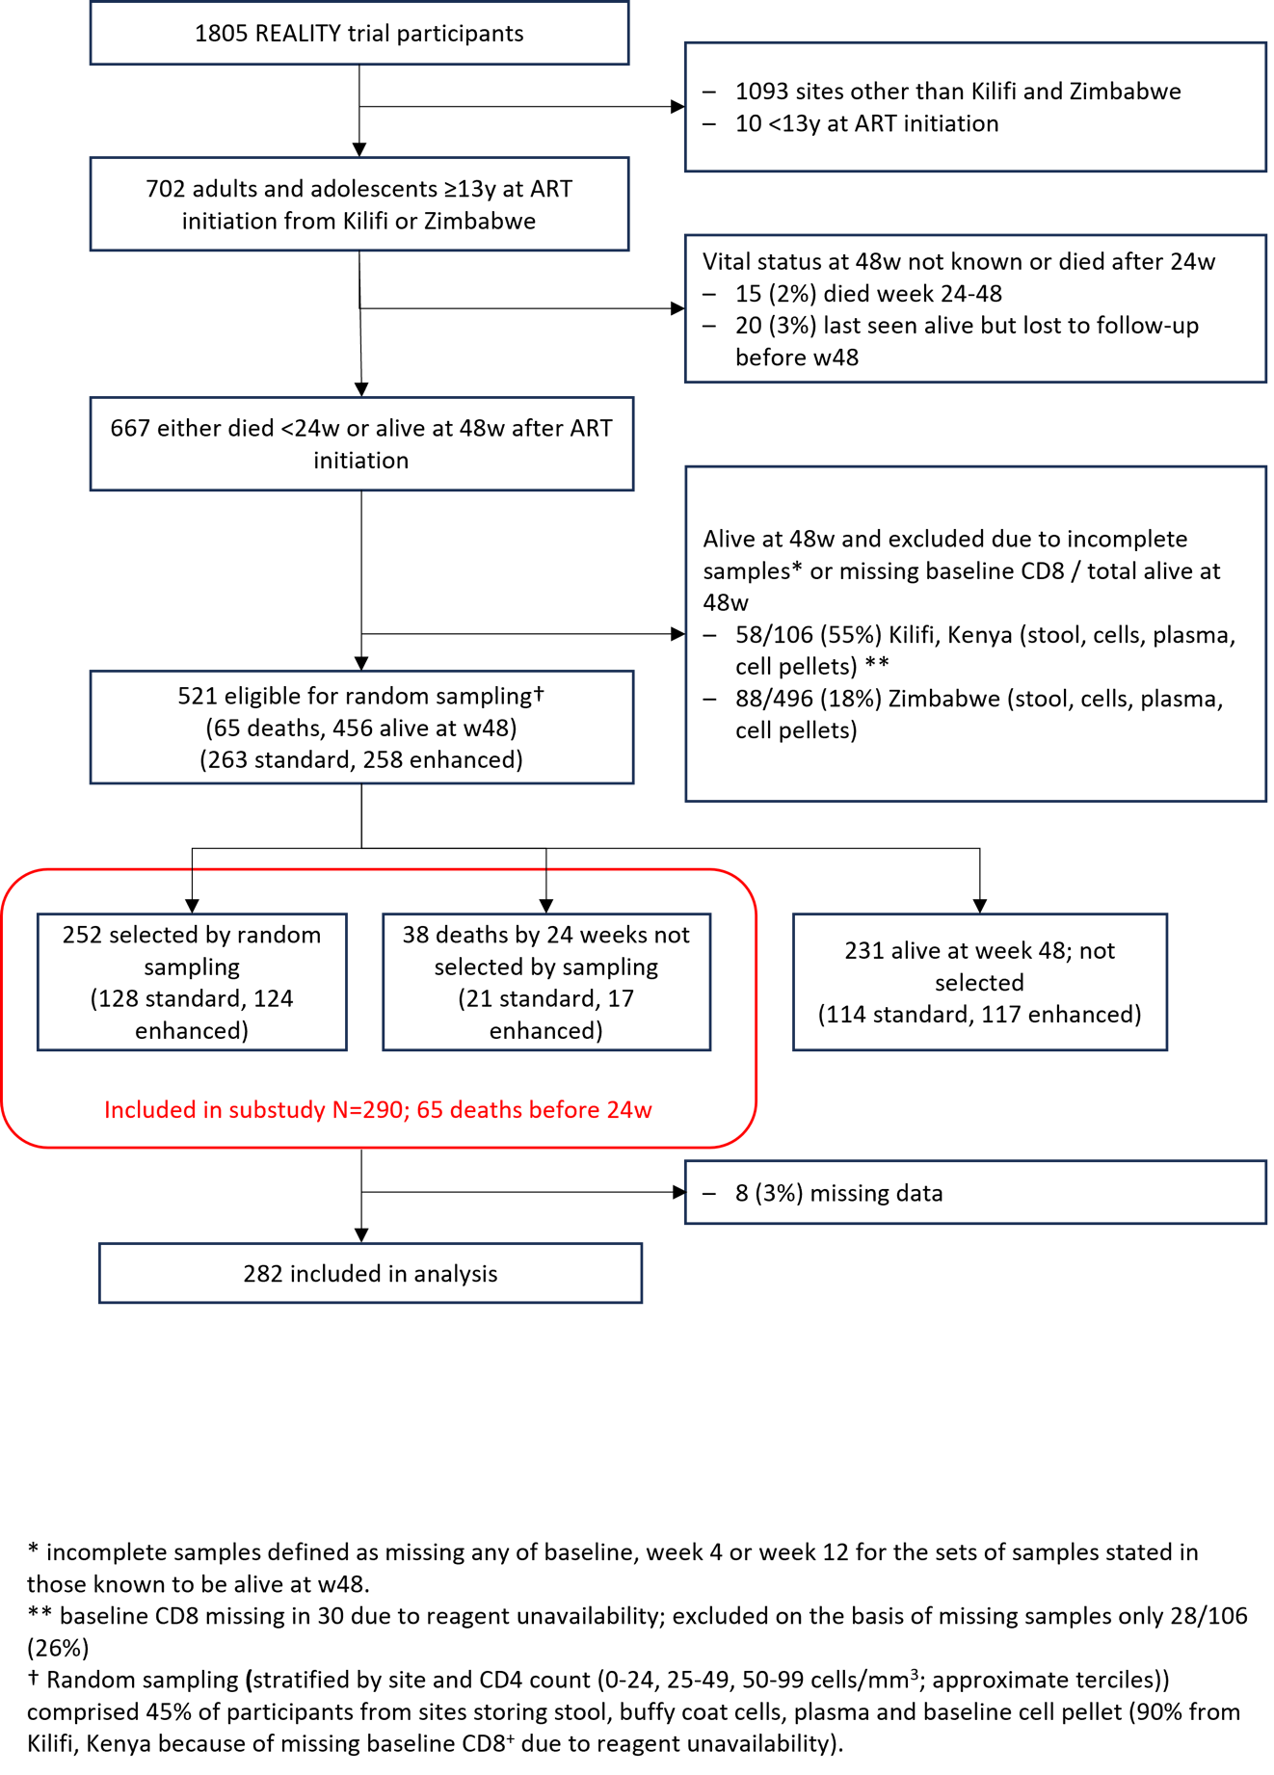
Supplementary Figure 1. Trial flow diagram

Supplementary Figure 2. Co-infection at A. baseline, B. week 4 and C. week 12. Prevalence of pathogens with/without others
A.
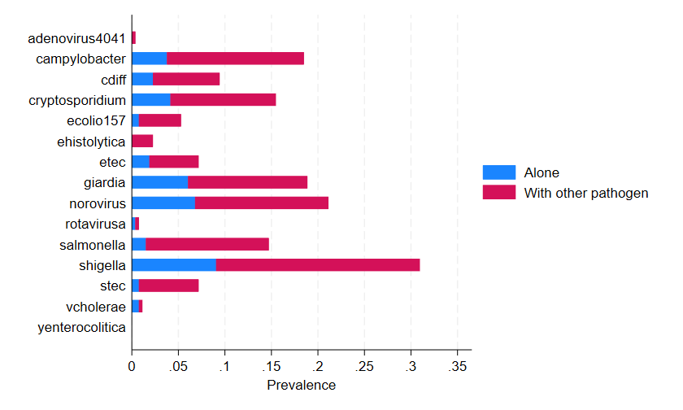
B.
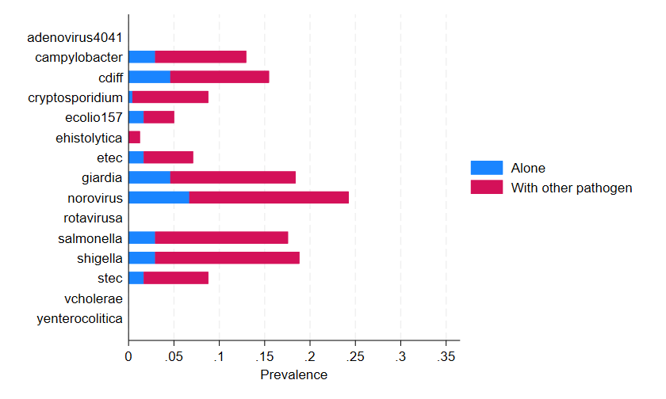
C.
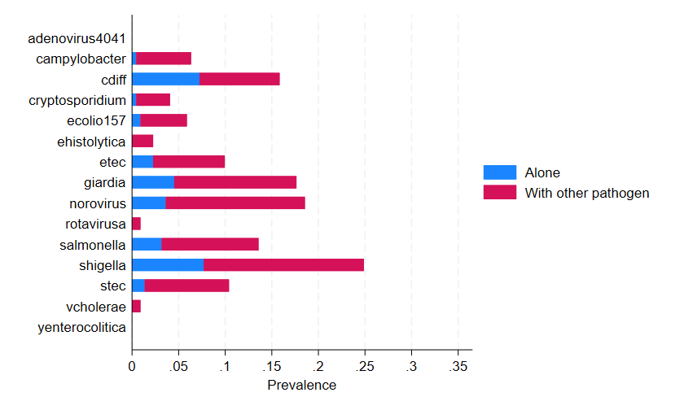

Supplementary Figure 3. Predicted prevalence of pathogens over time by enhanced prophylaxis randomisation, in survivors (>12 weeks). Note: Logistic mixed model adjusted for site, sex, and baseline CD4. P-values are from test of interaction between randomized group and time.
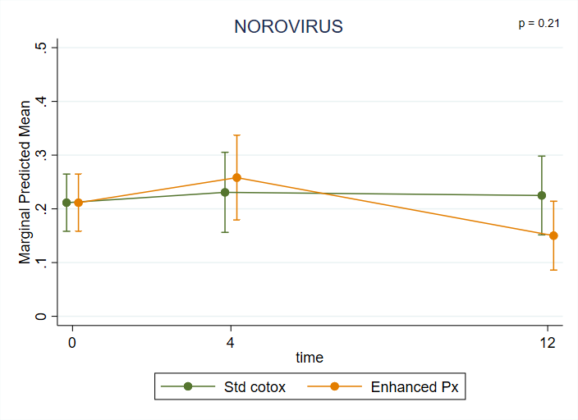 | 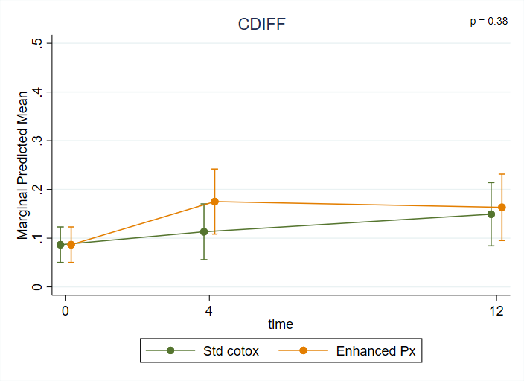
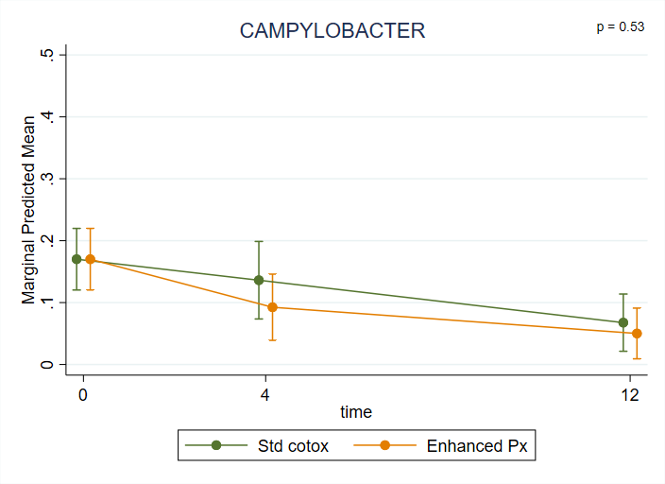 | 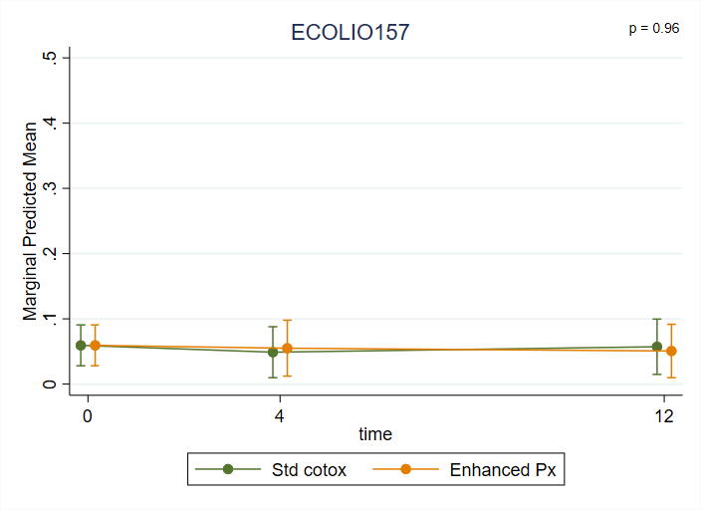
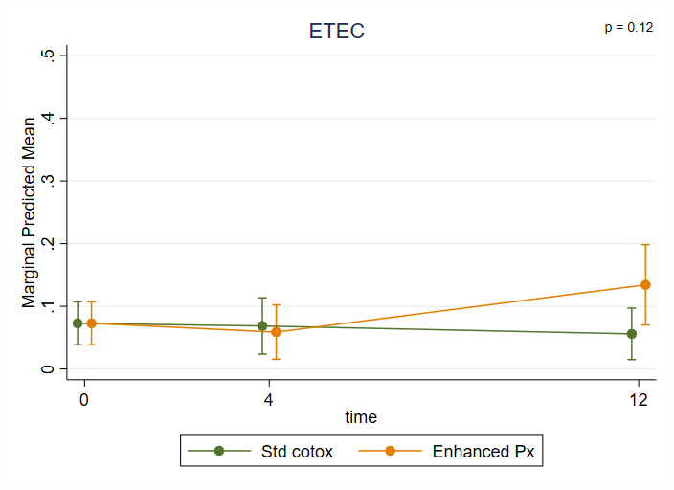 | 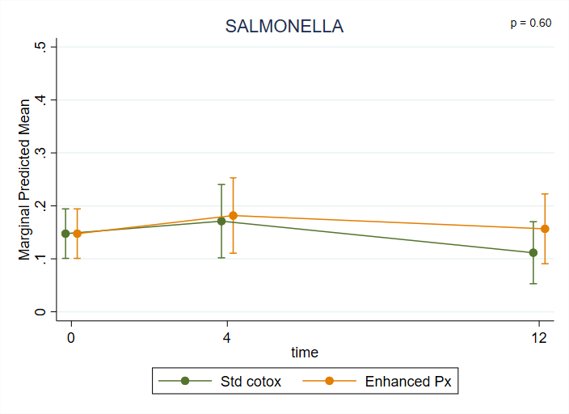
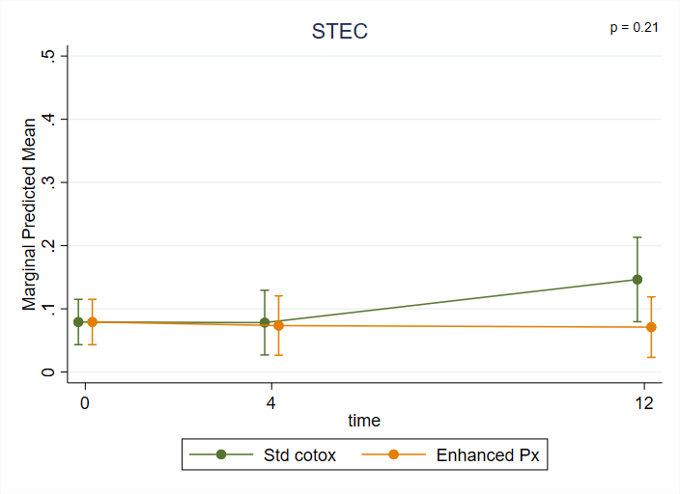 | 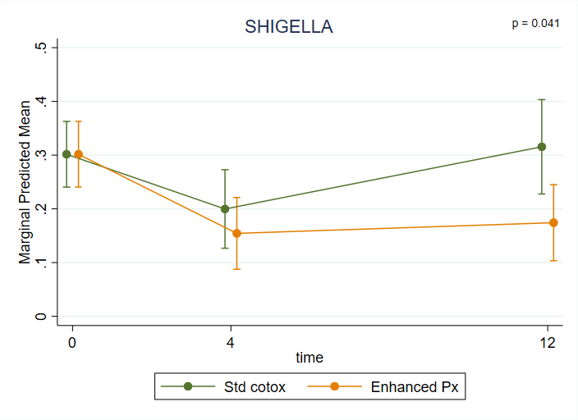
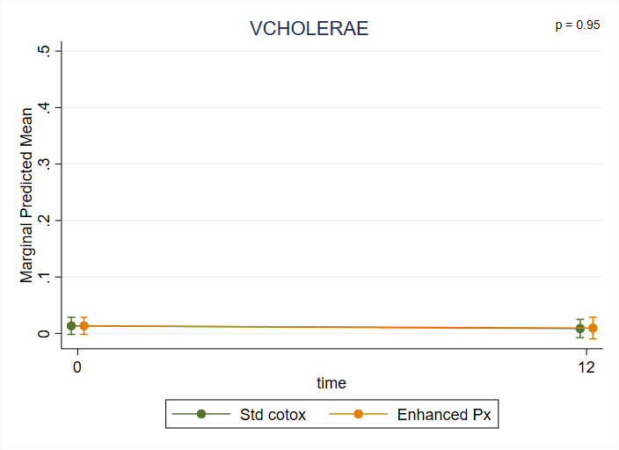 | 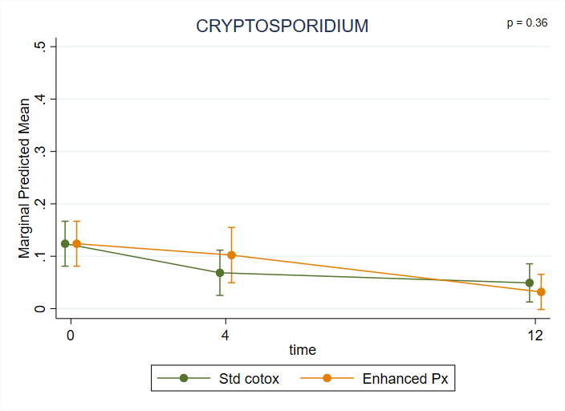
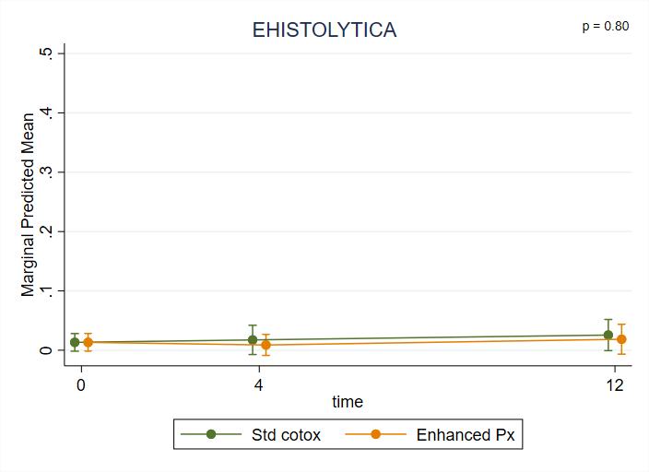 | 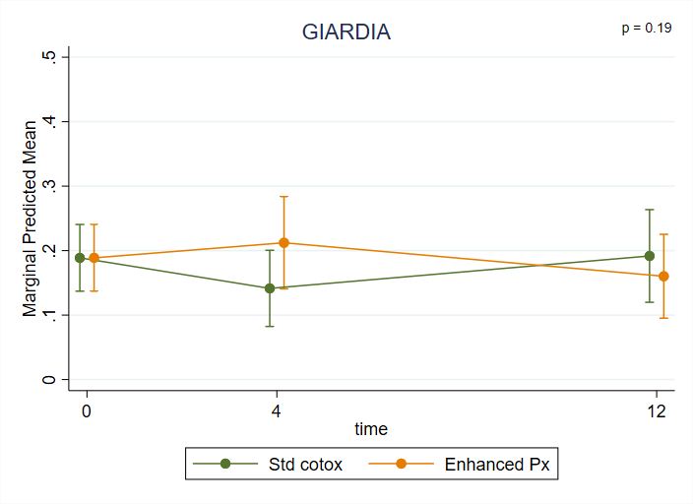
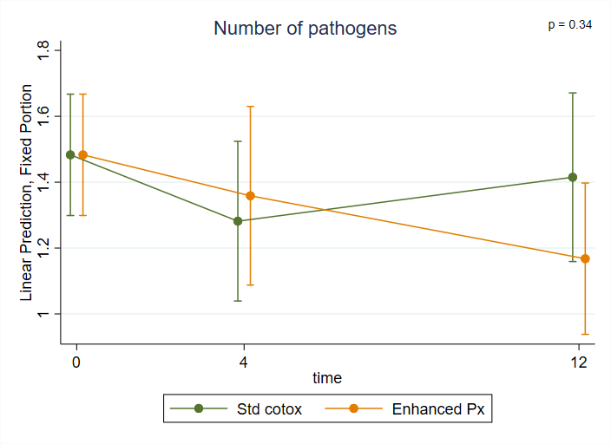

Supplementary Figure 4. Changes in number and type of pathogens over time by enhanced prophylaxis randomisation Note: Logistic mixed model adjusted for site, sex and baseline CD4. P-values are from test of interaction between randomisation and time.

