Supplementary Materials for
Resolving the cascade of uncertainty in global flood projections
Boen Zhang^{1,*}, Louise Slater^{1,*}, Simon Moulds², Michel Wortmann³, Neil Hart¹, Yinxue Liu^{1,4}, Jiabo Yin⁵, Xihui Gu⁶, Grey Nearing⁷, Manuela Brunner^{8,9,10},
Stephen Roberts^{11,} , Niko Wanders¹²
¹ School of Geography and the Environment, University of Oxford, Oxford, UK.
² School of Geosciences, University of Edinburgh, Edinburgh, UK
³ European Centre for Medium-Range Weather Forecasts, Shinfield Park, Reading, UK.
⁴ Geography and Environment, Loughborough University, Loughborough, UK
⁵ State Key Laboratory of Water Resources Engineering and Management, Wuhan University, Wuhan, PR China
⁶ Department of Atmospheric Science, School of Environmental Studies, China University of Geosciences, Wuhan 430074, China
⁷ Google Research, Mountain View, CA, USA
⁸ Institute for Atmospheric and Climate Science, ETH Zurich, Zurich, Switzerland
⁹ Institute for Snow and Avalanche Research SLF, Swiss Federal Institute for Forest, Snow and Landscape Research WSL, Davos Dorf, Switzerland
¹⁰ Climate Change, Extremes and Natural Hazards in Alpine Regions Research Center CERC, Davos Dorf, Switzerland
¹¹ Department of Engineering Science, University of Oxford, Oxford, United Kingdom
¹² Department of Physical Geography, Faculty of Geosciences, Utrecht University, Utrecht, The Netherlands
*Corresponding authors: boen.zhang@ouce.ox.ac.uk; louise.slater@ouce.ox.ac.uk

This PDF file includes:
Text S1
Tables S1 to S6
Figs. S1 to S19
References

Text S1. Model performance metrics
We use the Nash-Sutcliffe Efficiency (NSE), the Normalized Root Mean Squared Error (nRMSE), and the Kling–Gupta efficiency (KGE) metrics, along with the three components of KGE (i.e., Pearson’s correlation, bias ratio, and variability ratio) to evaluate the performance of random forest models.
The NSE is expressed as
$$NSE=1-\frac{\sum{{(O_{i}-S_{i})}^{2}}}{\sum{{(O_{i}-\overline{O})}^{2}}}$$ | (1)
where S_{i} and O_{i} denote simulations and observations, respectively, and are applicable to all the following equations; Ō is the observed mean.
The nRMSE is expressed as
$$nRMSE=\frac{1}{O_{max}-O_{min}}\sqrt{\frac{\sum{{(S_{i}-O_{i})}^{2}}}{N}}$$ | (2)
where N denotes the number of samples. O_{max} and O_{min} denote the maximum and minimum observations, respectively.
The KGE is expressed as
$$KGE=1-\sqrt{{(r-1)}^{2}+{(β-1)}^{2}+{(γ-1)}^{2}}$$ | (3)
where r, β, and γ represent Pearson’s correlation, bias ratio, and variability ratio, respectively, and are expressed as
$$r=\frac{\sum{(S_{i}-\overline{S})(O_{i}-\overline{O})}}{\sqrt{\sum{{(S_{i}-\overline{S})}^{2}}\sum{{(O_{i}-\overline{O})}^{2}}}}$$ | (4)
$$β=\overline{S}/\overline{O}$$ | (5)
$$γ=\frac{σ_{S}/\overline{S}}{σ_{O}/\overline{O}}$$ | (6)
In perfect prediction, where KGE and NSE equal unity, the r = β = γ = 1 and nRMSE = 0. According to equations 5 and 6, β < 1 corresponds with an overall negative bias, in which $\overline{S}$< $\overline{O}$. Similarly, β > 1 indicates a positive bias in prediction.

Table S1. Existing river flood projection studies. CMIP5/6 = Coupled Model Intercomparison Project Phase 5/6. ISIMIP = Inter-Sectoral Impact Model Intercomparison Project. CORDEX = Coordinated Regional Climate Downscaling Experiment. HM = hydrologic model. VIC = Variable Infiltration Capacity hydrologic model. CPM = convection-permitting climate model. AMS = annual maximum streamflow. MAX/MAX7 = maximum daily/7-day streamflow. Q90 = 90th percentile of daily streamflow.

No. | Approach | Index | Area (ref.)
1 | CMIP6 + ISIMIP + LSTM | AMS | China ⁵
2 | CMIP5/CMIP6/CORDEX + HM | 100-year flood | Europe ⁶
3 | CMIP6 + CaMa-Flood | 100-year flood | Global ⁷
4 | ISIMIP + VIC + CaMa-Flood | 100-year flood | China urban areas ⁸
5 | ISIMIP + LSTM | MAX/MAX7/Q90 | Global 2062 river basins ⁹
6 | ISIMIP | MAX7 | Global ¹⁰
7 | CMIP5 runoff + CaMa-Flood |  | Global ¹¹
8 | ISIMIP | River flow seasonality | Global ¹²
9 | EC-EARTH3-HR + CMIP5 + LISFLOOD + local value of the flood protection | Six return periods (10-500 years) | Global ¹³
10 | CMIP6 + VIC | Widespread flooding (streamflow > Q99 for all subbasins within a river basin) | India ¹⁴
11 | Bias-corrected CMIP5 + VIC | 1 % annual exceedance probability | USA ¹⁵
12 | Bias-corrected CMIP5 + NOAA’s HL-RDHM + LISFLOOD-FP | 100-year flood peak | Pennsylvania, USA ¹⁶
13 | Bias-corrected CMIP5 + HBV + LISFLOOD-FP | 100-year flood | USA ¹⁷
14 | HAPPI GCM + Tropical cyclone rainfall model + LISFLOOD-FP | Hurricane rainfall-induced flood | Puerto Rico ¹⁸
15 | CPM + LISFLOOD-FP | Urban flooding | UK ¹⁹
16 | CMIP6 + GAMLSS | Annual exceedance probabilities (e.g., 1 in 10) | USA ²⁰
17 | Bias-corrected CMIP5 + HM | Annual exceedance probabilities (e.g., 1 in 10) | Australia ²¹
18 | CMIP6 runoff – base flow separation | AMS | Global ²²
19 | Downscaled CMIP6 + GAMLSS | 10-year, 50-year, and 100-year flood | West-Central Himalayas ²³

Table S2. 19 CMIP6 models used in this study

No. | Model (ref.) | Variant label | Horizontal resolution  (lon × lat)
1 | ACCESS-CM2 ²⁴ | r1i1p1f1 | 1.9° × 1.3°
2 | ACCESS-ESM1-5 ²⁵ | r1i1p1f1 | 1.9° × 1.2°
3 | CanESM5 ²⁶ | r1i1p1f1 | 2.8° × 2.8°
4 | CNRM-ESM2-1 ²⁷ | r1i1p1f2 | 1.4° × 1.4°
5 | CNRM-CM6-1 ²⁸ | r1i1p1f2 | 1.4° × 1.4°
6 | AWI-ESM-1-REcoM ²⁹ | r1i1p1f1 | 1.9° × 1.9°
7 | EC-Earth3 ³⁰ | r1i1p1f1 | 0.7° × 0.7°
8 | EC-Earth3-Veg ³¹ | r1i1p1f1 | 0.7° × 0.7°
9 | GFDL-ESM4 ³² | r1i1p1f1 | 1.3° × 1°
10 | INM-CM5-0 ³³ | r1i1p1f1 | 2° × 1.5°
11 | HadGEM3-GC31-LL ³⁴ | r1i1p1f3 | 1.9° × 1.3°
12 | MIROC6 ³⁵ | r1i1p1f1 | 1.4° × 1.4°
13 | MIROC-ES2L ³⁶ | r1i1p1f2 | 2.8° × 2.8°
14 | MPI-ESM1-2-HR ³⁷ | r1i1p1f1 | 0.9° × 0.9°
15 | MPI-ESM1-2-LR ³⁸ | r1i1p1f1 | 1.9° × 1.9°
16 | MRI-ESM2-0 ³⁹ | r1i1p1f1 | 1.1° × 1.1°
17 | NorESM2-LM ⁴⁰ | r1i1p1f1 | 2.5° × 1.9°
18 | UKESM1-0-LL ⁴¹ | r1i1p1f2 | 1.9° × 1.3°
19 | IPSL-CM6A-LR ⁴² | r1i1p1f1 | 2.5° × 1.3°

Table S3. List of climate predictors used in the ML models. Area-weighted average values are extracted for each catchment, variable, and year, and then annual mean (mean) and standard deviation (std) are calculated for each variable across all years in the dataset.

No. | Variable | Unit | Potential predictors
1 | Total precipitation (Psum) | mm | Psum_mean, Psum_std
2 | Maximum 1-day precipitation (Rx1day) | mm | Rx1day_mean, Rx1day_std
3 | Maximum 1-month precipitation (Rx1mon) | mm | Rx1mon_mean, Rx1mon_std
4 | Maximum total precipitation of consecutive wet days (Pvol) | mm | Pvol_mean, Pvol_std
5 | Maximum 5-day precipitation (Rx5day) | mm | Rx5day_mean, Rx5day_std
6 | Relative humidity (RH) | % | RH_mean
6 | Average snow melting (SMave) | mm | SMave_mean
7 | Maximum near-surface air temperature (Tmax) | degreeC | Tmax_mean
8 | Minimum near-surface air temperature (Tmin) | degreeC | Tmin_mean
9 | Maximum snow melting (SMmax) | mm | SMmax_mean
10 | Surface downwelling shortwave radiation (RSDS) | W/m² | RSDS_mean
11 | Wind speed (WS) | m/s | WS_mean
12 | Surface snow amount (SNW) | kg/m² | SNW_mean

Table S4. Geographic predictors used in the ML models

No. | Predictor class | Predictor | Unit | Data source | Extraction method
1 | Land cover | Fractional built-up area | % | ESACCI land cover map in the year 2000 ⁴³ | Land cover fraction
2 | Land cover | Fractional forest | % | ESACCI land cover map in the year 2000 ⁴³ | Land cover fraction
3 | Land cover | Fractional grassland | % | ESACCI land cover map in the year 2000 ⁴³ | Land cover fraction
4 | Geomorphology | Slope | − | HydroSHEDS v1 DEM ⁴⁴ | Area-weighted average
5 | Geomorphology | Elevation | m | HydroSHEDS v1 DEM ⁴⁴ | Area-weighted average
6 | Soil | Thickness of the permeable layer | m | Global 1-km Gridded Thickness of Soil, Regolith, and Sedimentary Deposit Layers ⁴⁵ | Area-weighted average
7 | Soil | Permeability | Log(k) | GLHYMPS 2.0 ⁴⁶ | Area-weighted average
8 | Climate | Aridity index | − | Global Aridity Index and Potential Evapotranspiration Database - Version 3 ⁴⁷ | Area-weighted average
9 | Climate | Potential evapotransipiration | mm |  | Area-weighted average
10 | Climate | Fractional arid climate zone | % | Köppen-Geiger climate classification at an 1-km resolution for the present-day (1980–2016) ⁴⁸ | Climate zone fraction
11 | Climate | Fractional cold climate zone | % |  | Climate zone fraction
12 | Climate | Fractional temperate climate zone | % |  | Climate zone fraction
13 | Climate | Fractional tropical climate zone | % |  | Climate zone fraction
14 | Hydrologic signature | Runoff ratio | − | MSWEP v2.2 rainfall⁴⁹ and GloFAS v3.1 river discharge ⁵⁰ | Area-weighted average  rainfall is extracted; River discharge is extracted for the grid cell that is closest to the outlet point.
15 | Hydrologic signature | Streamflow precipitation elasticity | − | MSWEP v2.2 rainfall⁴⁹ and GloFAS v3.1 river discharge ⁵⁰
16 | Hydrologic signature | Baseflow index | − | MSWEP v2.2 rainfall⁴⁹ and GloFAS v3.1 river discharge ⁵⁰
17 | Hydrologic signature | Richards-Baker flashiness index⁵¹ | − | MSWEP v2.2 rainfall⁴⁹ and GloFAS v3.1 river discharge ⁵⁰
18 | Hydrologic signature | Groundwater storage (Q10/Q50); | − | MSWEP v2.2 rainfall⁴⁹ and GloFAS v3.1 river discharge ⁵⁰
19 | Hydrologic signature | High-flow frequency | day | MSWEP v2.2 rainfall⁴⁹ and GloFAS v3.1 river discharge ⁵⁰
20 | Hydrologic signature | Coefficient of streamflow variation | − | MSWEP v2.2 rainfall⁴⁹ and GloFAS v3.1 river discharge ⁵⁰
21 | Coordinate | Longitude | − | − | −
22 | Coordinate | Latitude | − | − | −
23 | Human activity | Population density | % | WorldPop ⁵² | Area-weighted average
24 | Human activity | GDP per capita | $ | Gridded global datasets for Gross Domestic Product in 2000 ⁵³ | Area-weighted average
25 | Human activity | Number of dams | % | Global Dam Tracker ⁵⁴ | Number of upstream dams

Table S5. Data sources of global streamflow observations

No. | Data source | URL
1 | Global Runoff Data Centre (GRDC) | https://www.bafg.de/GRDC/EN/Home/homepage_node.html
2 | The Bureau of Meteorology of the Australian Government (BOM) | http://www.bom.gov.au/
3 | The Brazilian National Water Agency and Bruno Guimarães for his Python webscraping code “scraping-hidroweb” (available on GitHub) | http://www.snirh.gov.br/hidroweb/apresentacao
4 | The Spanish Ecological transition ministry | https://ceh.cedex.es/anuarioaforos/default.asp
5 | Eaufrance, the public water information service in France | https://www.eaufrance.fr/
6 | National Water Data Archive of Canda (HYDAT) | https://collaboration.cmc.ec.gc.ca/cmc/hydrometrics/www/
7 | Polish Institute of Meteorology and Water Management (IMGW) | https://www.imgw.pl/
8 | The National River Flow Archive (NRFA), based at the UK Centre for Ecology & Hydrology | https://nrfa.ceh.ac.uk/
9 | The Norwegian Water Resources and Energy Directorate (NVE) | https://www.nve.no/english/
10 | The U.S. Geological Survey | https://waterdata.usgs.gov/nwis
11 | Environmental Information System for water resources and modelling for Africa (SIEREM) | http://www.hydrosciences.fr/sierem/
12 | Colombia Institute of Hydrology, Meteorology and Environmental Studies | http://institucional.ideam.gov.co/jsp/index.jsf
13 | Federal Office for the Environment (Switzerland) | https://www.bafu.admin.ch/bafu/en/home.html
14 | The Hydroinformatic Data Center managed by Ministry of Water Resources of China | http://xxfb.hydroinfo.gov.cn/ssIndex.html
15 | Slovenian Environment Agency | https://www.gov.si/en/state-authorities/bodies-within-ministries/slovenian-environment-agency/
16 | India- Water Resource Information System (WRIS) | https://indiawris.gov.in/wris/#/

Table S6. Parameter values used in the PCR-GLOBWB calibration process

Parameter | Short description | Prefactor | Scale
Minimum soil depth fraction | Controls the partitioning of liquid rainfall into direct runoff and infiltration to the soil | 0.5, 1, 2, and 3 | Linear
Saturated hydraulic conductivity | Determines the amount of infiltration into the first soil layer, the percolation to the second soil layer, and groundwater layer | -0.5, 0, and 0.5 | Log
Groundwater recession coefficient | Describes the linear relation between groundwater storage and outflow | -0.5, 0, and 0.5 | Log
Degree day factor | Relates the amount of snow melt to the temperature above the freezing point | 0.5, 1, 2, and 3 | Linear
Manning's n | Roughness coefficient used to simulate the kinematic wave routing | 0.5, 1, 2, and 3 | Linear

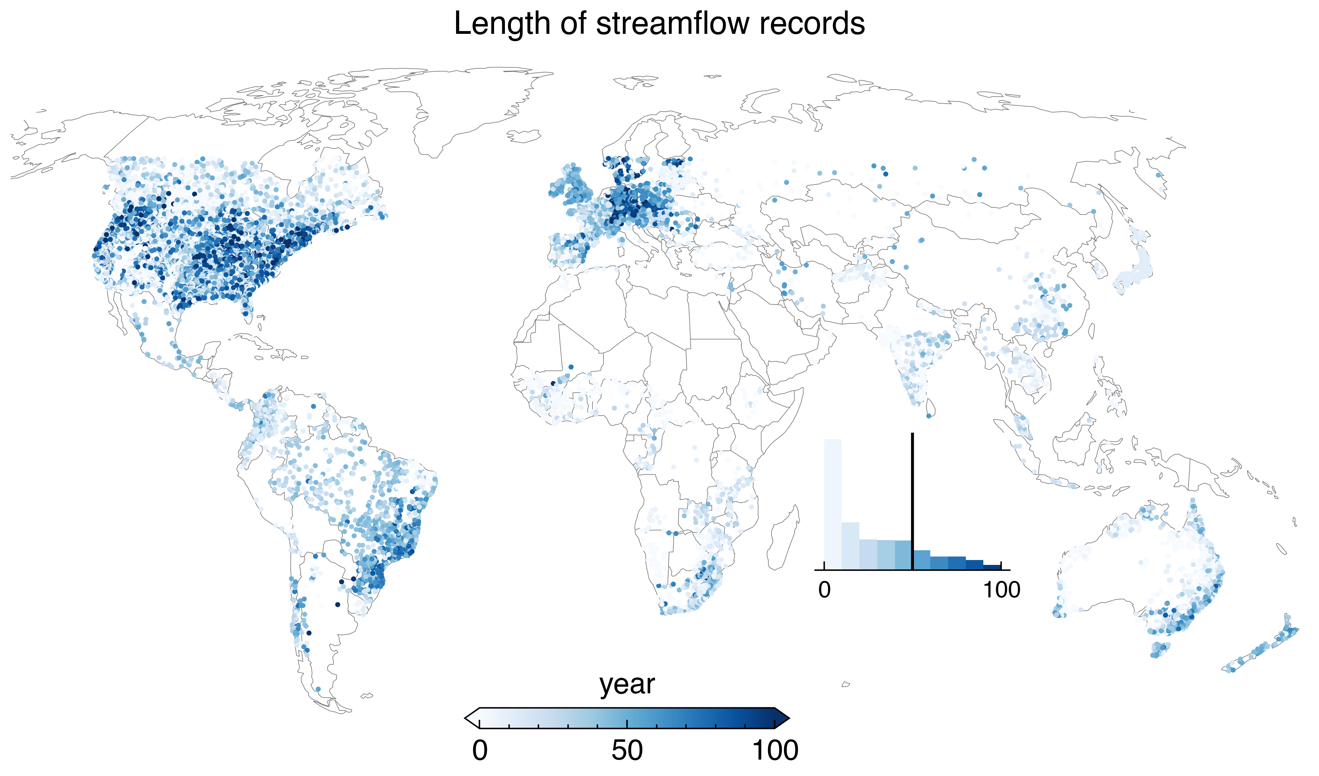

Fig. S1 Length of streamflow records. A minimum of 300 valid streamflow measurements were required per year. The inset histogram illustrates the distribution of the record lengths.

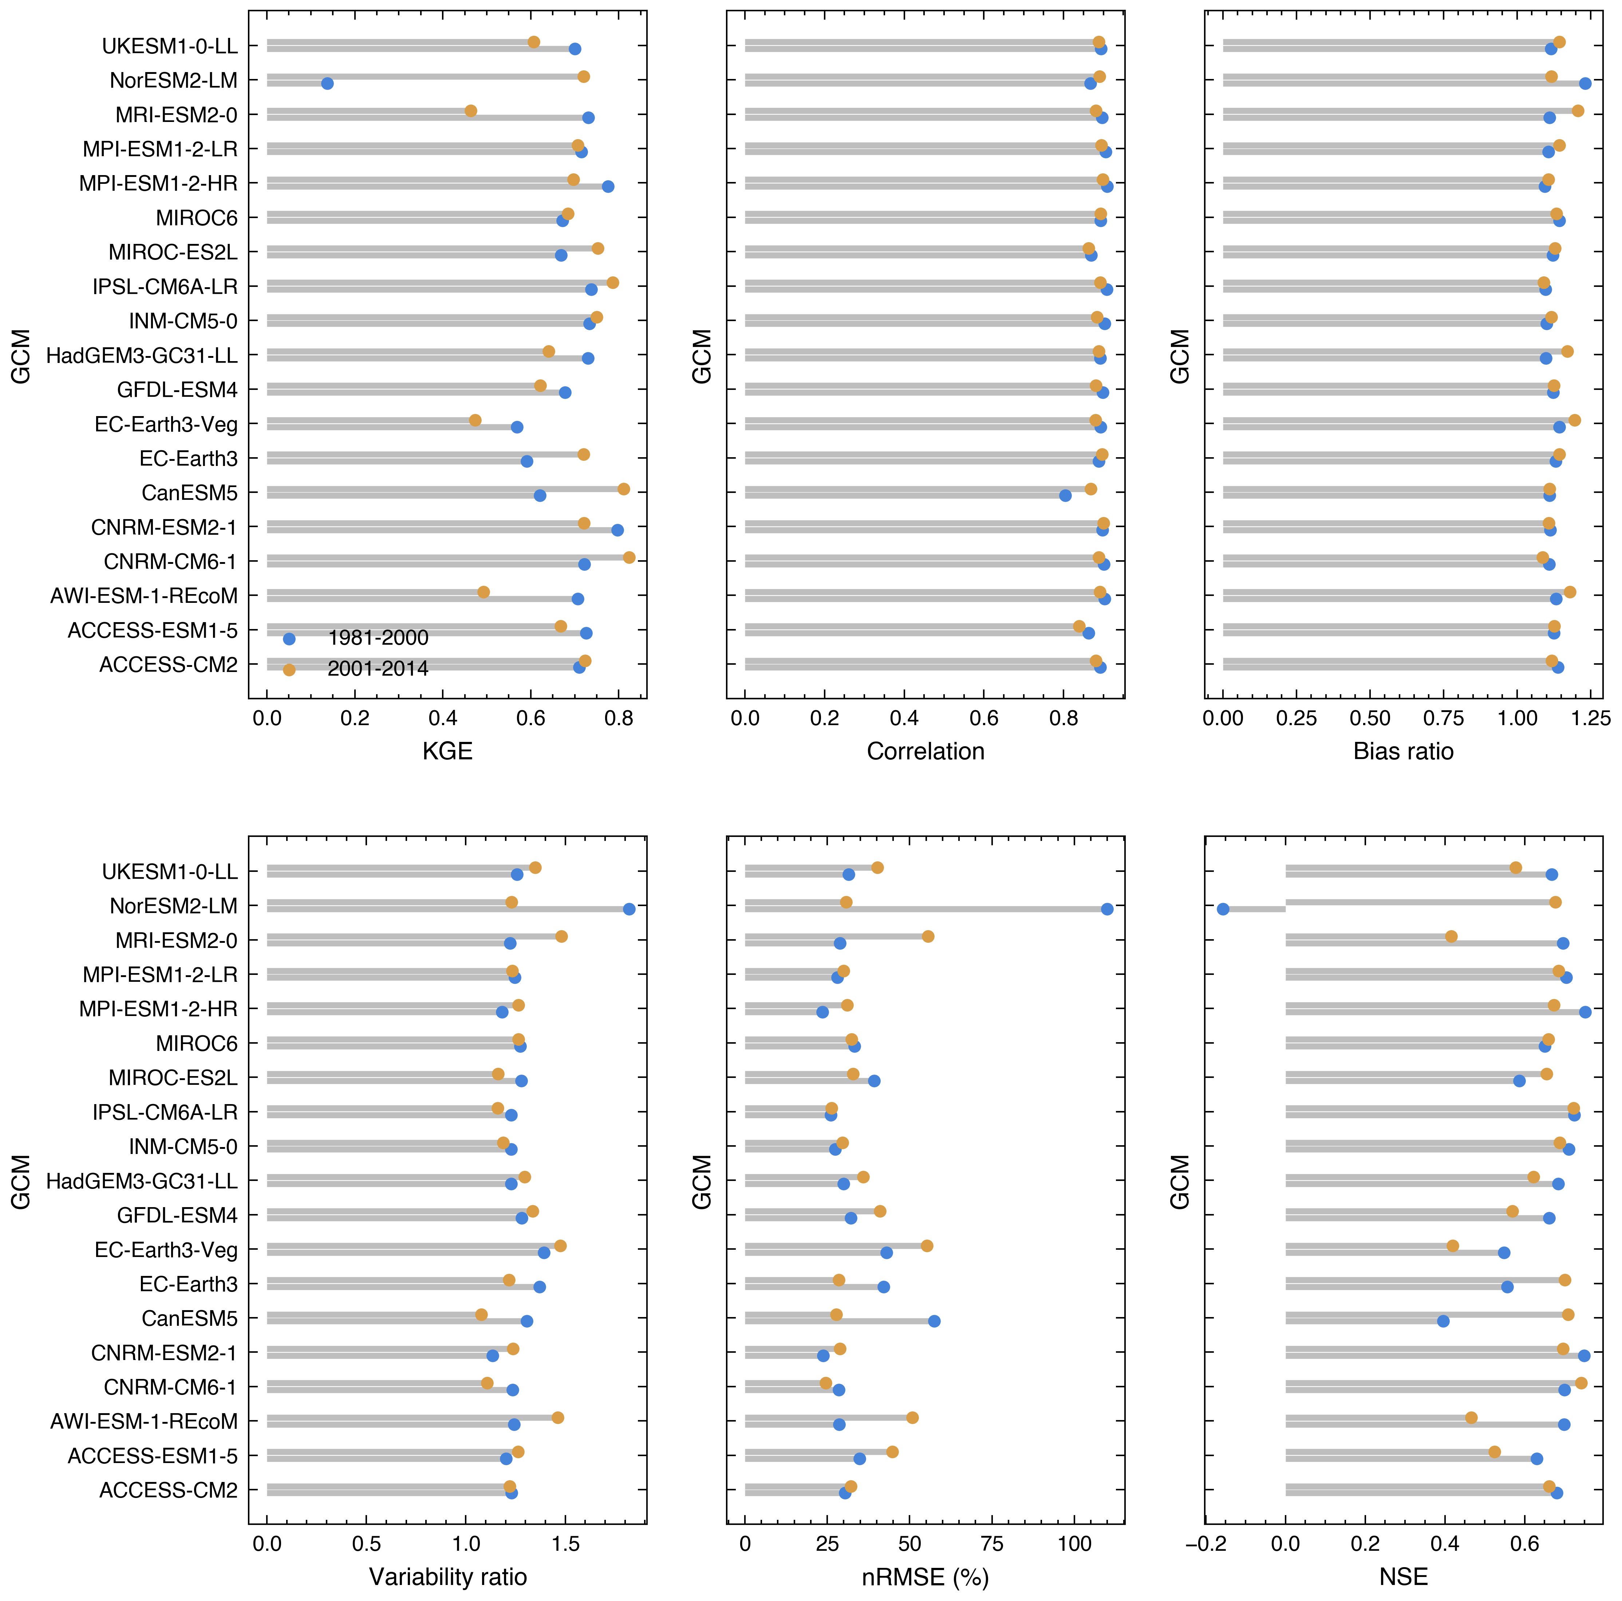

Fig. S2 Full cross-product cross-validation test of the ML models. The climate predictors and the 1-in-10-year flood magnitudes calculated for the 1981−2000 and 2001−2014 periods, respectively. A total of 20 cross-validation splits (i.e., 10 random spatial splits and 2 temporal splits) are generated to conduct the test.

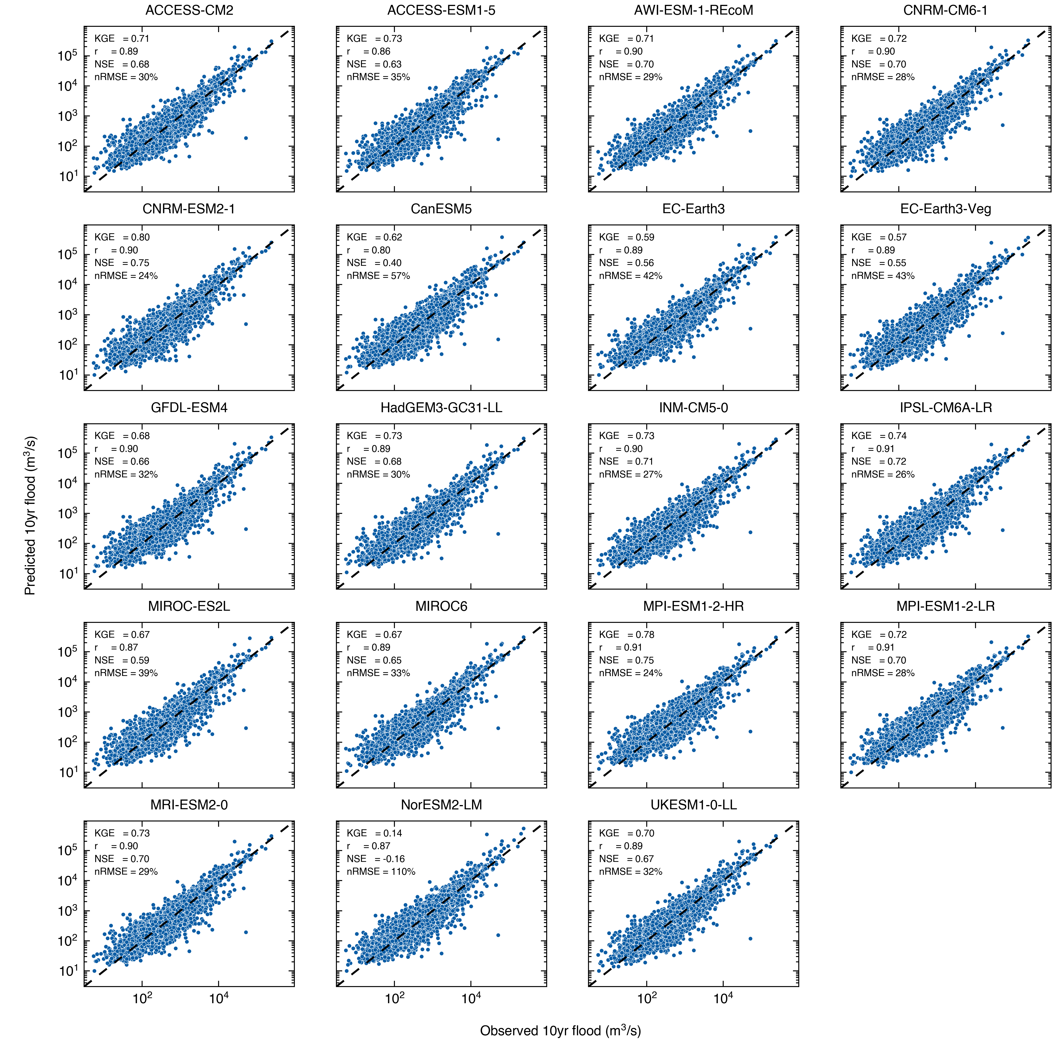

Fig. S3 Same as Fig. S2 but shows cross-validated predictions during the period 1981–2000.

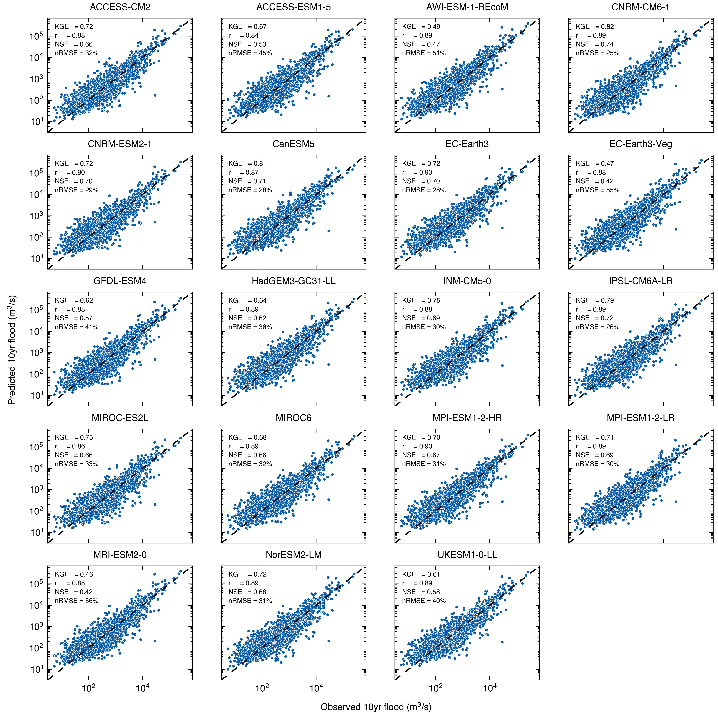

Fig. S4 Same as Fig. S2 but shows cross-validated predictions during the period 2000–2014.

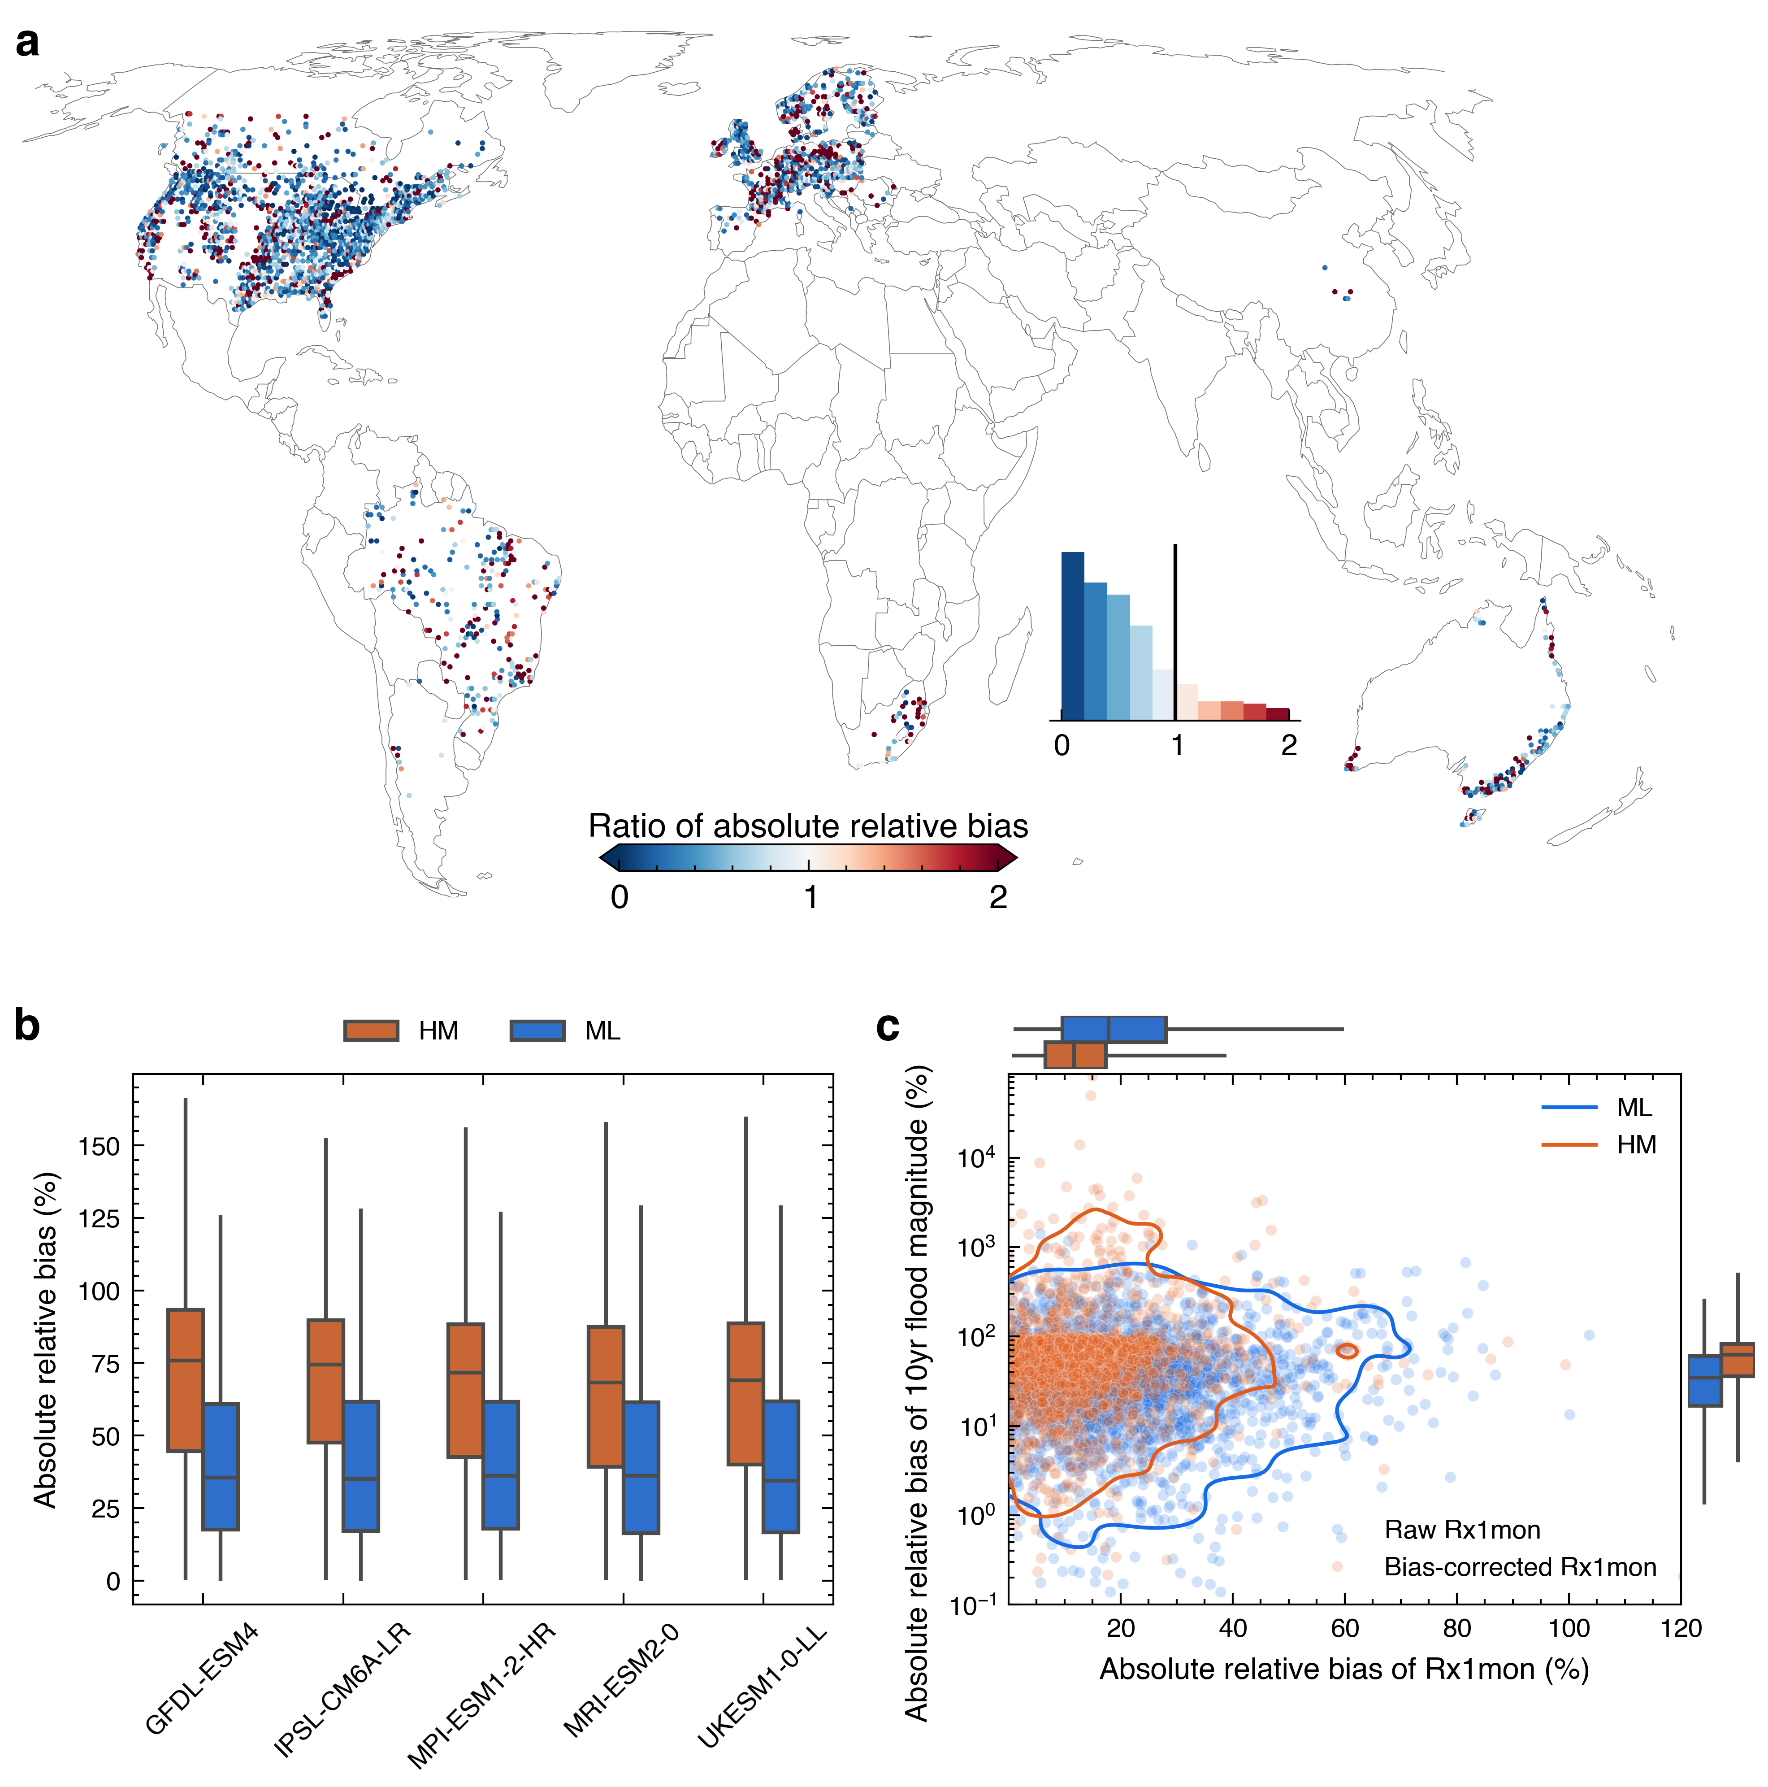

Fig. S5 Relative bias of the ML models versus the calibrated PCR-GLOBWB (HM) in predicting the 10-year flood event magnitude during the period 2001−2014. a Multi-model ensemble mean predictions of the 10-year flood magnitude from the 19-GCM ML models and PCR-GLOBWB global hydrologic models driven with five ISIMIP3b bias-corrected climate model outputs are compared with observed values to calculate the absolute relative bias separately. Note that the absolute value of relative bias is used here for better model comparison, and the ratio of the absolute relative biases generated from the ML and HM predictions are shown in a. The inset histogram in a indicates the distribution of absolute relative biases. b Absolute relative biases generated from the ML and PCR-GLOBWB driven by the same 5 GCMs (using the 5 GCMs from the ISIMIP3b experiment). c Bias of annual maximum 1-month CMIP6 precipitation (Rx1mon) in the ensemble mean of 19 ML models (uncorrected, blue) and 10 HMs (bias-corrected, red) versus bias of 10-year flood magnitude predicted by the same ML models and HMs. The contour lines in c represent the 95% confidence contour, indicating that 95% of the probability mass lies within the contour. Boxplots to the right and top of panel c indicate the distribution of flood biases and Rx1mon biases, respectively. Boxplot whiskers extend to the 2.5% and 97.5% percentiles. Note: average 10-year flood magnitude is computed as specific discharge (mm/day) for the HMs in each grid cell.

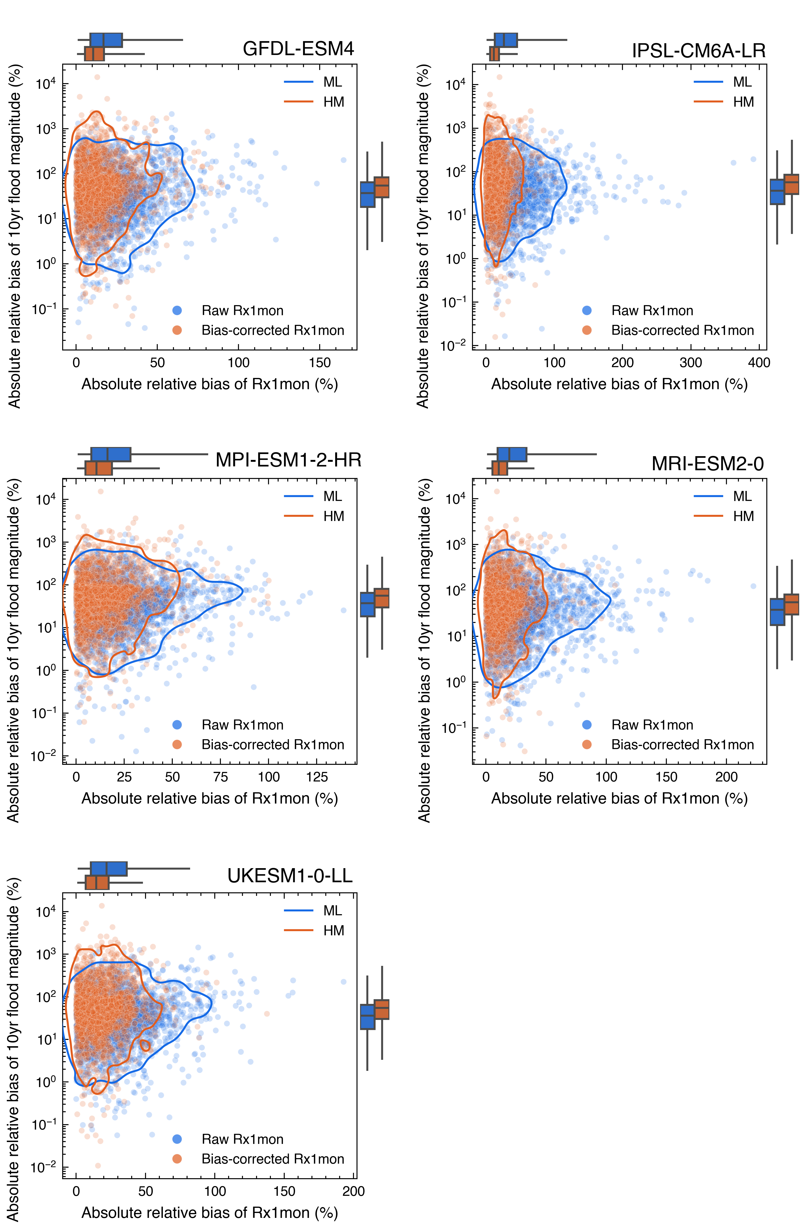

Fig. S6 Bias of CMIP6 annual maximum 1-month precipitation (Rx1mon) and of 10-year flood magnitude generated by the ensemble mean ML (blue) and HM (orange) predictions; contours represent the 95% confidence contour, indicating that 95% of the probability mass lies within the contour. Boxplots alongside each subplot indicate the distribution of flood biases and Rx1mon biases, respectively, and are significantly different (P < 0.01) based on the paired t-test. The boxplots whisker extend to the 2.5% and 97.5% percentiles.

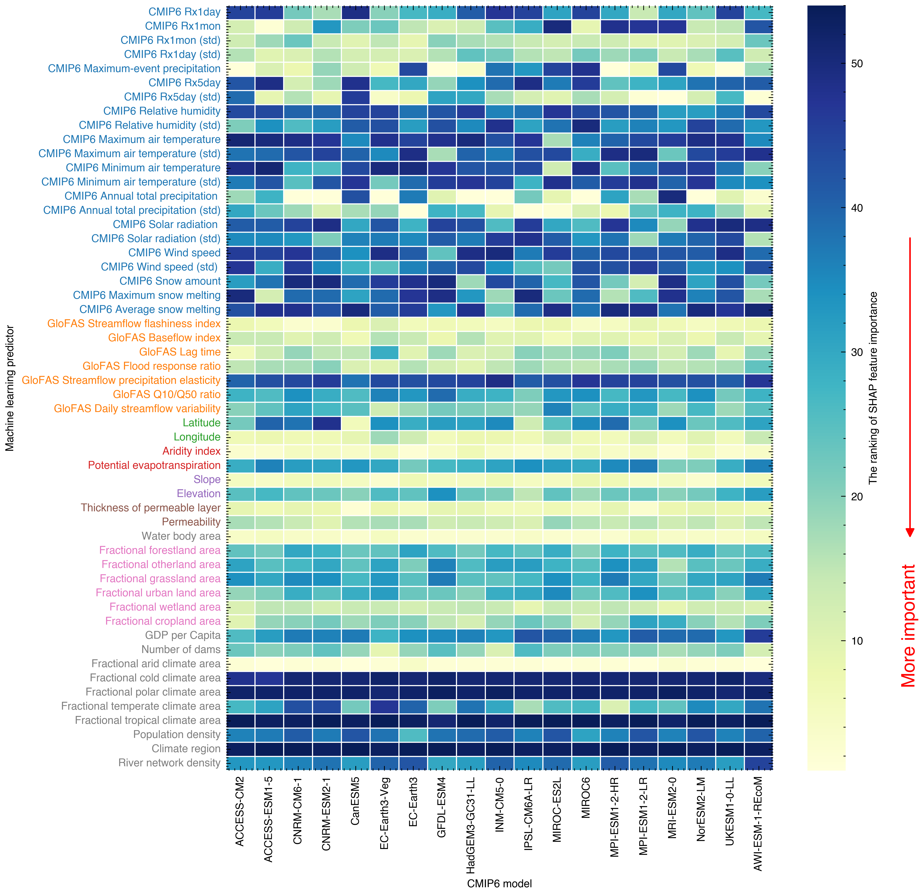

Fig. S7 Feature importance based on SHAP values. The mean absolute SHAP values for each feature were sorted to obtain the global feature importance and the procedure was repeated for each of the 19 CMIP6 models. The ranking from 1 to 54 indicates decreasing feature importance.

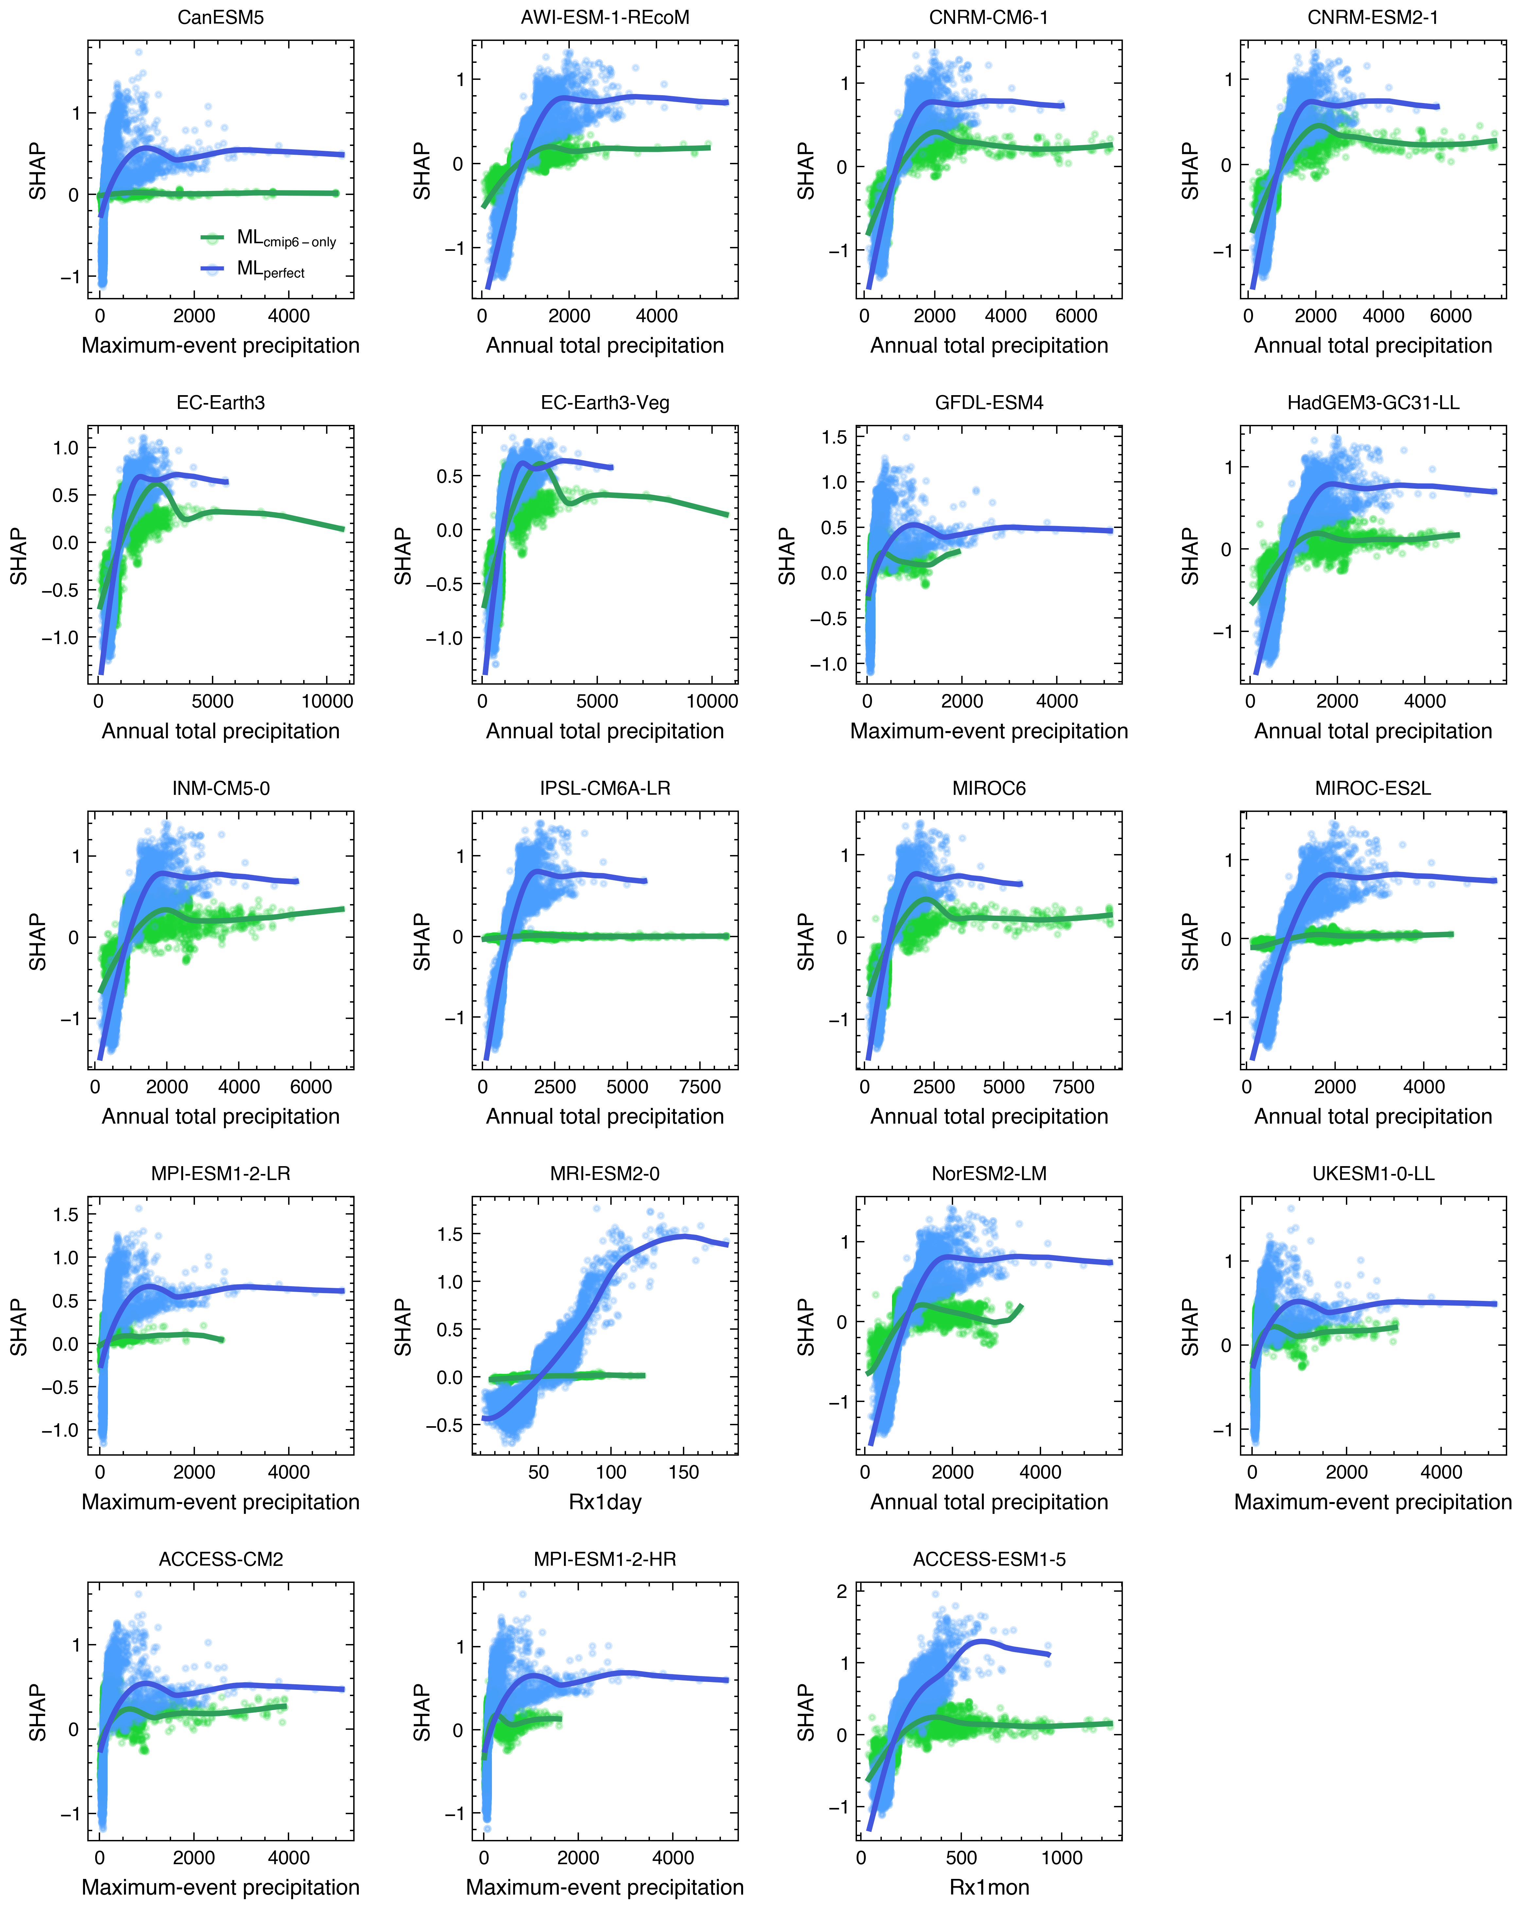

Fig. S8 We compare a simulation-only ML model (“CMIP6 only”, ML_{cmip6-only}, shown in green) trained on climate model simulations and a perfect prediction ML model (ML_{perfect}, shown in blue, as a baseline) in which the most important CMIP6 precipitation predictor (e.g., annual total precipitation, or another variable) is replaced by the equivalent predictor calculated from the MSWEP dataset. The most important climate predictor in each climate model is identified through the SHapley Additive exPlanations (SHAP) algorithm (see Fig. S7). The two ML models are trained separately over the period 1981−2014. We compare the contribution of the precipitation predictor to the flood magnitude in the two ML models using SHAP values. Positive SHAP values mean that the predictor affects the flood magnitude positively, and vice versa. The higher the absolute SHAP value, the more the predictor contributes to the flood magnitude. Each coloured circle represents a gauging station. The smooth lines were fitted with LOESS (locally weighted scatterplot smoothing) regression to highlight the average differences between the two ML models.

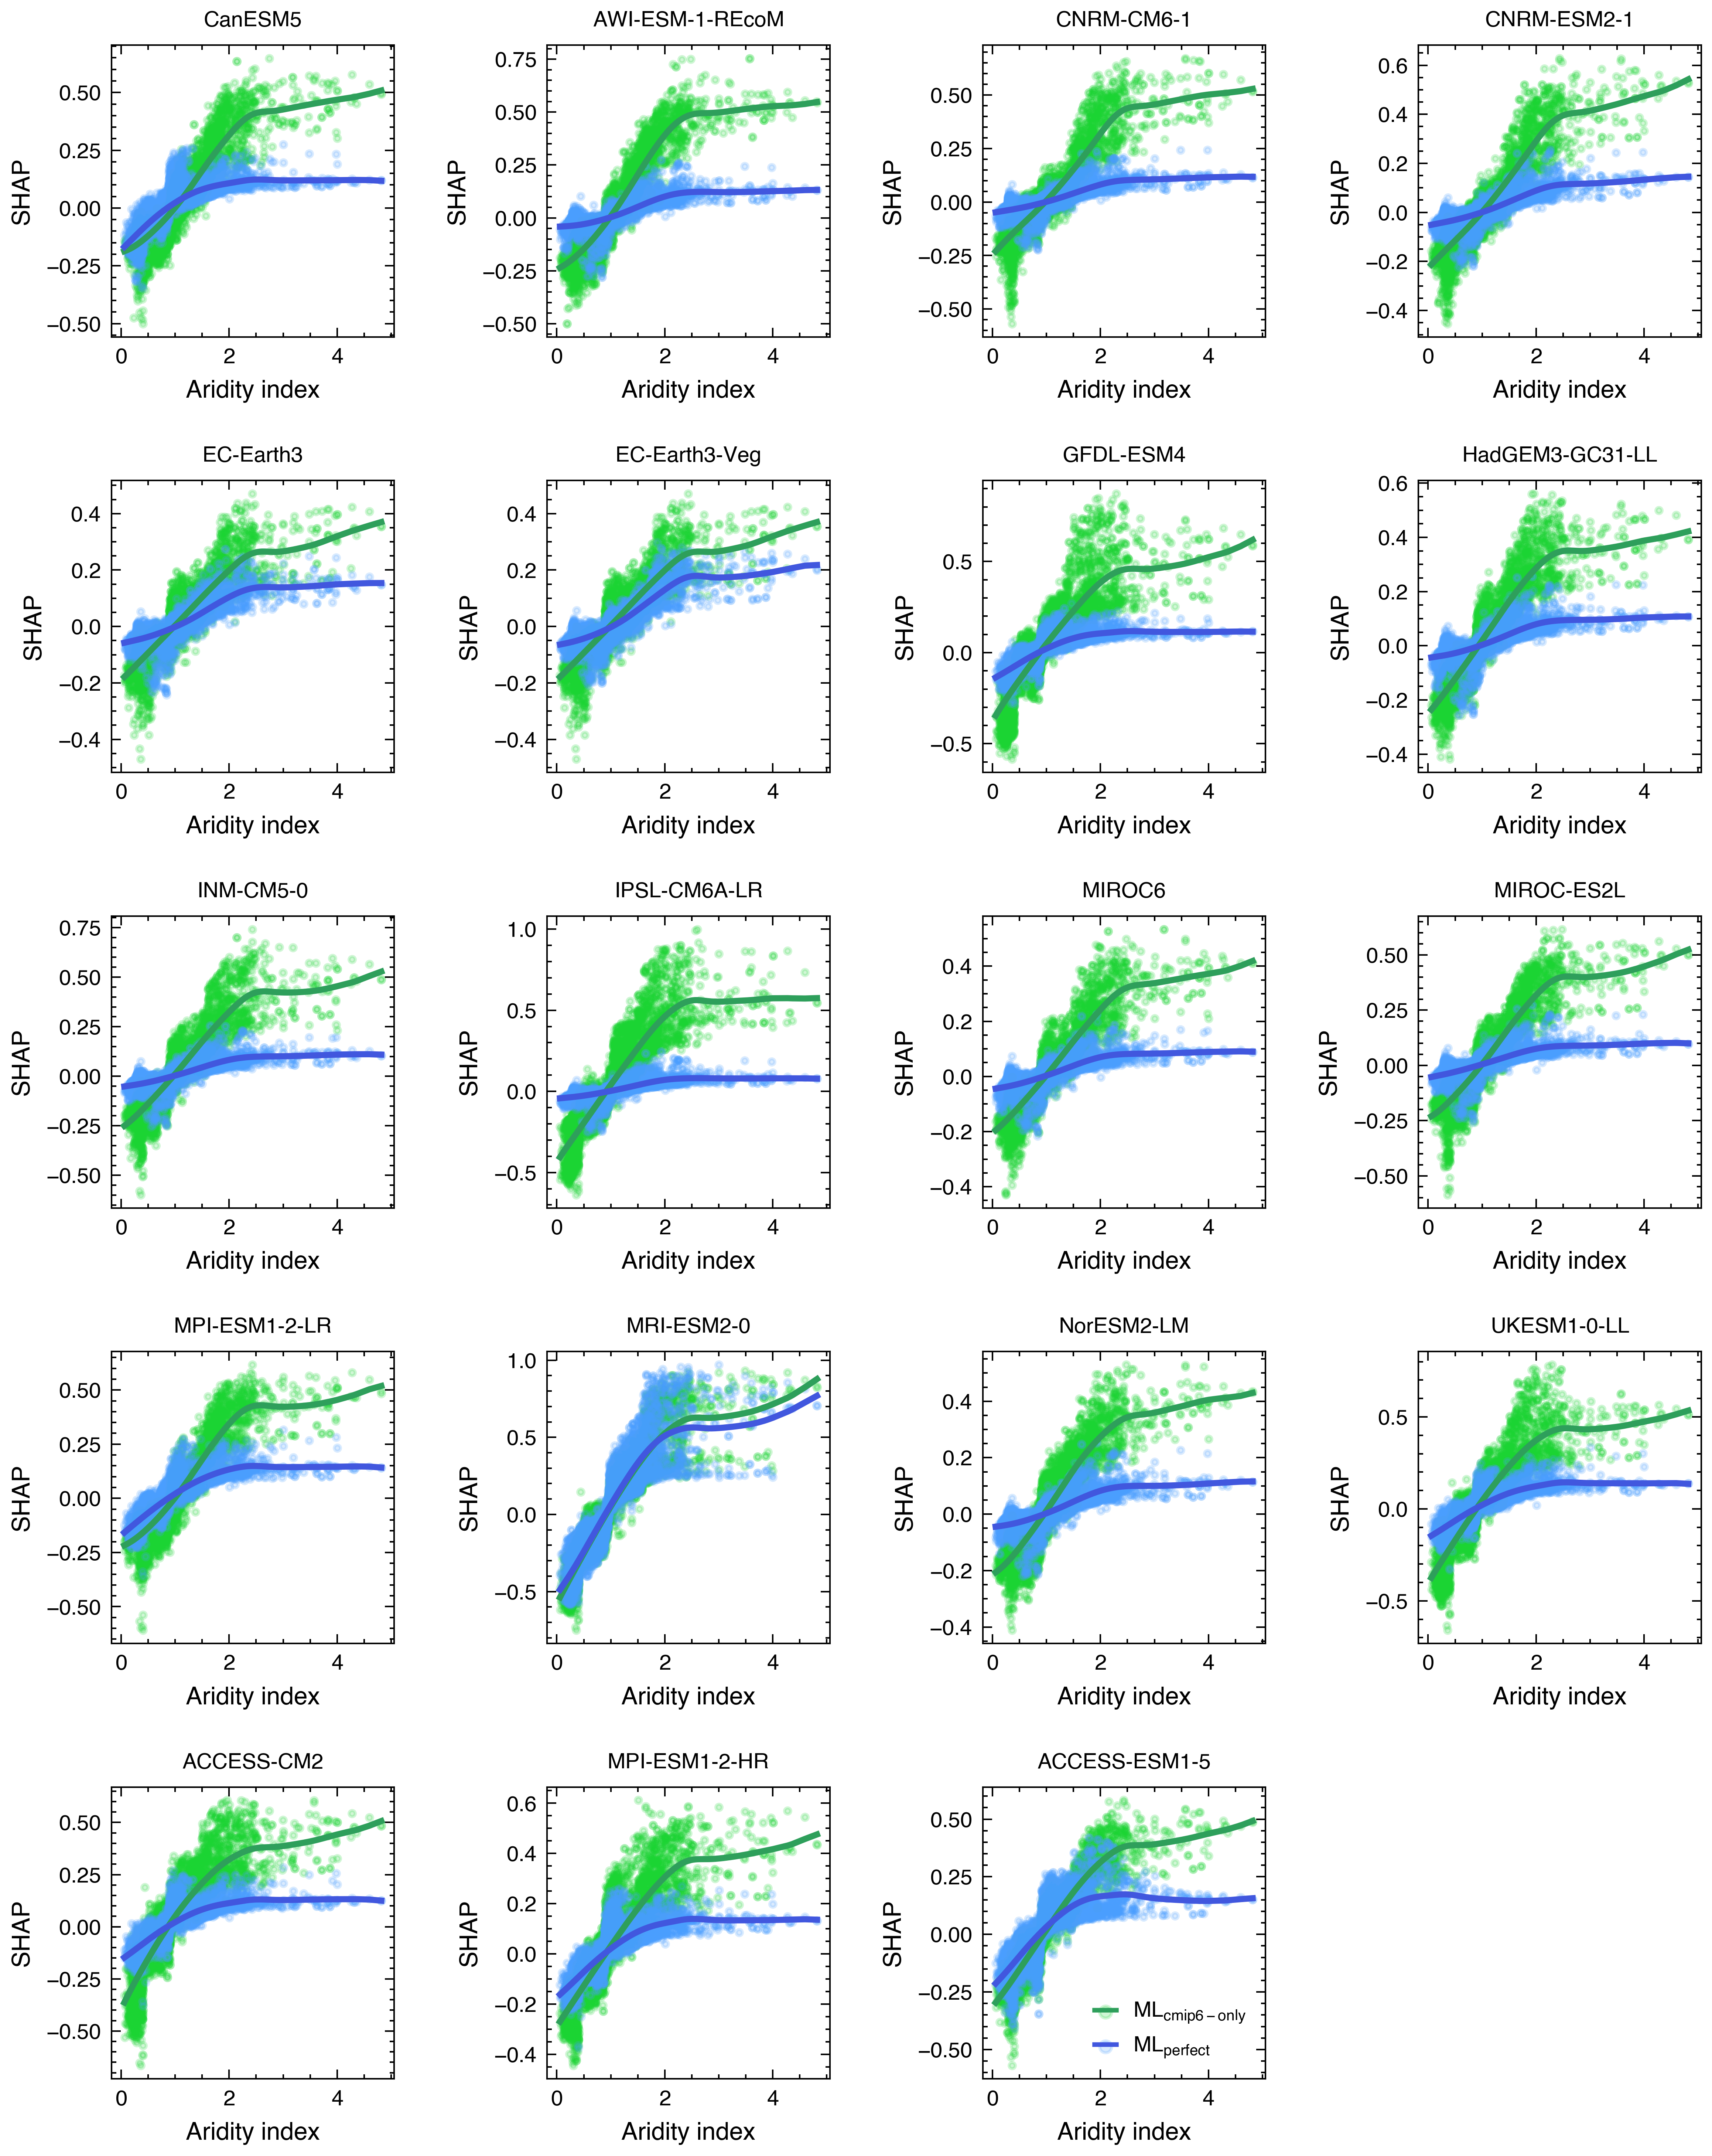

Fig. S9 Same as Fig. S8 but the contribution of the aridity index to the flood magnitude in the two ML models (ML_{cmip6-only} and ML_{perfect}) are compared.

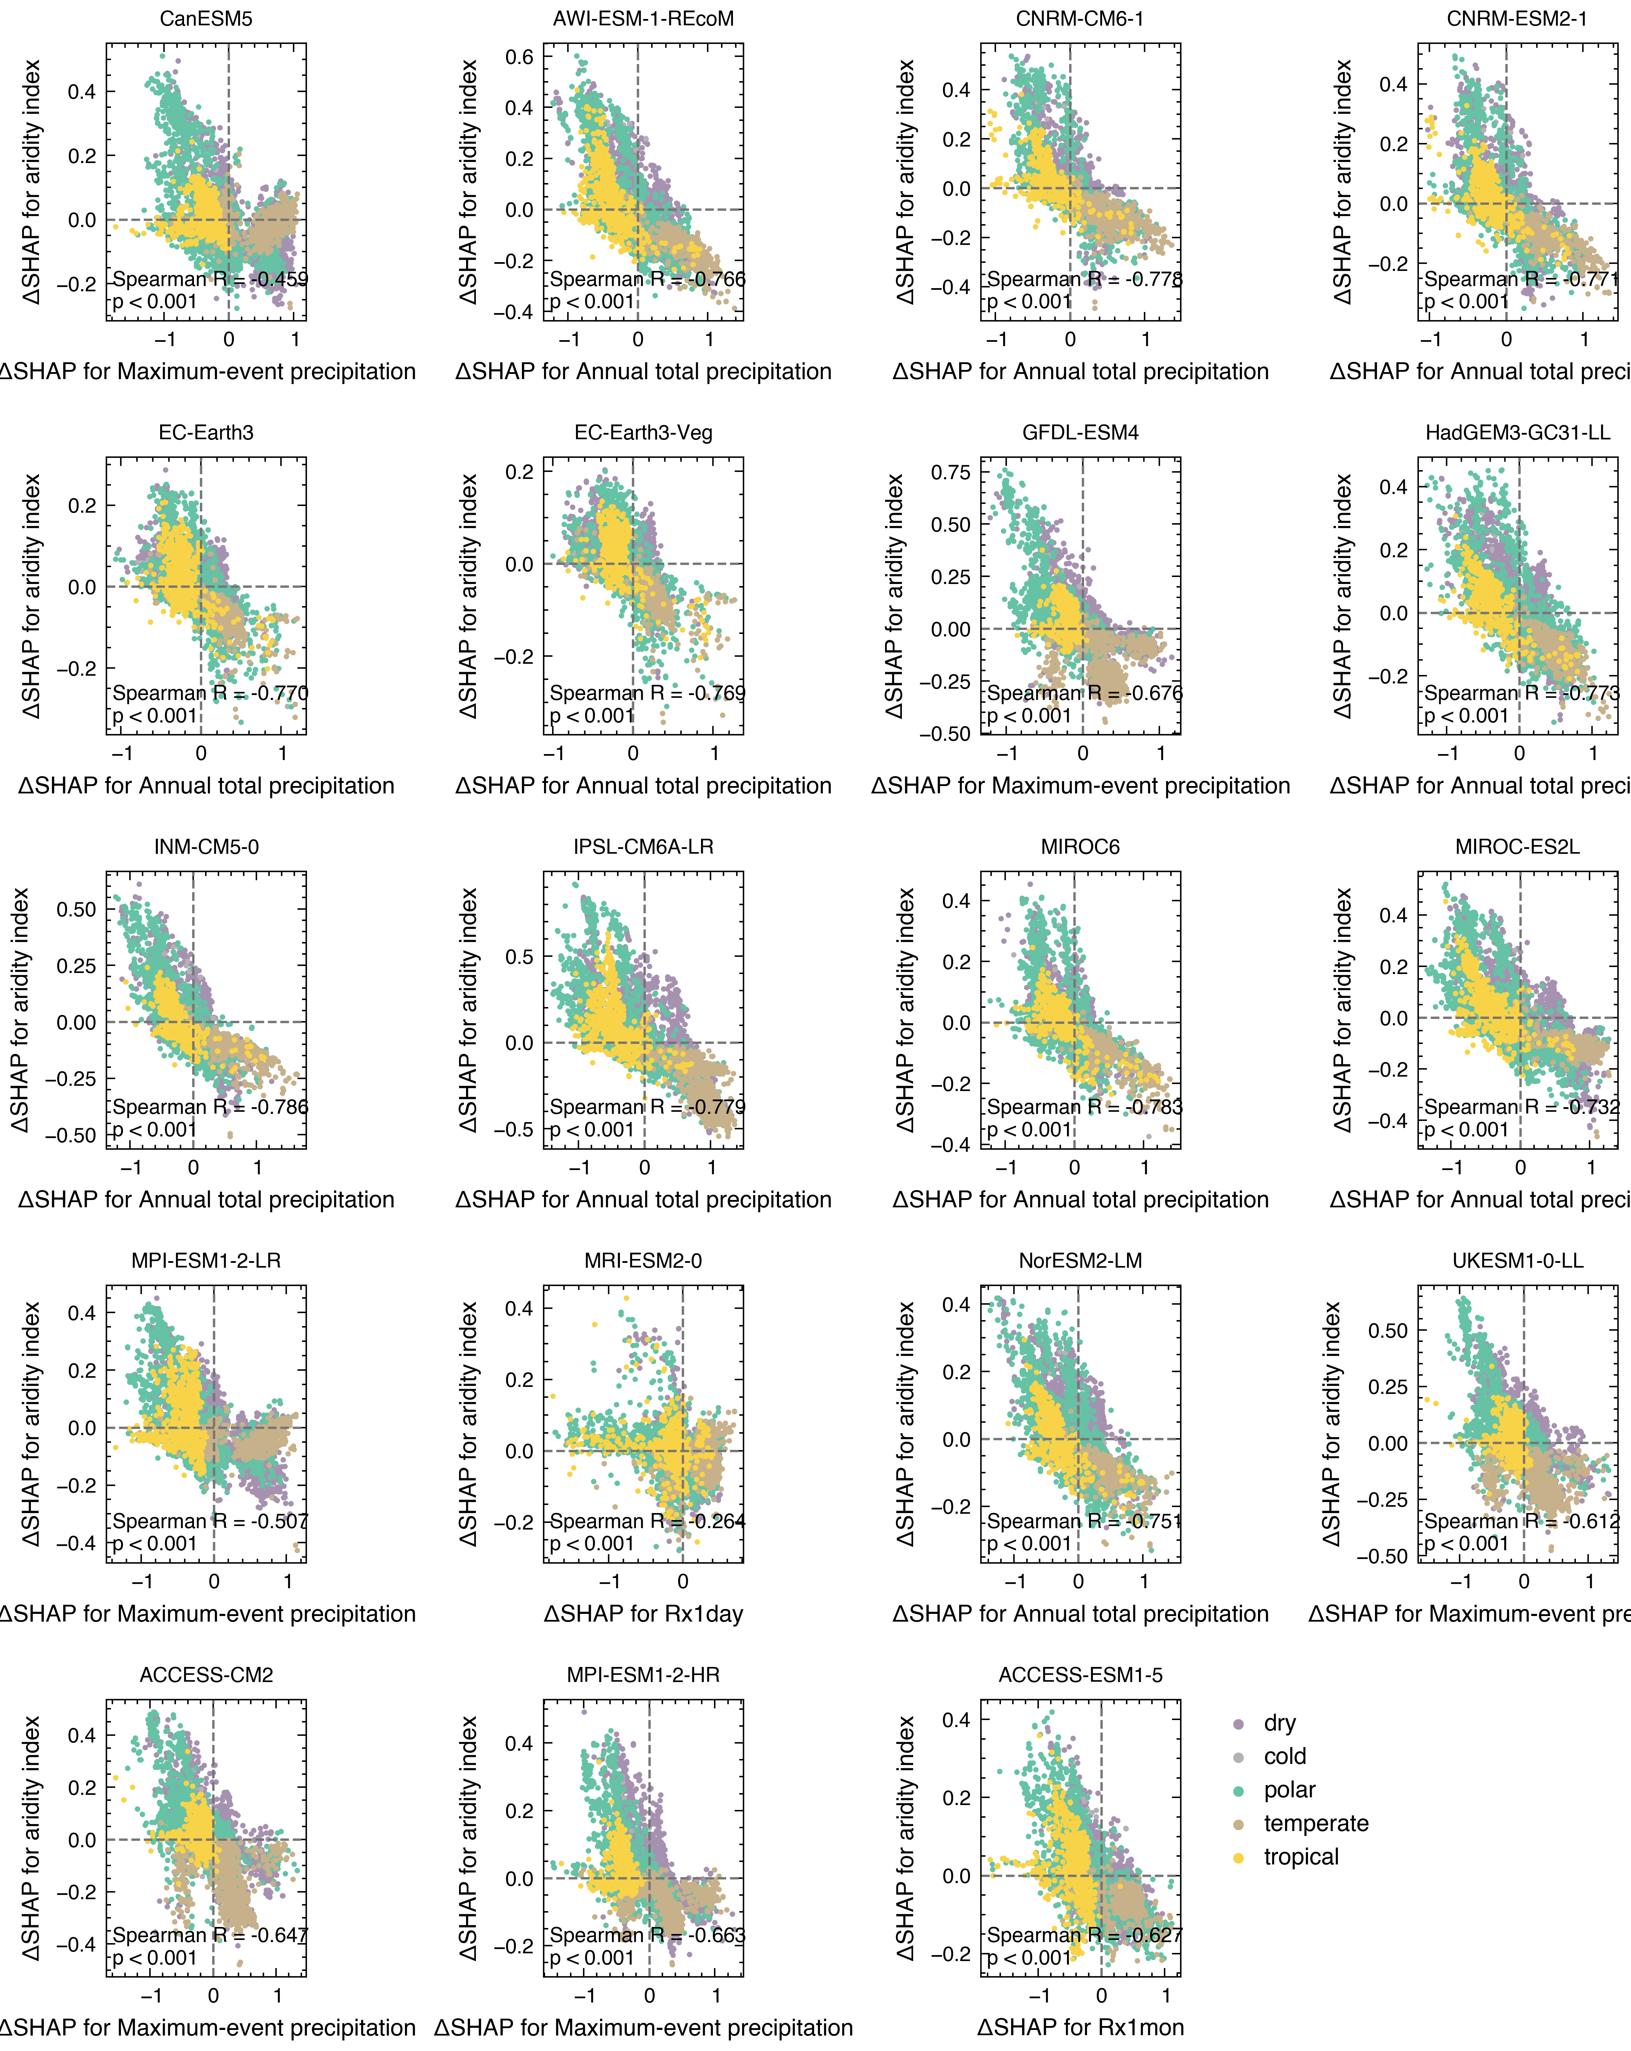

Fig. S10 The difference in SHAP values (i.e., ΔSHAP) of the most important climate variable for the ML_{cmip6-only} and ML_{perfect} models is compared with that of the aridity index (y-axis). The most important climate variable is identified through SHapley Additive exPlanations (SHAP) for the ML_{cmip6-only} model (see Fig. S7), however, the most important climate variables may differ between the ML_{cmip6-only} and ML_{perfect} models. Positive ΔSHAP values mean that the ML_{cmip6-only} model increases the contribution of the predictor to flooding compared to the ML_{perfect} model. The Spearman correlation and associated p-value are labelled in the bottom left of each panel. It should be noted that the most important climate predictor (x-axis) shown here varies with the climate model.

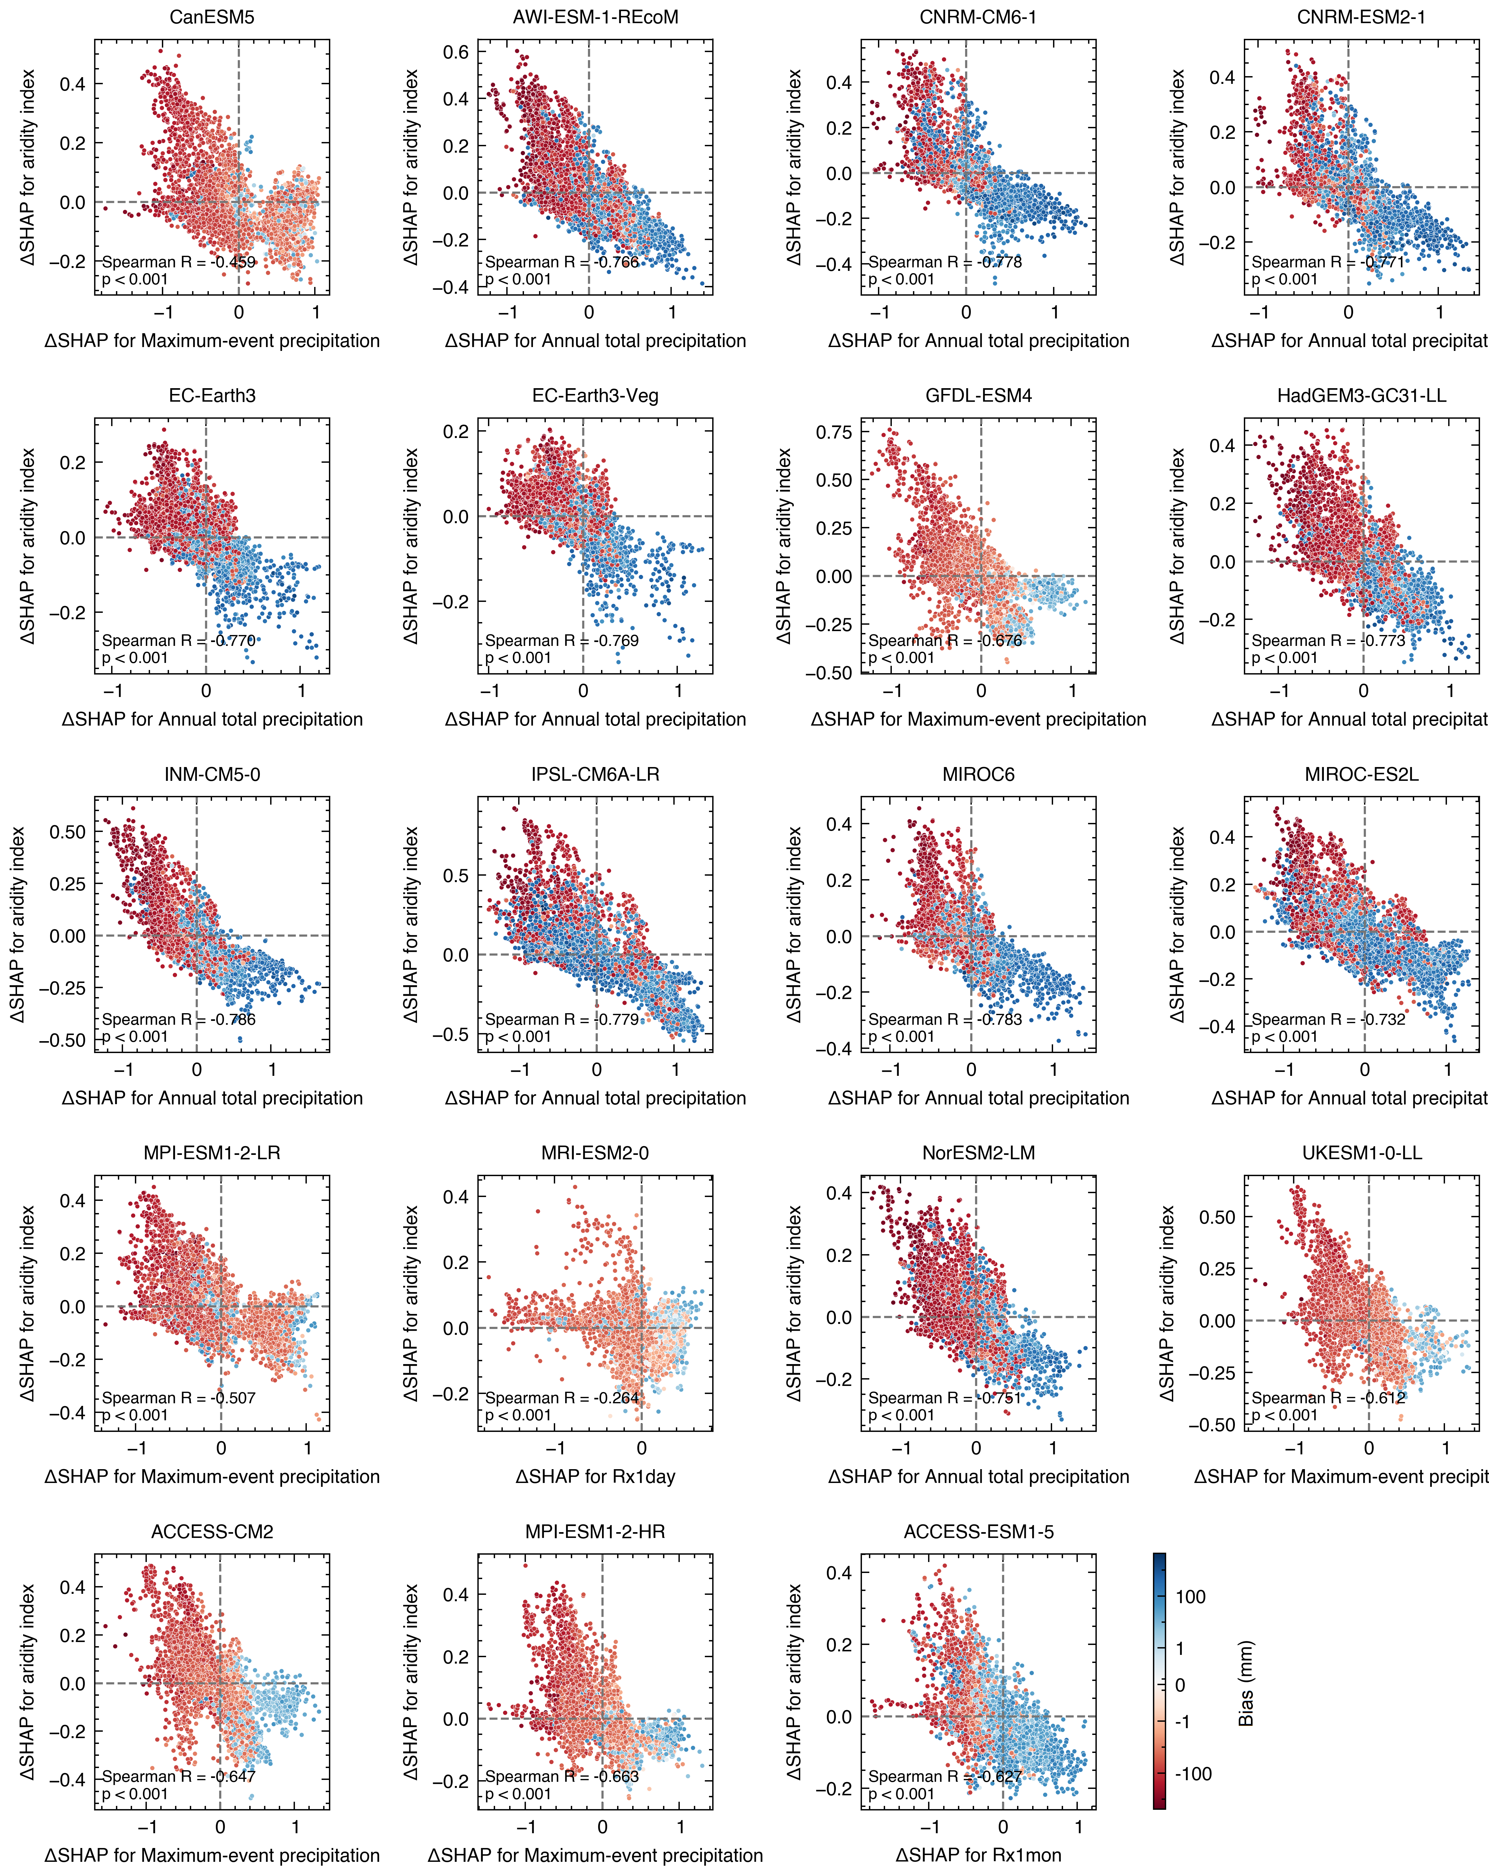

Fig. S11 Same as Fig. S10 but the dots are coloured by the bias of the climate predictors. It should be noted that the most important climate predictor (x-axis) shown here varies with the climate model (each panel is a different ML model and climate model).

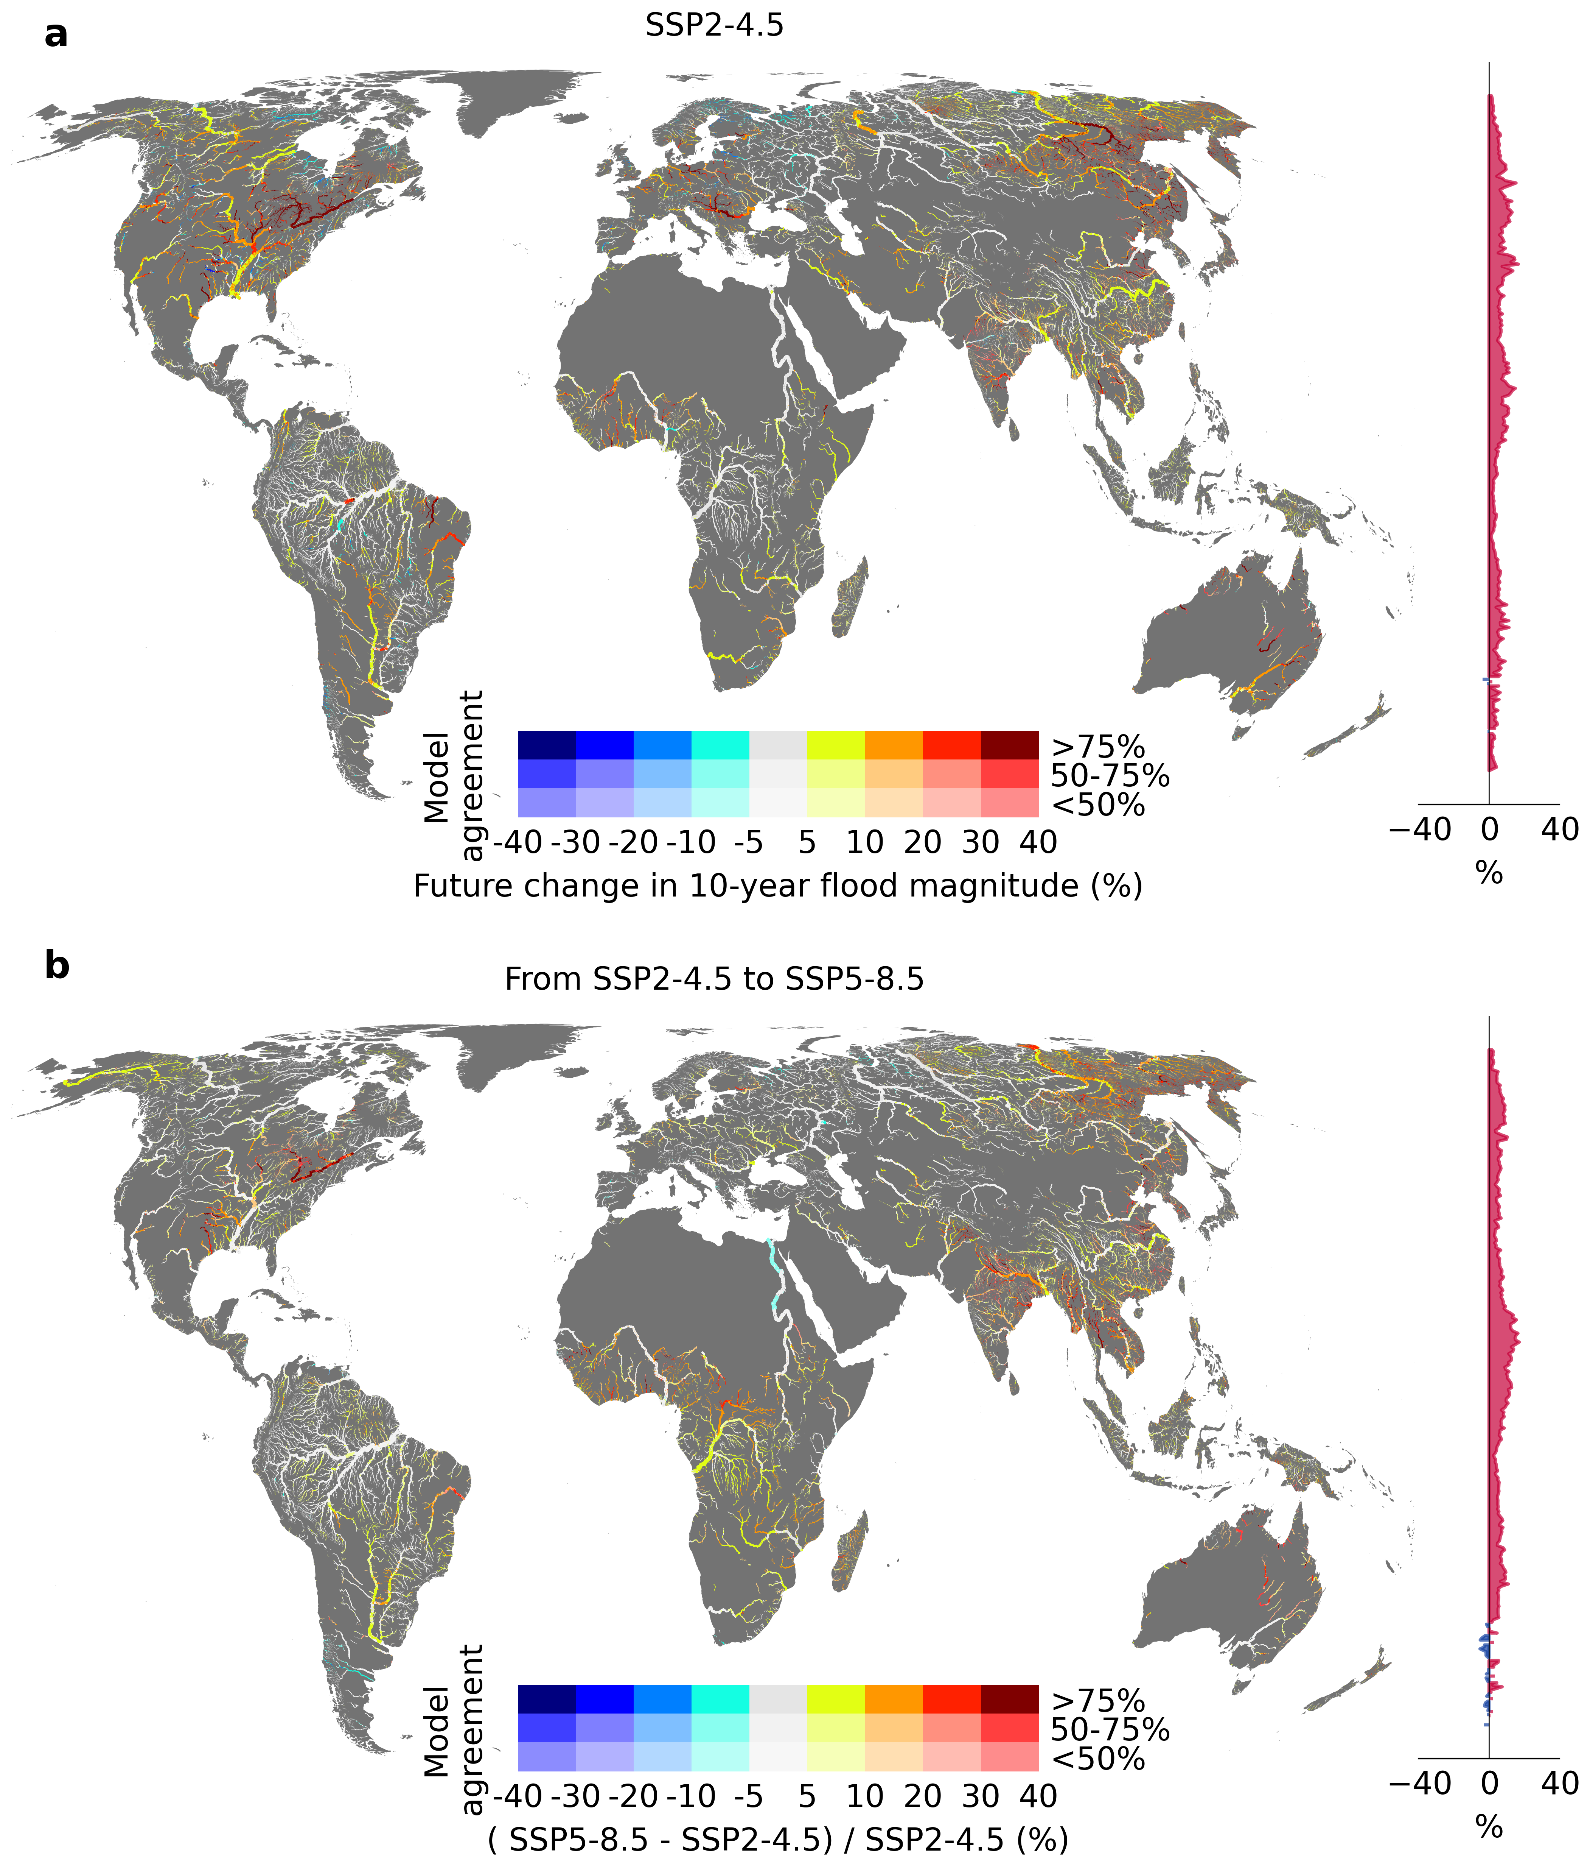

Fig. S12 Multi-model ensemble mean in the projected changes of flood magnitude between historical (1981−2014) and future (2071−2100) periods. a indicates future changes under SSP2-4.5 and b indicates the difference between SSP2-4.5 and SSP5-8.5. The colour in the maps shows the magnitude of change and the saturation indicates the agreement, among ensemble members, in the sign of change. The inset graph on the right shows the latitudinal mean flood change.

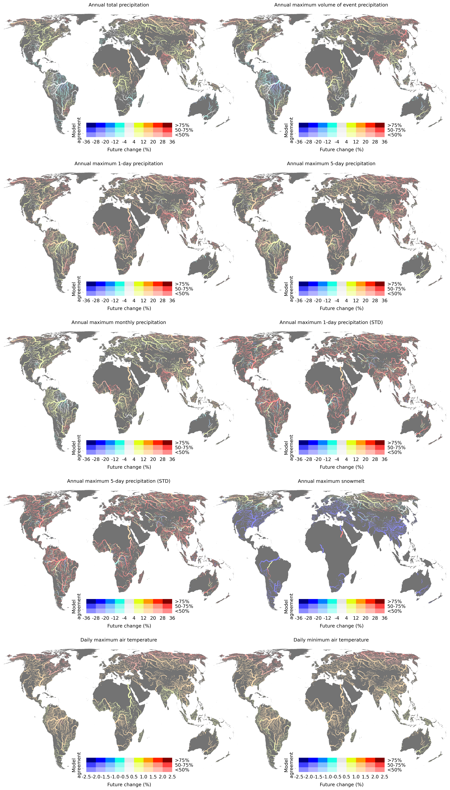

Fig. S13 Multi-model ensemble mean in the projected changes of each climate predictor under SSP2-4.5. The colour hues in the maps show the magnitude of change and the saturation indicates the agreement, among ensemble members, in the sign of change.

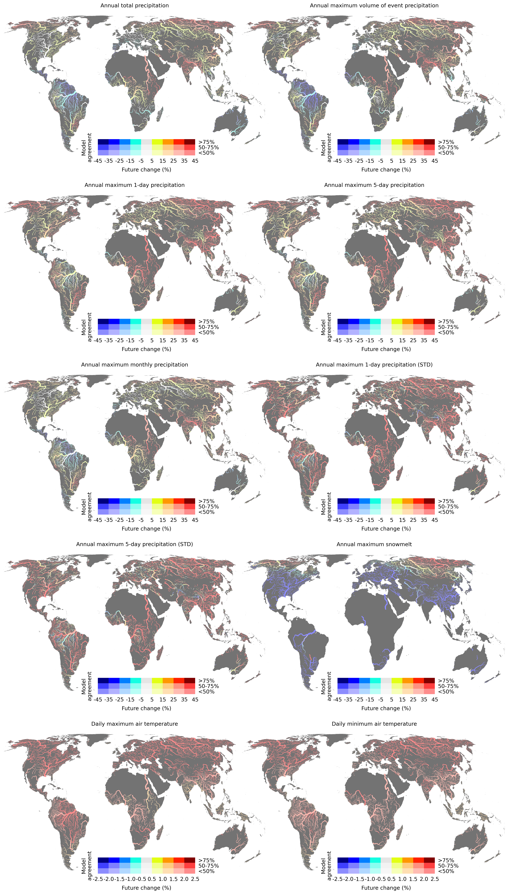

Fig. S14 Same as Fig. S13 but for the difference between SSP2-4.5 and SSP5-8.5 scenarios.
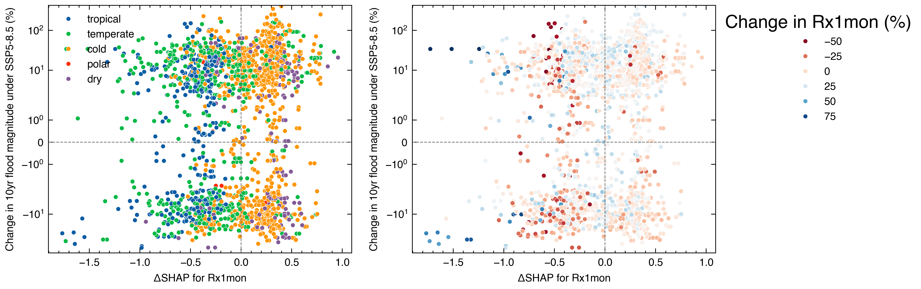

Fig. S15 We compare a simulation-only ML model (ML_{cmip6-only}) trained on climate model simulations and a perfect prediction ML model (ML_{perfect}) in which the most important CMIP6 climate predictor is replaced by a “perfect" predictor calculated from the MSWEP v2 dataset. The difference in SHAP values (i.e., ΔSHAP) of the annual maximum 1-month precipitation (Rx1mon) generated from the ML_{cmip6-only} and ML_{perfect} models are compared with the projected changes of flood magnitude for the 7,115 river basins under SSP5-8.5. Multi-model ensemble means in the projected changes of flood magnitude and Rx1mon are calculated between historical (1981−2014) and future (2071−2100) periods. The dots in the right panel are coloured by the projected changes of Rx1mon.

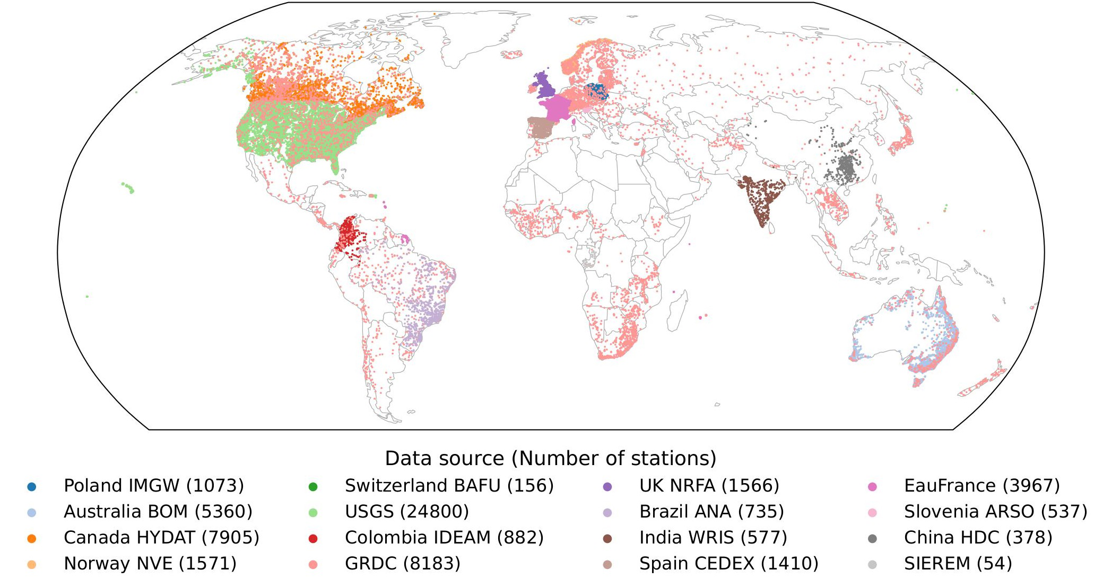

Fig. S16 Spatial distribution of global streamflow stations and data sources.

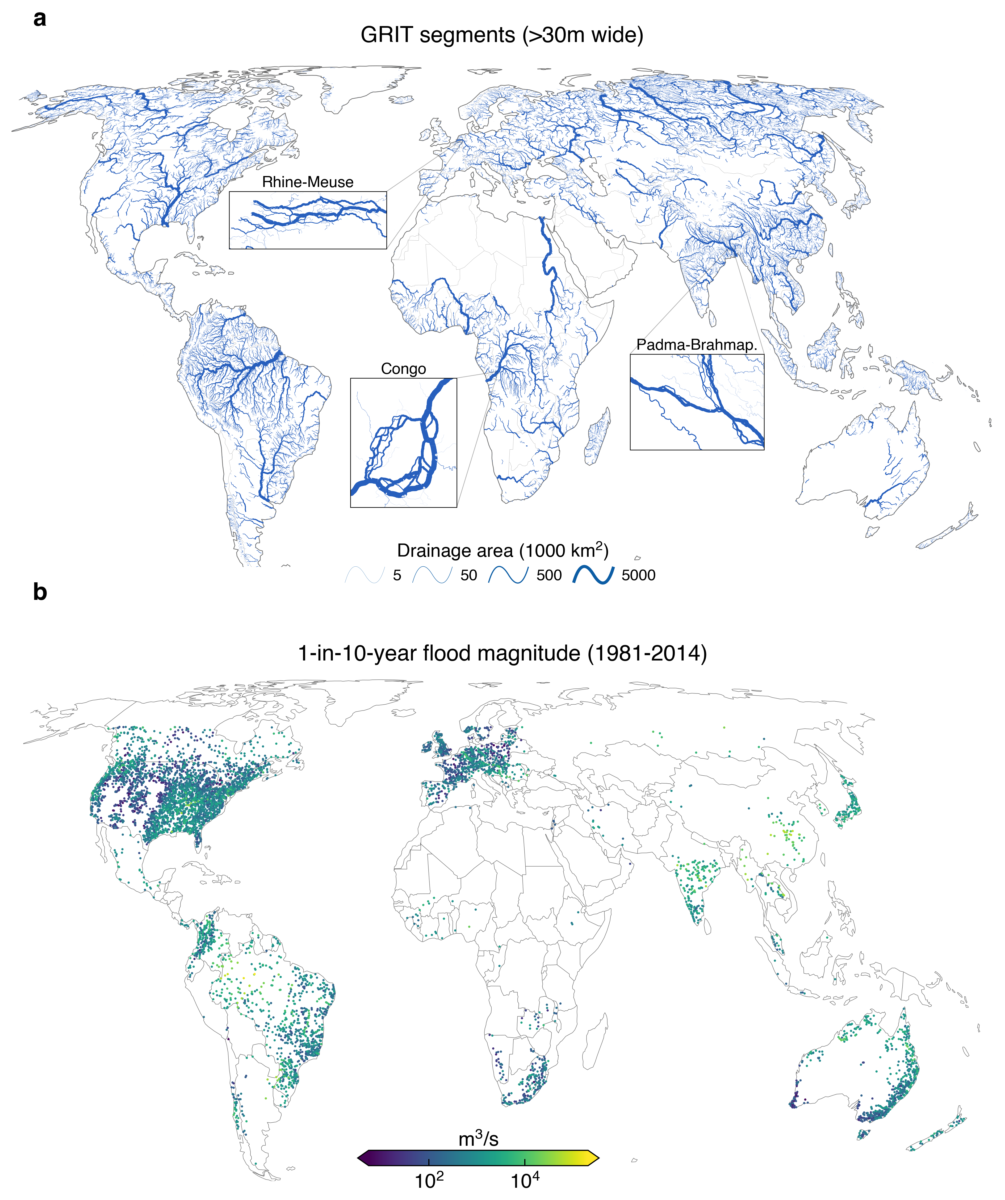

Fig. S17 GRIT reaches and 10-year flood magnitude. a presents reaches from the GRIT network with Global River Widths from Landsat (GRWL) width greater than 30 m as well as their downstream segments. The width is scaled by partitioned drainage area here for visualization purposes. The inset rectangles show the detail of the multi-threaded river network in three different regions of the globe (Rhine-Meuse, Congo, Padma-Brahmaputra). b presents the 10-year flood magnitude estimated using the empirical probability function of annual maximum discharge for each gauge, where each gauge has at least 10 years of daily discharge observations during the period 1981−2014.

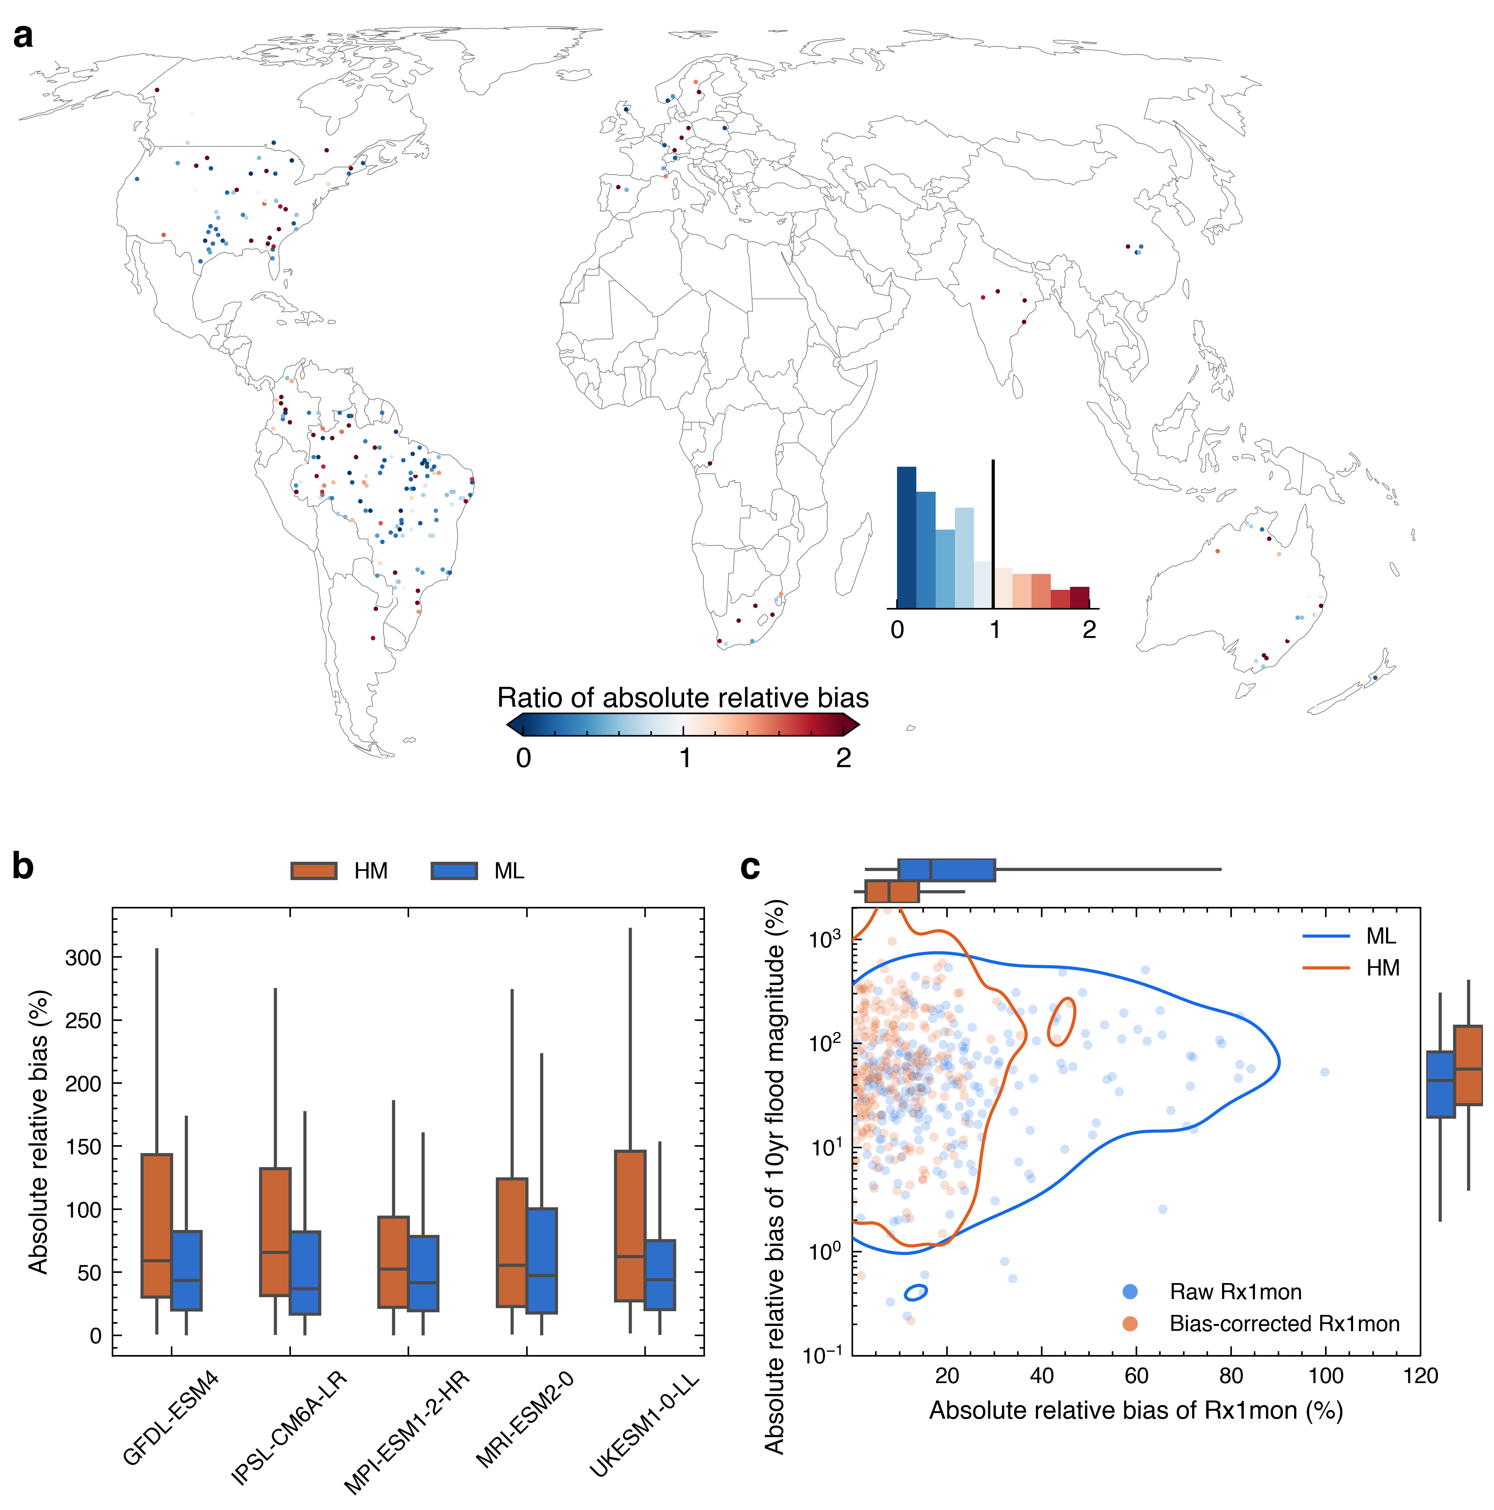

Fig. S18 Relative bias of the ML models versus hydrological models from the ISIMIP3b experiment in predicting the 10-year flood event during the period 2001−2014. Here grid cells are limited to those where the drainage area calculated using DDM30 differed by no more than 20% from the drainage area calculated using river basin polygons from the GRIT dataset. a Multi-model ensemble mean predictions of the 10-year flood magnitude from the 19-GCM ML models and 10 hydrologic models (HMs) from the ISIMIP3b experiment are compared with observed values to calculate the absolute relative bias separately. Note that the absolute value of relative bias is used here for better model comparison, and the ratio of the absolute relative biases generated from the ML and HM predictions is then shown in a. The inset histogram in a indicates the distribution of absolute relative biases. b Absolute relative biases generated from the ML and HMs driven by the same 5 GCMs (using the 5 GCMs from the ISIMIP3b experiment). c Bias of annual maximum 1-month CMIP6 precipitation (Rx1mon) in the ensemble mean of 19 ML models (uncorrected, blue) and 10 HMs (bias-corrected, red) versus bias of 10-year flood magnitude predicted by the same ML models and HMs. The contour lines in c represent the 95% confidence contour, indicating that 95% of the probability mass lies within the contour. Boxplots to the right and top of panel c indicate the distribution of flood biases and Rx1mon biases, respectively. Boxplot whiskers extend to the 2.5% and 97.5% percentiles. Note: average 10-year flood magnitude is computed as specific discharge (mm/day) for the HMs in each grid cell.
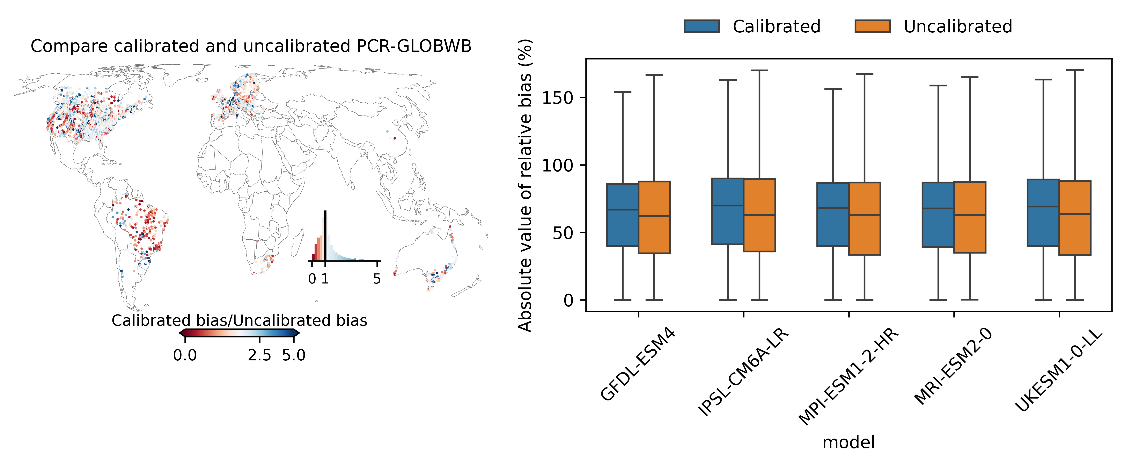

Fig. S19 Comparison of 10-year flood magnitude predictions (2001-2014) from the calibrated and uncalibrated 30-arcmin PCR-GLOBWB models, forced by five bias-corrected climate models (ISIMIP3b). A three-fold spatiotemporal cross-validation test was conducted: the model was calibrated by minimizing 1 - KGE between predicted and observed 10-year flood magnitudes using 2/3 of available gauges from 1981-1990, and then validated against the remaining 1/3 of gauges from 2001-2014. This process was repeated three times. The left panel compares the absolute relative biases of the calibrated and uncalibrated models (ratio) using the ensemble mean of the five climate model forcings; ratios < 1 indicate improved performance after calibration. The right panel presents the same comparison for each individual climate model forcing.

References
1. Sutanudjaja, E. H. et al. PCR-GLOBWB 2: A 5 arcmin global hydrological and water resources model. Geosci Model Dev 11, 2429–2453 (2018).
2. Döll, P. & Lehner, B. Validation of a new global 30-min drainage direction map. J Hydrol (Amst) 258, 214–231 (2002).
3. Ruijsch, J., Verstegen, J. A., Sutanudjaja, E. H. & Karssenberg, D. Systemic change in the Rhine-Meuse basin: Quantifying and explaining parameters trends in the PCR-GLOBWB global hydrological model. Adv Water Resour 155, (2021).
4. Sutanudjaja, E. H., Van Beek, L. P. H., De Jong, S. M., Van Geer, F. C. & Bierkens, M. F. P. Calibrating a large-extent high-resolution coupled groundwater-land surface model using soil moisture and discharge data. Water Resour Res 50, 687–705 (2014).
5. Kang, S. et al. Observation-constrained projection of flood risks and socioeconomic exposure in China. Earths Future 11, e2022EF003308 (2023).
6. Di Sante, F., Coppola, E. & Giorgi, F. Projections of river floods in Europe using EURO-CORDEX, CMIP5 and CMIP6 simulations. International Journal of Climatology 41, 3203–3221 (2021).
7. Hirabayashi, Y., Tanoue, M., Sasaki, O., Zhou, X. & Yamazaki, D. Global exposure to flooding from the new CMIP6 climate model projections. Sci Rep 11, 3740 (2021).
8. Jiang, R. et al. Substantial increase in future fluvial flood risk projected in China’s major urban agglomerations. Commun Earth Environ 4, (2023).
9. Liu, W. et al. Observation-constrained projection of global flood magnitudes with anthropogenic warming. Water Resour Res 57, e2020WR028830 (2021).
10. Xuan Do, H. et al. Historical and future changes in global flood magnitude - evidence from a model-observation investigation. Hydrol Earth Syst Sci 24, 1543–1564 (2020).
11. Yamazaki, D., Watanabe, S. & Hirabayashi, Y. Global Flood Risk Modeling and Projections of Climate Change Impacts. Geophysical Monograph Series 233, 185–203 (2018).
12. Wang, H. et al. Anthropogenic climate change has influenced global river flow seasonality. Science (1979) 383, 1009–1014 (2024).
13. Alfieri, L. et al. Global projections of river flood risk in a warmer world. Earths Future 5, 171–182 (2017).
14. J.-S., N. & Mishra, V. Projected increase in widespread riverine floods in India under a warming climate. J Hydrol (Amst) 630, (2024).
15. Wobus, C. et al. Climate change impacts on flood risk and asset damages within mapped 100-year floodplains of the contiguous United States. Natural Hazards and Earth System Sciences 17, 2199–2211 (2017).
16. Sharma, S., Gomez, M., Keller, K., Nicholas, R. E. & Mejia, A. Regional flood risk projections under climate change. J Hydrometeorol 22, 2259–2274 (2021).
17. Bates, P. D. et al. Combined modeling of US fluvial, pluvial, and coastal flood hazard under current and future climates. Water Resour Res 57, e2020WR028673 (2021).
18. Archer, L. et al. Current and future rainfall-driven flood risk from hurricanes in Puerto Rico under 1.5 and 2 °C climate change. Natural Hazards and Earth System Sciences 24, 375–396 (2024).
19. Archer, L. et al. Future change in urban flooding using new convection-permitting climate projections. Water Resour Res 60, (2024).
20. Kim, H. & Villarini, G. Higher emissions scenarios lead to more extreme flooding in the United States. Nat Commun 15, (2024).
21. Wasko, C., Guo, D., Ho, M., Nathan, R. & Vogel, E. Diverging projections for flood and rainfall frequency curves. J Hydrol (Amst) 620, 129403 (2023).
22. Zhang, S. et al. Reconciling disagreement on global river flood changes in a warming climate. Nat Clim Chang 12, 1160–1167 (2022).
23. Swarnkar, S. & Mujumdar, P. Increasing flood frequencies under warming in the west-central Himalayas. Water Resour Res 59, e2022WR032772 (2023).
24. Bi, D. et al. The ACCESS coupled model: Description, control climate and evaluation. Australian Meteorological and Oceanographic Journal 63, 41–64 (2013).
25. Law, R. M. et al. The carbon cycle in the Australian Community Climate and Earth System Simulator (ACCESS-ESM1) - Part 1: Model description and pre-industrial simulation. Geosci Model Dev 10, 2567–2590 (2017).
26. Swart, N. C. et al. The Canadian Earth System Model version 5 (CanESM5.0.3). Geosci Model Dev 12, 4823–4873 (2019).
27. Séférian, R. et al. Evaluation of CNRM Earth System Model, CNRM-ESM2-1: Role of Earth System Processes in Present-Day and Future Climate. J Adv Model Earth Syst 11, 4182–4227 (2019).
28. Voldoire, A. et al. Evaluation of CMIP6 DECK Experiments With CNRM-CM6-1. J Adv Model Earth Syst 11, 2177–2213 (2019).
29. Shi, X., Lohmann, G., Sidorenko, D. & Yang, H. Early-Holocene simulations using different forcings and resolutions in AWI-ESM. Holocene 30, 996–1015 (2020).
30. Massonnet, F. et al. Replicability of the EC-Earth3 Earth system model under a change in computing environment. Geosci Model Dev 13, 1165–1178 (2020).
31. Döscher, R. et al. The EC-Earth3 Earth system model for the Coupled Model Intercomparison Project 6. Geosci Model Dev 15, 2973–3020 (2022).
32. Dunne, J. P. et al. The GFDL Earth System Model version 4.1 (GFDL-ESM 4.1): Overall coupled model description and simulation characteristics. J Adv Model Earth Syst 12, (2020).
33. Volodin, E. & Gritsun, A. Simulation of observed climate changes in 1850-2014 with climate model INM-CM5. Earth System Dynamics 9, 1235–1242 (2018).
34. Andrews, M. B. et al. Historical Simulations With HadGEM3-GC3.1 for CMIP6. J Adv Model Earth Syst 12, (2020).
35. Tatebe, H. et al. Description and basic evaluation of simulated mean state, internal variability, and climate sensitivity in MIROC6. Geosci Model Dev 12, 2727–2765 (2019).
36. Hajima, T. et al. Development of the MIROC-ES2L Earth system model and the evaluation of biogeochemical processes and feedbacks. Geosci Model Dev 13, 2197–2244 (2020).
37. Müller, W. A. et al. A Higher-resolution Version of the Max Planck Institute Earth System Model (MPI-ESM1.2-HR). J Adv Model Earth Syst 10, 1383–1413 (2018).
38. Mauritsen, T. et al. Developments in the MPI-M earth system model version 1.2 (MPI-ESM1.2) and its response to increasing CO2. J Adv Model Earth Syst 11, 998–1038 (2019).
39. Yukimoto, S. et al. The meteorological research institute Earth system model version 2.0, MRI-ESM2.0: Description and basic evaluation of the physical component. Journal of the Meteorological Society of Japan 97, 931–965 (2019).
40. Seland, Ø. et al. Overview of the Norwegian Earth System Model (NorESM2) and key climate response of CMIP6 DECK, historical, and scenario simulations. Geosci Model Dev 13, 6165–6200 (2020).
41. Sellar, A. A. et al. UKESM1: Description and Evaluation of the U.K. Earth System Model. J Adv Model Earth Syst 11, 4513–4558 (2019).
42. Boucher, O. et al. Presentation and Evaluation of the IPSL-CM6A-LR Climate Model. J Adv Model Earth Syst 12, (2020).
43. ESA. Land Cover CCI Product User Guide Version 2.0. http://maps.elie.ucl.ac.be/CCI/viewer/download/ESACCI-LC-Ph2-PUGv2_2.0.pdf (2017).
44. Lehner, B., Verdin, K. & Jarvis, A. New global hydrography derived from spaceborne elevation data. Eos (Washington DC) 89, 93–94 (2008).
45. Pelletier, J. D. et al. A gridded global data set of soil, intact regolith, and sedimentary deposit thicknesses for regional and global land surface modeling. J Adv Model Earth Syst 8, 41–65 (2016).
46. Huscroft, J., Gleeson, T., Hartmann, J. & Börker, J. Compiling and mapping global permeability of the unconsolidated and consolidated earth: GLobal HYdrogeology MaPS 2.0 (GLHYMPS 2.0). Geophys Res Lett 45, 1897–1904 (2018).
47. Zomer, R. J., Xu, J. & Trabucco, A. Version 3 of the Global Aridity Index and Potential Evapotranspiration Database. Sci Data 9, 409 (2022).
48. Beck, H. E. et al. Present and future köppen-geiger climate classification maps at 1-km resolution. Sci Data 5, (2018).
49. Beck, H. E. et al. MSWep v2 Global 3-hourly 0.1° precipitation: Methodology and quantitative assessment. Bull Am Meteorol Soc 100, 473–500 (2019).
50. Harrigan, S. et al. GloFAS-ERA5 operational global river discharge reanalysis 1979-present. Earth Syst Sci Data 12, 2043–2060 (2020).
51. Baker, D. B., Richards, R. P., Loftus, T. T. & Kramer, J. W. A new flashiness index: Characteristics and applications to Midwestern rivers and streams. J Am Water Resour Assoc 40, 503–522 (2004).
52. Tatem, A. J. WorldPop, open data for spatial demography. Scientific Data vol. 4 Preprint at https://doi.org/10.1038/sdata.2017.4 (2017).
53. Kummu, M., Taka, M. & Guillaume, J. H. A. Gridded global datasets for Gross Domestic Product and Human Development Index over 1990-2015. Sci Data 5, (2018).
54. Zhang, A. T. & Gu, V. X. Global Dam Tracker: A database of more than 35,000 dams with location, catchment, and attribute information. Sci Data 10, 111 (2023).

