Supplement to:

Sex Differences in Mortality, Multidimensional Morbidity, and Health Care Utilization: A Secondary Analysis of the Canadian RECOVER Study

Karen E. A. Burns MD ^{1,2}
Ella Huszti PhD ^{3,}
Qixuan Li PhD ^{3,}
Margaret S. Herridge MD ^{1,4}
for the Canadian Recover Program and the Canadian Critical Care Trials Group

1. Interdepartmental Division of Critical Care Medicine, University of Toronto, Toronto, Canada.
- Division of Critical Care Medicine, Unity Health Toronto - St. Michael’s Hospital, Toronto, Canada.
- Biostatistics Research Unit, University Health Network, Toronto, Ontario, Canada.
- Division of Critical Care Medicine, University Health Network - Toronto General Hospital, Toronto, Ontario, Canada.

Journal: Intensive Care Medicine

Corresponding Author
Karen E. A. Burns MD, FRCPC, MSc
Unity Health Toronto – St. Michael’s Hospital
30 Bond Street, Office 4-045 Donnelly Wing
Toronto, Ontario, M5B 1W8
Electronic mail: Karen.burns@unityhealth.to

Table of Contents

eFigure 1: ICU Mortality of RECOVER Participants by Sex …………………………………………………………… page 3
eTable 1: Sex Differences in FIM Scores at Different Time Points and Disability Group ………………. page 4
eTable 2: Multivariable Linear Mixed Effects Model for FIM Including Interactions
Between Sex and Time and Sex and Disability Group…………………………………………………………………. page 5
.
eTable 3: Univariable and Multivariable Linear Mixed Effects Models for Longitudinal
BDI-II Scores………………………………………………………………………………………………………………………………. page 6

eTable 4: Univariable and Multivariable Linear Mixed Effects Models for Longitudinal
IES-R Scores…………………………………………………………………………………………………………………………………. page 7

eTable 5: Health Care Utilization After Hospital Discharge………………………………………………………….. page 8

eFigure 1: ICU Mortality of RECOVER Participants by Sex

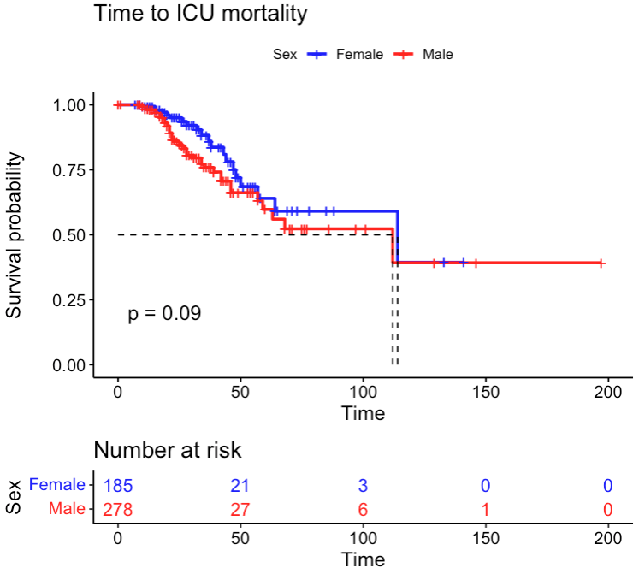
This survival plot depicts the time to intensive care unit death in male (red line) and female (blue line) RECOVER participants with the number at risk by sex in the table below.
Legend
ICU – intensive care unit
eTable 1: Sex Differences in FIM Scores at Different Time Points and Disability Group
Variable | Female  (n=165) | Male  (n=233) | P-value
FIM scores, median (IQR)  7 day  3-months  6-months  12-months  Disability Group, n (%)  Group 1, Young, Short ICU LOS  Group 2, Mixed Age, variable LOS  Group 3, Older, Long ICU LOS  Group 4, Oldest, Long ICU LOS  ICU LOS, median (IQR) | 51.0 (36.0, 78.0)  106.0 (76.0, 119.0)  111.5 (99.8, 121.3)  115.0 (96.0, 122.0)  8 (4.8)  47 (28.5)  67 (40.6)  43 (26.1)  19.0 (14.0, 32.0) | 56.0 (37.0, 86.0)  117 (84.8, 123.3)  119 (110.0, 124.0)  121.0 (108.0, 125.0)  14 (6.0)  89 (38.2)  81 (34.8)  49 (21.0)  20.0 (14.0, 33.0) | 0.17  0.005  0.005  0.003  0.18  0.75

Legend
FIM = functional independence measure (20), IQR = interquartile range, ICU = intensive care unit, LOS = length of stay.

eTable 2: Multivariable Linear Mixed Effects Model for FIM Including Interactions Between Sex and Time and Sex and Disability Group

Variable | Estimate (95% CI) | p-value
Sex – Male  FIM scores  FIM score, 3-months  FIM score, 6-months  FIM score, 12-months  Disability Group  Group 1, Young, Short ICU LOS  Group 3, Older, Long ICU LOS  Group 4, Oldest, Long ICU LOS  Interactions  Male and FIM score, 3-months  Male and FIM score, 6-months  Male and FIM score, 12-months  Male and Group 1, Young Short ICU LOS  Male and Group 3, Older Long ICU LOS  Male and Group 4, Oldest Long ICU LOS | 2.1 (-7.2, 11.4)  36.3 (31.5, 41.0)  39.0 (33.9, 44.0)  43.7 (38.7, 48.7)  20.3 (2.5, 38.1)  -12.5 (-21.8, 3.1)  -14.8 (-25.4, -4.3)  1.9 (-4.5, 8.2)  5.0 (-1.5, 11.5)  3.2 (-3.2, 9.7)  -3.8 (-26.7, 19.2)  5.12 (-6.9, 17.1)  -5.1 (-19, 8.7) | 0.66  <0.0001  <0.0001  <0.0001  0.03  <0.01  <0.01  0.56  0.13  0.32  0.75  0.40  0.47

Legend
FIM = functional independence measure (20), ICU = intensive care unit, LOS = length of stay.

eTable 3: Univariable and Multivariable Linear Mixed Effects Models for Longitudinal BDI-II Scores
 | Univariable |  | Multivariable
Risk Factors | Coefficient  (95% CI) | p-value | Coefficient  (95% CI) | p-value
Male  Time  6-months  12-months  Disability Group  Group 1 Young, Short ICU LOS  Group 3 Older, Long ICU LOS  Group 4 Oldest, Long ICU LOS | -3.6 (-5.8,-1.4)  -0.2 (-1.6, 1.1)  -0.2 (-1.5 1.1)  -3.0 (-7.4, 1.4)  1.8 (-.0.6,4.3)  -1.3 (-4.4,1.7) | <0.01  0.7  0.8  0.2  0.1  0.4 | -3.5 (-5.7,-1.4)  - 0.3 (-1.6, 1.1)  -0.3 (-1.6, 1.1)  -2.6 (-7.1, 1.9)  2.0 (-0.5, 4.6)  -0.9 (-4.1, 2.2) | <0.01  0.7  0.7  0.3  0.1  0.6

Legend
BDI-II = Beck Depression Inventory-II (21), CI = confidence interval, ICU = intensive care unit, LOS = length of stay.

eTable 4: Univariable and Multivariable Linear Mixed Effects Models for Longitudinal IES-R Scores
 | Univariable |  | Multivariable
Risk Factors | Coefficient  (95% CI) | p-value | Coefficient  (95% CI) | p-value
Male  Time  6-months  12-months  Disability Group  Group 1 Young, Short ICU LOS  Group 3 Older, Long ICU LOS  Group 4 Oldest, Long ICU LOS | -4.5 (-8.4,-0.6)  -0.5 (-3.3, 2.2)  -0.6 (-3.3, 2.2)  -5.1 (-12.9, 2.7)  2.2 (-2.2, 6.6)  -7.2 (-12.7, -1.7) | 0.03  0.7  0.7  0.2  0.3  0.01 | -4.2 (-8.1,-0.2)  - 0.5 (-3.3, 2.2)  -0.7 (-3.4, 2.0)  -4.7 (-12.5, 3.2)  2.4 (-2.1, 6.8)  --6.8 (-12.3, -1.2) | 0.04  0.7  0.6  0.2  0.3  0.02

Legend
IES-R = Impact Event Scale–Revised (22), CI = confidence interval, ICU = intensive care unit, LOS = length of stay.

eTable 5: Health Care Utilization After Hospital Discharge
Variable | Total | Female | Male | p-value
 | 128 (35%)  114 (31%)  122 (34%)  69 (17%)  162 (41%)  188 (47%)  135 (19)  43 ( 6)  82 (12)  177 (25)  142 (20)  85 (12)  61 (9)  40 (6)  103 (15)  45 (6)  60 (8)  202 (28)  54 (8) | 53 (35%)  57 (37%)  43 (28%)  32 (19%)  62 (38%)  71 (43%)  39 (14)  11 ( 4)  27 ( 9)  65 (23)  99 (35)  30 (11)  21 (7)  19 (7)  48 (17)  34 (12)  18 (6)  59 (21)  19 (7) | 75 (36%)  57 (27%)  79 (37%)  37 (16%)  100 (43%)  117 (50%)  96 (23)  32 ( 8)  55 (13)  112 (26)  43 (10)  55 (13)  40 (9)  21 (5)  55 (13)  11 (3)  42 (10)  143 (34)  35 (8) | 0.07  0.4  0.3  0.2  0.002  0.03  0.08  0.33  <0.001  0.4  0.3  0.3  0.2  <0.001  0.04  <0.001  0.52
  Disposition, n (%)
  Home
  Other Hospital
  Rehabilitation
  ICU Readmission, n (%)
  ICU
  Hospital
  Specialty Visit, n (%)  Any specialty visit | Any visit
  Cardiology
  Endocrinology
  Gastroenterology
  Hematology
  Nephrology
  Neurology
  Ophthalmology
  Psychiatry
  Respirology
  Rheumatology
  Rehabilitation
  General/Dental Surg
  Orthopedic Surgery

