Supplementary Information:
Contents
1. Non-Abelian topological charges in four-band models 2
2. Rotations in four-dimension 4
3. Tight-binding model 6
4. Analytical solutions of edge states for the flat-band models 9
(i) Edge states of the charges ±q_{mn} 9
(ii) Edge states of the charges ±q₁₂₃₄ 10
(iii) Evolution of edge states of the charges ±q₁₂₃₄ between different factorizations 10
(iv) Edge states of the charge -1 represented by q_{mn}² 11
(v) Evolution of edge states of the charge -1 12
5. Experimental methods 15
6. Reference: 16
7. Supplementary Figures 16

Non-Abelian topological charges in four-band models
The calculation¹ of non-Abelian topological charges requires lifting the Berry connection one-form from the Lie algebra $so(4)$ to $spin(4)$, i.e.,
$L_{ij}→t_{ij}=-\frac{1}{4}\left[Γ_{i},Γ_{j}\right]∈spin\left(4\right)$ (S1)
where the corresponding coefficients $β_{a}^{ij}$ are kept as,
${\left[A\left(k\right)\right]}_{a}=\sum_{i<j}{β_{a}^{ij}\left(k\right)L_{ij}} \underset{→}{lift} {\left[\overline{A}\left(k\right)\right]}_{a}=\sum_{i<j}{β_{a}^{ij}\left(k\right)t_{ij}}$ (S2)
We set the basis of the Lie algebra $so(4)$ as ${\left(L_{ij}\right)}_{a,b=1:4}=-δ_{ia}δ_{jb}+δ_{ib}δ_{ja}$, the explicit forms are,
$$L_{12}=\left(\begin{matrix}0 & -1 & 0 & 0 \\ 1 & 0 & 0 & 0 \\ 0 & 0 & 0 & 0 \\ 0 & 0 & 0 & 0\end{matrix}\right),L_{13}=\left(\begin{matrix}0 & 0 & -1 & 0 \\ 0 & 0 & 0 & 0 \\ 1 & 0 & 0 & 0 \\ 0 & 0 & 0 & 0\end{matrix}\right),L_{14}=\left(\begin{matrix}0 & 0 & 0 & -1 \\ 0 & 0 & 0 & 0 \\ 0 & 0 & 0 & 0 \\ 1 & 0 & 0 & 0\end{matrix}\right);$$$L_{23}=\left(\begin{matrix}0 & 0 & 0 & 0 \\ 0 & 0 & -1 & 0 \\ 0 & 1 & 0 & 0 \\ 0 & 0 & 0 & 0\end{matrix}\right),L_{24}=\left(\begin{matrix}0 & 0 & 0 & 0 \\ 0 & 0 & 0 & -1 \\ 0 & 0 & 0 & 0 \\ 0 & 1 & 0 & 0\end{matrix}\right),L_{34}=\left(\begin{matrix}0 & 0 & 0 & 0 \\ 0 & 0 & 0 & 0 \\ 0 & 0 & 0 & -1 \\ 0 & 0 & 1 & 0\end{matrix}\right)$ (S3)
We use the following $Γ$ matrices,
$Γ_{1}=\left(\begin{matrix}0 & 0 & 0 & ⅈ \\ 0 & 0 & ⅈ & 0 \\ 0 & -ⅈ & 0 & 0 \\ -ⅈ & 0 & 0 & 0\end{matrix}\right),Γ_{2}=\left(\begin{matrix}0 & 0 & 0 & 1 \\ 0 & 0 & -1 & 0 \\ 0 & -1 & 0 & 0 \\ 1 & 0 & 0 & 0\end{matrix}\right)$ $Γ_{3}=\left(\begin{matrix}0 & 0 & ⅈ & 0 \\ 0 & 0 & 0 & -ⅈ \\ -ⅈ & 0 & 0 & 0 \\ 0 & ⅈ & 0 & 0\end{matrix}\right),Γ_{4}=\left(\begin{matrix}0 & 0 & 1 & 0 \\ 0 & 0 & 0 & 1 \\ 1 & 0 & 0 & 0 \\ 0 & 1 & 0 & 0\end{matrix}\right)$ (S4)
They are obtained from,
$Γ_{1}=-σ_{2}⨂σ_{1},Γ_{2}=-σ_{2}⨂σ_{2},Γ_{3}=-σ_{2}⨂σ_{3},Γ_{4}=σ_{1}⨂σ_{0}$ (S5)
where $σ_{i}\left(i=1,2,3\right)$ are Pauli matrices and $σ_{0}$ is the $2×2$ identity matrix. They satisfy the anticommutation relations $\left\{Γ_{i},Γ_{j}\right\}=2δ_{ij}$.

The basis of Clifford algebra $Cl_{0,3}$ that generates the group $Q_{16}$ is obtained by,
$e_{j-1}≡\exp\left(-\frac{π}{4}\left[Γ_{1},Γ_{j}\right]\right)=\frac{1}{2}\left[Γ_{j},Γ_{1}\right]$ (S6)
for $2≤j≤4$. Their explicit forms are,
$e_{1}=\frac{1}{2}\left[Γ_{2},Γ_{1}\right]=\left(\begin{matrix}-ⅈ & 0 & 0 & 0 \\ 0 & ⅈ & 0 & 0 \\ 0 & 0 & -ⅈ & 0 \\ 0 & 0 & 0 & ⅈ\end{matrix}\right)$
$e_{2}=\frac{1}{2}\left[Γ_{3},Γ_{1}\right]=\left(\begin{matrix}0 & 1 & 0 & 0 \\ -1 & 0 & 0 & 0 \\ 0 & 0 & 0 & 1 \\ 0 & 0 & -1 & 0\end{matrix}\right)$
$e_{3}=\frac{1}{2}\left[Γ_{4},Γ_{1}\right]=\left(\begin{matrix}0 & -ⅈ & 0 & 0 \\ -ⅈ & 0 & 0 & 0 \\ 0 & 0 & 0 & ⅈ \\ 0 & 0 & ⅈ & 0\end{matrix}\right)$ (S7)
with $e_{i}^{2}=-I_{4×4}$ and $e_{i}e_{j}=-e_{j}e_{i}$ (or we combine them two together as $\left\{e_{i},e_{j}\right\}=-2δ_{ij}$).

From the basis $\left\{e_{1},e_{2},e_{3}\right\}$, we have,
$$Q_{16}=\bigcup_{n_{i}∈\left\{0,1\right\}}{\left\{±e_{1}^{n_{1}}e_{2}^{n_{2}}e_{3}^{n_{3}}\right\}}$$
$=\left\{±e_{1},±e_{2},±e_{3},±e_{1}e_{2},±e_{1}e_{3},±e_{2}e_{3}\right\}∪\left\{+1,-1,+e_{1}e_{2}e_{3},-e_{1}e_{2}e_{3}\right\}$ (S8)
where,
$e_{12}≡e_{1}e_{2}=\left(\begin{matrix}0 & -ⅈ & 0 & 0 \\ -ⅈ & 0 & 0 & 0 \\ 0 & 0 & 0 & -ⅈ \\ 0 & 0 & -ⅈ & 0\end{matrix}\right),e_{13}≡e_{1}e_{3}=\left(\begin{matrix}0 & -1 & 0 & 0 \\ 1 & 0 & 0 & 0 \\ 0 & 0 & 0 & 1 \\ 0 & 0 & -1 & 0\end{matrix}\right)$
$e_{23}≡e_{2}e_{3}=\left(\begin{matrix}-ⅈ & 0 & 0 & 0 \\ 0 & ⅈ & 0 & 0 \\ 0 & 0 & ⅈ & 0 \\ 0 & 0 & 0 & -ⅈ\end{matrix}\right),e_{123}≡e_{1}e_{2}e_{3}=\left(\begin{matrix}-1 & 0 & 0 & 0 \\ 0 & -1 & 0 & 0 \\ 0 & 0 & 1 & 0 \\ 0 & 0 & 0 & 1\end{matrix}\right)$ (S9)
We rename each $Q_{16}$ group element as (to be more convenient in physics analysis; also see Table 1 in the main text),
$e_{1}→q_{12},e_{2}→q_{13},e_{3}→q_{14},e_{12}→q_{23},e_{13}→q_{24},e_{23}→q_{34},e_{123}→q_{1234}$ (S10)
Finally, we have the multiplication tables as shown in Tables S1 and S2.

Table S1. Multiplication table of $Q_{16}$ group labelled with Clifford algebra basis.
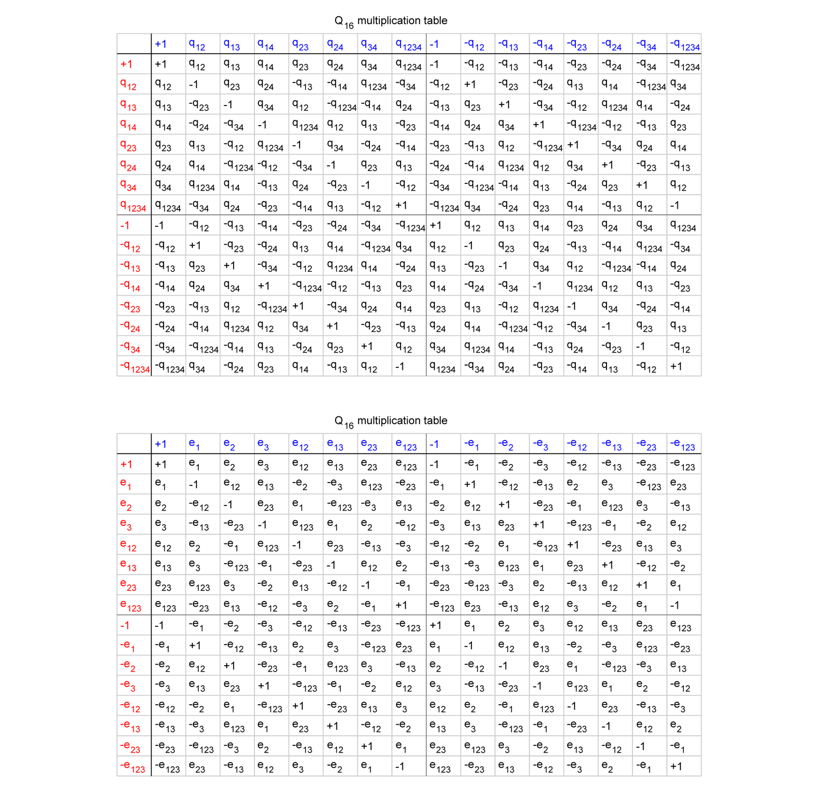

Table S2. Multiplication table of $Q_{16}$ group labelled with band-index.

Rotations in four-dimension
We briefly recall some facts about rotations in the four-dimension²⁻⁴. For each rotation $R$, there is at least one pair of orthogonal 2-planes (the 2-planes are also dubbed as invariant planes) - $A$ and $B$ which are invariant under the rotation $R$ and span the four-dimensional space, i.e. for any $\vec{a}∈A$ and $\vec{b}∈B$ we have $\vec{a}⊥\vec{b}$, $R\vec{a}∈A$ and $R\vec{b}∈B$. We define the angle between $\vec{a}$ and $R\vec{a}$ ($\vec{b}$ and $R\vec{b}$) in the 2-plane $A$ ($B$) as $α$ ($β$). As thus, four-dimensional rotations can be categorized into two types: simple rotations ($α=0$ and $β≠0$ or $α≠0$ and $β=0$) and double rotations ($α≠0$ and $β≠0$). When the two rotation angles satisfy $\left|α\right|=\left|β\right|$, the rotation $R$ is called isoclinic rotation, where there are infinitely many pairs of orthogonal 2-planes. Assuming that the coordinate set is ordered as $ouxyz$ with $o$ indicating the origin, we consider two 2-planes $A=oux$ and $B=oyz$ and set the rotation angle $α$ ($β$) positive from $ou$ to $ox$ ($oy$ to $oz$). Then isoclinic rotations with $αβ>0$ are denoted as left-isoclinic; those with $αβ<0$ as right-isoclinic. Note that the two cases with $\left|α\right|=\left|β\right|=0 or π$ are the only ones that are simultaneously left- and right-isoclinic. When the Bloch wave-vector runs across the 1D first Brillouin zone ($k=-π→π$), the rotation matrix $R\left(k\right)$ at each $k$ for each charge can be classified to be single or double rotations. The charges $±q_{1234}$ have to be realized via double rotations. In some ideal cases, $+/-q_{1234}$ consists of purely left/right-isoclinic rotations, where there are infinitely many pairs of orthogonal 2-planes. All the other charges can be ideally described by simple rotations.

It is well known that rotations can be encoded by quaternion ($H$) multiplication (discovered by Hamilton in 1843 and frequently used in engineering applications). For example, in three-dimension the rotation ${\vec{r}}_{3D}^{'}=R_{3D}{\vec{r}}_{3D}$ can be calculated with $r_{3D}^{'}=qr_{3D}q^{-1}$, where $q∈SU(2)$ being the unit quaternion and ${\vec{r}}_{3D} \& {\vec{r}}_{3D}^{'}∈R^{3}$ can be identified with the pure quaternion (no real part), i.e. $r_{3D} \& r_{3D}^{'}∈Im(H)$, respectively. Actually the calculation is made by a surjective homomorphism, $ρ:q∈SU\left(2\right)→R_{3D}∈SO(3)$, whose kernel is $\left\{1,-1\right\}$ indicting $SU(2)$ is a double cover of $SO(3)$. In four-dimension, we have similar forms like $r'=q_{L}rq_{R}$ where $q_{L,R}∈SU(2)$ and $r \& r'∈H$ are identified with $\vec{r} \& \vec{r}'∈R^{4}$, respectively. Likewise, a surjective homomorphism $ρ:\left(q_{L},q_{R}\right)∈SU\left(2\right)×SU\left(2\right)→R∈SO(4)$ with kernel being $\left\{\left(1,1\right),\left(-1,-1\right)\right\}$ also enables a double-cover. All above properties can be summarized as $Spin(N)$ is a double cover of $SO(N)$, and there are group isomorphisms $Spin\left(3\right)≅SU(2)$ and $Spin\left(4\right)≅SU\left(2\right)×SU\left(2\right)$.

Left/right isoclinic rotations are represented by left/right multiplication of unit quaternions. Thus, any rotation in four-dimension can be factorized into the commutative composition of two isoclinic rotations, i.e. $R=R_{q_{L}}R_{q_{R}}$. We denote $R_{q_{L}}\left(r\right)=q_{L}r$ with $q_{L}=a+bi+cj+dk$ and $r=u+xi+yj+zk$. Then,
$R_{q_{L}}\left(r\right)=\left(\begin{matrix}a & -b & -c & -d \\ b & a & -d & c \\ c & d & a & -b \\ d & -c & b & a\end{matrix}\right)\left(\begin{matrix}u \\ x \\ y \\ z\end{matrix}\right)$ (S11)
This is a left quaternion multiplication of $r$ by $q_{L}$. For a right quaternion multiplication, i.e. $R_{q_{R}}\left(r\right)=rq_{R}$. Assuming $q_{R}=p+qi+rj+sk$, we have,
$R_{q_{R}}\left(r\right)=\left(\begin{matrix}p & -q & -r & -s \\ q & p & s & -r \\ r & -s & p & q \\ s & r & -q & p\end{matrix}\right)\left(\begin{matrix}u \\ x \\ y \\ z\end{matrix}\right)$ (S12)
It is easy to see $R_{q_{L}}\left(R_{q_{R}}\left(r\right) \right)=R_{q_{R}}\left(R_{q_{L}}\left(r\right) \right)=q_{L}rq_{R}$ where quaternion multiplication is associative. Thus, the two isoclinic rotations are commutative.

Tight-binding model
The real-space Hamiltonian reads,
$H=\sum_{n}{\left(\begin{aligned}\sum_{\begin{aligned}X=A,B,C,D \\ Y=A,B,C,D\end{aligned}}{s_{XY}c_{X,n}^{†}c_{Y,n}}+ \\ \sum_{\begin{aligned}X=A,B,C,D \\ Y=A,B,C,D\end{aligned}}{v_{XY}c_{X,n}^{†}c_{Y,n+1}}+\sum_{\begin{aligned}X=A,B,C,D \\ Y=A,B,C,D\end{aligned}}{v_{XYl}c_{X,n}^{†}c_{Y,n+2}+h.c.}\end{aligned}\right)}$ (S13)
where $c_{X,n}^{†}$ and $c_{X,n}$ are creation and annihilation operators on the sub-lattice ‘$X$/$Y$’ and site ‘$n$’, respectively. Here, we consider a more general case having both the NN (nearest neighbour) and NNN (next-nearest neighbour) hoppings. After Fourier transformation we obtain,

$$H\left(k\right)=\left[\begin{matrix}s_{AA}+2v_{AA}\cos{k} & 2w_{AB}\sin{k} & 2w_{AC}\sin{k} & 2w_{AD}\sin{k} \\ 2w_{AB}\sin{k} & s_{BB}+2v_{BB}\cos{k} & 2w_{BC}\sin{k} & 2w_{BD}\sin{k} \\ 2w_{AC}\sin{k} & 2w_{BC}\sin{k} & s_{CC}+2v_{CC}\cos{k} & 2w_{CD}\sin{k} \\ 2w_{AD}\sin{k} & 2w_{BD}\sin{k} & 2w_{CD}\sin{k} & s_{DD}+2v_{DD}\cos{k}\end{matrix}\right] \\ +\left[\begin{matrix}2v_{AAl}\cos{2k} & 2w_{ABl}\sin{2k} & 2w_{ACl}\sin{2k} & 2w_{ADl}\sin{2k} \\ 2w_{ABl}\sin{2k} & 2v_{BBl}\cos{2k} & 2w_{BCl}\sin{2k} & 2w_{BDl}\sin{2k} \\ 2w_{ACl}\sin{2k} & 2w_{BCl}\sin{2k} & 2v_{CCl}\cos{2k} & 2w_{CDl}\sin{2k} \\ 2w_{ADl}\sin{2k} & 2w_{BDl}\sin{2k} & 2w_{CDl}\sin{2k} & 2v_{DDl}\cos{2k}\end{matrix}\right] \\ +\left[\begin{matrix}0 & s_{AB}+2r_{AB}\cos{k} & s_{AC}+2r_{AC}\cos{k} & s_{AD}+2r_{AD}\cos{k} \\ s_{AB}+2r_{AB}\cos{k} & 0 & s_{BC}+2r_{BC}\cos{k} & s_{BD}+2r_{BD}\cos{k} \\ s_{AC}+2r_{AC}\cos{k} & s_{BC}+2r_{BC}\cos{k} & 0 & s_{CD}+2r_{CD}\cos{k} \\ s_{AD}+2r_{AD}\cos{k} & s_{BD}+2r_{BD}\cos{k} & s_{CD}+2r_{CD}\cos{k} & 0\end{matrix}\right]$$$+\left[\begin{matrix}0 & 2r_{ABl}\cos{2k} & 2r_{ACl}\cos{2k} & 2r_{ADl}\cos{2k} \\ 2r_{ABl}\cos{2k} & 0 & 2r_{BCl}\cos{2k} & 2r_{BDl}\cos{2k} \\ 2r_{ACl}\cos{2k} & 2r_{BCl}\cos{2k} & 0 & 2r_{CDl}\cos{2k} \\ 2r_{ADl}\cos{2k} & 2r_{BDl}\cos{2k} & 2r_{CDl}\cos{2k} & 0\end{matrix}\right]$ (S14)
where we have set,
$$v_{AB(l)}=r_{AB(l)}+iw_{AB(l)}=v_{BA(l)} \\ v_{AC(l)}=r_{AC(l)}+iw_{AC(l)}=v_{CA(l)} \\ v_{AD(l)}=r_{AD(l)}+iw_{AD(l)}=v_{DA(l)} \\ v_{BC(l)}=r_{BC(l)}+iw_{BC(l)}=v_{CB(l)} \\ v_{BD(l)}=r_{BD(l)}+iw_{BD(l)}=v_{DB(l)}$$$v_{CD(l)}=r_{CD(l)}+iw_{CD(l)}=v_{DC(l)}$ (S15)

Table S3. Tight-binding coefficients of the ideal flat band models for different non-Abelian topological charges (charge $-1$ needs next nearing neighbour hoppings).
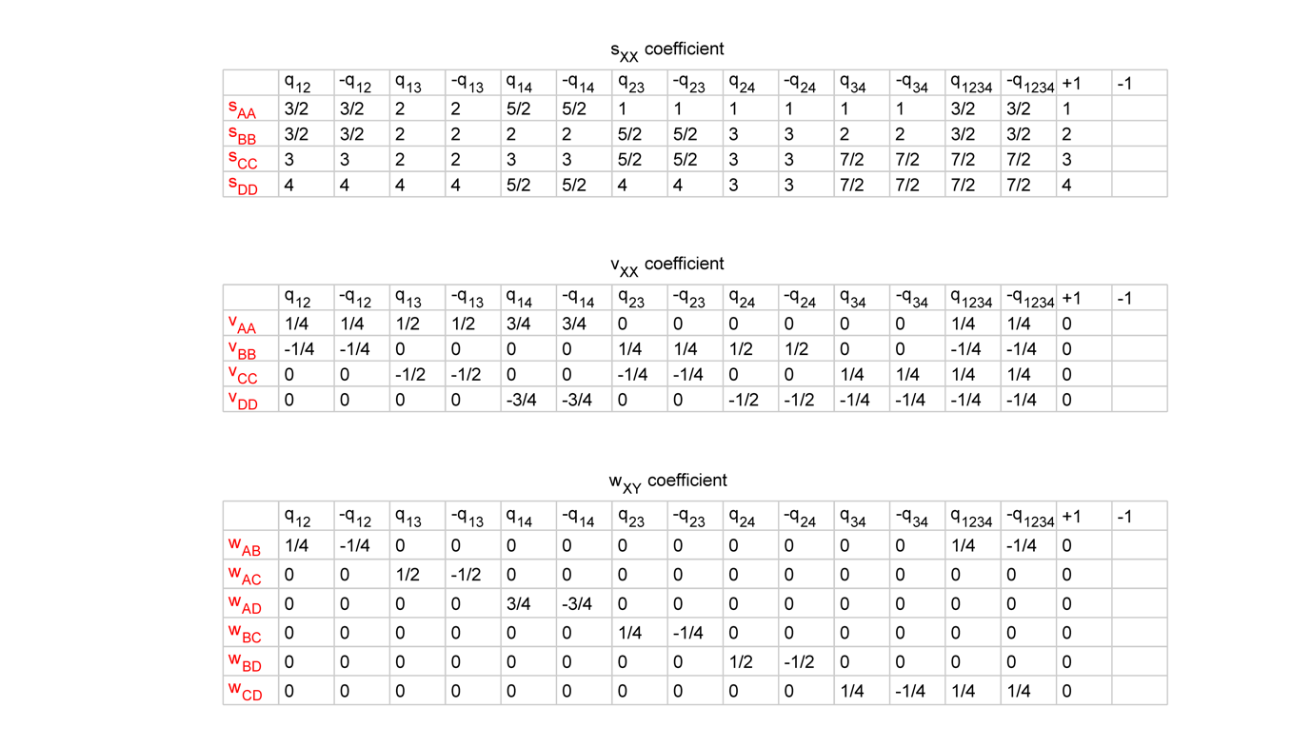

Table S4. Tight-binding coefficients of the ideal flat band models for different factorizations of charges $±q_{1234}$.
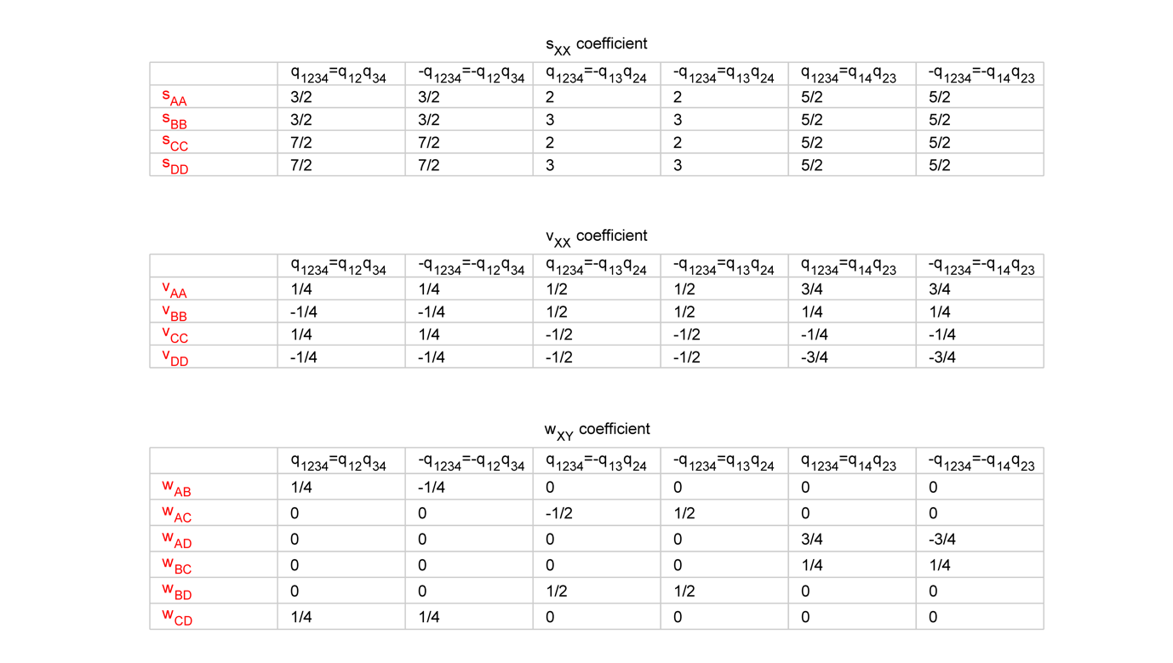

Table S5. Integer-valued tight-binding coefficients of the general simulation and experiment models for transmission line networks.
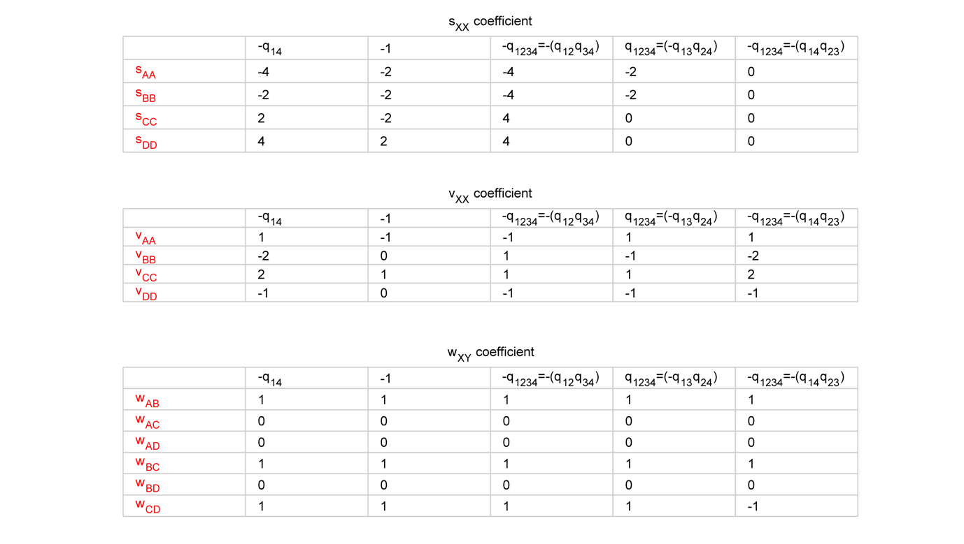

Analytical solutions of edge states for the flat-band models
Here we present an analytic method to find the exact solutions of edge states for the flat-band models. We consider the following five types: (i) Edge states of the charges $±q_{mn}$; (ii) Edge states of the charges $±q_{1234}$; (iii) Evolution of edge states of the charges $±q_{1234}$ between different factorizations; (iv) Edge states of the charge $-1$ represented by $q_{mn}^{2}$; (v) Evolution of edge states of the charge $-1$.

(i) Edge states of the charges ±q_{mn}
The 1D Hamiltonian corresponding to the above charges can be constructed as $H\left(k\right)=R\left(k\right)diag(1,2,3,4)R^{T}(k)$, where the rotation matrix $R\left(k\right)=e^{\frac{k}{2}L_{ij}}$ with $k=0→2π$ and$i,j=1,2,3,4.$ It should be noted that the choice of $e^{\frac{k}{2}L_{ij}}$ is different from the choice of $e^{\frac{k+π}{2}L_{ij}}$ with $k=-π→π$ (used in the main text). The eigen energy of edge states is independent of the choice. In order to find the edge states of the system, we rewrite $H\left(k\right)$ in the form of,
$H\left(k\right)=H_{11}+{H_{12}^{*}e^{-ik}+H}_{12}e^{ik}$ (S16)
Take the charge $q_{34}$ as an example. We have,
$H_{11}=\left(\begin{matrix}\begin{matrix}1 & 0 \\ 0 & 2\end{matrix} & \begin{matrix}0 & 0 \\ 0 & 0\end{matrix} \\ \begin{matrix}0 & 0 \\ 0 & 0\end{matrix} & \begin{matrix}\frac{7}{2} & 0 \\ 0 & \frac{7}{2}\end{matrix}\end{matrix}\right)$ (S17)
and,
$H_{12}^{*}=\frac{1}{4}\left(\begin{matrix}\begin{matrix}0 & 0 \\ 0 & 0\end{matrix} & \begin{matrix}0 & 0 \\ 0 & 0\end{matrix} \\ \begin{matrix}0 & 0 \\ 0 & 0\end{matrix} & \begin{matrix}-1 & -i \\ -i & 1\end{matrix}\end{matrix}\right)$ (S18)

In terms of the tight-binding model, the diagonal elements of $H_{11}$ describe the site energies and $H_{12}^{*}$ and $H_{12}$ describe the nearest-neighbour hoppings between two sites. Since all bulk modes are strongly localized in real space due to the fact that all bands are flat, it is natural to assume that the edge modes of the system are also strongly localized at the boundaries. For a system of $N$ sites, we use the following ansatz for the edge state wave functions: $Ψ_{L}={\left(a,b,c,d\right)}^{T}δ_{n,1}$ and $Ψ_{R}={\left(a^{'},b^{'},c^{'},d'\right)}^{T}δ_{n,N}$, for the left and right edge states, respectively. To study the edge state at the left end, we let N goes to infinity. Since the wave function vanishes for all sites except $n=1$, the only non-trivial equations of motion at sites $n=1$ and 2 we need to consider are $(H_{11}-{E)\left(a, b,c,d\right)}^{T}=0 and H_{12}^{*}{\left(a,b,c,d\right)}^{T}=0$, respectively. It is easy to see that the matrix $H_{12}^{*}$ is defective and there exists only one solution for the edge state: $Ψ_{L}={\left(0,0,1,i\right)}^{T}δ_{n,1}$ and $E=\frac{7}{2}$. Similarly, for the edge state at the right boundary, we find from the equations of motion at sites $n=N$ and $N-1$, i.e., $(H_{11}-{E)\left(a^{'},b^{'},c^{'},d^{'}\right)}^{T}=0$ and $H_{12}{\left(a^{'},b^{'},c^{'},d^{'}\right)}^{T}=0$, the solution $Ψ_{R}={\left(0,0,1,-i\right)}^{T}δ_{n,N}$ and $E=\frac{7}{2}$. Thus two edge states are degenerate and have their wave functions in complex conjugate pairs. This is the result of PT symmetry. In the following, we will only consider the left edge state. The method can be equally applied to all other $±q_{mn}$ charges in this subsection. For charge $-q_{34}$, we only need to replace $k$ by $-k$ in $H(k)$. Since the solutions found here satisfy the equations of motion for all sites, they are exact solutions. Here we do not concern with the normalization of the wave function.

(ii) Edge states of the charges ±q₁₂₃₄
This charge $q_{1234}$ can be factorized into three different configurations, i.e., $q_{12}q_{34},$ ${-q}_{13}q_{24}$ and $q_{14}q_{23}.$ The corresponding rotation matrices are $R(k)=e^{kL_{12}/2}e^{kL_{34}/2},$ $e^{-kL_{13}/2}e^{kL_{24}/2}$ and ${e^{{kL}_{14}/2}e}^{kL_{23}/2}$, respectively, from which we can obtain $H(k)$ for each configuration. By expressing $H(k)$ in terms of $H_{11}$ and $H_{12}^{*}$ and solving the equations of motion at the sites $n=1$ and 2, i.e., ${(H}_{11}-E){\left(a,b,c,d\right)}^{T}=0$ and $H_{12}^{*}{\left(a,b,c,d\right)}^{T}=0$, we find two edge states for each configuration, i.e., $E=\frac{3}{2}$ with $Ψ_{L}={\left(1,i,0,0\right)}^{T}δ_{n,1}$ and $E=\frac{7}{2}$ with $Ψ_{L}={\left(0,0, 1,i\right)}^{T}δ_{n,1}$ for the case of $q_{12}q_{34}$; $E=2$ with $Ψ_{L}={\left(1,0,-i,0\right)}^{T}δ_{n,1}$ and $E=3$ with $Ψ_{L}={\left(0,1, 0, i\right)}^{T}δ_{n,1}$ for the case of ${-q}_{13}q_{24}$; $E=\frac{5}{2}$ with $Ψ_{L}={\left(1,0,0,i\right)}^{T}δ_{n,1}$ and $E=\frac{5}{2}$ with $Ψ_{L}={\left(0,1,i,0\right)}^{T}δ_{n,1}$ for the case of${q_{14}q}_{23}.$

(iii) Evolution of edge states of the charges ±q₁₂₃₄ between different factorizations
Here we first consider the trajectory of edge states when the system is continuously transformed from one configuration to another one. There are three possible cases: (a) From $q_{12}q_{34}$to ${-q}_{13}q_{24}$; (b) From ${-q}_{13}q_{24}$ to $q_{14}q_{23}$; (c) From ${q_{14}q_{23} to q}_{12}q_{34}$.

For case (c), we consider two commuting hybrid generators $L_{a}=cosθL_{14}+\sin{θL_{12}}$ and $L_{b}=\cos{θ}L_{23}+\sin{θL_{34}}$, where the parameter $θ∈\left[0,\frac{π}{2}\right]$ describing the transition from ${{q_{14}q}_{23} to q}_{12}q_{34}.$From the corresponding rotation matrix ${R\left(k,θ\right)=e}^{kL_{a}/2}e^{kL_{b}/2}$, we obtain the Hamiltonian $H\left(k,θ\right)=R\left(k,θ\right)diag(1,2,3,4)R^{T}(k,θ)$ and the decomposed components:
$H_{11}=\left(\begin{matrix}\begin{matrix}2+\frac{1}{2}\cos{2θ} & 0 \\ 0 & 2+\frac{1}{2}\cos{2θ}\end{matrix} & \begin{matrix}\frac{1}{2}\sin{2θ} & 0 \\ 0 & -\frac{1}{2}\sin{2θ}\end{matrix} \\ \begin{matrix}\frac{1}{2}\sin{2θ} & 0 \\ 0 & -\frac{1}{2}\sin{2θ}\end{matrix} & \begin{matrix}3-\frac{1}{2}\cos{2θ} & 0 \\ 0 & 3-\frac{1}{2}\cos{2θ}\end{matrix}\end{matrix}\right)$ (S19)
$H_{12}^{*}=\frac{1}{4}\left(\begin{matrix}\begin{matrix}-2-cos{2θ} & -i\sin{θ} \\ -i\sin{θ} & -\cos{2θ}\end{matrix} & \begin{matrix}-\sin{2θ} & -3i\cos{θ} \\ -i\cos{θ} & \sin{2θ}\end{matrix} \\ \begin{matrix}-\sin{2θ} & -i\cos{θ} \\ -3i\cos{θ} & \sin{2θ}\end{matrix} & \begin{matrix}\cos{2θ} & -i\sin{θ} \\ -i\sin{θ} & 2+\cos{2θ}\end{matrix}\end{matrix}\right)$ (S20)
The matrix $H_{12}^{*}$ is partially defective and $H_{12}^{*}φ=0$has two eigenvectors, which can be chosen as $φ_{1}={\left(-i,\sin{θ},0,\cos{θ}\right)}^{T}$ and $φ_{2}={(-\sin{θ},-i,\cos{θ},0)}^{T}$. We write the edge state wave functions as $c_{1}φ_{1}+c_{2}φ_{2}$ and solve the equation ${(H}_{11}-E)(c_{1}φ_{1}+c_{2}φ_{2})=0$for E and $c_{1,2}$. We find the two edge states at energies $E^{±}=\frac{5}{2}±\sin{θ. }$ This result is shown in Fig. 3f. The corresponding wave functions are $Ψ_{L}^{±}=\left[∓i\sec{θ}φ_{1}-\sec{θ}φ_{2}\right]δ_{n,1}$. The edge state energies can also be obtained directly from the eigenvalues of $H_{11}$ without knowing the edge state wave functions. Similarly, we apply the same procedure to cases (a) and (b) and find the following trajectories of the edge state energies: $E^{±}=\frac{5}{2}±\frac{\sqrt{2}}{4}\sqrt{5+3\cos{2θ}}$ for case (a) and $E^{±}=\frac{5}{2}±\frac{1}{2}\cos{θ}$ for case (b). These results are plotted in Figs. 3d and 3e, respectively.

(iv) Edge states of the charge -1 represented by q_{mn}²
For the above cases, the rotation matrix becomes $R\left(k\right)=e^{kL_{ij}}$. We can simply replace $k$ in $H$(k) by $2k$ and rewrite it in the form of $H\left(k\right)=H_{11}+{H_{13}^{*}e^{-2ik}+H}_{13}e^{2ik}$. In the real space, such replacement represents a next-nearest neighbor hopping. For a finite chain with even number of sites, the tight-binding Hamiltonian becomes two disconnected sublattices, one with indices $n=1,3,5…N-1$ and the other with $n=2,4,6…N$. For the case of $q_{34}^{2}$, the matrices $H_{11}$ and $H_{13}^{*}$ are identical to those shown in Eqs. (S17) and (S18), respectively. From which we find one edge state at the left boundary per sublattice, i.e., $Ψ_{L1}={\left(0,0,1,i\right)}^{T}δ_{n,1}$ and $Ψ_{L2}={\left(0,0,1,i\right)}^{T}δ_{n,2}$ with the same eigen energy at $E=\frac{7}{2}$.

(v) Evolution of edge states of the charge -1
Here we consider the following three cases: (a) Transition from $q_{ij}^{2}$ to $q_{jk}^{ 2}$; (b) Edge state evolution involving the mixing of $q_{ij}^{2}$, $q_{jk}^{ 2}$ and $q_{ik}^{ 2}$ with rotation of eigenvectors in three bands; (c) Edge state evolution involving the mixing of $q_{ij}^{2}$, $q_{jk}^{ 2}$ and $q_{jl}^{ 2}$ with rotation of eigenvectors in four bands.

(a) Transition from $q_{ij}^{2}$ to $q_{jk}^{ 2}$
As an example, we consider a continuous transition from $q_{23}^{2}$ to $q_{12}^{2}.$ We choose a hybrid generator $L=\cos{t}L_{23}+\sin{t}L_{12}$ with $t∈\left[0,\frac{π}{2}\right].$ We obtain the Hamiltonian through $H\left(k,t\right)=R\left(k,t\right)diag\left(1,2,3,4\right)R^{T}\left(k,t\right)$and rewrite it in the form of,
$H\left(k,t\right)=H_{11}\left(t\right)+{H_{12}^{*}{\left(t\right)e}^{-ik}+H}_{12}\left(t\right)e^{ik}+{H_{13}^{*}{\left(t\right)e}^{-2ik}+H}_{13}\left(t\right)e^{2ik}$ (S21)
where,
$H_{11}\left(t\right)=\frac{1}{8}\left(\begin{matrix}-2\cos\left(2t\right)-3\cos\left(4t\right)+13 & 0 & -3\sin\left(4t\right) & 0 \\ 0 & 4\left(\cos\left(2t\right)+4\right) & 0 & 0 \\ -3\sin\left(4t\right) & 0 & -2\cos\left(2t\right)+3\cos\left(4t\right)+19 & 0 \\ 0 & 0 & 0 & 32\end{matrix}\right)$ (S22)
$H_{12}^{*}=-\frac{\sin\left(2t\right)}{2}\left(\begin{matrix}\sin\left(2t\right) & ⅈ\cos\left(t\right) & -\cos\left(2t\right) & 0 \\ ⅈ\cos\left(t\right) & 0 & ⅈ\sin\left(t\right) & 0 \\ -\cos\left(2t\right) & ⅈ\sin\left(t\right) & -\sin\left(2t\right) & 0 \\ 0 & 0 & 0 & 0\end{matrix}\right)$ (S23)
$H_{13}^{*}=\frac{\cos\left(2t\right)}{4}\left(\begin{matrix}\sin^{2}\left(t\right) & ⅈ\sin\left(t\right) & -\cos\left(t\right)\sin\left(t\right) & 0 \\ ⅈ\sin\left(t\right) & -1 & -ⅈ\cos\left(t\right) & 0 \\ -\cos\left(t\right)\sin\left(t\right) & -ⅈ\cos\left(t\right) & \cos^{2}\left(t\right) & 0 \\ 0 & 0 & 0 & 0\end{matrix}\right)$ (S24)
At $t=0$ or $\frac{π}{2},$ $H_{12}=0$ and the system reduces to two disconnected sublattices and$H_{13}$ describes the hopping elements within each sublattice. For a general value of $t$, $H_{12}$ couples two sublattices and it is natural to assume that an edge state occupies two sites at boundary, one from each sublattice. Thus, we use the edge state ansatz with the form of $Ψ_{L}=Φ_{1}δ_{n,1}+Φ_{2}δ_{n,2}$, where $Φ_{1}={\left(a,b,c,d\right)}^{T}$and ${Φ_{2}=\left(e,f,g,h\right)}^{T}$. Both the wave function and the edge state energy $E$ are to be determined through solving the equations of motion. Since the wave function vanishes for sites with $n>2$, we only need to consider the equations of motion of the four boundary sites, i.e.,
$\left(H_{11}-E\right)Φ_{1}+H_{12}Φ_{2}=0 (n=1)$ (S25)
$\left(H_{11}-E\right)Φ_{2}+H_{12}^{*}Φ_{1}=0 (n=2)$ (S26)
$H_{13}^{*}Φ_{1}+H_{12}^{*}Φ_{2}=0 (n=3)$ (S27)
$H_{13}^{*}Φ_{2}=0 (n=4)$ (S28)
Both the matrices $H_{13}^{*}$ and $H_{12}^{*}$ are defective. $H_{13}^{*}$ has two independent eigen vectors, which can be chosen as ${\left(\sin{t, i,-\cos{t,0}}\right)}^{T}$ and ${\left(\cos{t,0,\sin{t,0}}\right)}^{T}$. However, the matrix $H_{12}^{*}$ has only one coalesced eigenvector in the form of ${\left(\sin{t,i,-\cos{t},0}\right)}^{T}$. With these eigen vectors of $H_{13}^{*}$ and $H_{12}^{*}$, a simple edge state can be obtained immediately by choosing $Φ_{2}=0$ and $Φ_{1}={\left(\sin{t,i,-\cos{t},0}\right)}^{T}$, which satisfies Eqs. S25-28. Eigenvalue of such an edge state is determined from Eq. (S25). From the equation $\left(H_{11}-E\right)Φ_{1}=0$, we obtain the first solution of the edge state,
$E^{0}=2+\frac{1}{2}\cos{2t}$ (S29)
with,
$Ψ_{L}^{0}={\left(\sin{t,i,-\cos{t},0}\right)}^{T}δ_{n,1}$ (S30)
The other edge state solutions can be obtained by choosing $Φ_{2}={\left(\sin{t,i,-\cos{t,0}}\right)}^{T}$ and ${Φ_{1}=c\left(\cos{t,0,\sin{t},0}\right)}^{T}$ so that Eqs. (S27) and (S28) are satisfied automatically. The unknown function $c$ and the eigenvalue E are to be determined by solving Eqs. (S25) and (S26), from which we find two more edge states:
$E^{±}=\frac{1}{8}(16-2\cos{2t±\sqrt{2}\sqrt{17+\cos{4t}})}$ (S31)
with,
$Ψ_{L}^{±}=c_{±}{\left(\cos{t,0,\sin{t}},0\right)}^{T}δ_{n,1}+{\left(\sin{t, i,-\cos{t},0}\right)}^{T}δ_{n,2}$ (S32)
where $c_{±}=\frac{-4\sin{2t}}{3\cos{2t±\sqrt{9-\sin^{2}2t}}}$. Eqs. (S29) and (S31) are plotted in the Panel “From $q_{23}^{2}$ to $q_{12}^{2}$” of Fig. S10c with $θ_{23→12}=t$.

(b) Edge state evolution involving the mixing of $q_{ij}^{2}$, $q_{jk}^{ 2}$ and $q_{ik}^{ 2}$ with rotation of eigenvectors in three bands
Now we consider a more general case where the edge states form surfaces in a 2D parameter space. As an example, we consider a hybrid generator of the form:
$L =\cos{t L_{23}+\sin{t\cos{f}}L_{12}+\sin{t\sin{f}}L_{13}}$ (S33)
where the parameters $t, f∈\left[0,\frac{π}{2}\right].$ From the rotation matrix $R\left(k,t\right)=e^{kL}$, we obtain the Hamiltonian $H(k,t,f)$ and the decomposed components of $H_{11}$, $H_{12}^{*}$ and $H_{13}^{*}$. By solving Eqs. (S25-S28) we can obtain both the edge state energies and wave functions. However, the edge state energies can also be obtained from the roots of the determinant in Eqs. (S25) and (S26), i.e., det$\left(\begin{matrix}H_{11}-EI_{4} & H_{12} \\ H_{12}^{*} & H_{11}-EI_{4}\end{matrix}\right)=0$. From which, we find four pairs of degenerate eigen energies. Apart from the trivial one at $E=4$, the other three are edge state energies of the left and right edge states with the forms of,
$E^{0}=\frac{1}{16}\left(\cos\left(2f-2t\right)+\cos\left(2f+2t\right)-2\cos\left(2f\right)+6\cos\left(2t\right)+34\right)$ (S34)
$E^{±}=\frac{1}{32}\left(\begin{aligned}-\cos\left(2f-2t\right)-\cos\left(2\left(f+t\right)\right)+2\cos\left(2f\right)-6\cos\left(2t\right)+62± \\ \sqrt{8\cos\left(4f\right)\sin^{4}\left(t\right)-48\cos\left(2f\right)\sin^{2}\left(t\right)\left(\cos\left(2t\right)-5\right)+148cos⁡(2t)+19cos⁡(4t)+409}\end{aligned}\right)$(S35)
Eqs. (S34) and (S35) are plotted in the Fig. S11a, which shows three surfaces of edge states involving three bands only. Since these edge states do not involve the fourth band, Fig. S11a also describes the edge state evolution of the charge $-1$ in the 3-band model⁵ involving the mixtures of factorizations $i^{2}$, $j^{2}$and $k^{2}$.
It should be noted that Fig. S11a shows the edge state surfaces inside the triangle formed by $q_{12}^{2}$, $q_{23}^{ 2}$ and $q_{13}^{ 2}$ shown in Figs. S10a and b. At $f=0$, Eqs. (S34) and (S35) reduce to Eqs. (S29) and (S31), describing the edge state evolution from $q_{23}^{2}$ to $q_{12}^{2}$. At $t=\frac{π}{2}$, the parameter $f$ describes the evolution from $q_{12}^{2}$ to $q_{13}^{2}$ as can be seen from Eq. (S33). The above results reduce to,
$E^{0}=\frac{1}{4}\left(7-\cos\left(2f\right)\right)$ (S36)
$E^{±}=\frac{1}{8}\left(17+\cos\left(2f\right)±\sqrt{2}\cos{f}\sqrt{\cos\left(2f\right)+17}\right)$ (S37)
Eqs. (S36) and (S37) are plotted in the Panel “From $q_{12}^{2}$ to $q_{13}^{2}$” of Fig. S10c with $θ_{12→13}=f$.

At $f=\frac{π}{2}$, the parameter $t$ describes the evolution from $q_{23}^{2}$ to $q_{13}^{2}$ as can be seen from Eq. (S33). Eqs. (S34) and (S35) reduce to,
$E^{0}=\frac{1}{4}(9+cos⁡(2t))$ (S38)
$E^{±}=\frac{1}{8}\left(15-\cos\left(2t\right)±\sqrt{2}\cos{t}\sqrt{\cos\left(2t\right)+17}\right)$ (S39)
Eqs. (S38) and (S39) are plotted in the Panel “From $q_{23}^{2}$ to $q_{13}^{2}$” of Fig. S10c with $θ_{23→13}=t$. It should be noted the same analytic method can be applied to all edges of the regular octahedron as shown in Figs. S10a and b. It can also be used to obtain the 3D maps of edge state surfaces resulting from the mixing of $q_{ij}^{2}$, $q_{jk}^{ 2}$ and $q_{ik}^{2}$ for any three bands $i$, $j$ and $k$.

(c) Edge state evolution involving the mixing of $q_{ij}^{2}$, $q_{jk}^{ 2}$ and $q_{jl}^{ 2}$ with rotation of eigenvectors in four bands
Finally, we consider a hybrid generator of the form,
$L=\cos{t}L_{12}+\sin{t}\cos{f}L_{13}+\sin{t}\sin{f}L_{14}$ (S40)
where$t, f∈\left[0,\frac{π}{2}\right]$. Different from case (b), Eq. (S40) now produces the edge state surfaces inside the triangle formed by $q_{12}^{2}$, $q_{13}^{ 2}$ and $q_{14}^{ 2}$ highlighted in the Figs. S10a and b, in which all four bands are involved. By using the same procedure of case (b), we obtain the four edge state surfaces as shown in Fig. S11b, which fits well with the numerical results shown in Fig. S10d. One of the four surfaces has the form of,
$E^{0}=\frac{1}{16}\left(\cos\left(2\left(f-t\right)\right)+\cos\left(2\left(f+t\right)\right)-2\cos\left(2f\right)-6\cos\left(2t\right)+30\right)$ (S41)
The other three ones are complex as the roots of a cubic equation.

Thus, the method can be used to obtain the edge states inside every face triangle of the regular octahedron as shown in the Figs. S10a and b. The number of edge state surfaces depends on the number of bands involved.

Experimental methods
There are four meta-atoms A, B, C and D in one unit-cell. The hoppings between two meta-atoms are realized by connecting 2-m-long coaxial cables (model: RG58C/U). To achieve the complex hoppings, we create a hidden dimension by placing four nodes in each meta-atom so that four subspaces are allowed. Due to periodic connections in this hidden dimension, the four subspaces correspond to four pseudo angular momenta that are $exp⁡(i4φ_{n})=1$, with $φ_{1}=0,φ_{2}=\frac{π}{2},φ_{3}=π and φ_{4}=-π/2$. Through the specific excitation from a 4-channel signal generator (Keysight M3201A), we carried out our experiments in the $φ_{2}=π/2$ subspace. The amplitude and phase of voltage of each meta-atom are probed by an oscilloscope (Keysight DSOX2002A). After subsequent Fourier transformation, we obtain the energy bands and eigenstates in the momentum space. Figure S13 shows the specific transmission line network corresponding to charges $±q_{14}$.

Reference:
1 Wu, Q., Soluyanov, A. A. & Bzdušek, T. Non-Abelian band topology in noninteracting metals. Science 365, 1273, doi:10.1126/science.aau8740 (2019).
2 Perez-Gracia, A. & Thomas, F. On Cayley’s Factorization of 4D Rotations and Applications. Advances in Applied Clifford Algebras 27, 523-538, doi:10.1007/s00006-016-0683-9 (2017).
3 Le Bihan, N. The geometry of proper quaternion random variables. Signal Processing 138, 106-116, doi:https://doi.org/10.1016/j.sigpro.2017.03.017 (2017).
4 Erdoğdu, M. & Özdemir, M. Simple, Double and Isoclinic Rotations with a Viable Algorithm. Mathematical Sciences and Applications E-Notes, 8 (1), 11-24, doi:10.36753/mathenot.642208 (2020).
5 Guo, Q. et al. Experimental observation of non-Abelian topological charges and edge states. Nature 594, 195-200, doi:10.1038/s41586-021-03521-3 (2021).

Supplementary Figures

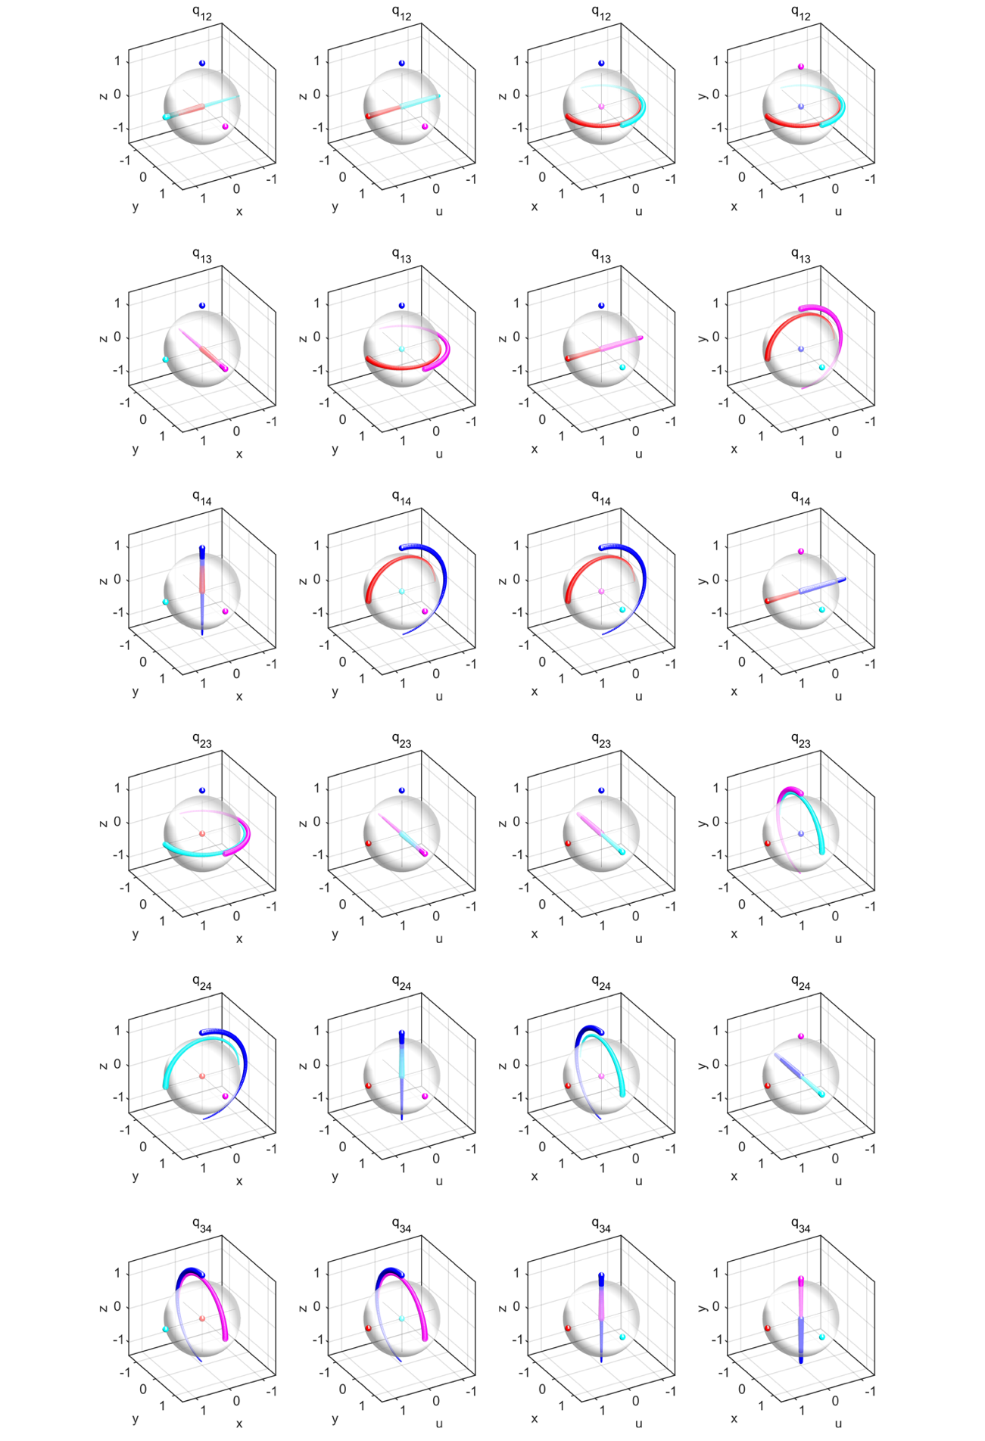
Figure S1. Trajectories of eigenstates of charges $q_{mn}$ orthographically projected onto four solid spheres in $R^{3}$. The colours (red, cyan, magenta, blue) correspond to the (first, second, third, fourth) bands. The direction of line-width decreasing indicates $k=-π→π$.

Figure S2. Trajectories of eigenstates of charges $±q_{1234}$ orthographically projected onto four solid spheres in $R^{3}$. We factorize the charge $q_{1234}$ into three configurations: $q_{1234}=q_{12}q_{34}$, $q_{1234}=-q_{13}q_{24}$ and $q_{1234}=q_{14}q_{23}$. The colours (red, cyan, magenta, blue) correspond to the (first, second, third, fourth) bands. The direction of line-width decreasing indicates $k=-π→π$.

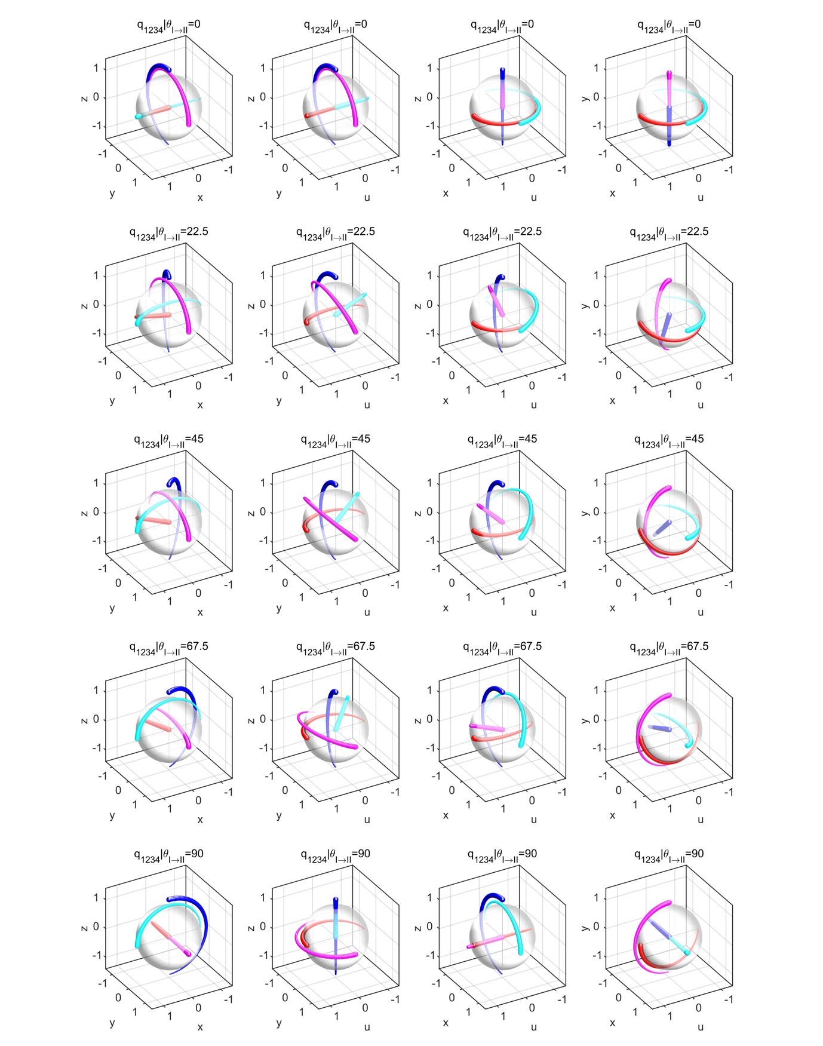
Figure S3. Trajectories of eigenstates of charge $q_{1234}$ orthographically projected onto four solid spheres in $R^{3}$. We continuously rotate the charge $q_{1234}$ from the configuration $q_{1234}=q_{12}q_{34}$ to $q_{1234}=-q_{13}q_{24}$, where the parameter $θ_{I→II}$ is defined as, $L_{a}=\cos{θ_{I→II}}L_{12}-\sin{θ_{I→II}}L_{13} and L_{b}=\cos{θ_{I→II}}L_{34}+\sin{θ_{I→II}}L_{24}$. The Hamiltonian can be written as $H=\exp\left(\frac{k_{π}}{2}L_{b}\right)\exp\left(\frac{k_{π}}{2}L_{a}\right)I_{1234}\exp\left(-\frac{k_{π}}{2}L_{a}\right)\exp\left(-\frac{k_{π}}{2}L_{b}\right)$ with $k_{π}=k+π$. The colours (red, cyan, magenta, blue) correspond to the (first, second, third, fourth) bands. The direction of line-width decreasing indicates $k=-π→π$.

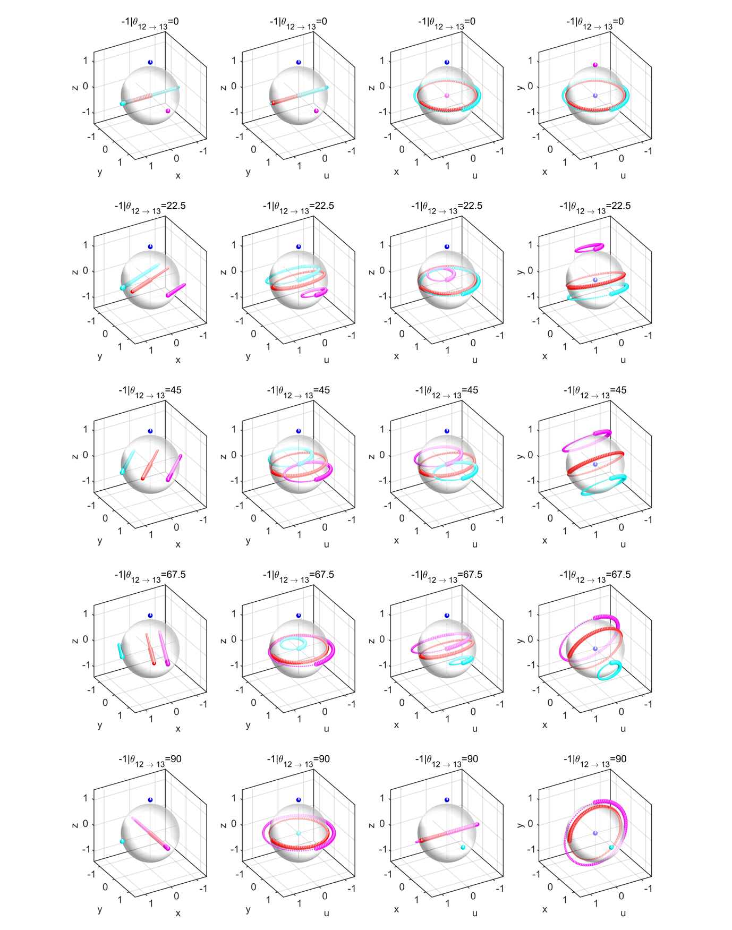
Figure S4. Trajectories of eigenstates of charge $-1$ orthographically projected onto four solid spheres in $R^{3}$. We continuously rotate the charge $-1$ from the configuration $-1=q_{12}^{2}$ to $-1=-q_{13}^{2}$, where the parameter $θ_{12→13}$ is defined as, $L=\cos{θ_{12→13}}L_{12}+\sin{θ_{12→13}}L_{13}$. The Hamiltonian can be written as $H=\exp\left(k_{π}L\right)I_{1234}\exp\left(-k_{π}L\right)$ with $k_{π}=k+π$. The colours (red, cyan, magenta, blue) correspond to the (first, second, third, fourth) bands. The direction of line-width decreasing indicates $k=-π→π$.

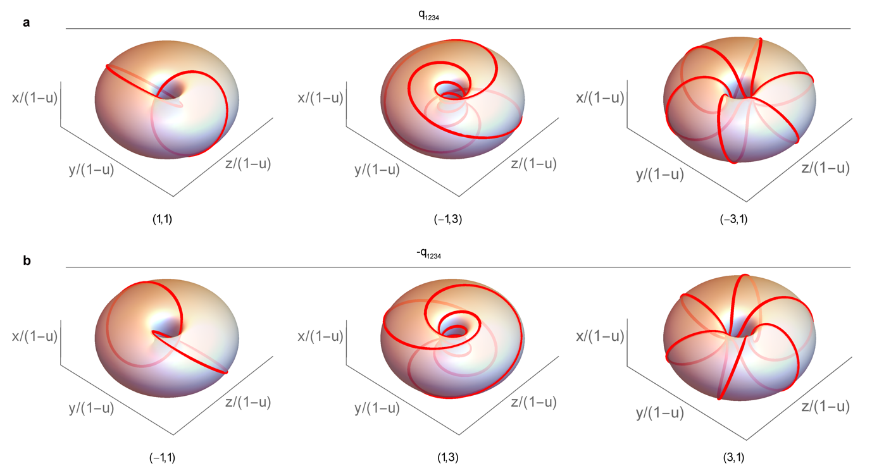
Figure S5. Stereographically projected Clifford tori in $R^{3}$, i.e. $\left(u,x,y,z\right)→\left(\frac{x}{1-u},\frac{y}{1-u},\frac{z}{1-u}\right)$. The index $\left(m,n\right)$ indicates the eigenstates rotate $mπ$ and $nπ$ on the $oux$ and $oyz$ planes, respectively. a, The three cases corresponding to charge $+q_{1234}$, they can be continuously transformed into each other. b, The opposite rotation senses corresponding to charge $-q_{1234}$.

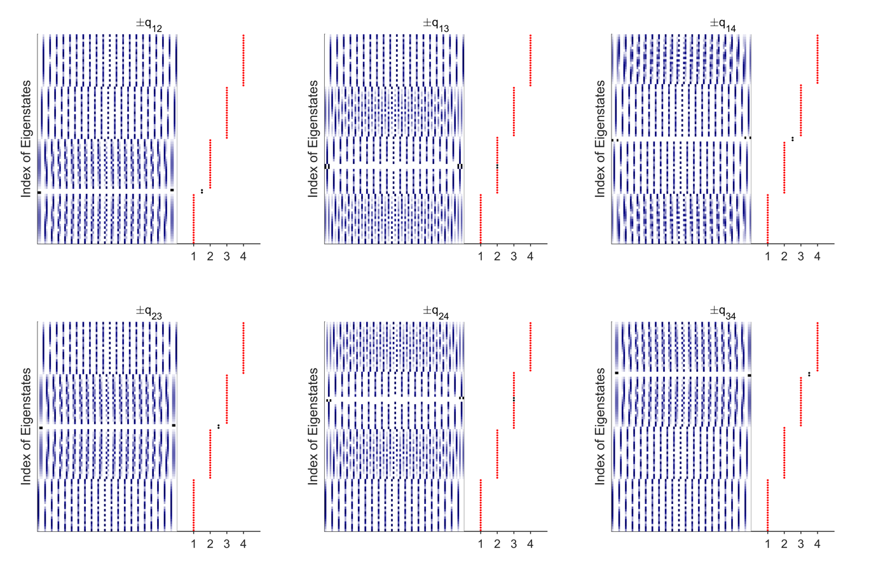
Figure S6. Edge state distributions at the hard boundaries of a finite lattice for charges $±q_{mn}$ of flat band models.

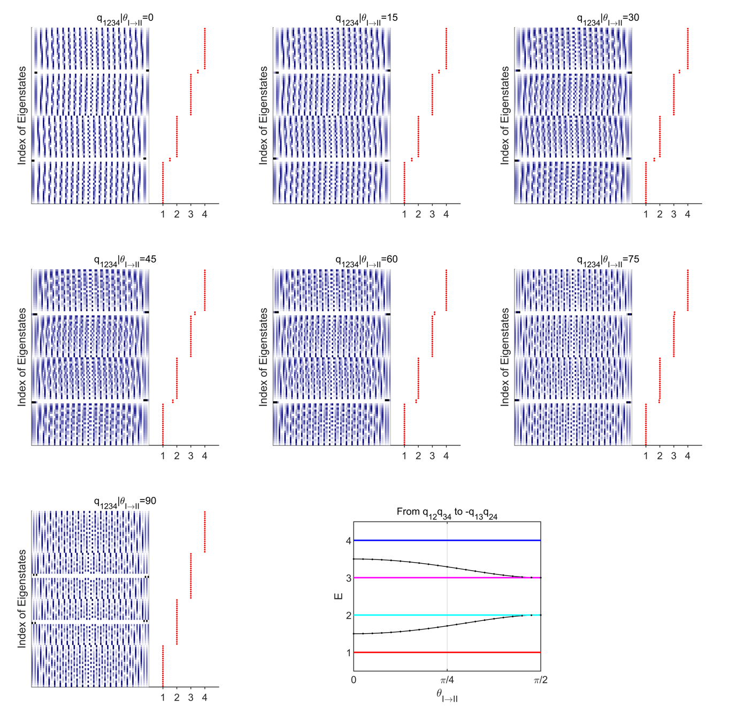
Figure S7. Evolution of edge state distributions for charge $q_{1234}$ from the factorization of $q_{1234}=q_{12}q_{34}$ to $q_{1234}=-q_{13}q_{24}$, parametrized by $θ_{I→II}$ with unit of degrees. Lines/dots indicate numerical/analytical results.

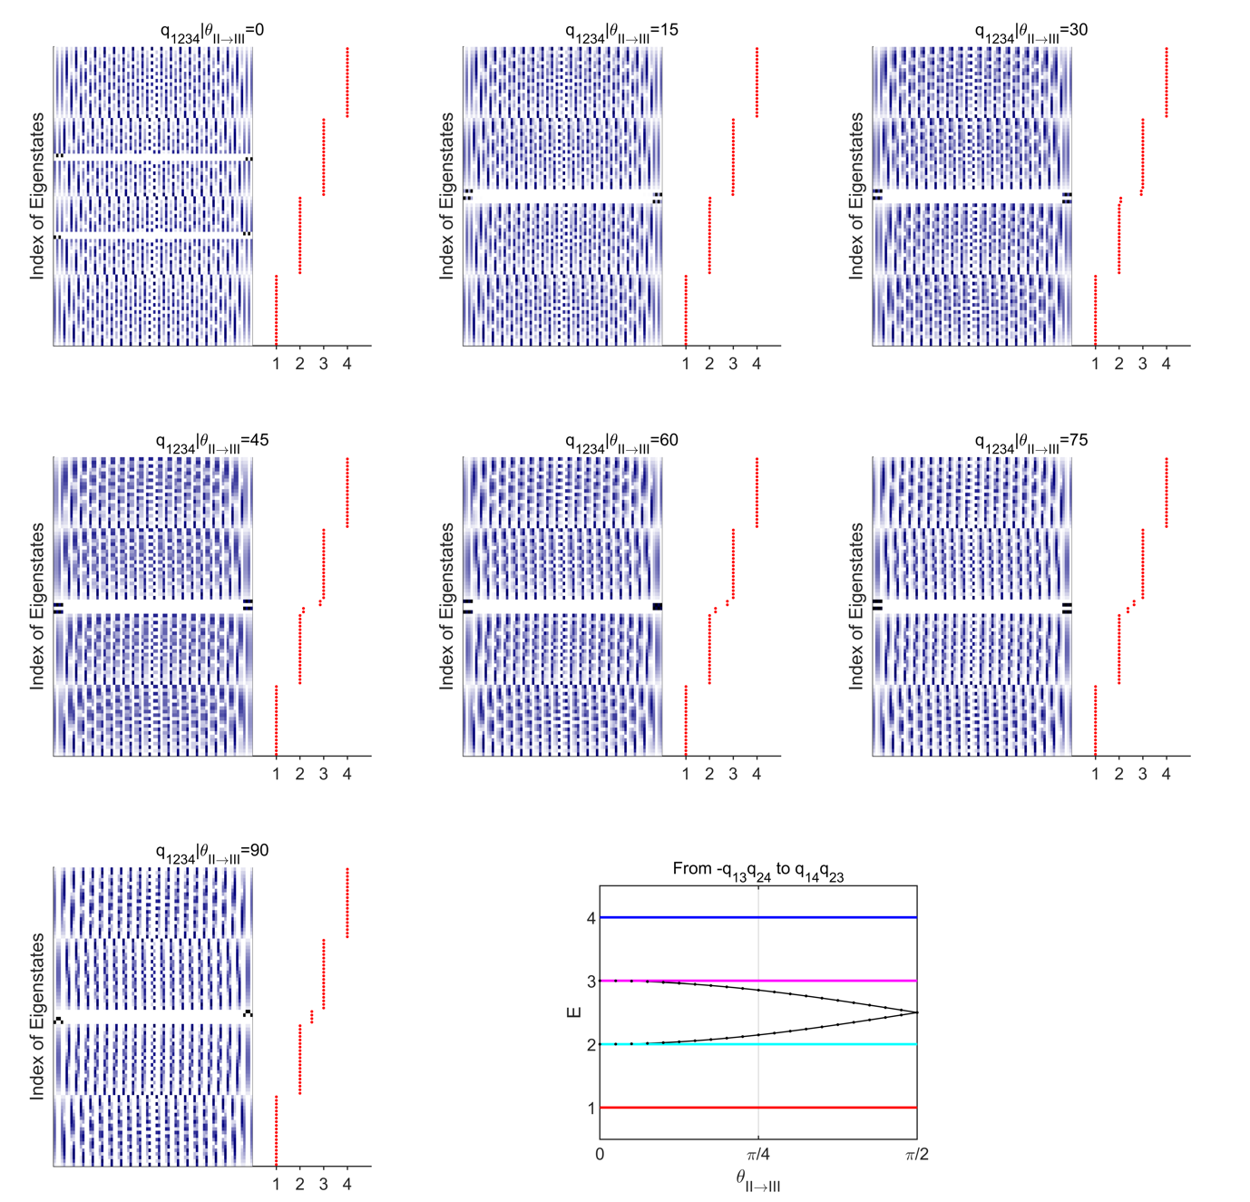
Figure S8. Evolution of edge state distributions for charge $q_{1234}$ from the factorization of $q_{1234}=-q_{13}q_{24}$ to $q_{1234}=q_{14}q_{23}$, parametrized by $θ_{II→III}$ with unit of degrees. Lines/dots indicate numerical/analytical results.

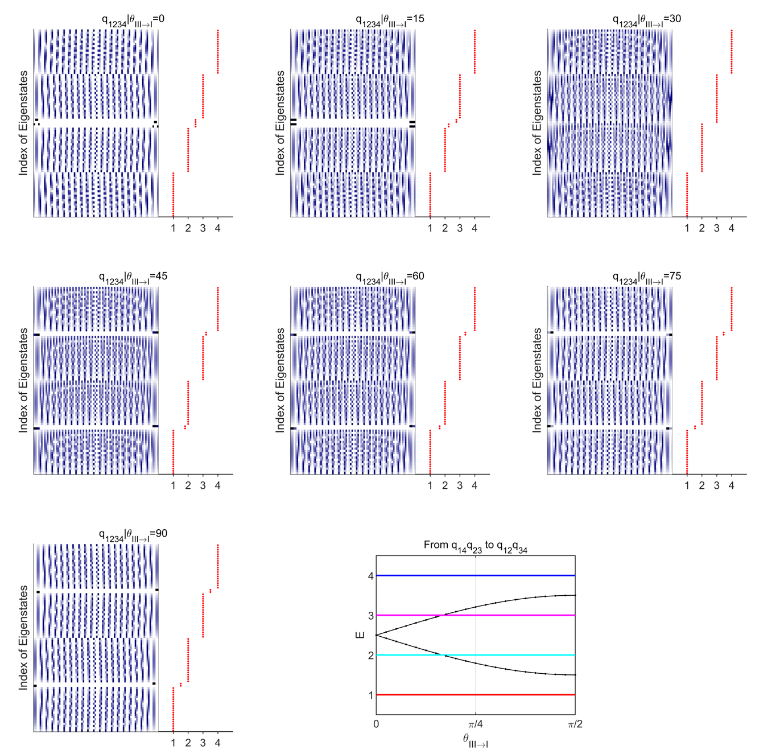
Figure S9. Evolution of edge state distributions for charge $q_{1234}$ from the factorization of $q_{1234}=q_{14}q_{23}$ to $q_{1234}=q_{12}q_{34}$, parametrized by $θ_{III→I}$ with unit of degrees. Lines/dots indicate numerical/analytical results.

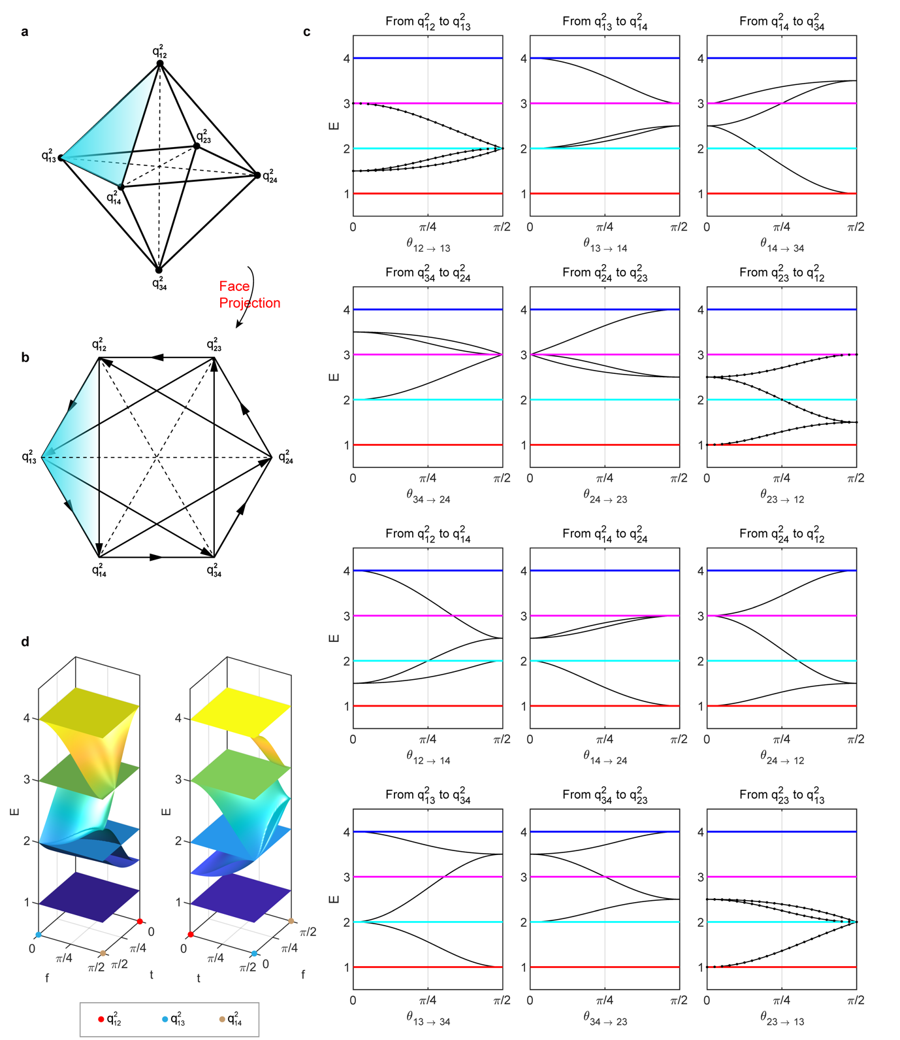
Figure S10. Evolution of edge state distributions for charge $-1$. a, All possible factorizations of charge $-1$ illustrated on a regular octahedron. b, Orthogonal projection centred by face. There are 12 possible transitions, the direct transition (dashed lines) between one pair of diagonal points is not allowed as they are located on two orthogonal planes, i.e. $q_{12}^{2}⇎q_{34}^{2}$. c, Evolution of edge state distributions along 12 edges of the regular octahedron. d, Evolution of edge state distributions on one face (with vertices $q_{12}^{2},q_{13}^{2} and q_{14}^{2}$) of the regular octahedron. Lines/dots indicate numerical/analytical results.
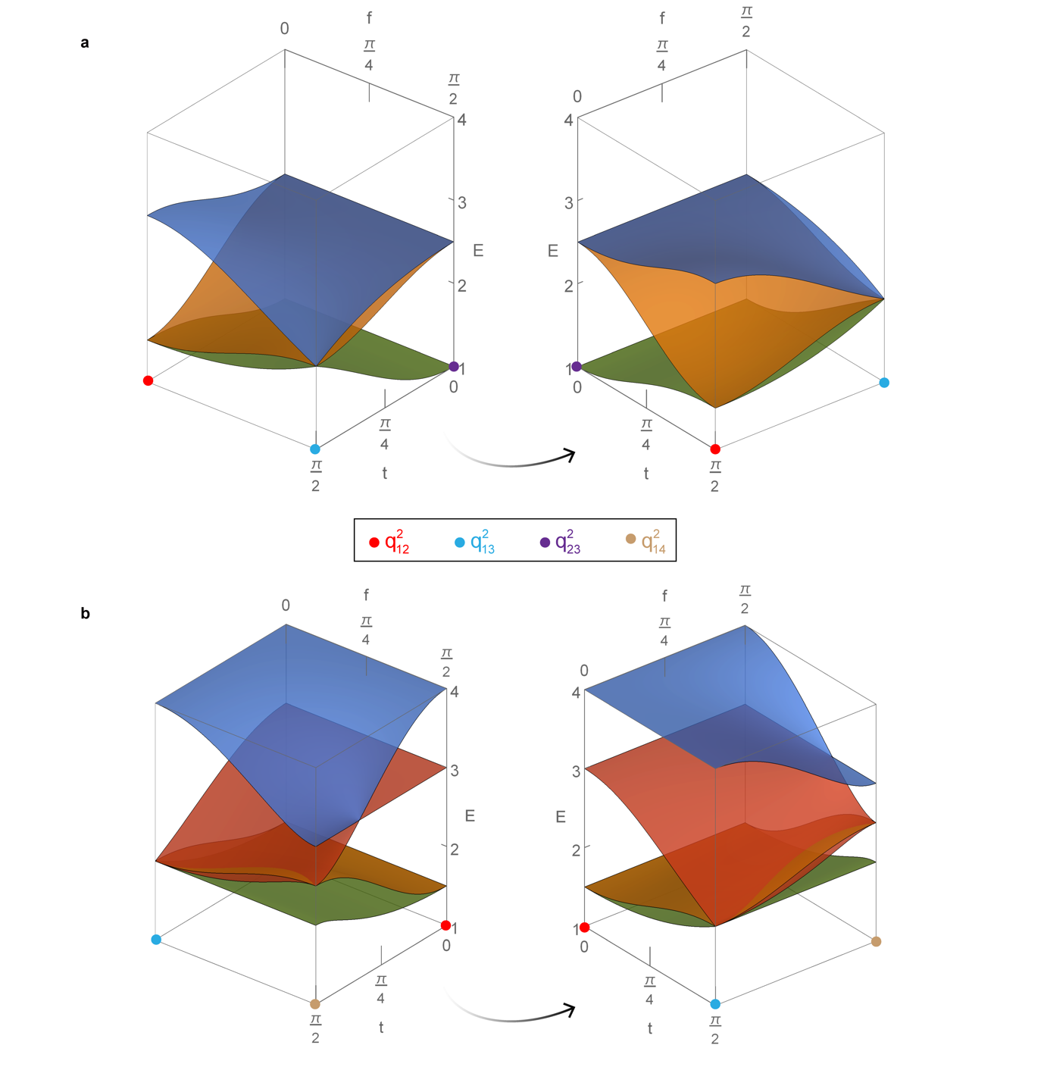
Figure S11. Analytical edge state surfaces. a, Edge state surfaces on the triangle face of $(q_{12}^{2},q_{13}^{2},q_{23}^{2})$ involving three bands. b, Edge state surfaces on the triangle face of $(q_{12}^{2},q_{13}^{2},q_{14}^{2})$ involving four bands.

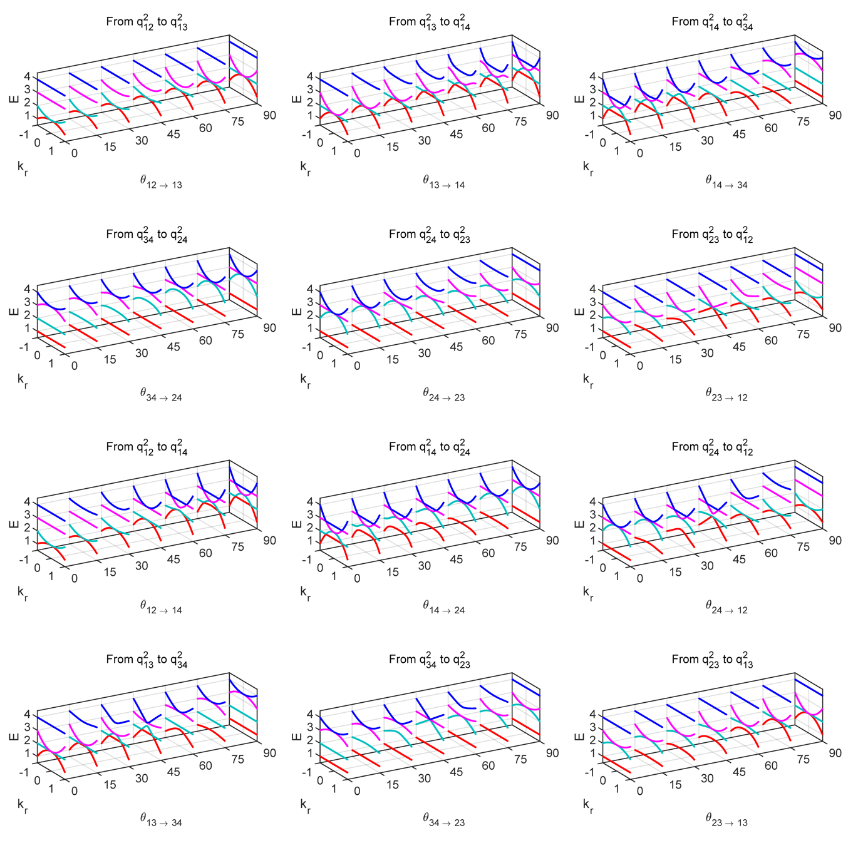
Figure S12. The evolution of radial cuts $E(k_{r})$ of the extended two-dimensional bands between different factorizations of charge $-1$. The point degeneracies at $k_{r}=0$ can be topologically related to the edge states of the 1D systems shown in Fig. S10. The other degeneracies ($k_{r}≠0$) are accidental without topological meaning.
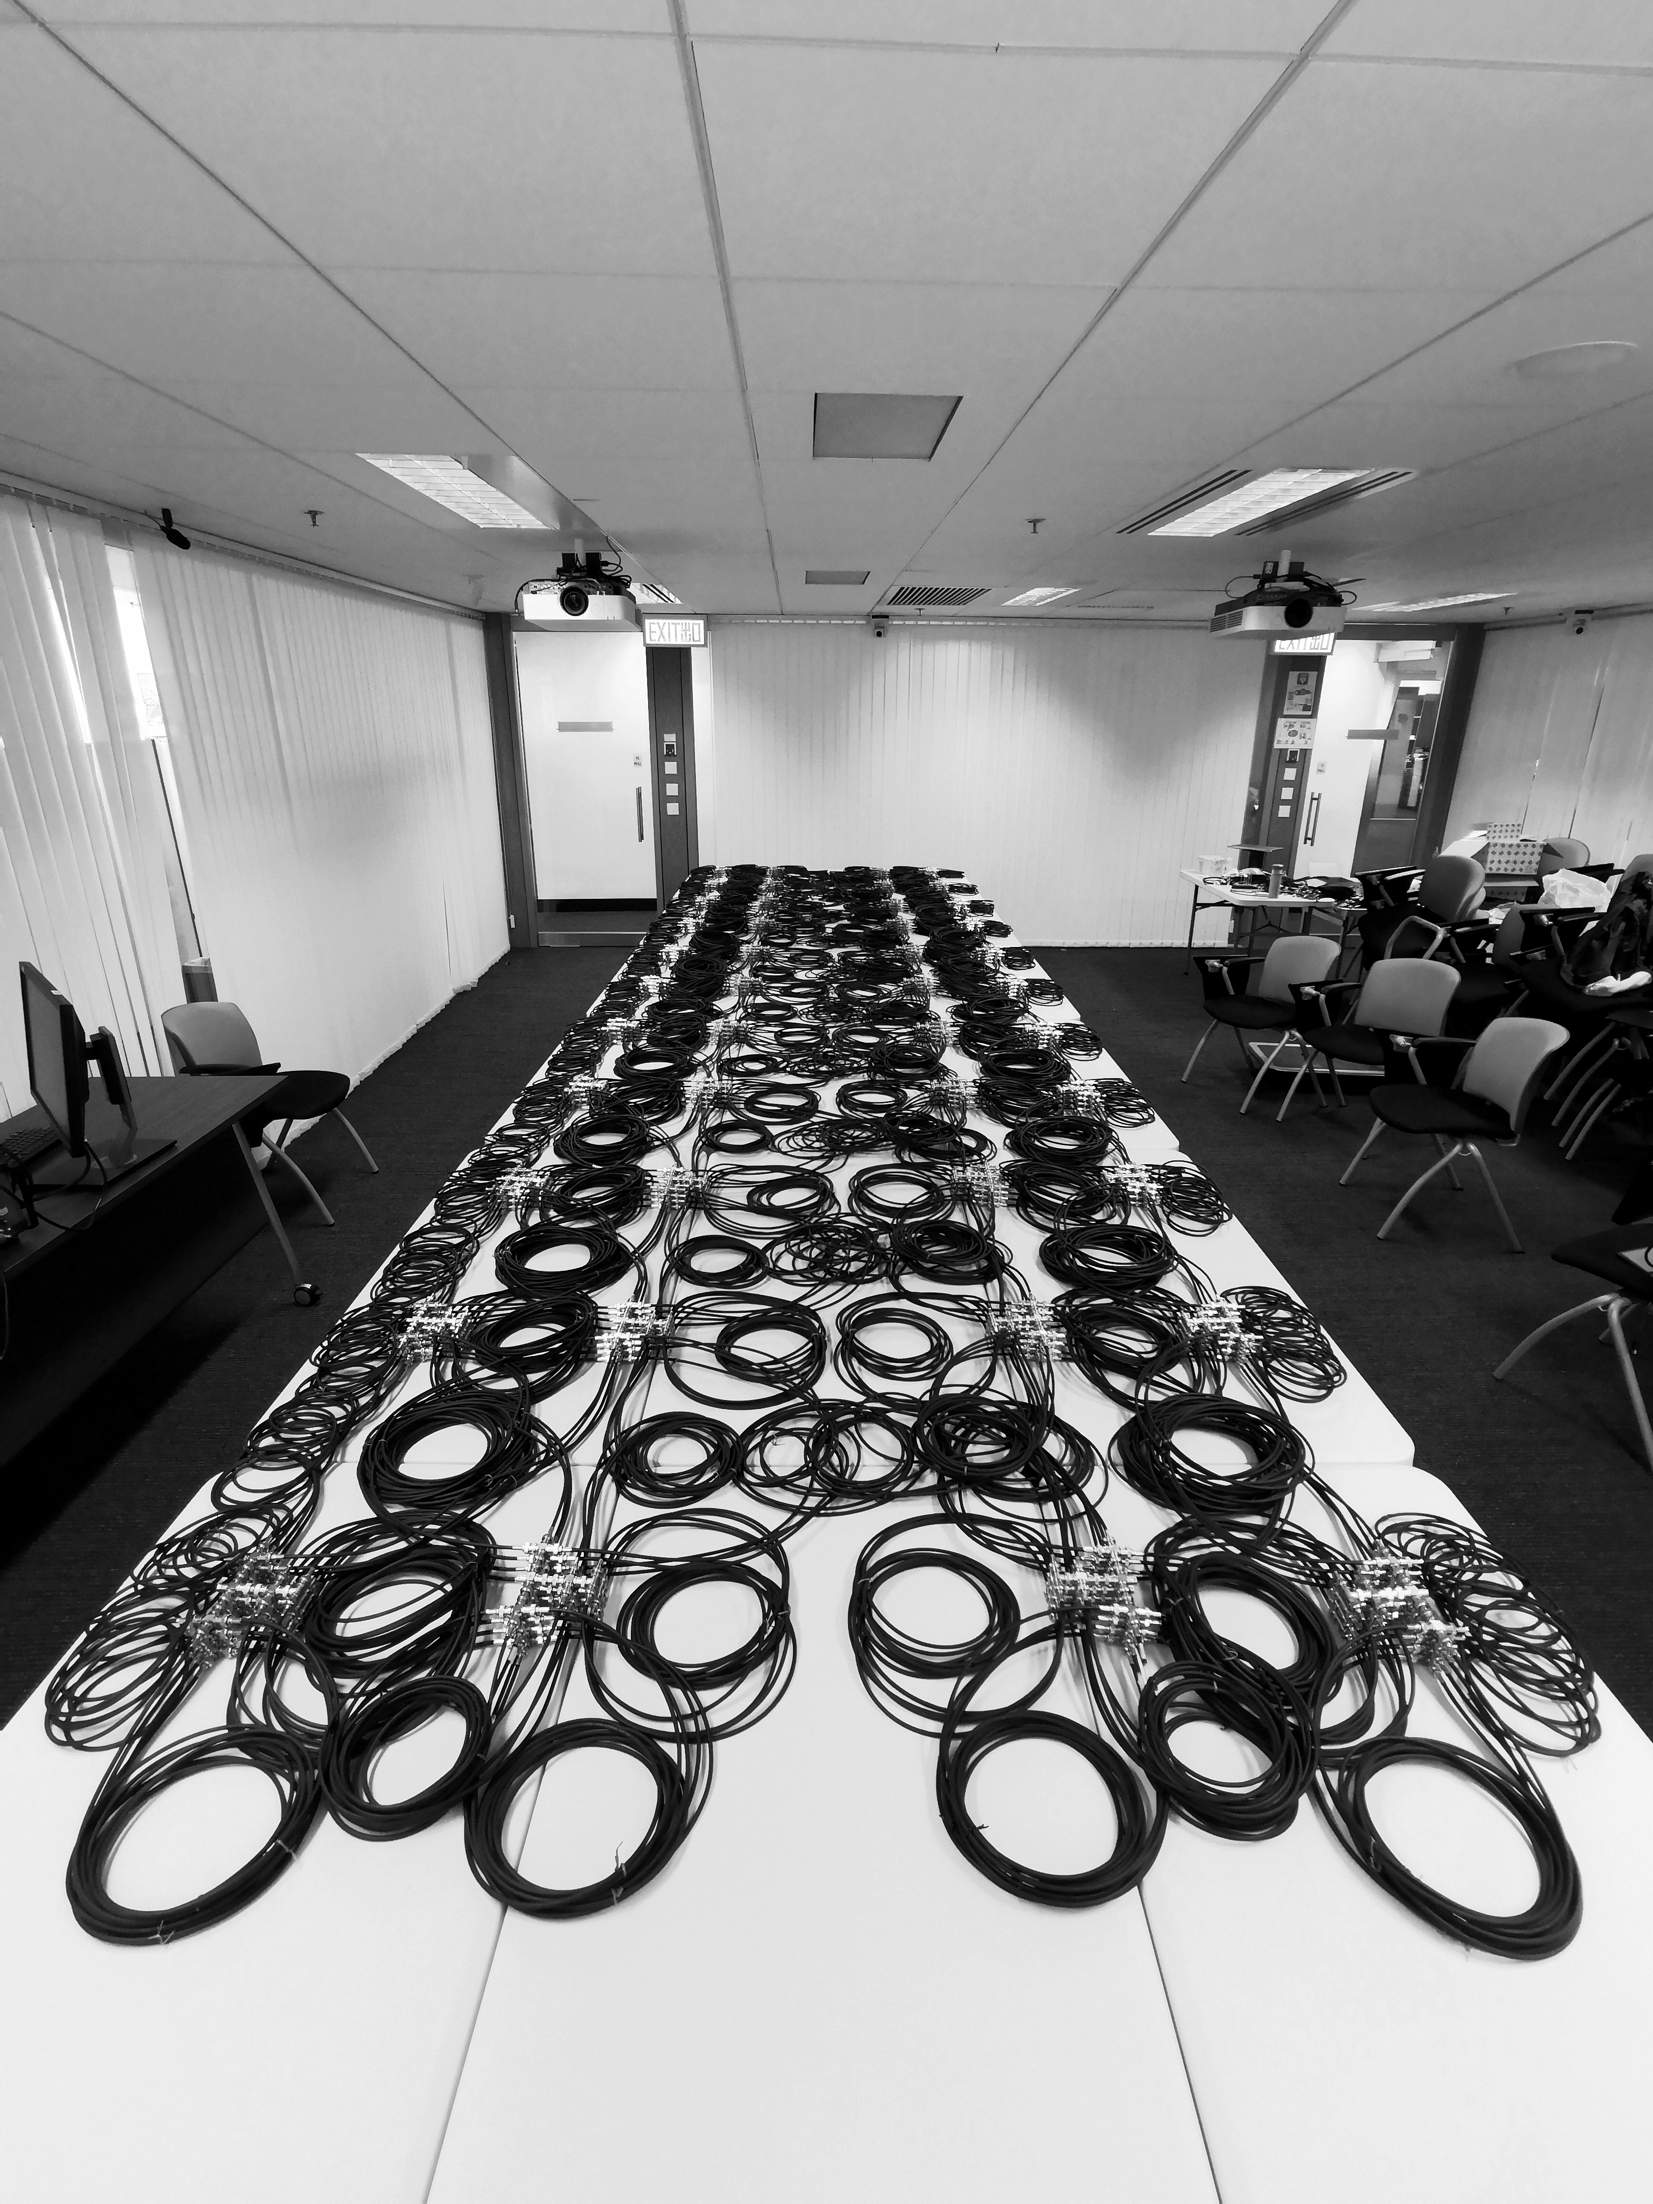
Figure S13. Transmission line network constructed for charges $±q_{14}$, where around 880 coaxial cables are used.

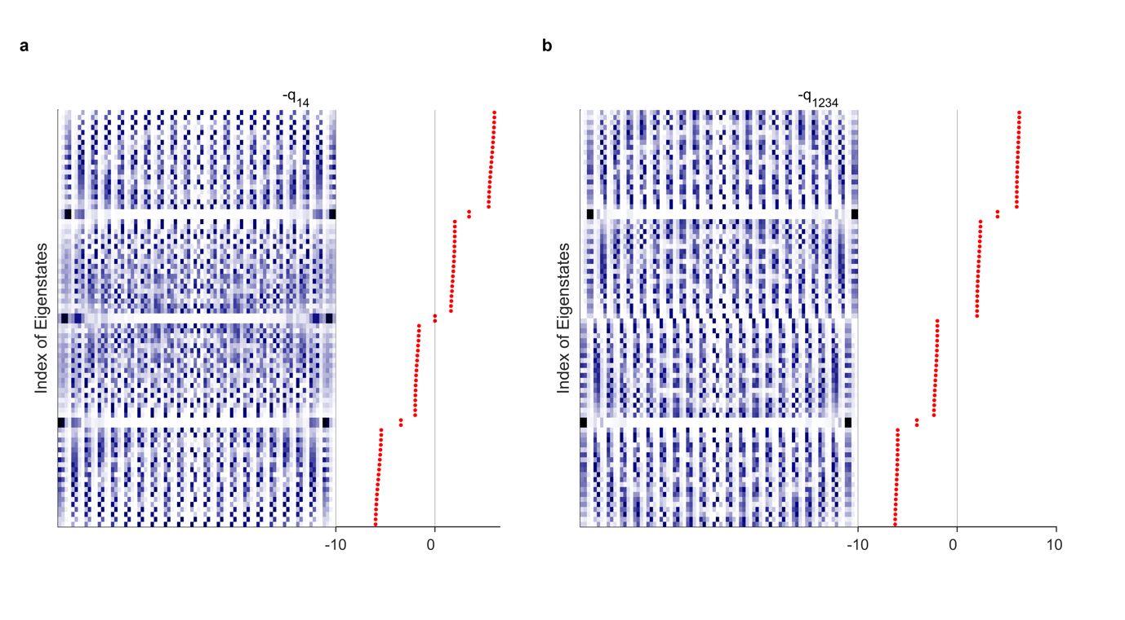Figure S14. Distribution of hard boundary edge states for charges $±q_{14}$(a) and $-q_{1234}=-q_{12}q_{34}$(b). Detailed parameters are listed in Table S5.

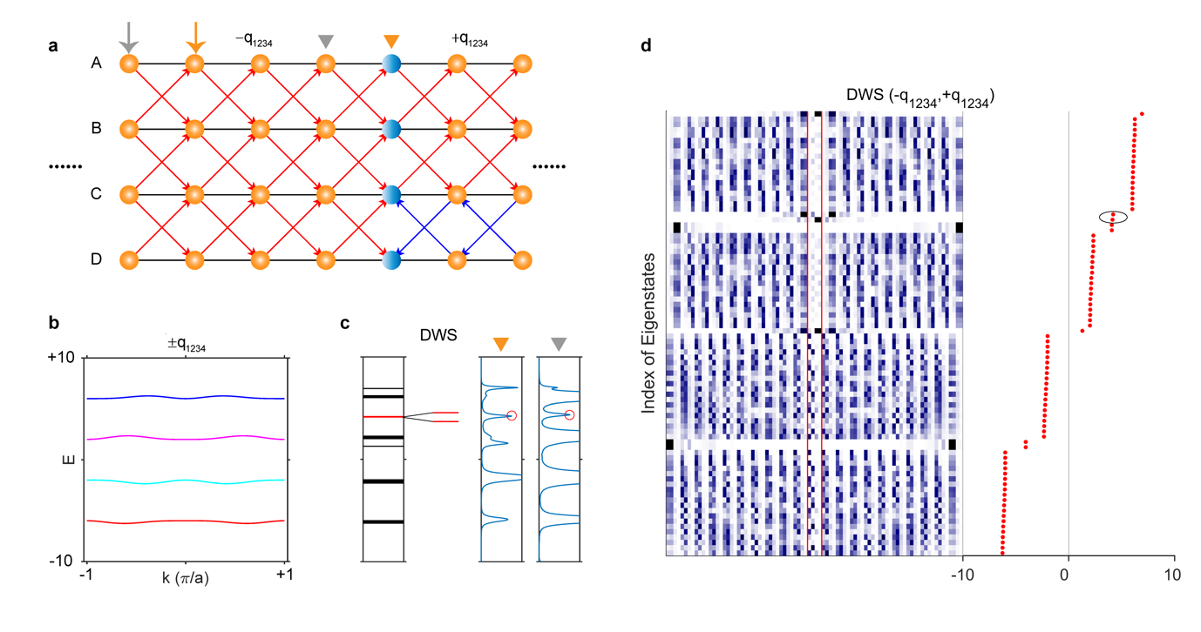
Figure S15. Construction of domain-wall (blue spheres in panel a) and distribution of domain-wall states (DWS) indicated by the black ellipse in panel (d). Panels (a) and (c) are copied from the main text (Fig. 4) for comparison purpose. b, Bulk states of $±q_{1234}$, they are overlapped. Detailed parameters are listed in Table S5 (see the column of $-q_{12}q_{34}$). For charge $q_{1234}$, we set $w_{CD}=-1$. We say that one domain-wall state locating in the second bandgap and another one with energy beyond the bulk spectrum are induced by the domain-wall construction, and thus topologically trivial.

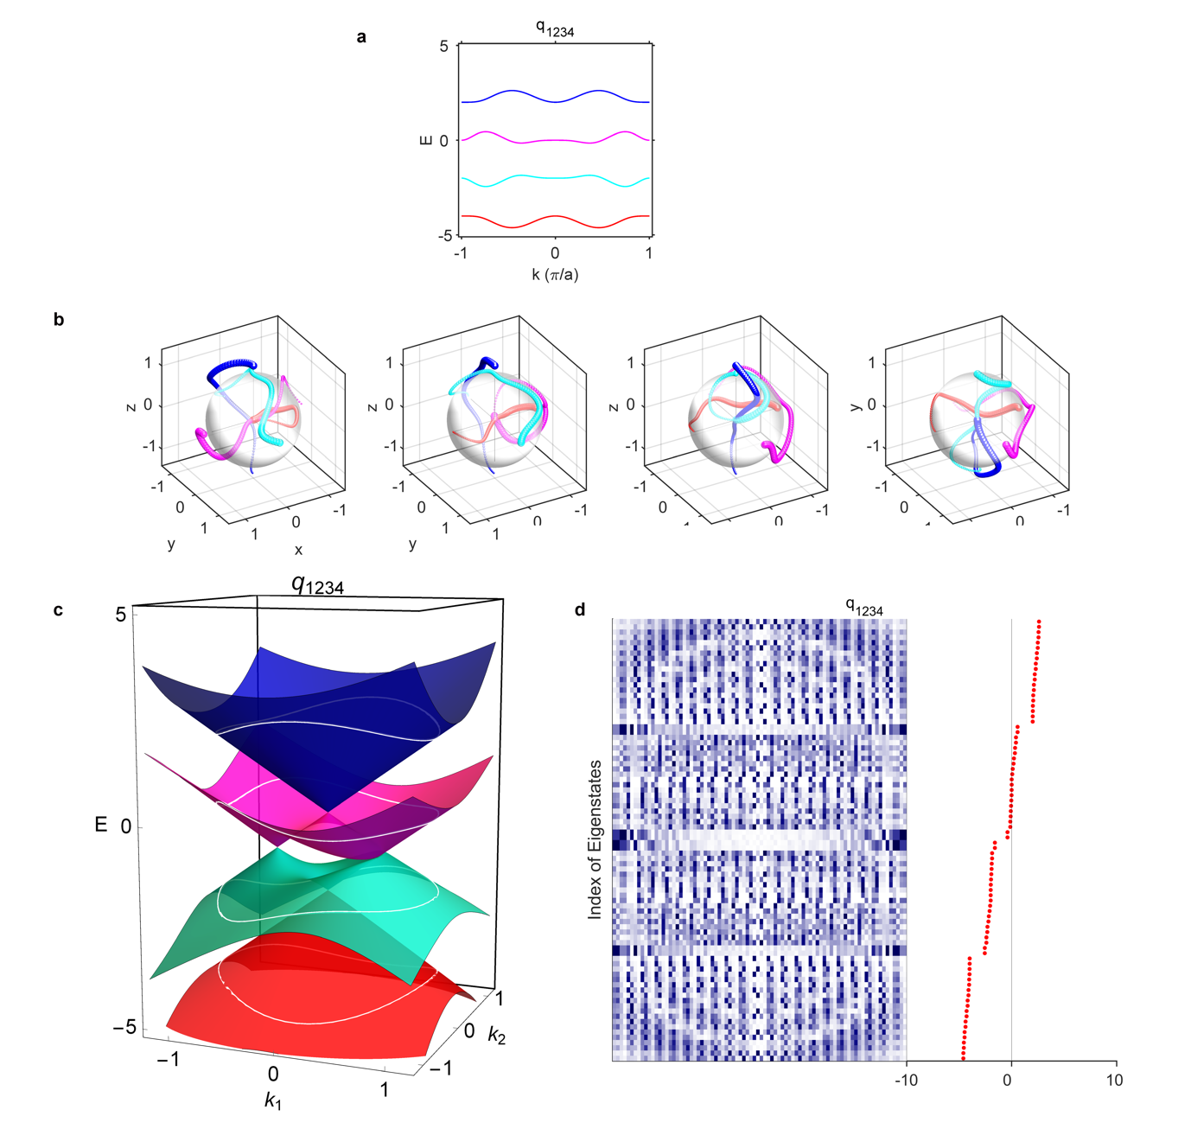
Figure S16. The case of $q_{1234}=-q_{13}q_{24}$. a, Bulk states. b, Trajectories of four eigenstates as wavevector runs across the first Brillouin zone ($k=-π→π$). c, The extended energy bands on a 2D plane, where the white circles indicate the corresponding 1D energy bands. d, Distribution of hard boundary edge states. The first, second, third and fourth bands are coloured as red, cyan, magenta and blue, respectively. There is one linear Dirac cone between the first/third and second/fourth bands, and two linear Dirac cones between the second and third bands. Each linear Dirac cone implies one corresponding edge state per edge.
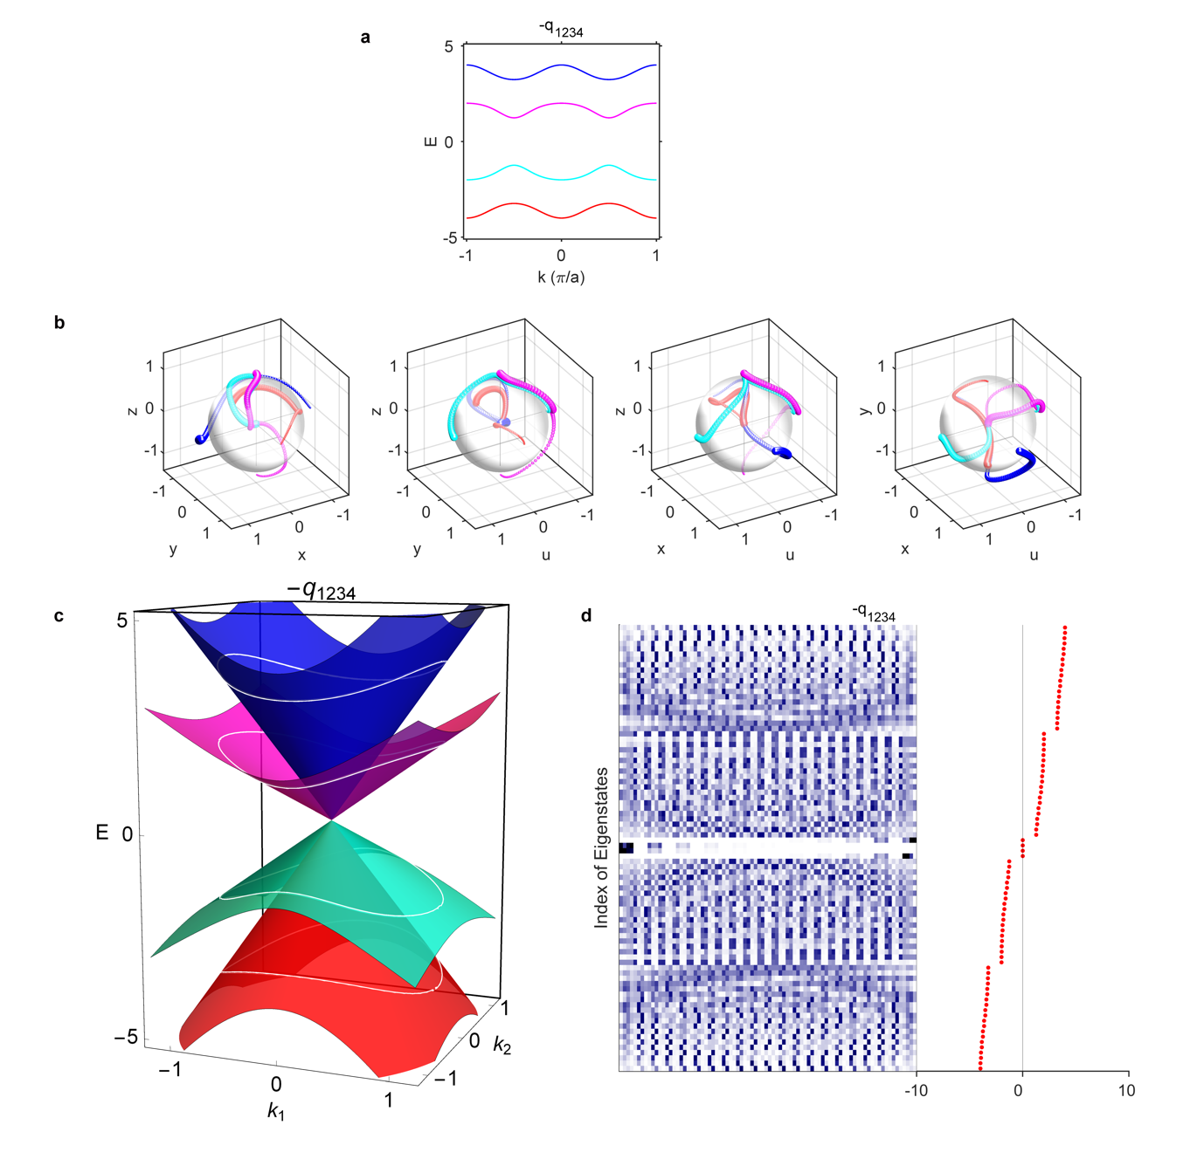
Figure S17. The case of $-q_{1234}=-q_{14}q_{23}$. a, Bulk states. b, Trajectories of four eigenstates as wavevector runs across the first Brillouin zone ($k=-π→π$). c, The extended energy bands on a 2D plane, where the white circles indicate the corresponding 1D energy bands. d, Distribution of hard boundary edge states. The first, second, third and fourth bands are coloured as red, cyan, magenta and blue, respectively. There is one four-fold linear Dirac cone between the four bands, which implies two edge states per edge.
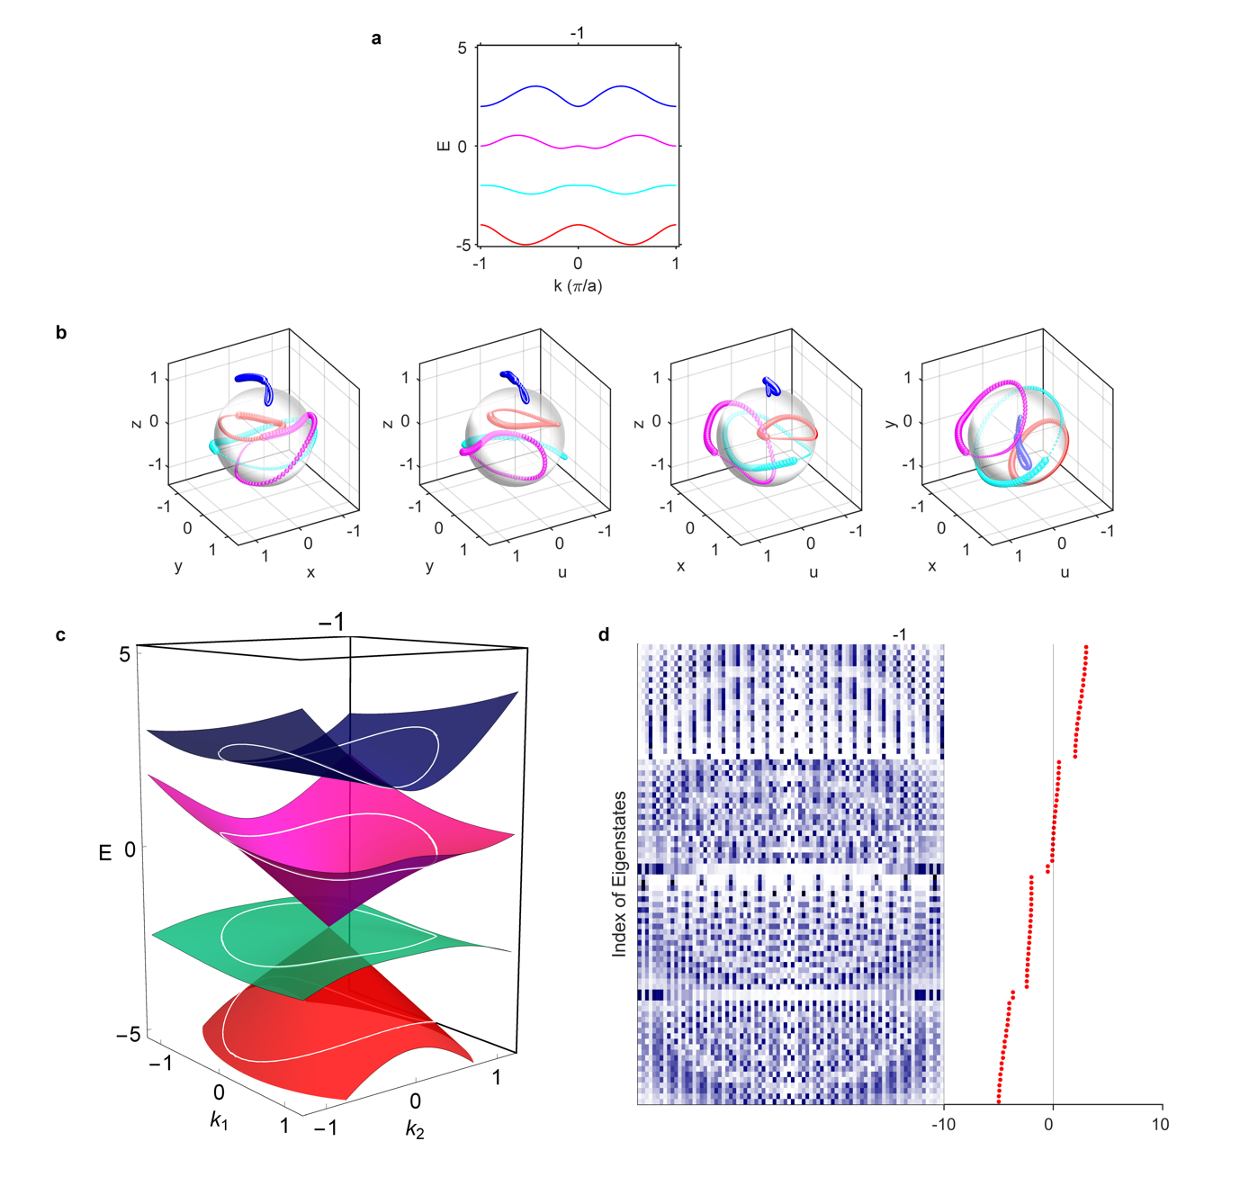
Figure S18. The case of charge $-1$. a, Bulk states. b, Trajectories of four eigenstates as wavevector runs across the first Brillouin zone ($k=-π→π$). c, The extended energy bands on a 2D plane, where the white circles indicate the corresponding 1D energy bands. d, Distribution of hard boundary edge states. The first, second, third and fourth bands are coloured as red, cyan, magenta and blue, respectively. There is one triple linear degeneracy constructed by the lower three bands, which implies that for the first and second bandgaps each supports one edge state per edge, being similar to some cases of charge $-1$ in three-band models⁵.

