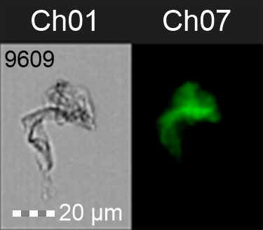
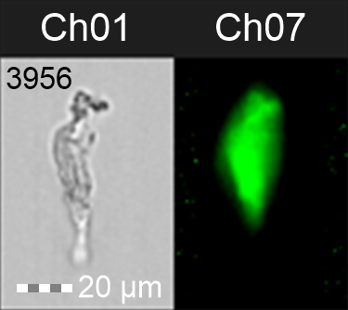
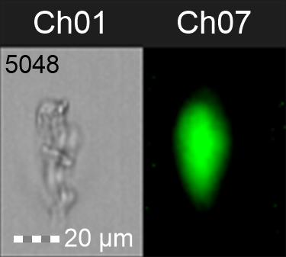
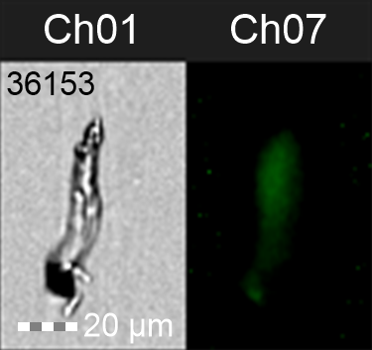
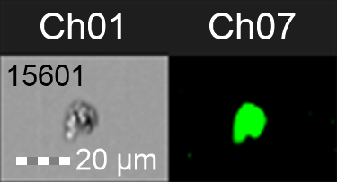
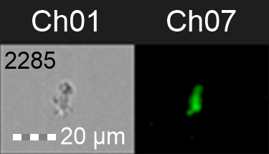
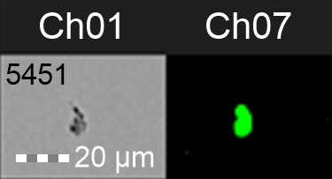
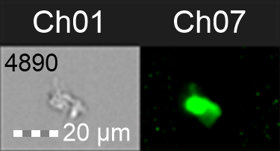
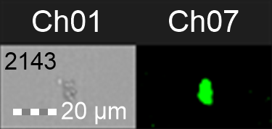
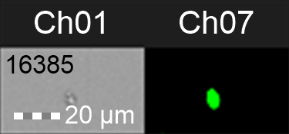
Supplementary Figure 4. Representative images of different sizes of fibrinaloid microclots that is typically seen in samples from patients obtained at 20X magnification using the FlowSight imaging flow cytometer. Channel 1 (Ch01) and channel 7 (Ch07) represents brightfield and fluorescent images, respectively. The numbers in the top left corner of the brightfield channel (Ch01) corresponds to the event number assigned during acquisition

