A  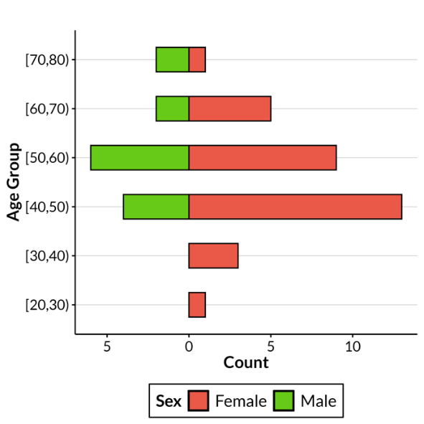 | B  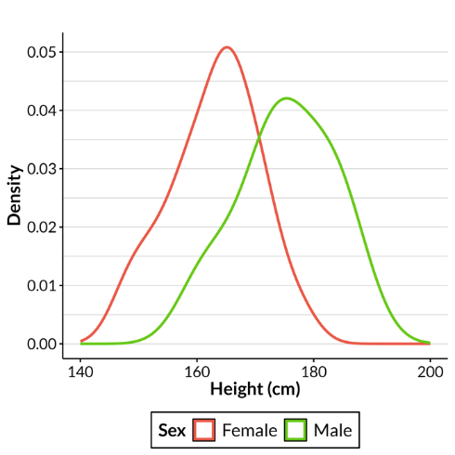
C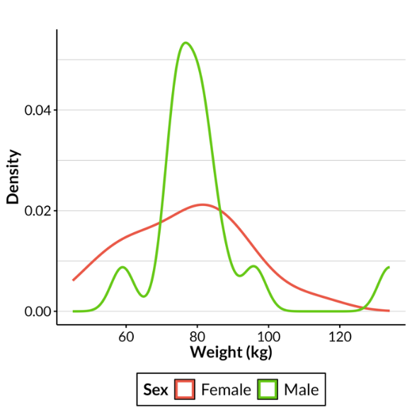

Supplementary Figure 2. Additional demographic information. A: Age pyramid. B: Height distributions by sex. C: Weight distributions by sex.

