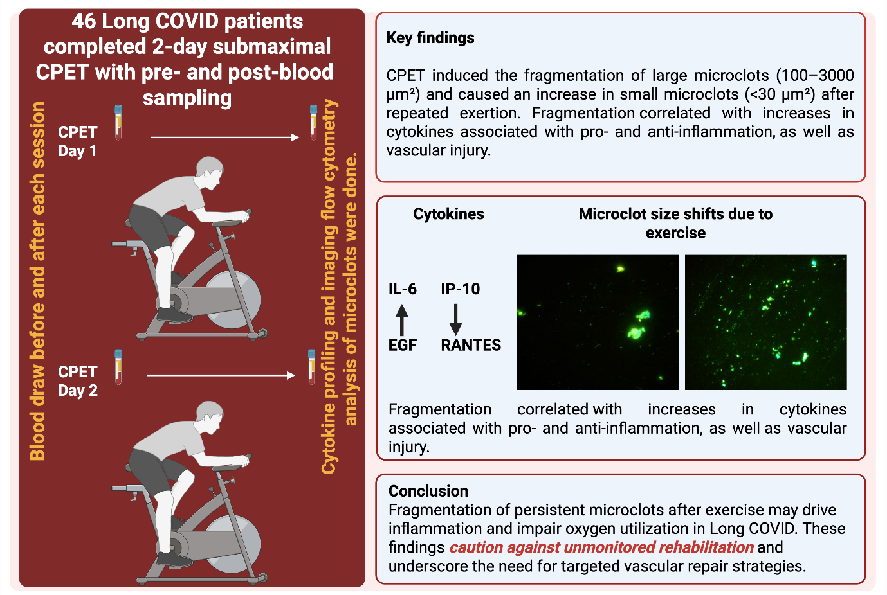
Supplementary Figure 5. Schematic abstract summary of the study design, key findings, and conclusions.

