A  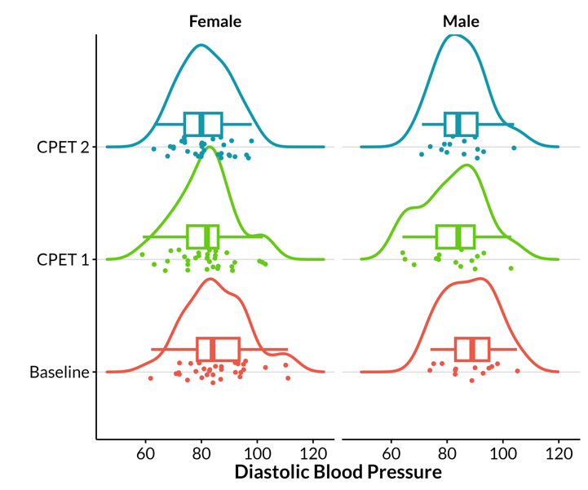 | B  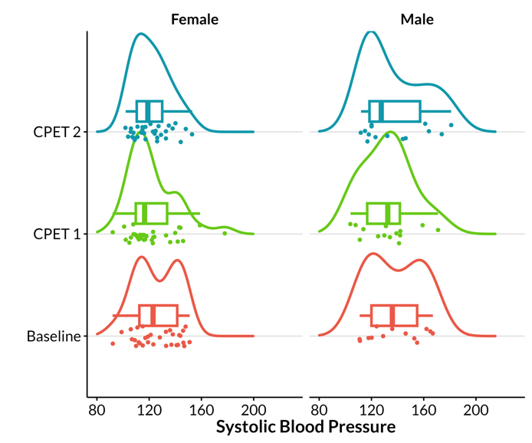
C  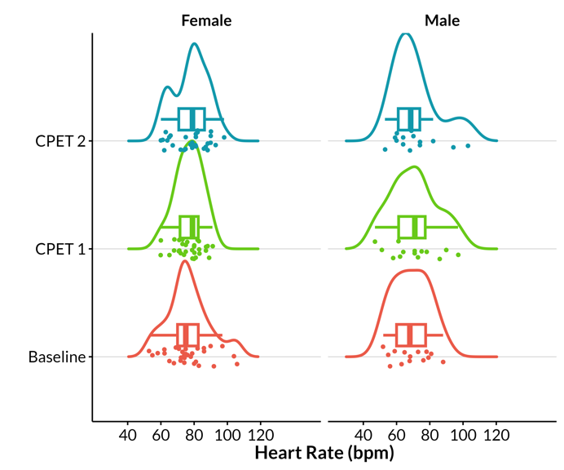 | D  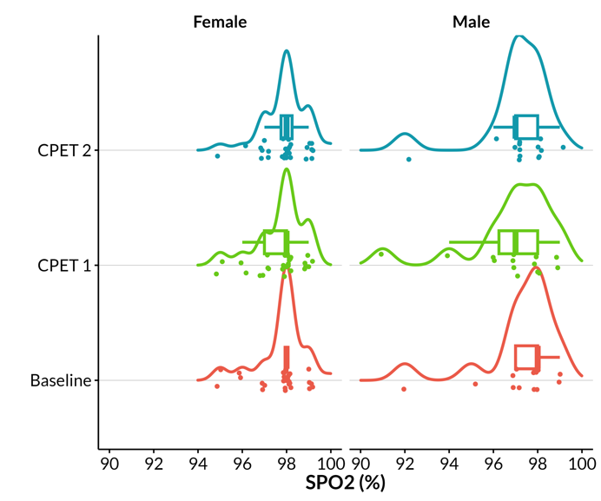

Supplementary Figure 3. Physiological measures of sample by sex and time point. A: Diastolic blood pressure (mmHg). B: Systolic blood pressure (mmHg). C: Heart rate (bpm). D: Peripheral oxygen percentage (%).

