Water Stained
Water Unstained
A
B
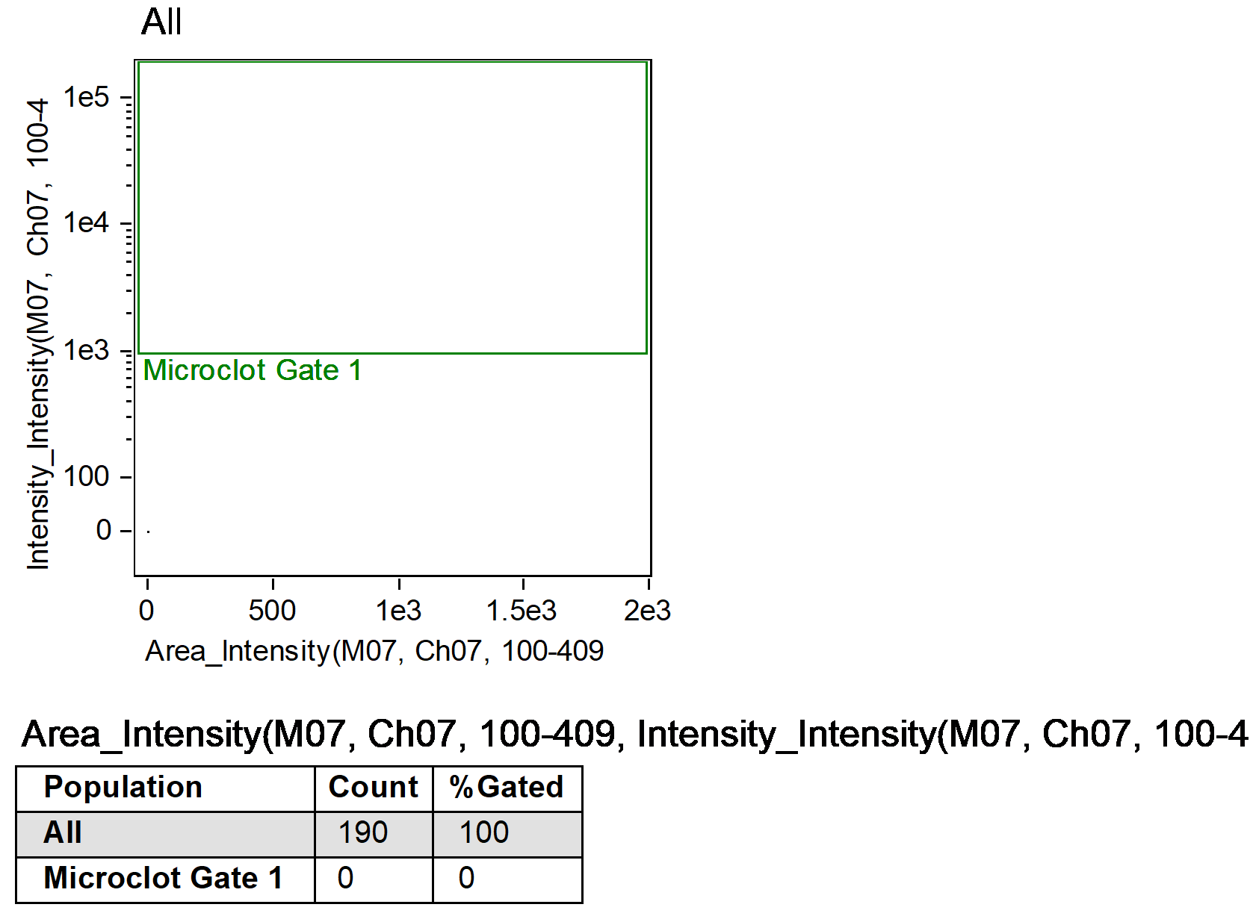
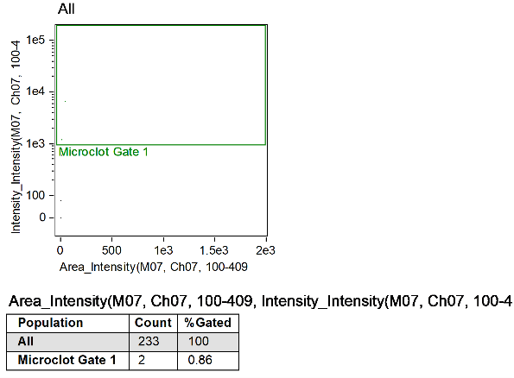

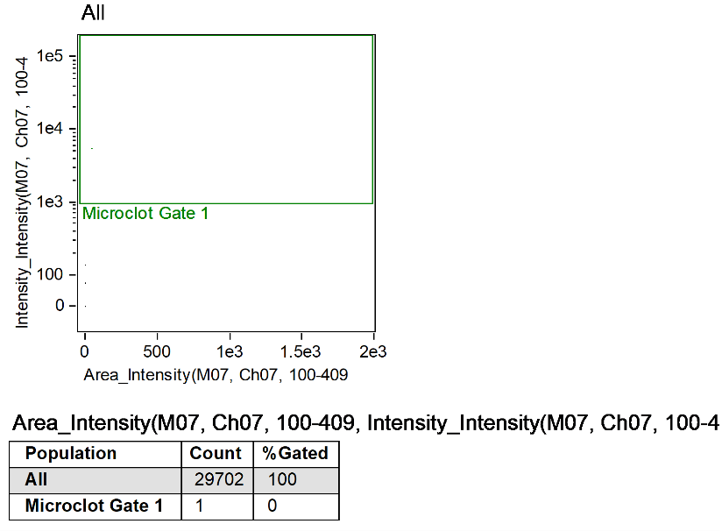
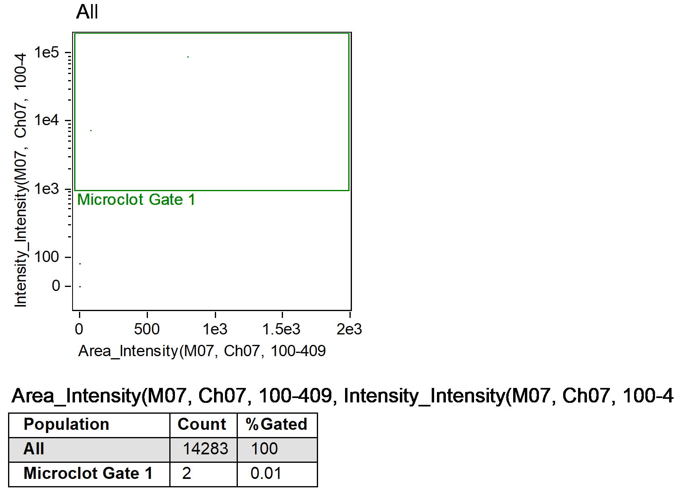
Long COVID Sample A Unstained
Long COVID Sample B Unstained
C
D

Supplementary Figure 1. Negative controls and unstained Long COVID samples used to establish and validate the acquisition and analysis gate (only the latter is represented in this figure). A) Water unstained; B) Water stained with ThT; C & D) Unstained Long COVID samples. The rectangle nature of the gate enables the assessment of the entire profile of microclots within samples, ranging from 1µm² to an upper limit of 3000µm².

