Supplementary materials of manuscript:

Machine Learning Framework for Longitudinal Functional Decline and Time-to-Event Prediction
Delgado-SanMartin, Juan A.; Gupta, Varsha; McDonough, Harry E.; Ong, Siying Jane; the Pooled Resource Open-Access ALS Clinical Trials Consortium; McDermott, Christopher J.; and Wang, Dennis
Submitted to NPJ Digital Medicine in May 2025

Appendix A: Extra information on Data & models

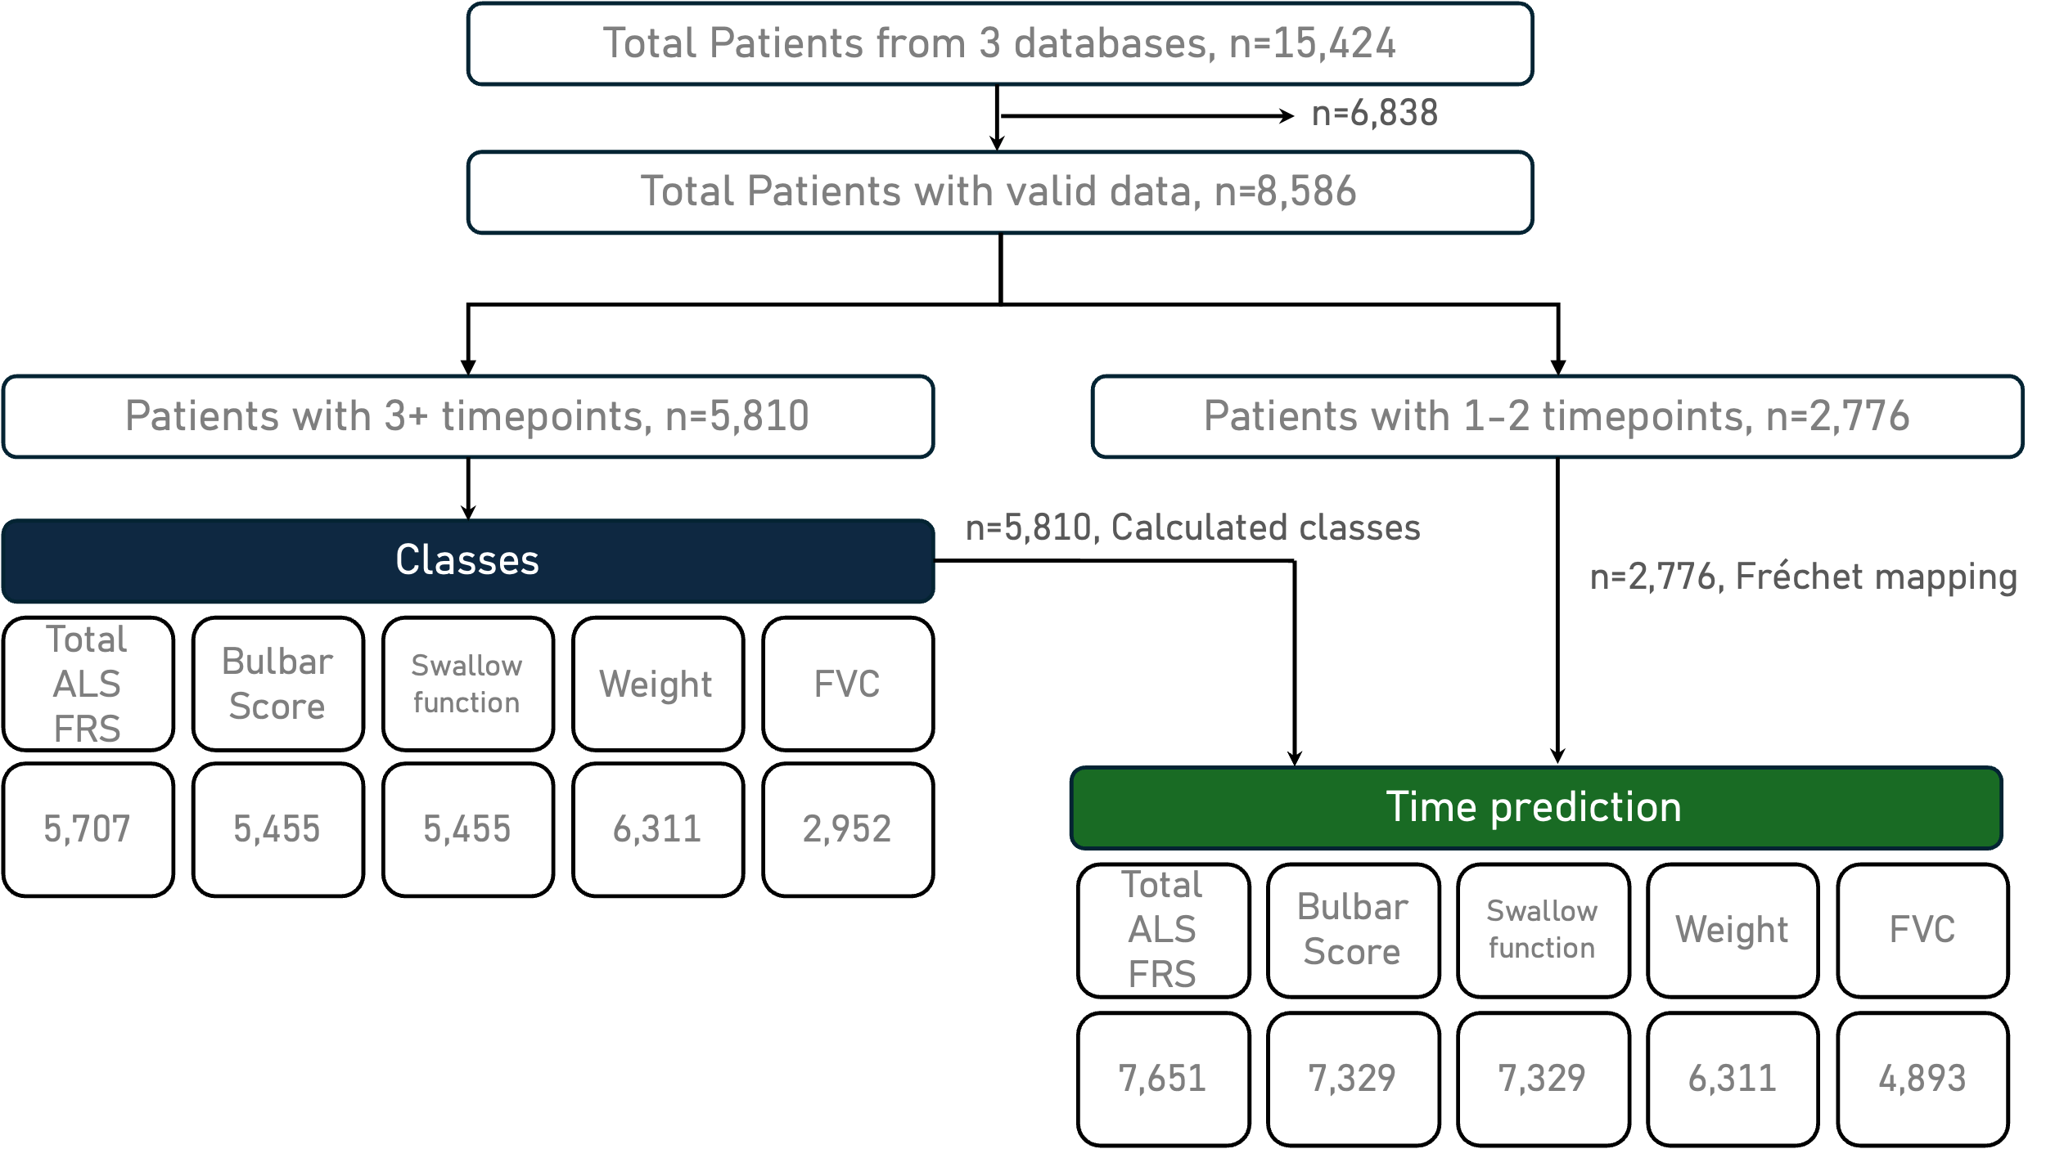
Figure S1: breakdown of longitudinal data based on number of available datapoints

Table S1: Patient characteristics table for data
 | ArQ  (N=1195) | IDPP  (N=1794) | PROACT  (N=5597) | Overall  (N=8586)
sex
Female | 500 (41.8%) | 842 (46.9%) | 2105 (37.6%) | 3447 (40.1%)
Male | 695 (58.2%) | 952 (53.1%) | 3492 (62.4%) | 5139 (59.9%)
Age at onset
Mean (SD) | 61.4 (12.2) | 63.9 (11.0) | 54.5 (11.3) | 57.4 (12.0)
Median [Min, Max] | 62.8 [22.2, 90.7] | 65.3 [20.3, 88.8] | 55.4 [16.9, 85.4] | 58.5 [16.9, 90.7]
Site onset
Missing | 19 (1.6%) | 0 (0%) | 1 (0.0%) | 20 (0.2%)
Bulbar | 296 (24.7%) | 553 (30.8%) | 1470 (26.3%) | 2319 (27.0%)
Generalised | 79 (6.6%) | 6 (0.3%) | 2 (0.0%) | 87 (1.0%)
Respiratory | 17 (1.4%) | 0 (0%) | 1 (0.0%) | 18 (0.2%)
Spinal | 784 (65.6%) | 1204 (67.1%) | 3767 (67.3%) | 5755 (67.0%)
Other | 0 (0%) | 31 (1.7%) | 356 (4.3%) | 387 (4.5%)
Diagnostic delay months
Mean (SD) | 18.9 (23.8) | 12.3 (10.9) | 10.7 (8.3) | 12.2 (12.7)
Median [Min, Max] | 11.7 [0, 268] | 9.1 [0.9, 121] | 8.8 [0, 101] | 9.10 [0, 251]
Missing | 97 (8.1%) | 0 (0%) | 2128 (38.0%) | 2225 (25.9%)
El escorial
Missing | 139 (11.6%) | 1794 (100%) | 3132 (55.9%) | 5065 (62.7%)
Possible | 86 (7.2%) | 0 (0%) | 121 (2.2%) | 207 (58.9%)
Probable | 403 (33.7%) | 0 (0%) | 1376 (24.6%) | 1779 (20.7%)
Definite | 499 (41.7%) | 0 (0%) | 968 (17.3%) | 1467 (17.0%)
Suspected | 68 (5.7%) | 0 (0%) | 0 (0%) | 68 (0.8%)
C9orf72 mutation
Missing | 777 (65.0%) | 855 (47.7%) | 5597 (100%) | 7229 (84.2%)
Negative | 356 (29.8%) | 854 (47.6%) | 0 (0%) | 1210 (14.1%)
Positive | 62 (5.2%) | 85 (4.7%) | 0 (0%) | 147 (1.7%)

Table S2: Number of data observation available at each timepoint from onset in training data used for JLCGA-DSTA for Total ALSFRS, Bulbar scores, Swallowing function (Q3) and FVC (respiration marker)
time from onset (days) | Total ALSFRS | Bulbar | Q3 | Respiration marker
30 | 6 | 6 | 6 | 1
60 | 15 | 15 | 15 | 3
90 | 52 | 51 | 51 | 16
120 | 106 | 105 | 105 | 41
150 | 209 | 203 | 203 | 89
180 | 330 | 322 | 322 | 148
210 | 488 | 483 | 483 | 223
240 | 661 | 644 | 644 | 307
270 | 840 | 823 | 823 | 388
300 | 969 | 941 | 941 | 458
330 | 1105 | 1080 | 1080 | 534
360 | 1199 | 1173 | 1173 | 612
390 | 1381 | 1344 | 1344 | 676
420 | 1411 | 1372 | 1372 | 691
450 | 1599 | 1569 | 1569 | 803
480 | 1652 | 1612 | 1612 | 810
510 | 1725 | 1672 | 1672 | 836
540 | 1738 | 1701 | 1701 | 853
570 | 1791 | 1751 | 1751 | 872
600 | 1777 | 1734 | 1734 | 846
630 | 1801 | 1756 | 1756 | 836
660 | 1783 | 1743 | 1743 | 813
690 | 1765 | 1720 | 1720 | 810
720 | 1719 | 1664 | 1664 | 753
750 | 1758 | 1720 | 1720 | 762
780 | 1631 | 1595 | 1595 | 704
810 | 1553 | 1520 | 1520 | 679
840 | 1493 | 1459 | 1460 | 614
870 | 1446 | 1411 | 1411 | 624
900 | 1398 | 1358 | 1358 | 576
930 | 1265 | 1244 | 1244 | 532
960 | 1228 | 1203 | 1203 | 499
990 | 1129 | 1105 | 1105 | 457
1020 | 1057 | 1038 | 1038 | 403
1050 | 925 | 906 | 906 | 371
1080 | 808 | 787 | 787 | 321

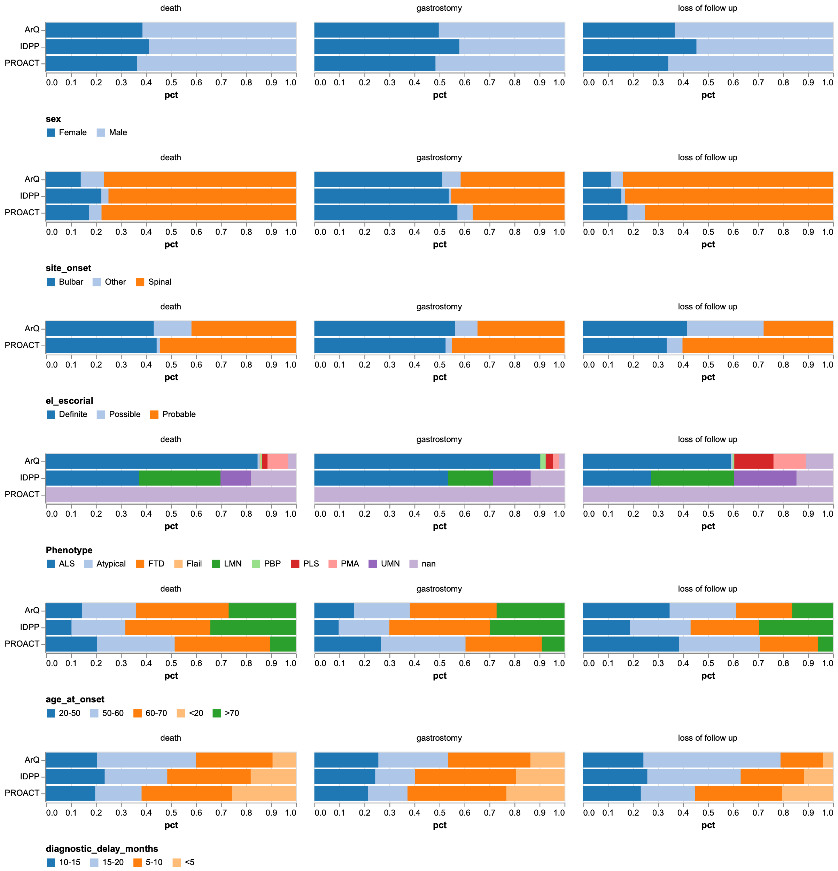
Figure S2: distribution of static features by label and database.

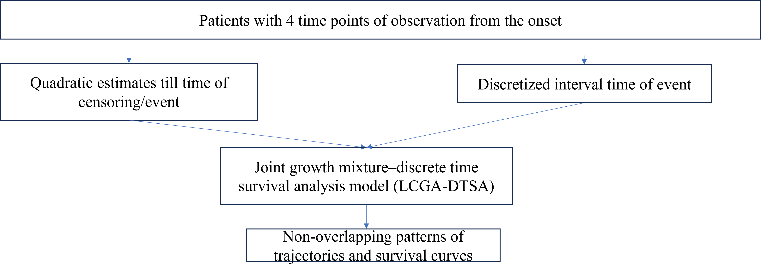
Figure S3: Schematic diagram to show summary of longitudinal patterns

Fréchet distances are calculated based on any collection of points belonging to one patient and their overall proximity to the median of each group as shown in Figure S4.
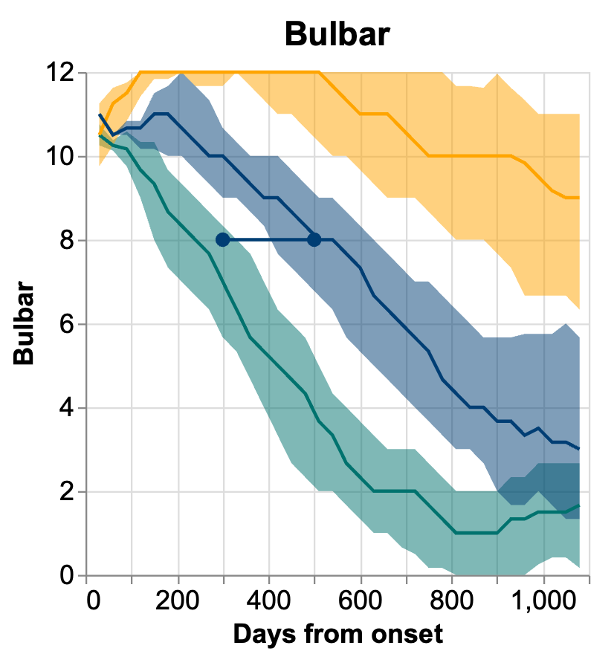
Figure S4: example of Fréchet distance calculation. The plot shows 3 example groups for Bulbar scores and a new patient (dots joined by line). The overall shortest distance shows belonging to the middle group (blue).

Weight loss trajectories showed median [IQR] values of 0.0 [0.0, 1.4] Kg for no weight loss and -2.0 [-5.7, 0.0] Kg for 5% weight loss and individual trajectories portrayed in Figure S3.
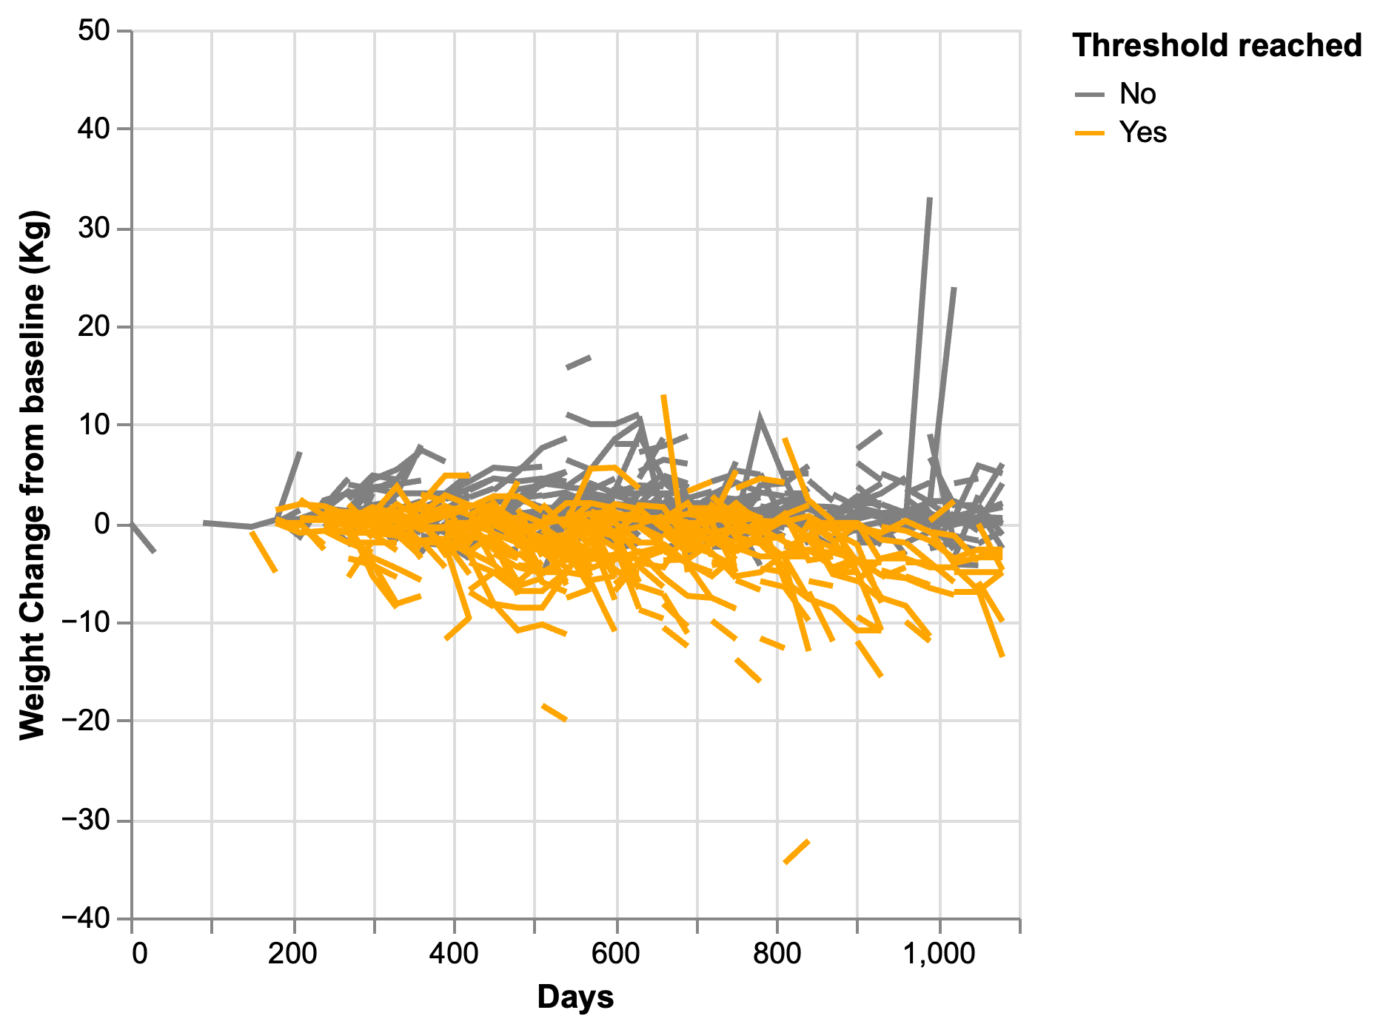
Figure S5: sample of 1000 patients’ weight loss trajectories split by weight loss groups.

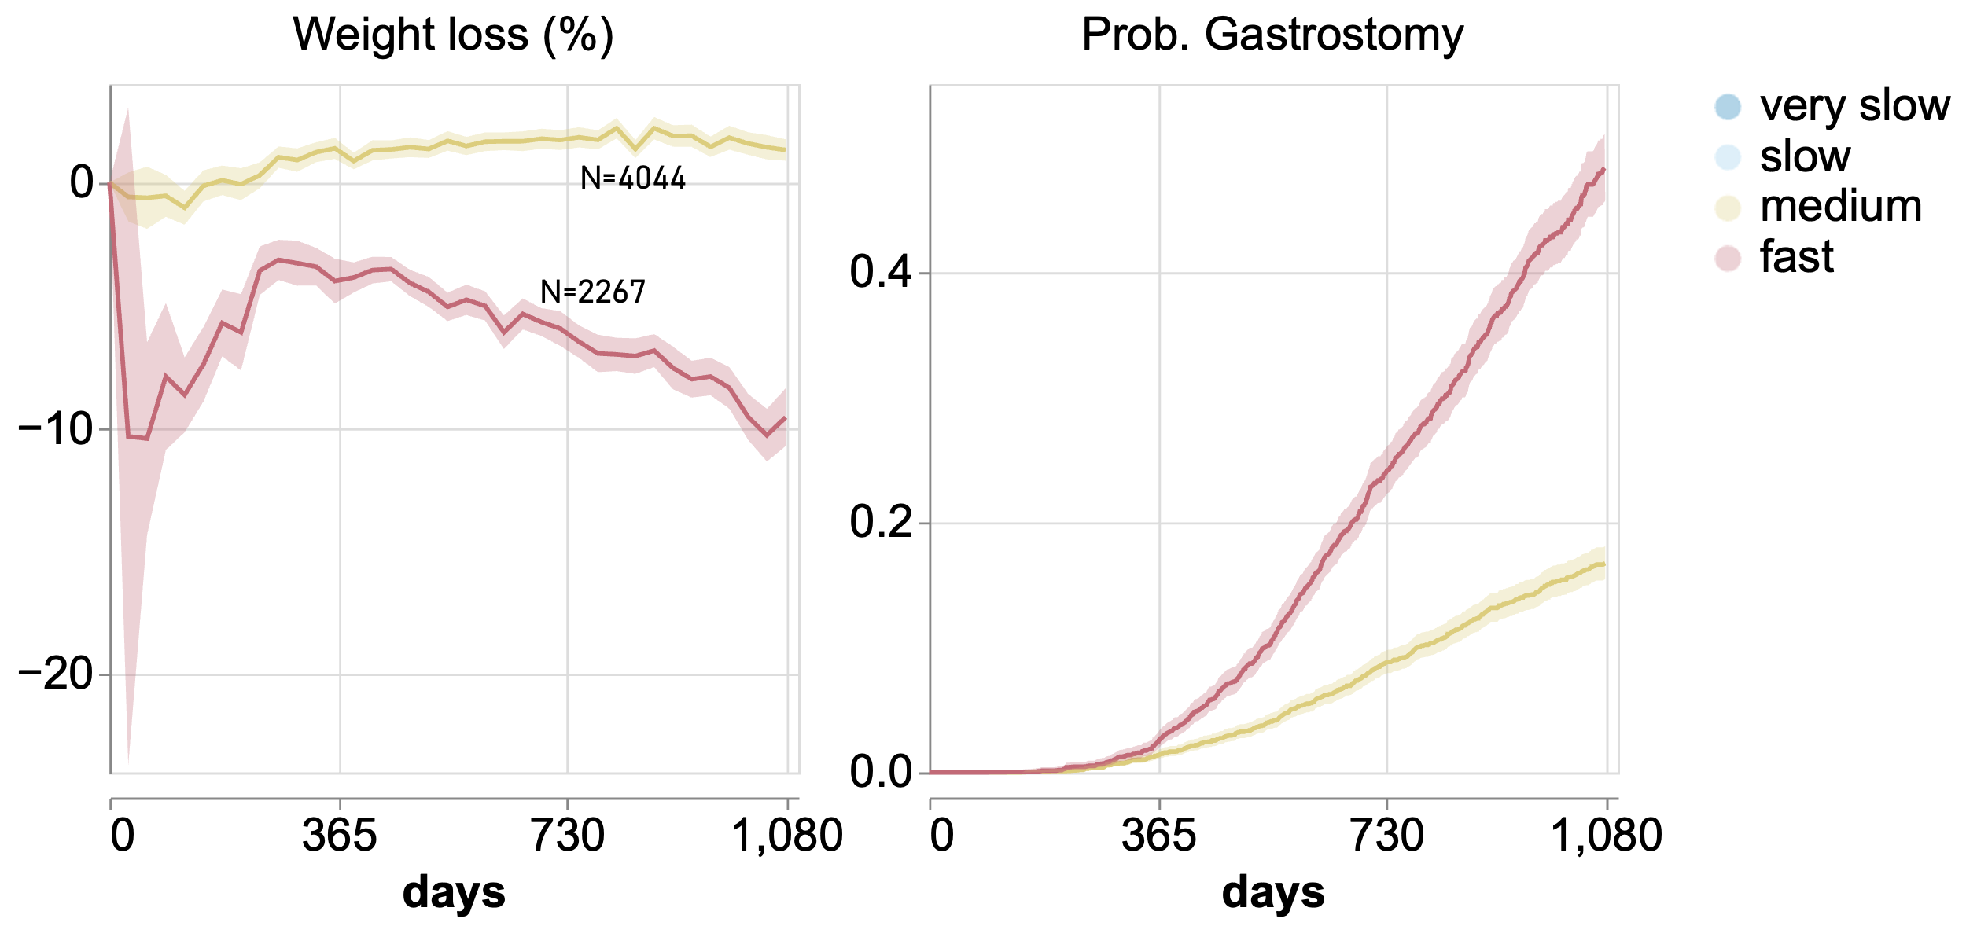
Figure S6: weight classes with 5% weight loss and the equivalent survival trajectory. Lines represent mean and 95% CI.

More details on the models
- Cox proportional Hazards model
A linear survival model where the hazards’ function ($H\left(t\right)$) is defined as:
$$H\left(t\right)=H_{0}\left(t\right)⋅\exp\left(Σ_{i}β_{i}C_{i}+Σ_{j}β_{j}P_{j}+Σ_{k}β_{k}{Q(t)}_{k}\right)$$ | (SA1)
where $H_{0}\left(t\right)$ is the baseline hazards’ function obtained from non-parametric survival curve of the whole population (commonly Kaplan-Meier or Nelson-Aalen), $C_{i}$ refers to class variables, $P_{j}$ to the patient demographic data at onset, $Q_{k}$ to the slopes of the time-dependent variables: bulbar subscore & total ALSFRS-R slopes, and $β_{i}$, $β_{j}$, $β_{k}$ to the parameters trained for each set of features.¹ The probability or gastrostomy ($P_{G}$) is then calculated as:
$P_{G}\left(t\right)=1-\exp\left(-\int_{0}^{t}{H\left(t\right)dt}\right)$. | (SA2)

In the scikit-learn implementation we used, we optimised the L1 regularization parameter (alpha).
- XGboost Cox loss
A non-linear survival model where the hazards’ function ($H\left(t\right)$) is defined as a boosted ensemble of decision trees characterised by hyperparameters.² The hyperparameters of most relevance in our case are learning rate, maximum tree depth, minimum child weight, L1 regularisation (alpha), and L2 regularization (lambda). All these parameters will be optimised. In our case, we implemented early stopping manually using the scikit-learn lower-level API, but we used the native parameters for objective (survival:cox) and evaluation metric (cox negative log likelihood, cox-nloglik)³. The motivation to include this model is to understand the benefits of using a non-linear survival model alongside Linear Cox (also known as Cox Proportional Hazards).

Appendix B: Extra information on joint LCGA-DSTA
Table S3: Example of time of events and censoring in the discretized interval. The variables u1-u12 were used to construct the factor for joint latent class growth analysis -discrete survival time analysis in MPLUS.
Survival time | Censored | U1 | U2 | U3 | U4 | U5 | U6 | U7 | U8 | U9 | U10 | U11 | U12
1267 | 1, died after 1080 days | 0 | 0 | 0 | 0 | 0 | 0 | 0 | 0 | 0 | 0 | 0 | 0
928 | 1,died | 0 | 0 | 0 | 0 | 0 | 0 | 0 | 0 | 0 | 0 | -9999 | -9999
670 | 0,event | 0 | 0 | 0 | 0 | 0 | 0 | 0 | 1 | -9999 | -9999 | -9999 | -9999
236 | 0,event | 0 | 0 | 1 | -9999 | -9999 | -9999 | -9999 | -9999 | -9999 | -9999 | -9999 | -9999
581 | 0,event | 0 | 0 | 0 | 0 | 0 | 0 | 1 | -9999 | -9999 | -9999 | -9999 | -9999

Below we illustrate the fastest decline class for each variable, demonstrating that the fastest decline is associated with ALSFRS-R in the first year and overtaken by bulbar score and swallow function with 16-18 months to reach 50% probability of gastrostomy need.
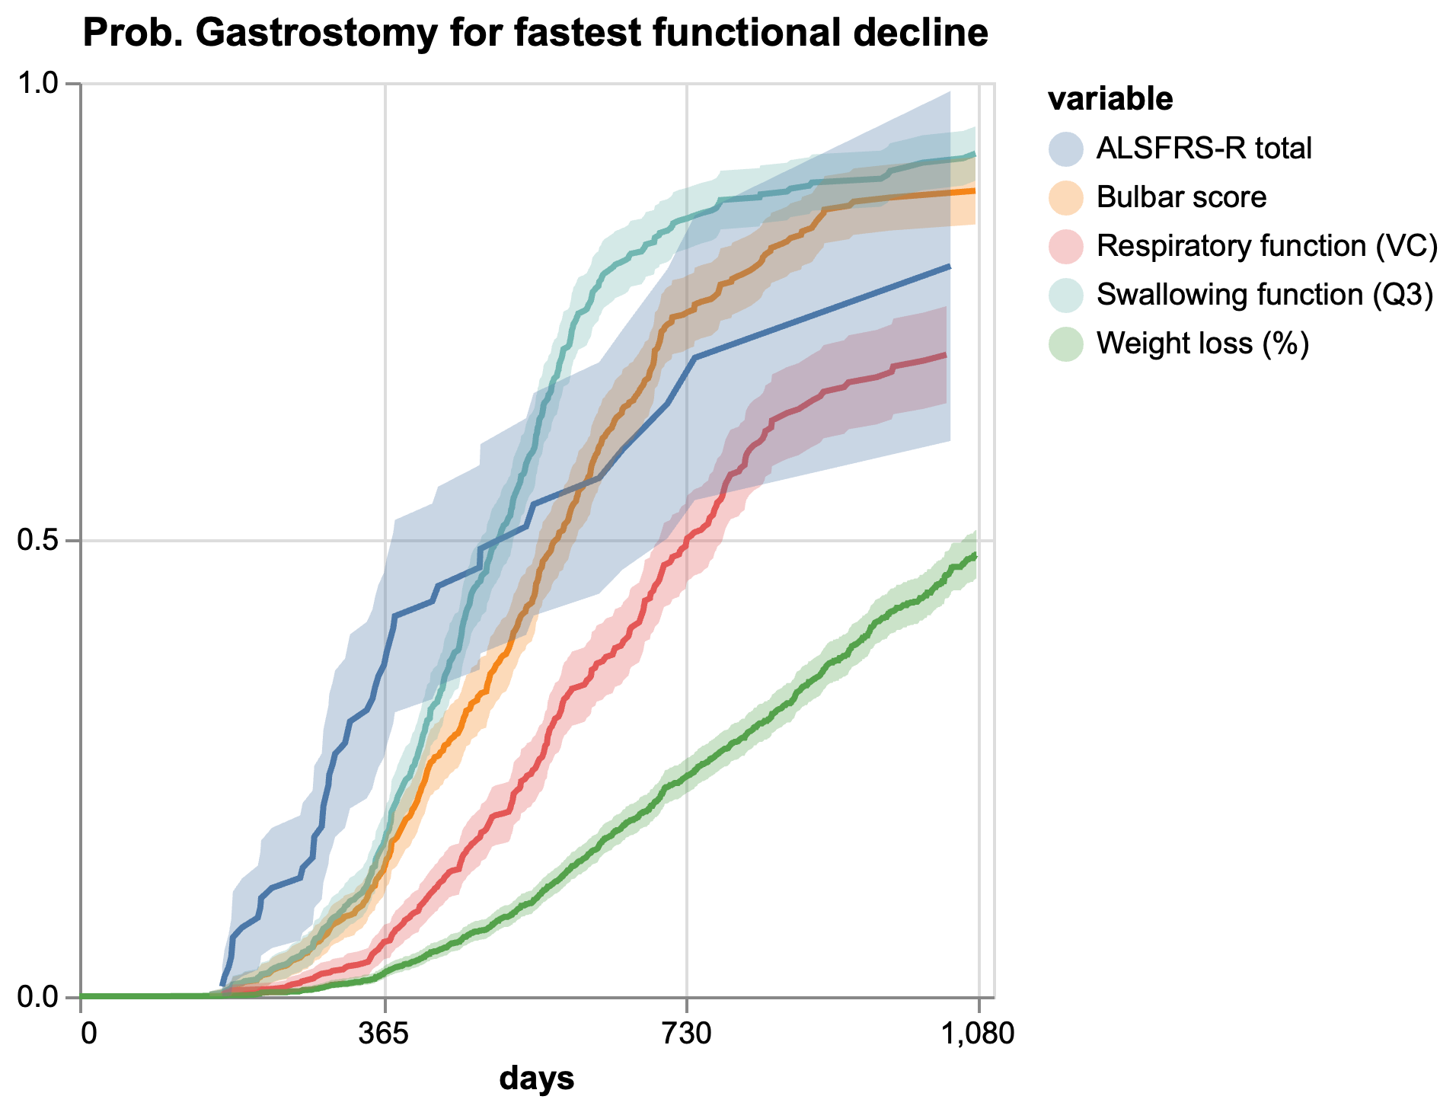
Figure S7: probabilities of gastrostomy for the fastest functional decline class for each longitudinal variable

Fréchet mappings were imperfect with averages of 59% (ALS FRS), 64% (Bulbar Score), 75% (Bulbar Score) and 76% (Swallowing function (Q3)), the values for each class were also very variable see Figure S5. The variables with higher number of classes (Bulbar Score and ALS FRS showed worse performance and higher variability.
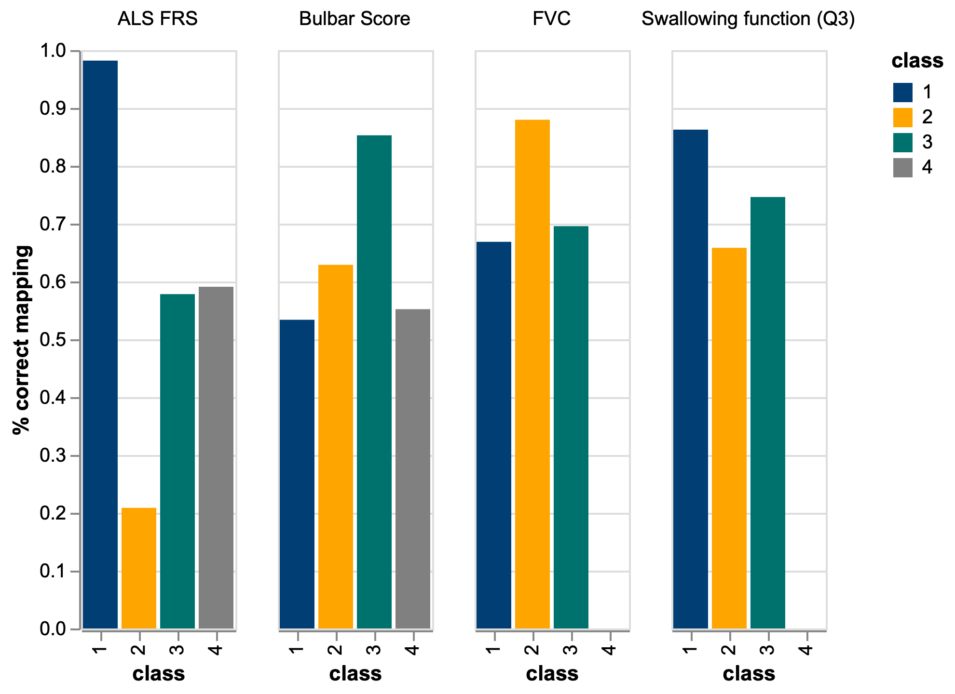
Figure S8: Validation of accuracy of Fréchet distance based classification

Table S4: Classification performance for joint latent class growth analysis–discrete time survival analysis model (LCGA-DTSA).

classes | Sample size adjusted Bayesian Information Criteria | Entropy | Mean posterior probability of classification | Membership of classes
Total ALFFRS (N=5707)
2 | 360062.161 | 0.942 | 0.969/0.988 | 1494(26.18%)4213(73.82%)
3 | 353254.240 | 0.925 | 0.955/0.966/0.973 | 2251(39.44%)/726(12.72%)2730(47.84%)
4 | 344577.336 | 0.934 | 0.954/0.954/0.965/0.969 | 2266(39.71%) 93(1.63%)956(16.75%)2392(41.91%)
5 | 339004.490 | 0.931 | 0.939/0.966/0.954/0.967/0.952 | 2181(38.22%)2000(35.05%)1149(20.13%)311(5.45%)66(1.16%)
Bulbar Score (N=5455)
2 | 211853.437 | 0.950 | 0.973/0.990 | 1433(26.27%)4022(73.73%)
3 | 200219.834 | 0.942 | 0.981/0.977/0.953 | 3319(60.84%)621(11.38%)1515(27.78%)
4 | 195885.889 | 0.960 | 0.979/0.956/0.967/0.982 | 567(10.39%)176(3.23%)1410(25.85%)3302(60.53%)
5 | 180977.386 | 0.957 | 0.949/0.982/0.963/0.981/0.962 | 1321(24.22%)225(4.13%)168(3.08%)3063(56.15%)678(12.43%)
Q3 score (N=5455)
2 | 116983.540 | 0.939 | 0.987/0.962 | 4240(77.73%)1215(22.27%)
3 | 110079.773 | 0.916 | 0.982/0.962/0.955 | 543(9.95%)1473(27.00%)3439(63.05%)
4 | 102568.922 | 0.957 | 0.944/0.987/0.962/0.933 | 1131(20.73%)3965(72.69%)81(1.49%)278(5.10%)
Respiration data (N=2952)
2 | 240148.729 | 0.88 | 0.958/0.971 | 1251(42.39%%)/1701(57.62%)
3 | 235392.301 | 0.898 | 0.955/0.954/0.953 | 774(26.22%)/618(20.93%)1560(52.85%)
4 | 232338.676 | 0.916 | 0.949/0.960/0.952/0.950 | 1016(34.42%)324(10.98%)1359(46.04%)253(8.57%)

Appendix C: Extra information on Time prediction model

Results for all estimations and hyperparameter optimizations can be seen in the excel file in the attached supplementary materials.

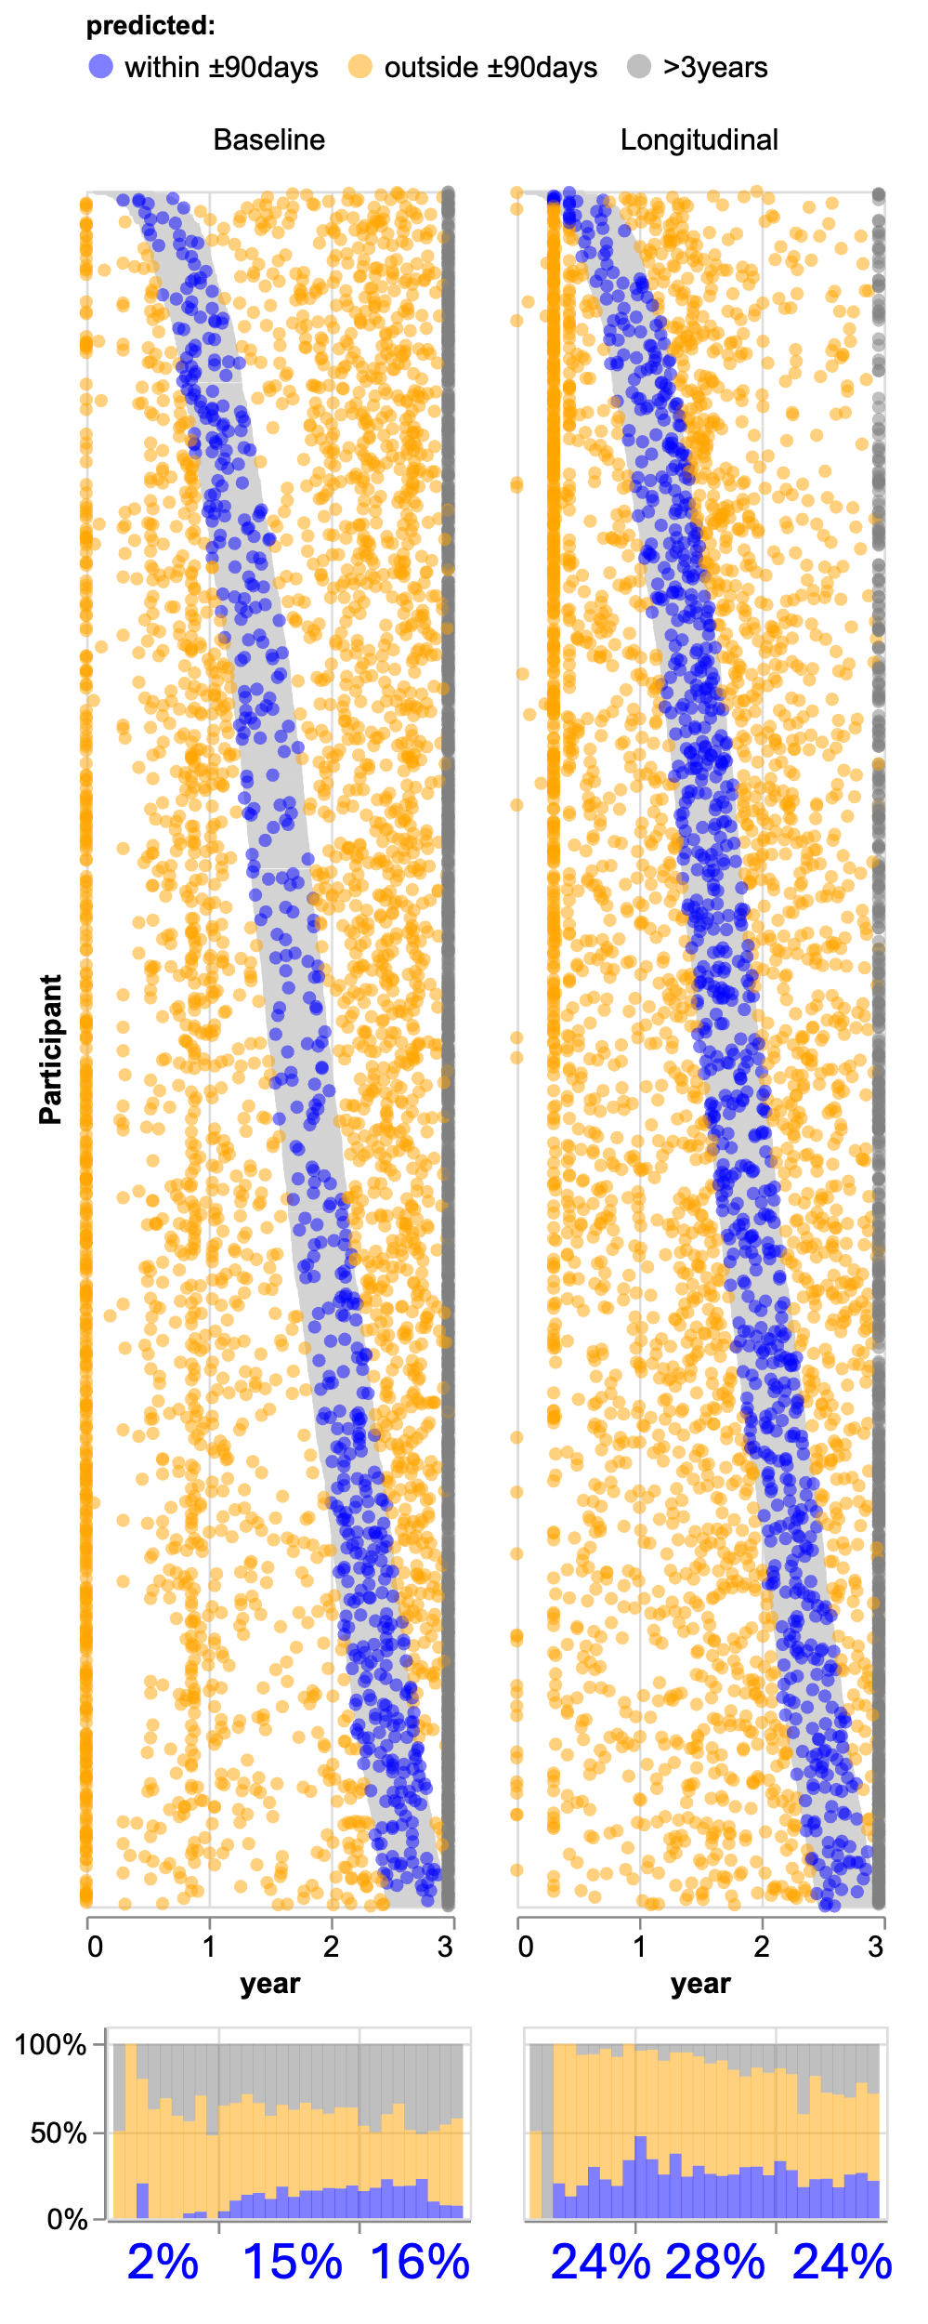
Figure S9: individual predictions for the XGBoost MAEPO model for both feature sets.
We performed a Multiple Imputation by Chained Equations (MICE) and denoted that the XGBoost model is best across all metrics and all rotations with the exception of IDPP. The imputation results are marginally better than the unimputed data, however imputation carries the risk of introducing artificial bias in the analysis, therefore we decided to leave it out.
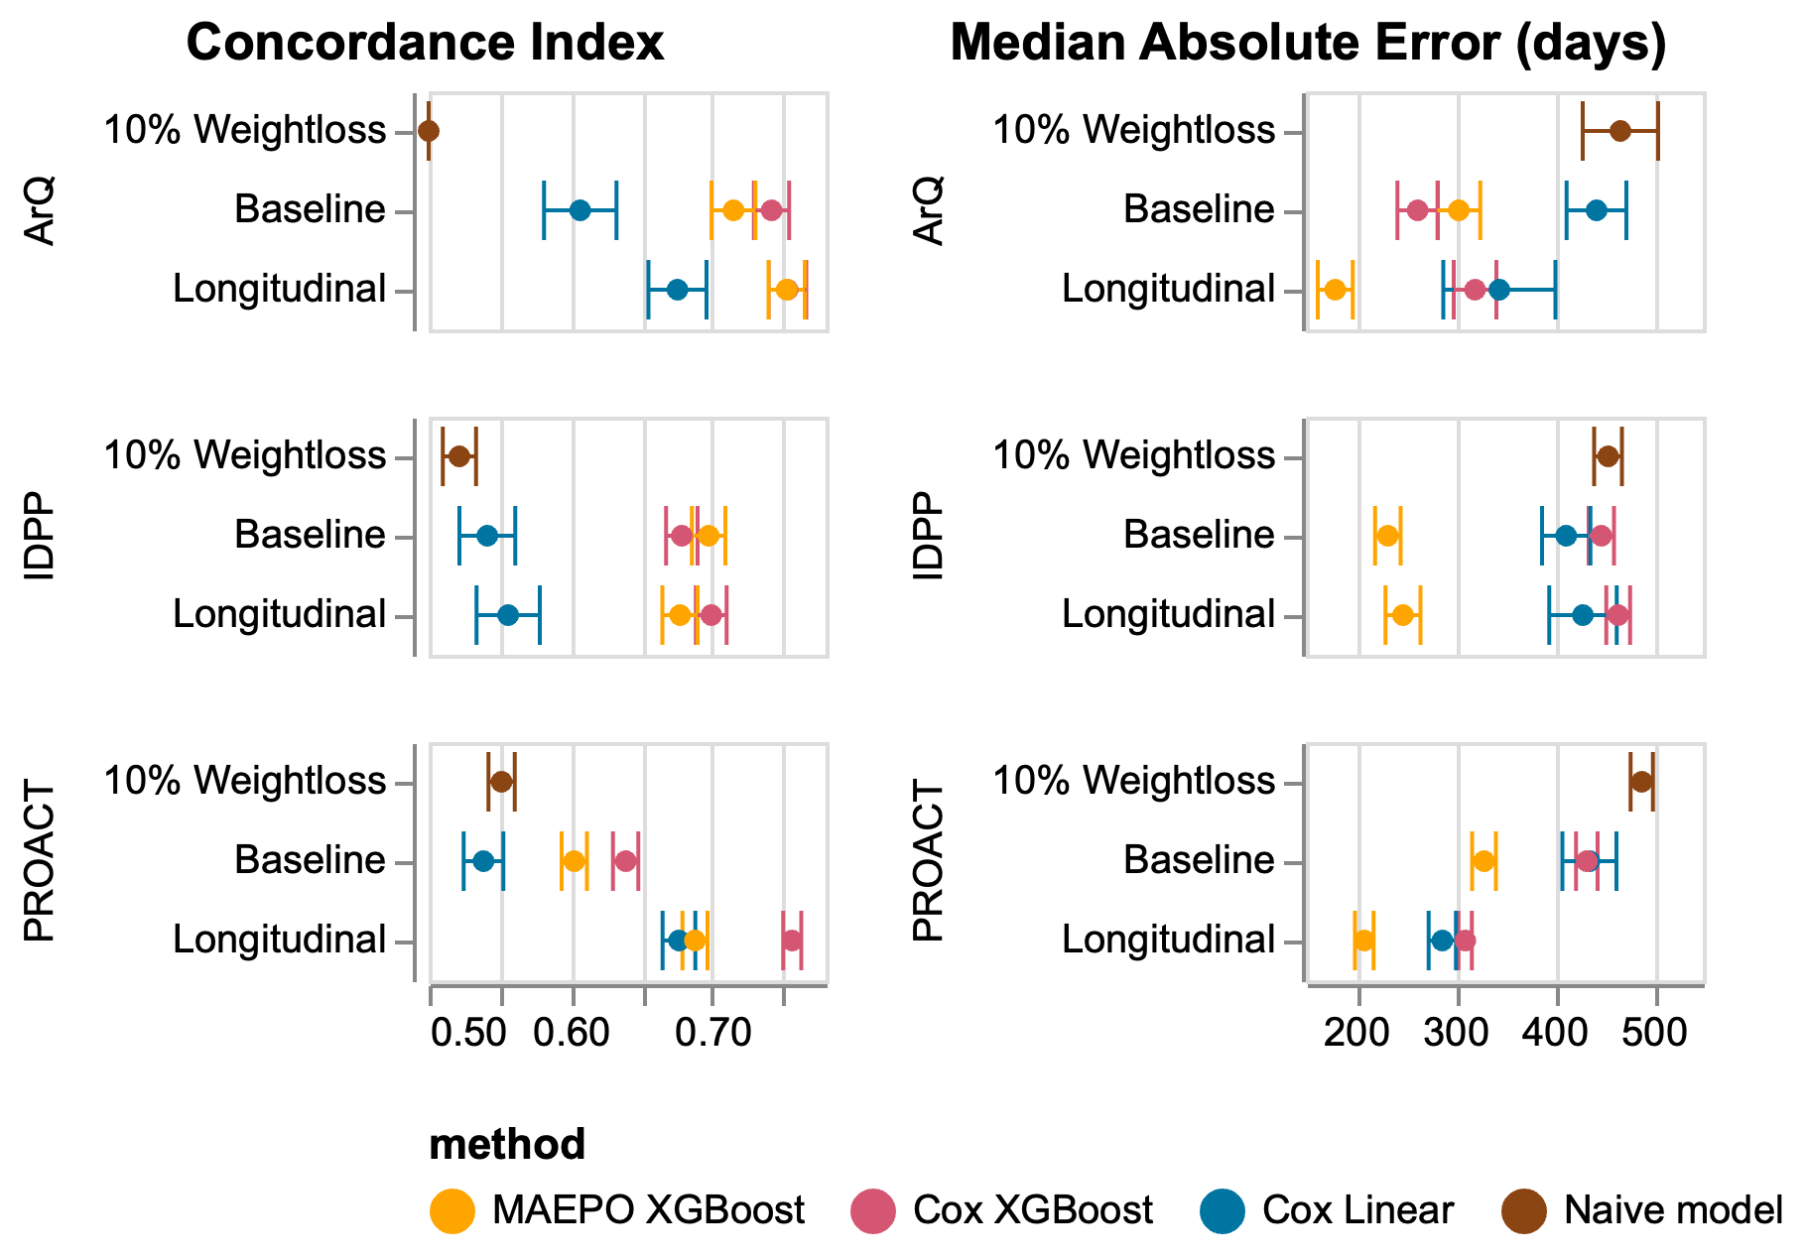
Figure S10: MICE performance results for the three models: Cox Linear, XGBoost MAEPO and XGBoost Cox. Performance is measured by Concordance index (Cindex), Median Absolute Error (MedianAE).

Sensitivity Analyses
Prediction within tolerance
MAEPO XGBoost shows the most stable performance across different rotations (see Figure S11).
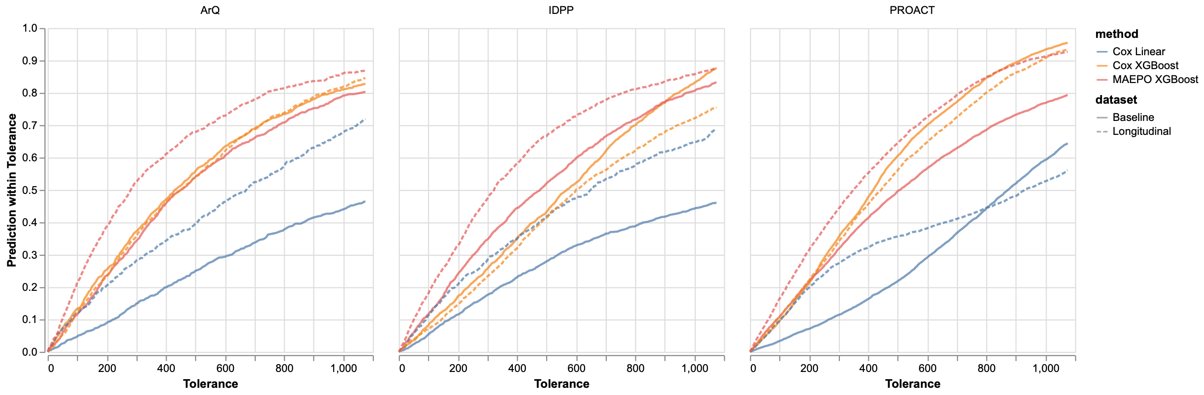
Figure S11: performance at different tolerance levels for each model and feature set.

Sensitivity of availability of number of datapoints in time
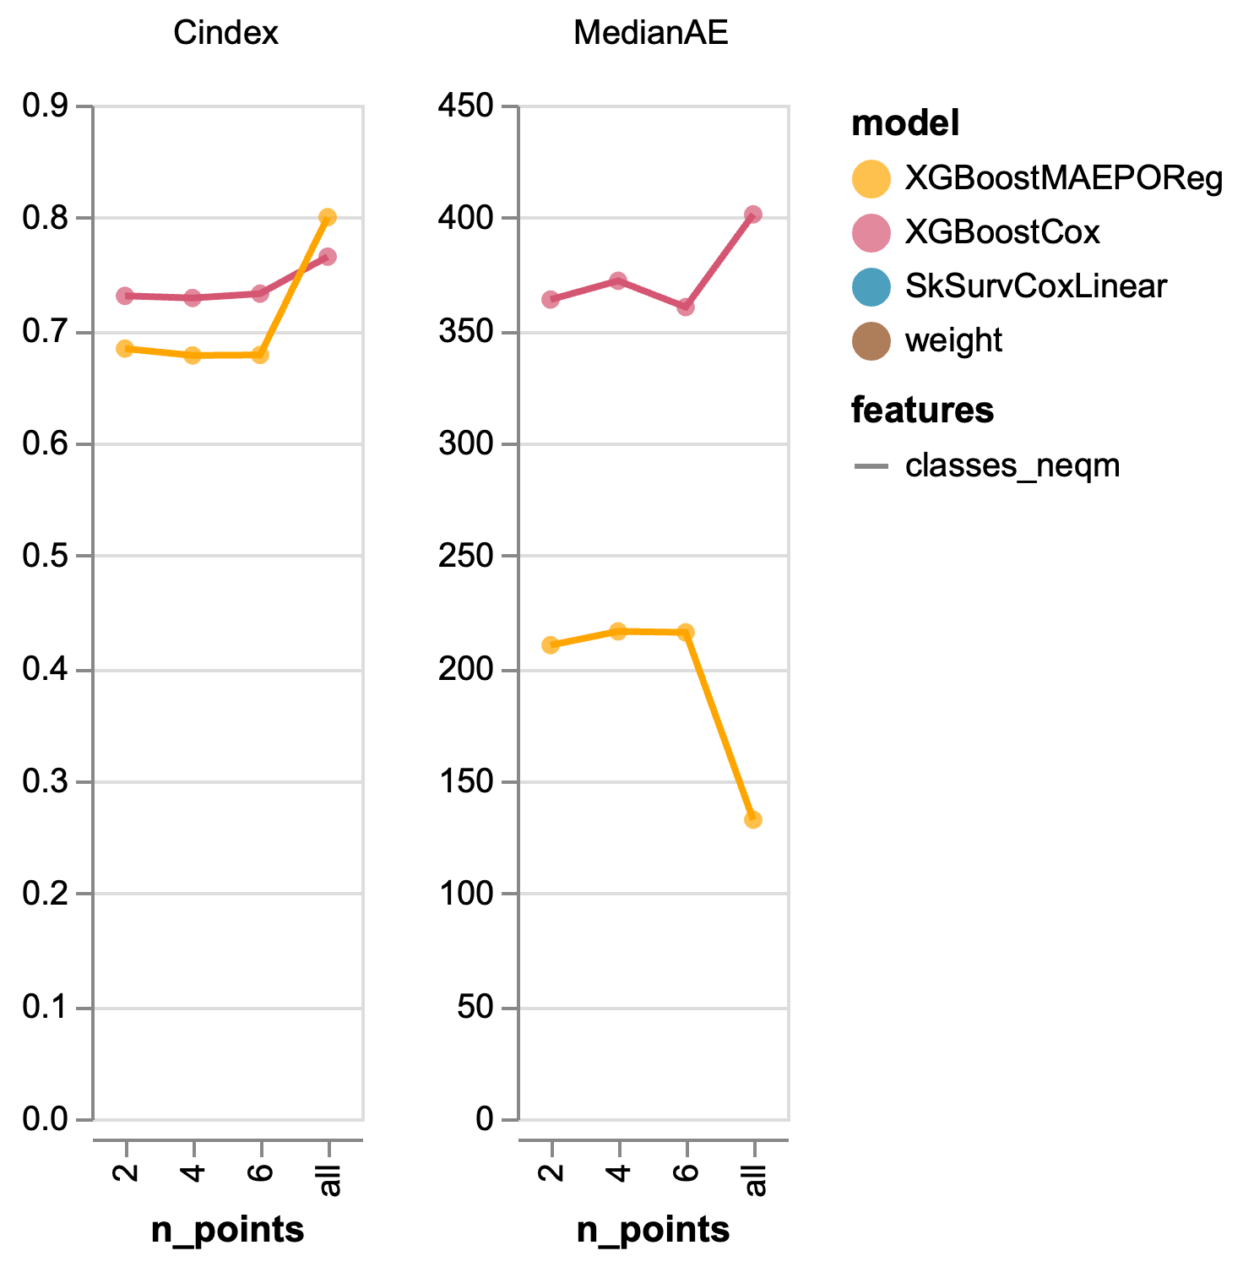
Figure S12: sensitivity analysis – number of longitudinal points
There is a modest increase in performance from 6 points to all points, but it is stable and performant until then, therefore we consider both models to be stable and robust even with 2 longitudinal points. XGBoost Cox model is slightly more stable but less performant.

Sensitivity to missingness of data
We observe that both models are resilient to missingness of data with an increase of 60 days or 26% in Median Absolute Error in the worst-case scenario for XGBoost MAEPO. Again, XGBoost Cox model is slightly more stable but less performant.

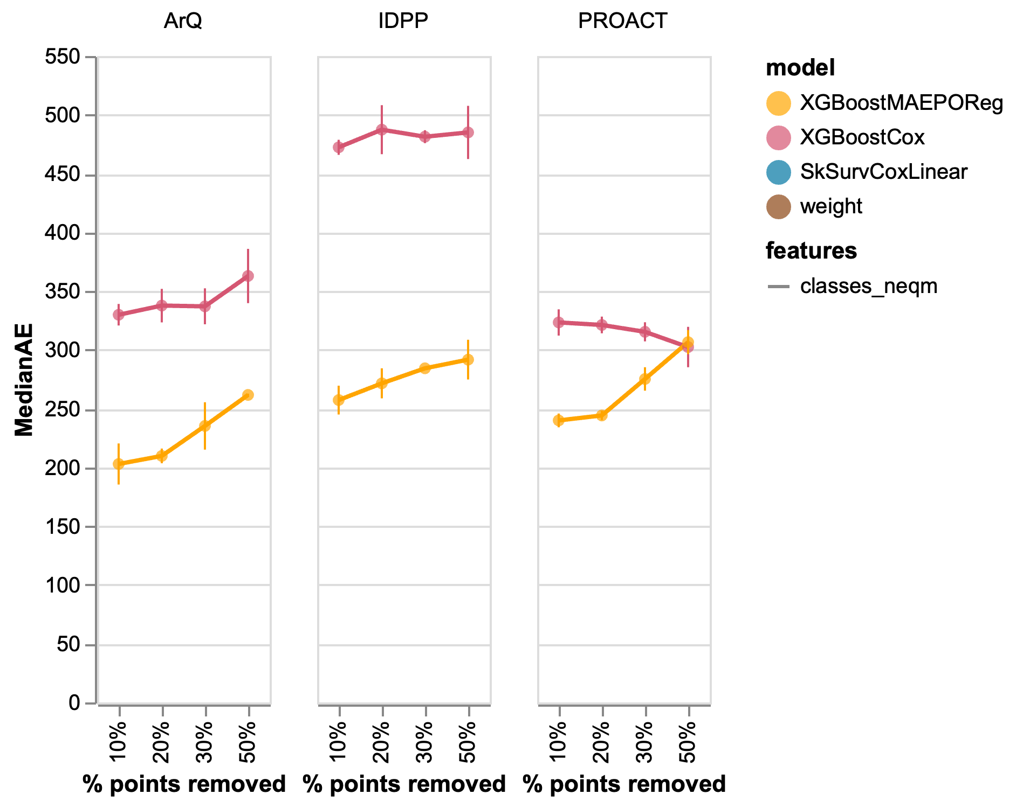
Figure S13: sensitivity analysis to missingness of data (NaNs).

Appendix D: Extra information on the death-gastrostomy comparison
We express the numbers of Figure 5B and those corresponding to the diagonal method in table form Table S6. We also looked at the distribution of points of the two feature model, showing a very large overlap (Figure S15). Figure S16 shows the distribution of points from the diagonal and logistic regression models denoting that the optimal logistic regression shows a vertical split of the data at around 800 days. Figure S17 shows that the Encals death model has an L-shaped bias as opposed to our model.

Table S5: numeric values of likelihood of gastrostomy compared to death
Method | Predicted label | True label | %
Diagonal | Gastrostomy | Loss follow up | 60%
 |  | Death | 58%
 |  | Gastrostomy | 73%
 | Death | Loss follow up | 40%
 |  | Death | 42%
 |  | Gastrostomy | 27%
Logistic regression | Gastrostomy | Gastrostomy | 44%
 |  | Loss follow up | 20%
 |  | Death | 25%
 | Death | Loss follow up | 80%
 |  | Death | 75%
 |  | Gastrostomy | 56%

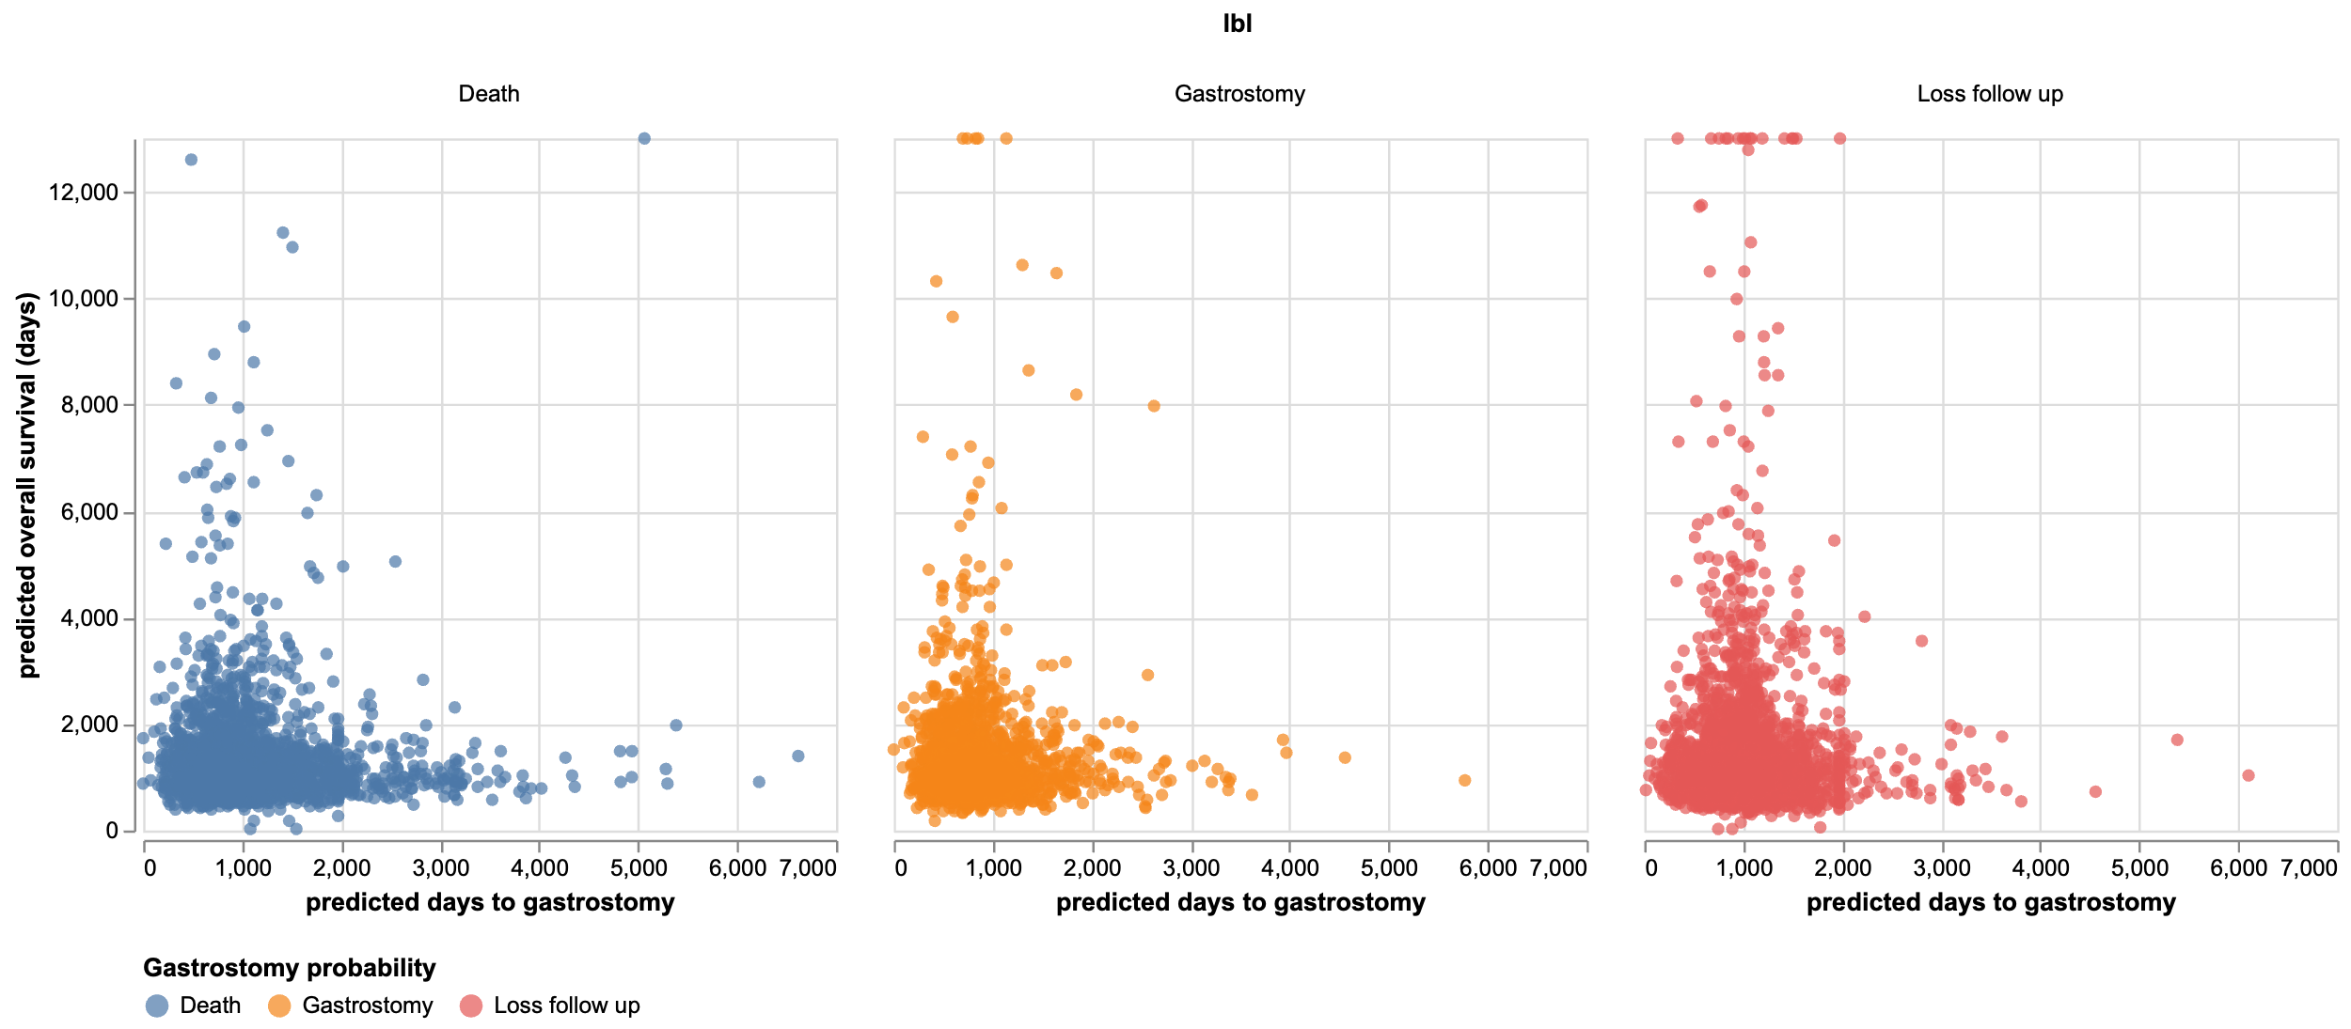
Figure S14: breakdown by true label of gastrostomy / death prediction for the XGBoost MAEPO model & Encals. Distributions show clear overlap between groups

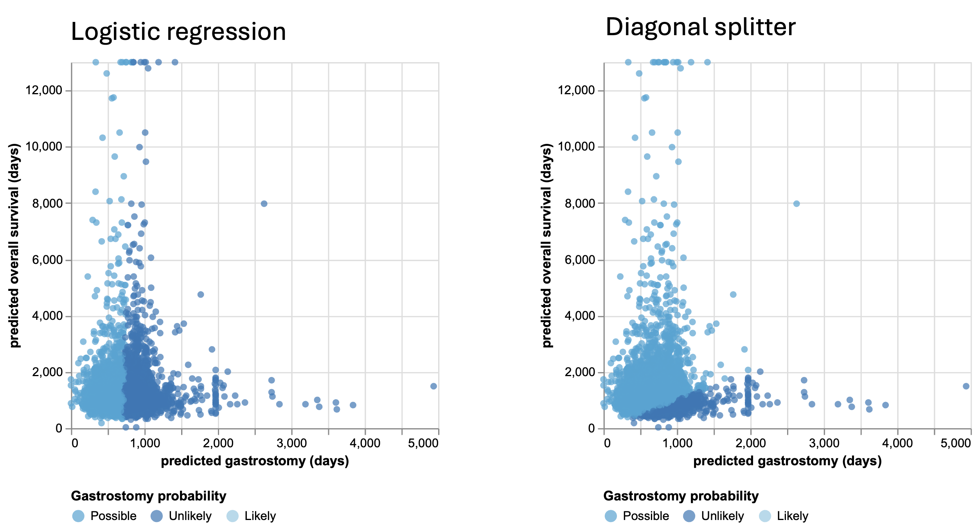
Figure S15: Comparison of logistic regression predictions and a simple diagonal splitter.
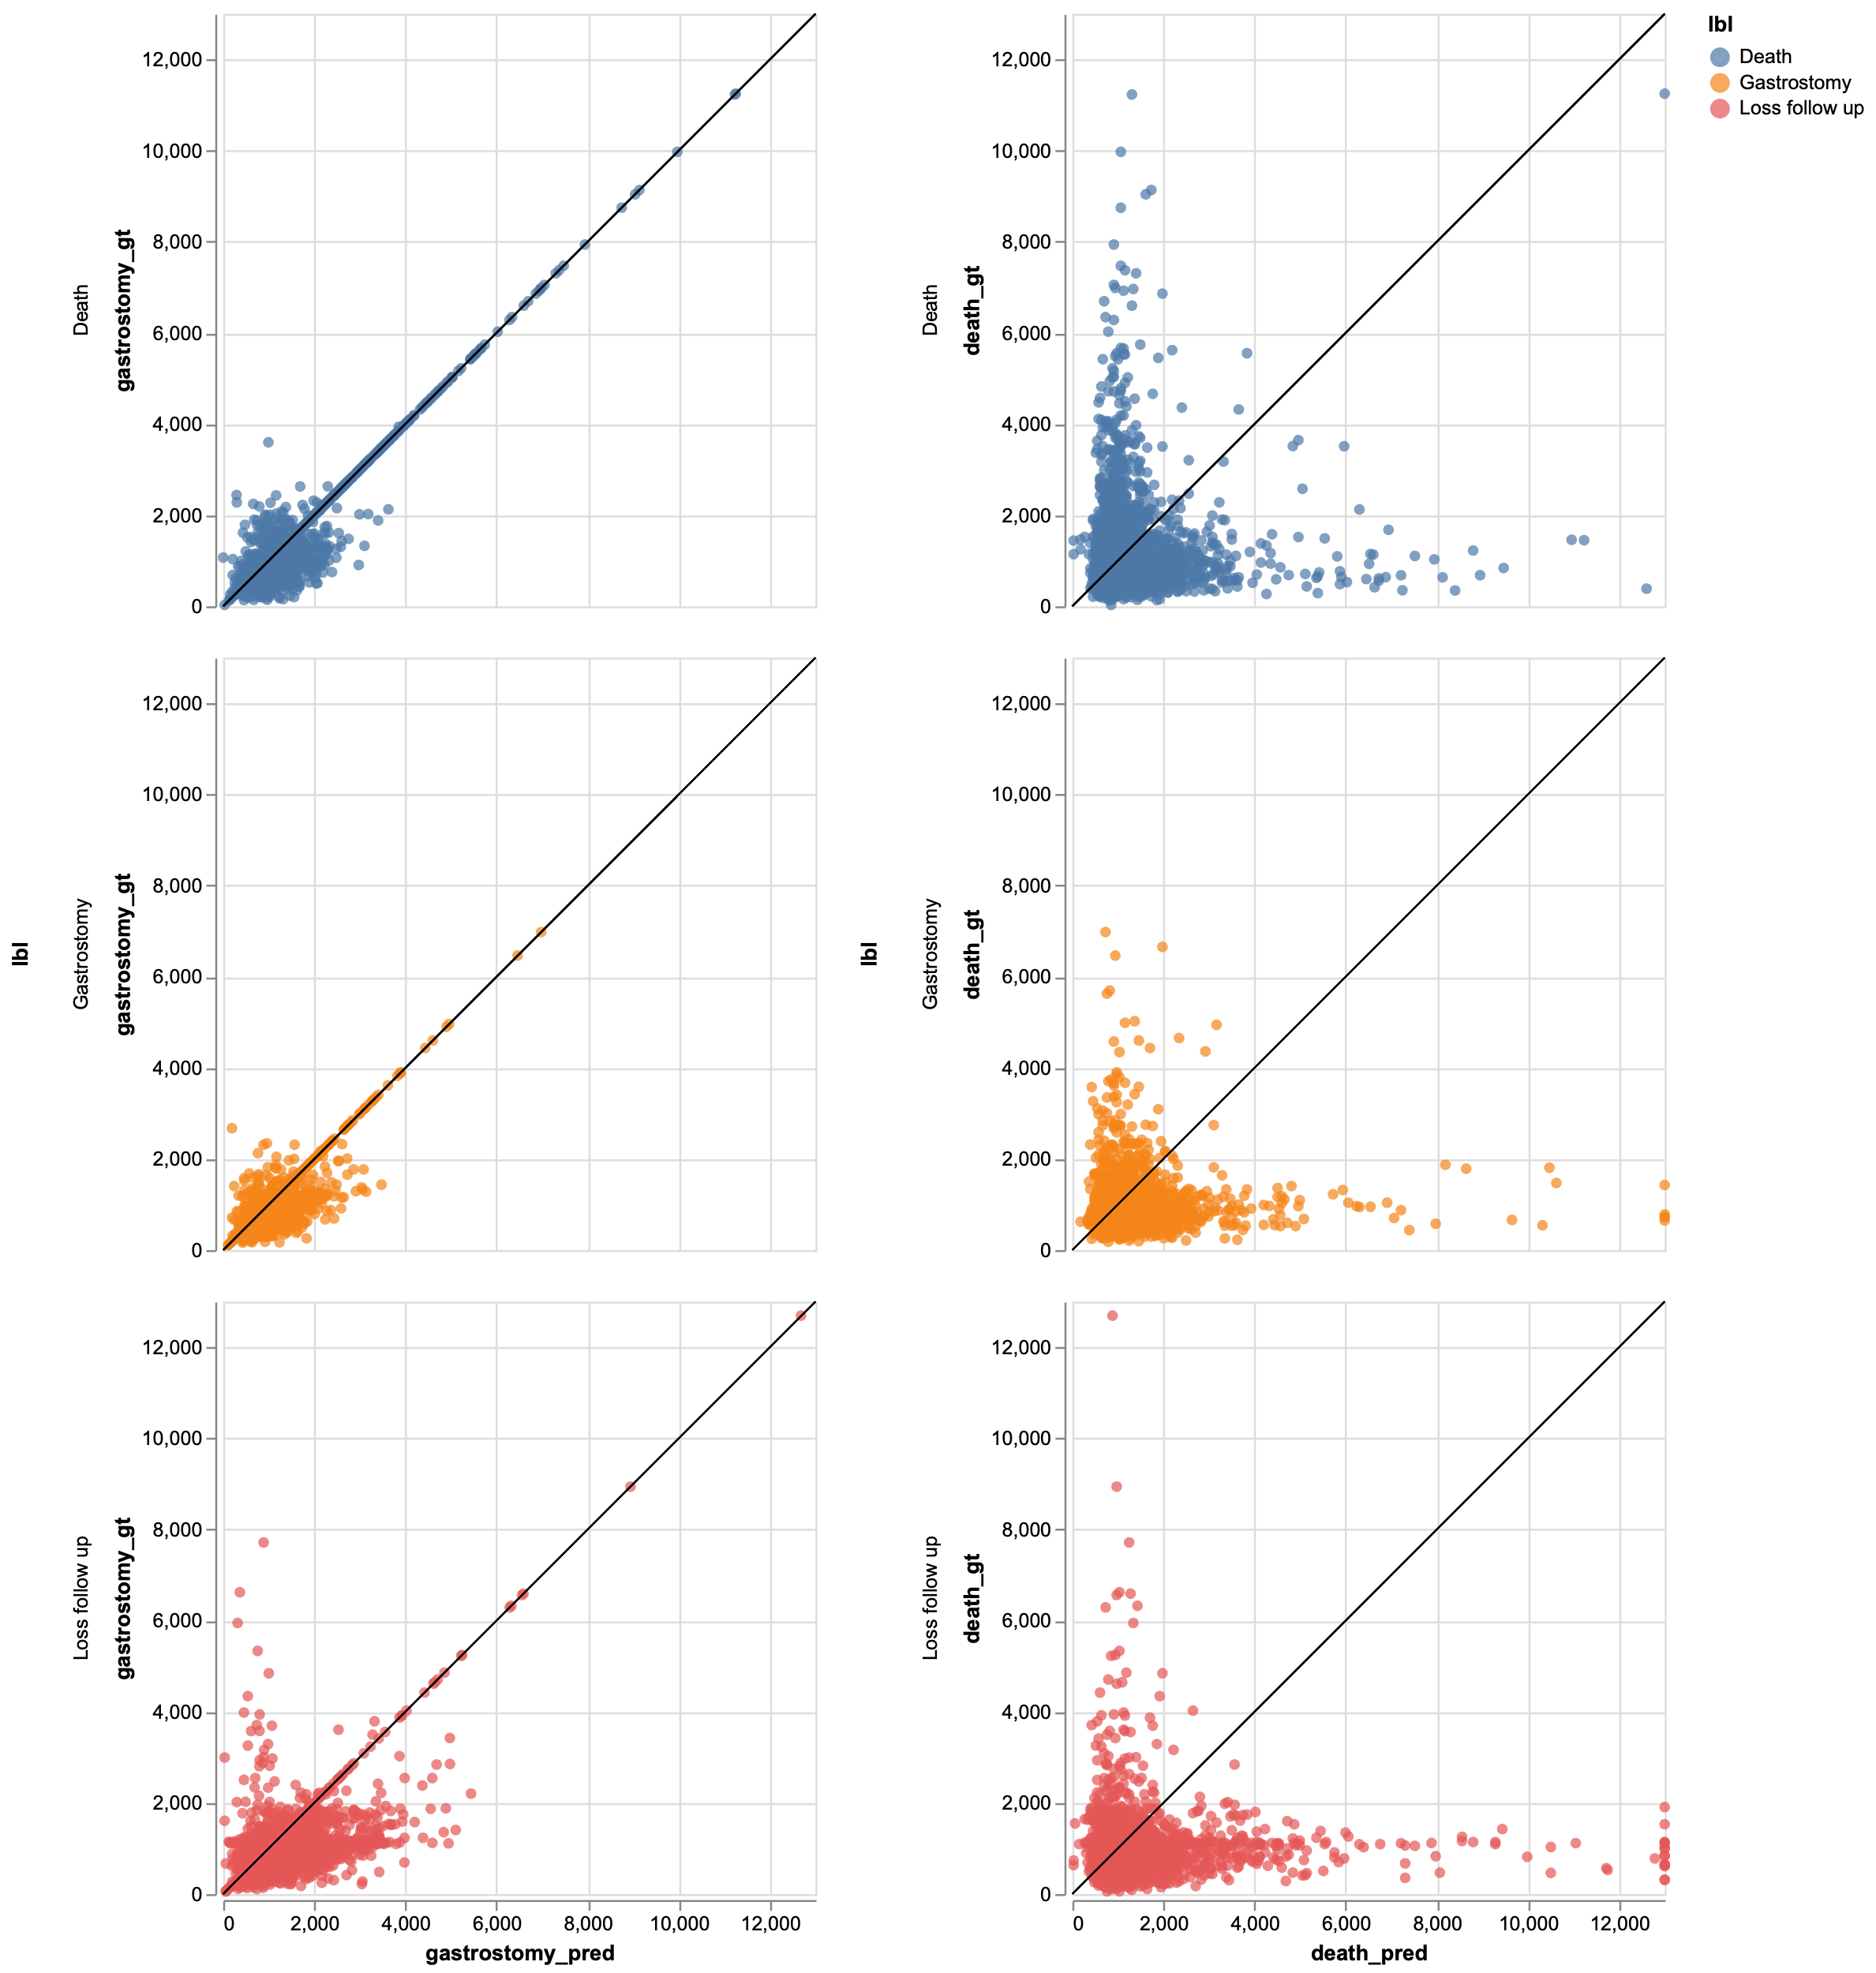
Figure S16: breakdown by label of gastrostomy / death prediction for the XGBoost MAEPO model & Encals death model compared to ground truth.

Appendix E: Extra information on App
The upload csv should contain the following fields:
Table S6: csv structure for upload into app
Column name | Description | Units | Data type
numid | Patient number |  | Integer
days_from_onset | Days from symptom onset | days | Integer
ALSFRS | ALSFRS-R total score |  | Integer (0-48)
Weight | Weight | Kg | Float (0+)
Resp100 | Vital Capacity | % | Float (0-100)
Q3 | Swallow function score |  | Integer (0-4)
Bulbar | Bulbar score |  | Integer (0-12)
Age | Age at onset |  | Float
Sex | Sex assigned at birth |  | String (Male/Female/Other)
diagnostic_delay_months | Delay in diagnosis | Months | Floart
site_onset | Site of symptom onset |  | String  (Bulbar/Spinal/Generalised/Other)
el_escorial | El Escorial score |  | String  (Definite/Other)
c9orf72 | Mutation c9orf72 |  | String  (Present/No Present/Other)
ftd | Fronto-temporal dementia |  | String  (Present/No Present/Other)

The tool we created is for research purposes only and its characteristics can be read below:
Purpose:
- Used for analysing ALS patient data, likely to track disease progression, predict outcomes, and possibly support clinical decision-making.
Features:
- Data Input: Users can enter patient data manually or upload it via a CSV file. The data fields include:
  - Patient ID
  - Days from onset
  - ALS-FRS score (ALS Functional Rating Scale)
  - Weight
  - Q3 (likely a measure of respiratory function)
  - Bulbar (related to bulbar muscle involvement)
  - Age at onset
  - Sex
  - El Escorial
  - c9orf72 mutation
  - Fronto-temporal dementia
  - Diagnostic delay
  - Site of onset
  - ALS-FRS slope
  - Bulbar slope
- Data Visualization: The tool displays several graphs and charts, including:
  - ALS-FRS: Shows the decline of ALS-FRS score over time.
  - Weight: Tracks changes in patient weight.
  - Q3: Likely represents changes in respiratory function.
  - Bulbar: Shows the progression of bulbar muscle involvement.
  - Survival: Plots survival curves for different patient groups.
- Data Analysis: The tool likely performs various calculations and statistical analyses on the input data, such as:
  - Calculating slopes of disease progression.
  - Estimating survival probabilities.
  - Identifying potential prognostic factors.
Potential Use Cases:
- Clinical Research: Researchers can use this tool to analyse large datasets of ALS patients, identify patterns, and gain insights into disease progression.
- Clinical Practice: Clinicians can use the tool to track individual patient progress, make treatment decisions, and potentially predict outcomes.
- Drug Development: Pharmaceutical companies can use the tool to evaluate the efficacy of new treatments by analysing patient data.
Overall, ALS Analytics seems to be a valuable tool for researchers and clinicians working in the field of ALS. It provides a user-friendly interface for data input and visualization, as well as powerful analysis capabilities.

Appendix F: Consortium disclosure
§ Data used in the preparation of this article were obtained from the Pooled Resource Open-Access ALS Clinical Trials (PRO-ACT) Database. As such, the following organizations and individuals within the PRO-ACT Consortium contributed to the design and implementation of the PRO-ACT Database and/or provided data, but did not participate in the analysis of the data or the writing of this report:
- ALS Therapy Alliance
- Cytokinetics, Inc.
- Amylyx Pharmaceuticals, Inc.
- Knopp Biosciences
- Neuraltus Pharmaceuticals, Inc.
- Neurological Clinical Research Institute, MGH
- Northeast ALS Consortium
- Novartis
- Orion Corporation
- Prize4Life Israel
- Regeneron Pharmaceuticals, Inc.
- Sanofi
- Teva Pharmaceutical Industries, Ltd.
- The ALS Association

References

1 Deo, S. V., Deo, V. & Sundaram, V. Survival analysis-part 2: Cox proportional hazards model. Indian J Thorac Cardiovasc Surg 37, 229-233 (2021). https://doi.org/10.1007/s12055-020-01108-7
2 Chen, T. G., T. XGBoost: A Scalable Tree Boosting System. (2016). https://doi.org/https://doi.org/10.48550/arXiv.1603.02754
3 Barnwal, A. C., H; Hocking, T D. Survival regression with accelerated failure time model in XGBoost. (2020). https://doi.org/https://doi.org/10.48550/arXiv.2006.04920

