Supplementary information
Table S1. Characterization data of the different porous materials in terms of shrinkage, density (pure cellulose), density (PLA-coated), and PLA gain. Letters indicate statistically significant differences between samples (p ≤ 0.05).
 | FOAM 1% | FOAM 2% | LYOPH 1% | LYOPH 2% | SC 1% | SC 2%
Density (mg/cm³) | 47.0 ± 8.7^{b} | 40.3 ± 5.9^{b} | 12.4 ± 2.0ª | 23.3 ± 1.1ª | 62.3 ± 10.9^{c} | 69.6 ± 8.8^{c}
Shrinkage (%) | 78.8 ± 3.1e | 52.0 ± 8.7^{c} | 24.2 ± 1.6^{b} | 13.8 ± 6.8ª | 78.2 ± 3.3e | 68.0 ± 4.3^{d}
Density +PLA (mg/cm³) | 106.3 ± 2.2^{c} | 82.8 ± 12.8^{abc} | 71.7 ± 9.5^{ab} | 67.8 ± 5.4ª | 93.5 ± 3.7^{bc} | 104.4 ± 4.0^{c}
PLA  (%) | 20.2 ± 6.8ª | 33.2 ± 5.8^{ab} | 70.9 ± 4.4^{c} | 47.7 ± 1.7^{b} | 41.1 ± 2.5^{ab} | 23.7 ± 6.9ª

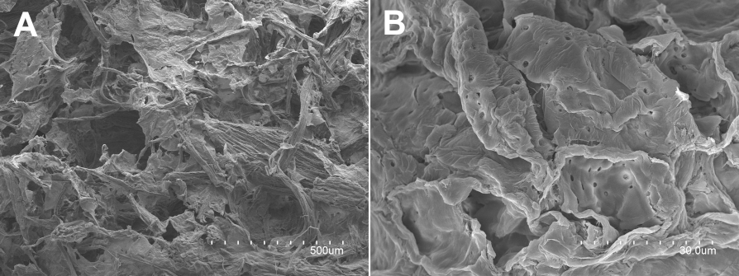Figure S1. SEM images of supercritical aerogels produced with an alternative method. The cellulose suspension was frozen before adding the citric acid, which results in an easier to manipulate aqueous gel and ultimately in an aerogel with intermediate properties between lyophilized and supercritical aerogels. Scale markers: A: 500 µm; B: 30.0 µm.

