Supplementary Information

Combined land cover (this study) | ESA WorldCover class | ESVD biome type | Backshore and hinterland area (‘000 km²) | Value (billion USD) | Value per ha (USD) | % sandy*
Coastal systems | Bare/sparse vegetation / Permanent water bodies / Herbaceous wetland** | Coastal systems | 20.7 | 86.7 | 41,809 | 49
Mangroves | Mangroves | Mangroves | 11.8 | 107.1 | 90,437 | 15
Permanent water bodies | Permanent water bodies | Rivers and lakes | 44.4 | 172.2 | 38,816 | 40
Herbaceous wetland | Herbaceous wetland | Inland wetlands | 29.0 | 114.6 | 39,479 | 45
Tropical forest | Tree cover*** | Tropical and subtropical forests | 53.8 | 51.0 | 9477 | 14
Temperate forest | Tree cover*** | Temperate forest and woodland | 90.4 | 163.4 | 18,069 | 27
Boreal forest | Tree cover*** | Boreal and montane forests & woodland | 104.3 | 67.3 | 6451 | 32
Shrubland | Shrubland / Tree cover*** | Shrubland and shrubby woodland | 68.6 | 5.8 | 845 | 67
Grassland | Grassland | Rangeland, natural grasslands and savannas | 227.3 | 156.5 | 6887 | 45
Cropland | Cropland | Intensive land uses | 56.5 | 113.8 | 20,147 | 47
Bare/sparse vegetation | Bare/sparse vegetation | Polar-alpine | 181.1 | 37.2 | 2053 | 82
Snow and ice | Snow and ice | Polar-alpine | 4.2 | 0.9 | 2053 | 59
Moss and lichen | Moss and lichen | Polar-alpine | 10.7 | 2.2 | 2053 | 57
Built-up | Built-up | Urban and industrial areas | 56.9 | –**** | –**** | 73
Total |  |  | 959.7 | 1078.7 | 11,239 | 34
Supplementary Table 1. Land cover classes considered in the study, combining ESA WorldCover (Zanaga et al. 2021) and ESVD biomes (Brander et al. 2024). Summary statistics refer to the sandy coastal zone identified in this study. Notes: * % of coastal zone area along sandy shorelines relative to the entire coastal zone within 4 km of the shoreline. ** if located before the first coastal peak (Athanasiou et al. 2024). *** depending on the climate zone (Beck et al. 2023); **** assumed to have zero value, differently from ESVD.

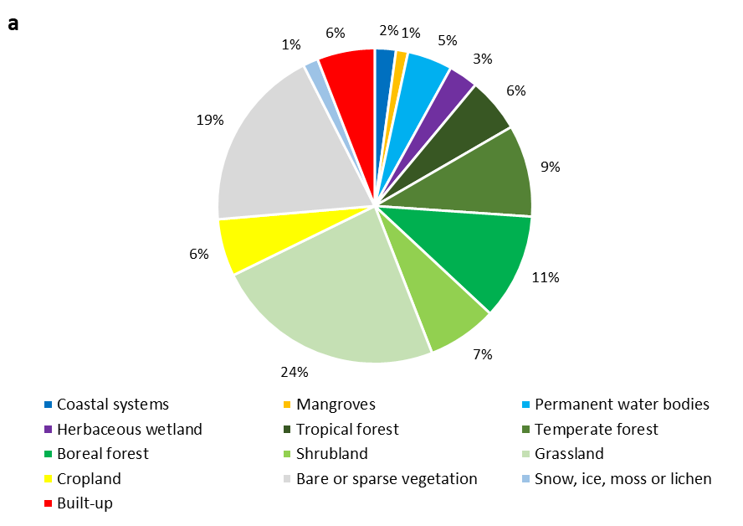
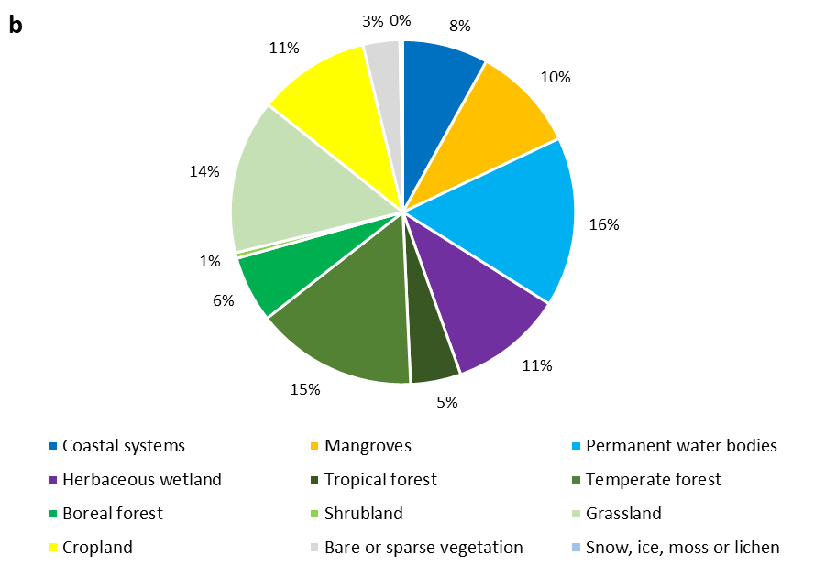
Supplementary Figure S1. Share of different land cover types in (a) total sandy coastal zone area and (b) value of ecosystem services.

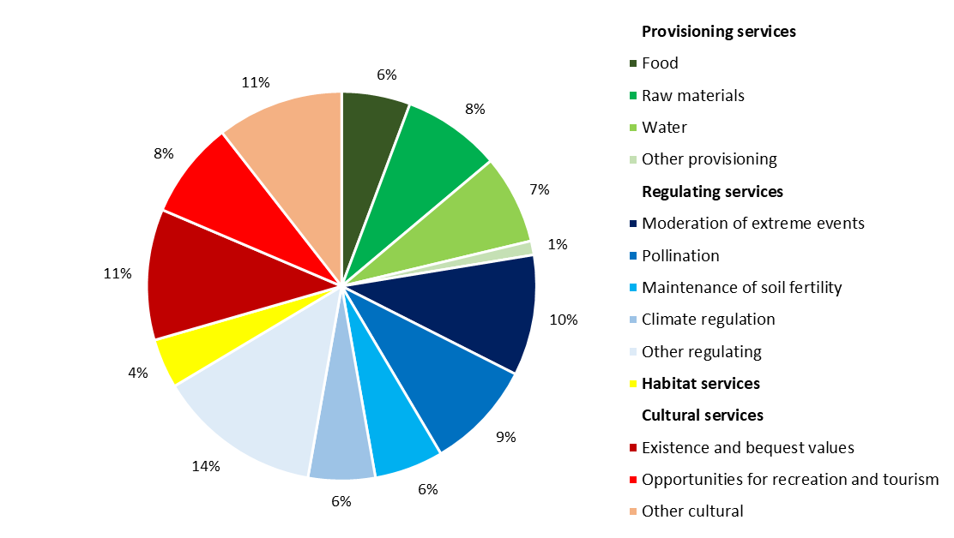
Supplementary Figure S2. Share of sandy coast ecosystem services (SCES) by types, with most important subcategories (by present value) highlighted.

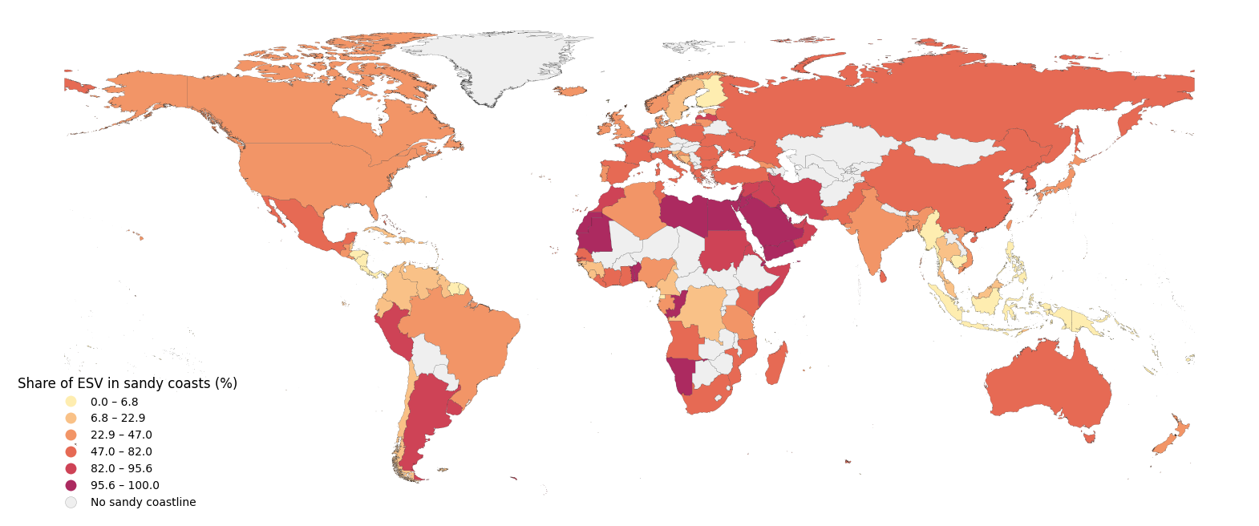
Supplementary Figure S3. Share of present value of SCES as % of ecosystem services in all coastal zones, by country.

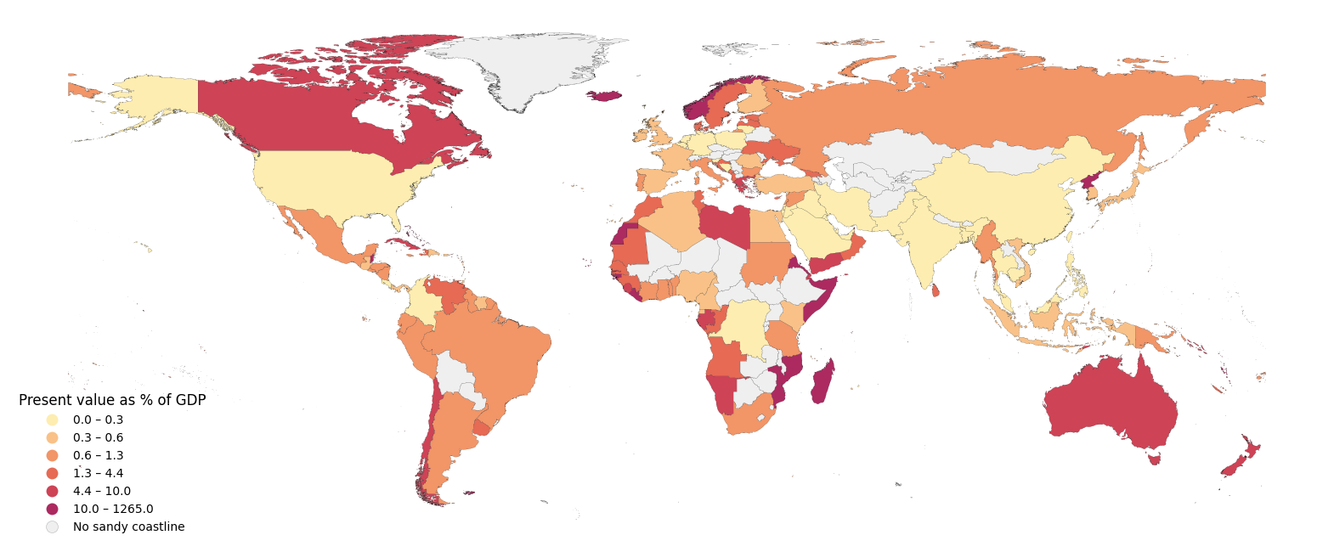
Supplementary Figure S4. Relative present value of SCES by country as % of gross domestic product (GDP).

Supplementary Text S1. Sensitivity analysis. As detailed above, we quantified the uncertainty related to ecosystem service valuation and the erosion projections (Supplementary Fig. S6a). We further analysed the sensitivity of the results to various other model assumptions (Supplementary Fig. S6b). In the study, we use the maximum elevation between the two digital elevation models (DEMs). This results in a more conservative estimate, 4-7% lower than when using any of the two DEMs separately. We assumed that the topographical barrier equals an elevation of 10 m (typically assumed limit of coastal zones), but changing it to either 5 or 20 m influences the results only by a few percent. The results are also not very sensitive to artificial barriers, at least on a global scale. The lack of coastal squeeze due to build-up areas would allow more backshore migration, but cause more losses in the hinterland and also have limited benefit where topography anyway creates a barrier to erosion. Without any constraints to beach migration, losses would be 8-14% higher, as less erosion to coastal systems would be offset by much higher loss of all other biomes (by more than 50% in the most extreme scenario). The effect would be further compounded without beach migration: unlimited erosion and no migration would nearly double the estimated losses (Supplementary Fig. S6b).

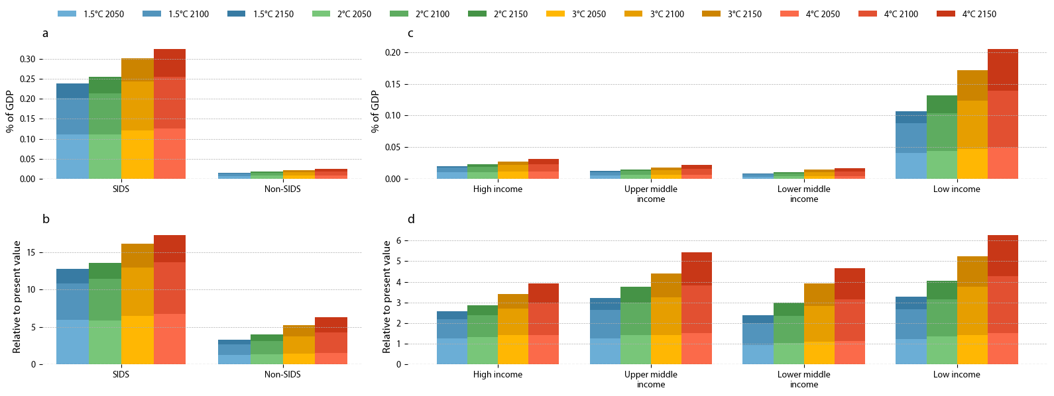
Supplementary Figure S5. Loss of SCES by country groups relative to GDP (a,b) and relative to existing value in % (c,d). Countries are grouped by their Small Island Development States (SIDS) status or lack thereof (a,c) and by World Bank income groups (b,d). Colors indicate different warming scenarios and the shading indicates timesteps of the analysis (2050, 2100, 2150).

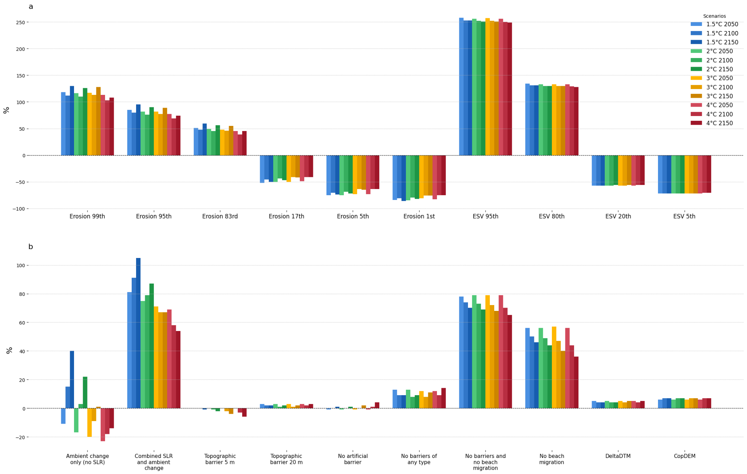
Supplementary Figure S6. Uncertainty and sensitivity of the absolute ecosystem service losses, as % difference from the main scenario. Uncertainty is quantified for different percentiles of the erosion model (Erosion) and ecosystem service valuation (ESV) (a). Sensitivity analysis indicates the effect of various alternative model assumptions on the results (b).

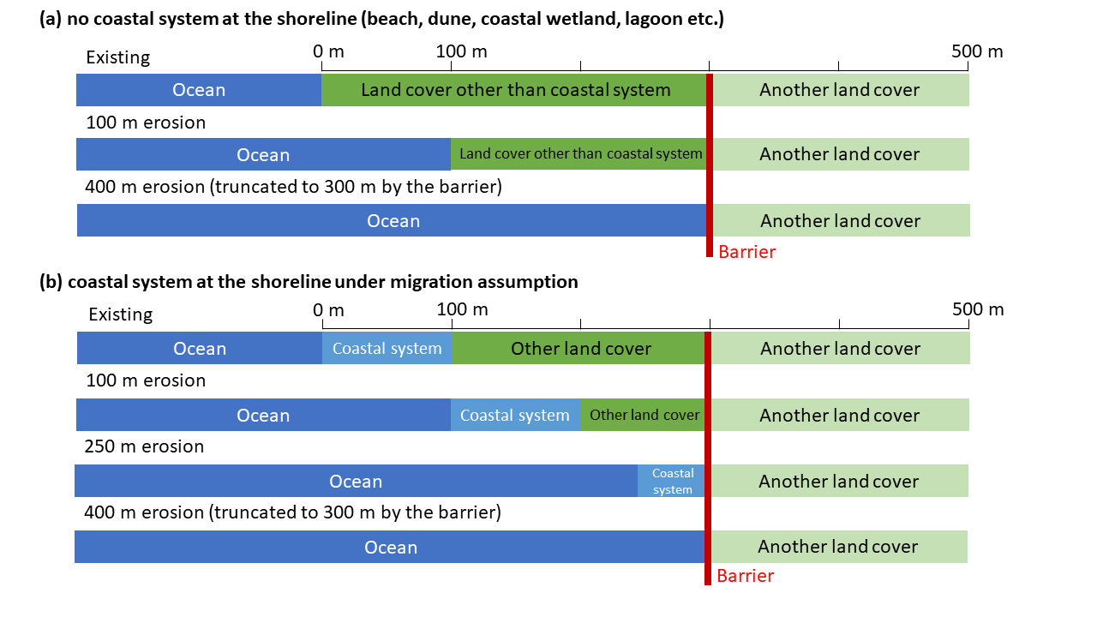
Supplementary Figure S7. Erosion of land cover in (a) the absence of a coastal system, and (b) in the presence of a coastal system under backshore migration assumption.

