Table S1 The basic soil properties of the site sampled at 0–45 cm depth in 2020
Treatment | Year | Available  nitrogen  (mg/kg) | Available  phosphorus  (mg/kg) | Available  potassium  (mg/kg) | Organic  carbon  (g/kg)
Farmers' shallow rotation  （CK） | 2021 | 53.07 | 2.56 | 66.06 | 18.81
Straw incorporated with deep tillage  (DPR) | 2021 | 70.343 | 3.83 | 117.02 | 26.55
straw incorporated with subsoiling  (SSR) | 2021 | 74.16 | 3.49 | 99.02 | 25.48
no-tillage mulching straw return  (NTR) | 2021 | 73.19 | 4.67 | 91.08 | 25.40

Type | Carbon source | Location | Type | Carbon source | Location
Carbohydrates | β-methyl-D-glucoside | H1 | Polymer category | Tween 40 | C1
Carbohydrates | D-xylulose / pentose sugar | G1 | Polymer category | Tween 80 | D1
Carbohydrates | i-erythritol | C2 | Polymer category | α-Cyclodextrin | E1
Carbohydrates | D-mannitol | B2 | Polymer category | Lactose in liver | F1
Carbohydrates | N-acetyl-D-glucosamine | E2 | Phenolic acids | 2-Hydroxybenzoic acid | C3
Carbohydrates | D-fructose dimer | D2 | Phenolic acids | 4-Hydroxybenzoic acid | D3
Carbohydrates | α-D-galactose | H1 | Amines | Phenylethylamine | G4
Carbohydrates | D-galacturonic acid γ-lactone | A3 | Amines | Putrescine | F4
Carbohydrates | D,L-α-phosphoglycerate | H2 | Carboxylic acids | γ-Hydroxybutyric acid | E3
Carbohydrates | 1-phosphoglucose | C2 | Carboxylic acids | α-Butanone acid | G3
Amino acids | L-Arginine | A4 | Carboxylic acids | D-Glucamine acid | F2
Amino acids | L-Asparagine | B4 | Carboxylic acids | D-Glumatic acid | B3
Amino acids | L-Phenylalanine | C4 | Carboxylic acids | D-Galacturonic acid | H3
Amino acids | L-Serine | D4 | Carboxylic acids | Methyl pyruvic acid | B2
Amino acids | L-Threonine | E4 | Carboxylic acids | Valencic acid | F3
Amino acids | Glycyl-L-Glutamic acid | F4 | Blank control |  | A1
TableS2 Carbon sources in Biolog-ECO plates

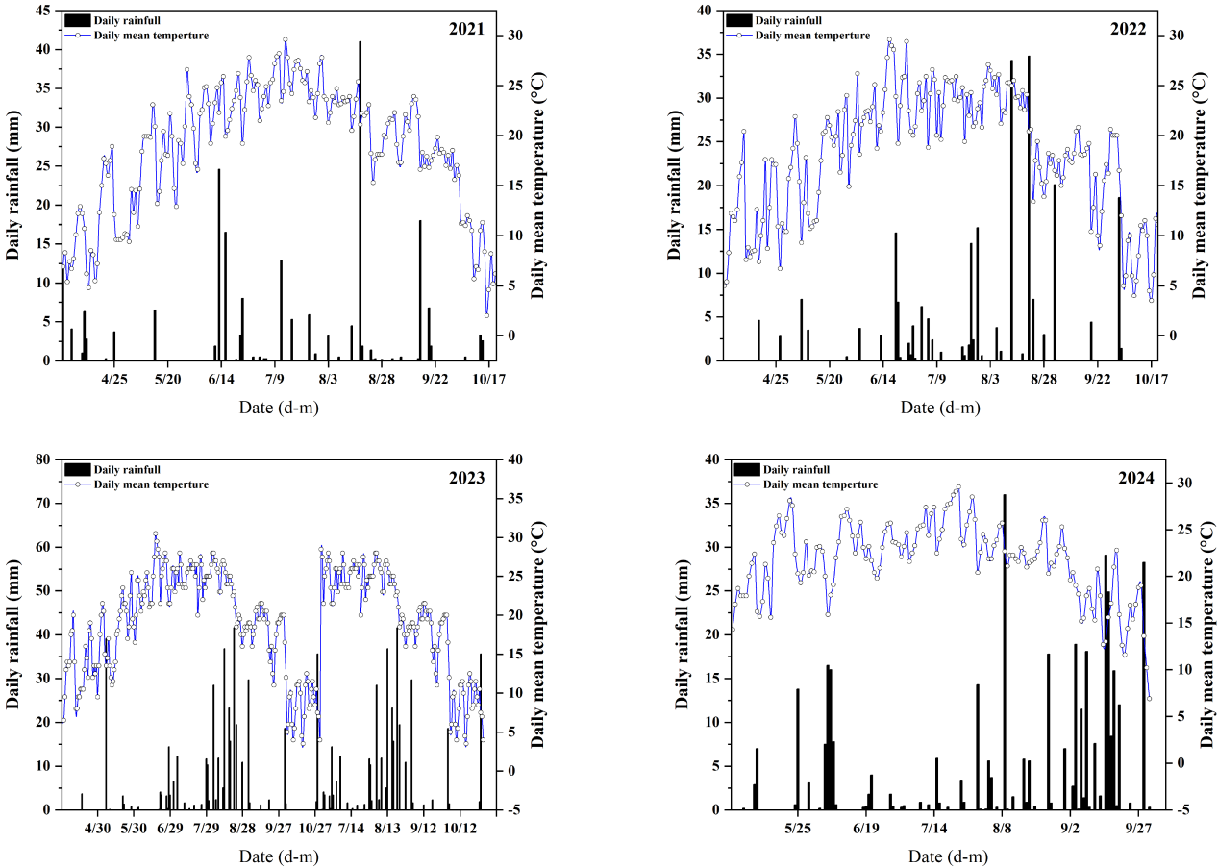
Fig.S1 Main meteorological factors during the growing period in the experimental area
Fig. S2 Soil physical properties of different straw return methods. Error bars indicate standard error of the mean (n = 3). Different lowercase letters on the columns indicate statistically significant differences between treatments, p < 0.05. CK, farmer's shallow rotary; DPR, deep rotary straw pulverized and returned to the field; SSR, deep loosened straw mixed and returned to the field; NTR, no-till straw mulch and returned to the field. Soil bulk density, BD; soil moisture content, SM.

Figure S3 Chemical properties of soil under different straw returning methods. Error bars represent the standard error of the mean (n = 3). Different lowercase letters in columns indicate statistically significant differences among treatments, p < 0.05. CK, shallow tillage and shallow plowing with straw returning; DPR, deep plowing and straw returning after crushing; SSR, deep loosening and straw mixing returning; NTR, no-tillage and straw covering returning. AN, available nitrogen; AK, available potassium; AP, available phosphorus; SOC, soil organic matter; soil total nitrogen; TN.
Figure S4 Average weighted carbon source utilization profiles (AWCD) of soil microorganisms under different straw returning methods. Error bars represent the standard error of the mean (n = 3). Different lowercase letters in the columns indicate statistically significant differences among treatments, p < 0.05. CK, shallow tillage with straw; DPR, deep plowing and straw crushing returning; SSR, deep loosening and straw mixing returning; NTR, no-tillage straw covering returning.

