In vitro anticoagulant and antiviral properties of low molecular weight sulfated chitosan from Loligo duvauceli against herpes simplex virus

Vignesh Narasimman^{1,3} and Saravanan Ramachandran²*

¹Department of Medical Biotechnology, ²Native Medicine & Marine Pharmacology Laboratory, Faculty of Allied Health Sciences, Chettinad Hospital and Research Institute, Chettinad Academy of Research and Education, Kelambakkam-603103, Tamil Nadu, India
³Department of Biotechnology, Karpaga Vinayaga College of Engineering & Technology, Maduranthakam-603308, Tamil Nadu, India.

*Corresponding author
Dr. Saravanan Ramachandran,
Native Medicine & Marine Pharmacology Laboratory,
Faculty of Allied Health Sciences, CHRI,
Chettinad Academy of Research & Education
(Deemed to be University), Kelambakkam-603103, Tamil Nadu, India.
E-mail: saran_prp@yahoo.com
Phone: +91 44 4741 9200

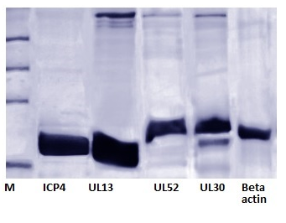
Fig.1S. Western blot analysis (Control)

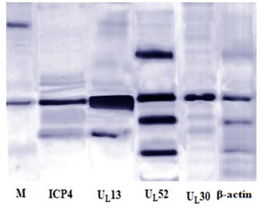
Fig.2S. Western blot analysis (Sample)

