Table 1. Probiotic properties of B. aryabhattai CKNJH11, including enzyme activity, sporulation efficiency, stress tolerance, antimicrobial effects, and safety attributes.

Probiotic properties |  | Bacillus aryabhattai CKNJH11
% Spore efficiency |  |  | 95.65 ± 1.11
% survival rate in acidic pH conditions | pH2 |  | 64.88 ± 0.40
% survival rate in acidic pH conditions | pH3 |  | 84.13 ± 2.31
% survival rate in acidic pH conditions | pH4 |  | 97.85 ± 0.35
% survival rate in bile salt | 1.0% |  | 84.62 ± 0.78
% survival rate in bile salt | 2.5% |  | 84.43 ± 0.73
% survival rate in bile salt | 5.0% |  | 78.06 ± 8.12
% Inhibit biofilm formation | V. parahaemolyticus |  | 59.89 ± 6.49
% Inhibit biofilm formation | P. aeruginosa |  | 58.27 ± 3.17
% Inhibit biofilm formation | S. aureus |  | 31.91 ± 6.25
% Inhibit biofilm formation | B. subtilis |  | Not detected
% Salinity | 0.5 |  | 99.08 ± 0.94
% Salinity | 1.0 |  | 92.43 ± 10.74
% Salinity | 2.0 |  | 92.43 ± 10.74
% Salinity | 3.0 |  | 90.42 ± 9.65
Antibiotic susceptibility | Ampicillin (10 µg/disc) |  | S
Antibiotic susceptibility | Tetracycline (30 µg/disc) |  | S
Antibiotic susceptibility | Amoxicillin (30 µg/disc) |  | M
Antibiotic susceptibility | Cloxacillin (1 µg/disc) |  | S
S, susceptibility; M, moderate susceptibility; and R, resistance
Table 2. Morphological characteristics of B. aryabhattai CKNJH11 based on Gram staining, cell shape, spore formation, and colony morphology.

Samples | Isolate | Colony characteristics | Shape | Gram
Shrimp pond soil | CKNJH11 | 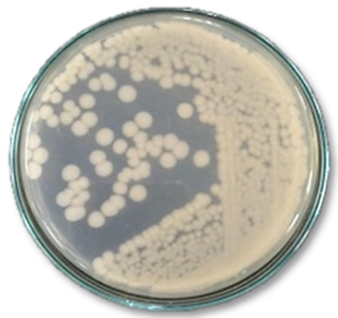 | 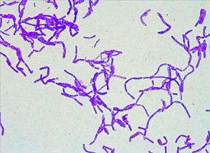 | +
Note: “+” Gram-positive bacterium

