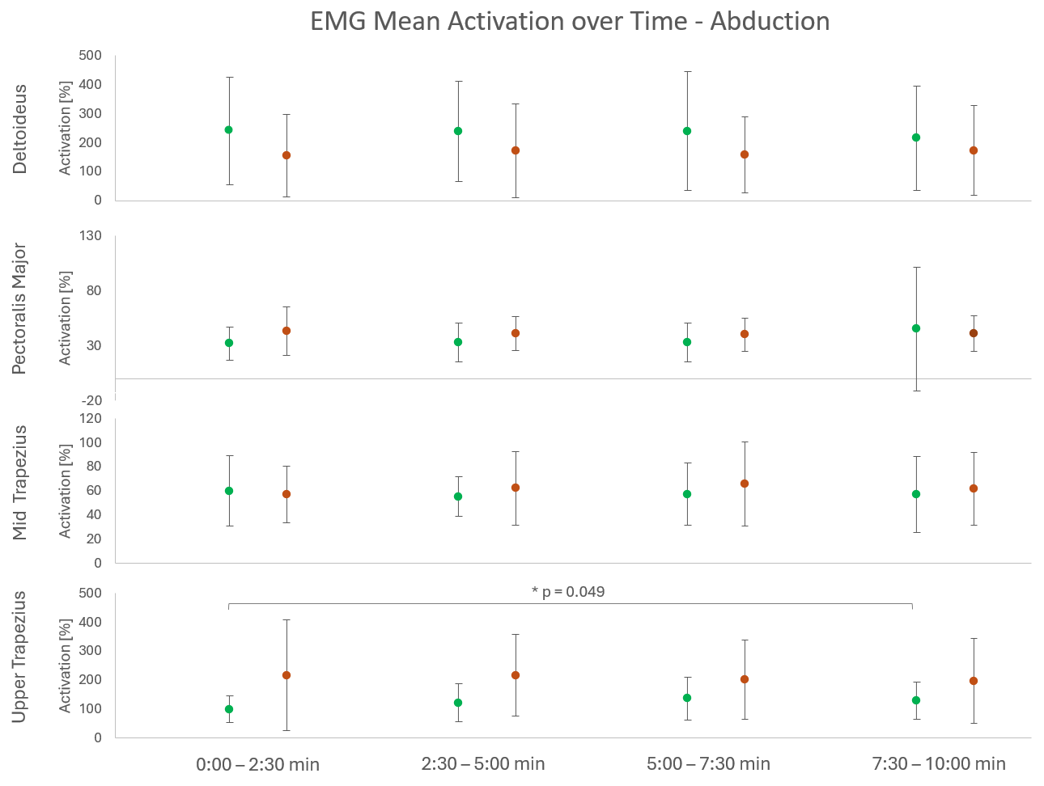
Appendix
Figure S5 - Mean relative muscular activation (±SD) in % relative to activation during rest of the four muscles (Deltoideus, Pectoralis Major, Mid Trapezius and Upper Trapezius) of both the healthy and injured side over the four measurement intervals (overall 10 min) during the abduction and adduction motion.

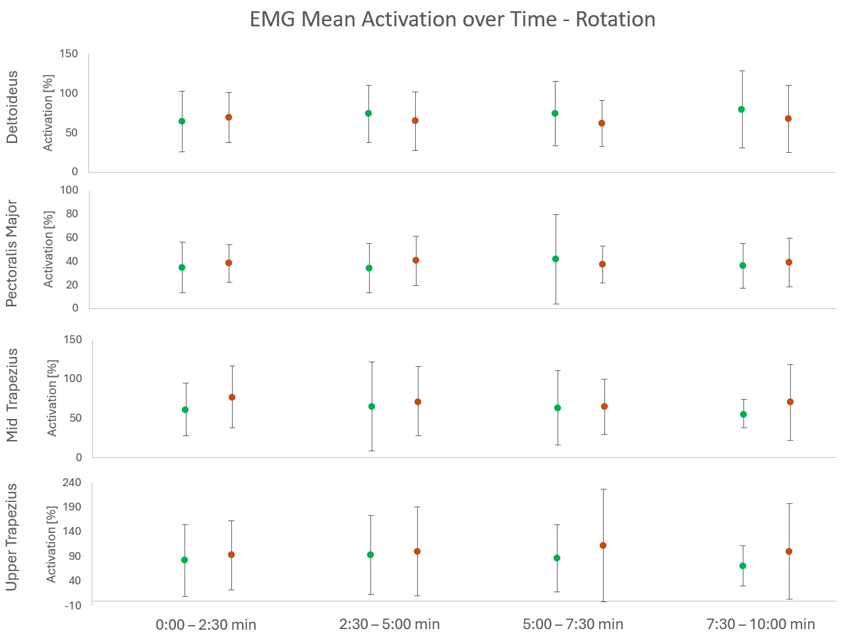
Figure S6 - Mean relative muscular activation (±SD) in % relative to activation during rest of the four muscles (Deltoideus, Pectoralis Major, Mid Trapezius and Upper Trapezius) of both the healthy and injured side over the four measurement intervals (overall 10 min) during the rotation motion.

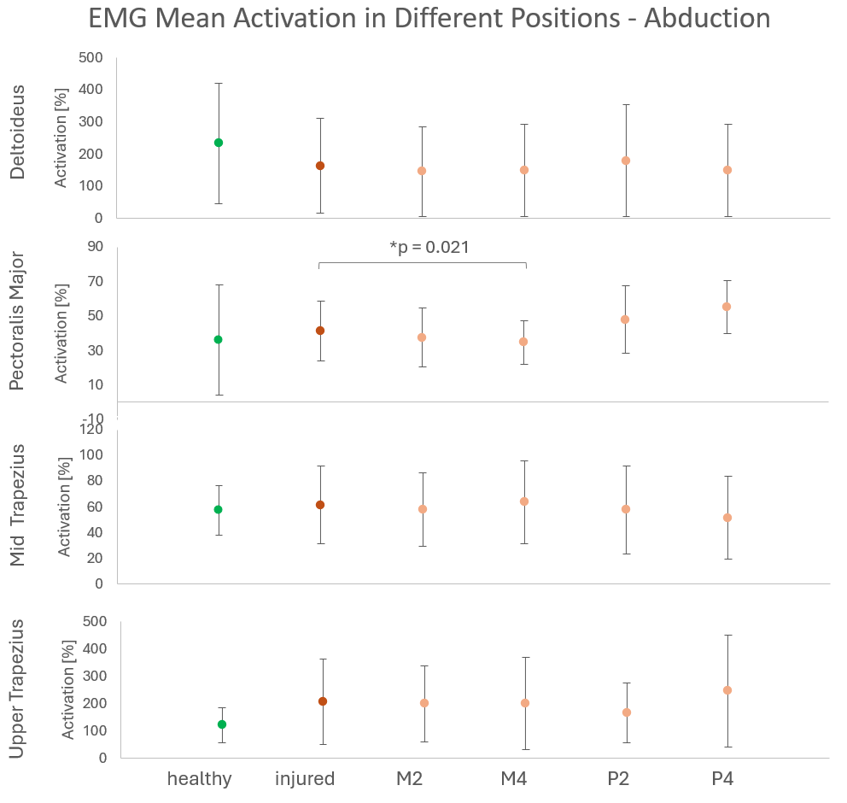
Figure S7 - Mean relative muscular activation (±SD) in % relative to activation during rest of the four muscles (Deltoideus, Pectoralis Major, Mid Trapezius and Upper Trapezius) of both the healthy and injured side as well as the trials in the different positions (m2, m4, p2, p4) during the abduction and adduction motion.

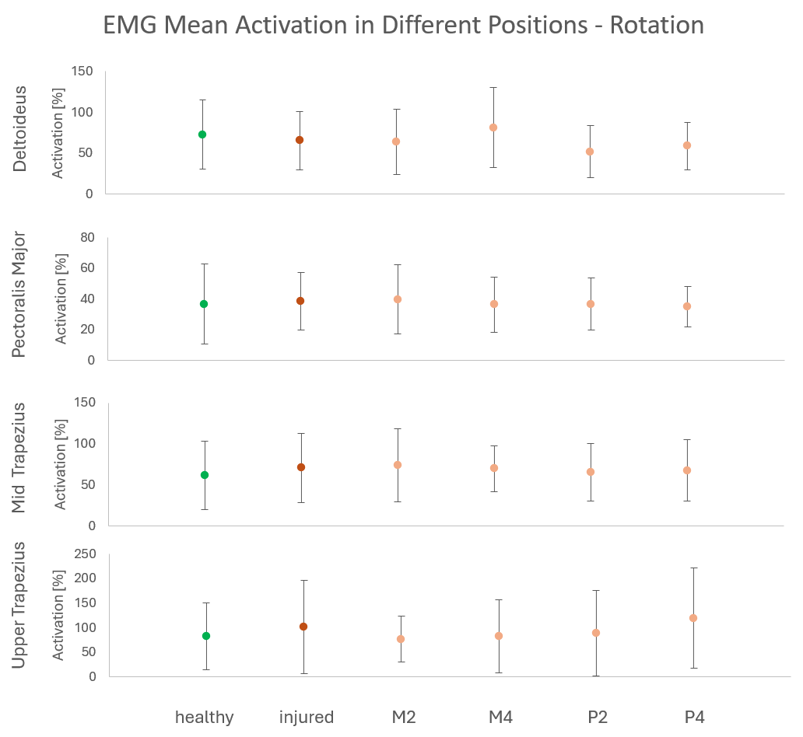
Figure S8 - Mean relative muscular activation (±SD) in % relative to activation during rest of the four muscles (Deltoideus, Pectoralis Major, Mid Trapezius and Upper Trapezius) of both the healthy and injured side as well as the trials in the different positions (m2, m4, p2, p4) during the rotation motion.

