Graph-1: Prevalence of health conditions of surveyed individuals

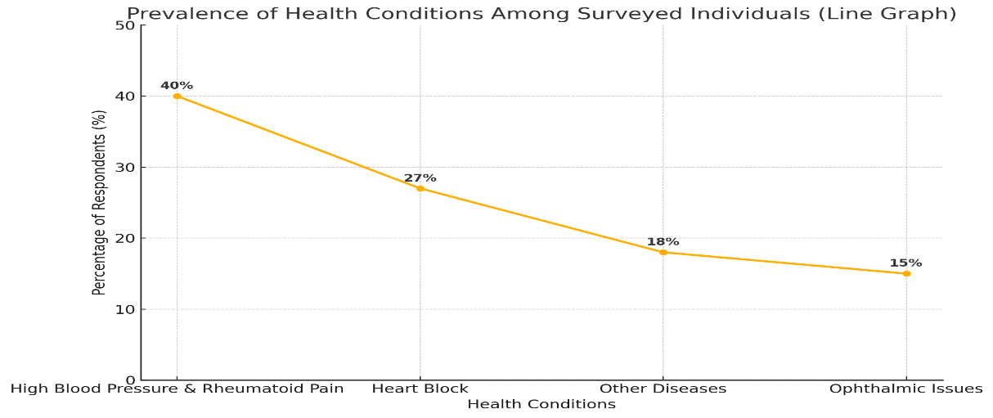

Graph-2: Access to medical treatment of respondents (older adults)

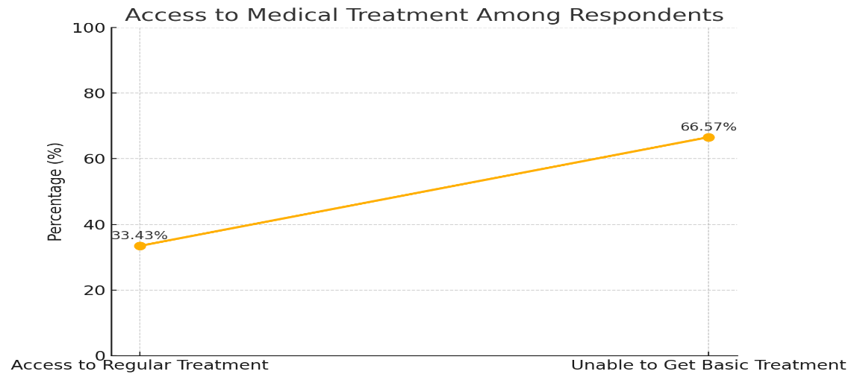

Graph-3: Sources of income of the older adults surveyed

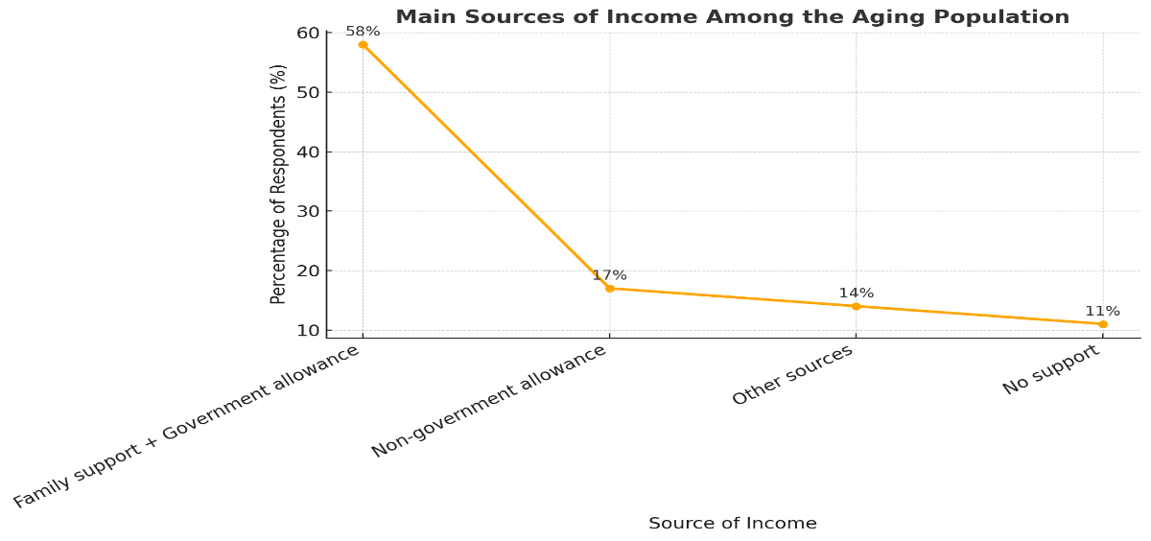

Graph-4: Loneliness of older adults surveyed

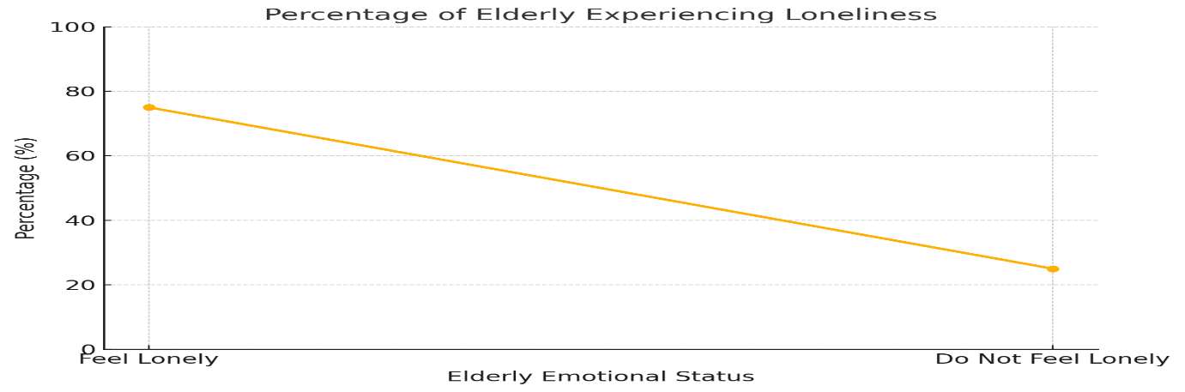

Graph-5: This graph presented the types of services provided by the NGOs to the older adults, NGOs activities in mental health to the older adults and healthcare accessibility by NGOs

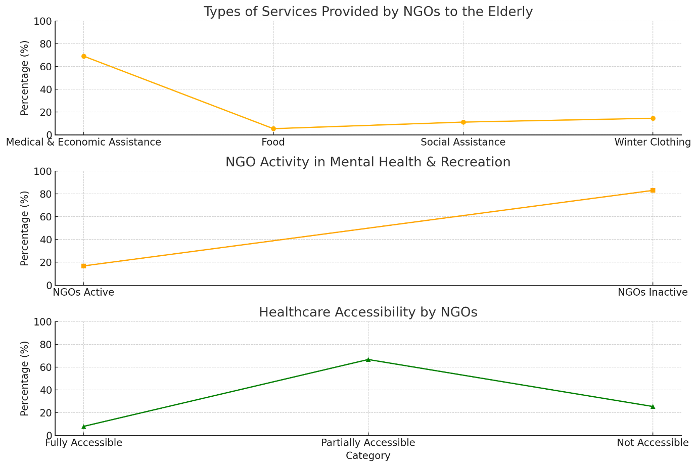

Graph-6: This graph shows the percentage of NGOs reporting various characteristics and challenges related to older welfare services.

