Appendix
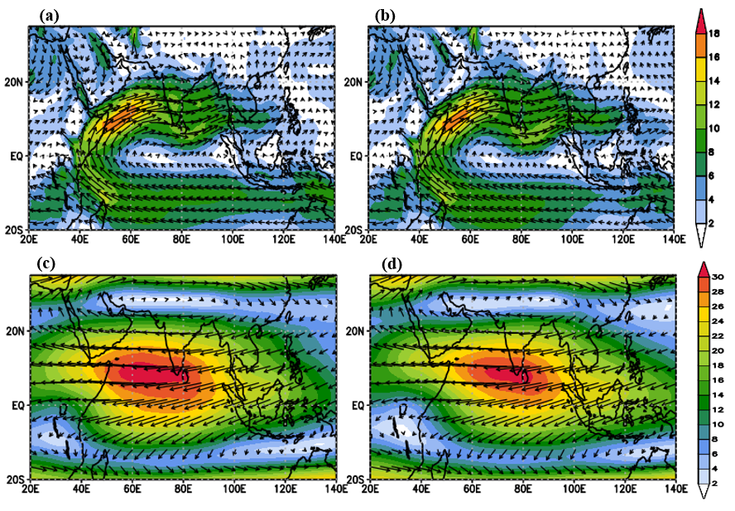
Figure A.1 The mean wind (m s-1 ) at (a&b) 850 and (c&d) 150 hPa wind for excess (left panel) and deficient (right panel) composites during the summer monsoon (JJAS) period over the South Asian domain from 1980-2009.
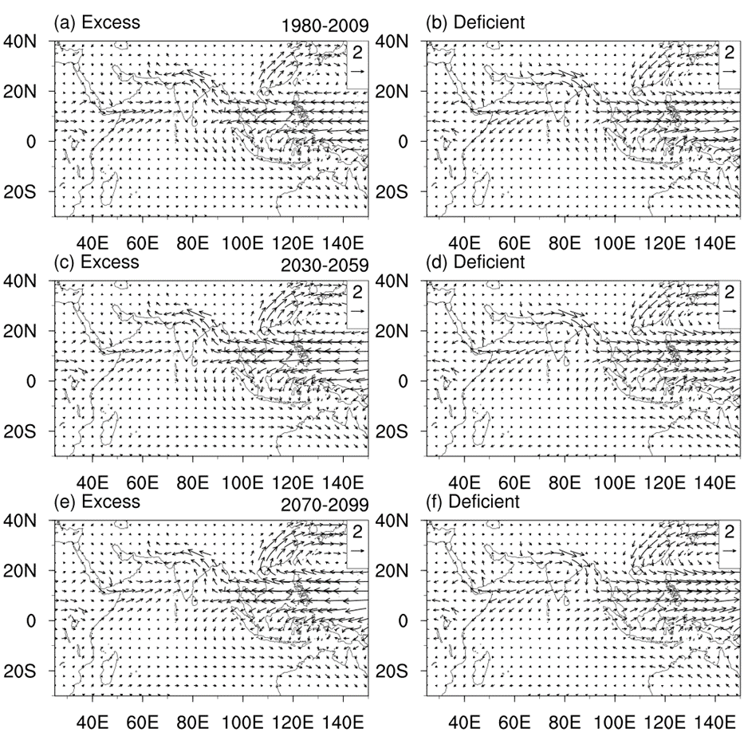
Figure A.2 Mean 850 hPa wind anomaly for (a) excess cases of the near future (b) deficient cases of near future (c) excess cases of the far future (d) deficient cases of far future during the summer monsoon period.

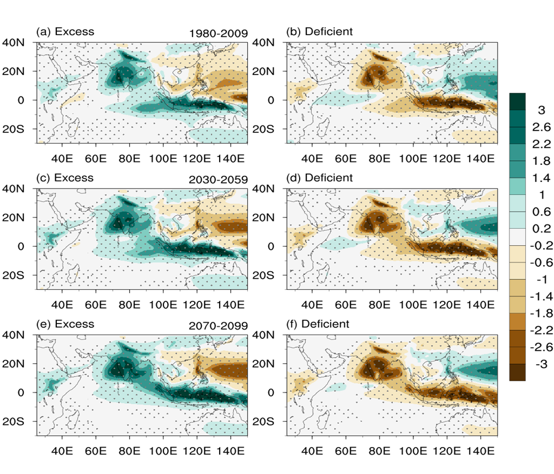
Fig. A.3 Rainfall anomaly for (a,c,e) excess and deficit (b,d,f) cases for historical, near future, and far future scenarios averaged for the summer monsoon season. The stippled region indicates the rainfall anomalies are significant above 95% confidence level.

