STable A1. AMIP6 models Names, corresponding institutions, and the number of realizations.
Model Names | Institutions | Number
IITM-ESM | Indian Institute of Tropical Meteorology (IITM) | 1
INM-CM5-0 | Institute of Numerical Mathematics, Russia (INM) | 1
SAM0-UNICON | Seoul National University (SNU) | 1
CNRM-CM6-1 | Centre National de Recherches Météorologiques (CNRM) | 1
CMCC-CM2-HR4 | Centro Euro-Mediterraneo sui Cambiamenti Climatici (CMCC) | 1
GFDL-ESM4 | NOAA Geophysical Fluid Dynamics Laboratory (GFDL) | 1
TaiESM1 | Research Center for Environmental Changes, Academia Sinica (AS-RCEC) | 1
KACE-1-0-G | National Institute of Meteorological Sciences (NIMS) | 1
BCC-CSM2-MR | Beijing Climate Center, China Meteorological Administration (BCC) | 3
CIESM | Tsinghua University, China (THU) | 3
E3SM-1-0 | Energy Exascale Earth System Model, U.S. DOE（E3SM） | 3
FIO-ESM-2-0 | First Institute of Oceanography, China (FIO) | 3
MPI-ESM1-2-HR | Max Planck Institute for Meteorology (MPI-M) | 3
MRI-ESM2-0 | Meteorological Research Institute, Japan (MRI) | 3
EC-Earth3 | EC-Earth Consortium（EC-Earth-Cons） | 5
FGOALS-f3-L | Institute of Atmospheric Physics, Chinese Academy of Sciences (CAS) | 5
GISS-E2-1-G | NASA Goddard Institute for Space Studies (GISS) | 5
NESM3 | Nanjing University of Information Science and Technology (NUIST) | 5
HadGEM3-GC31-LL | Met Office Hadley Centre (MOHC) | 5
ACCESS-ESM1-5 | Commonwealth Scientific and Industrial Research Organisation (CSIRO) | 10
CESM2 | National Center for Atmospheric Research (NCAR) | 10
MIROC6 | Model for Interdisciplinary Research on Climate, Japan (MIROC) | 10
NorCPM1 | Norwegian Climate Centre (NCC) | 10

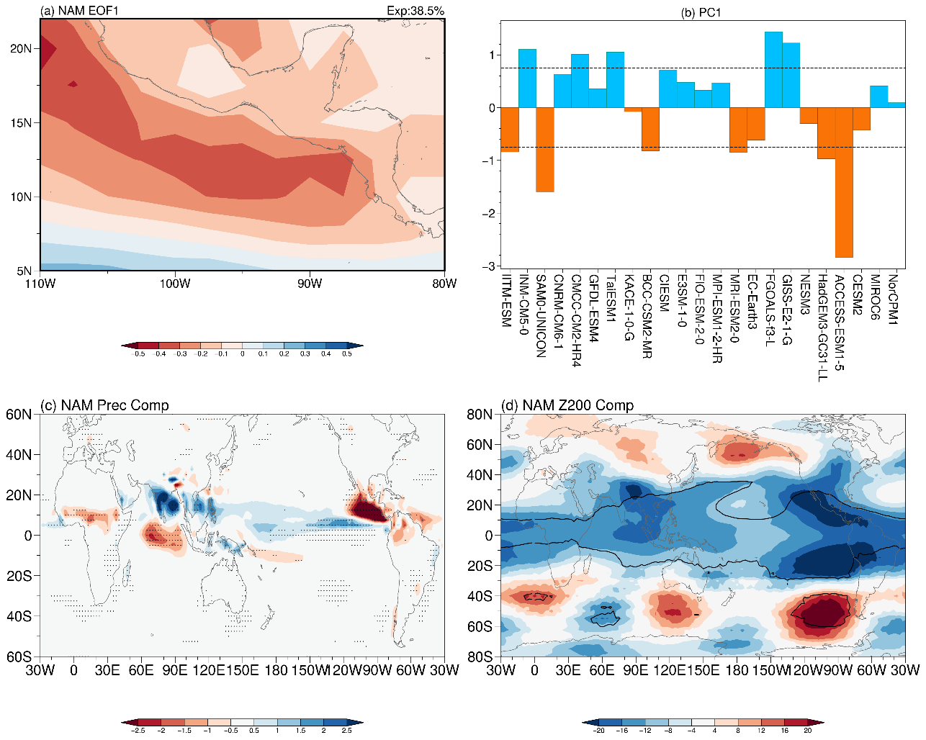
SFigure 1. (a) The first leading mode of summer precipitation deviations (units: mm/day) in the North American (NAM) monsoon region and (b) its corresponding principal components (PC1), with dashed lines indicating ±0.75 standard deviations. (c) and (d) Composite maps of global precipitation anomalies (left panel, units: mm/day) and 200-hPa geopotential height anomalies (right panel, units: gpm) based on the PC1 index. Stippled areas indicate regions significant at the 90% confidence level.

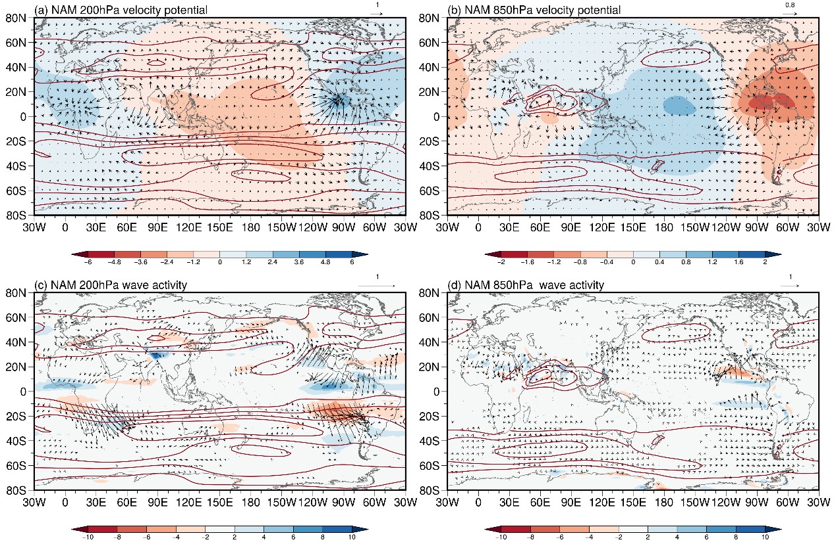

SFigure 2. Composite maps based on PC1 index of the NAM in SFig. 1b. Panels (a) and (b) show the velocity potential (shaded, units: 10⁶ m²/s) and divergent wind (vectors, units: m/s) at 200 hPa and 850 hPa, respectively. Panels (c) and (d) display wave activity fluxes (vectors, units: m²/s²) and vorticity (shaded, units: 10⁻⁶/s) at 200 hPa and 850 hPa, respectively. Brown contours represent the climatological zonal wind, with contour intervals of 10 m/s at 200 hPa and 5 m/s at 850 hPa.

STable 2. Correlation coefficients of the principal components (PCs) of precipitation deviations for monsoon regions, with the selected EOF mode closely related to first mode of NAM precipitation deviations. Bold values with double asterisks in the upper-right corner indicate significance at the 95% confidence level, while those with a single asterisk denote significance at the 90% confidence level.

Corr. | WNP  (PC2) | EA  (PC2) | SA  (PC2) | AUS  (PC3) | NAF  (PC2) | SAF  (PC1) | SAM  (PC2) | NAM  (PC1)
WNP_PC2 | 1 | -0.47** | 0.14 | 0.27 | -0.29 | 0.14 | -0.08 | -0.35*
EA_PC2 |  | 1 | 0.23 | -0.27 | 0.08 | 0.06 | 0.04 | -0.35*
SA_PC2 |  |  | 1 | -0.39* | -0.3 | 0.1 | -0.21 | -0.41*
AUS_PC3 |  |  |  | 1 | 0.22 | -0.32 | 0.31 | 0.26
NAF_PC2 |  |  |  |  | 1 | 0.07 | 0.11 | 0.39*
SAF_PC1 |  |  |  |  |  | 1 | -0.76** | -0.32
SAM_PC2 |  |  |  |  |  |  | 1 | 0.51**
NAM_PC1 |  |  |  |  |  |  |  | 1

