Supplemental information

Targeted Nanoencapsulation of Tunicamycin Reduces Toxicity While Improving its Therapeutic Effectiveness in Pancreatic Cancer Cells
Debasmita Dutta^{1#}, Sunil Upadhayay^{2#}, Archana De², Inamul Haque^{2,3}, Axel H. Breier², Alok De², Daniel J. Mettman^{2,4,5}, Suman Kambhampati², Mohiuddin Quadir^{1*}, Francisco Diaz⁶, Sushanta K Banerjee^{2,5*}, Stefan H. Bossmann⁶, and Snigdha Banerjee^{2,5*}

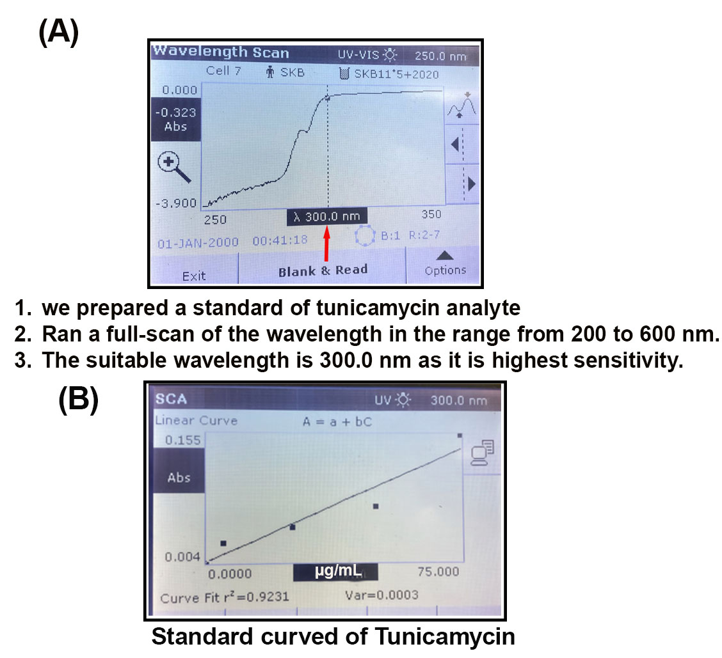
Figure S1. Detection of Tunicamycin in cell-free system. (A). detection of highest sensitive wavelength of Tunicamycin using UV/VIS spectrophotometer, and (B). Standard curve of Tunicamycin

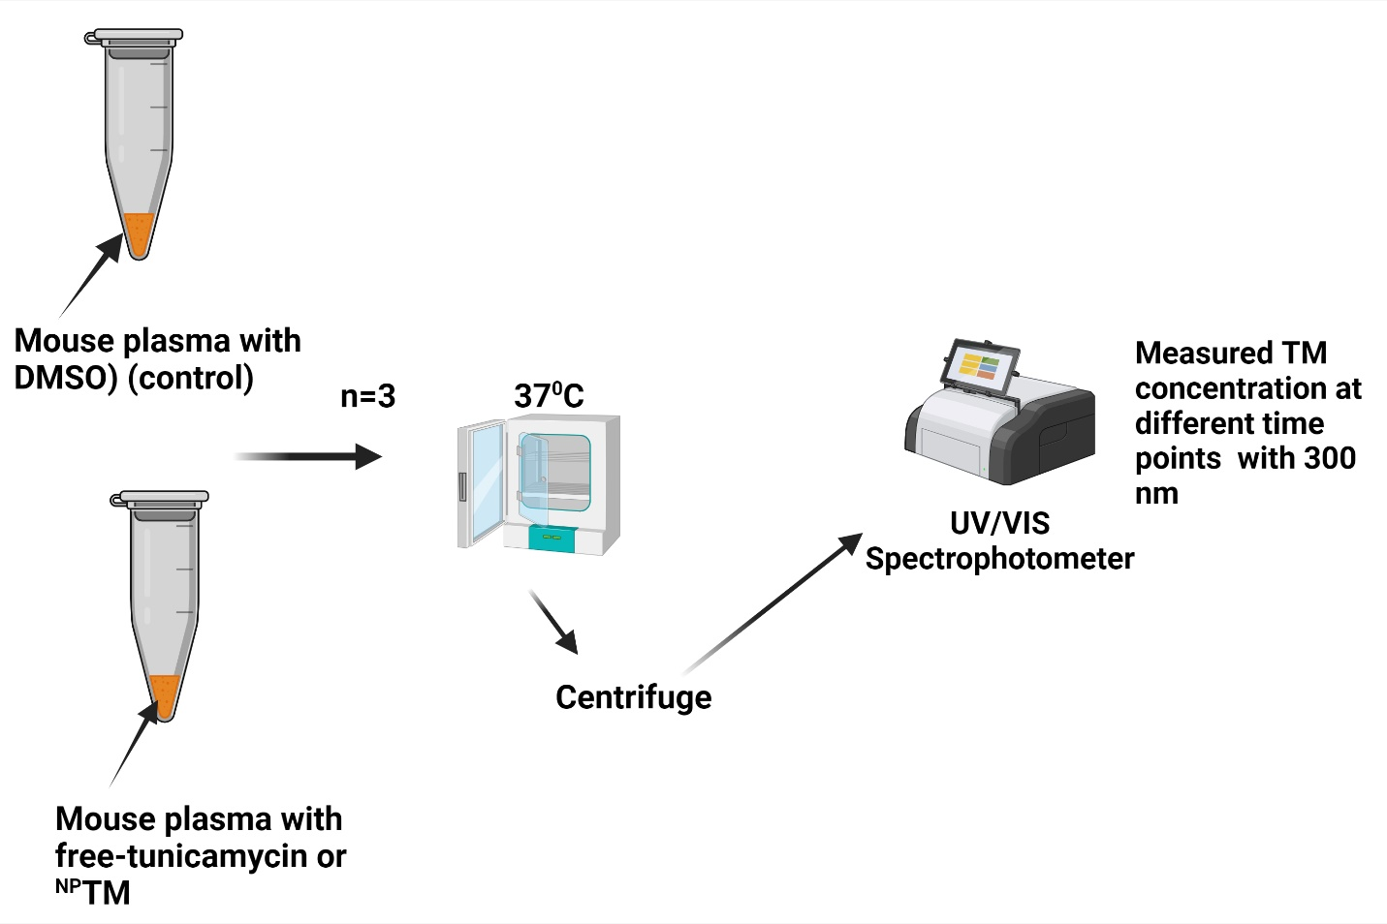
Figure S2. In vitro plasma assay. The bioavailability of Tunicamycin was measured using in vitro plasma assay. Tunicamycin or ^{NP}TM (1µM) in 1 mL mouse plasma ( diluted to 80% with 0.05M PBS, pH 7.4) was incubated at 37ºC for different time points. After centrifugation, TM concentration was measured in a UV/VIS spectrophotometer at 300nm.

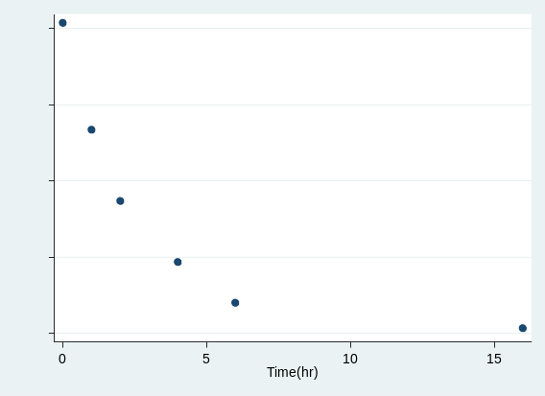
Figure S3. Half-life calculation. The in vitro plasma half-life (t_{1/2}) of free-TM was calculated using the expression t1/2=0.693/b, where b is the slope found in the linear fit of the natural logarithm of the fraction remaining of the parent compound vs. incubation time. We calculated the half-life after excluding the observations at 16 hr. The obtained half-life was t_{1/2} = 1.836 hr. [95% confidence interval, (1.717, 1.955)].

