Appendix I
Protein profile of experimental samples (HS1, C1, C28, HS28) under denaturing and reducing conditions in 12% (w/v) polyacrylamide gel. Twenty micrograms (20µg) of total proteins from each sample were used in this assay.
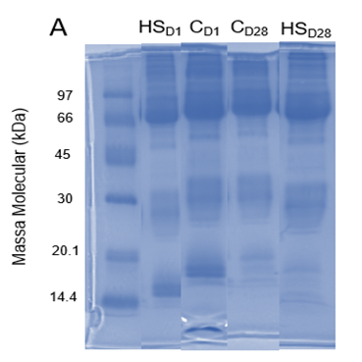

Appendix II
Table 1. Total and maximum parsimony proteomic identifications for each of the samples evaluated.
Laboratory sample identification | Sample identification in the context of experimentation | Total protein identifications | Maximum parsimony identification
D12 | C1 | 125 | 90
D17 | C28 | 108 | 85
D8 | HS28 | 122 | 83
D28 | HS28 | 110 | 88

Appendix III
Tabela 2. Proteins expressed in different abundances between samples (p-value < 0.05; fold change ≥ 2.0) resulting from Volcano Plot analysis.
log2 (FC) | C28 vs. C1 | HS28 vs. HS1 | HS28 vs. C28
>2,0 |  | FETUB: A0A8V0YUY5^{b}  Fetuim B  GSN: A0A8V1AHE5^{b}  Gelsolin | GSN: A0A8V1AHE5^{b}  Gelsolin
1,0-2,0 | A0A8V0XKS3  Ig-like domain-containing protein  A0A8V0ZHU1  Beta-microseminoprotein  A0A8V0ZVP0  Ig-like domain-containing protein | HRG: A0A8V0YWP7^{b}  Histidine-rich glycoprotein  CFH: A0A8V0YEL1  Sushi domain-containing protein  F2: A0A8V0ZY87^{b}  Prothrombin  SERPING1: A0A8V1A5Q4  Serpin family G member 1 | APOB: A0A8V1AEU3  Apolipoprotein A  FETUB: A0A8V0YUY5^{b}  Fetuim B  HRG: A0A8V0YWP7^{b}  Histidine-rich glycoprotein  F2: A0A8V0ZY87^{b}  Prothrombin
-1,0 a  -2,0 | HBBA: P02112ª  Hemoglobin subunit β  HBA1: A0A8V0ZB98ª  Hemoglobin subunit α A  HBAD: A0A8V0Z399ª  Hemoglobin α, subunit D | APOV1: P02659  Apovitellenin-1
<-2,0 | HBRH: P02127  Hemoglobin subunit rho  HBE: P02128  Hemoglobin subunit ε | HBA1: A0A8V0ZB98ª  Hemoglobin subunit α A  HBBA: P02112ª  Hemoglobin subunit β  HBZ: P02007  Hemoglobin subunit π  HBAD: A0A8V0Z399^{ac}  Hemoglobin α, subunit D | HBAD: A0A8V0Z399^{c}  Hemoglobin α, subunit D
a. Down-regulated proteins in both the comfort group and the heat stress group.
b. Up-regulated proteins in heat stress, in comparisons HS28 vs. HS1 and HS28 vs. C28;
c. Down-regulated proteins in heat stress, in comparisons HS28 vs. HS1 and HS28 vs. C28;
- Protein codes not followed by letters represent proteins exclusive to that comparison.

