Table 1. Differences in the quality variables of eggs collected in the last three days of the Comfort and Heat Stress treatments.
Variable | Comfort | Heat stress
Weight (g) | 64.6 ± 0.5ª | 54.4 ± 0.8^{b}
Shell Strength (kgf/cm²) | 4.11 ± 0.15ª | 2.88 ± 0.16^{b}
Shell Thickness (mm) | 0.400 ± 0.01ª | 0.346 ± 0.01^{b}
Albumen Height (mm) | 7.6 ± 0.2ª | 6.7 ± 0.3^{b}
Haugh Unit | 84.1 ± 1.6 | 82.9 ± 1.6
Specific Gravity (g/cm³) | 1088.5 ± 0.8ª | 1083.3 ± 1.1^{b}
Different letters indicate significant difference by Fisher's test (p < 0.05).
Table 2. Unique proteins are present in HS28 when compared with groups C1, C28 and HS1.
Protein Code¹ | Gene:  Protein Name | Function | Metabolic pathway and protein interactions ²
A0A8V0YGQ5 | ST13P5 ³:  Hsp70 interacting protein | Heat shock protein70 biding, released to protect tissues from heat, Suppression of tumorigenicity, response to bacteria | 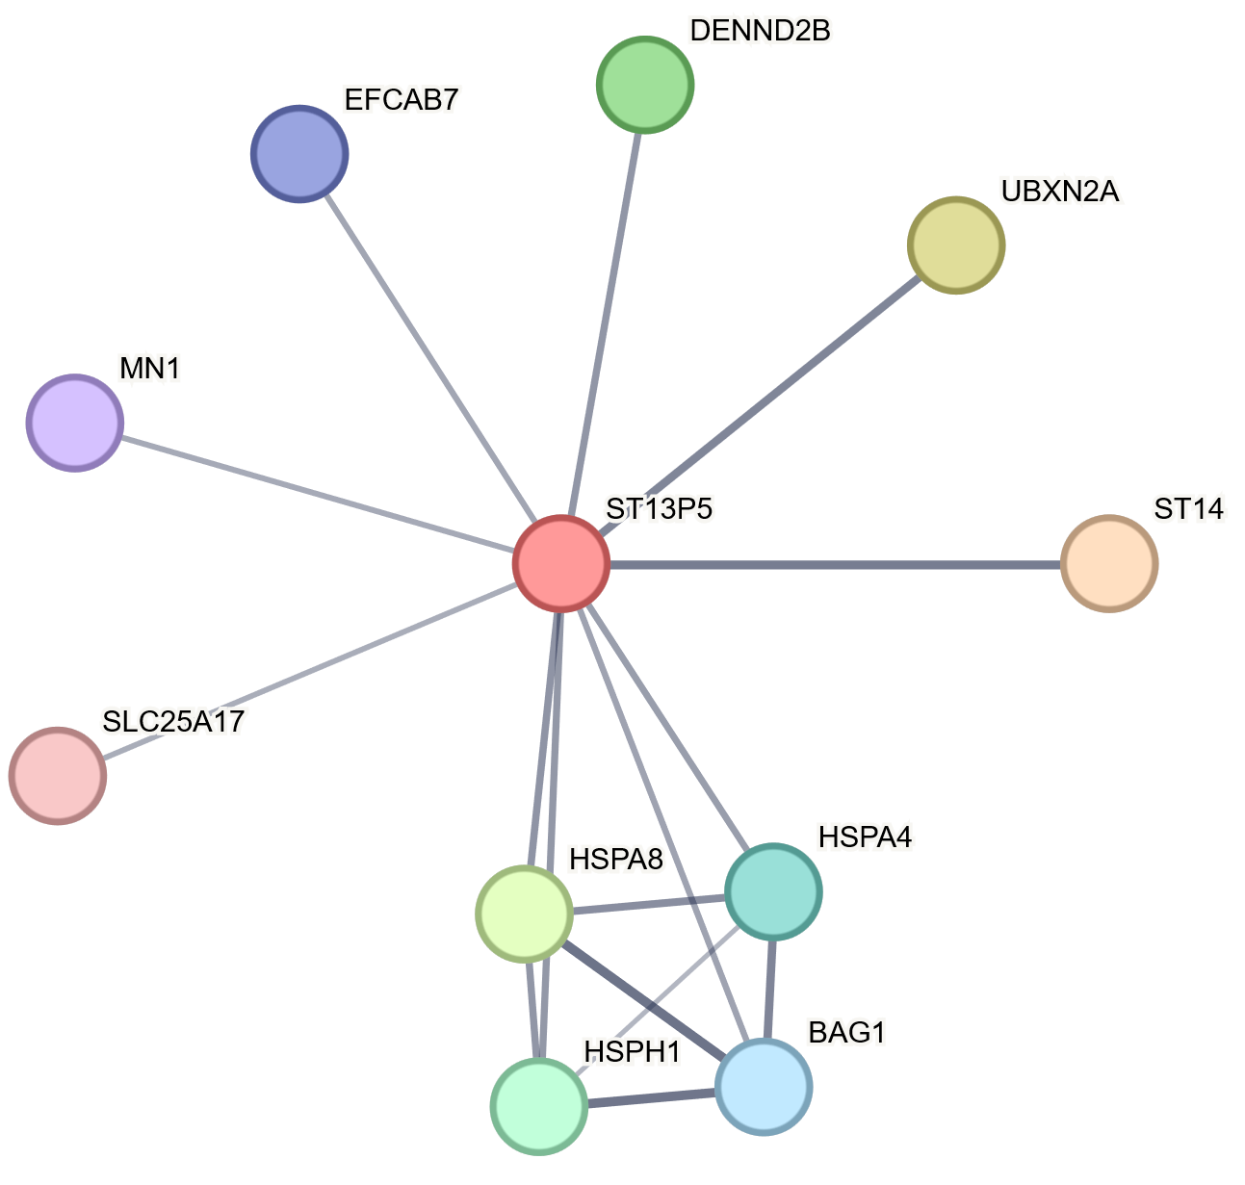
Q5ZLF0 | ST13 ³:  Hsc70-interacting protein | Protection of the proteome against stress
P11722 | FN1: Fibronectin | They bind cell surfaces to various compounds, such as collagen, fibrin, heparin, DNA and actin.  Expressed in the thrombocyte wall  (Horiuchi,1992) | 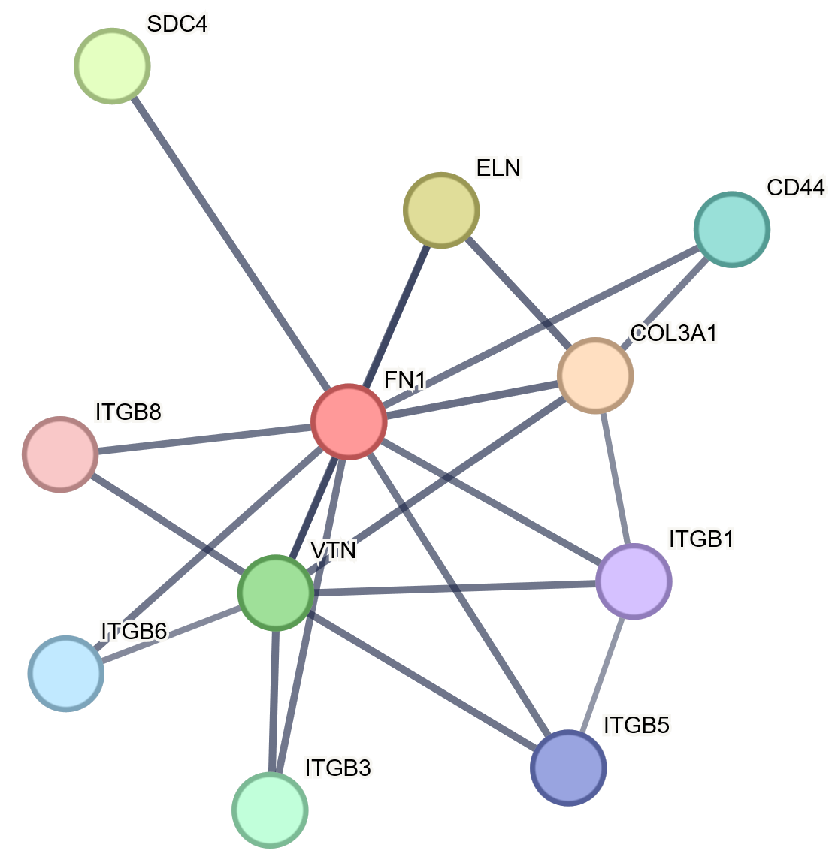
A0A8V0Z1E6 | SPIA1:  Serpin family A member 1 | Blood clotting, Protease inhibitor | 
A0A8V0ZUA2 | VCAM1:  Ig-like domain-containing protein | Integrin binding, cell-cell adhesion | 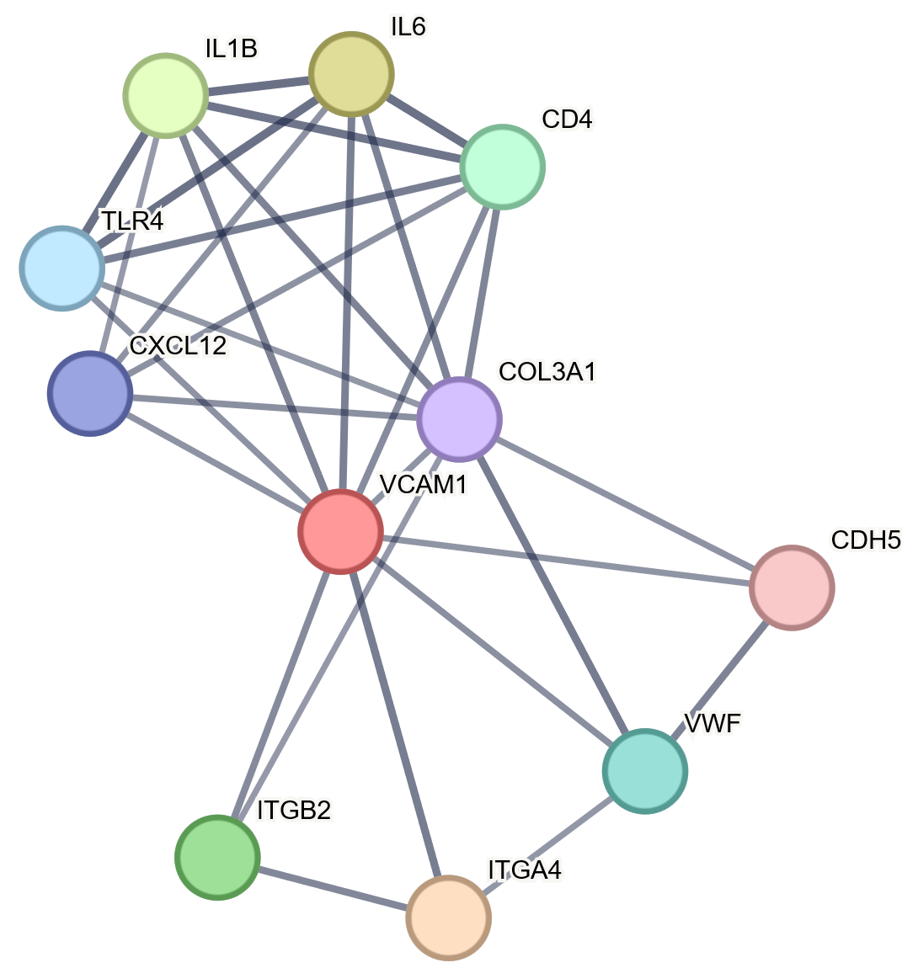
A0A8V1A3I6 | GIF: DUF4430 domain-containing protein | Cobalamin (Vitamin B12) binding, cobalt binding, cobalt ion transport | 
P79780 | IBSP: Bone sialoprotein 2 | Calcium fixation in bones. It binds firmly to hydroxyapatite. | 
A0A8V0Z519 | DYNC1H1: Dynein cytoplasmic 1 heavy chain 1 | ATP Binding and Hydrolysis | 
¹ Uniprot Access Code - https://www.uniprot.org/
² Images generated by String Data Base – minimum required interaction score 0,7 (high confidence) - https://string-db.org/ [32]
Table 3. Up-regulated proteins in heat stress, in comparisons HS28 vs. HS1 e HS28 vs. C28 (p-value < 0.05; fold change ≥ 2.0) resulting from Volcano Plot analysis.
Protein  Code¹ | Gene:  Protein Name | Functions | Metabolic pathway and protein interactions ²
A0A8V0YUY5 | FETUB:  Fetuim B | Fibrin clot formation and dissolution of fibrin clot, fibrinolysis and fibrinogen complex. | 
A0A8V1AHE5 | GSN:  Gelsolin | Calcium-regulated actin modulating protein. Acts in the cytoplasm of cells in cell motility and contraction. | 
A0A8V0YWP7 | HRG:  Histidine-rich glycoprotein | Participates in the blood coagulation process and clot dissolution. | 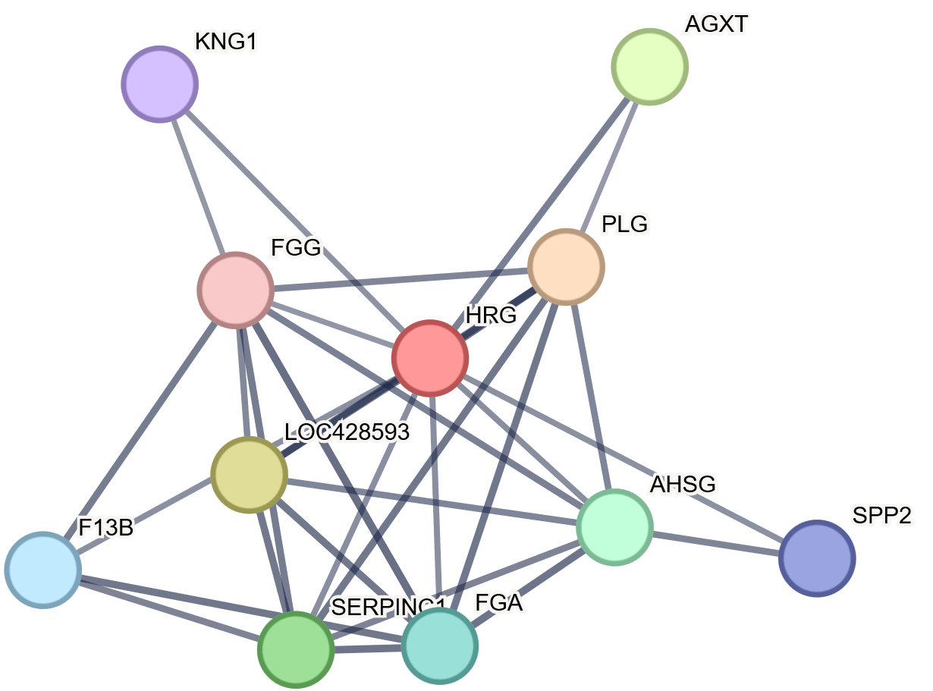
A0A8V0ZY87 | F2: Prothrombin | Blood clotting, Platelet activation, Acute phase response of infections | 
A0A8V1AEU3 | APOB: Apolipoprotein A | The main protein constituent of chylomicrons, VLDL (very low-density lipoproteins) and LDL (low-density lipoproteins), participate in the metabolic processes of cholesterol. | 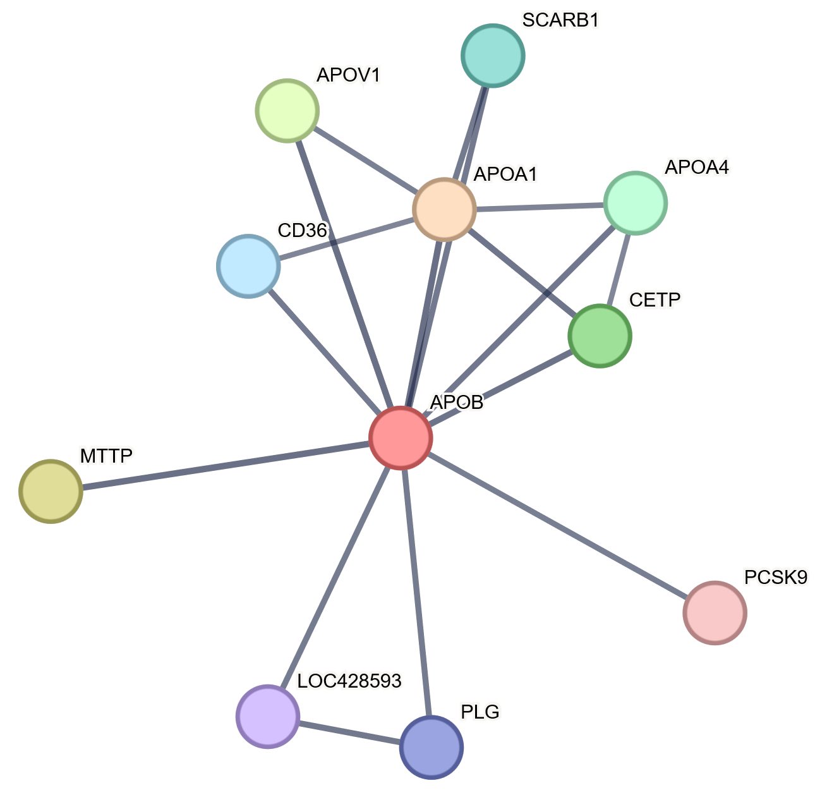
A0A8V0YEL1 | CFH:  Sushi domain-containing protein | Protein is expressed in the membrane of the body's cells. Binding agent for Interleukin-15 and participates in complement system activation. | 
A0A8V1A5Q4 | SERPING1: Serpin family G member 1 | Complement system activation. It has an impact on blood clotting and innate immunity. | 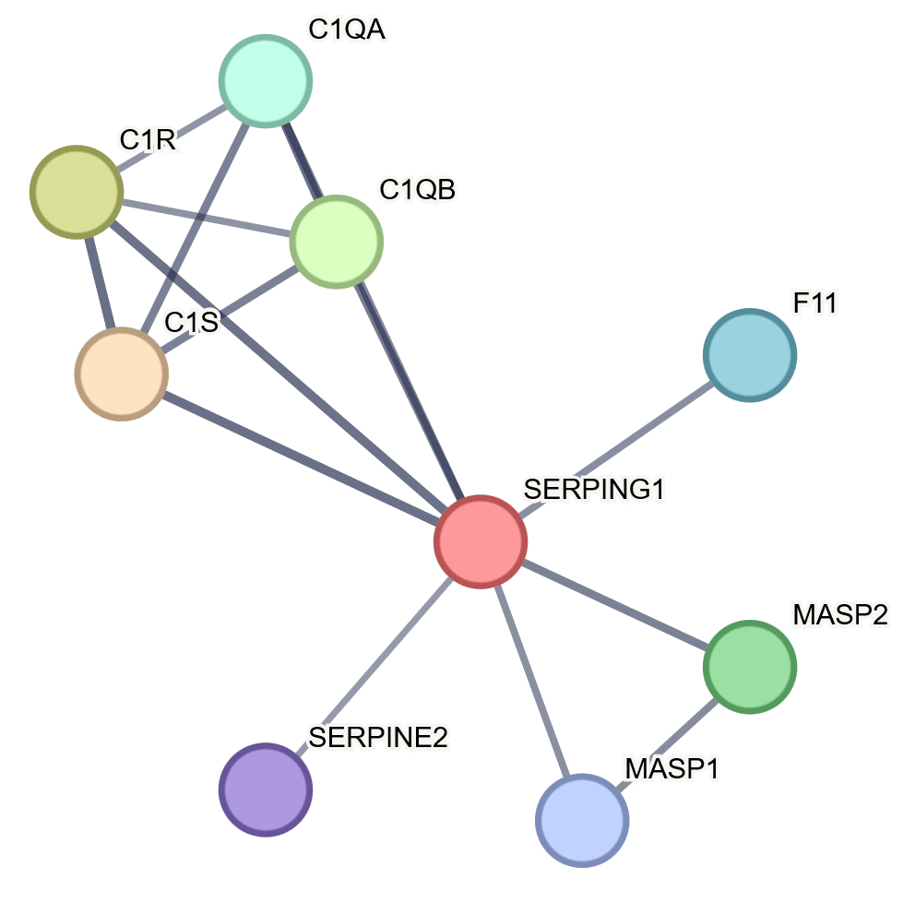
¹ Uniprot Access Code - https://www.uniprot.org/
² Images generated by String Data Base - https://string-db.org/ [32]
Table 4. Down-regulated proteins in heat stress, in comparisons HS28 vs. HS1 e HS28 vs. C28 (p-value < 0.05; fold change ≥ 2.0) resulting from Volcano Plot analysis.
Protein Code¹ | Protein Name | Functions | Metabolic pathway and protein interactions ²
P02659 | APOV1: Apovitellenin-1 | Protein component of very low-density lipoprotein (VLDL) from laying hens, lipoprotein lipase inhibitor | 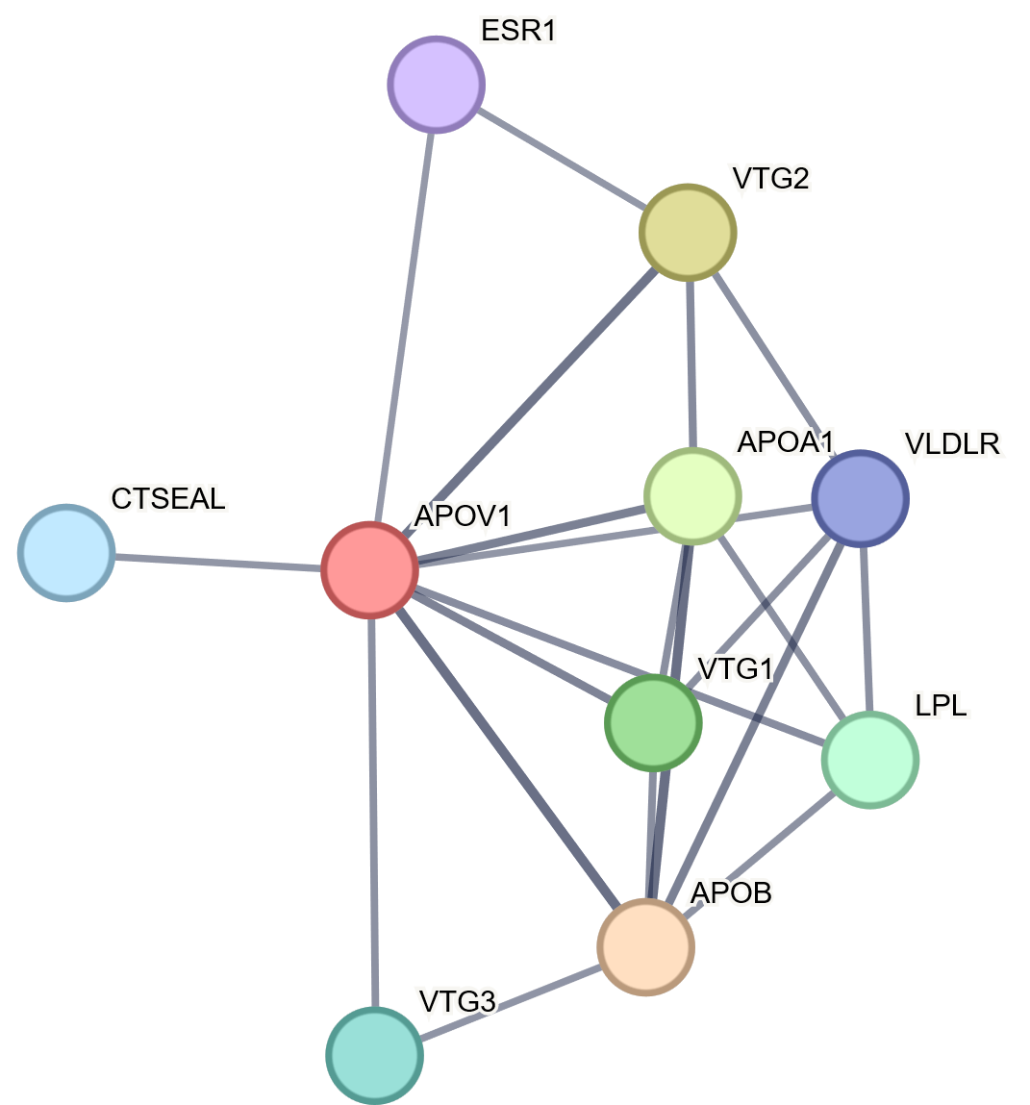
P02007 | HBZ: Hemoglobin subunit π | Hydrogen peroxides catabolic process, Cellular oxidant detoxification | 
¹ Uniprot Access Code - https://www.uniprot.org/
² Images generated by String Data Base - https://string-db.org/ [32]

