Figure S1 Forest plots of stratified analysis of Lipid accumulation product with periodontitis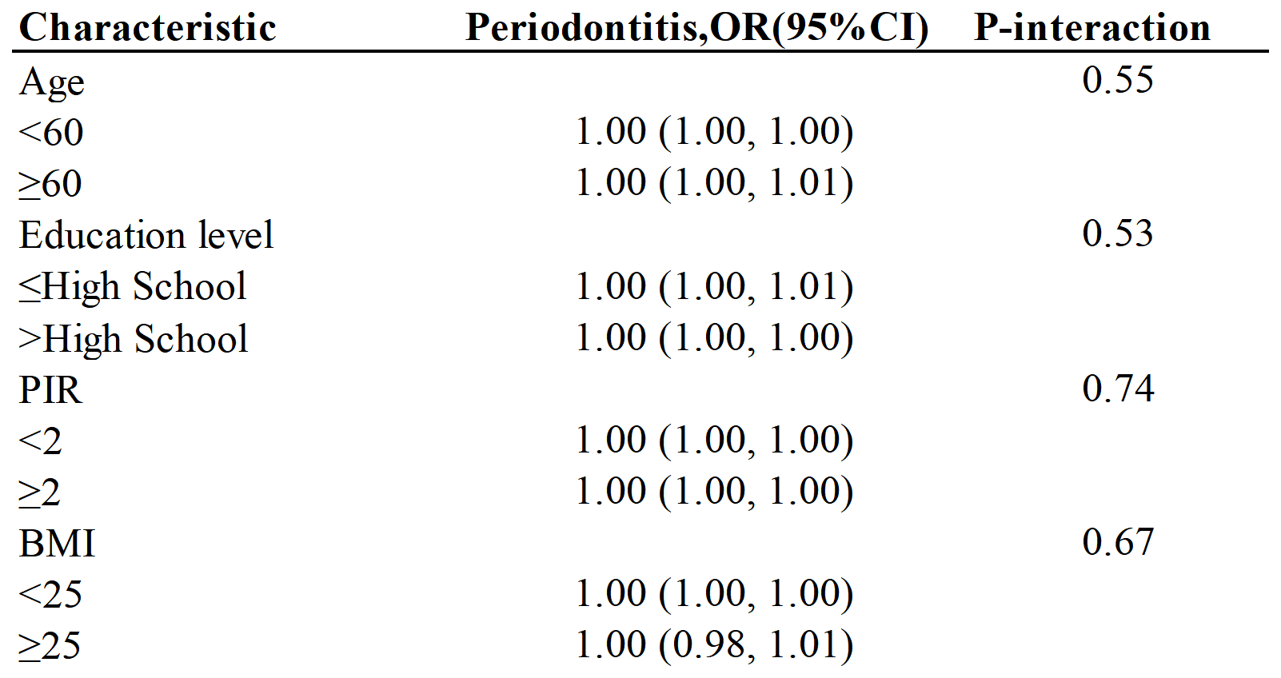
Note: Age, gender, race/ethnicity, education level, marital status, PIR, BMI, smoking status, alcohol consumption, Hypertension, and Diabetes were all adjusted except the variable itself.

 | Periodontitis, OR (95%CI), P-value
 | Adjust I (Complete case) | Adjust II (Multiple imputation)
LAP | 1.00 (1.00, 1.00) 0.4052 | 1.01 (0.99, 1.04) 0.2810
LAP quartile
Q1 | 1.0 | 1.0
Q2 | 0.91 (0.63, 1.32) 0.6278 | 0.87 (0.61, 1.24) 0.4351
Q3 | 0.90 (0.60, 1.36) 0.6246 | 0.88 (0.59, 1.30) 0.5214
Q4 | 0.71 (0.45, 1.10) 0.1257 | 0.74 (0.49, 1.13) 0.1680
Table S1 Logistic regression analyses of the associations between Lipid accumulation product and periodontitis
Note: Adjusted for age, gender, race/ethnicity, education level, marital status, PIR, BMI, smoking status, alcohol consumption, Hypertension, and Diabetes. Multiple imputation techniques were employed to address missing covariate data.
Abbreviations: LAP: Lipid accumulation product; OR: odd ratio; CI: confidence interval

