Supporting information
Exceptional hydrogen evolution in acid enabled by a multi-function-site complex oxide via atomic-scale hydrogen spillover

Dai et al.

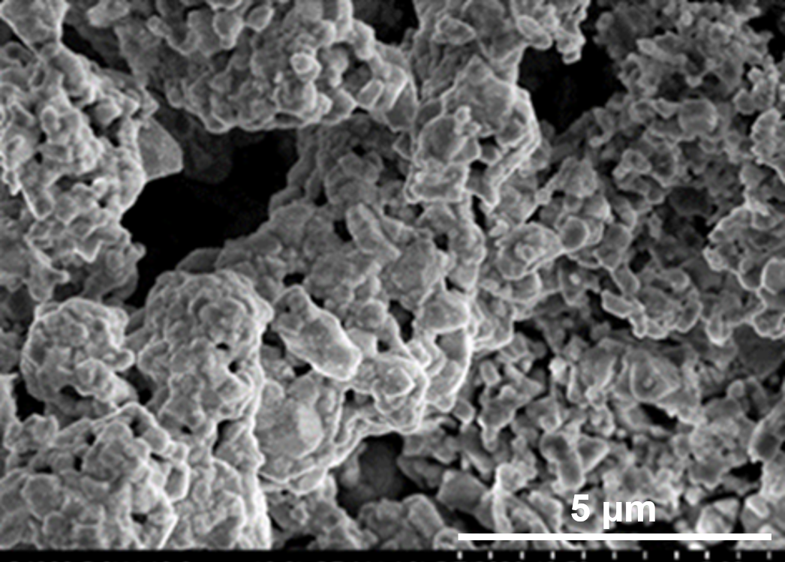

Supplementary Figure 1. SEM image of La₂Sr₂PtO_{7+δ}.

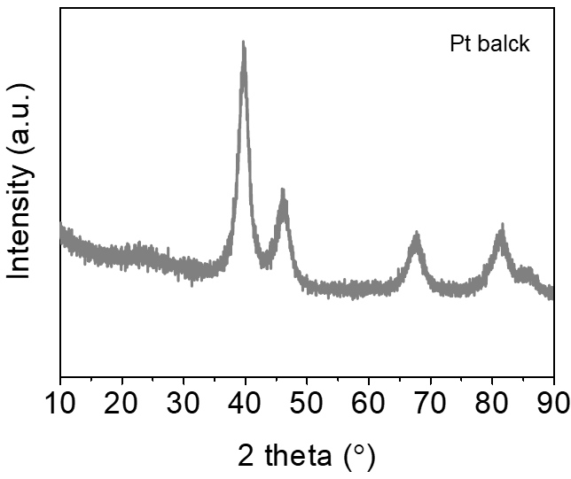

Supplementary Figure 2. XRD pattern of Pt black.

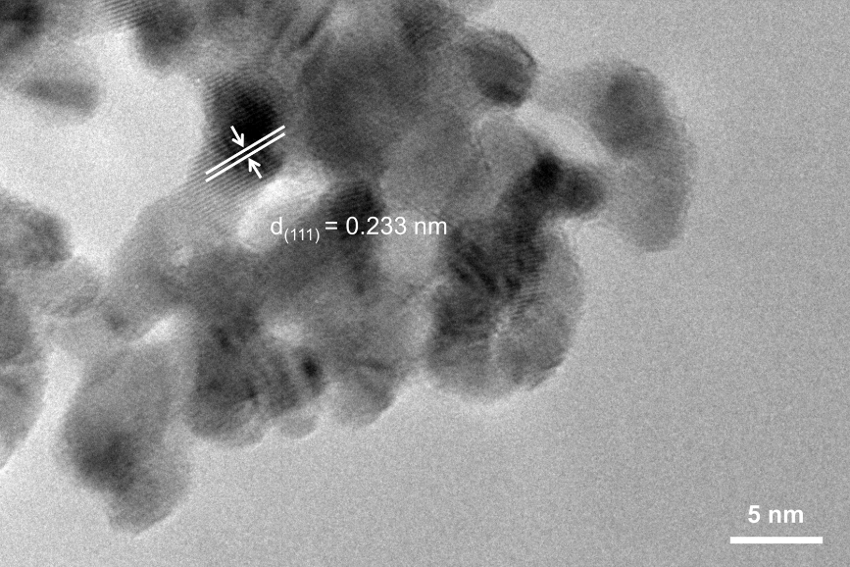

Supplementary Figure 3. HRTEM image of Pt black with particle size of about 5nm. The lattice spacing is about 0.233 nm for (111) plane.

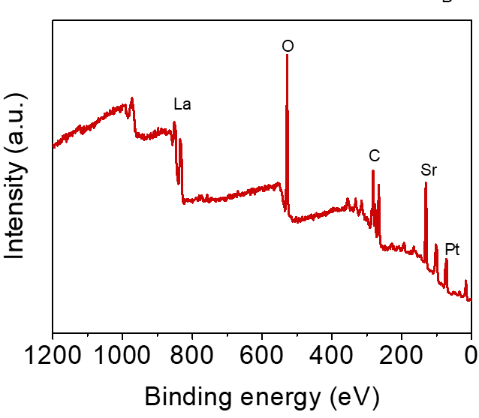

Supplementary Figure 4. XPS survey of La₂Sr₂PtO_{7+δ}.

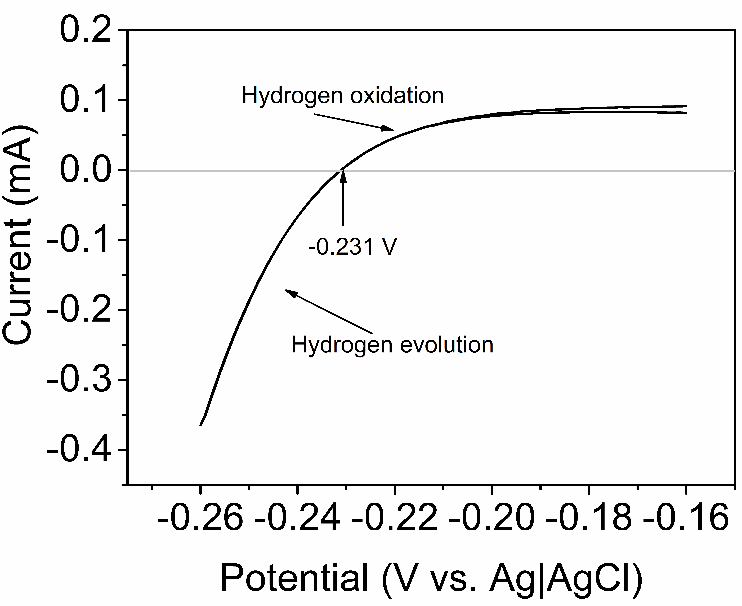

Supplementary Figure 5. RHE calibration.RHE calibration of the Ag|AgCl reference electrode in 0.5 M H₂SO₄. The calibration process was performed in a high purity H₂-saturated 0.5 MH₂SO₄with a platinum RDE (PINE, 0.126 cm²) as the working electrode, Pt foil as the counter electrode, and Ag|AgCl (3.5 M KCl) as the reference electrode. Cyclic voltammetry (CV) was conducted at a scan rate of 1 mV s⁻¹, and the average of the two potentials at whichthe current crossed zero was taken as the thermodynamic potential for the hydrogen electrode reaction. In 0.5 MH₂SO₄ solution, E_{RHE} = E_{Ag|AgCl} +0.231 V.

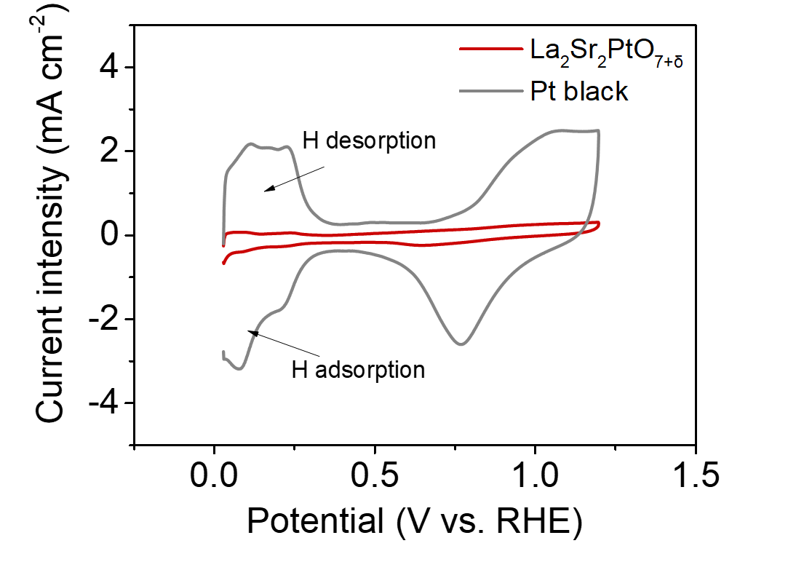

Supplementary Figure 6. Cyclic voltammetry curves of La₂Sr₂PtO_{7+δ} and Pt black.

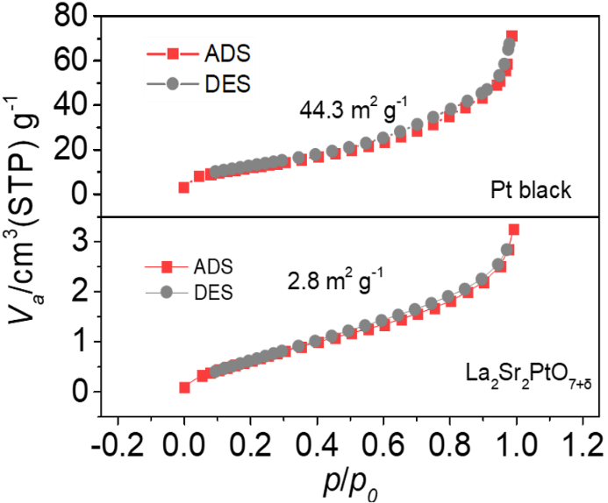

Supplementary Figure 7. N₂ adsorption-desorption isotherm of Pt black and La₂Sr₂PtO_{7+δ}.

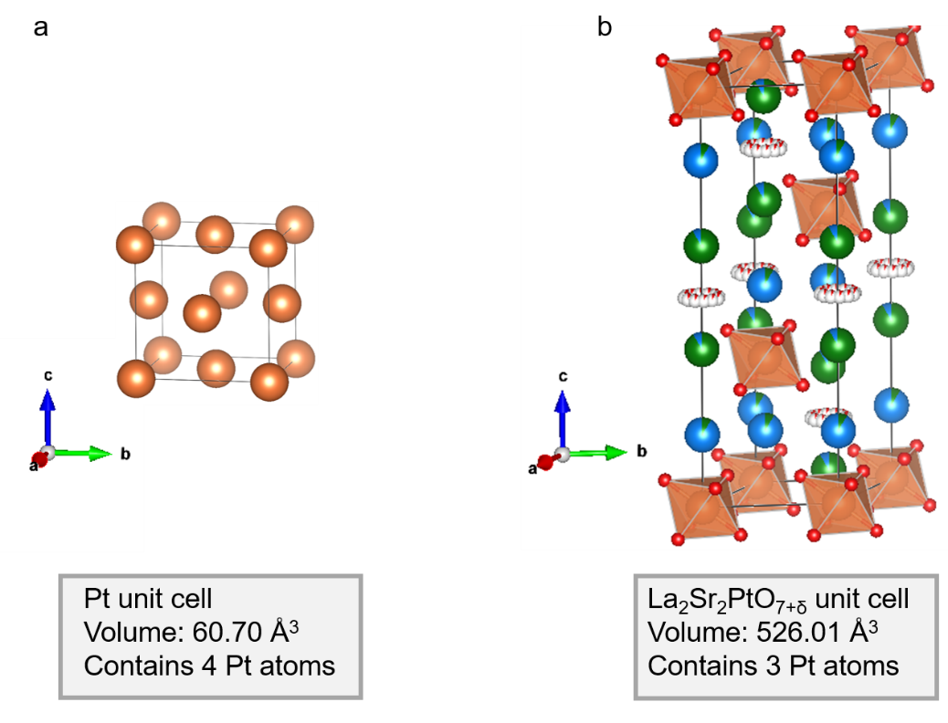

Supplementary Figure 8. Unit cell of catalysts. (a) Pt black and (b) La₂Sr₂PtO_{7+δ}.

Supplementary Figure 9. XRD patterns of La₂Sr₂PtO_{7+δ} before and after different CV cycles during HER.

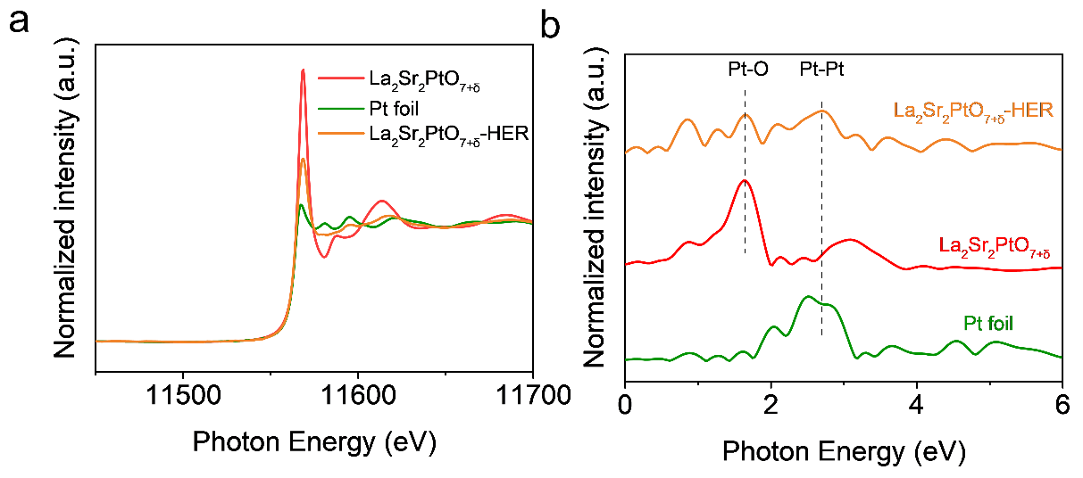

Supplementary Figure 10. (a) Pt L₃-edge XANES spectra of La₂Sr₂PtO_{7+δ} before and after 1000 cycles during HERas well as Pt foil. (b) K³-weighted Fourier transform EXAFS spectra of the La₂Sr₂PtO_{7+δ} before and after 1000 cycles during HER as well as Pt foil.

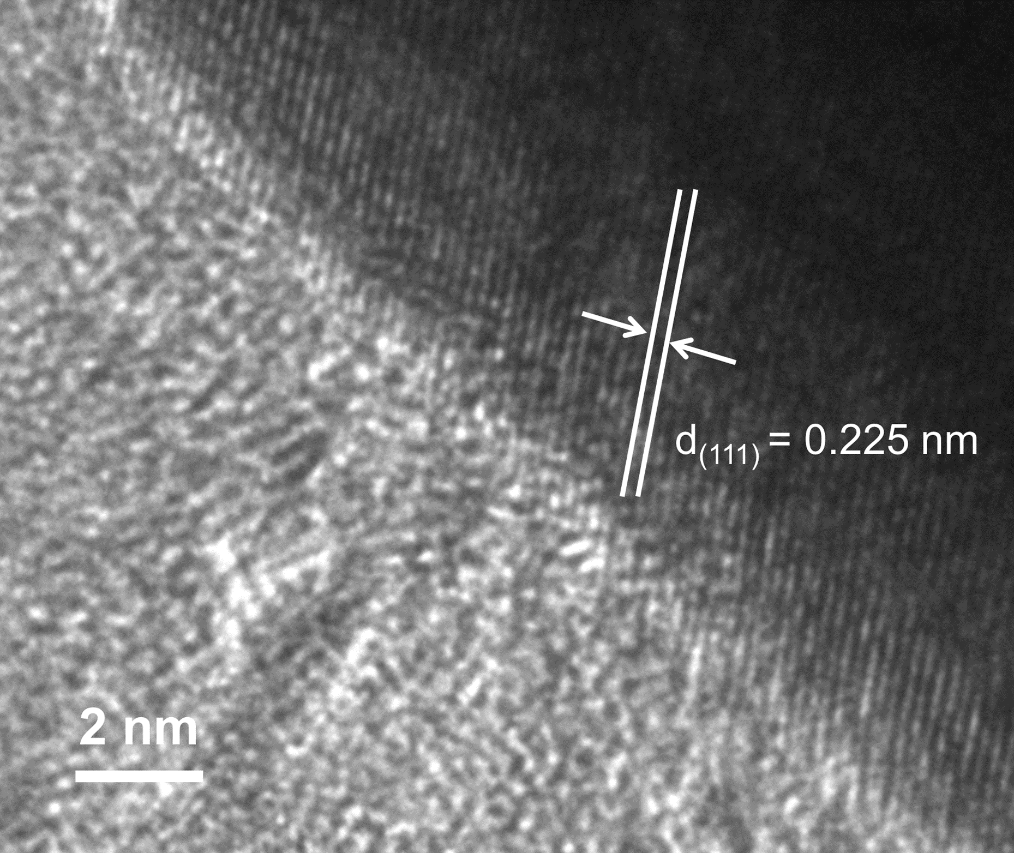

Supplementary Figure 11. HRTEM image of post-ADT La₂Sr₂PtO_{7+δ}.

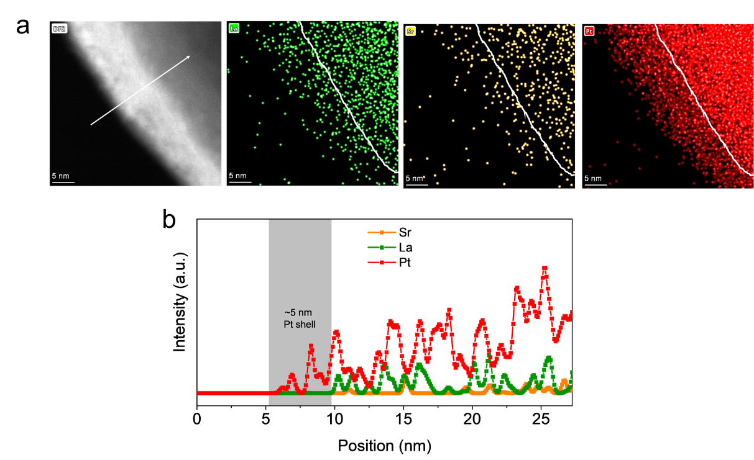

Supplementary Figure 12. (a) HAADF-STEM and the corresponding elemental mapping images of post-ADT La₂Sr₂PtO_{7+δ}. (b) STEM-EDS spectrum of post-ADT La₂Sr₂PtO_{7+δ}.

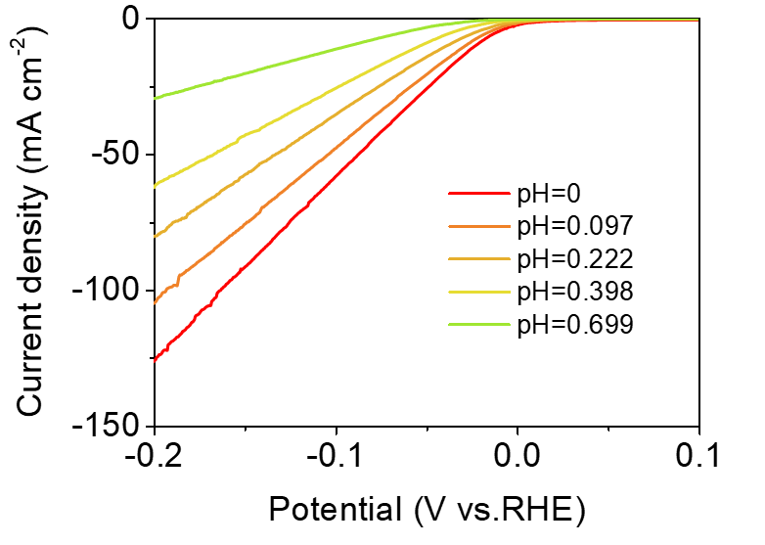

Supplementary Figure 13. LSV curves of La₂Sr₂PtO_{7+δ} in Ar-saturated H₂SO₄ electrolyte with pH ranging from 0 to 0.68.

Supplementary Table 1. Atomic coordinates, isotropic displacement parameters and cell parameters for La₂Sr₂PtO_{7+δ}.
Site | Np | x | y | z | Occ
Pt | 3a | 0 | 0 | 0 | 1
La1 | 6c | 0 | 0 | 0.6233 | 0.915
Sr1 | 6c | 0 | 0 | 0.6233 | 0.085
La2 | 6c | 0 | 0 | 0.1731 | 0.085
Sr2 | 6c | 0 | 0 | 0.1731 | 0.915
O1 | 18f | 0.3145 | 0.2169 | 0.0621 | 1
O2 | 18f | 0.1258 | 0 | 0.5 | 0.082
O3 | 18f | 0.1452 | 0.0726 | 0.5 | 0.082
Space group: R$\overline{3}$, a=b=5.7913(2) Å, c=18.1097(7) Å, V= 526.0149(5) Å³, R_{wp} = 8.85,R_{p} = 6.80, χ² = 1.40.

Supplementary Table 2. HER activity comparison between La₂Sr₂PtO_{7+δ} and reported hydrogen spillover-based binary-component catalysts (HSBCCs) and state-of-the-art Pt-based catalysts in 0.5 M H₂SO₄.
Catalysts | Substrate | Mass loading (mg·cm⁻²) | η @10 mA  cm⁻² (mV) |  | Tafel slope (mV dec⁻¹) | Ref
La₂Sr₂PtO_{7+δ} | Glass carbon | 0.232 | 13 |  | 22 | This work
Pt-group metal based catalysts
Pt@C₂N | Glass carbon | 0.285 | ~40 |  | 33 | Nat. Nanotech., 2017, 12, 441
PtRu@RFCS | Glass carbon | 0.354 | 20 |  | 27.2 | Energy Environ. Sci., 2018, 11, 1232
Pt₁/N-C | Glass carbon | 0.250 | 19 |  | 14 | Nat. Commun., 2020, 11, 1029
Mo₂TiC₂T_{x}-Pt_{SA} | Glass carbon | 1 | 30 |  | 30 | Nat. Catal.,  2018, 1, 985
Pt@PCM | Glass carbon | NA | 105 |  | 64 | Sci. Adv., 2016, 2, e1501602
Pt/np-Co_{0.85}Se | Glass carbon | 2.5 | 55 |  | 35 | Nat. Commun., 2019, 10, 1743
Pd/Cu-Pt NRs | Glass carbon | 0.2 | 23 |  | 25 | Angew. Chem. Int. Ed., 2017, 56, 16047
ALD50Pt/NGNs | Glass carbon | 0.077 | ~38 |  | 29 | Nat. Commun., 2016, 7, 13638
Pt₁/OLC | Glass carbon | 0.510 | 38 |  | 35 | Nat. Energy,  2019, 4, 512
Pt-GT-1 | Glass carbon | 0.280 | 18 |  | 24 | Nat. Energy,  2018, 3, 773
PtNC/S-C | Glass carbon | 0.051 | 11 |  | 24 | Nat. Commun., 2019, 10, 4977
PtW₆O₂₄/C | Glass carbon | NA | 22 |  | 30 | Nat. Commun., 2020, 11, 490
Hydrogen spillover-based binary-component catalysts (HSBCCs)
Rh/SiNW | Glass carbon | 0.193 |  | ~80 | 24 | Nat. Commun., 2016, 7, 12272
Rh-MoS₂ | Glass carbon | 0.309 |  | 47 | 24 | Adv. Funct. Mater., 2017, 27, 1700359
Ir/SiNW | Glass carbon | 0.339 |  | 20 | 22 | ACS Nano,  2019, 13, 2786
Pt/CoP | Glass carbon | 0.102 |  | 21 | 43 | Energy Environ. Sci., 2019, 12, 2298
Pt-SA/ML-WO₃ | Glass carbon | 0.56 |  | 22 | 27 | Adv. Funct. Mater., 2021, 2009770
Pt-WO₃ | Glass carbon | 0.141 |  | 39 | 33 | Nano Energy,  2020, 71, 104653
Pt SA/m-WO_{3−x} | Glass carbon | 0.196 |  | 47 | 45 | Angew. Chem. Int. Ed., 2019, 58, 16038
Pt/RuCeO_{x}-PA | Glass carbon | 0.388 |  | 45 | 31 | Angew. Chem. Int. Ed., 2020, 59, 20423
V_{O}-Pt/TiO₂ | Glass carbon | 0.238 |  | ~60 | 33 | Angew. Chem. Int. Ed., 2020, DOI:10.1002/anie.202104856

Supplementary Note 1. Turnover frequency calculations

The active sites per real surface area are calculated from the following formula:
No. of active sites = ${(\frac{No.of atoms/unit cell }{Volume/unit cell})}^{\frac{2}{3}}$
From Figure S8, we can calculate the number of active sites per surface area for Pt and La₂Sr₂PtO_{7+δ}:
No. of active sites (Pt) =${\left(\frac{\frac{4}{unit}cell}{60.42\frac{Å^{3}}{unit}cell}\right)}^{\frac{2}{3}}$ = 1.637×${10}^{15}$ atoms cm⁻²
No. of active sites (La₂Sr₂PtO_{7+δ}) = ${\left(\frac{\frac{3}{unit}cell}{526.01\frac{Å^{3}}{unit}cell}\right)}^{\frac{2}{3}}$= 3.192×${10}^{14}$ atoms cm⁻²
The real surface area for HER is calculated from the electrochemical active surface area (ECSA), which can be determined by integratingthe charge of hydrogen underpotential deposition (H_{UPD}) in cyclic voltammogram (CV) curves according to previous studies.^{1, 2} The H_{UPD} integrated areas of La₂Sr₂PtO_{7+δ}and Pt black are 1.99 m²/g_{Pt} and 70.11 m²/g_{Pt}, respectively.
Finally, the plot of current density can be converted into a TOF plot according to the following formula:
TOF=$\frac{I}{2Fn}$
where I is the current (A) during linear sweep measurement, F is the Faraday constant (C mol⁻¹),n is the number of active sites (mol). The factor 1/2 is based on the consideration that two electronsare required to form one hydrogen molecule.

Supplementary References

- B. Lim, M. Jiang, P. H. C. Camargo, E. C. Cho, J. Tao, X. Lu, Y. Zhu, Y. Xia, Science2009,324, 1302.
- M. Li, Z. Zhao, T. Cheng, A. Fortunelli, C. Y. Chen, R. Yu, Q. Zhang, L. Gu, B. V. Merinov, Z. Lin, E. Zhu, T. Yu, Q. Jia, J. Guo, L. Zhang, W. A. Goddard III, Y. Huang, X. Duan, Science2016, 354, 1414.

