Associations between Residential Greenness and Influenza Virus Infection in China: An Individual-Level, National, Cross-Sectional Study, 2010–2017

Supplementary material

TableS1 The demographic characteristics of the 3,131,881 participates.
Characteristics | N(%)
Gender
Male | 1703584(54.39%)
Female | 1428297(45.61%)
Age
0-17 | 2003480(63.97%)
18-59 | 952084(30.40%)
≥60 | 176317(5.63%)
Region
Northern China | 1176385(37.56%)
Southern China | 1955496(62.44%)
Influenza tested result
Influenza A positive | 286773(9.16%)
Influenza B positive | 160973(5.14%)
Negative | 2682481(85.65%)
City scale
Micropolis | 468562(14.96%)
Medium-sized city | 837738(26.75%)
Large city | 928706(29.65%)
Super city | 253979(8.11%)
Megacity | 392969(12.55%)
Season
Spring | 801832(25.60%)
Summer | 631795(20.17%)
Fall | 781243(24.94%)
Winter | 917011(29.28%)
Year
2010 | 273676(8.74%)
2011 | 220758(7.05%)
2012 | 244882(7.82%)
2013 | 393429(12.56%)
2014 | 496270(15.85%)
2015 | 500501(15.98%)
2016 | 529255(16.90%)
2017 | 473110(15.11%)

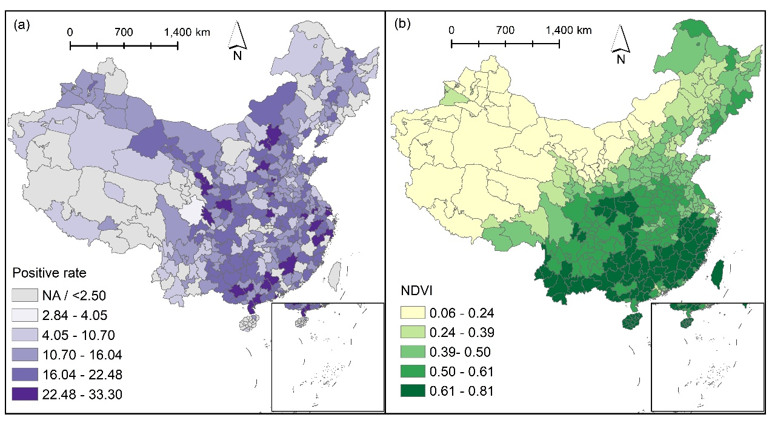
FigureS1 Distribution of city-level influenza positivity and NDVI from 2010-2017. (a) average influenza positivity, (b) average monthly NDVI.

TableS2 Associations between Residential Greenness and Seasonal Influenza among Children Aged <18 years.
Variables | Aged 0-6 years | Aged 7-17 years
NDVI(per0.171) | 0.996(0.977,1.016) | 1.104(1.079,1.129)
The analysis included data for 609852 ILI cases. In different subgroups, odds ratio(OR) and the 95% Confidence Interval (CI) were reported. NDVI: normalized difference vegetation index.

TableS3 Associations between Residential Greenness and Seasonal Influenza. (residential greenness exposure was measured by the monthly NDVI within a 1 km radius of the ILI residence.)
Variables | Model1  (OR) | Model2  (OR) | Model3  (OR) | Model4  (OR)
NDVI (per 0.171) | 0.608*** | 0.860*** | 0.901*** | 0.952***
Gender (Ref Female) | 0.987* | 0.990 | 0.991 | 0.991
Age (years) | 1.006*** | 1.007*** | 1.007*** | 1.006***
Region (Ref Southern) | 0.607*** | 0.457*** | 0.443*** | 0.507***
Mean temperature (K) |  | 0.965*** | 0.971*** | 0.983***
Precipitation (mm) |  | 1.005*** | 1.006*** | 1.004***
Relative humidity (%) |  | 0.993*** | 0.992*** | 0.993***
Sunshine duration (h) |  | 0.976*** | 0.988*** | 0.995***
Wind speed (m/s) |  | 0.965*** | 1.013** | 1.009*
O₃ (ug/m3) |  |  | 0.997*** | 0.996***
PM_{2.5} (ug/m3) |  |  | 1.002*** | 1.002***
Spring (Ref Winter) |  |  |  | 0.819***
Summer (Ref Winter) |  |  |  | 0.922***
Fall (Ref Winter) |  |  |  | 0.470***
2011(Ref2010) |  |  |  | 0.578***
2012(Ref2010) |  |  |  | 1.111***
2013(Ref2010) |  |  |  | 0.685***
2014(Ref2010) |  |  |  | 1.066***
2015(Ref2010) |  |  |  | 0.768***
2016(Ref2010) |  |  |  | 1.713***
2017(Ref2010) |  |  |  | 1.215***
The analysis included data for 1012430 ILI cases. The residential greenness exposure metric was modified to the monthly NDVI within a 1 km radius of the ILI residence. Model 1 was adjusted only for demographic factors (gender, age, and geographic region). Model 2 was further adjusted for meteorological factors (temperature, relative humidity, precipitation, wind speed, and sunshine duration) on the basis of Model 1. Model 3 included additional adjustments for air pollutants (PM_{2.5}, O₃). Model 4 was a fully adjusted model that incorporated the monitoring year and seasonality based on Model 3. OR: odds ratio. NDVI: normalized difference vegetation index.
* p<0.05, ** p<0,01. *** p<0.001

TableS4 Associations between Residential Greenness and Seasonal Influenza. (meteorological and air pollutant exposure levels were characterized using data from the first day before the onset of influenza symptoms.)
Variables | Model1  (OR) | Model2  (OR) | Model3  (OR) | Model4  (OR)
NDVI (per 0.171) | 0.621*** | 0.876*** | 0.908*** | 0.963***
Gender (Ref Female) | 0.985** | 0.989 | 0.990 | 0.990
Age (years) | 1.006*** | 1.007*** | 1.007*** | 1.006***
Region (Ref Southern) | 0.623*** | 0.470*** | 0.456*** | 0.527***
Mean temperature (K) |  | 0.964*** | 0.969*** | 0.982***
Precipitation (mm) |  | 1.002*** | 1.003*** | 1.002***
Relative humidity (%) |  | 0.995*** | 0.994*** | 0.995***
Sunshine duration (h) |  | 0.985*** | 0.994*** | 0.999
Wind speed (m/s) |  | 0.973*** | 1.008* | 1.002
O₃ (ug/m3) |  |  | 0.998*** | 0.996***
PM_{2.5} (ug/m3) |  |  | 1.002*** | 1.002***
Spring (Ref Winter) |  |  |  | 0.798***
Summer (Ref Winter) |  |  |  | 0.875***
Fall (Ref Winter) |  |  |  | 0.451***
2011(Ref2010) |  |  |  | 0.574***
2012(Ref2010) |  |  |  | 1.113***
2013(Ref2010) |  |  |  | 0.688***
2014(Ref2010) |  |  |  | 1.063***
2015(Ref2010) |  |  |  | 0.760***
2016(Ref2010) |  |  |  | 1.704***
2017(Ref2010) |  |  |  | 1.188***
The analysis included data for 1012430 ILI cases. Meteorological and air pollutant exposure levels were characterized using data from the first day before the onset of influenza symptoms. Model 1 was adjusted only for demographic factors (gender, age, and geographic region). Model 2 was further adjusted for meteorological factors (temperature, relative humidity, precipitation, wind speed, and sunshine duration) on the basis of Model 1. Model 3 included additional adjustments for air pollutants (PM_{2.5}, O₃). Model 4 was a fully adjusted model that incorporated the monitoring year and seasonality based on Model 3. OR: odds ratio. NDVI: normalized difference vegetation index.
* p<0.05, ** p<0,01. *** p<0.001

TableS5 Associations between Residential Greenness and Seasonal Influenza. (meteorological and air pollutant exposure levels were characterized using data from the second day before the onset of influenza symptoms.)
Variables | Model1  (OR) | Model2  (OR) | Model3  (OR) | Model4  (OR)
NDVI (per 0.171) | 0.621*** | 0.888*** | 0.923*** | 0.971***
Gender (Ref Female) | 0.985** | 0.989 | 0.990 | 0.990
Age (years) | 1.006*** | 1.007*** | 1.007*** | 1.006***
Region (Ref Southern) | 0.623*** | 0.464*** | 0.450*** | 0.516***
Mean temperature (K) |  | 0.963*** | 0.968*** | 0.981***
Precipitation (mm) |  | 1.003*** | 1.004*** | 1.003***
Relative humidity (%) |  | 0.994*** | 0.993*** | 0.994***
Sunshine duration (h) |  | 0.982*** | 0.992*** | 0.997**
Wind speed (m/s) |  | 0.977*** | 1.013*** | 1.009*
O₃ (ug/m3) |  |  | 0.997*** | 0.996***
PM_{2.5} (ug/m3) |  |  | 1.002*** | 1.002***
Spring (Ref Winter) |  |  |  | 0.807***
Summer (Ref Winter) |  |  |  | 0.908***
Fall (Ref Winter) |  |  |  | 0.466***
2011(Ref2010) |  |  |  | 0.575***
2012(Ref2010) |  |  |  | 1.113***
2013(Ref2010) |  |  |  | 0.687***
2014(Ref2010) |  |  |  | 1.063***
2015(Ref2010) |  |  |  | 0.763***
2016(Ref2010) |  |  |  | 1.714***
2017(Ref2010) |  |  |  | 1.199***
The analysis included data for 1012430 ILI cases. Meteorological and air pollutant exposure levels were characterized using data from the second day before the onset of influenza symptoms. Model 1 was adjusted only for demographic factors (gender, age, and geographic region). Model 2 was further adjusted for meteorological factors (temperature, relative humidity, precipitation, wind speed, and sunshine duration) on the basis of Model 1. Model 3 included additional adjustments for air pollutants (PM_{2.5}, O₃). Model 4 was a fully adjusted model that incorporated the monitoring year and seasonality based on Model 3. OR: odds ratio. NDVI: normalized difference vegetation index.
* p<0.05, ** p<0,01. *** p<0.001

