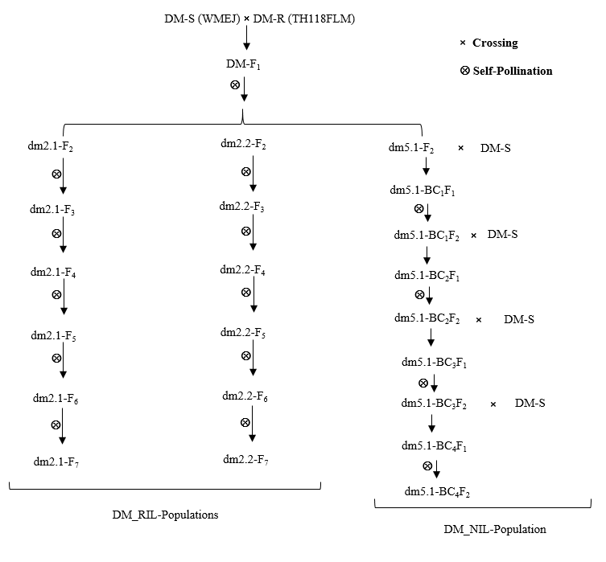
Supplementary Fig. 1 Generation of mapping populations for fine-genetic mapping via QTL-seq analysis and SNP-mining approach. Two recombinant inbred line (RIL) populations, namely dm2.1-F₇ for dm2.1 and dm2.2-F₇ for dm2.2 QTL loci, were established through successive self-pollination of DM-F₂, the progeny resulting from the cross between WMEJ and TH118FLM. Additionally, a near-isogenic line (NIL) population, dm5.1-BC₄F₂ for dm5.1 QTL locus, was established by repeated back-crossing of DM-F₂ to WMEJ. In this context, DM-R and DM-S represent the parental lines of these populations, with DM-R denoting resistance to downy mildew (DM), while DM-S represents susceptibility. For generating the RIL and NIL mapping populations from DM-F₂ generations, marker-assisted selection (MAS) by using various types of markers, including simple-sequence repeat (SSR), insertion/deletion (InDel), and cleaved amplified polymorphic sequence (CAPS) were employed and are listed in Figs. 2B, 3B, 4B, and Table S1.

a
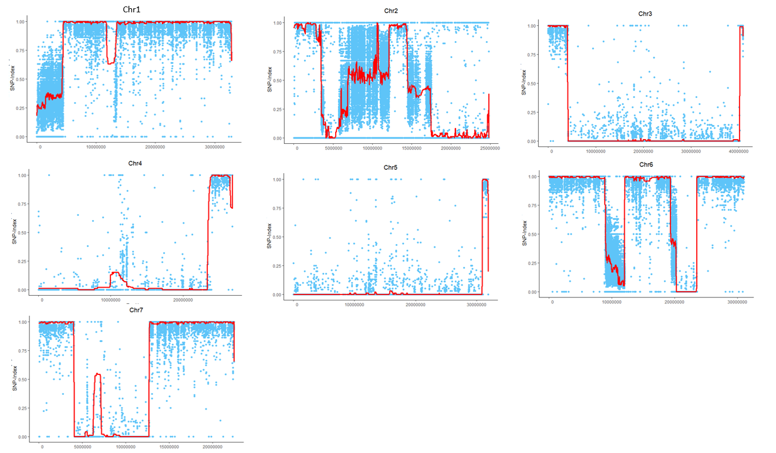

b
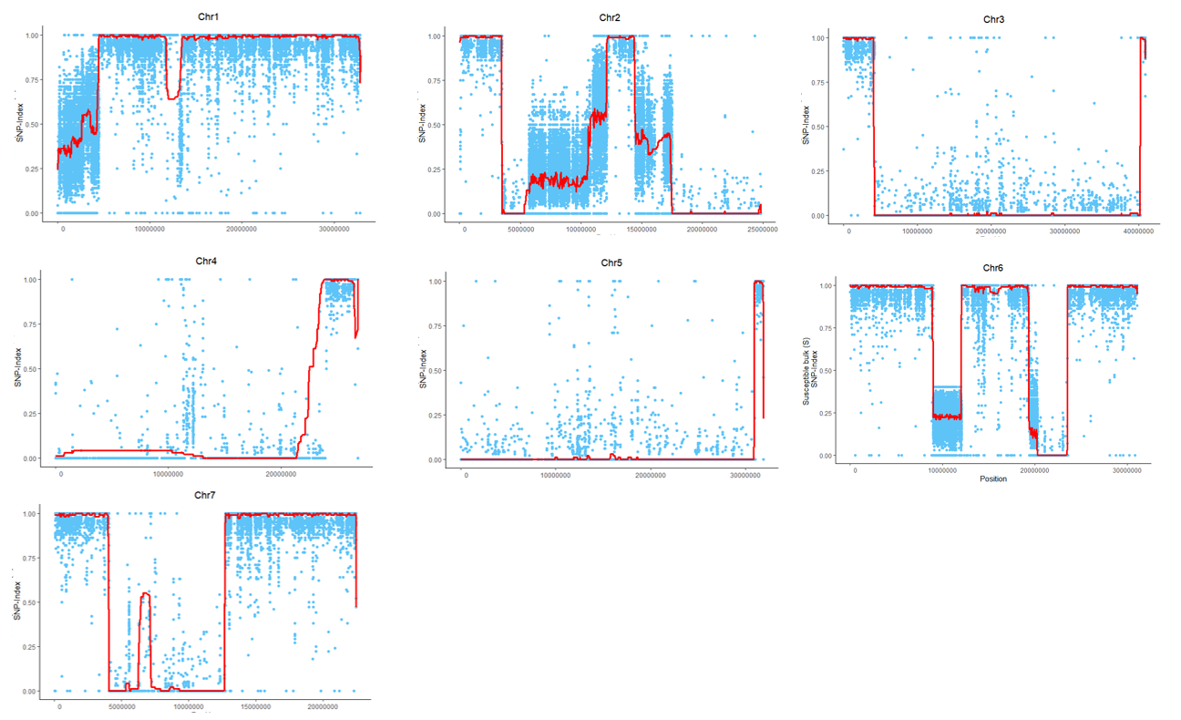

c
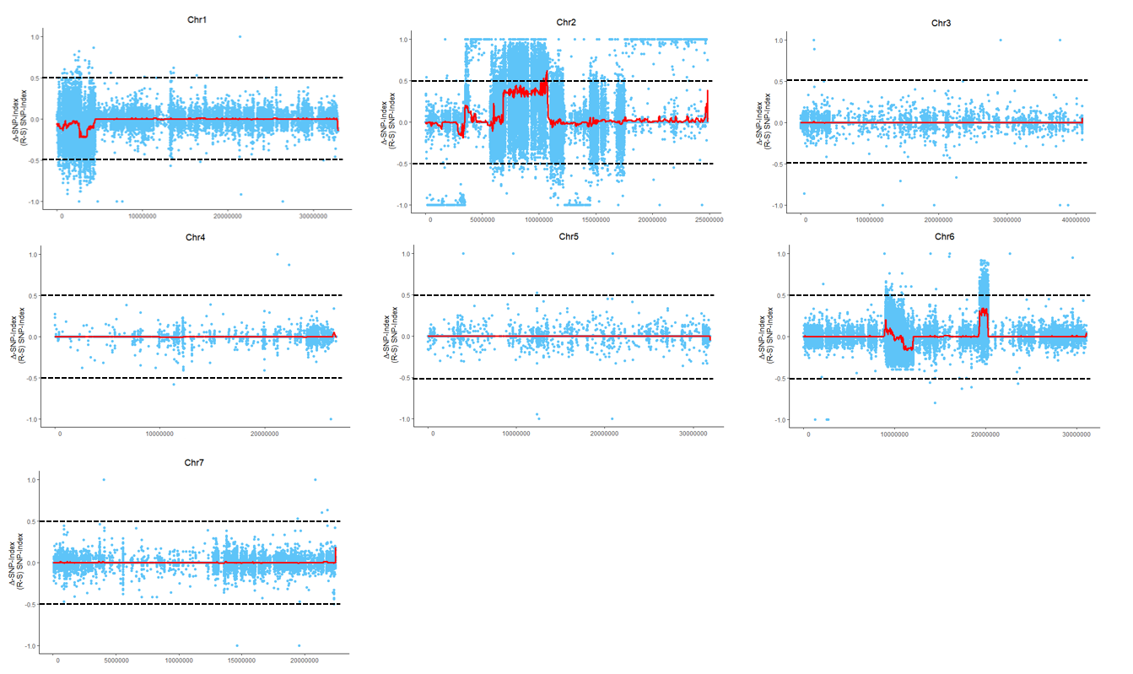
Supplementary Fig. 2 Single-nucleotide polymorphism (SNP)-index and Δ (SNP-index) plots. The SNP-index of DM-resistance (R-bulk) and DM-susceptibility (S-bulk) for the dm2.1-F₇ are represented by a and b, respectively. Δ (SNP-index) plot is represented by subtracting the S-bulk SNP-index from the R-bulk SNP-index for dm2.1-F₇ (c). Statistical confidence intervals under the null hypothesis of no QTLs are indicated as black dotted lines at P < 0.05.

a
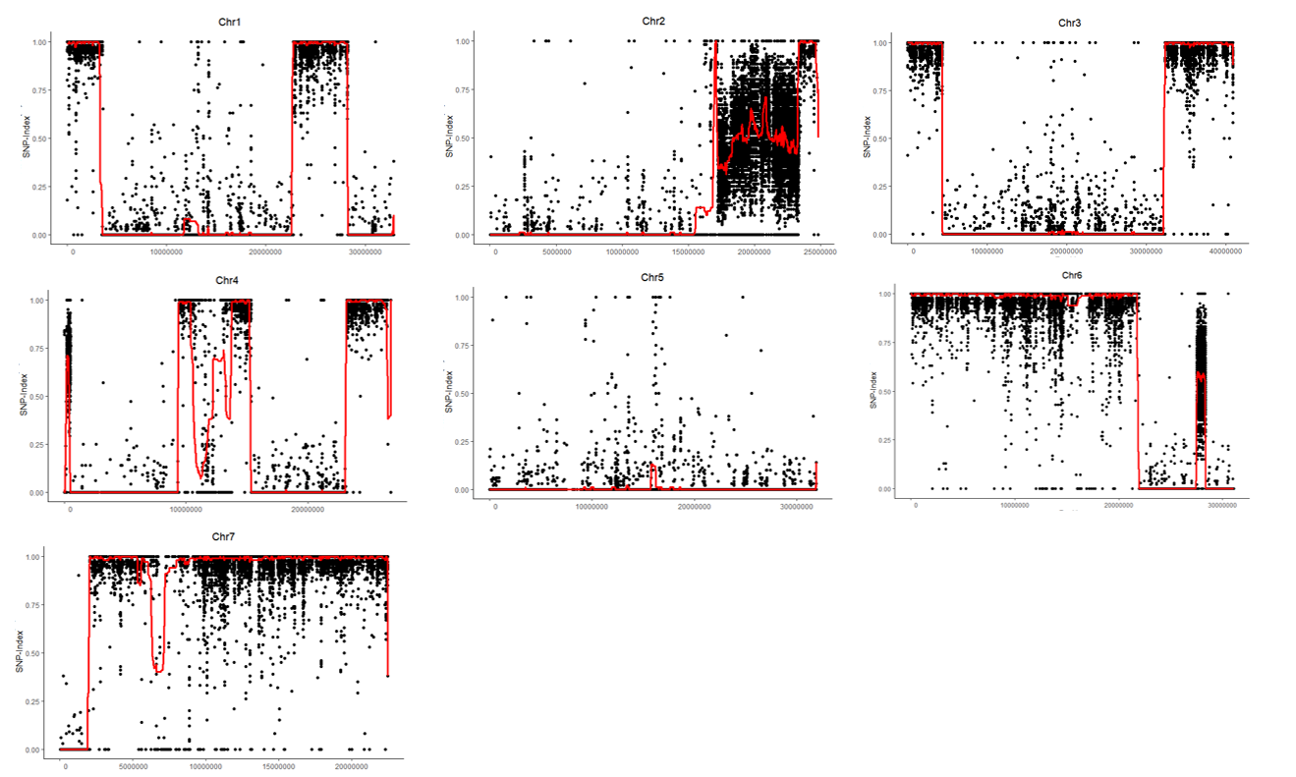

b
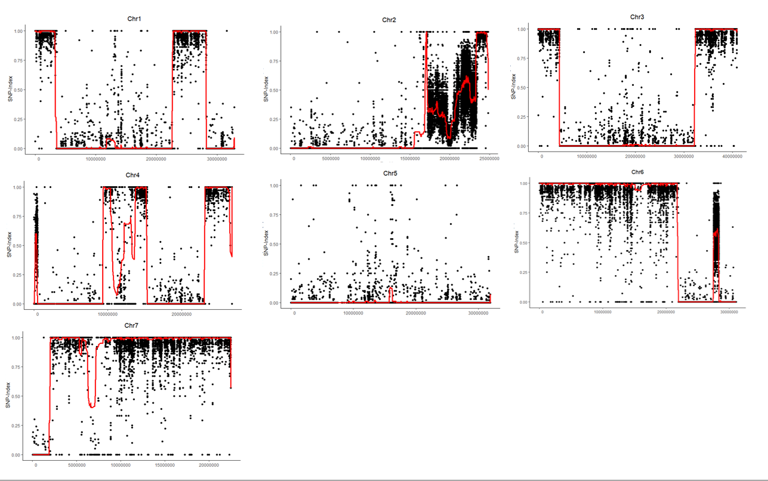

c
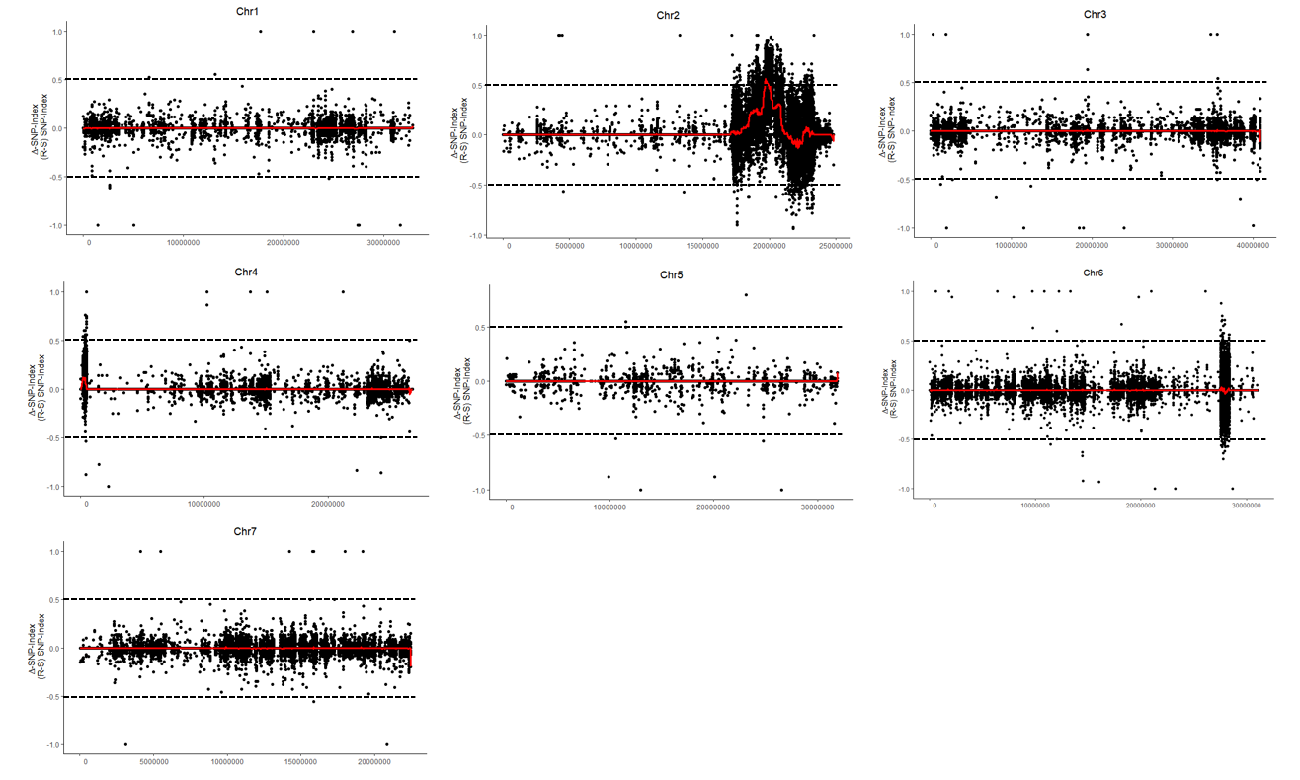
Supplementary Fig. 3 Single-nucleotide polymorphism (SNP)-index and Δ (SNP-index) plots. The SNP-index of DM-resistance (R-bulk) and DM-susceptibility (S-bulk) for the dm2.2-F₇ are represented by a and b, respectively. Δ (SNP-index) plot is represented by subtracting the S-bulk SNP-index from the R-bulk SNP-index for dm2.2-F₇ (c). Statistical confidence intervals under the null hypothesis of no QTLs are indicated as black dotted lines at P < 0.05.

a
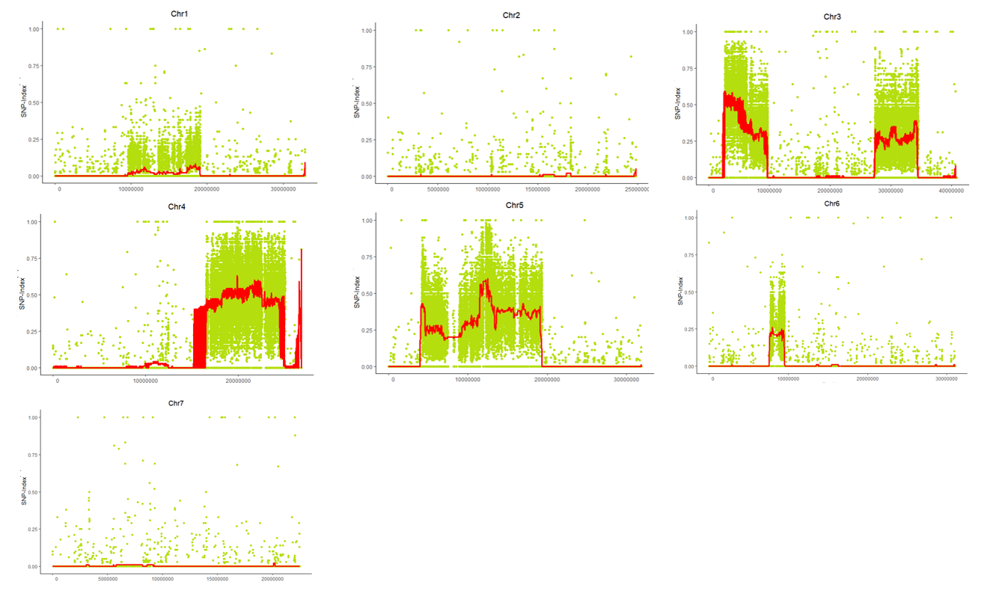

b
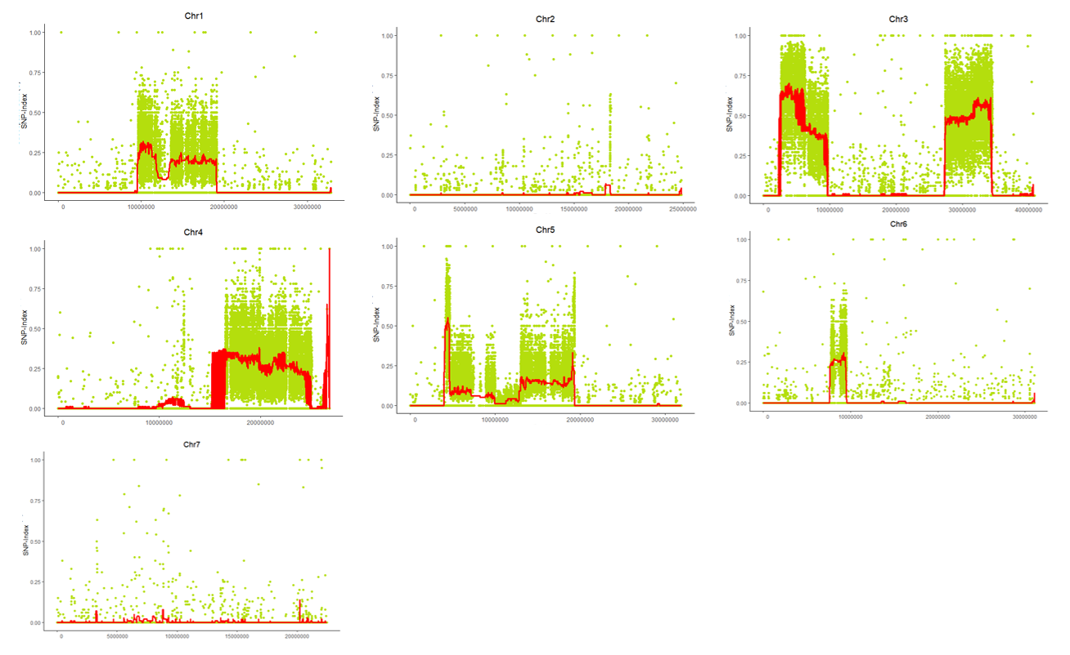

c
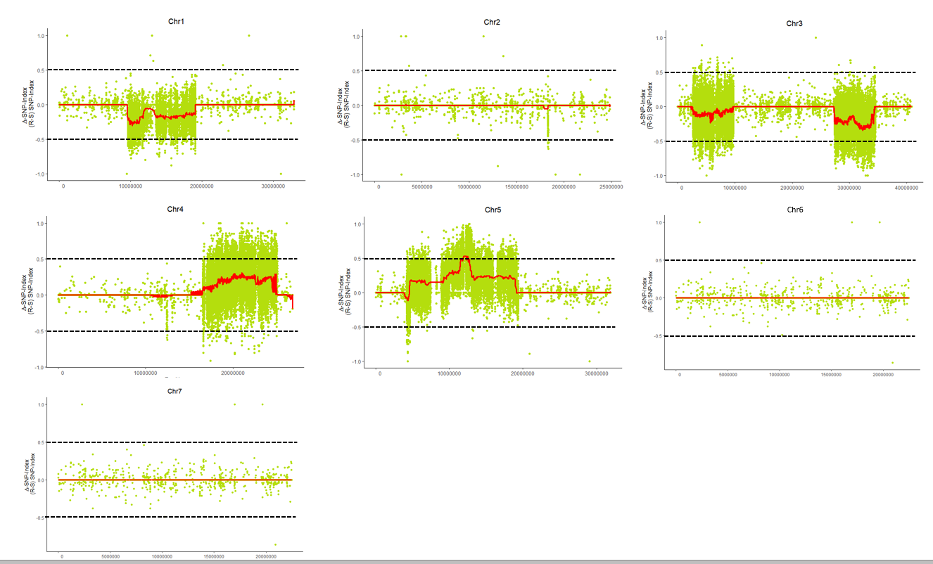
Supplementary Fig. 4 Single-nucleotide polymorphism (SNP)-index and Δ (SNP-index) plots. The SNP-index of DM-resistance (R-bulk) and DM-susceptibility (S-bulk) for the dm5.1-BC₄F₂ are represented by a and b, respectively. Δ (SNP-index) plot is represented by subtracting the S-bulk SNP-index from the R-bulk SNP-index for dm5.1-BC₄F₂ (c). Statistical confidence intervals under the null hypothesis of no QTLs are indicated as black dotted lines at P < 0.05.

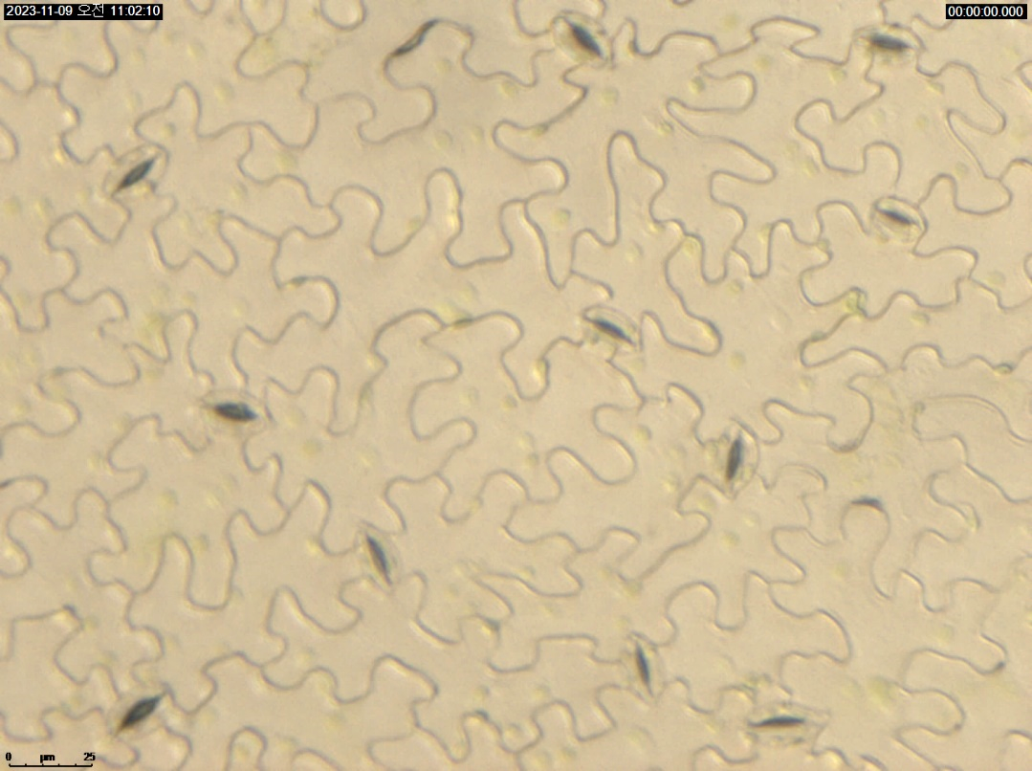
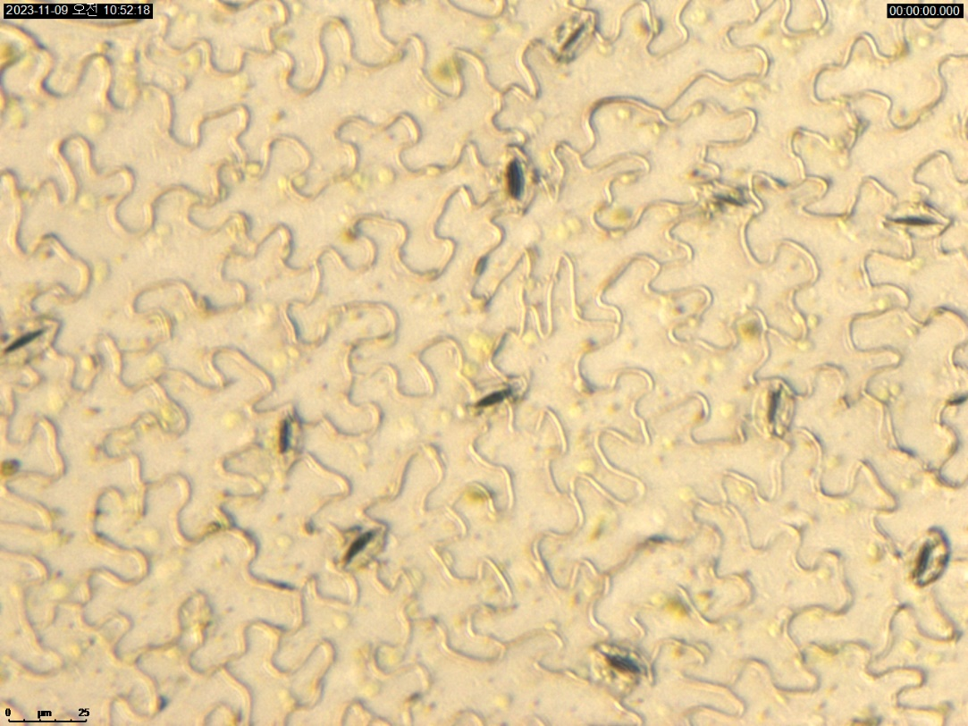
a
b

Supplementary Fig. 5 Illustration of stomatal opening and closure in cucumber leaves. Panel (A) displays the stomatal appearance before treatment, while panel (B) shows the condition of stomata after 8 h of ethephon (ETH) treatment. Stomata were observed under a LEICA DMi8 microscope (Wetzlar, Germany) at a 400X magnification. The scale bar in the lower left corner represents a 25-μm scale.

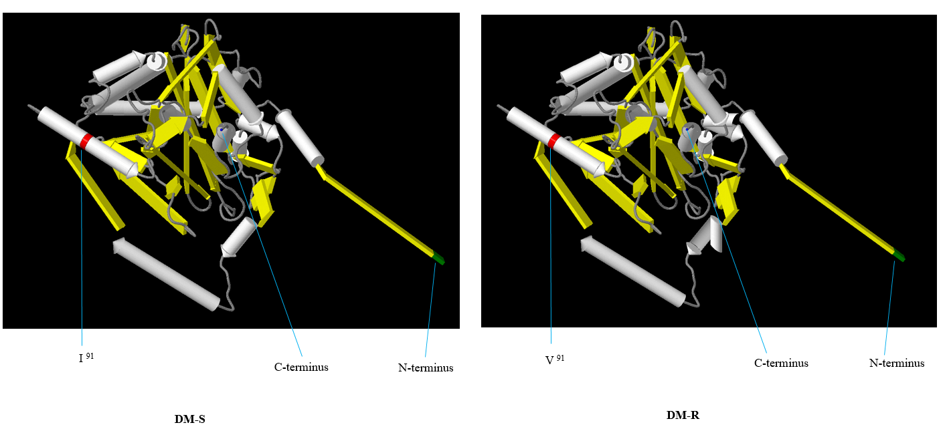
Supplementary Fig. 6 In silico 3D modeling of CsaV3_2G012920. The amino acid sequences of CsaV3_2G012920 from DM-S (on the left) and DM-R (on the right) were used for comparison. The α-helices and β-sheets are indicated by white and yellow regions, respectively. The loop structures are represented in gray. Notably, non-synonymous mutations occurring at amino acid position 91 are highlighted in red. Additionally, the N-terminus and C-terminus are marked in green and blue, respectively.

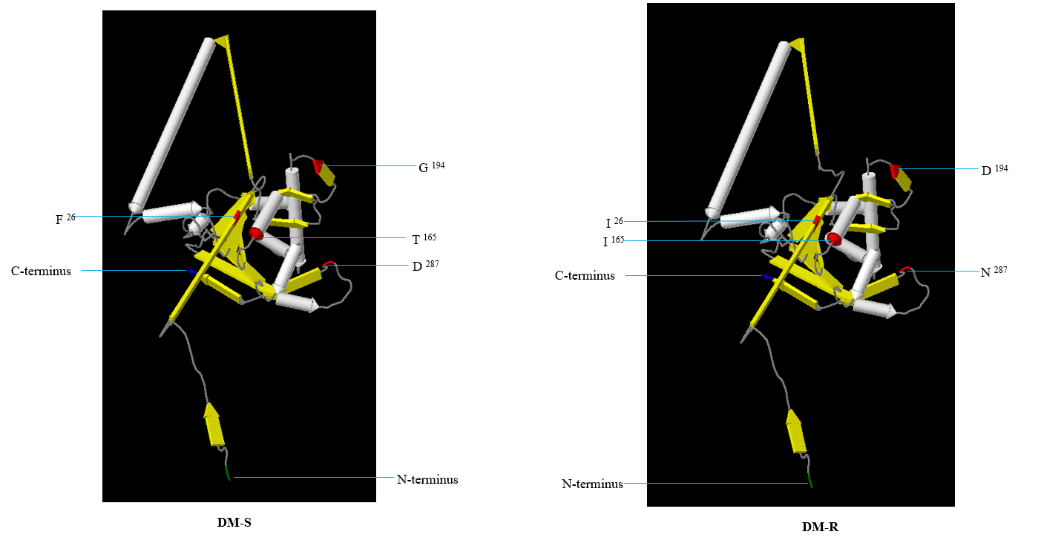
Supplementary Fig. 7 In silico 3D modeling of CsaV3_2G030320. The amino acid sequences of CsaV3_2G030320 from DM-S (on the left) and DM-R (on the right) were used for comparison. The α-helices and β-sheets are indicated by white and yellow regions, respectively. The loop structures are represented in gray. The non-synonymous mutations were indicated at their respective positions and emphasized using the color red. Additionally, the N-terminus and C-terminus are marked in green and blue, respectively.

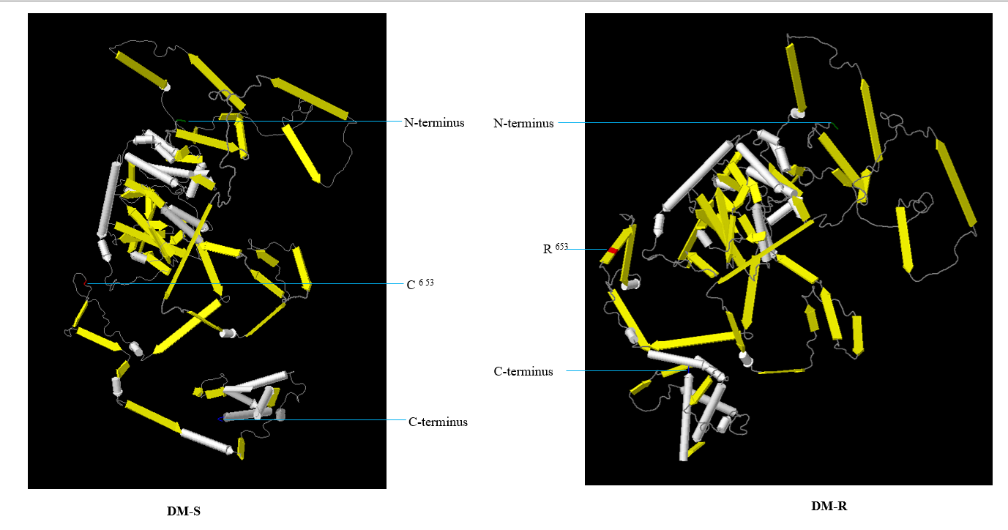
Supplementary Fig. 8 In silico 3D modeling of CsaV3_5G015170. The amino acid sequences of CsaV3_5G015170 from DM-S (on the left) and DM-R (on the right) were used for comparison. The α-helices and β-sheets are indicated by white and yellow regions, respectively. The loop structures are represented in gray. Notably, non-synonymous mutations occurring at amino acid position 653 are highlighted in red. Additionally, the N-terminus and C-terminus are marked in green and blue, respectively.

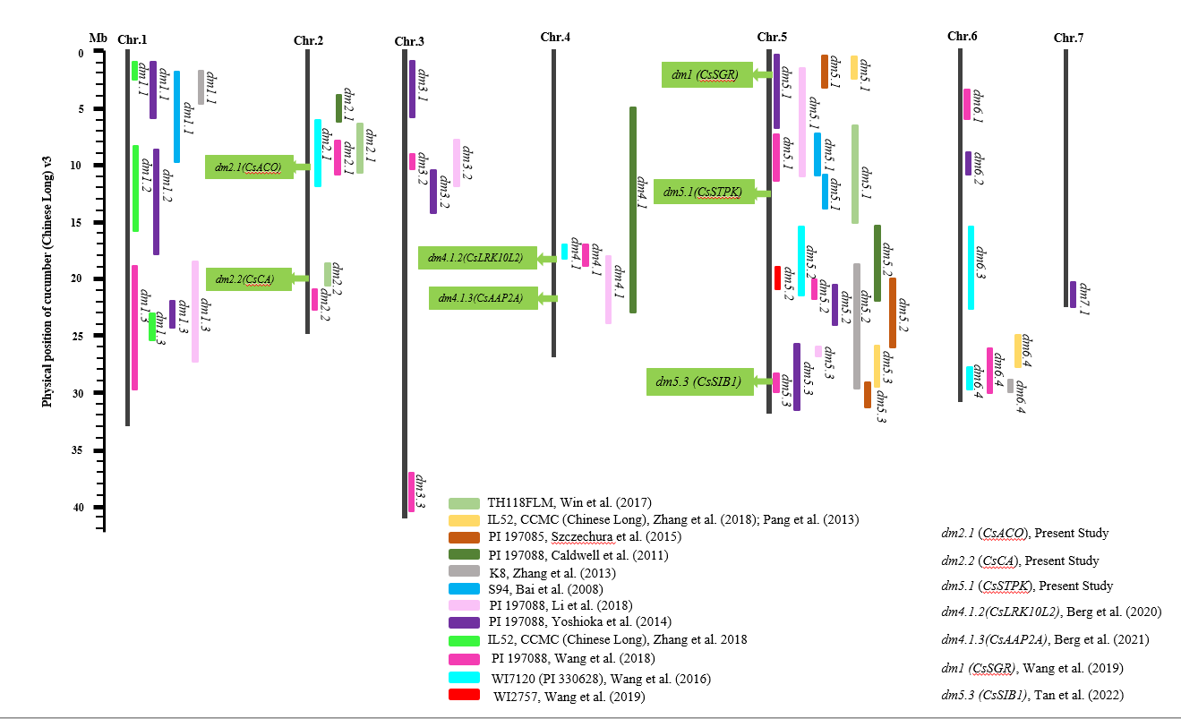
Supplementary Fig. 9 Chromosomal locations of downy mildew (DM) resistance quantitative trait loci (QTLs) and candidate genes. This diagram illustrates the chromosomal positions of both DM-resistance QTLs and candidate genes, consolidating insights from both previous research and the current study. The seven chromosomes of cucumber are represented as vertical black lines. A scale on the left side provides physical locations based on the reference genome (Chinese Long 9930 v3). DM-resistance QTLs are shown on the right side of each chromosome, while candidate genes are displayed on the left.

Supplementary Table 1 Information on SSR, InDel, and CAPS markers
QTL | Name of Marker | Restriction-Enzyme | Forward-Sequence  (5' - 3') | Reverse-Sequence  (5' - 3') | Annealing (℃) | Cycle
dm2.1 | dm2.1_InDel-1 | - | TTTGAGGGCTCGTAAAGAAATAA | CGTATCACAATTAAAGGTTGATTG | 58 | 35
dm2.1 | dm2.1_InDel-2 | - | CCGAGATCAAACTTCAATTGATTT | CCAAAGGAACCTAAAGTACACT | 58 | 35
dm2.1 | dm2.1_CAPS-3 | AluI | CCTAAAGATGGCAGCATGTAAT | CTGCCATTCATTACAAGCACAT | 59 | 35
dm2.1 | dm2.1_SSR-4 | - | AAAAGGGAGGTTAGGGGGTT | TCCATTGGTAATAGCTGGGTTT | 57 | 35
dm2.1 | dm2.1_InDel-5 | - | TTTGCATAAGTAGTCGTCATTGC | CATTTAAACTTGCTACGAGATCG | 59 | 35
dm2.1 | dm2.1_CAPS-6 | BsaAI | CACCAACAACTTCGTTCTCATC | TGAGTTGCGTAATCTGTGGTTC | 60 | 35
dm2.1 | dm2.1_CAPS-7 | HinfI | CTAAAGCCGATTTTGTAGTTGTG | CACAGGTCTAGAAAGCATACTG | 60 | 35
dm2.1 | dm2.1_CAPS-8 | MnlI | CTGTGAAATAAGTGGCACAGAG | TGAAATAAAGGGCCACCTGTGA | 60 | 35
dm2.2 | dm2.2_InDel-1 | - | ACGTGAGAGACACCCCTCC | TATCCCATGGGTATGGTGTG | 58 | 35
dm2.2 | dm2.2_SSR-2 | - | AGCATGATGAGGATCCCTTG | CCGAACTGCACAAAGTATGG | 57 | 35
dm2.2 | dm2.2_InDel-3 | - | CAACGTCGTTTATTGAATTTGCC | CTCATTGGACTTGACCACTAAG | 60 | 35
dm2.2 | dm2.2_SSR-4 | - | AATAATACCAGTGGCCCCATC | AAAGCTCCCTCCTCCCCTAC | 59 | 35
dm2.2 | dm2.2_SSR-5 | - | TCCCTCAACGATTCGAGTTT | AAAAGCAAGAAGCAACCCAA | 55 | 35
dm2.2 | dm2.2_InDel-6 | - | CACACTGGACAATTATGTTGAGG | CCGATTGAAATTGTAAAACAGAAACG | 61 | 35
dm2.2 | dm2.2_CAPS-7 | AluI | CCGTGGGGTCTTTGTTTTAT | GAGACCCATTAGCCAATTTTTT | 56 | 35
dm2.2 | dm2.2_CAPS-8 | RsaI | GTAGTCTATCTTAATCTATCATGG | CGTCTAGAAAGCTTGTAACAAC | 58 | 35
dm5.1 | dm5.1_InDel-1 | - | GAATGGAAATGAAAATGCAGAAGC | AATTAAATATGCCTTCAACCACCAG | 60 | 35
dm5.1 | dm5.1_CAPS-2 | NcoI | CCTCATTTCTTTTAGACAGAATG | CCATCCTACCTCAAAAATGGAT | 58 | 35
dm5.1 | dm5.1_SSR-3 | - | GAGGAATGTCGAATGAGGGA | CAACTTAACCCAAACCCGAA | 57 | 35
dm5.1 | dm5.1_SSR-4 | - | CAATGGAGGAGGAGTTGGAG | GGGGCAGGGTAGAAGAAATC | 59 | 35
dm5.1 | dm5.1_SSR-5 | - | TCCAATCCCACTCTGGTTTC | TCTTTCCAACACTAACCTTGGATT | 57 | 35
dm5.1 | dm5.1_CAPS-6 | MnlI | TCCATCTTTTTACCCCTTTTACC | AATAAAAGGTAGAAGCCCTTGTC | 59 | 35
dm5.1 | dm5.1_CAPS-7 | MseI | ATGTTACAAAAGCATCCTCACG | ATTGCGGTGAATAATTGTGAGG | 58 | 35
dm5.1 | dm5.1_InDel-8 | - | AATCTGAGGGAGCTTGGGATAT | CCCATTTTCTAGGTCGATCAACA | 60 | 35

Supplementary Table 2 The disease index (DI) of the individuals, consisting of both DM-R and DM-S bulks
Individual | Name of QTL (Bulk) | DI*
F₇-77 | dm2.1  (R-Bulk) | 2.25
F₇-87 | dm2.1  (R-Bulk) | 1.25
F₇-88 | dm2.1  (R-Bulk) | 1.5
F₇-89 | dm2.1  (R-Bulk) | 1
F₇-90 | dm2.1  (R-Bulk) | 1.25
F₇-91 | dm2.1  (R-Bulk) | 1.25
F₇-17 | dm2.1  (S-Bulk) | 7.25
F₇-21 | dm2.1  (S-Bulk) | 7.75
F₇-27 | dm2.1  (S-Bulk) | 7.75
F₇-30 | dm2.1  (S-Bulk) | 8
F₇-32 | dm2.1  (S-Bulk) | 7.75
F₇-34 | dm2.1  (S-Bulk) | 7.75
F₇-41 | dm2.1  (S-Bulk) | 7.75
F₇-48 | dm2.1  (S-Bulk) | 7.75
F₇-52 | dm2.1  (S-Bulk) | 7.75
F₇-54 | dm2.1  (S-Bulk) | 7.75
F₇-56 | dm2.1  (S-Bulk) | 7.5
F₇-9 | dm2.2  (R-Bulk) | 1.33
F₇-17 | dm2.2  (R-Bulk) | 1.5
F₇-23 | dm2.2  (R-Bulk) | 1
F₇-90 | dm2.2  (R-Bulk) | 1.25
F₇-93 | dm2.2  (R-Bulk) | 1.25
F₇-97 | dm2.2  (R-Bulk) | 1
F₇-100 | dm2.2  (R-Bulk) | 1
F₇-108 | dm2.2  (R-Bulk) | 1.5
F₇-113 | dm2.2  (R-Bulk) | 1.75
F₇-18 | dm2.2  (S-Bulk) | 6.75
F₇-35 | dm2.2  (S-Bulk) | 6.75
F₇-37 | dm2.2  (S-Bulk) | 7.25
F₇-38 | dm2.2  (S-Bulk) | 6.75
F₇-40 | dm2.2  (S-Bulk) | 6.75
F₇-41 | dm2.2  (S-Bulk) | 7
F₇-44 | dm2.2  (S-Bulk) | 7.5
F₇-46 | dm2.2  (S-Bulk) | 7
F₇-67 | dm2.2  (S-Bulk) | 7
F₇-122 | dm2.2  (S-Bulk) | 8
F₇-126 | dm2.2  (S-Bulk) | 8
BC₄F₂-61 | dm5.1  (R-Bulk) | 1.3
BC₄F₂-120 | dm5.1  (R-Bulk) | 1
BC₄F₂-129 | dm5.1  (R-Bulk) | 1.6
BC₄F₂-130 | dm5.1  (R-Bulk) | 1.3
BC₄F₂-131 | dm5.1  (R-Bulk) | 1.3
BC₄F₂-136 | dm5.1  (R-Bulk) | 1.3
BC₄F₂-144 | dm5.1  (R-Bulk) | 1.3
BC₄F₂-149 | dm5.1  (R-Bulk) | 1.3
BC₄F₂-25 | dm5.1  (S-Bulk) | 6
BC₄F₂-35 | dm5.1  (S-Bulk) | 6
BC₄F₂-40 | dm5.1  (S-Bulk) | 6.3
BC₄F₂-41 | dm5.1  (S-Bulk) | 6.6
BC₄F₂-42 | dm5.1  (S-Bulk) | 7.3
BC₄F₂-44 | dm5.1  (S-Bulk) | 6.6
BC₄F₂-46 | dm5.1  (S-Bulk) | 7.6
BC₄F₂-47 | dm5.1  (S-Bulk) | 6.3
BC₄F₂-72 | dm5.1  (S-Bulk) | 6
BC₄F₂-75 | dm5.1  (S-Bulk) | 6
BC₄F₂-76 | dm5.1  (S-Bulk) | 6
* The mean of six replicated outcomes

Supplementary Table 3 List of genes and primer sequences employed in reverse transcription-polymerase chain reaction (RT-PCR) analysis
QTL | Genes-ID | Forward-Sequence  (5′ – 3′) | Reverse-Sequence  (5′ – 3′)
dm2.1 | CsaV3_2G012920 | CGCTGGGTTGATGTTCATC | CTTGCCACTGAGATTCTTGG
dm2.2 | CsaV3_2G030320 | GGGCAAAGGCTGCTGCTG | CCAGGGGTATGACATCAAG
dm5.1 | CsaV3_5G015170 | GCAGGACAAGCTCTGGTC | GCTACAGTACCCCTATTGTC
- | Cs-Actin | CTCCTCTCAATCCTAAAGCC | GGCATACAGTGATAGAACGG

Supplementary Table 4 List of annotated genes located in the dm2.1, dm2.2, and dm5.1
# |  | QTL* |  | Gene-ID | Physical-Position  (Direction) |  | Type of Sequence Variance | Type of Mutation | Percentage of SNP Conservation** | Putative Gene Function
1 | dm2.1 |  | CsaV3_2G012840 |  | 10384983 .. 10385535 (+) | SNP |  | Synonymous | 60 | Proline-rich protein
2 |  | dm2.1 |  | CsaV3_2G012850 | 10392727 .. 10394326 (+) |  | - | - | - | repetitive proline-rich cell wall protein 1-like
3 |  | dm2.1 |  | CsaV3_2G012860 | 10409144 .. 10409476 (-) |  | - | - | - | Unknown protein
4 |  | dm2.1 |  | CsaV3_2G012870 | 10411032 .. 10412184 (-) |  | - | - | - | ethylene-responsive transcription factor 1B-like
5 |  | dm2.1 |  | CsaV3_2G012880 | 10447374 .. 10451295 (-) |  | - | - | - | Ethylene-responsive transcription factor
6 |  | dm2.1 |  | CsaV3_2G012890*** | 10465735 .. 10470455 (+) |  | - | - | - | RING-H2 finger protein ATL16
7 |  | dm2.1 |  | CsaV3_2G012900 | 10474274 .. 10477614 (-) |  | SNP | Synonymous | 100 | WAT1-related protein
8 |  | dm2.1 |  | CsaV3_2G012910 | 10478881 .. 10481363 (-) |  | SNP | Synonymous | 100 | CASP-like protein
9 |  | dm2.1 |  | CsaV3_2G012920 | 10486203 .. 10488514 (-) |  | SNP | Non-synonymous | 100 | 1-aminocyclopropane-1-carboxylate oxidase like 1
10 |  | dm2.1 |  | CsaV3_2G012930 | 10500493 .. 10502963 (-) |  | SNP | Synonymous | 100 | HR-like lesion-inducing protein-related
11 |  | dm2.1 |  | CsaV3_2G012940 | 10513414 .. 10516289 (+) |  | - | - | - | HR-like lesion-inducing protein-related
12 |  | dm2.1 |  | CsaV3_2G012950 | 10521532 .. 10522732 (+) |  | - | - | - | At1g04330
13 |  | dm2.1 |  | CsaV3_2G012960 | 10537977 .. 10539722 (+) |  | - | - | - | DUF668 domain-containing protein/DUF3475 domain-containing protein
14 |  | dm2.1 |  | CsaV3_2G012970 | 10540538 .. 10545421 (+) |  | - | - | - | AT-hook motif nuclear-localized protein
15 |  | dm2.1 |  | CsaV3_2G012980 | 10556875 .. 10558253 (-) |  | - | - | - | Transcriptional regulator tac1
16 |  | dm2.1 |  | CsaV3_2G012990 | 10564151 .. 10564693 (-) |  | SNP | Non-synonymous | 66 | transcriptional regulator SUPERMAN
17 |  | dm2.1 |  | CsaV3_2G013000 | 10566204 .. 10566852 (+) |  | - | - | - | Protein TIC 214
18 |  | dm2.1 |  | CsaV3_2G013010 | 10571662 .. 10571830 (+) |  | - | - | - | protein RALF-like 30
19 |  | dm2.1 |  | CsaV3_2G013020 | 10581382 .. 10586243 (+) |  | SNP | Synonymous | 50 | protein WVD2-like 3
20 |  | dm2.1 |  | CsaV3_2G013030 | 10600921 .. 10610422 (+) |  | SNP | Synonymous | 52 | P-loop containing nucleoside triphosphate hydrolases superfamily protein
21 |  | dm2.1 |  | CsaV3_2G013040 | 10611542 .. 10613703 (-) |  | - | - | - | protein RALF-like 30
22 |  | dm2.1 |  | CsaV3_2G013050 | 10622707 .. 10624936 (+) |  | - | - | - | Ribosomal S15 protein
23 |  | dm2.1 |  | CsaV3_2G013060 | 10626443 .. 10627763 (-) |  | SNP | Synonymous | 70 | transcription factor bHLH92
24 |  | dm2.1 |  | CsaV3_2G013070 | 10631192 .. 10633642 (+) |  | - | - | - | DNA-directed RNA polymerase II subunit RPB7
25 |  | dm2.1 |  | CsaV3_2G013080 | 10633637 .. 10637490 (-) |  | SNP | Non-synonymous | 60 | protein SIEVE ELEMENT OCCLUSION B-like
26 |  | dm2.1 |  | CsaV3_2G013090 | 10641378 .. 10646409 (-) |  | SNP | Non-synonymous | 56 | protein SIEVE ELEMENT OCCLUSION B-like
27 |  | dm2.1 |  | CsaV3_2G013100 | 10654437 .. 10655760 (-) |  | SNP | Synonymous | 72 | acidic endochitinase-like
28 |  | dm2.1 |  | CsaV3_2G013110 | 10659165 .. 10659316 (-) |  | SNP | Synonymous | 58 | Unknown protein
29 |  | dm2.1 |  | CsaV3_2G013120 | 10668354 .. 10674051 (+) |  | - | - | - | protein SIEVE ELEMENT OCCLUSION B-like
30 |  | dm2.1 |  | CsaV3_2G013130 | 10684990 .. 10685190 (-) |  | - | - | - | Unknown protein
31 |  | dm2.1 |  | CsaV3_2G013140 | 10692752 .. 10700748 (+) |  | SNP | Synonymous | 78 | protein SIEVE ELEMENT OCCLUSION B-like
1 |  | dm2.2 |  | CsaV3_2G030070 | 19675209 .. 19677195 (-) |  | SNP | Synonymous | 52 | serine/threonine-protein kinase-like protein At3g51990
2 |  | dm2.2 |  | CsaV3_2G030080 | 19681483 .. 19683217 (-) |  | - | - | - | Zinc ion binding protein
3 |  | dm2.2 |  | CsaV3_2G030090 | 19685080 .. 19689447 (-) |  | - | - | - | transcription factor bHLH143-like isoform X1
4 |  | dm2.2 |  | CsaV3_2G030100 | 19704671 .. 19708523 (-) |  | SNP | Synonymous | 50 | cyclin-D4-1-like
5 |  | dm2.2 |  | CsaV3_2G030110 | 19719951 .. 19724440 (+) |  | - | - | - | protein CutA, chloroplastic
6 |  | dm2.2 |  | CsaV3_2G030120 | 19725119 .. 19730941 (+) |  | SNP | Non-synonymous | 70 | Rhamnogalacturonate lyase family protein
7 |  | dm2.2 |  | CsaV3_2G030130 | 19735105 .. 19750877 (+) |  | - | - | - | E3 ubiquitin-protein ligase UPL1-like
8 |  | dm2.2 |  | CsaV3_2G030140 | 19751781 .. 19755025 (+) |  | - | - | - | Cox19-like CHCH family protein
9 |  | dm2.2 |  | CsaV3_2G030150 | 19756109 .. 19762681 (+) |  | - | - | - | Crt
10 |  | dm2.2 |  | CsaV3_2G030160 | 19763489 .. 19790220 (+) |  | SNP | Non-synonymous | 75 | Golgi-body localization protein domain isoform 1
11 |  | dm2.2 |  | CsaV3_2G030170 | 19791787 .. 19799588 (-) |  | SNP | Synonymous | 65 | GATA transcription factor
12 |  | dm2.2 |  | CsaV3_2G030180 | 19800418 .. 19806745 (-) |  | - | - | - | GATA transcription factor
13 |  | dm2.2 |  | CsaV3_2G030190 | 19811478 .. 19818721 (+) |  | SNP | Synonymous | 60 | VIN3-like protein 2 isoform X1
14 |  | dm2.2 |  | CsaV3_2G030200 | 19819270 .. 19821248 (-) |  | SNP | Synonymous | 64 | Tetratricopeptide repeat-like superfamily protein
15 |  | dm2.2 |  | CsaV3_2G030210 | 19822974 .. 19829224 (+) |  | - | - | - | Telomeric repeat-binding factor like
16 |  | dm2.2 |  | CsaV3_2G030220 | 19829666 .. 19829983 (+) |  | - | - | - | Unknown protein
17 |  | dm2.2 |  | CsaV3_2G030230 | 19830188 .. 19831408 (-) |  | SNP | Non-synonymous | 72 | Ribosomal RNA small subunit methyltransferase A
18 |  | dm2.2 |  | CsaV3_2G030240 | 19831469 .. 19832692 (-) |  | SNP | Synonymous | 78 | Unknown protein
19 |  | dm2.2 |  | CsaV3_2G030250 | 19842803 .. 19848017 (+) |  | - | - | - | Argininosuccinate lyase
20 |  | dm2.2 |  | CsaV3_2G030260 | 19845191 .. 19852989 (-) |  | - | - | - | kinesin-like protein KIN-4C
21 |  | dm2.2 |  | CsaV3_2G030270 | 19856439 .. 19863491 (+) |  | - | - | - | mechanosensitive ion channel protein 3, chloroplastic-like
22 |  | dm2.2 |  | CsaV3_2G030280 | 19863461 .. 19868513 (-) |  | - | - | - | O-fucosyltransferase family protein
23 |  | dm2.2 |  | CsaV3_2G030290 | 19868942 .. 19878534 (-) |  | - | - | - | Sentrin/sumo-specific protease, putative
24 |  | dm2.2 |  | CsaV3_2G030300 | 19879642 .. 19887659 (-) |  | - | - | - | MADS-box protein like
25 |  | dm2.2 |  | CsaV3_2G030310 | 19895721 .. 19897132 (+) |  | - | - | - | transcription factor bHLH30-like
26 |  | dm2.2 |  | CsaV3_2G030320 | 19898474 .. 19901723 (+) |  | SNP | Non-synonymous | 100 | Carbonic anhydrase
27 |  | dm2.2 |  | CsaV3_2G030330 | 19910233 .. 19910391 (-) |  | - | - | - | Unknown protein
28 |  | dm2.2 |  | CsaV3_2G030340 | 19910568 .. 19911386 (+) |  | - | - | - | AT-hook motif nuclear-localized protein
29 |  | dm2.2 |  | CsaV3_2G030350 | 19919928 .. 19927180 (-) |  | SNP | Synonymous | 66 | Ubiquitin carboxyl-terminal hydrolase
30 |  | dm2.2 |  | CsaV3_2G030360 | 19932551 .. 19935987 (+) |  | - | - | - | Universal stress protein A-like protein
31 |  | dm2.2 |  | CsaV3_2G030370 | 19938618 .. 19942436 (+) |  | - | - | - | Aspartyl protease
32 |  | dm2.2 |  | CsaV3_2G030380 | 19939529 .. 19942285 (-) |  | - | - | - | Mitochondrial carrier protein
33 |  | dm2.2 |  | CsaV3_2G030390 | 19945922 .. 19949310 (+) |  | - | - | - | Mitochondrial carrier protein
34 |  | dm2.2 |  | CsaV3_2G030400 | 19946151 .. 19963325 (-) |  | SNP | Synonymous | 81 | rho GTPase-activating protein REN1
35 |  | dm2.2 |  | CsaV3_2G030410 | 19966512 .. 19971142 (+) |  | - | - | - | MADS box interactor-like protein, putative
1 |  | dm5.1 |  | CsaV3_5G014750 | 11863289 .. 11867036 (-) |  | SNP | Non-synonymous | 60 | RING-type E3 ubiquitin transferase
2 |  | dm5.1 |  | CsaV3_5G014760 | 11869643 .. 11869906 (-) |  | - | - | - | Unknown protein
3 |  | dm5.1 |  | CsaV3_5G014770 | 11895386 .. 11896353 (+) |  | SNP | Non-synonymous | 78 | MLP-like protein 329
4 |  | dm5.1 |  | CsaV3_5G014780 | 11897267 .. 11900601 (-) |  | - | - | - | Unknown protein
5 |  | dm5.1 |  | CsaV3_5G014790 | 11918471 .. 11919339 (-) |  | - | - | - | MLP-like protein 329
6 |  | dm5.1 |  | CsaV3_5G014800 | 11920534 .. 11921636 (+) |  | - | - | - | Unknown protein
7 |  | dm5.1 |  | CsaV3_5G014810 | 11931904 .. 11932908 (-) |  | - | - | - | MLP-like protein 329
8 |  | dm5.1 |  | CsaV3_5G014820 | 11933677 .. 11934391 (-) |  | - | - | - | Cysteine proteinase inhibitor
9 |  | dm5.1 |  | CsaV3_5G014830 | 11936336 .. 11936609 (-) |  | SNP | Non-synonymous | 70 | MLP-like protein 329
10 |  | dm5.1 |  | CsaV3_5G014840 | 11949639 .. 11950291 (-) |  | SNP | Non-synonymous | 70 | MLP-like protein 328
11 |  | dm5.1 |  | CsaV3_5G014850 | 11955939 .. 11956315 (-) |  | - | - | - | Unknown protein
12 |  | dm5.1 |  | CsaV3_5G014860 | 11957037 .. 11957973 (-) |  | - | - | - | MLP-like protein 328
13 |  | dm5.1 |  | CsaV3_5G014870 | 11967340 .. 11969576 (+) |  | - | - | - | Unknown protein
14 |  | dm5.1 |  | CsaV3_5G014880 | 11995291 .. 11996308 (-) |  | - | - | - | MLP-like protein 328
15 |  | dm5.1 |  | CsaV3_5G014890 | 12018406 .. 12019756 (-) |  | - | - | - | MLP-like protein 329
16 |  | dm5.1 |  | CsaV3_5G014900 | 12025902 .. 12026432 (-) |  | - | - | - | Unknown protein
17 |  | dm5.1 |  | CsaV3_5G014910 | 12033997 .. 12034987 (+) |  | - | - | - | MLP-like protein 329
18 |  | dm5.1 |  | CsaV3_5G014920 | 12048321 .. 12048572 (+) |  | - | - | - | RNA-directed DNA polymerase (Reverse transcriptase), Ribonuclease H
19 |  | dm5.1 |  | CsaV3_5G014930 | 12072869 .. 12073336 (+) |  | - | - | - | Retrovirus-related pol polyprotein from transposon tnt 1-94
20 |  | dm5.1 |  | CsaV3_5G014940 | 12076782 .. 12077755 (+) |  | - | - | - | MLP-like protein 328
21 |  | dm5.1 |  | CsaV3_5G014950 | 12101827 .. 12102223 (+) |  | - | - | - | Gag-pro-like protein
22 |  | dm5.1 |  | CsaV3_5G014960 | 12114037 .. 12115013 (+) |  | - | - | - | MLP-like protein 328
23 |  | dm5.1 |  | CsaV3_5G014970 | 12146702 .. 12147647 (+) |  | - | - | - | MLP-like protein 328
24 |  | dm5.1 |  | CsaV3_5G014980 | 12151706 .. 12152547 (-) |  | - | - | - | MLP-like protein 328
25 |  | dm5.1 |  | CsaV3_5G014990 | 12157137 .. 12158825 (-) |  | - | - | - | Unknown protein
26 |  | dm5.1 |  | CsaV3_5G015000 | 12164822 .. 12170857 (-) |  | - | - | - | APO protein
27 |  | dm5.1 |  | CsaV3_5G015010 | 12171460 .. 12172857 (+) |  | SNP | Non-synonymous | 76 | Retrovirus-related Pol polyprotein from transposon TNT 1-94
28 |  | dm5.1 |  | CsaV3_5G015020 | 12198474 .. 12198690 (-) |  | - | - | - | Unknown protein
29 |  | dm5.1 |  | CsaV3_5G015030 | 12203912 .. 12204671 (-) |  | - | - | - | MLP-like protein 328
30 |  | dm5.1 |  | CsaV3_5G015040 | 12210665 .. 12222452 (-) |  | - | - | - | Drug/metabolite transporter protein
31 |  | dm5.1 |  | CsaV3_5G015050 | 12241456 .. 12241803 (+) |  | - | - | - | Unknown protein
32 |  | dm5.1 |  | CsaV3_5G015060 | 12245033 .. 12245879 (-) |  | - | - | - | MLP-like protein 328
33 |  | dm5.1 |  | CsaV3_5G015070 | 12261080 .. 12262053 (-) |  | - | - | - | MLP-like protein 328
34 |  | dm5.1 |  | CsaV3_5G015080 | 12267268 .. 12267832 (-) |  | - | - | - | Unknown protein
35 |  | dm5.1 |  | CsaV3_5G015090 | 12289424 .. 12289627 (+) |  | - | - | - | Transposase
36 |  | dm5.1 |  | CsaV3_5G015100 | 12302543 .. 12303187 (+) |  | SNP | Synonymous | 75 | Unknown protein
37 |  | dm5.1 |  | CsaV3_5G015110 | 12304259 .. 12304408 (-) |  | - | - | - | Unknown protein
38 |  | dm5.1 |  | CsaV3_5G015120 | 12316329 .. 12319286 (-) |  | SNP | Non-synonymous | 68 | neurochondrin isoform X1
39 |  | dm5.1 |  | CsaV3_5G015130 | 12323638 .. 12324670 (-) |  | - | - | - | Unknown protein
40 |  | dm5.1 |  | CsaV3_5G015140 | 12327275 .. 12328211 (-) |  | SNP | Non-synonymous | 76 | MLP-like protein 328
41 |  | dm5.1 |  | CsaV3_5G015150 | 12337268 .. 12343923 (-) |  | - | - | - | Receptor-kinase, putative
42 |  | dm5.1 |  | CsaV3_5G015160 | 12355805 .. 12356046 (-) |  | SNP | Synonymous | 100 | Unknown protein
43 |  | dm5.1 |  | CsaV3_5G015170 | 12373260 .. 12403661 (+) |  | SNP | Non-synonymous | 100 | serine/threonine-protein kinase max-2 isoform X2
44 |  | dm5.1 |  | CsaV3_5G015180 | 12419415 .. 12423841 (+) |  | - | - | - | gibberellin 2-beta-dioxygenase 8-like
45 |  | dm5.1 |  | CsaV3_5G015190 | 12428997 .. 12430929 (-) |  | SNP | Synonymous | 100 | Serine/threonine-protein kinase dhkG
46 |  | dm5.1 |  | CsaV3_5G015200 | 12431330 .. 12431580 (-) |  | - | - | - | Unknown protein
47 |  | dm5.1 |  | CsaV3_5G015210 | 12434134 .. 12479444 (+) |  | - | - | - | ADP-ribosylation factor GTPase-activating protein
48 |  | dm5.1 |  | CsaV3_5G015220 | 12451079 .. 12454628 (+) |  | SNP | Synonymous | 78 | Unknown protein
49 |  | dm5.1 |  | CsaV3_5G015230 | 12487645 .. 12488211 (+) |  | - | - | - | Unknown protein
50 |  | dm5.1 |  | CsaV3_5G015240 | 12497165 .. 12497387 (+) |  | - | - | - | Unknown protein
51 |  | dm5.1 |  | CsaV3_5G015250 | 12503193 .. 12503470 (+) |  | SNP | Synonymous | 53 | Unknown protein
52 |  | dm5.1 |  | CsaV3_5G015260 | 12503969 .. 12504154 (+) |  | - | - | - | Unknown protein
53 |  | dm5.1 |  | CsaV3_5G015270 | 12523081 .. 12523304 (+) |  | - | - | - | Unknown protein
54 |  | dm5.1 |  | CsaV3_5G015280 | 12526815 .. 12527066 (+) |  | SNP | Synonymous | 56 | Unknown protein
55 |  | dm5.1 |  | CsaV3_5G015290 | 12528690 .. 12529869 (-) |  | SNP | Non-synonymous | 70 | Oxidoreductase, short chain dehydrogenase/reductase family
* dm2.1, dm2.2, and dm5.1 located in the chromosomes 2 and 5, respectively. ** This signifies the level of SNP identity in short reads between the DM-R (or DM-S) parental line and the DM-resistant (or DM-susceptible) bulk. *** The underlined and bold text highlights potential candidate genes for DM resistance, identified through an SNP-mining method.

Supplementary Table 5 List of SNPs exhibiting 100% concordance between the DM-R (or DM-S) parental line and the DM-resistant (or DM-susceptible) bulk within the dm2.1, dm2.2, and dm5.1
Name of QTL | Position (9930_v3) | DMS-Parental Line | DMS-Bulk | DMR-Parental Line | DMR-Bulk
dm2.1 | 10,461,069 | G | G | A | A
dm2.1 | 10,475,048 | C | C | T | T
dm2.1 | 10,475,069 | A | A | T | T
dm2.1 | 10,475,071 | C | C | G | G
dm2.1 | 10,475,078 | T | T | G | G
dm2.1 | 10,475,086 | A | A | T | T
dm2.1 | 10,475,589 | C | C | G | G
dm2.1 | 10,486,122 | G | G | A | A
dm2.1 | 10,497,699 | C | C | G | G
dm2.1 | 10,497,700 | A | A | G | G
dm2.1 | 10,521,828 | A | A | C | C
dm2.2 | 19,833,180 | T | T | C | C
dm2.2 | 19,902,469 | A | A | T | T
dm2.2 | 19,902,476 | T | T | A | A
dm2.2 | 19,906,801 | A | A | G | G
dm2.2 | 19,906,828 | G | G | C | C
dm2.2 | 19,906,878 | T | T | C | C
dm2.2 | 19,907,907 | G | G | T | T
dm2.2 | 19,907,917 | G | G | A | A
dm2.2 | 19,908,325 | A | A | C | C
dm2.2 | 19,908,405 | G | G | T | T
dm2.2 | 19,908,588 | C | C | T | T
dm2.2 | 19,908,626 | T | T | G | G
dm2.2 | 19,908,654 | G | G | A | A
dm2.2 | 19,915,787 | C | C | G | G
dm2.2 | 19,915,794 | G | G | T | T
dm2.2 | 19,915,795 | A | A | G | G
dm2.2 | 19,915,796 | T | T | A | A
dm2.2 | 19,915,803 | T | T | G | G
dm2.2 | 19,917,905 | C | C | T | T
dm5.1 | 12,351,644 | A | A | G | G
dm5.1 | 12,351,936 | C | C | T | T
dm5.1 | 12,351,956 | C | C | T | T
dm5.1 | 12,352,535 | C | C | T | T
dm5.1 | 12,353,626 | A | A | G | G
dm5.1 | 12,353,632 | G | G | A | A
dm5.1 | 12,353,636 | G | G | T | T
dm5.1 | 12,353,639 | G | G | T | T
dm5.1 | 12,353,649 | A | A | C | C
dm5.1 | 12,353,685 | T | T | A | A
dm5.1 | 12,353,693 | G | G | C | C
dm5.1 | 12,353,705 | A | A | T | T
dm5.1 | 12,353,706 | G | G | A | A
dm5.1 | 12,353,722 | T | T | C | C
dm5.1 | 12,353,730 | T | T | C | C
dm5.1 | 12,353,736 | G | G | A | A
dm5.1 | 12,353,745 | C | C | T | T
dm5.1 | 12,353,748 | T | T | C | C
dm5.1 | 12,353,750 | C | C | A | A
dm5.1 | 12,353,751 | A | A | G | G
dm5.1 | 12,353,772 | A | A | G | G
dm5.1 | 12,353,785 | T | T | A | A
dm5.1 | 12,353,790 | T | T | C | C
dm5.1 | 12,353,791 | C | C | T | T
dm5.1 | 12,355,362 | T | T | C | C
dm5.1 | 12,355,411 | A | A | C | C
dm5.1 | 12,356,854 | G | G | T | T
dm5.1 | 12,356,856 | G | G | A | A
dm5.1 | 12,367,276 | A | A | T | T
dm5.1 | 12,368,134 | A | A | G | G
dm5.1 | 12,413,159 | G | G | T | T
dm5.1 | 12,413,208 | A | A | C | C
dm5.1 | 12,413,213 | C | C | A | A
dm5.1 | 12,413,293 | C | C | T | T
dm5.1 | 12,413,304 | G | G | C | C
dm5.1 | 12,413,308 | A | A | G | G
dm5.1 | 12,421,645 | G | G | A | A
dm5.1 | 12,421,656 | G | G | A | A
dm5.1 | 12,422,260 | G | G | A | A
dm5.1 | 12,424,145 | T | T | A | A
dm5.1 | 12,424,149 | T | T | A | A
dm5.1 | 12,424,160 | G | G | T | T
dm5.1 | 12,424,165 | C | C | A | A
dm5.1 | 12,424,166 | A | A | T | T
dm5.1 | 12,424,182 | T | T | A | A
dm5.1 | 12,428,589 | T | T | A | A
dm5.1 | 12,431,634 | A | A | G | G

