Supplementary Information

DNA-guided CRISPR/Cas effector for programable RNA-recognition and cleavage

Xiaolong Wu¹, Zibin Zhao¹, Yumeng Cao¹, Haosi Lin¹, Xianzhen Feng¹ and I-ming Hsing¹*

Corresponding author: kehsing@ust.hk

Table of Contents
Fig. S1. Correlation of trans-cleavage activity of Cas12a and RNA-DNA duplex conformation. 4
Fig. S2. Structural models of DNA-guided CRISPR/Cas9 ternary complexes. 5
Fig. S3. crDNA structure optimizations with AsCas12a. 7
Fig. S4. Representative cleavage assay for 5’ -FAM labelled RNA using Cas12a - crDNA. 8
Fig. S5. RNA ladder and specific exonuclease cleavage for RNA site mapping. 9
Fig. S6. Effect of Mg²⁺ for DNA- guided CRISPR/Cas system. 10
Fig. S7. Exploration of the key reagents of DNA-guided CRISPR/Cas system. 11
Fig. S8. DNA-guided CRISPR/Cas tran-cleavage activity test with different subtype of Cas12a. 12
Fig. S9. Sensitivity test with DNA-guided CRISPR/Cas12a without pre-amplification. 13
Fig. S10. Supplementary structural analysis of AsCas12a interacting with crDNAs harboring mutated PAM sequences. 14
Fig. S11. Computational analysis of AsCas12a binding strength to crDNAs with varying PAM sequences. 15
Fig. S12. Molecular dynamics simulation analysis of structural stability and flexibility for PAM-related mutation of the crDNA and AsCas12a. 16
Fig. S13. Electrophoretic Mobility Shift Assay (EMSA) for SpCas9-crDNA binding test. 18
Fig. S14. Impact of K134A/T166A/T167A/K607A mutations in the AsCas12a PAM-Interacting (PI) domain on PAM sequence engagement. 19
Fig. S15. Schematics of DNA-guided CRISPR/ Cas system formed binary complex and ternary complex. 20
Fig. S16. Kd₁ and Kd₂ of RNA-guided CRISPR/Cas9 system measurement with fluorescence polarization assay. 21
Fig. S17. Kd₁ and Kd₂ of RNA-guided CRISPR/Cas12a system measurement with fluorescence polarization assay. 22
Fig. S18. Target-selectivity test of DNA-guided and RNA-guided CRISPR/ Cas9 system. 23
Fig. S19. Detection results of SARS-CoV-2 clinical samples. 24
Fig. S20. Fluorescence microscope photograph results of RNA silencing. 25
Fig. S21. Aging test for crDNA and crRNA. 27
Table S1. Sequence information. (separate file) 28
Table S2. Significance analysis of single nucleotide specificity result with one-way ANOVA followed by Dunnett’s posttest. 29

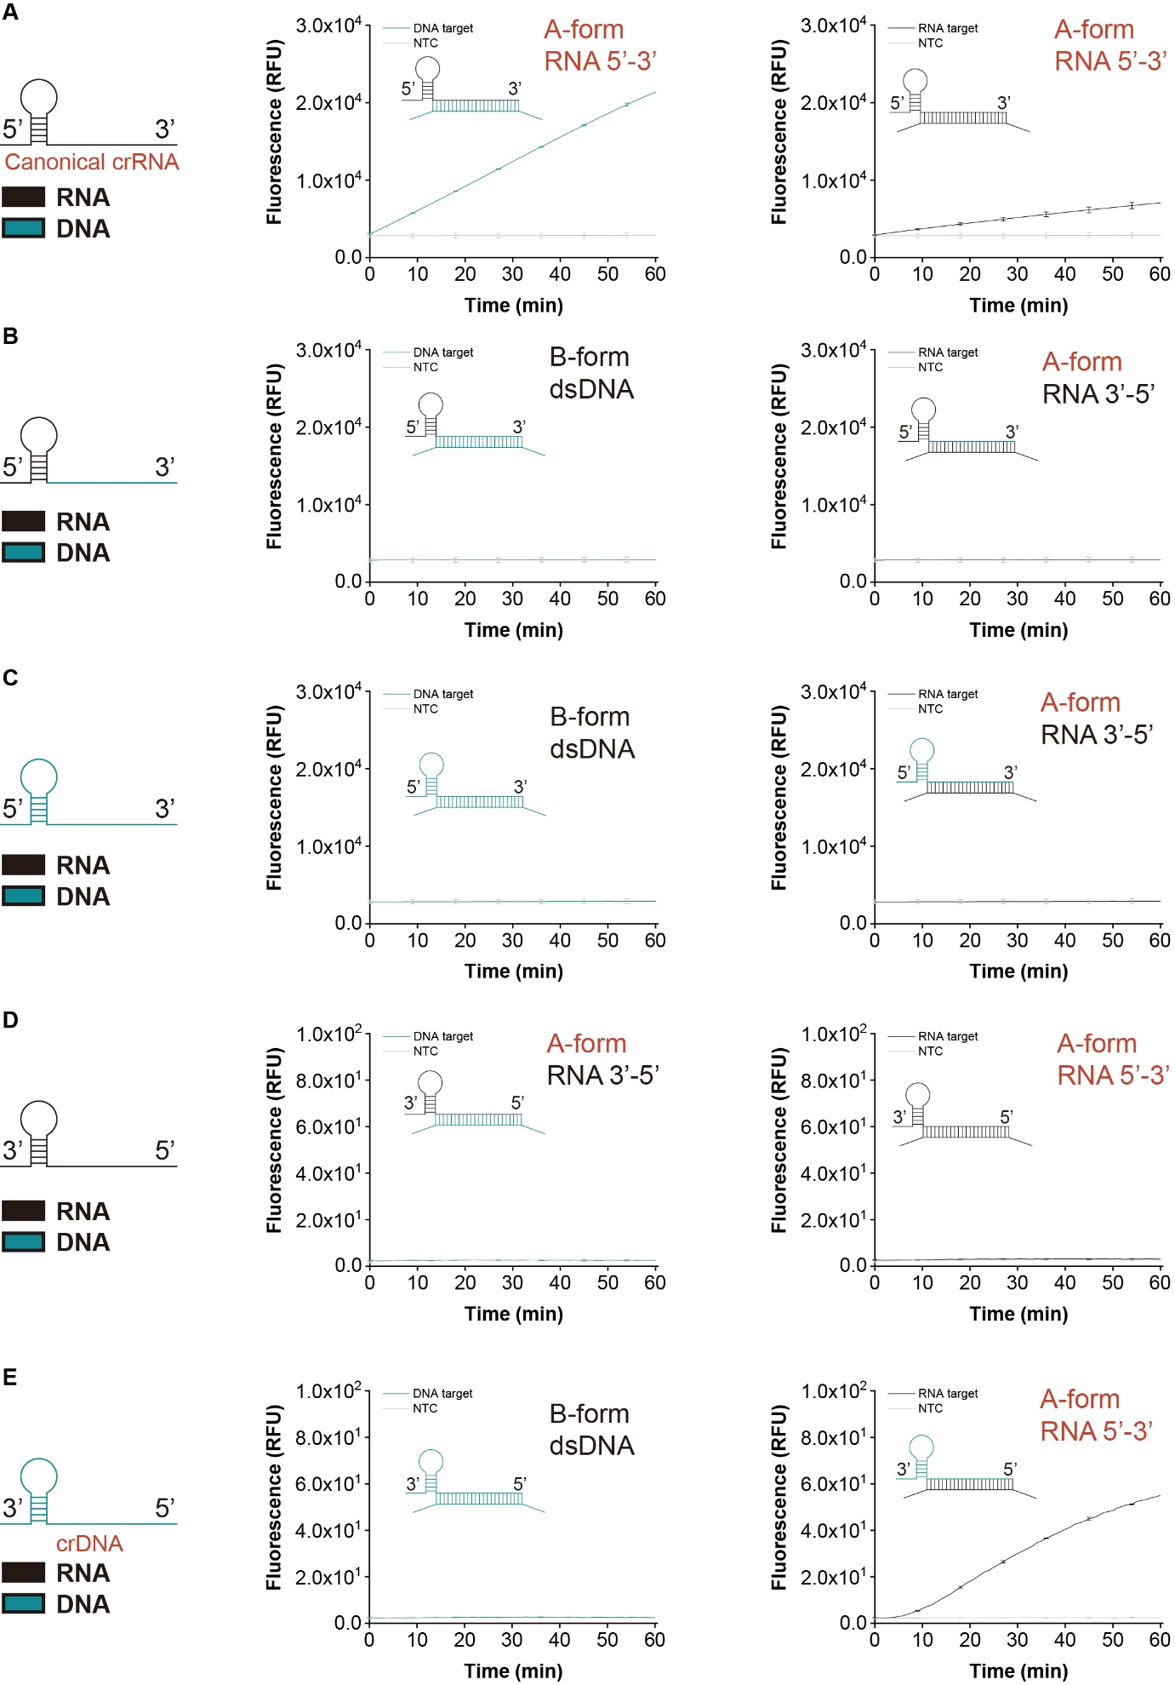

Fig. S1. Correlation of trans-cleavage activity of Cas12a and RNA-DNA duplex conformation.
(A) Both DNA and RNA targets can activate the trans-cleavage activity of canonical crRNA guided AsCas12a. (B) Trans-cleavage activity cannot be activated by replacing the spacer region RNA bases to DNA. (C) Trans-cleavage activity cannot be activated by replacing all the crRNA bases to DNA. (D) Trans-cleavage activity cannot be activated by reverse the crRNA bases direction from 5’-3’ to 3’-5’. (E) Only RNA targets can activate the trans-cleavage activity of 3’-5’ crDNA guided AsCas12a.

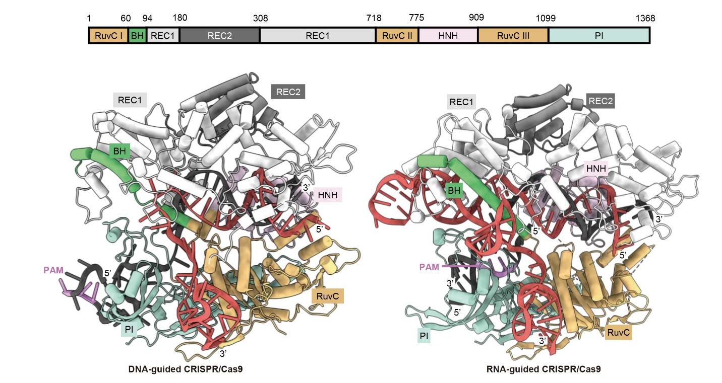

Fig. S2. Structural models of DNA-guided CRISPR/Cas9 ternary complexes.
Structural models of DNA-guided CRISPR/Cas9 ternary complexes (left, MDAF3 predicted structure) and RNA-guided CRISPR/Cas9 system (right, PDB: 4un3). The crDNA (black) docks into the PI domain (mint green) and base-pairs with target RNA (red).

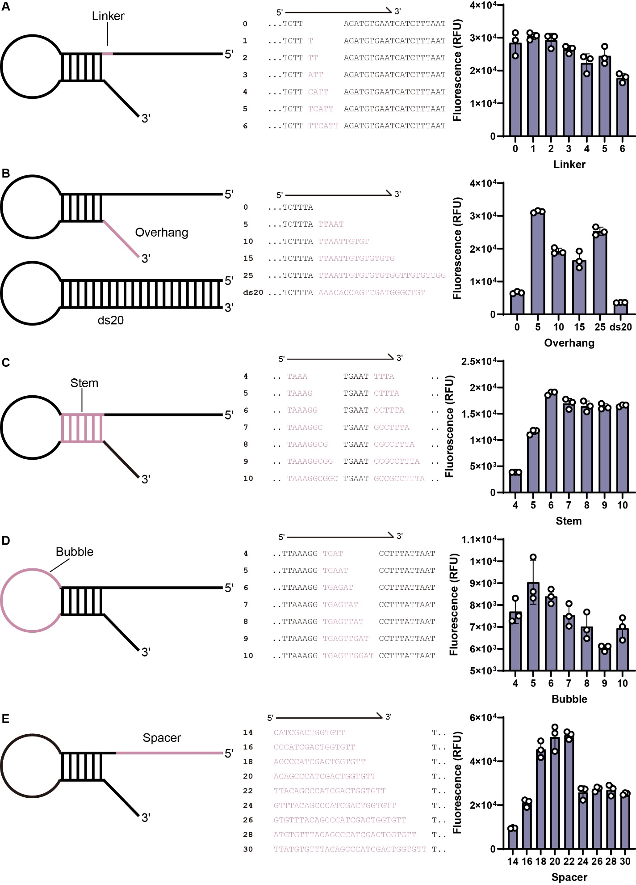

Fig. S3. crDNA structure optimizations with AsCas12a.
(A) Linker region length of crDNA optimization with trans-cleavage assay. Linker region position marks as pink, testing sequences are shown in the middle. (B) Overhang region length of crDNA optimization with trans-cleavage assay. Overhang region position marks as pink, testing sequences are shown in the middle. (C) Stem region length of crDNA optimization with trans-cleavage assay. Stem region position marks as pink, testing sequences are shown in the middle. (D) Bubble region length of crDNA optimization with trans-cleavage assay. Bubble region position marks as pink, testing sequences are shown in the middle. (E) Spacer region length of crDNA optimization with trans-cleavage assay. Spacer region position marks as pink, testing sequences are shown in the middle. n = 3 technical replicates, bars represent mean ± SD.

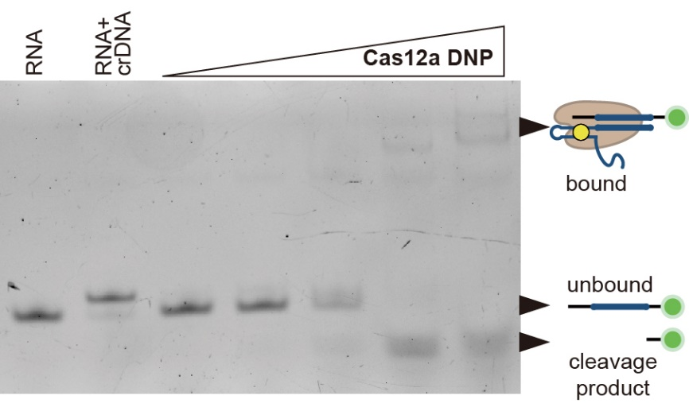

Fig. S4. Representative cleavage assay for 5’ -FAM labelled RNA using Cas12a - crDNA.
Lane 1 loads RNA target only, and lane 2 loads the complex of RNA target and crDNA. Lane 3 to 7 loads constant 50 nM RNA target with increased Cas12a DNP (12.5 nM, 25 nM, 50 nM, 100 nM and 200 nM).

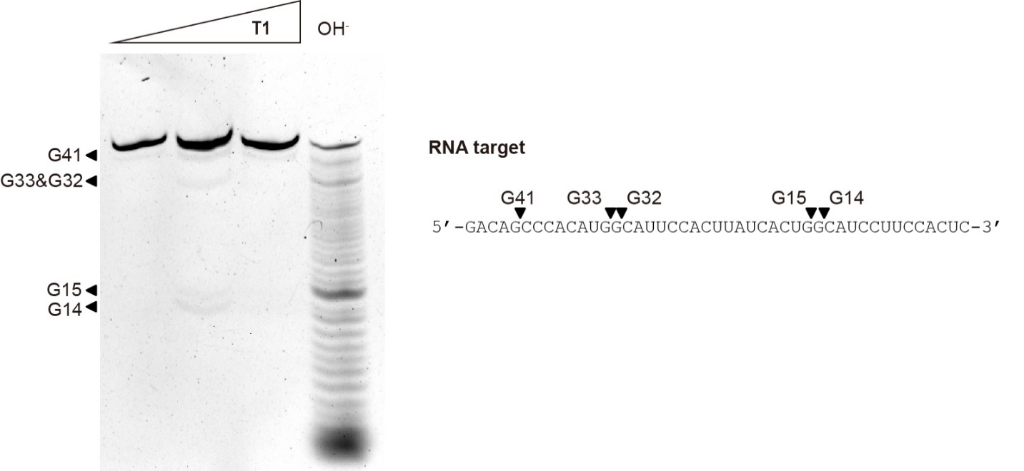

Fig. S5. RNA ladder and specific exonuclease cleavage for RNA site mapping.
RNA target was digested by RNase T1 and OH-, respectively. Lane 1- 3, increasing concentration of RNase T1 (0.5 U, 1U and 2U). Target RNA (right) was cleaved specifically in the position of G14, G15, G32, G33 and G41 by the RNase T1. Combine the RNA ladder and the specific cleavage product to determine the cleavage position of DNA-guided CRISPR/Cas system.

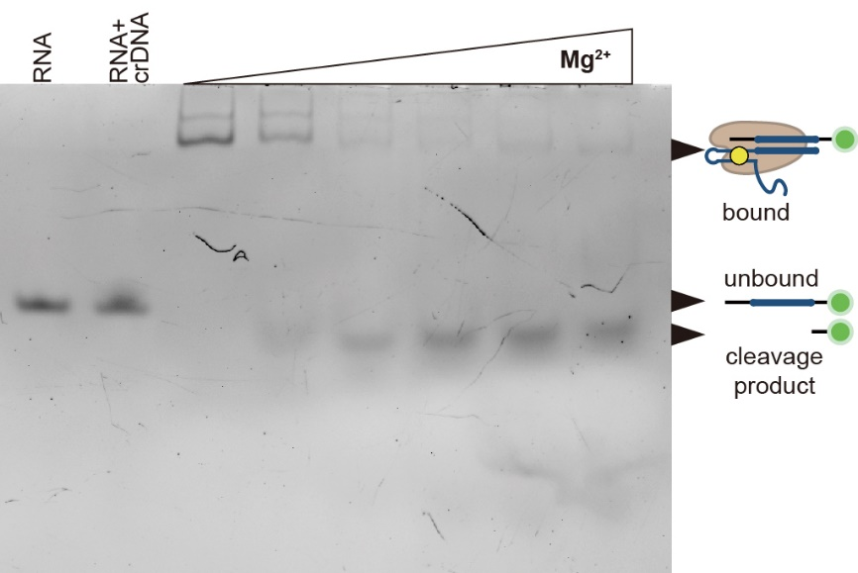

Fig. S6. Effect of Mg²⁺ for DNA- guided CRISPR/Cas system.
Lane 1 loads RNA target only, and lane 2 loads the complex of RNA target and crDNA. Lane 3 to 8 loads constant 50 nM RNA target, 200 nM Cas12a DNP with increasing Mg²⁺ (0 mM, 1 mM, 5 mM, 10 mM, 15 mM and 20 mM). The fraction of ternary complex decreased with the increasing Mg²⁺ while the cleavage product increased.

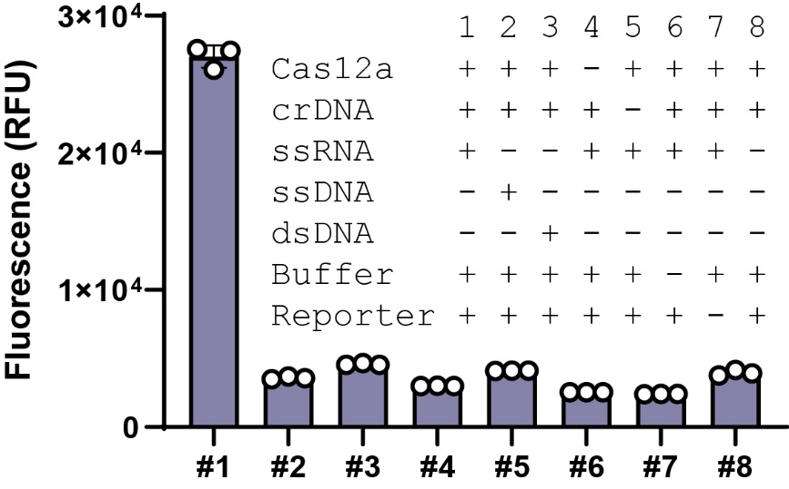

Fig. S7. Exploration of the key reagents of DNA-guided CRISPR/Cas system.
Key reagents omitted one of the four critical components (AsCas12a, crDNA, reporter gene, synthetic ssRNA/ssDNA/dsDNA targets) at a time, confirming that the absence of any element led to assay failure. Data was corrected at 30 min. n = 3 technical replicates, bars represent mean ± SD.

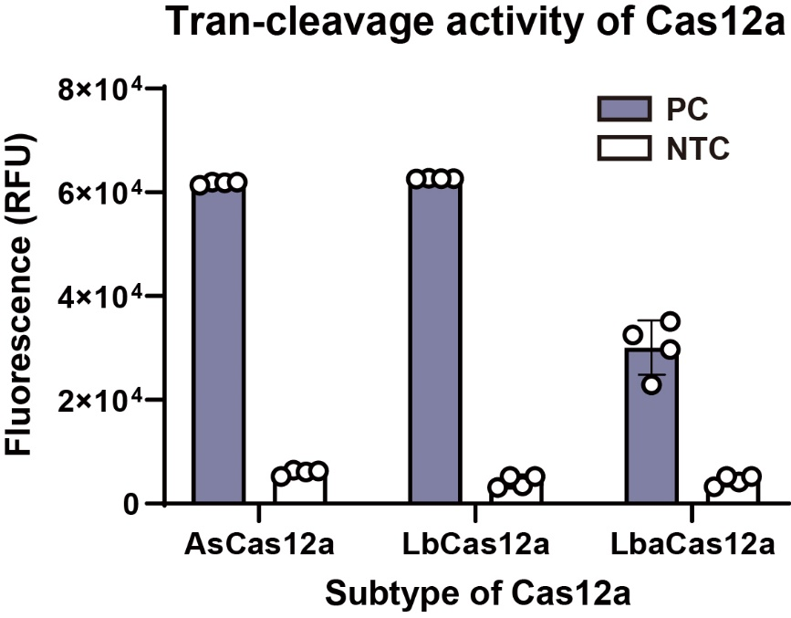

Fig. S8. DNA-guided CRISPR/Cas tran-cleavage activity test with different subtype of Cas12a.
AsCas12a, LbCas12a and LbaCas12a trans-cleavage activity were tested with crDNA. Data was corrected at 60 min. n = 3 technical replicates, bars represent mean ± SD.

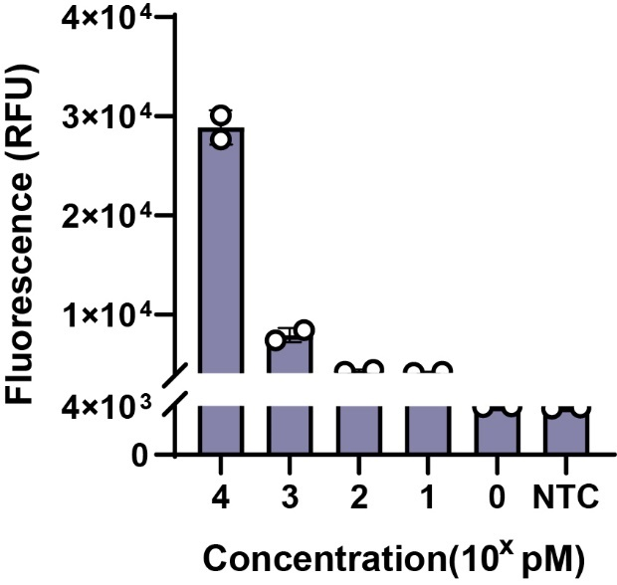

Fig. S9. Sensitivity test with DNA-guided CRISPR/Cas12a without pre-amplification.
Sensitivity test was conducted with trans-cleavage assay, showing that DNA-guided CRISPR/Cas system can detect RNA at picomolar concentrations. n = 3 technical replicates, bars represent mean ± SD.

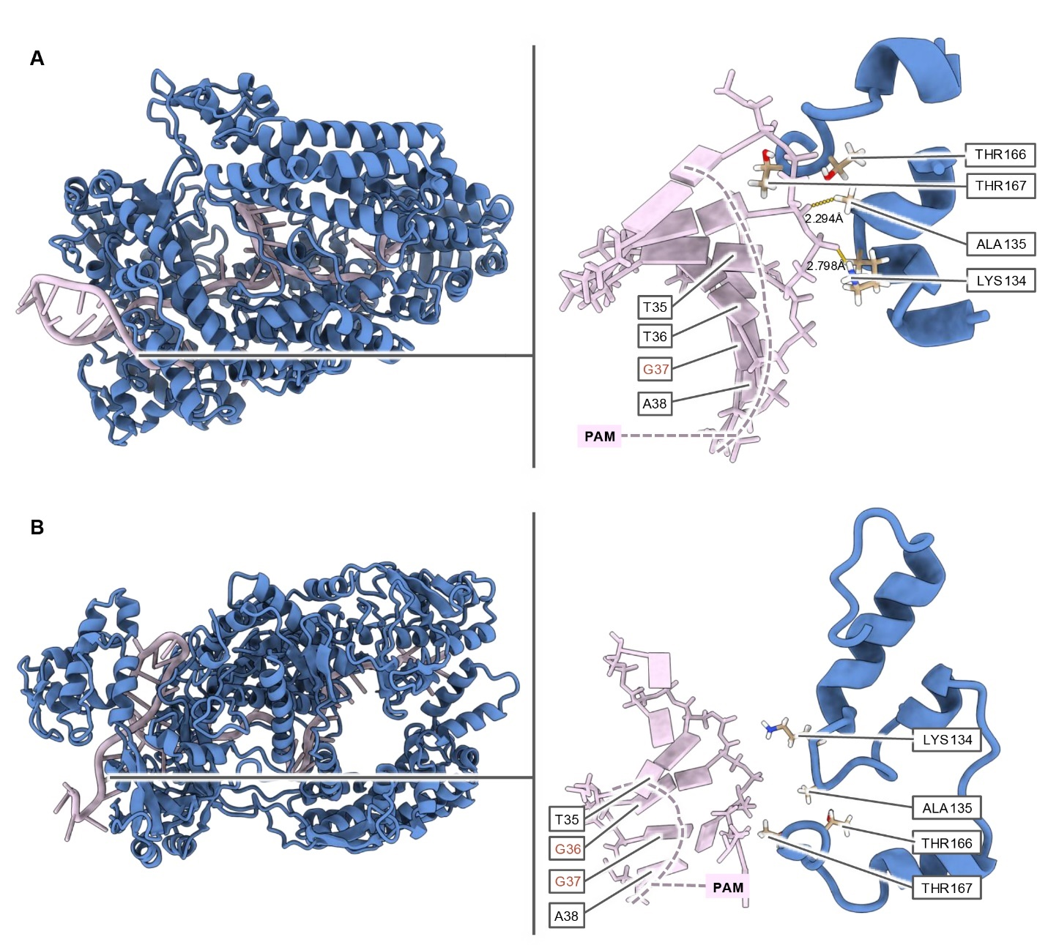

Fig. S10. Supplementary structural analysis of AsCas12a interacting with crDNAs harboring mutated PAM sequences.
MDAF3-predicted structures illustrate AsCas12a in complex with crDNAs containing two distinct PAM mutations: (A) crDNA with mutated PAM sequence 5'-TTGA-3'. (B) crDNA with mutated PAM sequence 5'-TGGA-3'. For both panels (A) and (B): (Left) Overall structural view of the AsCas12a protein complexed with the crDNA containing the specified mutated PAM. (Right) Detailed, zoomed-in view highlighting potential bonding interactions between the DNA bases of the mutated PAM region and key amino acid residues within AsCas12a.

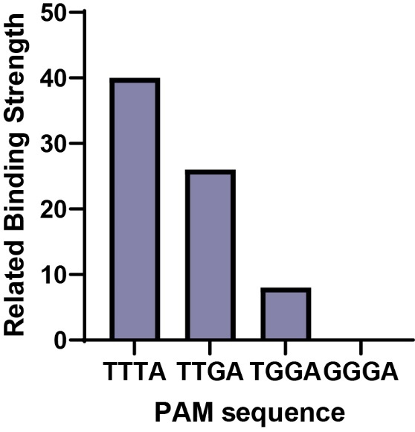

Fig. S11. Computational analysis of AsCas12a binding strength to crDNAs with varying PAM sequences.
The bar chart displays the number of polar bonds identified in MDAF3-predicted binary complexes of AsCas12a and crDNA molecules harboring different PAM sequences (TTTA, TTGA, TGGA, and GGGA). The number of these polar bonds serves as an indicator of relative binding strength, and this computationally derived metric shows a correlation with experimentally determined dissociation constants (Kd).

Fig. S12. Molecular dynamics simulation analysis of structural stability and flexibility for PAM-related mutation of the crDNA and AsCas12a.
(A) Trajectories and fluctuations for PAM “TTTA” (original crDNA) over the 300 ns simulation period (B) Trajectories and fluctuations for PAM “TTGA”. (C) For Trajectories and fluctuations for PAM “TGGA”. (D) For Trajectories and fluctuations for PAM “GGGA”. For (A)-(D): (Left) Number of hydrogen bonds at the protein-DNA interface as a function of time (300 ns). (Center) Root Mean Square Deviation (RMSD, in nm) of the DNA component over time (300 ns), calculated after a least-squares fit to the reference DNA structure. (Right) Root Mean Square Fluctuation (RMSF, in nm) per residue, indicating local flexibility.
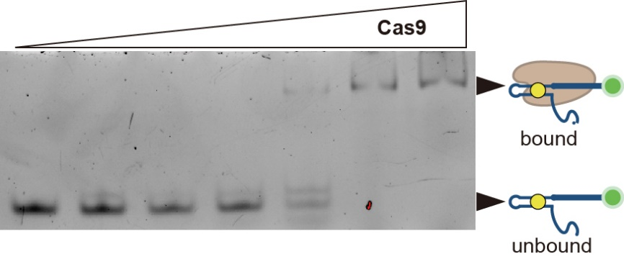

Fig. S13. Electrophoretic Mobility Shift Assay (EMSA) for SpCas9-crDNA binding test.
Electrophoretic Mobility Shift Assay (EMSA) shows crDNA with PAM sequence binds with increased Cas9.

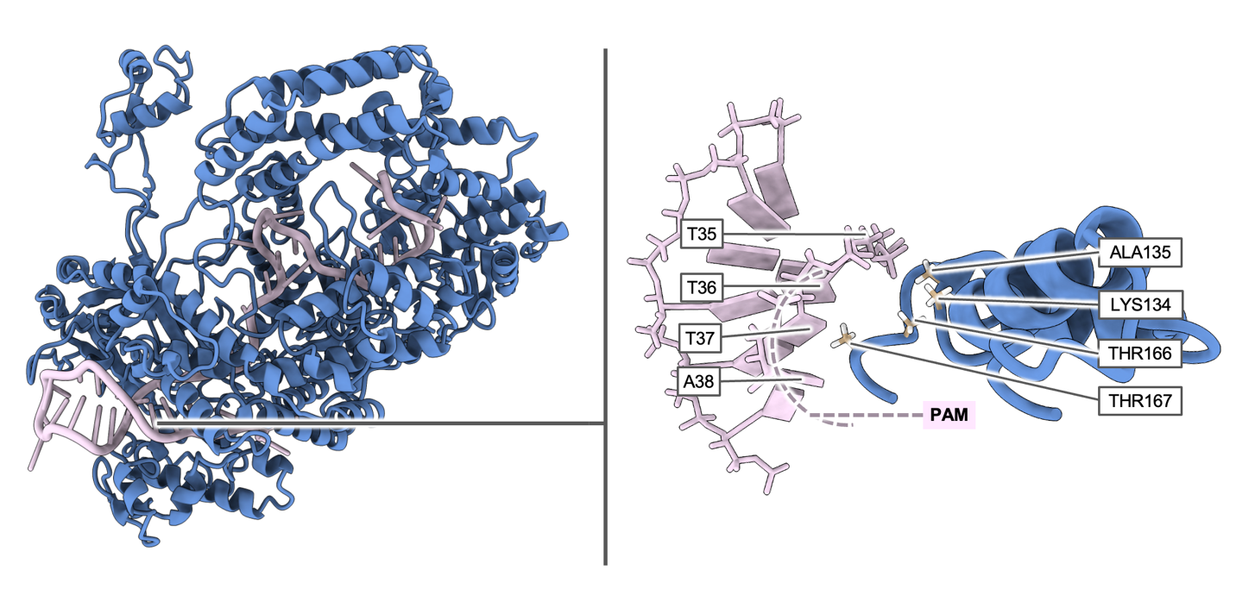

Fig. S14. Impact of K134A/T166A/T167A/K607A mutations in the AsCas12a PAM-Interacting (PI) domain on PAM sequence engagement.
Analysis was performed using MDAF3 pipeline, indicates that the simultaneous substitution of these four key residues (K134, T166, T167, and K607) significantly weakens and disrupts the interaction between the PI domain and the PAM sequence.

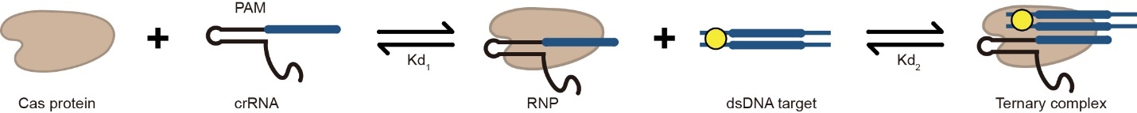

Fig. S15. Schematics of DNA-guided CRISPR/ Cas system formed binary complex and ternary complex.
We modeled RNA-guided ternary complex formation as a two-step process. First, the Cas protein associates with crRNA to form a binary complex (RNP), characterized by a dissociation constant Kd₁​. Next, this binary complex binds the nucleic acid target to yield the ternary complex, with a dissociation constant Kd₂.
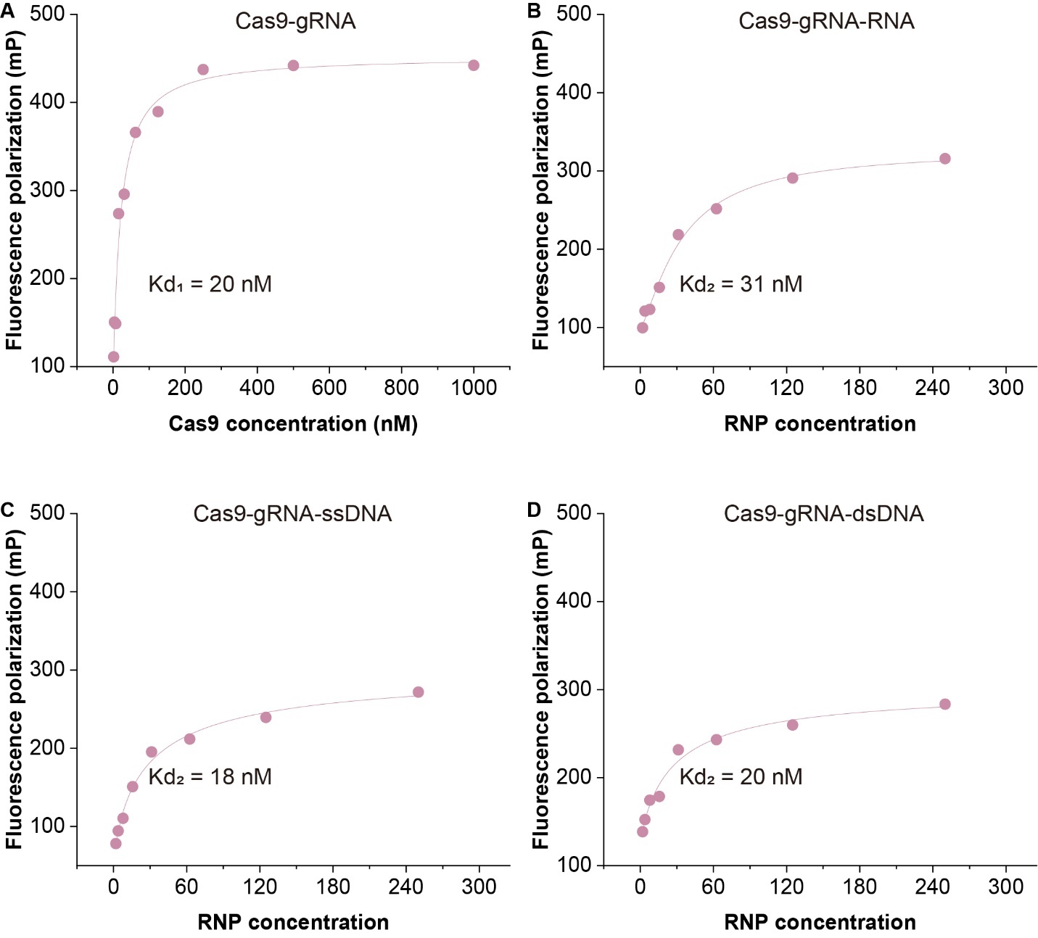

Fig. S16. Kd₁ and Kd₂ of RNA-guided CRISPR/Cas9 system measurement with fluorescence polarization assay.
(A) Kd₁ and Kd₂ of RNA-guided CRISPR/Cas9 system measurement with fluorescence polarization assay. Kd₂ of RNA-guided CRISPR/Cas9 system with RNA (B), ssDNA (C) or dsDNA (D) target measurement by fluorescence polarization assay. Data points are the mean of two independent experiments (n = 2), and the solid line represents a logistic fit to the averaged data.
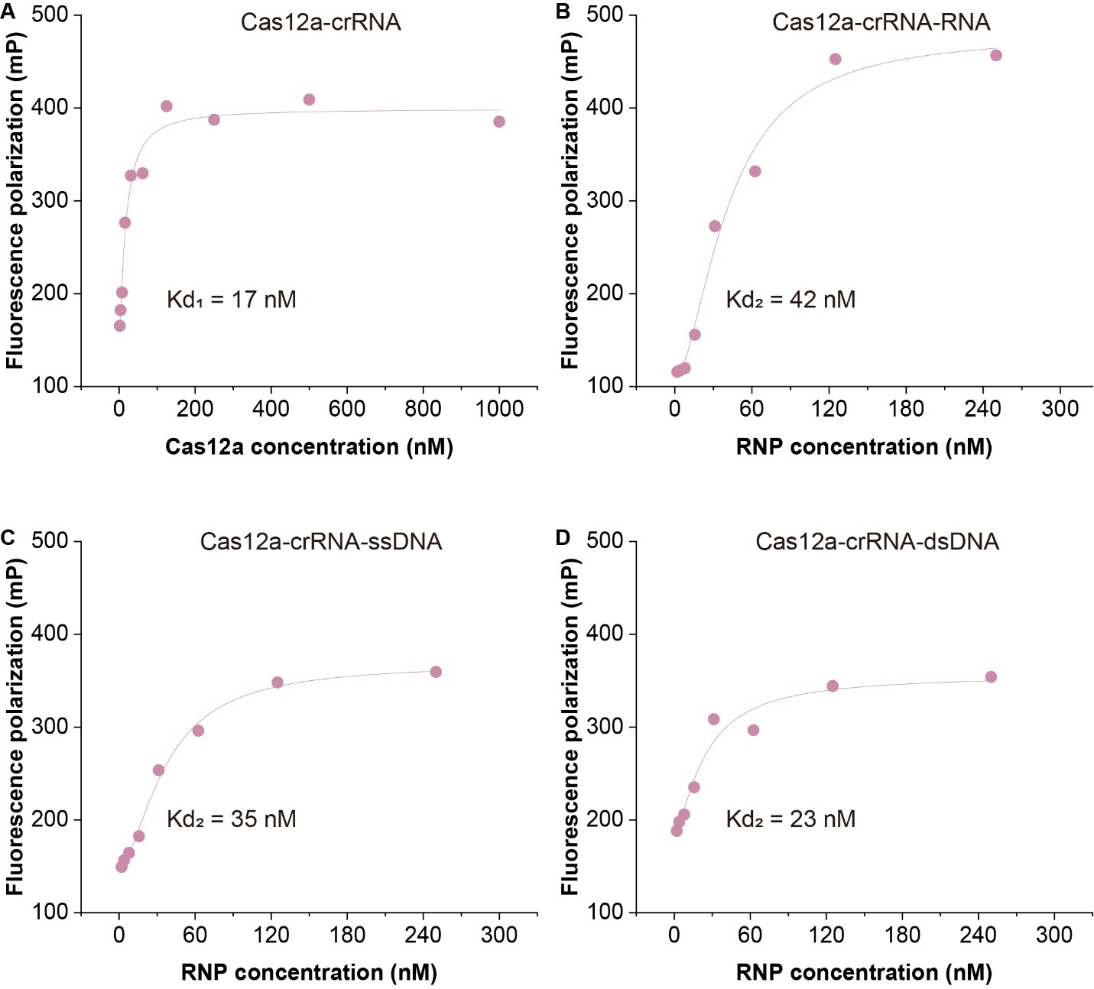

Fig. S17. Kd₁ and Kd₂ of RNA-guided CRISPR/Cas12a system measurement with fluorescence polarization assay.
(A) Kd₁ and Kd₂ of RNA-guided CRISPR/Cas12a system measurement with fluorescence polarization assay. Kd₂ of RNA-guided CRISPR/Cas12a system with RNA (B), ssDNA (C) or dsDNA (D) target measurement by fluorescence polarization assay. Data points are the mean of two independent experiments (n = 2), and the solid line represents a logistic fit to the averaged data.

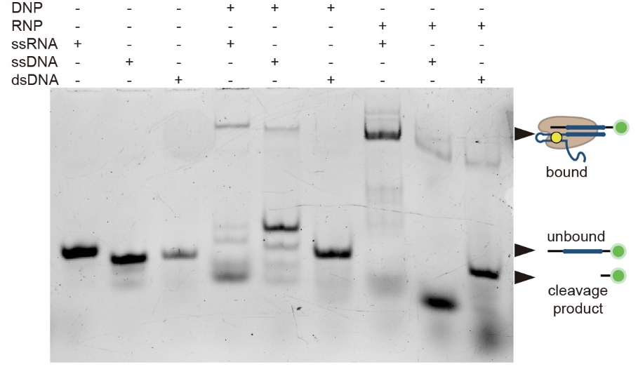

Fig. S18. Target-selectivity test of DNA-guided and RNA-guided CRISPR/ Cas9 system.
EMSA experiment shows that DNA - guided CRISPR/Cas12a only targeting ssRNA while RNA - guided targeting ssRNA, ssDNA and dsDNA.
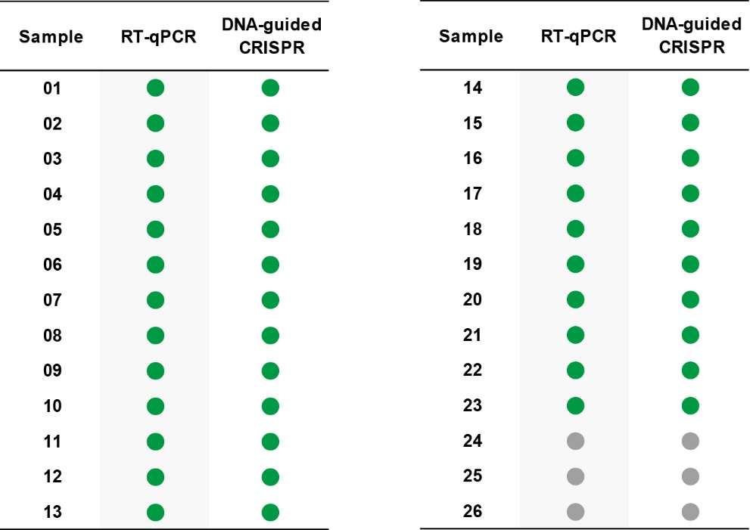

Fig. S19. Detection results of SARS-CoV-2 clinical samples.
Detection results of SARS-CoV-2 with RT-qPCR and DNA guided CRISPR/Cas system. n = 2 technical replicates.

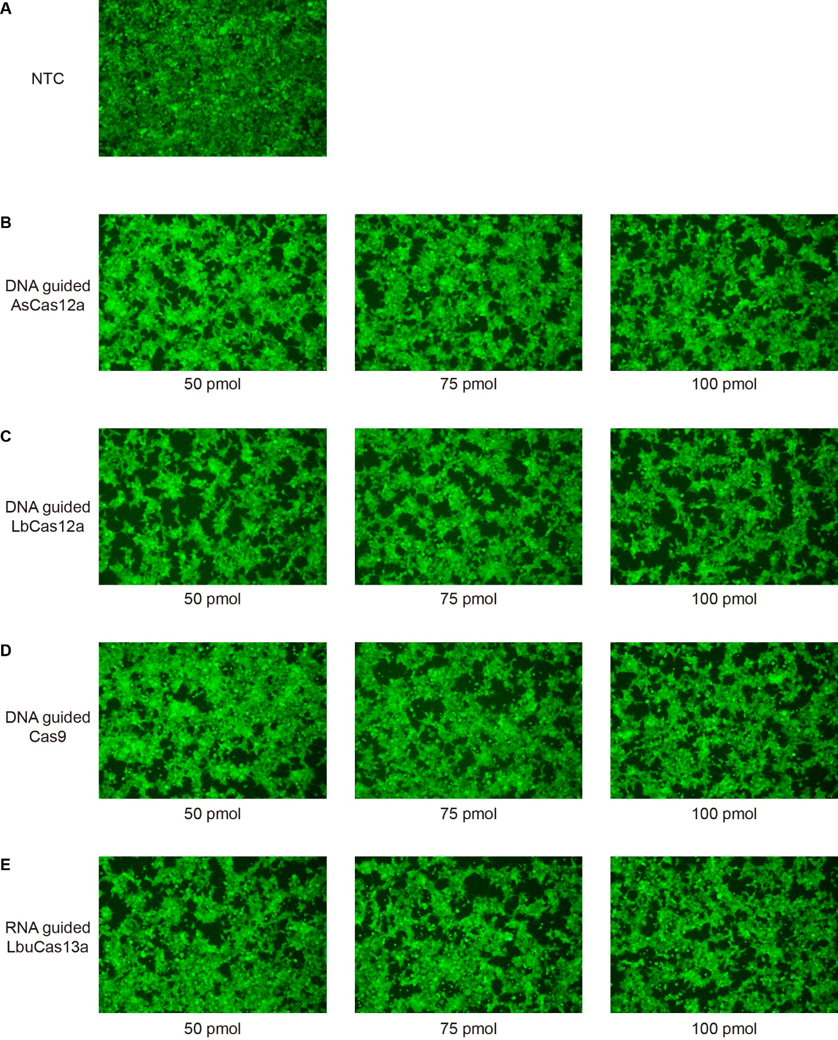

Fig. S20. Fluorescence microscope photograph results of RNA silencing.
(A) Control experiment for EGFP mRNA silencing without transfection CRISPR/Cas system. (B) Image result of transfecting 50, 75 and 100 pmol AsCas12a-crDNA. (C) Image result of transfecting 50, 75 and 100 pmol LbCas12a-crDNA. (D) Image result of transfecting 50, 75 and 100 pmol SpCas9-crDNA. (E) Image result of transfecting 50, 75 and 100 pmol LbuCas13a-crRNA. All image was capture after 24h incubation.

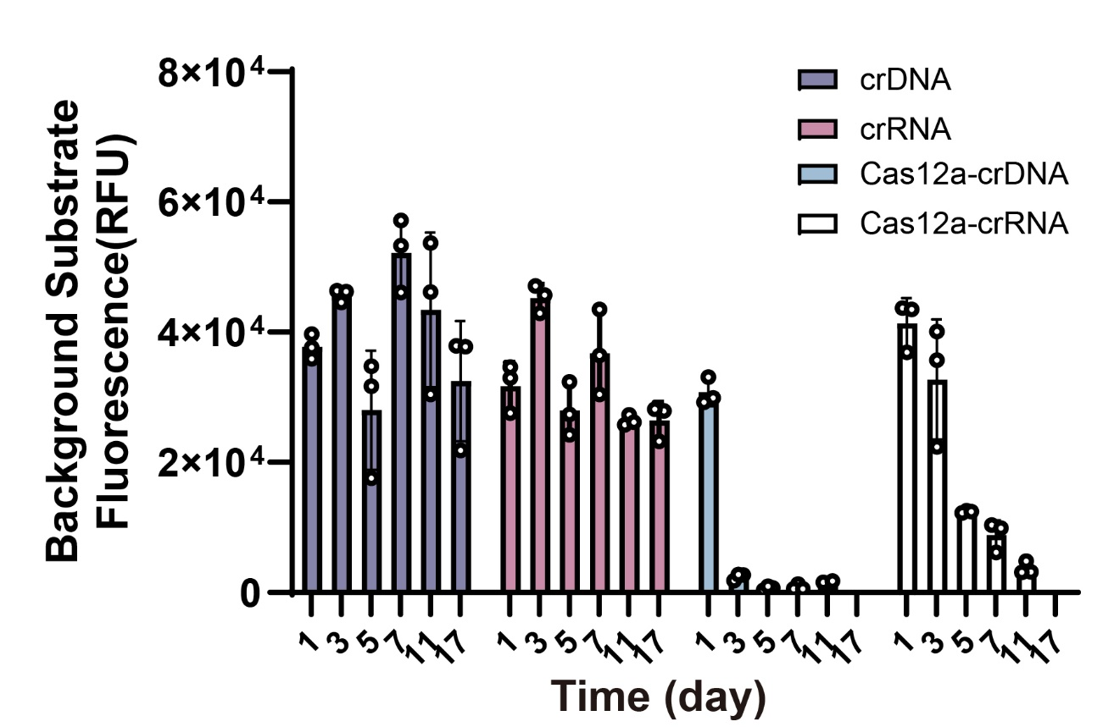

Fig. S21. Aging test for crDNA and crRNA.
crDNA, crRNA, AsCas12a-crDNA complex and AsCas12a-crRNA complex were storage in 37 ºC for 1, 3, 5, 7, 11 and 17 days, then test the trans-cleavage activity. n = 3 technical replicates, bars represent mean ± SD.

Table S1. Sequence information. (separate file)
Oligonucleotide sequences used in this study.

Table S2. Significance analysis of single nucleotide specificity result with one-way ANOVA followed by Dunnett’s posttest.
Dunnett's multiple comparisons test | Mean Diff. | 95.00% CI of diff. | Below threshold? | Summary | Adjusted P Value | Dunnett's multiple comparisons test
WT vs. 20 | -6688 | -11141 to -2234 | Yes | *** | 0.0007 | WT vs. 20
WT vs. 19 | -9539 | -13993 to -5086 | Yes | **** | <0.0001 | WT vs. 19
WT vs. 18 | 7192 | 2738 to 11645 | Yes | *** | 0.0002 | WT vs. 18
WT vs. 17 | 9638 | 5185 to 14092 | Yes | **** | <0.0001 | WT vs. 17
WT vs. 16 | 14435 | 9982 to 18888 | Yes | **** | <0.0001 | WT vs. 16
WT vs. 15 | 11945 | 7491 to 16398 | Yes | **** | <0.0001 | WT vs. 15
WT vs. 14 | 9983 | 5529 to 14436 | Yes | **** | <0.0001 | WT vs. 14
WT vs. 13 | 14955 | 10502 to 19409 | Yes | **** | <0.0001 | WT vs. 13
WT vs. 12 | 14303 | 9849 to 18756 | Yes | **** | <0.0001 | WT vs. 12
WT vs. 11 | 12428 | 7975 to 16882 | Yes | **** | <0.0001 | WT vs. 11
WT vs. 10 | 8191 | 3737 to 12644 | Yes | **** | <0.0001 | WT vs. 10
WT vs. 9 | 6631 | 2178 to 11084 | Yes | *** | 0.0008 | WT vs. 9
WT vs. 8 | 9634 | 5180 to 14087 | Yes | **** | <0.0001 | WT vs. 8
WT vs. 7 | 5740 | 1287 to 10193 | Yes | ** | 0.0047 | WT vs. 7
WT vs. 6 | 8209 | 3755 to 12662 | Yes | **** | <0.0001 | WT vs. 6
WT vs. 5 | 4332 | -121.4 to 8785 | No | ns | 0.0611 | WT vs. 5
WT vs. 4 | 20022 | 15568 to 24475 | Yes | **** | <0.0001 | WT vs. 4
WT vs. 3 | 16006 | 11553 to 20459 | Yes | **** | <0.0001 | WT vs. 3
WT vs. 2 | 5410 | 956.9 to 9864 | Yes | ** | 0.0089 | WT vs. 2
WT vs. 1 | 16561 | 12108 to 21015 | Yes | **** | <0.0001 | WT vs. 1
WT vs. NC | 31725 | 27272 to 36178 | Yes | **** | <0.0001 | WT vs. NC

