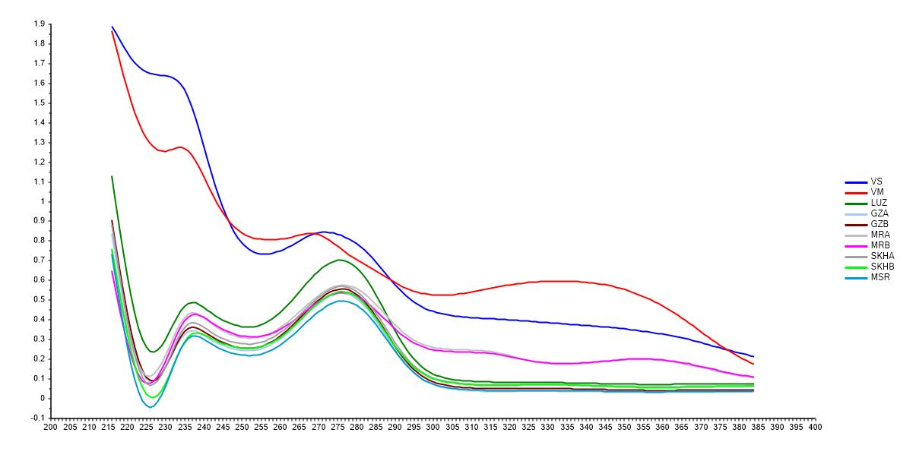
Figure 1S. The UV absorbance spectra of the methanol extracts of the ten Vicia samples were measured in the range of 200 – 400 nm

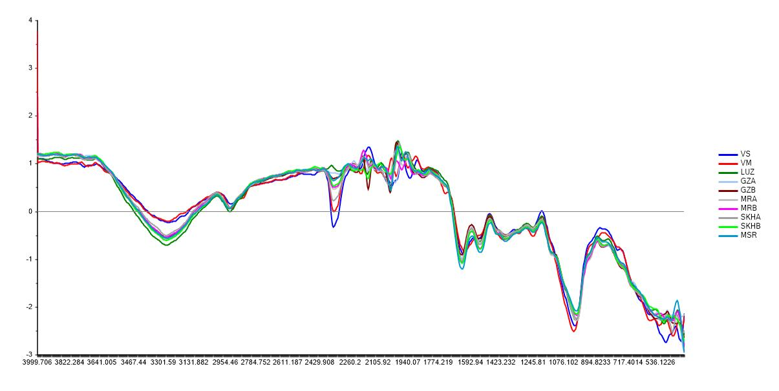
Figure 2S. The FT-IR spectra of ten different Vicia seed samples in the mid-IR region (4000–400 cm-) after preprocessing with Standard normal variate (SNV) algorithm to reduce the scatter effect.

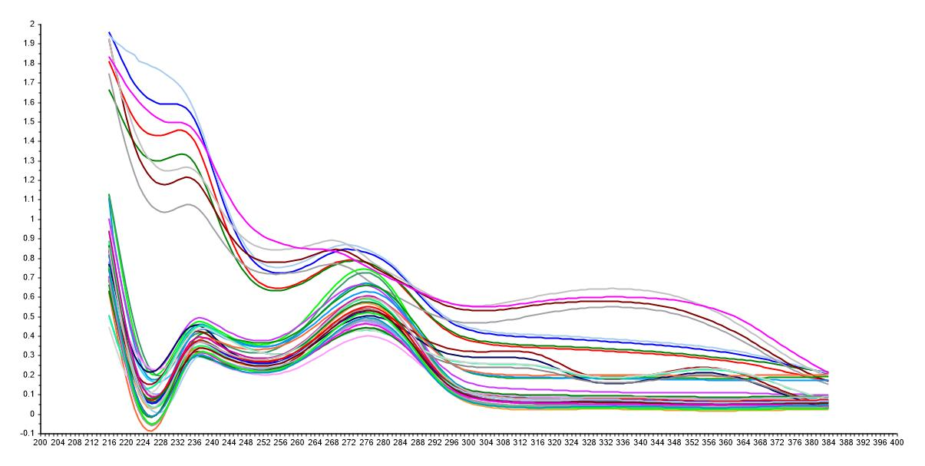
Figure 3S. The UV absorbance spectra of 40 samples of Vicia seeds the 200-400 nm range.

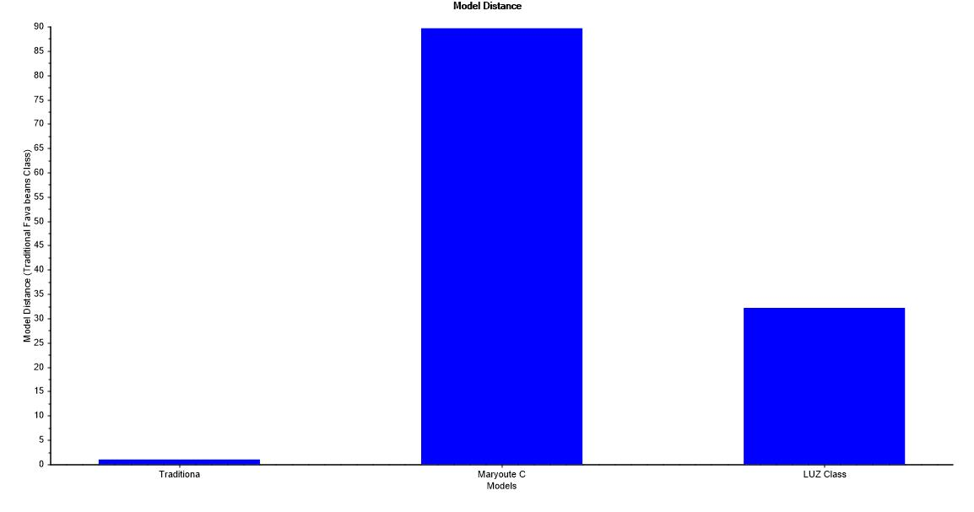
Figure 4S. Model distance relative to the traditional fava bean class. This metric can provide information about the separation between any pair of classes. If the model distance value for certain class is greater than three, then this model is well separated from the model we compare with. In this figure, both Maryoute class and Luz class are well separated from the traditional fava bean class as they have model distance values of about 89 and 32, respectively.

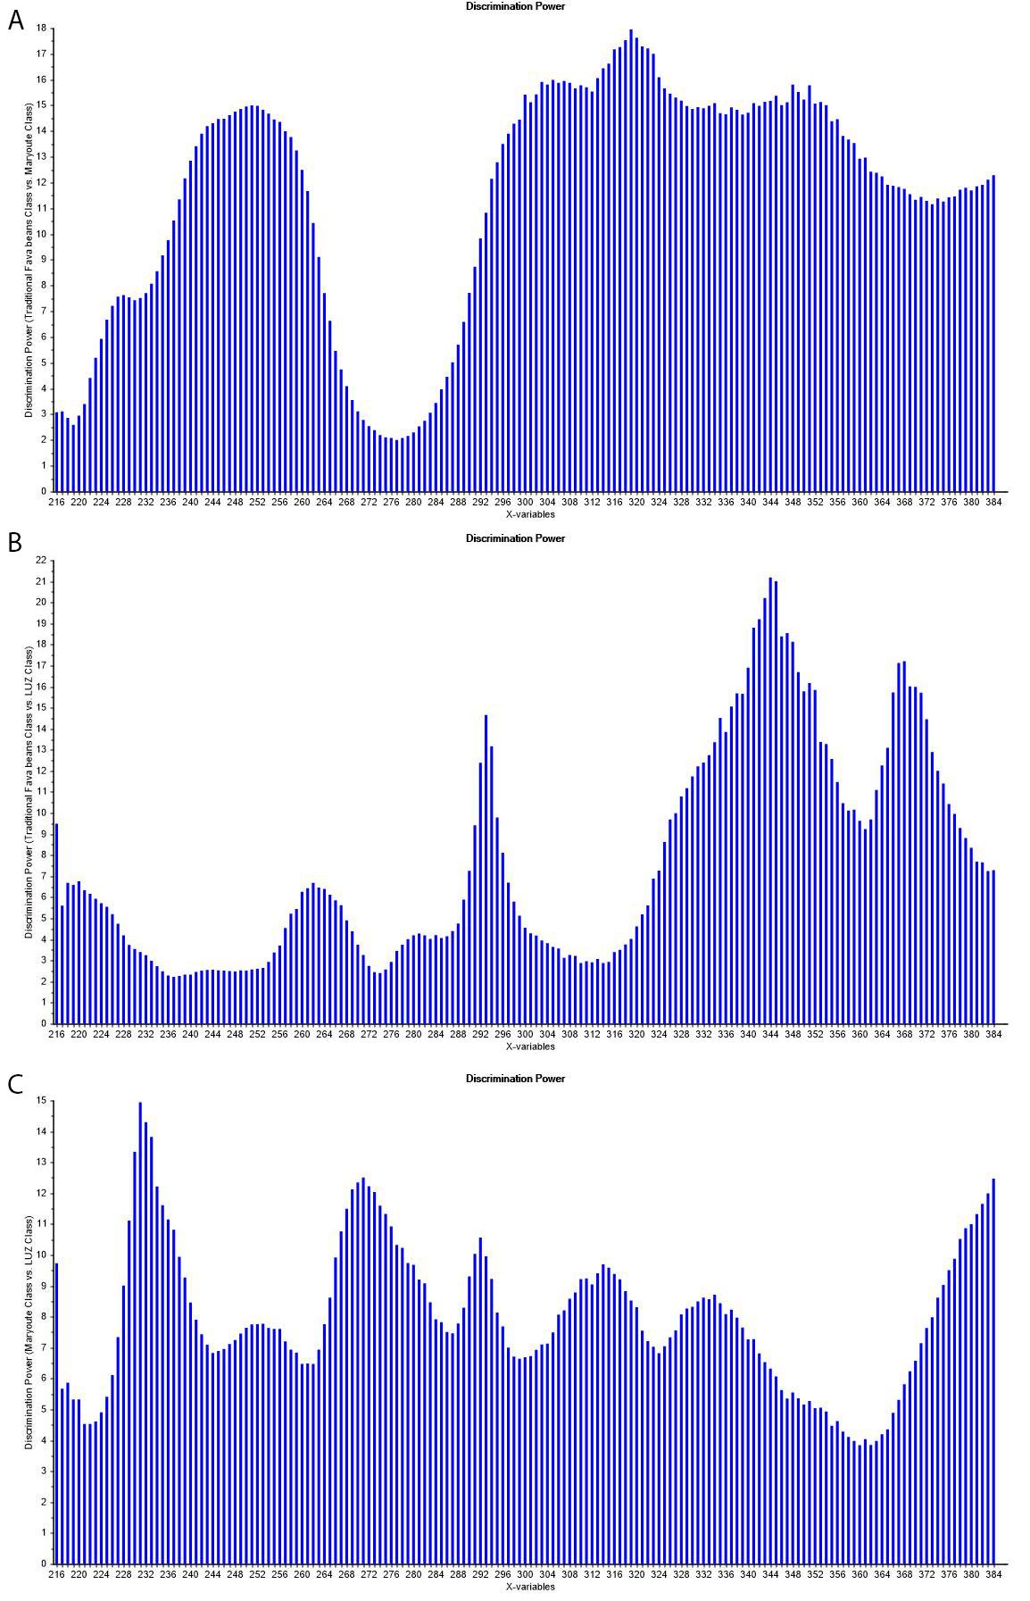
Figure 5S. The discriminatory power of spectral variables between all pairs of the three classes. If the variable value is greater than 3, then it is important in the discrimination between these pairs of classes. The discriminatory power of spectral variables of traditional Fava bean class vs Maryoute class (A), traditional fava bean class vs Luz de Otono class (B), and Maryoute class vs LUZ de Otono class (C).

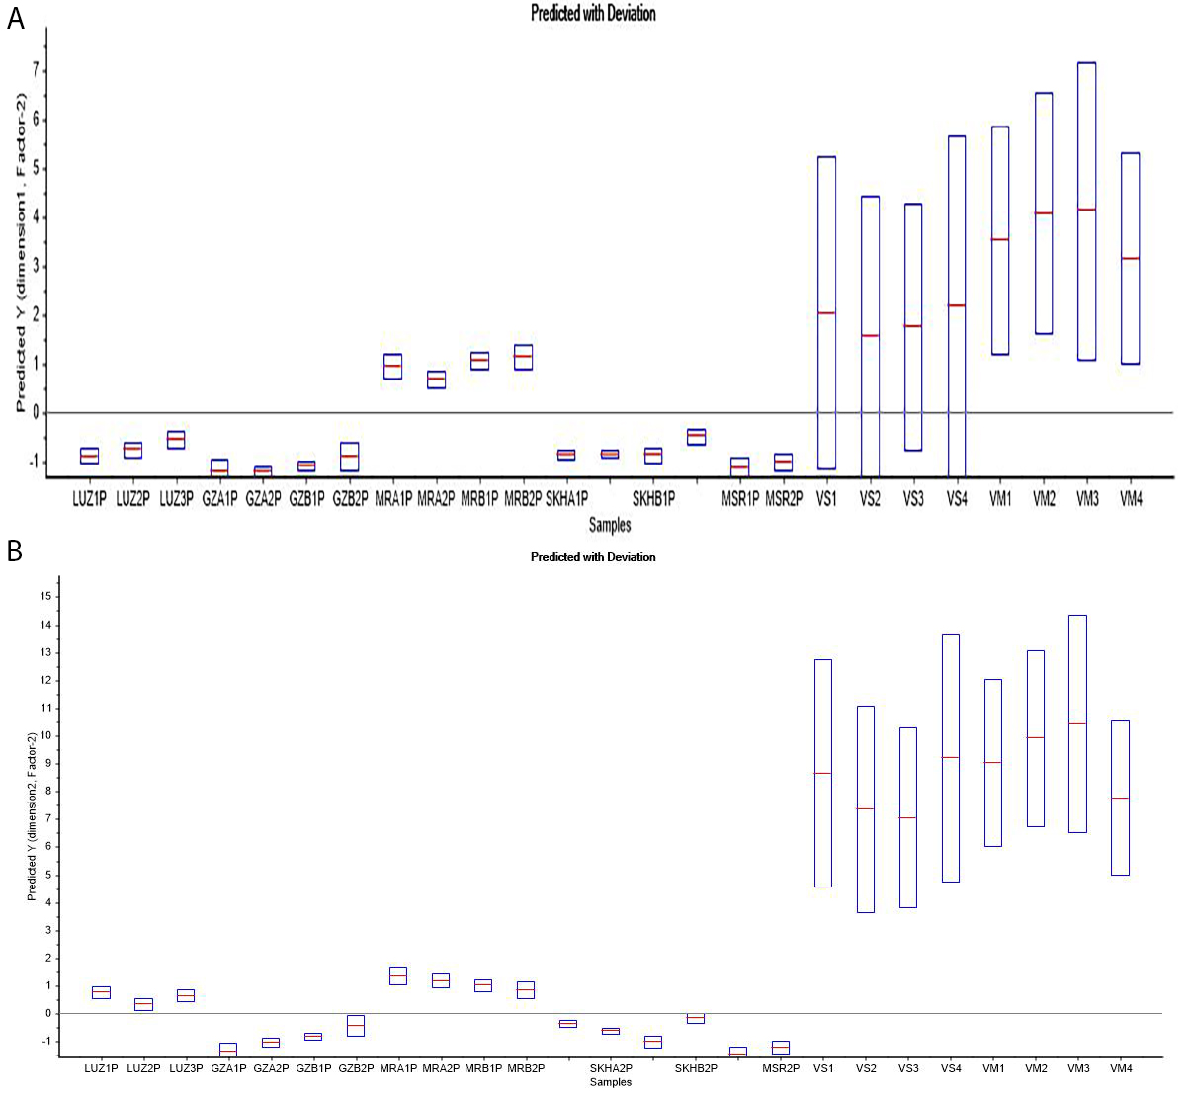
Figure 6S. showed the predicted with deviation plot for all the non-fava bean samples as well as the test set samples of fava bean varieties. Fava bean samples in the validation set were correctly classified with low deviation, whereas the Vicia sativa and Vicia monantha samples appeared as very outliers with very high deviation.

Table 1S. the SIMCA classification results.
Sample - Class membership 5% | Traditional Fava bean Class | Maryoute Class | LUZ Class
LUZ1P |  |  | *
LUZ2P |  |  | *
LUZ3P |  |  | *
GZA1P | *
GZA2P | *
GZB1P | *
GZB2P | *
MRA1P |  | *
MRA2P |  | *
MRB1P |  | *
MRB2P |  | *
SKHA1P | *
SKHA2P | *
SKHB1P | *
SKHB2P | *
MSR1P | *
MSR2P | *
VS1
VS2
VS3
VS4
VM1
VM2
VM3
VM4
Every fava bean sample in the validation set was assigned to a specific class of the three fava bean classes. On the other hand, all Vicia sativa and Vicia monantha samples were not assigned to any of the three fava bean classes.

