Supplementary material: Appendix 1 Flow chart showing study cohort.
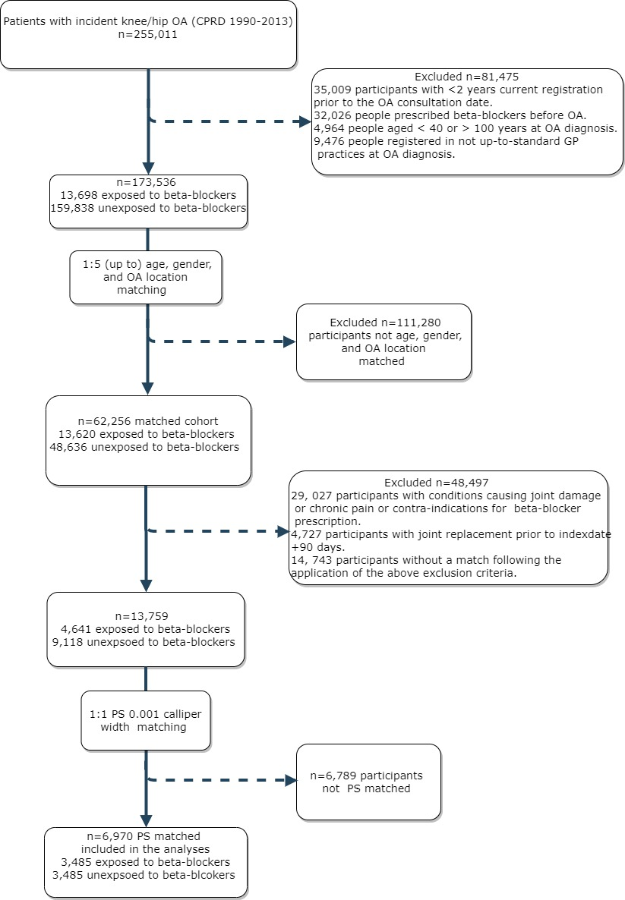
Appendix 2: Code list
Readcode | Readterm
Knee osteoarthritis
N05z611 | Knee osteoarthritis NOS
N053611 | Patellofemoral osteoarthritis
N05zL00 | Osteoarthritis NOS, of knee
N06z611 | Knee Arthritis NOS
N05z600 | Osteoarthritis NOS, of the lower leg
N051600 | Localised, primary osteoarthritis of the lower leg
Nyu2511 | [X] Unilateral primary gonarthrosis
Nyu2811 | [X] Unilateral secondary gonarthrosis
N051B00 | Primary gonarthrosis, bilateral
N052600 | Localised, secondary osteoarthritis of the lower leg
N053600 | Localised osteoarthritis, unspecified, of the lower leg
N054600 | Oligoarticular osteoarthritis, unspecified, of lower leg
Nyu2500 | [X]Other primary gonarthrosis
N05zM00 | Osteoarthritis NOS, of tibio-fibular joint
Nyu2800 | [X]Other secondary gonarthrosis
Nyu2700 | [X]Other secondary gonarthrosis, bilateral
Hip osteoarthritis
N053512 | Hip osteoarthitis NOS
N05z511 | Hip osteoarthritis NOS
N05z500 | Osteoarthritis NOS, pelvic region/thigh
N05zJ00 | Osteoarthritis NOS, of hip
N06z511 | Hip Arthritis NOS
Nyu2100 | [X]Other primary coxarthrosis
N051500 | Localised, primary osteoarthritis of the pelvic region/thigh
N053500 | Localised osteoarthritis, unspecified, pelvic region/thigh
N051900 | Primary coxarthrosis, bilateral
Nyu2E11 | [X] Unilateral secondary coxarthrosis
N052500 | Localised, secondary osteoarthritis of pelvic region/thigh
N054500 | Oligoarticular osteoarthritis, unspecified, of pelvis/thigh
Nyu2400 | [X]Other secondary coxarthrosis, bilateral
Nyu2E00 | [X]Other secondary coxarthrosis
Nyu2300 | [X]Other post-traumatic coxarthrosis
Nyu2200 | [X]Other dysplastic coxarthrosis
Knee joint replacement
7K32z00 | Other total prosthetic replacement of knee joint NOS
7K30.00 | Total prosthetic replacement of knee joint using cement
7K32.12 | TKR - Other total prosthetic replacement of knee joint
7K30.1V | TKR -Total prosthetic replacement of knee joint using cement
7K30z00 | Total prosthetic replacement of knee joint using cement NOS
7K32.00 | Other total prosthetic replacement of knee joint
7K38.00 | Uncemented unicompartmental knee replacement
7K31.12 | TKR - Total prosthetic replacement knee joint without cement
7K30y00 | Total prosthetic replacement of knee joint using cement OS
7K32.11 | Other arthroplasty of knee joint
7K37.00 | Cemented unicompartmental knee replacement
7K31.00 | Total prosthetic replacement of knee joint not using cement
7K30000 | Primary cemented total knee replacement
7K32000 | Primary total knee replacement NEC
7K30.12 | Arthroplasty of knee joint using cement
7K37000 | Primary cemented unicompartmental knee replacement
7K39000 | Primary hybrid unicompartmental knee replacement
7K32y00 | Other total prosthetic replacement of knee joint OS
7K30.18 | Denham total replacement of knee joint using cement
7K30.1R | Stanmore total replacement of knee joint using cement
7K30.16 | Charnley total replacement of knee joint using cement
7K30.1N | Polycentric total replacement of knee joint using cement
7K31.11 | Arthroplasty of knee joint not using cement
7K31000 | Primary uncemented total knee replacement
7K30.1S | Swanson total replacement of knee joint using cement
7K30.17 | Deane total replacement of knee joint using cement
7K31y00 | Total prosthetic replacement knee joint not using cement OS
7K38000 | Primary uncemented unicompartmental knee replacement
7K30.19 | Freeman total replacement of knee joint using cement
7K39.00 | Hybrid unicompartmental knee replacement
7K30.1P | Sheehan total replacement of knee joint using cement
7K31z00 | Total prosthetic replacement knee joint not using cement NOS
7K30.13 | Attenborough total replacement of knee joint using cement
7K30.1T | Uci total replacement of knee joint using cement
7K30.1A | Geomedic total replacement of knee joint using cement
7K30.1E | Herbert total replacement of knee joint using cement
7K30.1Q | Shiers total replacement of knee joint using cement
7K30.15 | Cavendish total replacement of knee joint using cement
7K32011 | Primary hybrid total knee replacement NEC
7K30.1H | Liverpool total replacement of knee joint using cement
7K30.11 | Anametric total replacement of knee joint using cement
7K3A.00 | Unicompartmental knee replacement NOS
7K30.1I | Manchester total replacement of knee joint using cement
7K30.1F | Ilch total replacement of knee joint using cement
7K30.1U | Wallidus hinge arthroplasty of knee joint using cement
7K30.14 | Autophor arthroplasty of knee joint using cement
7K6q000 | Primar hybrid prosthetic replacement knee joint using cement
7K6qy00 | OS hybrid prosthetic replacement of knee joint using cement
7K30.1J | Marmor total replacement of knee joint using cement
7K6q.00 | Hybrid prosthetic replacement of knee joint using cement
7K30.1C | Guepar hinge replacement of knee joint using cement
Hip joint replacement
7K22z00 | Total prosthetic replacement of hip joint NOS
7K21.17 | THR - Total prosthetic replacement hip joint without cement
7K20.1G | THR - Total prosthetic replacement of hip joint using cement
7K23z00 | Prosthetic cemented hemiarthroplasty of hip NOS
7K22.12 | THR - Other total prosthetic replacement of hip joint
7K20.00 | Total prosthetic replacement of hip joint using cement
7K20.1C | Muller total replacement of hip joint using cement
7K23.12 | Austin - Moore hemiarthroplasty of hip joint using cement
7K24.19 | Thompson hemiarthroplasty of hip joint not using cement
7K22.00 | Other total prosthetic replacement of hip joint
7K22.11 | Other arthroplasty of hip joint
7K21y00 | Total prosthetic replacement hip joint not using cement OS
7K20300 | Primary hybrid total replacement of hip joint NEC
7K20000 | Primary cemented total hip replacement
7K24.12 | Austin Moore hemiarthroplasty of hip joint not using cement
7K23.00 | Prosthetic cemented hemiarthroplasty of hip
7K25y00 | Other specified other prosthetic hemiarthroplasty of hip
7K20.13 | Charnley total replacement of hip joint using cement
ZV43612 | [V]Has artificial hip joint
7K68500 | Excision arthroplasty of hip
7K68500 | Excision arthroplasty of hip
7K20.11 | Arthroplasty of hip joint using cement
7K23.16 | Thompson hemiarthroplasty of hip joint using cement
7K21.00 | Total prosthetic replacement of hip joint not using cement
7K24.13 | Bateman hemiarthroplasty of hip joint not using cement
7K25z00 | Other prosthetic hemiarthroplasty of hip NOS
7K20.14 | Exeter total replacement of hip joint using cement
7K25000 | Primary prosthetic hemiarthroplasty of hip NEC
7K25.00 | Other prosthetic hemiarthroplasty of hip
7K20.1E | Stanmore total replacement of hip joint using cement
7K23100 | Conversion to cemented hemiarthroplasty of hip
7K22000 | Primary total prosthetic replacement of hip joint NEC
7K24z00 | Prosthetic uncemented hemiarthroplasty of hip NOS
7K20.1A | McKee total replacement of hip joint using cement
7K20.18 | Howse total replacement of hip joint using cement
7K22y00 | Other specified total prosthetic replacement of hip joint
7K20y00 | Total prosthetic replacement of hip joint using cement OS
7K20.17 | Furlong total replacement of hip joint using cement
7K21z00 | Total prosthetic replacement hip joint not using cement NOS
7K23000 | Primary cemented hemiarthroplasty of hip
7K24100 | Conversion to uncemented hemiarthroplasty of hip
7K24.00 | Prosthetic uncemented hemiarthroplasty of hip
7K23x00 | Conversion from cemented hemiarthroplasty of hip
7K24000 | Primary uncemented hemiarthroplasty of hip
7K21000 | Primary uncemented total hip replacement
7K21000 | Primary uncemented total hip replacement
7K20.1B | Monk total replacement of hip joint using cement
7K21.12 | Furlong total replacement of hip joint not using cement
7K20z00 | Total prosthetic replacement of hip joint using cement NOS
7K23.13 | Hastings hemiarthroplasty of hip joint using cement
7K24.18 | Austin Moore hemiarthroplasty of hip joint not using cement
7K21.15 | Monk total replacement of hip joint not using cement
7K20011 | Charnley cemented total hip replacement
7K20.16 | Freeman total replacement of hip joint using cement
7K21.11 | Freeman total replacement of hip joint not using cement
7K22011 | Primary hybrid total replacement of hip joint NEC
7K20.19 | Ilch total replacement of hip joint using cement
7K23y00 | Other specified prosthetic cemented hemiarthroplasty of hip
7K23.14 | Monk hemiarthroplasty of hip joint using cement
7K24y00 | Other specified prosthetic uncemented hemiarthroplasty hip
7K20.1F | Turner total replacement of hip joint using cement
7K24.17 | Monk hemiarthroplasty of hip joint not using cement
7K25100 | Conversion to prosthetic hemiarthroplasty of hip NEC
7K20.15 | Farrer total replacement of hip joint using cement
7K25x00 | Conversion from previous hemiarthroplasty of hip NEC
7K20.12 | Aufranc total replacement of hip joint using cement
7K24x00 | Conversion from uncemented hemiarthroplasty of hip
7K21.16 | Ring total replacement of hip joint not using cement
7K6e.00 | Hybrid prosthetic replacement of hip joint using cement
7K6d.00 | Hybrid prosthetic replace hip joint cemented femoral compon
7K6c.00 | Hybrid prosthetic replacement hip joint cemented acetab comp
7K6e000 | Primary hybrid prosthetic replacement hip joint cement NEC
7K20.1D | Pretoria total replacement of hip joint using cement
7K21.13 | Lord total replacement of hip joint not using cement
7K24.14 | Brown hemiarthroplasty of hip joint not using cement
7L0G211 | Colonna arthroplasty of hip
7K6ez00 | Hybrid prosthetic replacement of hip joint using cement NOS
7K6d000 | Primary hybrid prosthetic replace hip jo cemented femo comp
8AC..00 | Metal-on-metal hip replacement annual review
ZV45R00 | [V]Metal-on-metal hip prosthesis in situ
7K6dy00 | OS hybrid prosthetic replacement hip jo cement femoral comp
7K6ey00 | OS hybrid prosthetic replacement of hip joint using cement
7K6dz00 | Hybrid prosthetic replace hip jo cemented femoral compon NOS
7K24.15 | Judet hemiarthroplasty of hip joint not using cement

Appendix 3: List of variables included in the calculation of propensity score for β-adrenoreceptor prescription.
Demographic factors
Age, gender, body mass index (WHO classification categories)*, smoking status*, deprivation score (General practice level index of multiple deprivation score)
Comorbidities
Hypertension, angina, myocardial infarction, congestive cardiac failure, atrial fibrillation, stroke, chronic kidney disease, diabetes, anxiety, migraine, essential tremor, duration in years of cardiovascular comorbidities, osteoarthritis at any other joint, knee, hip, neck or back pain prior to index date.
Drug prescriptions
Calcium channel blockers, angiotensin-converting enzyme (ACE) inhibitors, angiotensin II receptor antagonists, bendroflumethiazide, aldosterone antagonists, loop diuretics, alfa-adrenoreceptor blocking drugs, aspirin, clopidogrel, statins, fibrates.
*categorized as missing if not available

.
.

Table S1: The association between β-adrenoreceptor blocking drug prescription and large joint replacement in 10 multiple imputed datasets
Imputed dataset | Knee or hip replacement  HR (95% CI)¹ | Knee replacement  HR (95% CI)¹ | Hip replacement  HR (95% CI)¹
1 | 1.09 (0.96-1.24) | 1.15 (0.98-1.35) | 1.28 (0.99-1.64)
2 | 1.09 (0.96-1.24) | 1.08 (0.92-1.26) | 1.32 (1.03-1.70)
3 | 1.10 (0.97-1.25) | 1.12 (0.96-1.31) | 1.30 (1.02-1.67)
4 | 1.15 (1.01-1.30) | 1.18 (1.01-1.38) | 1.31 (1.02-1.69)
5 | 1.15 (1.01-1.30) | 1.19 (1.01-1.39) | 1.26 (0.99-1.62)
6 | 1.10 (0.97-1.24) | 1.11 (0.95-1.31) | 1.29 (1.01-1.65)
7 | 1.09 (0.97-1.24) | 1.06 (0.91-1.24) | 1.28 (1.00-1.64)
8 | 1.17 (1.03-1.32) | 1.18 (1.01-1.39) | 1.33 (1.04-1.70)
9 | 1.15 (1.01-1.30) | 1.15 (0.98-1.34) | 1.41 (1.09-1.83)
10 | 1.11 (0.98-1.26) | 1.14 (0.97-1.33) | 1.41 (1.10-1.80)
¹PS matched, and, additionally adjusted for number of GP consultations, hospital out-patient referrals, hospital admissions and number of bisphosphonate, glucosamine/chondroitin sulphate prescription in the 12 month period preceding index date; total number of GP consultations for knee or hip injury, non-osteoporotic fractures, hand osteoarthritis, neck or back pain or spinal degenerative diseases, hypertension, duration of OA prior to index date; number of analgesic prescription between the first consultation for knee/hip OA and beta-blocker prescription.
Multiple imputation was performed to handle missing BMI values and smoking status using chained equations. Ten imputed datasets were created to account for random variability. PS calculation, matching and Cox regression analyses were undertaken in each imputed dataset.

Table S2: The association between β-adrenoreceptor blocking drug prescription and knee or hip replacement in10 multiple imputed datasets: stratified according to drug class^{1≠}
Imputed dataset | Low lipophilic only | High lipophilic only | Beta1selective and low lipophilic | Beta1selective and high lipophilic | MSE and high lipophilic
1 | 1.38 (0.83-2.31) | 1.92 (0.95-3.87) | 1.12 (0.98-1.28) | 0.95 (0.58-1.56) | 0.76 (0.57-1.01)
2 | 1.25 (0.73-2.15) | 2.16 (1.07-4.37) | 1.14 (1.00-1.30) | 1.05 (0.67-1.66) | 0.71 (0.53-0.95)
3 | 1.09 (0.61-1.96) | 1.59 (0.71-3.58) | 1.16 (1.02-1.32) | 1.09 (0.68-1.75) | 0.74 (0.56-0.98)
4 | 1.14 (0.65-2.00) | 2.31 (1.14-4.67) | 1.19 (1.04-1.35) | 1.11 (0.70-1.76) | 0.80 (0.60-1.06)
5 | 0.99 (0.54-1.81) | 2.42 (1.24-4.70) | 1.20 (1.05-1.36) | 1.22 (0.77-1.91) | 0.85 (0.64-1.12)
6 | 1.03 (0.57-1.84) | 2.36 (1.26-4.44) | 1.16 (1.02-1.32) | 0.99 (0.62-1.59) | 0.70 (0.52-0.94)
7 | 1.09 (0.62-1.92) | 1.97 (0.98-3.99) | 1.14 (1.00-1.30) | 0.98 (0.60-1.60) | 0.73 (0.55-0.97)
8 | 1.21 (0.69-2.12) | 1.86 (0.88-3.94) | 1.22 (1.07-1.40) | 1.24 (0.81-1.91) | 0.72 (0.54-0.97)
9 | 0.99 (0.54-1.85) | 2.22 (1.10-4.49) | 1.19 (1.05-1.36) | 1.07 (0.68-1.68) | 0.82 (0.62-1.09)
10 | 1.01 (0.57-1.77) | 2.12 (1.09-4.12) | 1.17 (1.02-1.33) | 1.15 (0.75-1.77) | 0.68 (0.51-0.91)
Comparison group is unexposed to β-blockers;¹HR(95 CI), propensity score matched, and, additionally adjusted for number of GP consultations, hospital out-patient referrals, hospital admissions and number of bisphosphonate, glucosamine/chondroitin sulphate prescription in the 12 month period preceding index date; total number of GP consultations for knee or hip injury, non-osteoporotic fractures, hand osteoarthritis, neck or back pain or spinal degenerative diseases, hypertension, duration of OA prior to index date; number of analgesic prescription between the first consultation for knee/hip OA and beta-blocker prescription; ≠β-blocker properties independent of each other; MSE: membrane stabilising effect. Drugs from the rest of β-blocker class combinations were not present.
Multiple imputation was performed to handle missing BMI values and smoking status using chained equations. Ten imputed datasets were created to account for random variability. PS calculation, matching and Cox regression analyses were undertaken in each imputed dataset.

Table S3: The association between β-adrenoreceptor blocking drug prescription and knee or hip replacement in10 multiple imputed datasets: stratified according to individual drugs

Imputed dataset | Atenolol  HR (95% CI)1 | Bisoprolol  HR (95% CI)¹ | Propranolol  HR (95% CI)¹
1 | 1.14 (0.98-1.31) | 1.14 (0.90-1.38) | 0.74 (0.55-0.99)
2 | 1.14 (0.99-1.32) | 1.14 (0.93-1.41) | 0.70 (0.52-0.94)
3 | 1.18 (1.03-1.36) | 1.10 (0.89-1.36) | 0.72 (0.54-0.96)
4 | 1.18 (1.003-1.37) | 1.21 (0.98-1.50) | 0.80 (0.60-1.07)
5 | 1.20 (1.04-1.38) | 1.17 (0.95-1.45) | 0.81 (0.62-1.08)
6 | 1.17 (1.02-1.35) | 1.13 (0.91-1.39) | 0.69 (0.51-0.92)
7 | 1.13 (0.99-1.30) | 1.18 (0.96-1.45) | 0.72 (0.54-0.97)
8 | 1.22 (1.06-1.41) | 1.22 (0.99-1.50) | 0.75 (0.56-1.01)
9 | 1.20 (1.04-1.38) | 1.20 (0.97-1.48) | 0.82 (0.62-1.10)
10 | 1.17 (1.01-1.34) | 1.16 (0.95-1.43) | 0.70 (0.52-0.94)
Comparison group is unexposed to β-blockers. ¹PS matched, and, additionally adjusted for number of GP consultations, hospital out-patient referrals, hospital admissions and number of bisphosphonate, glucosamine/chondroitin sulphate prescription in the 12 month period preceding index date; total number of GP consultations for knee or hip injury, non-osteoporotic fractures, hand osteoarthritis, neck or back pain or spinal degenerative diseases, hypertension, duration of OA prior to index date; number of analgesic prescription between the first consultation for knee/hip OA and beta-blocker prescription.
Multiple imputation was performed to handle missing BMI values and smoking status using chained equations. Ten imputed datasets were created to account for random variability. PS calculation, matching and Cox regression analyses were undertaken in each imputed dataset.

