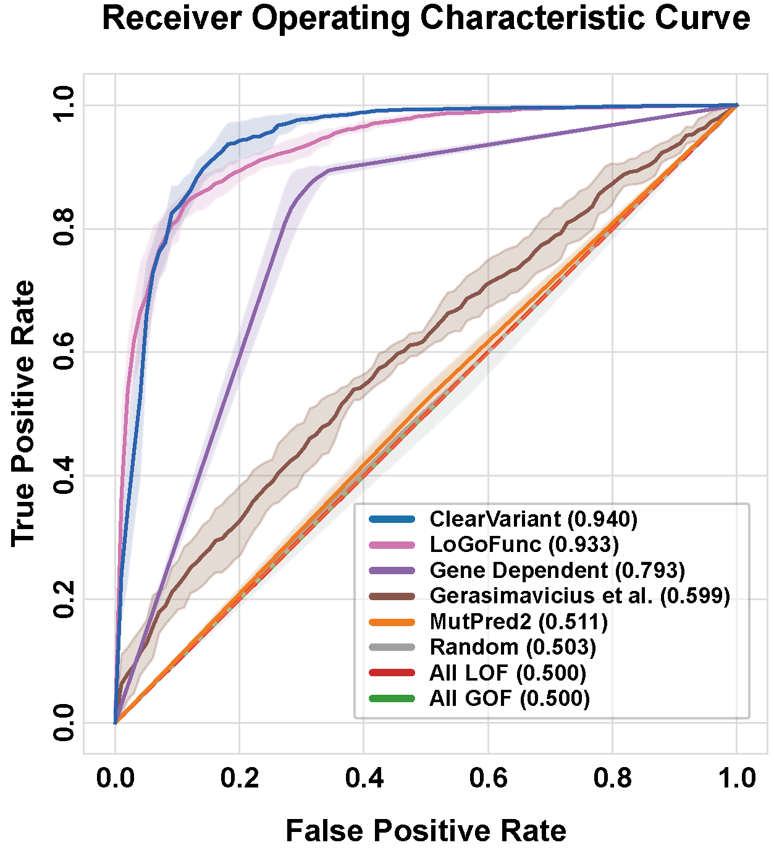
Supplementary Fig. 1. Receiver operating characteristic (ROC) curves of ClearVariant and baseline models. ClearVariant outperforms all baseline models. The dotted red line represents the y = x line, and with both All LOF and All GOF curves coinciding with it.
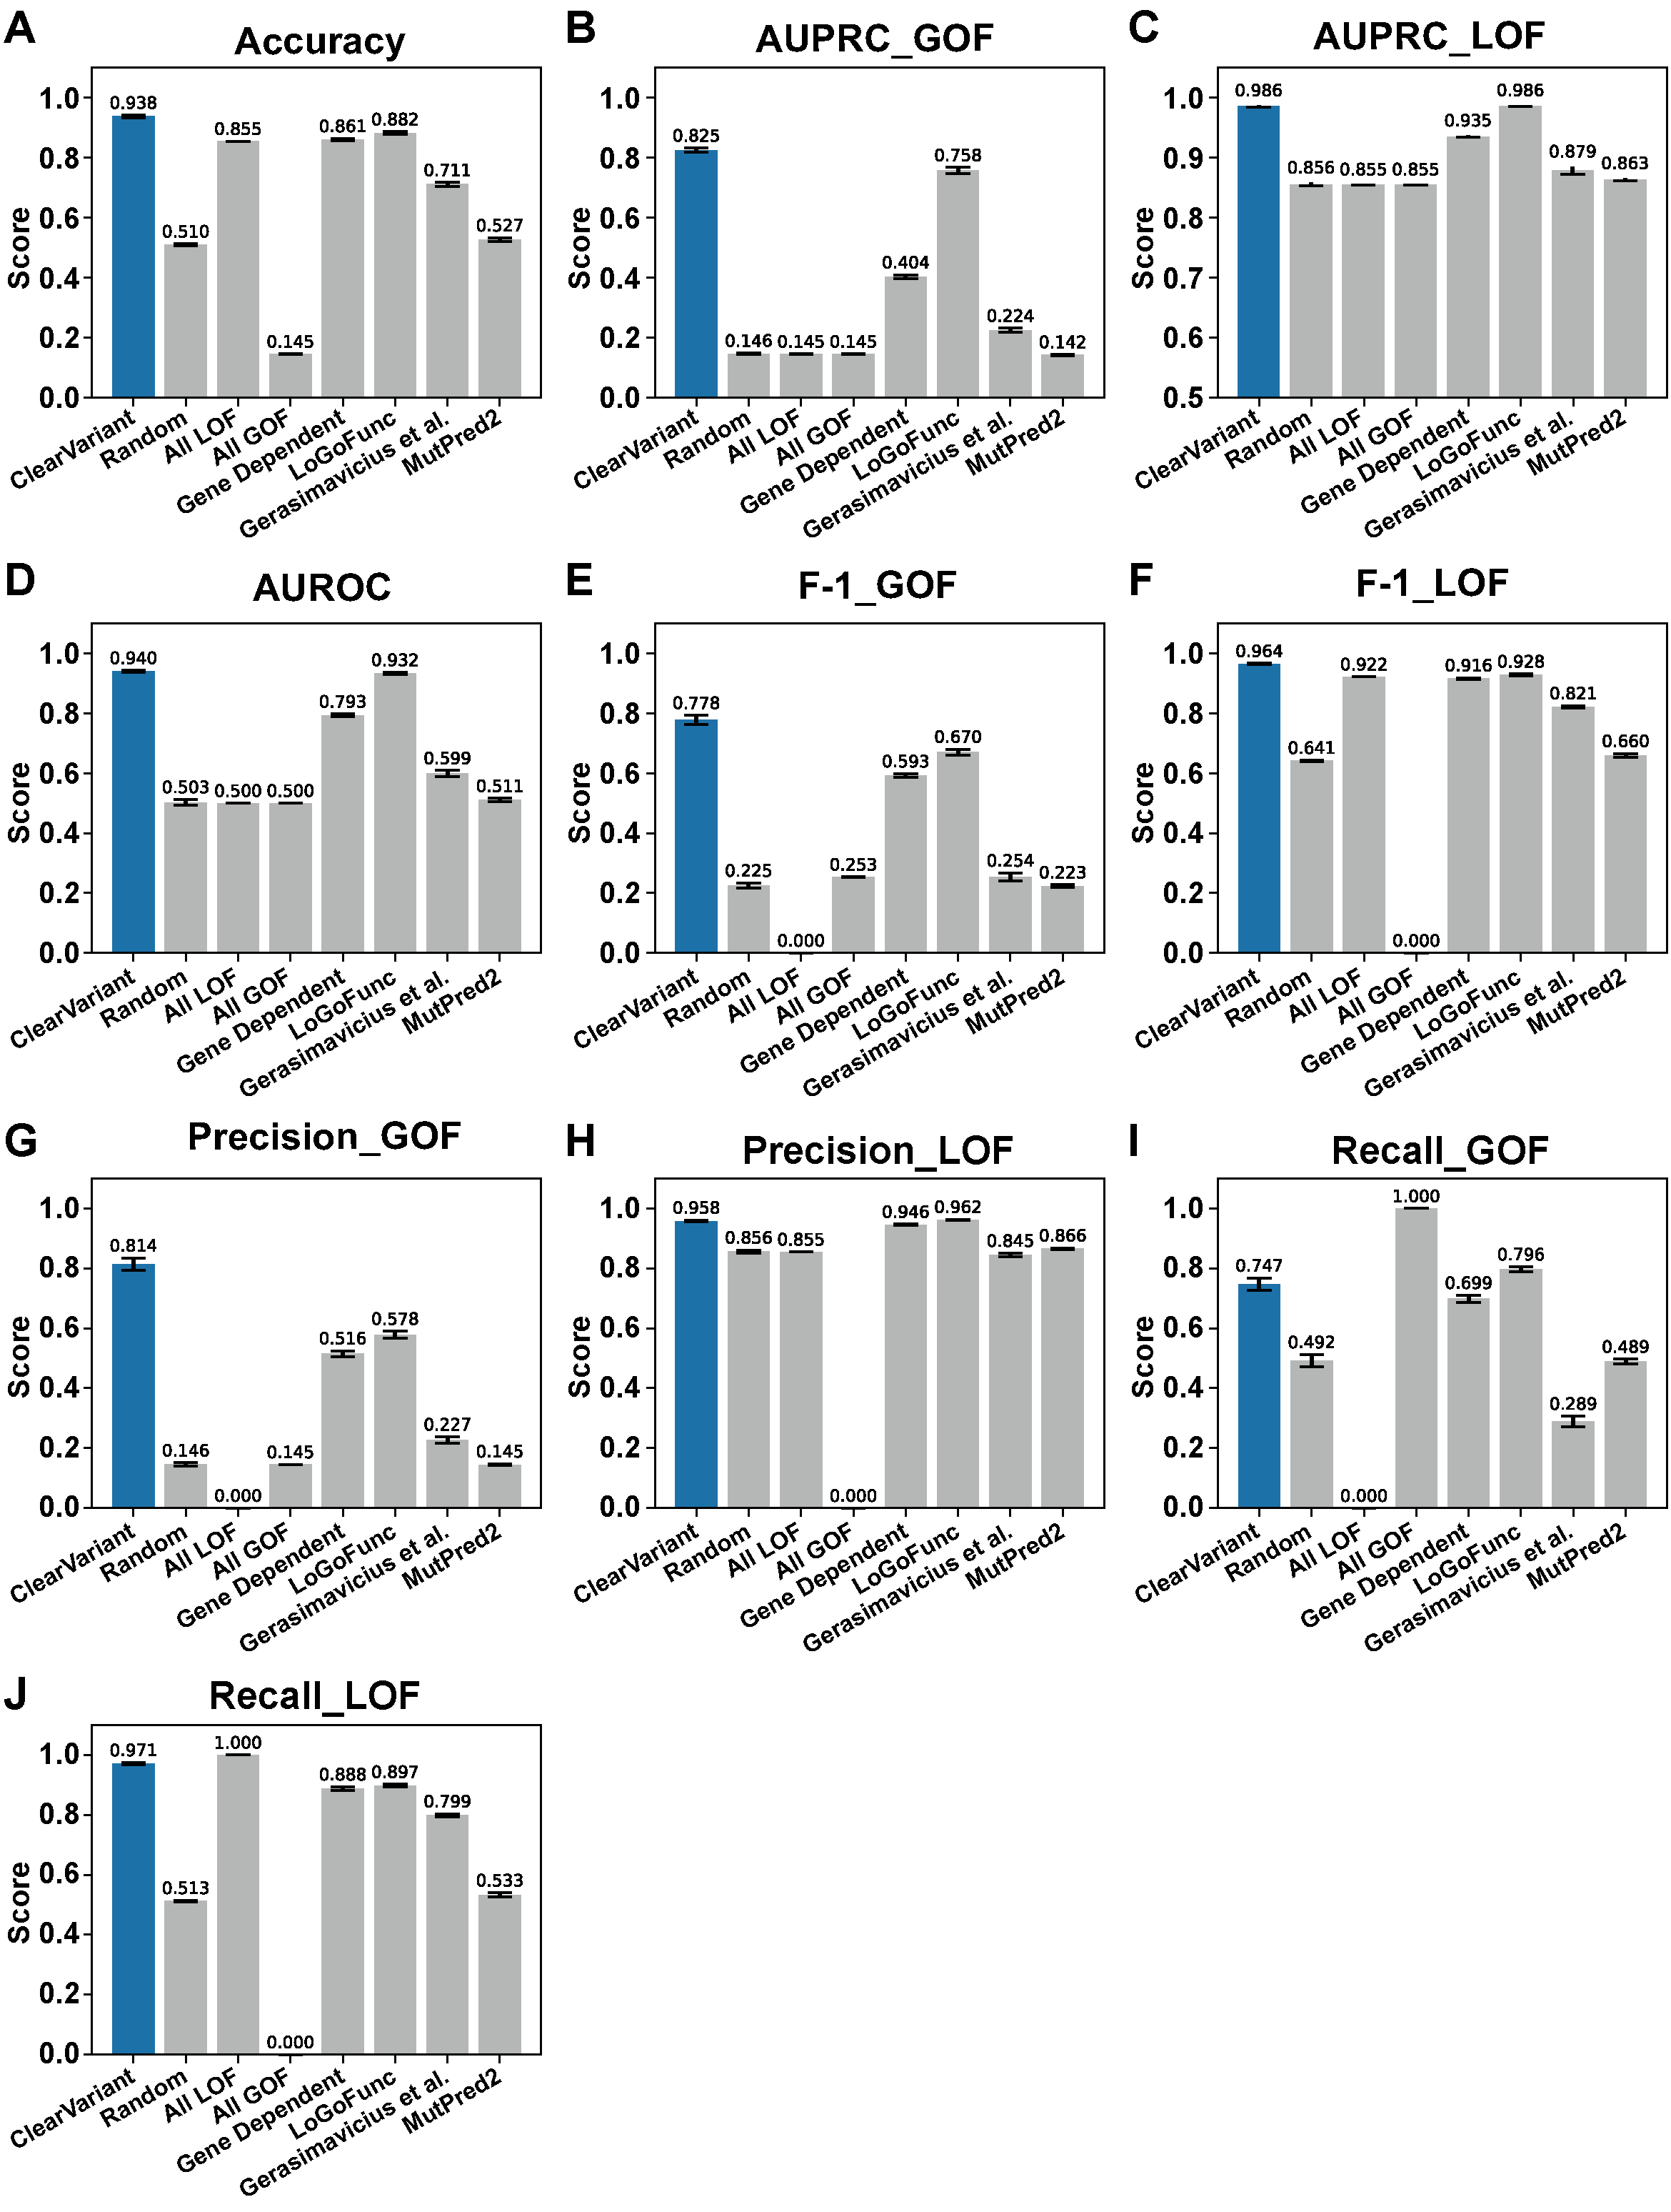
Supplementary Fig. 2. Multiple performance metrics for GOF/LOF prediction. Comparison of ClearVariant and baseline models. a, Accuracy. b, GOF AUPRC. c, LOF AUPRC. d, AUROC. e, GOF F1. f, LOF F1. g, GOF Precision. h, LOF Precision. i, GOF Recall. j, LOF Recall.
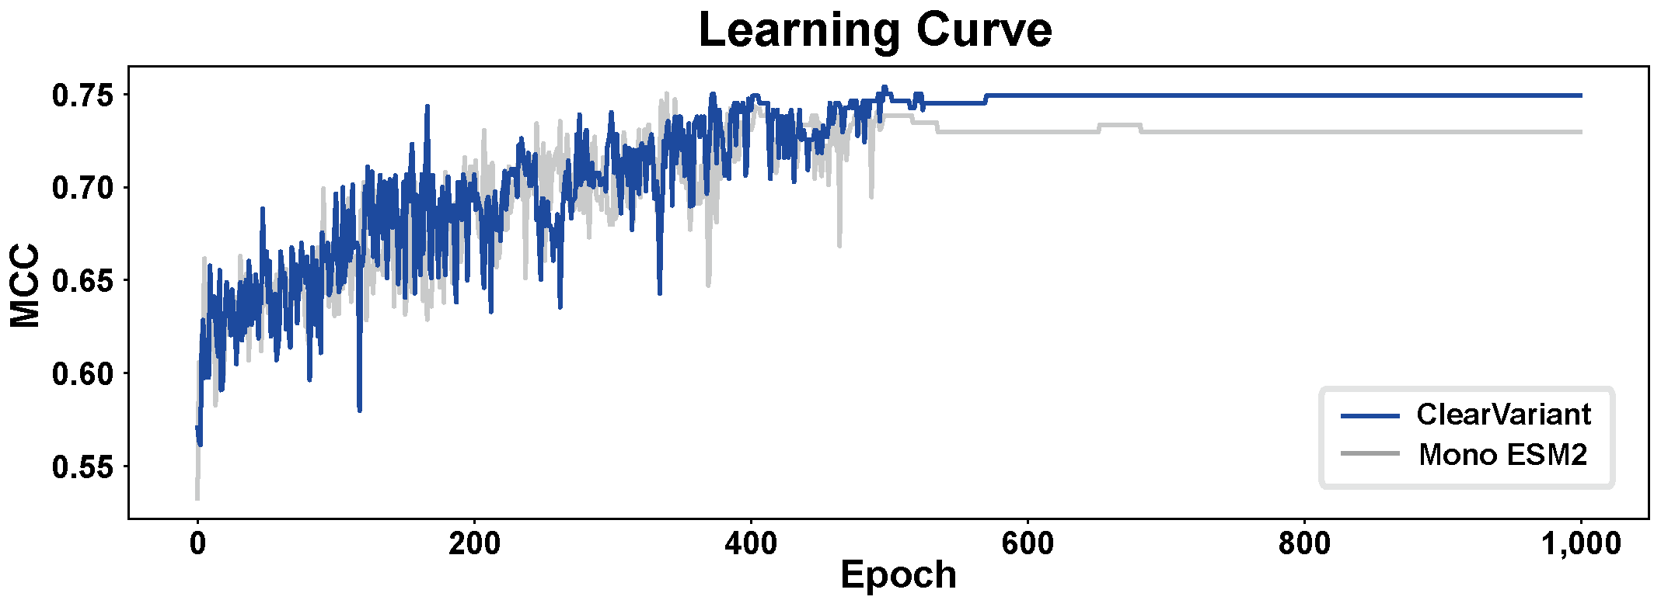
Supplementary Fig. 3. Performance comparison between ClearVariant and a model with a single ESM-2 encoder. Shown are the learning curves of ClearVariant, which compares reference and variant sequences using two ESM-2 encoders (blue line), and of a model trained only on variant sequences using one ESM-2 encoder (gray line). The Matthews Correlation Coefficient (MCC) is presented as training progress.

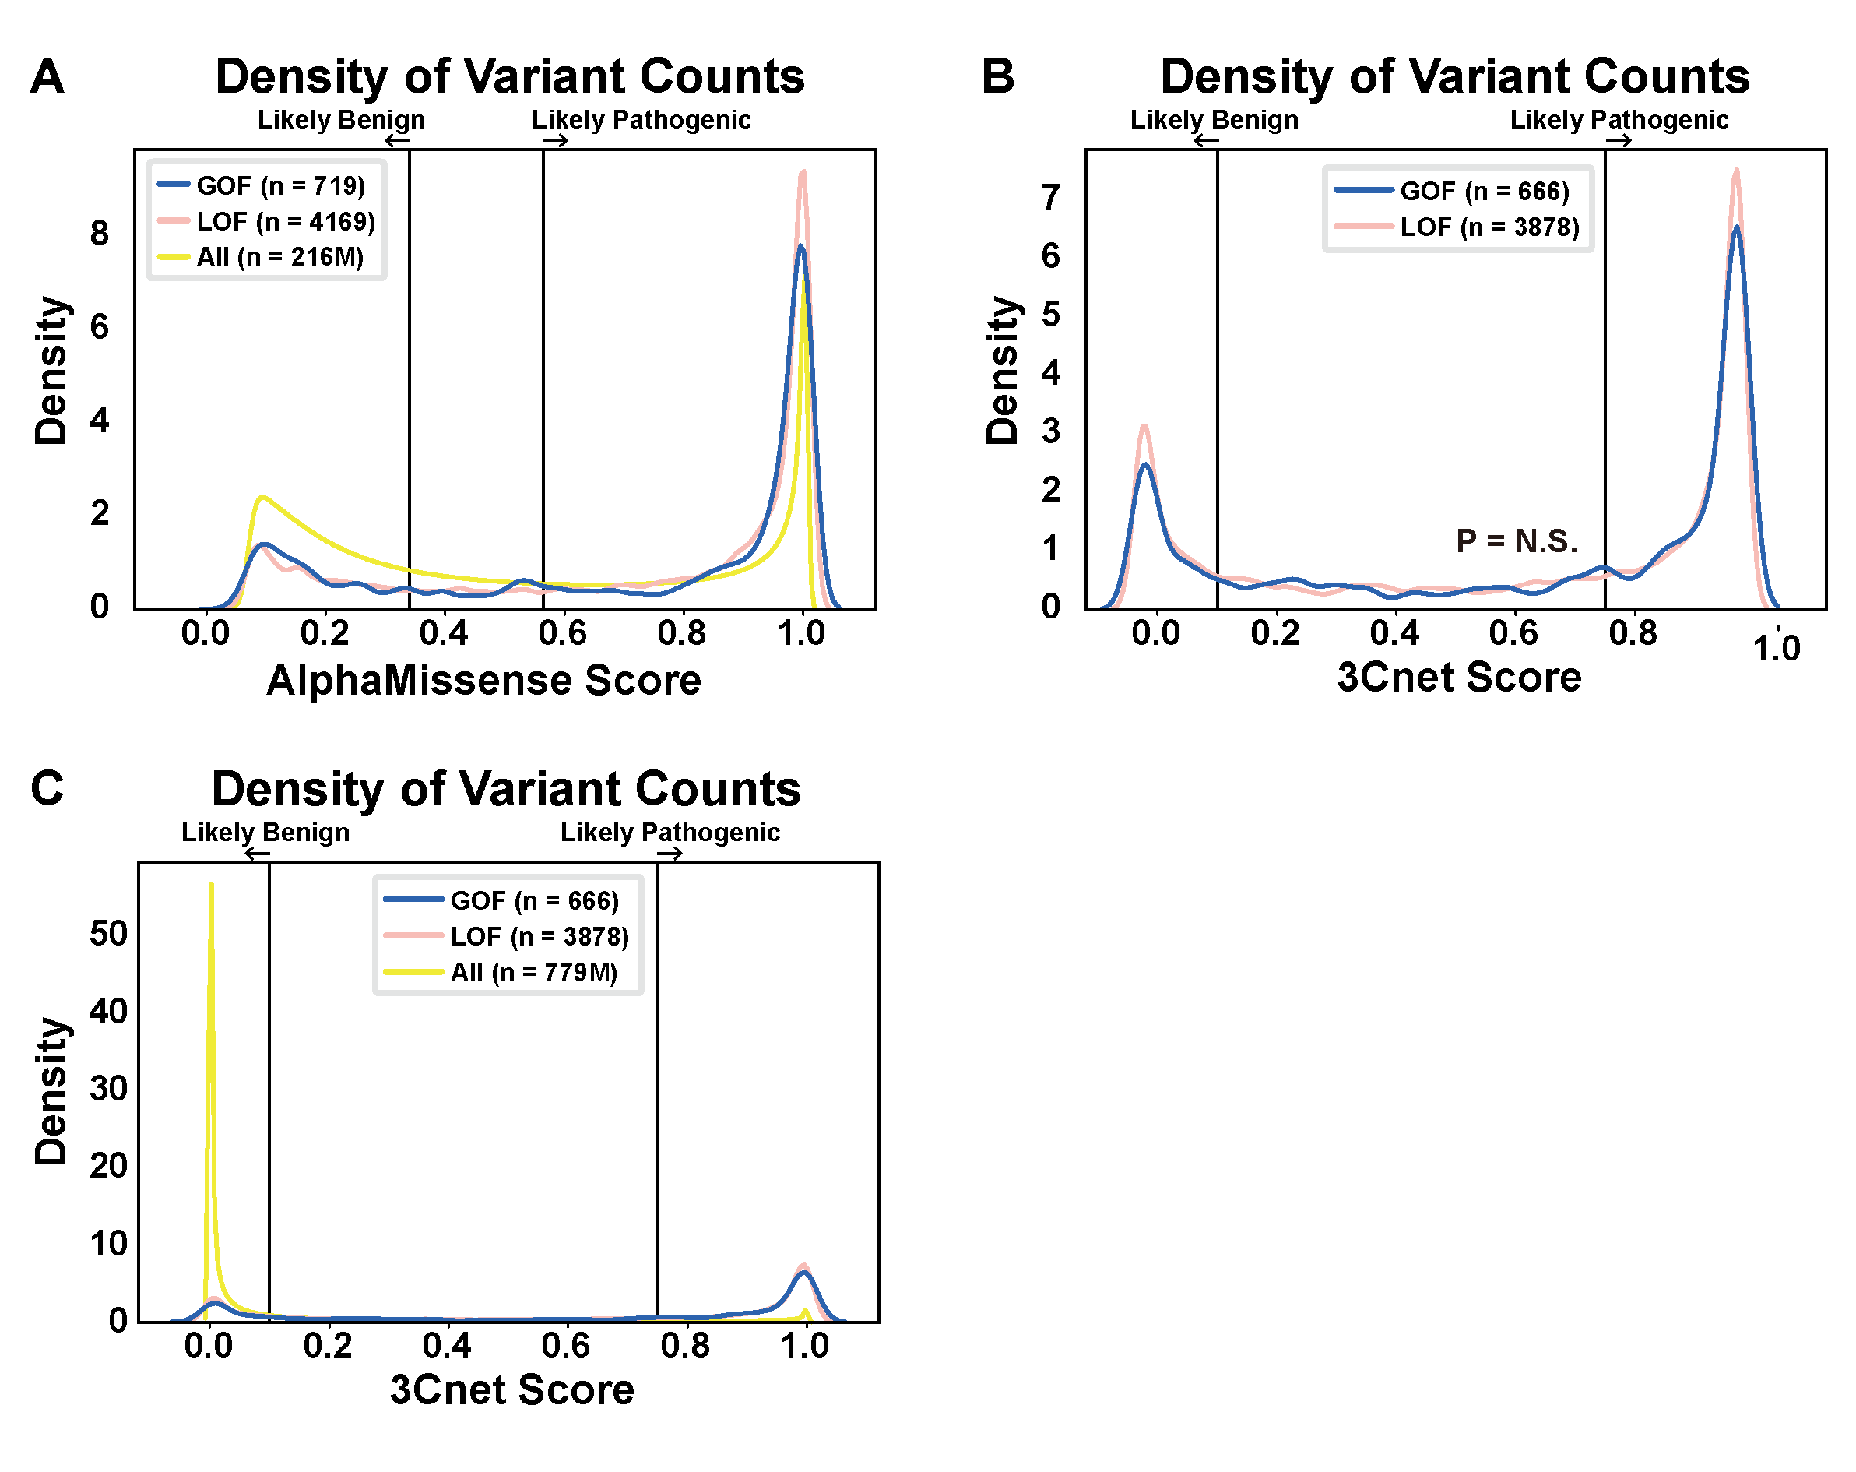
Supplementary Fig. 4. Density plots of in-silico pathogenicity prediction scores for GOF and LOF variants. a, Distribution of AlphaMissense scores for GOF, LOF, and all possible missense variants in canonical human proteins. b, Distribution of 3Cnet scores for GOF and LOF variants (P = N.S., Mann–Whitney U test). c, Distribution of 3Cnet scores for GOF, LOF, and all possible missense variants for RefSeq human proteins. N.S. indicates P > 0.01.
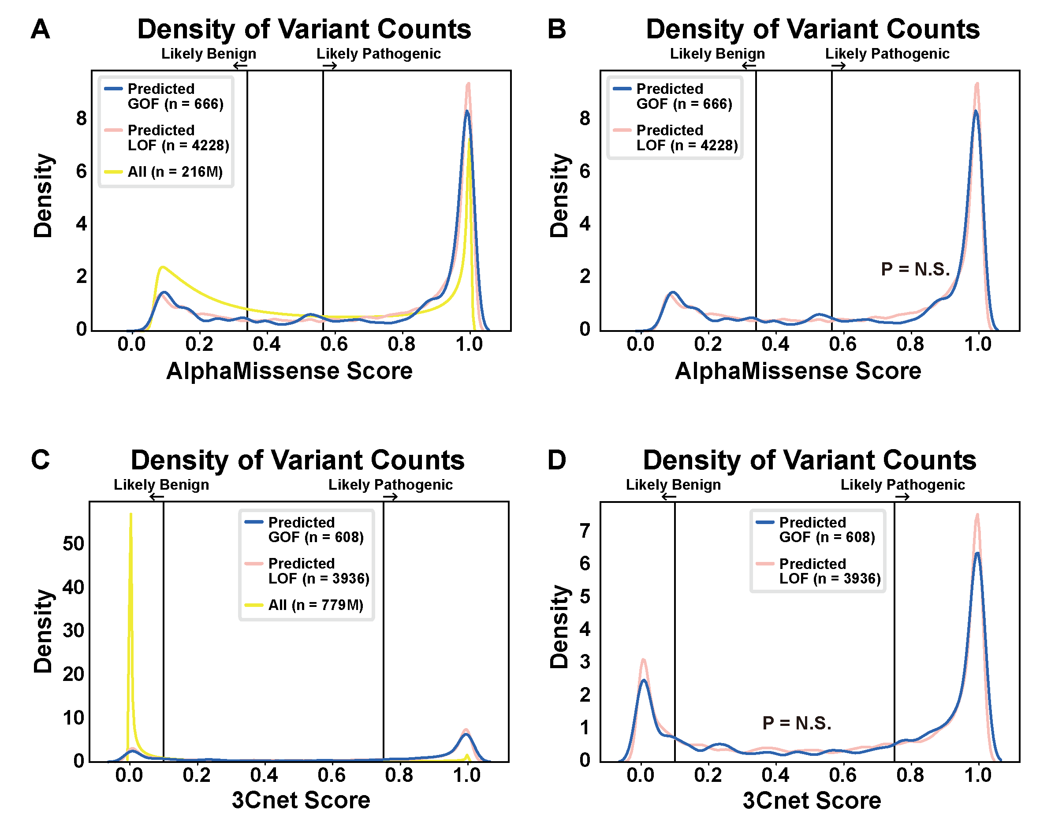
Supplementary Fig. 5. Density plots of in-silico pathogenicity prediction scores for GOF and LOF variants predicted by ClearVariant. a, Distribution of AlphaMissense scores for predicted GOF, predicted LOF, and all possible missense variants in canonical human proteins. b, Distribution of AlphaMissense score for predicted GOF and LOF variants (P = N.S., Mann–Whitney U test). c, Distribution of 3Cnet scores for predicted GOF, predicted LOF, and all possible missense variants for RefSeq human proteins. d, 3Cnet score distribution for predicted GOF and LOF variants (P = N.S., Mann–Whitney U test). N.S. indicates P > 0.01.
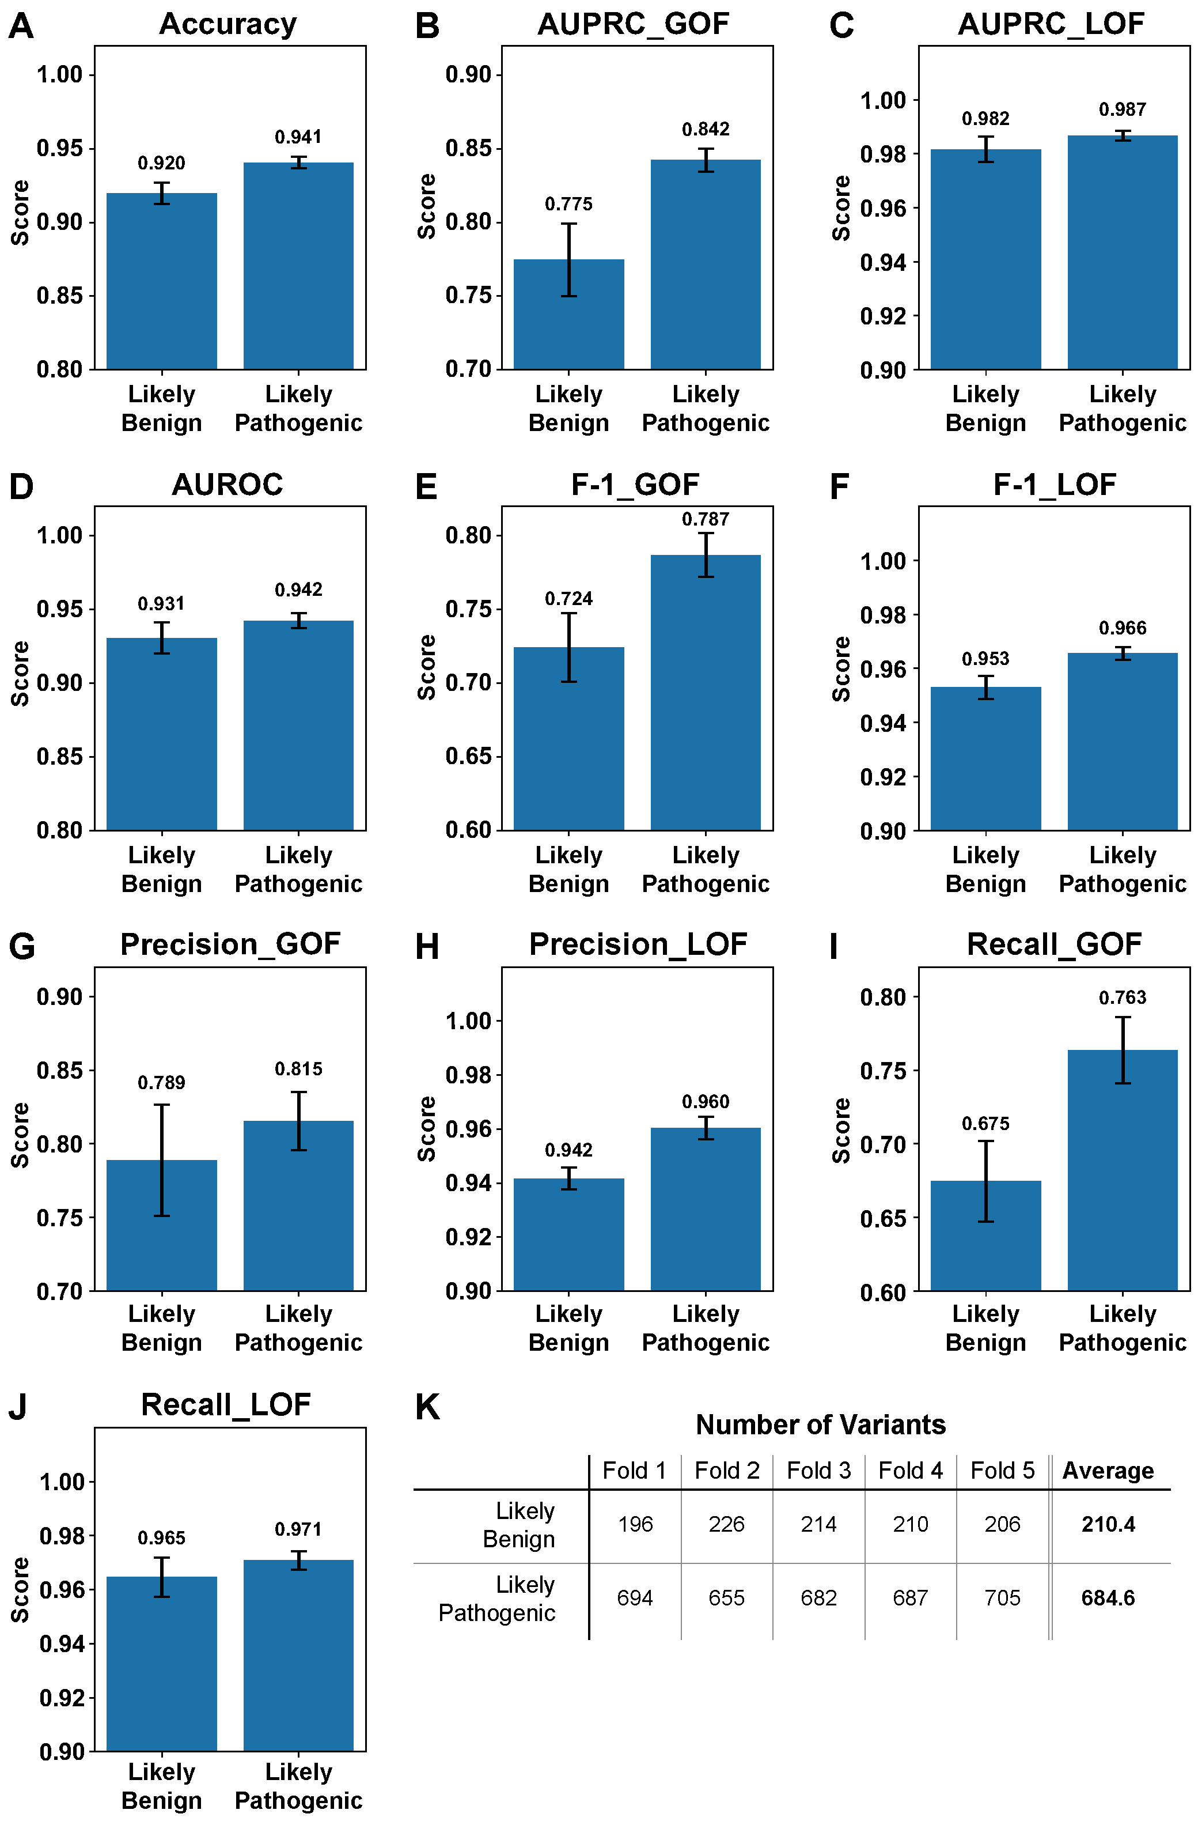
Supplementary Fig. 6. ClearVariant prediction performance for GOF and LOF classification, based on AlphaMissense-predicted pathogenicity. a-j, Comparison of ClearVariant's predictive performance between likely benign and likely pathogenic variants classified by AlphaMissense. (a) Accuracy. (b) GOF AUPRC. (c) LOF AUPRC. (d) AUROC. (e) GOF F1 score. (f) LOF F1 score. (g) GOF precision. (h) LOF precision. (i) GOF recall. (j) LOF recall. k, Number of predicted benign and pathogenic variants in the test sets of the 5-fold cross-validation.

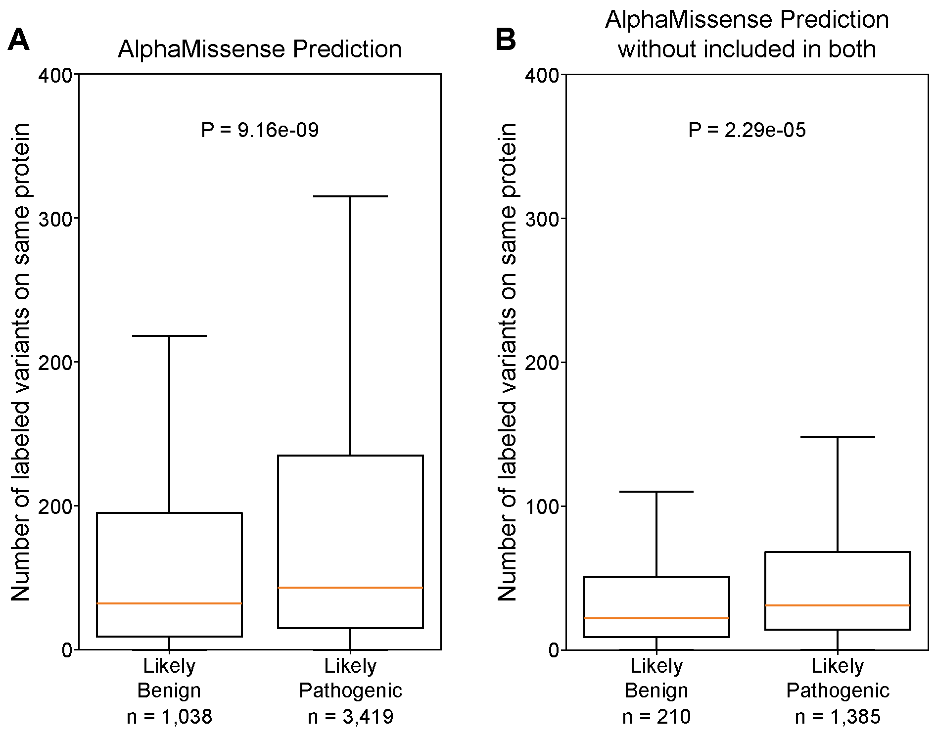
Supplementary Fig. 7. Number of labeled variants per protein for variants predicted as likely benign or likely pathogenic by ClearVariant. For each variant, the total number of labeled variants (i.e., variants with ground truth annotations as pathogenic or benign) associated with the same protein was counted. a,b, Prediction of AlphaMissense on likely benign versus likely pathogenic labels for variants with pathogenic GOF or LOF annotations. (a) Comparison of the number of labeled variants per protein between variants predicted as likely pathogenic and those predicted as likely benign. (b) Same as (a), but excluding proteins that contain variants in both the “likely benign” and “likely pathogenic” groups.
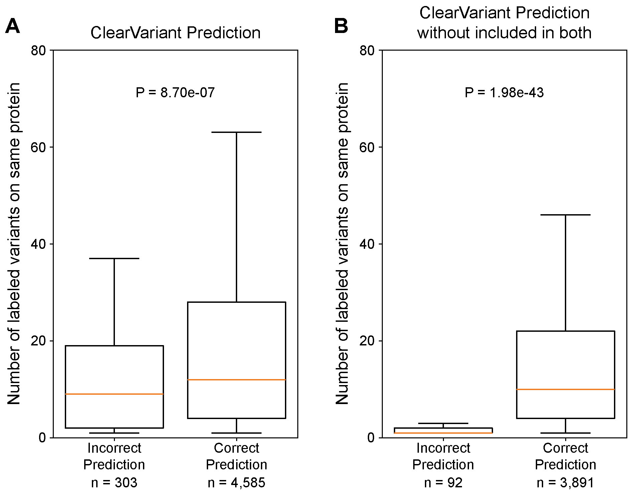
Supplementary Fig. 8. Number of labeled variants per protein for variants correctly and incorrectly predicted by ClearVariant. For each variant, the total number of labeled variants (i.e., variants with ground truth annotations, GoF/LoF) associated with the same protein was counted. a,b, ClearVariant predictions for pathogenic gain-of-function (GOF) and loss-of-function (LOF) variants. (a) Comparison of the number of labeled variants per protein between variants where ClearVariant correctly predicted the GOF/LOF label and those where it did not. (b) Same as (a) but excluding proteins that contain variants in both the "incorrect" and "correct" groups.

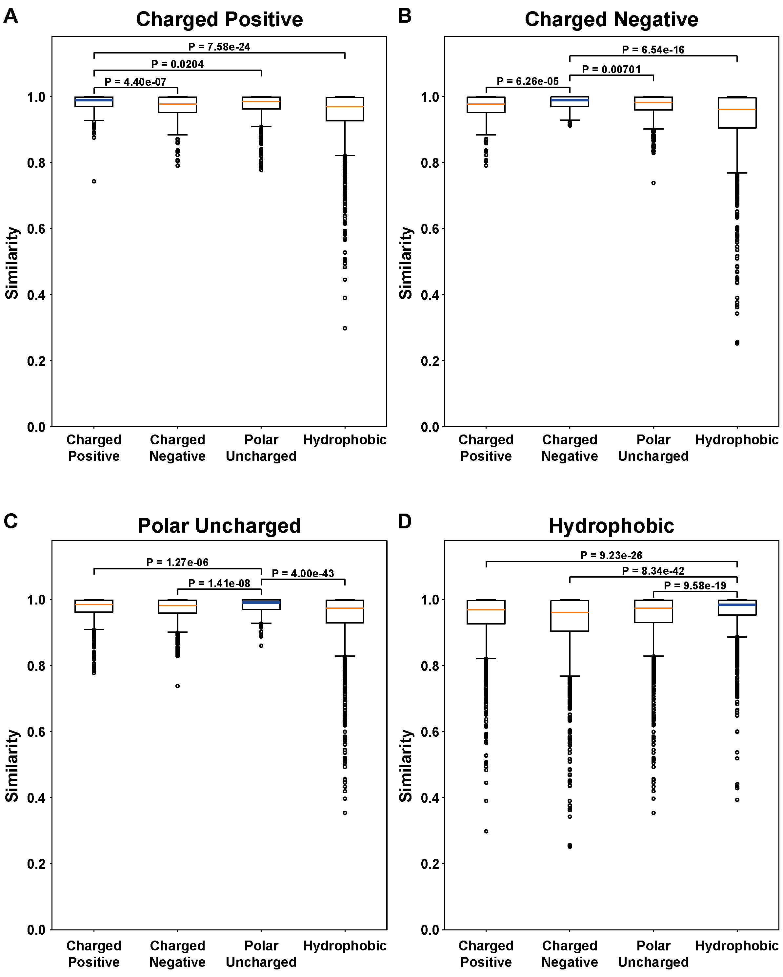
Supplementary Fig. 9. Similarity in ClearVariant's mutation effect predictions based on the chemical properties of the variant residue, for variants not included in the training set. Similarity was calculated using the mutation effect prediction values for two variants and defined as 1 minus the absolute difference between their predicted effects. a, One of two variant residues is charged positive (Arg, His, Lys). b, One of two variant residues is charged negative (Asp, Glu). c, One of two variant residues is polar uncharged (Ser, Thr, Asn, Gln). d, One of two variant residues is hydrophobic (Ala, Val, Ile, Leu, Met, Phe, Tyr, Trp).

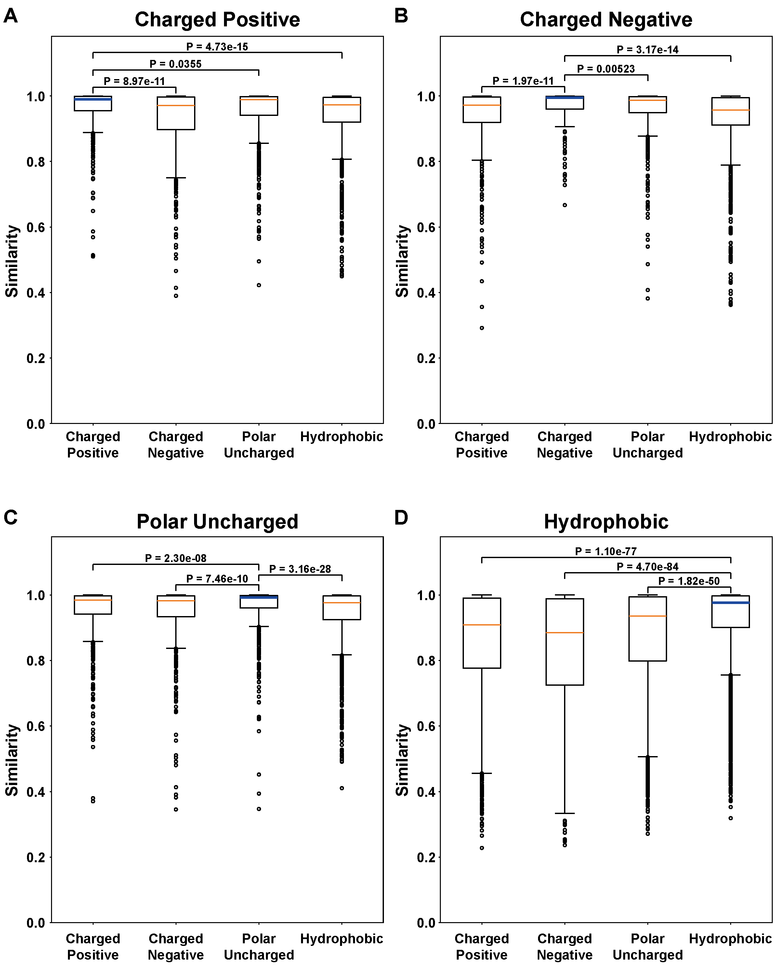
Supplementary Fig. 10 Similarity in mutational effect predictions based on the chemical properties of wild-type and variant amino acids. The similarity between the predicted mutational effect scores of the wild-type and variant protein was analyzed based on the chemical property similarities between the wild-type and variant amino acids. Similarity was defined as 1 - abs (predicted score of wild-type - predicted score of the variant). a, Wild-type amino acid is charged positive (Arg, His, Lys). b, Wild-type amino acid is charged negative (Asp, Glu). c, Wild-type amino acid is polar uncharged (Ser, Thr, Asn, Gln). d, Wild-type amino acid is hydrophobic (Ala, Val, Ile, Leu, Met, Phe, Tyr, Trp).

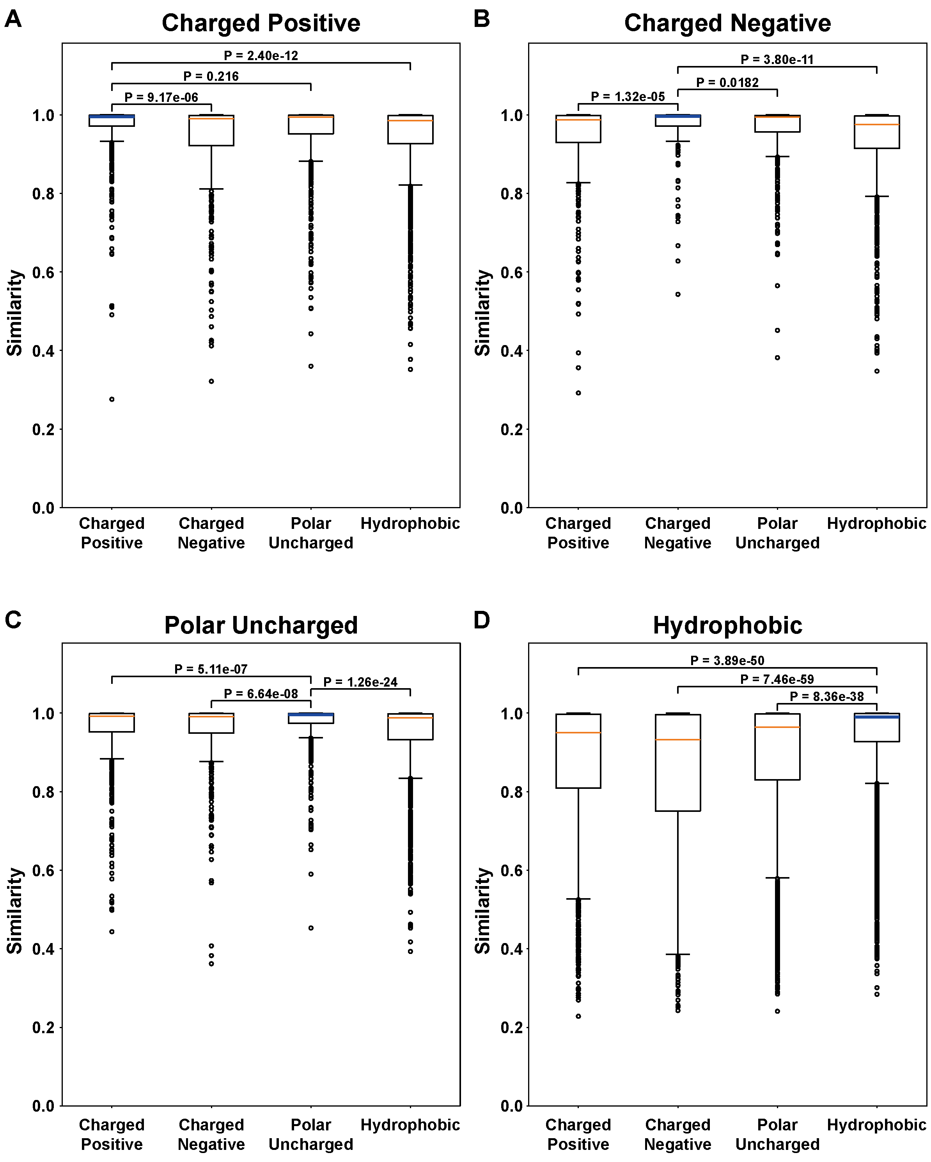
Supplementary Fig. 11. Similarity in mutational effect predictions based on the chemical properties of wild-type and variant amino acids for variants not included in the training set. The similarity between the predicted mutational effect scores of the wild-type protein and variant proteins was analyzed based on the chemical property similarities between the wild-type and variant amino acids. Similarity was defined as 1 - abs (predicted score of wild-type - predicted score of the variant). a, Wild-type amino acid is charged positive (Arg, His, Lys). b, Wild-type amino acid is charged negative (Asp, Glu). c, Wild-type amino acid is polar uncharged (Ser, Thr, Asn, Gln). d, Wild-type amino acid is hydrophobic (Ala, Val, Ile, Leu, Met, Phe, Tyr, Trp).

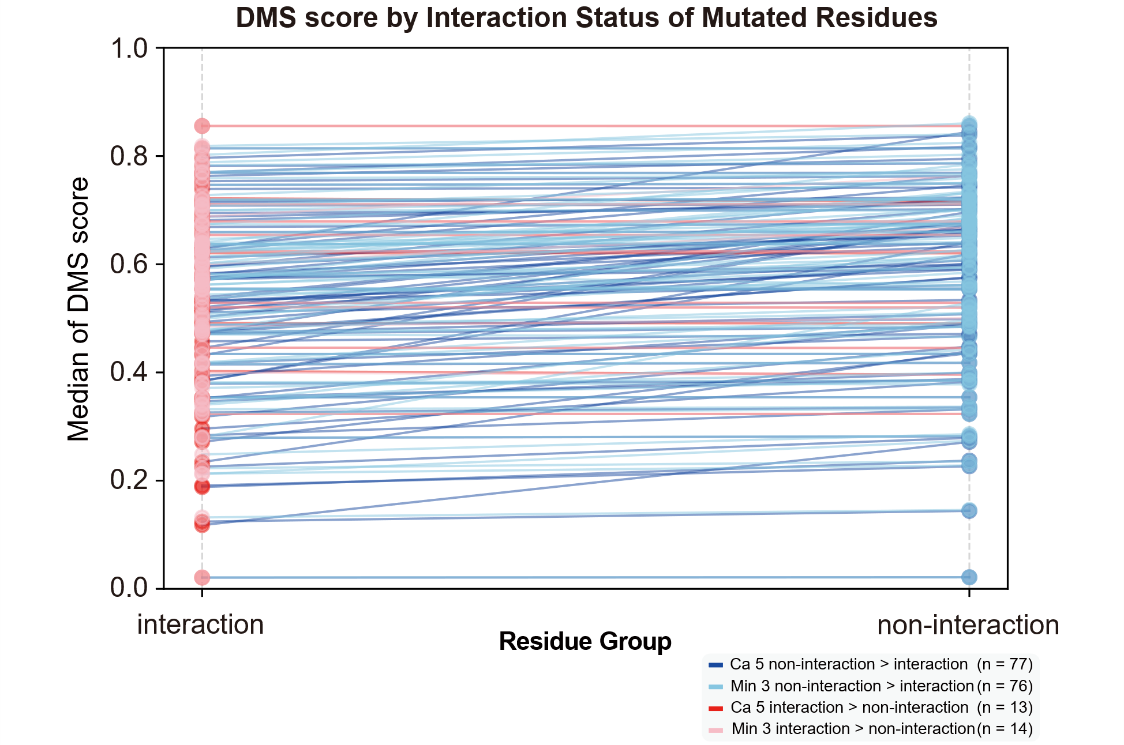
Supplementary Fig. 12. Median DMS scores of residues with and without inter-residue interactions in each ProteinGym dataset.
Red dots represent mutated residues involved in inter-residue interactions, while blue dots represent mutated residues without such interactions. Each pair of dots connected by a solid line corresponds to the same dataset. If the interacting residue has a higher DMS score, the line is colored red; if the non-interacting residue has a higher score, the line is colored blue. Dark-coloured dots represent residue pairs with a C-alpha distance ≤ 5 Å, whereas light-coloured dots represent cases where the shortest atomic distance is ≤ 3 Å, defining an interaction.
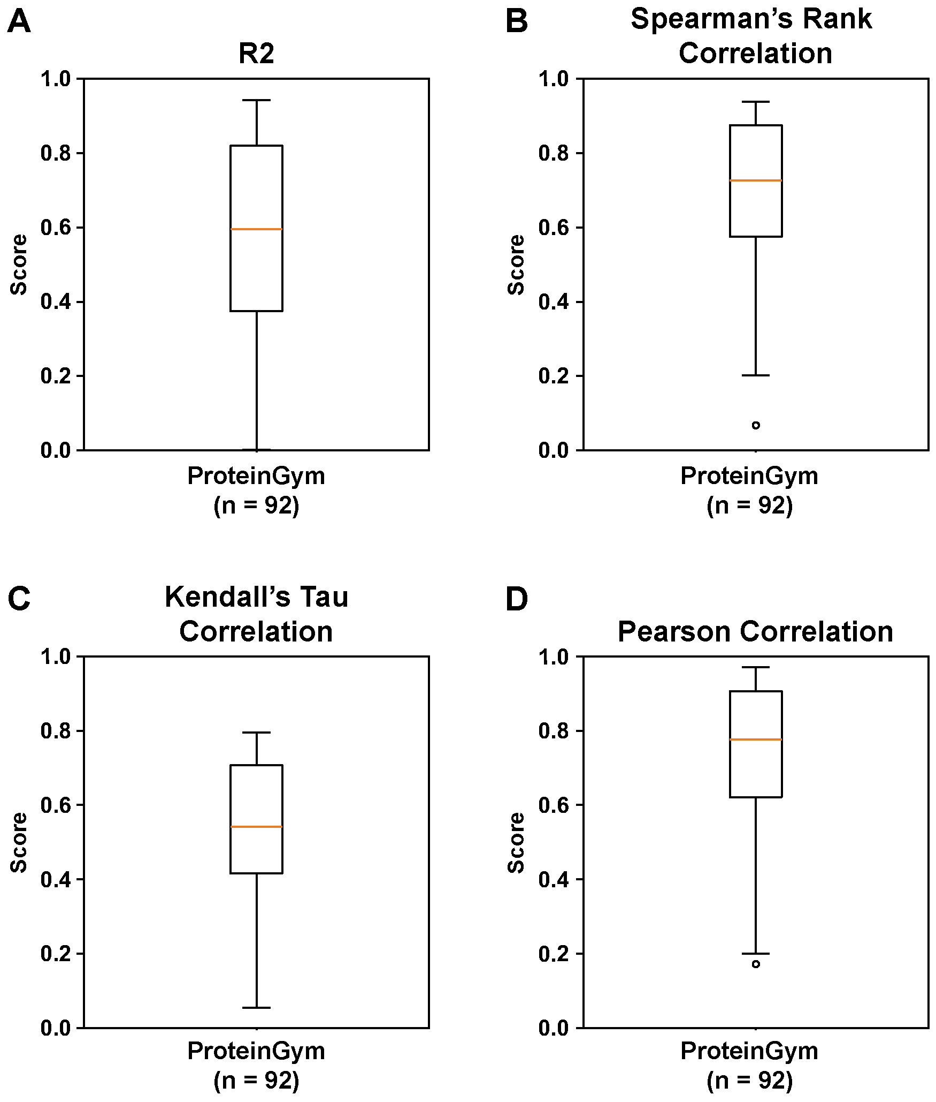
Supplementary Fig. 13. Multiple performance metrics for protein mutational effect prediction. Performance evaluation on the ProteinGym dataset. Performance was assessed using a, R². b, Spearman’s rank correlation. c, Kendall’s Tau correlation. d, Pearson correlation.
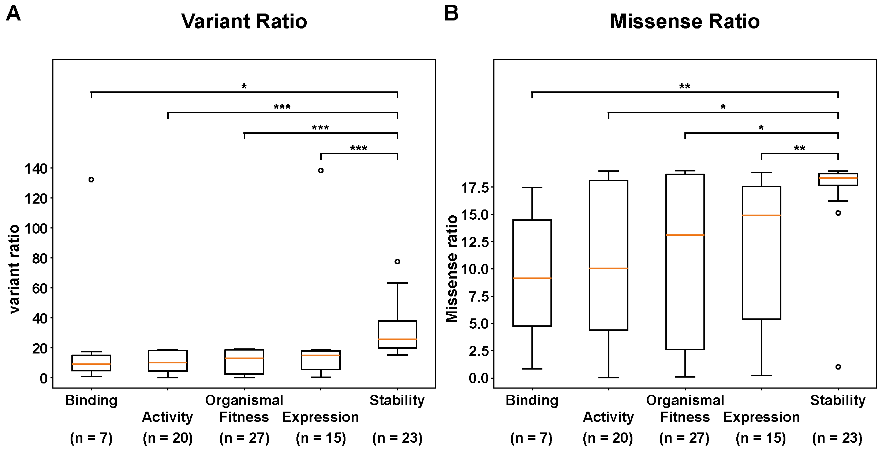
Supplementary Fig. 14. Variant coverage by experiment types. Variant coverage across different mutational scanning experiment categories in the ProteinGym dataset. Variant coverage was calculated as number of variants divided by sequence length, with the maximum of 19 missense variants. a, Coverage of all variants, including double mutations. b, Coverage of missense variants. The p-value was determined using the Mann-Whitney U test. Statistical significance is indicated as follows: * for p ≤ 0.05; ** for p ≤ 0.001; and *** for p ≤ 0.0001. Pairs without significance marks indicate that no significant difference was observed. Apart from comparisons involving stability, no significant differences were observed.
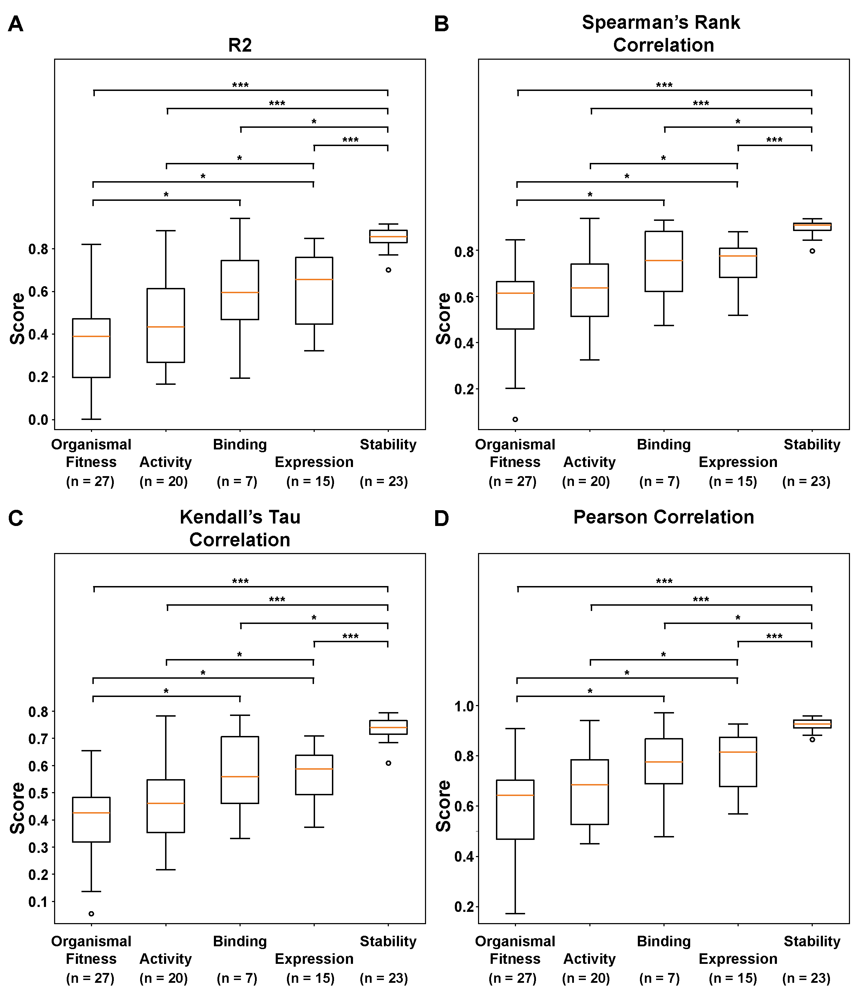
Supplementary Fig. 15. Prediction performance by experiment types. Mutational effect prediction performance across different mutational scanning experiment categories in the ProteinGym dataset. a, R². b, Spearman’s rank correlation. c, Kendall’s Tau correlation. d, Pearson correlation. The p-value was determined using the Mann-Whitney U test. Statistical significance is indicated as follows: * for p ≤ 0.05; ** for p ≤ 0.001; and *** for p ≤ 0.0001. Pairs without significance marks indicate that no significant difference was observed.
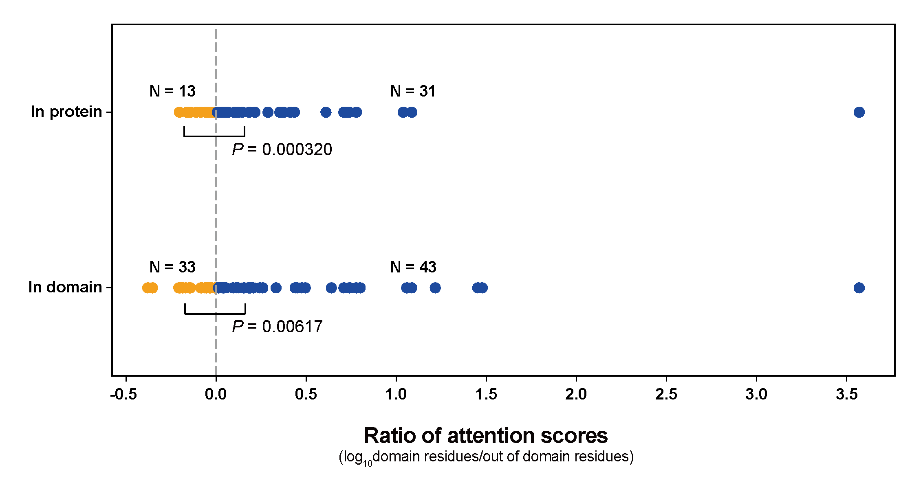
Supplementary Fig. 16. Ratio of the median attention score between domain residues and other residues. A ratio above 0.0 indicates that residues within the same domain as the region of interest (ROI) have higher attention scores than residues in other domains or non-domain regions. The x-axis is log₁₀-transformed. Dots are coloured blue if the ratio is above 0.0 and salmon if below. The Wilcoxon signed-rank test was used to assess whether positive ratios have statistically larger absolute values than negative ratios. Interestingly, attention scores tend to be higher within protein domains, suggesting that residues in other domains and non-domain regions have lower attention scores with the ROI. This pattern reflects established biological knowledge, highlighting the functional importance of intra-domain residue interactions.

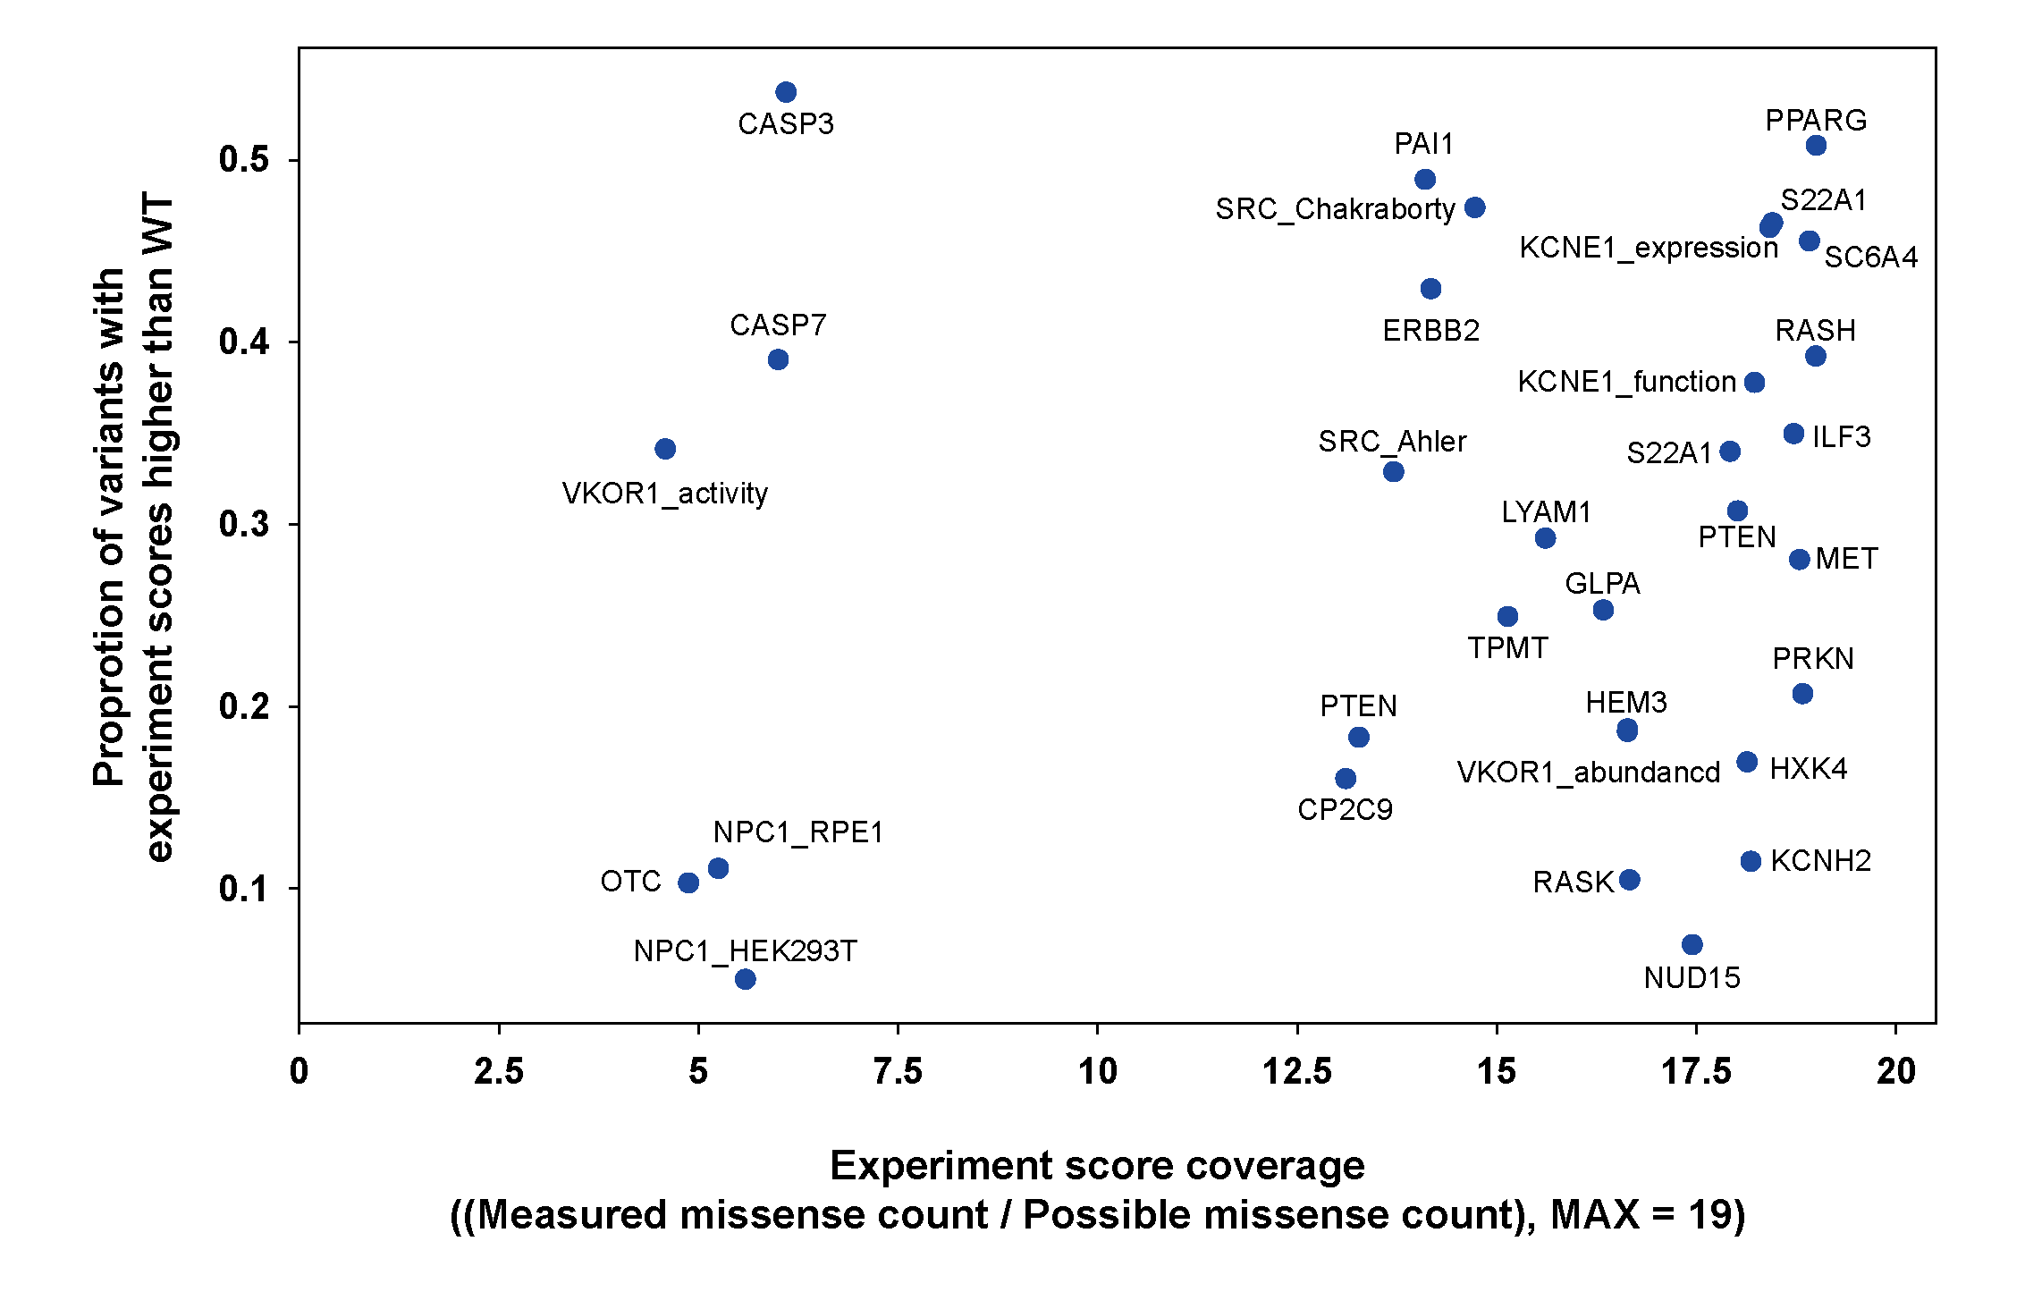
Supplementary Fig. 17. Experimental score coverage and the proportion of variants with experiment scores higher than that of the wild type in each ProteinGym dataset. Experiment score coverage refers to the proportion of possible missense variants for which experimental scores have been measured. The y-axis represents the proportion of variants with measured experimental scores that exceed that of the wild type. Among the 92 proteins in the ProteinGym expression, stability, and activity collections, only 32 proteins for which wild-type experimental values could be identified from the original publications were included in this analysis.
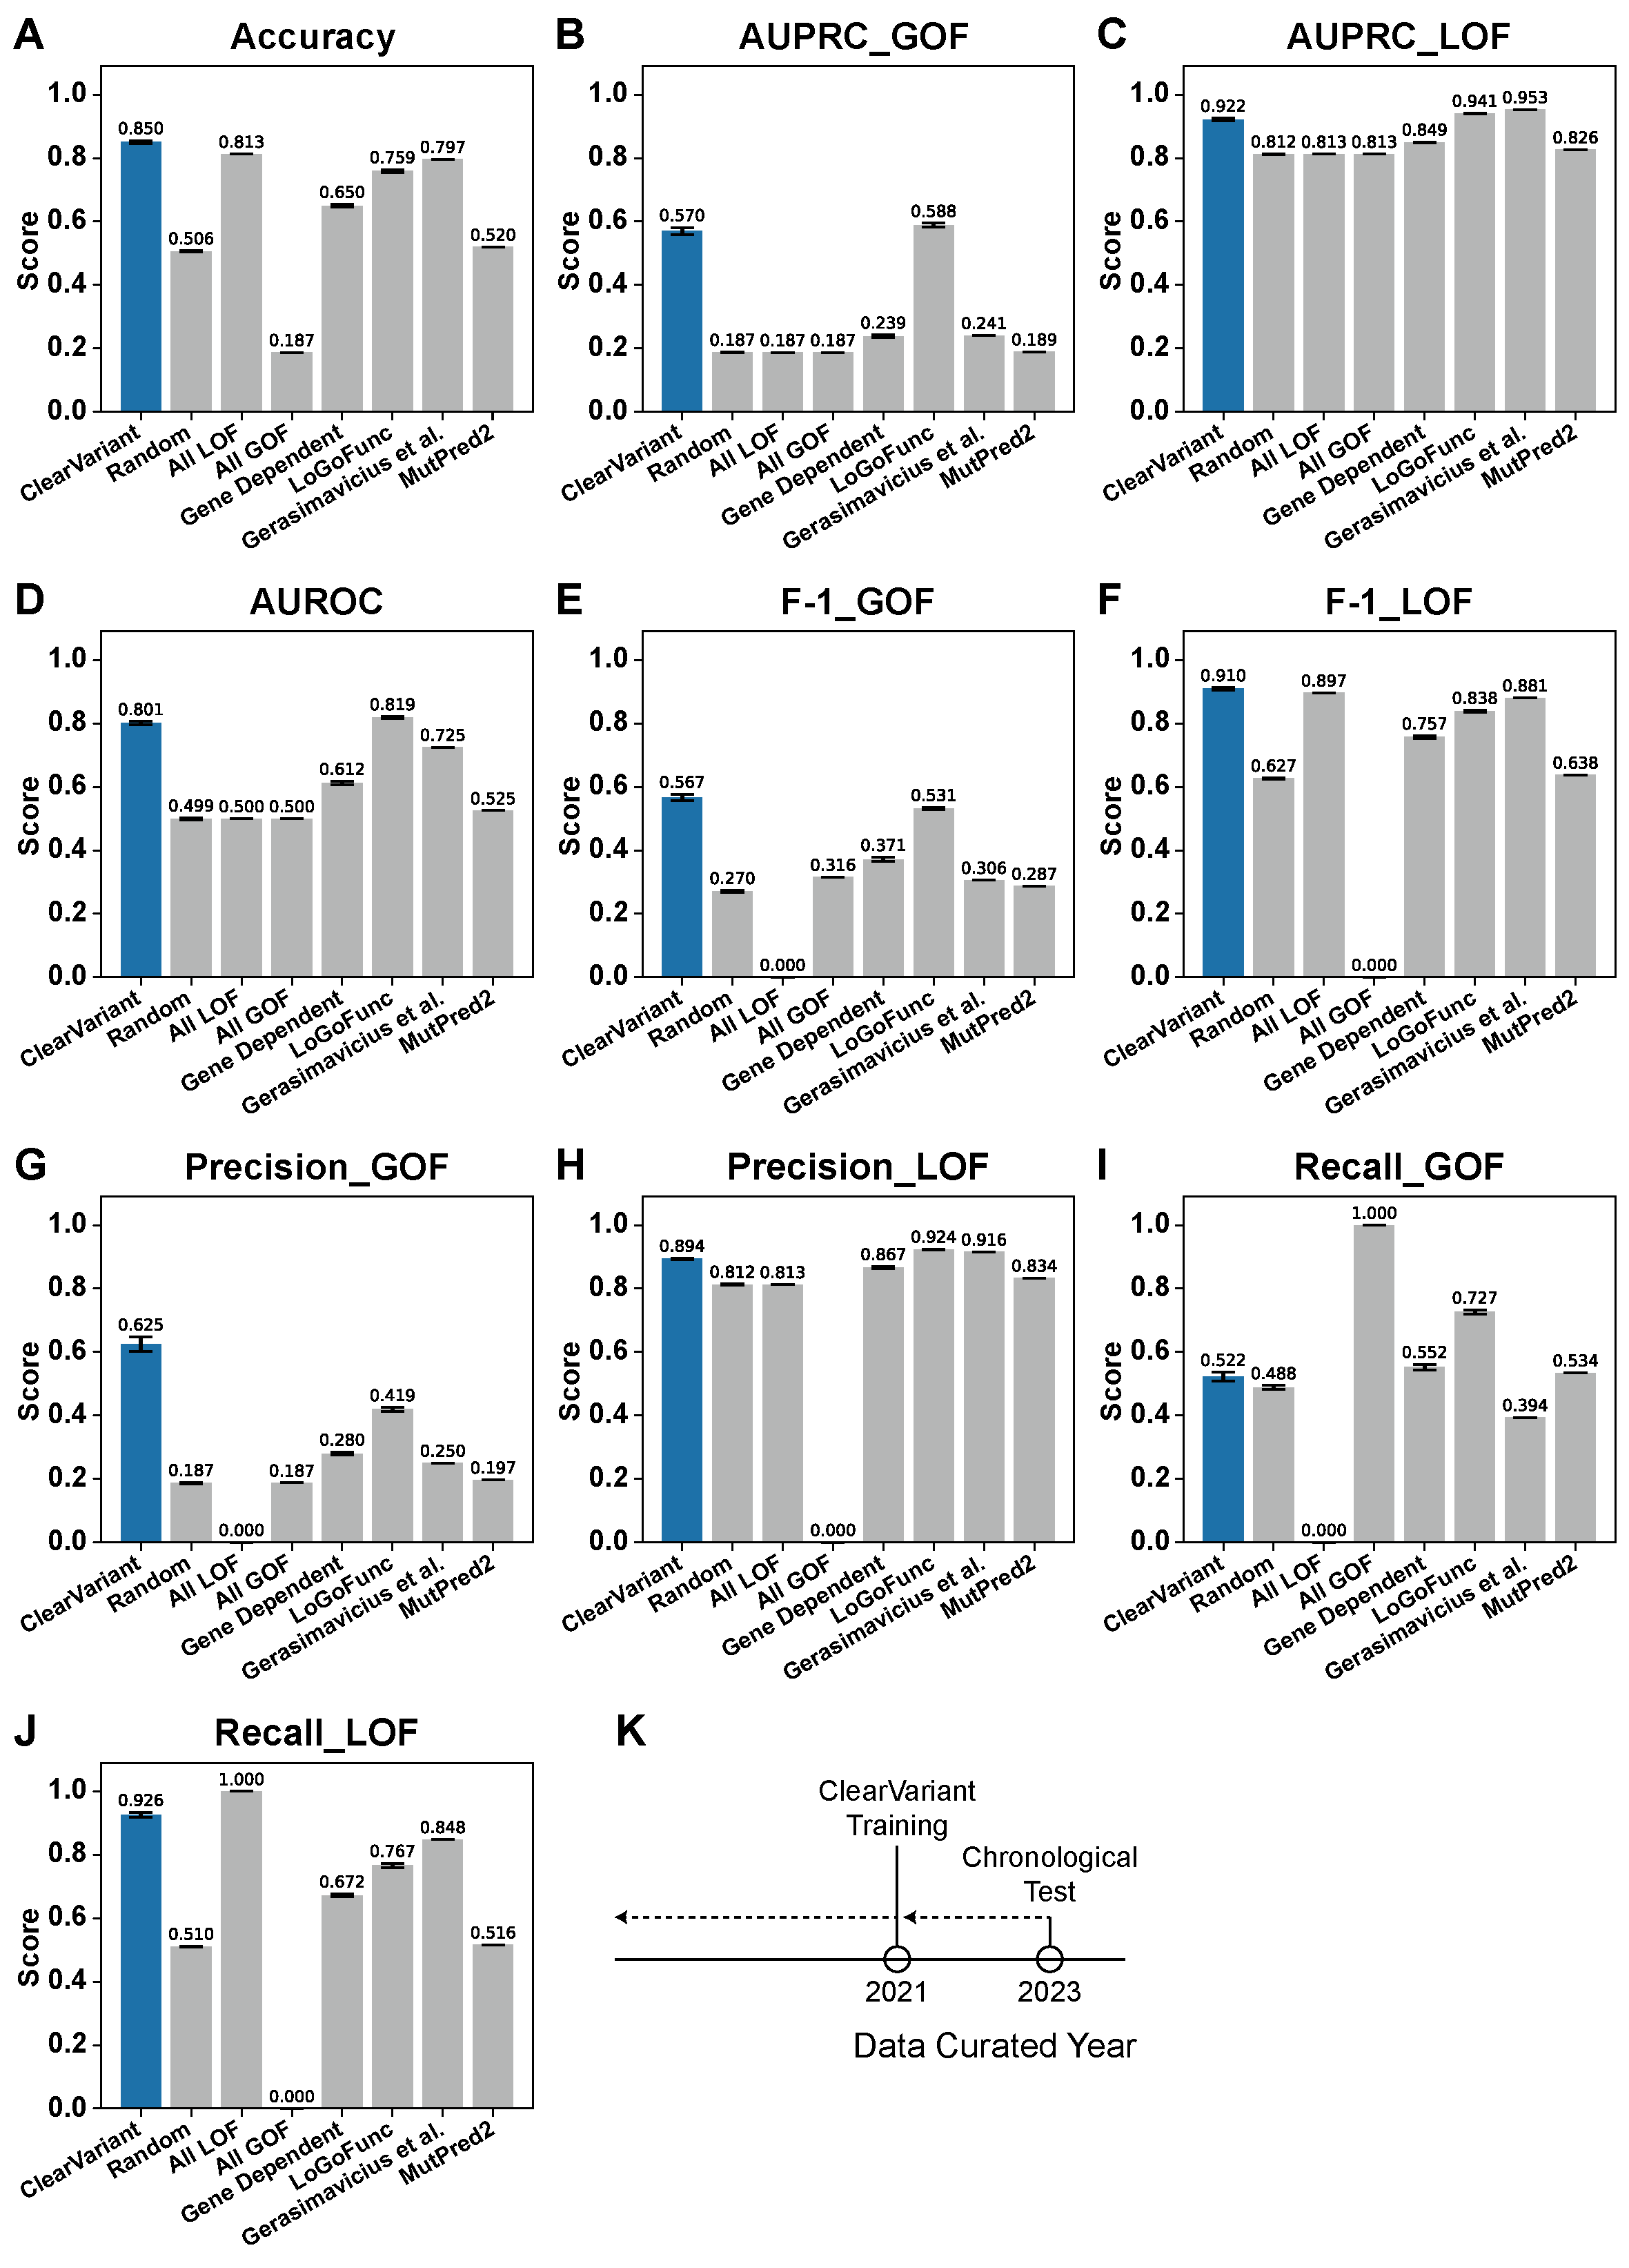
Supplementary Fig. 18. Multiple performance metrics for chronological GOF/LOF prediction. Prediction performance on a dataset updated in chronological order. a, Accuracy. b, GOF AUPRC. c, LOF AUPRC. d, AUROC. e, GOF F1. f, LOF F1. g, GOF Precision. h, LOF Precision. i, GOF Recall. j, LOF Recall. k, Year of data curation for the training and chronological test datasets used in ClearVariant. The training data for ClearVariant were curated in 2021, while the chronological test data were curated in 2023. The test dataset excludes any variants that were already included in the 2021 training dataset.

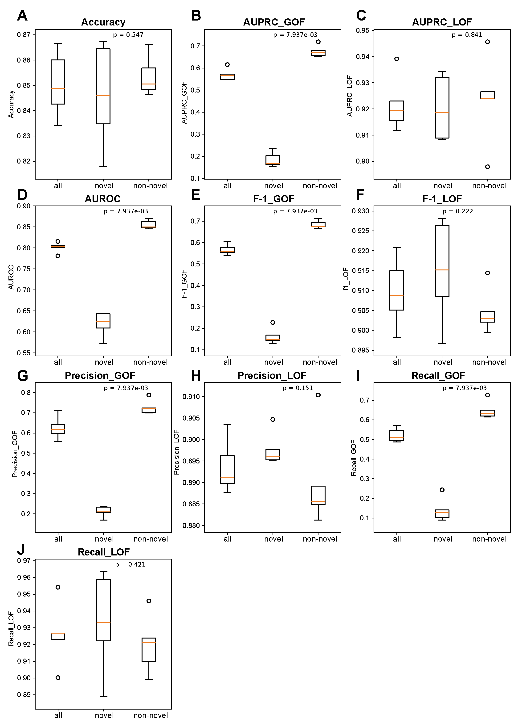
Supplementary Fig. 19. GOF/LOF prediction performance of ClearVariant on variants from novel and non-novel proteins in the chronological test.
Novel proteins are those for which no variants were included in the training dataset. Non-novel proteins are those for which at least one variant was present in the training data, although the specific variants tested here were not. a, Accuracy. b, GOF AUPRC. c, LOF AUPRC. d, AUROC. e, GOF F1 score. f, LOF F1 score. g, GOF precision. h, LOF precision. i, GOF recall. j, LOF recall.

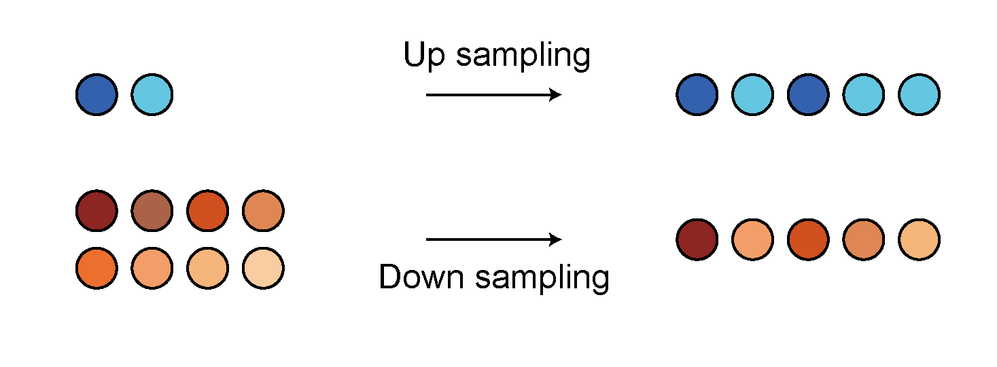
Supplementary Fig. 20. Balanced sampling of GOF/LOF variants. A schematic representation of the sampling strategy used for input data in each training epoch. To ensure equal representation during model training, GOF variants, which are relatively fewer, were randomly up-sampled, while LOF variants, which are more abundant, were randomly down-sampled. The number of data points per epoch remains the same before and after sampling.

