Supporting Information

Ultra-Sensitive Room-Temperature Ammonia Detection Enabled by MEMS-Based 0D/1D/2D PA₁₀Mo₂ Nanocomposites

Ping Luo ^{a,b}, Wenfeng Shen ^{b,c,d,e*}, Jin Zhang ^{b,f}, Dawu Lv ^{b,c}, Ruiqin Tan ^{g*}, Weijie Song ^{b,c*}

ª School of Chemistry and Chemical Engineering, Jiangxi University of Science and Technology, Ganzhou, Jiangxi 341000, China
^{b} Zhejiang Provincial Engineering Research Center of Energy Optoelectronic Materials and Devices, Ningbo Institute of Material Technology and Engineering, Chinese Academy of Sciences, Ningbo, Zhejiang 315201, China
^{c} Center of Materials Science and Optoelectronics Engineering, University of Chinese Academy of Sciences, Beijing, 100049, China
^{d} CS-Microsensor (Ningbo) Technology Co. Ltd., Ningbo, Zhejiang, 311121, China
^{e} Research and Manufacturing Base of Olfactory Sensors in China Sensing Valley, Bengbu 233040, China
^{f} Ningbo No.2 Hospital, Ningbo, Zhejiang 315099, China
^{g} Faculty of Electrical Engineering and Computer Science, Ningbo University, Ningbo, Zhejiang 315211, China

Fig. S1 (a) The ultrasonic gold wire welding machine; (b) The climate Test Chamber.

Fig. S2. MEMS chip structure.

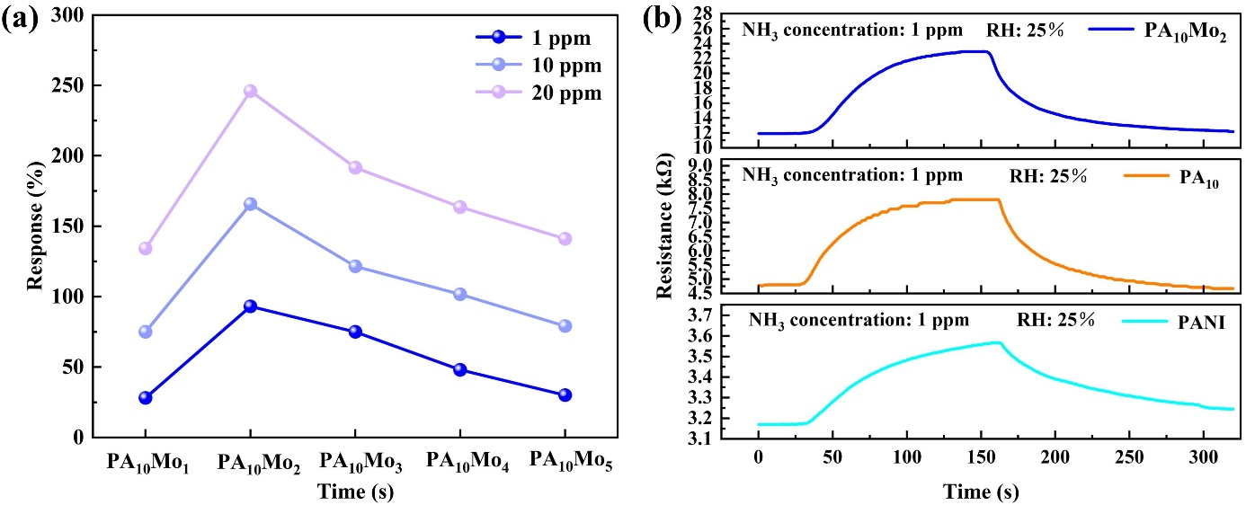
Fig. S3 (a) Ammonia response curves of PA₁₀Mo₁, PA₁₀Mo₂, PA₁₀Mo₃, PA₁₀Mo₄, PA₁₀Mo₅ at 1 ppm, 10 ppm, and 20 ppm; (b) The resistance curve of PA₁₀Mo₂, PA₁₀ and PANI for 1ppm ammonia gas.

Fig. S4 SEM images of (a) PANI; (b) PA₁₀; (c) Au in PA₁₀.

Fig. S5 (a) Full XRD Pattern of PANI; (b) XPS of Au in PANI.

Table S1 Comparison of the performances of the flexible PA₁₀Mo₂ sensor prepared in this work and the other NH₃ sensors reported recently.
Material | Method | Response (%) | T_{res}/T_{rec} | LOD | Long-term stability | Ref.
PANI/LIG | laser direct writing＋spraying | 68@60 ppm | 53/167 s | 14.6 ppb | 31 days | [15]
Au-In₂O₃@PANI | Hydrothermal+ in-situ | 46@100 ppm | 118 /144 s | 500 ppb | - | [29]
Au@SiO₂-PANI | droplet-evaporation self-assembly＋in-situ | 0.8@10 ppm | 35 /133 s | 10 ppb | 30 days | [30]
HE-MOF-1 | mild solvothermal | 55@1 ppm | 38.9/40.9 s | - | 30 days | [31]
ZP1 | in aqueous | 89@5 ppm | 31/12 s | ＜1 ppm | 60 days | [32]
PANI/WS₂ | in situ | 277@5 ppm | 108/229 s | 100 ppb | 30 days | [33]
PANI/MoS₂/SnO₂ | electrostatic spinning＋hydrothermal＋in-situ | 990@100 ppm | 21/130 s (20 ppm) | 200 ppb | 7 days | [34]
PA₁₀Mo₂ | in-situ | 92.5@1 ppm | 69/89 s | 0.45 ppb | 30 days | This work

