SUPPLEMENTARY DATA

Supplementary Figure 1
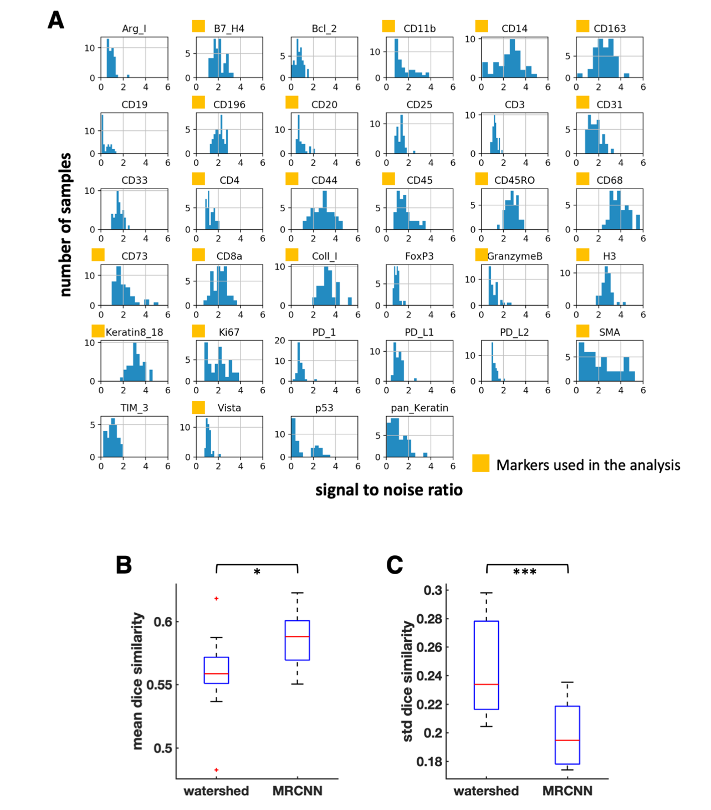

Supplementary Figure 1. Signal-to-noise ratio (SNR) of all imaging mass cytometry (IMC) markers and dice similarity comparison between watershed and mask-R-CNN. A. Histogram of SNR of IMC markers (n = 41 samples). Highlighted markers that had overall good SNR across all samples were used in the whole data analysis. B. Mean dice similarity comparison between watershed and mask-R-CNN (MRCNN) with the reference segmentation drawn manually (n = 10 images, 300 cells segmented per image on average, paired t test). C. Standard deviation of dice similarity comparison between watershed and MRCNN with the reference segmentation drawn manually (n = 10 images, 300 cells segmented per image on average, paired t test). *p < 0.05, ***p < 0.001.

Supplementary Figure 2
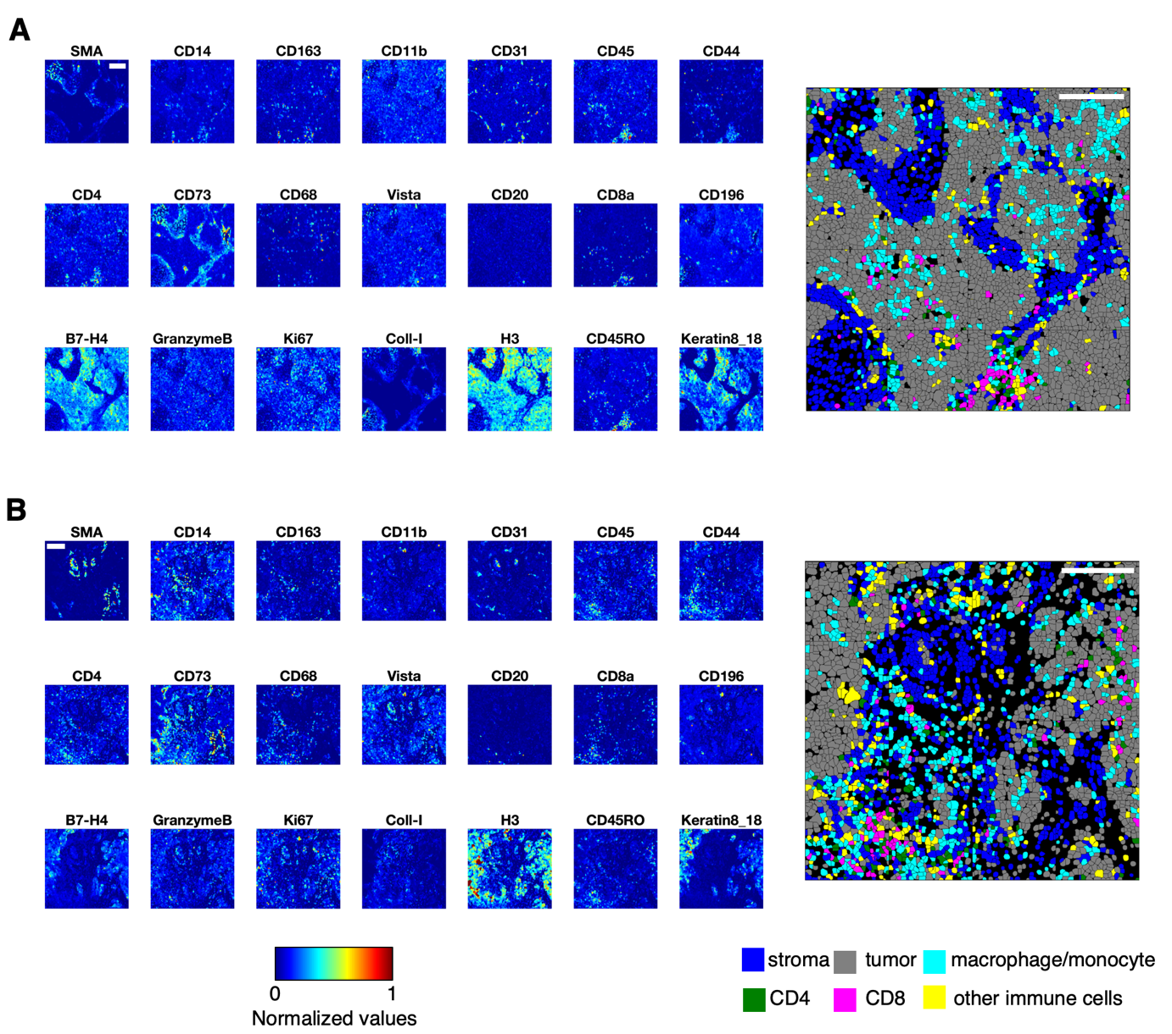

Supplementary Figure 2. Spatial distribution of representative cell subtypes from two different samples. A map of the normalized expression of each marker on the cell masks is shown on the left, and the spatial distribution of multiple cell subtypes is shown on the right. White scale bar, 200 μm. A- B. Representative samples.

Supplementary Figure 3

Supplementary Figure 3. Normalized marker expression of tumor subtypes compared with non-tumor cells. Each data point represents the median of the normalized marker expression of a group of cells for each sample. Two-sample t test, **p < 0.01. “Diff” is computed as the difference between the mean of two groups.

Supplementary Figure 4

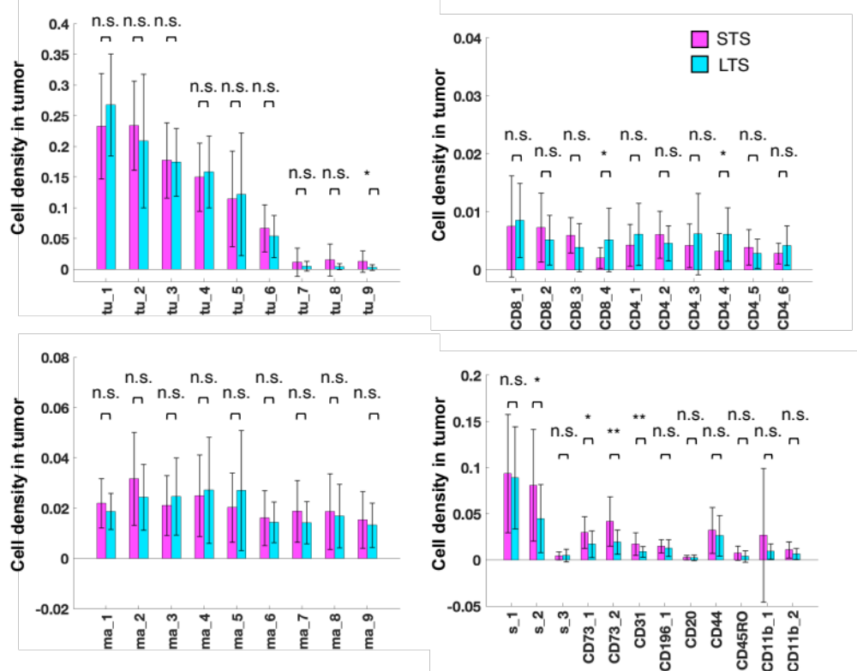

Supplementary Figure 4. Comparison of cell subtype densities in tumor-enriched regions between long-term survivors (LTS) and short-term survivors (STS). Two sample t test, * p < 0.05, ** p < 0.01, n.s. not significant.

Supplementary Figure 5

Supplementary Figure 5. Spatial distribution of pairs of cell subtypes of interest. White scale bar, 200 μm. White arrowhead, interaction between two different cell subtypes. A. Interaction between granzyme B⁺ CD8⁺ cytotoxic T cells (CD8_4) and tu_1 tumor cells. B. Interaction between CD73^{mid} cells (CD73_2) and CD163⁺ CD68⁺ CD14⁺ macrophages (ma_9). C. Interaction between CD45RO⁺ CD4⁺ memory T cells (CD4_4) and CD163⁺ CD68⁺ Vista^{mid} CD14⁺ macrophages (ma_1). D. Interaction between CD45RO⁺ CD44⁺ CD8⁺ memory T cells (CD8_3) and CD163⁺ CD14^{mid} macrophages (ma_8) macrophages.

Supplementary Figure 6
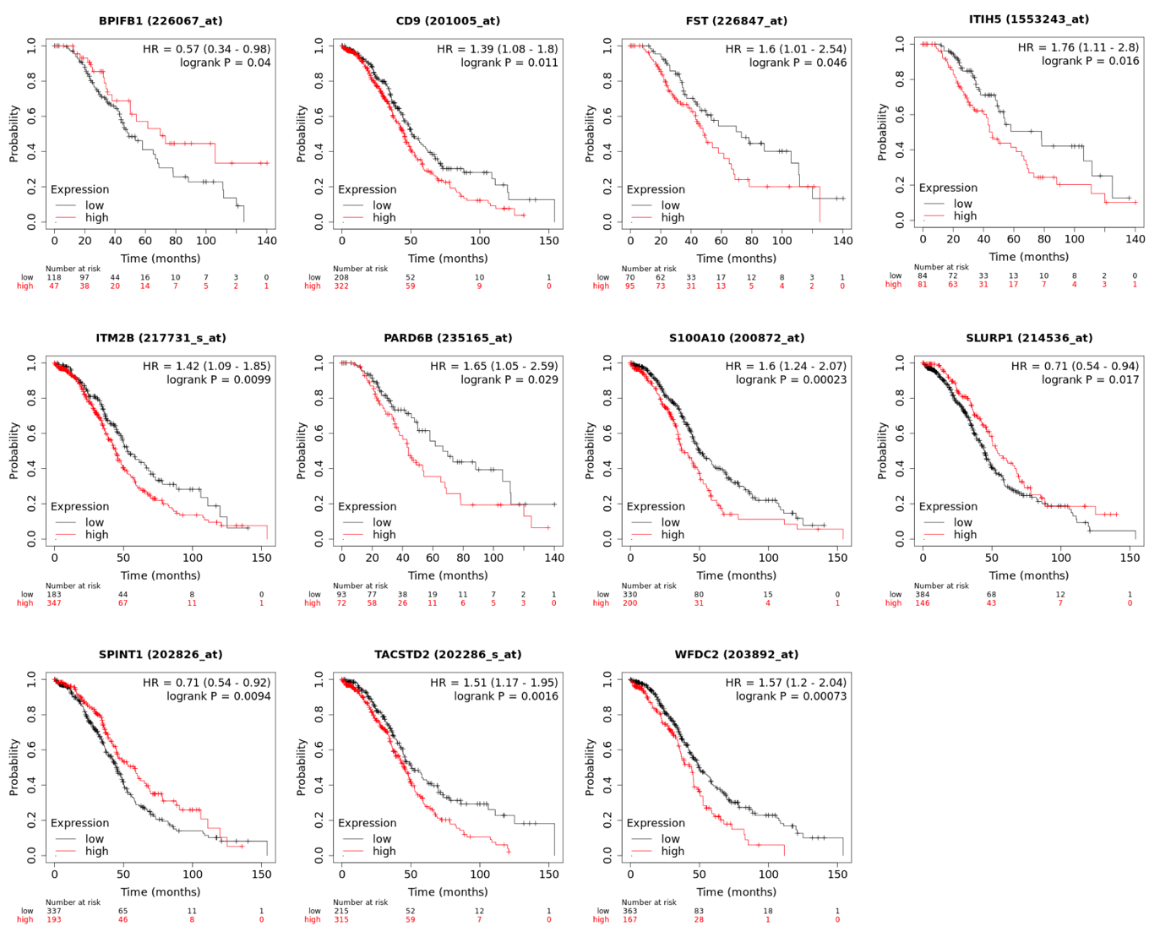

Supplementary Figure 6. Kaplan-Meier plots of various genes of interest in the microdissected epithelial component of high-grade serous ovarian cancer. HR, hazard ratio.

Supplementary Figure 7
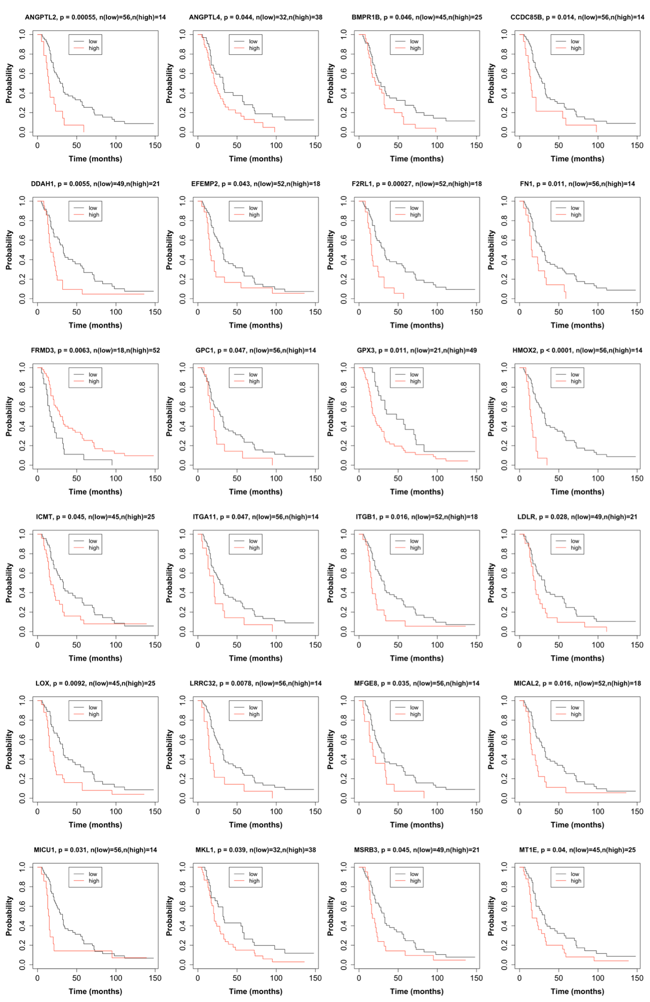
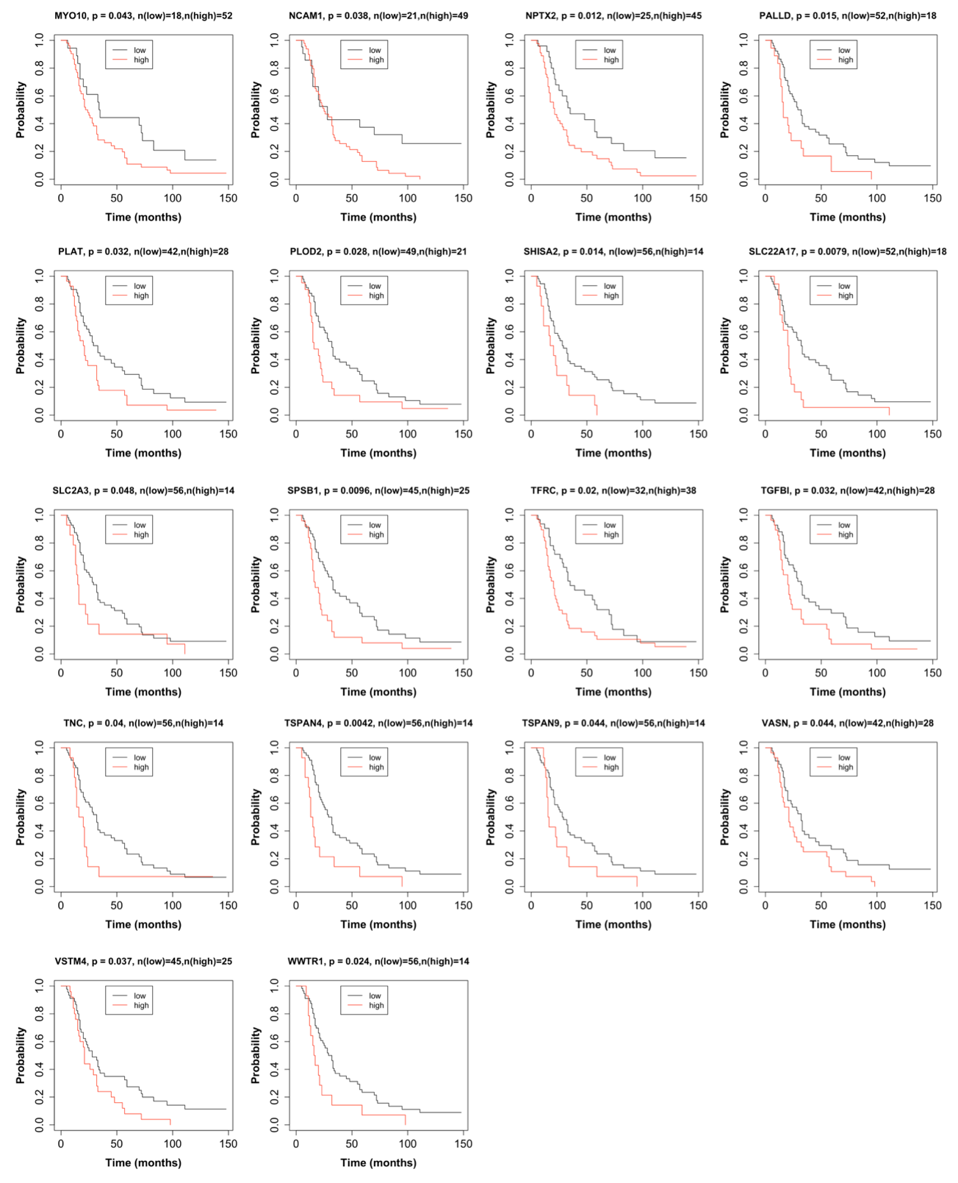

Supplementary Figure 7. Kaplan-Meier plots of various genes of interest in the microdissected fibroblastic component of high-grade serous ovarian cancer.

Supplementary Table 1. Clinicopathologic characteristics of samples used in the study

Variable | LTS | STS | p*
Total number of samples | 21 | 20
Age |  |  | 0.013
<50 years | 7 | 2
>50 years | 14 | 18
Race |  |  | 2.5*10⁻⁵
Asian | 16 | 2
White | 5 | 18
Stage |  |  | 0.61
III | 20 | 18
IV | 1 | 2
Grade |  |  | 0.70
2 | 5 | 3
3 | 16 | 17
LTS, long-term survivors: patients survived ≥60 months.
STS, short-term survivors: patients survived ≤20 months.
*Fisher exact test (two-sided).

Supplementary Table 2. Phenotypes of imaging mass cytometry (IMC) cell subtypes

IMC cell subtype | Phenotype
ma_1 | CD163⁺ CD68⁺ Vista^{mid} CD4⁺ CD44^{mid} CD11b^{mid} CD14⁺ macrophage
ma_2 | CD14⁺ monocytes
ma_3 | CD163⁺ CD68⁺ CD4^{mid} CD44^{mid} CD14⁺ macrophage
ma_4 | CD163^{mid} CD68⁺ CD4^{mid} CD44^{mid} CD11b^{mid} CD14⁺ macrophage
ma_5 | CD68⁺ macrophage
ma_6 | CD163⁺ CD68⁺ Vista^{mid} CD4^{mid} CD44⁺ CD11b⁺ CD14⁺ macrophage
ma_7 | CD163⁺ CD68^{mid} CD4^{mid} CD14⁺ macrophage
ma_8 | CD163⁺ CD14^{mid} macrophage
ma_9 | CD163⁺ CD68⁺ CD4^{mid} CD14⁺ macrophage
CD4_1 | CD45RO⁺ CD44⁺ CD4⁺ memory T cell
CD4_2 | CD4⁺ T cell
CD4_3 | CD45RO^{mid} CD44⁺ CD4⁺ memory T cell
CD4_4 | CD45RO⁺ CD4⁺ memory T cells
CD4_5 | CD45RO^{mid} CD44^{mid} CD4⁺ memory T cell
CD4_6 | Vista^{mid} CD4⁺ T cell
CD8_1 | CD45RO⁺ CD44⁺ CD8⁺ memory T cell
CD8_2 | CD8⁺ T cell
CD8_3 | CD45RO⁺ CD44⁺ CD8⁺ memory T cell
CD8_4 | Granzyme B⁺ CD8⁺ cytotoxic T cell
tu_1 | Keratin8/18^{mid}
tu_2 | B7-H4^{mid}, Ki67⁺, Keratin8/18⁺
tu_3 | B7-H4^{mid}, Keratin8/18^{mid}
tu_4 | B7-H4⁺, Keratin8/18⁺
tu_5 | B7-H4^{mid}, Ki67^{mid}, Keratin8/18^{mid}
tu_6 | B7-H4^{mid}, Keratin8/18^{mid}
tu_7 | B7-H4⁺, Ki67^{mid}, Keratin8/18⁺
tu_8 | B7-H4^{mid}, Ki67⁺, Keratin8/18^{mid}
tu_9 | B7-H4⁺, Ki67^{mid}, Keratin8/18^{mid}
s_1 | Coll-I⁺
s_2 | SMA⁺, Coll-I^{mid}
s_3 | SMA^{mid}, CD45RO⁺
CD73_1 | CD73⁺, Coll-I^{mid}
CD73_2 | CD73^{mid}
CD31 | CD31⁺, CD73^{mid}
CD196_1 | CD11b^{mid}, CD196⁺
CD44 | CD44⁺
CD45RO | SMA⁺, CD45RO⁺, CD196^{mid}
CD20 | CD20⁺
CD11b_1 | CD11b⁺, CD45RO^{mid}
CD11b_2 | CD11b⁺, GranzymeB⁺, Vista^{mid}

Supplementary Table 3. Spearman correlations between IMC cell densities and selected genes in microdissected epithelial compartment of HGSC

Gene name | Correlated IMC feature | Correlation coefficient | p | Kaplan-Meier survival p* | Function | Reference
BPIFB1 | CD4_4 | 0.533 | 0.0050 | 0.04 | Inhibits cell migration and invasion; good prognosis | ¹⁹
CD9 | CD4_4 | -0.434 | 0.0266 | 0.011 | Cell motility, tumor metastasis, CD4⁺ T cell activation; poor prognosis in ovarian cancer | ^{21,86}
FST | CD31 | 0.493 | 0.0103 | 0.046 | Regulates autocrine endothelial cell activity and induces angiogenesis | ^{87,88}
ITIH5 | CD8_4  CD4_4 | -0.442  -0.430 | 0.0237  0.0283 | 0.016 | Tumor suppressor gene, extracellular matrix modulator, blocks T cell infiltration | ²²
ITM2B | CD4_4 | -0.426 | 0.0297 | 0.0099 | Induces apoptosis in activated T cells | ⁷⁴
PARD6B | CD31 | 0.446 | 0.0222 | 0.029 | Increases metastatic potential | ⁸⁹
S100A10 | CD73_1  CD73_2 | 0.416  0.440 | 0.0342  0.0242 | 0.0002 | Involved in tumor progression, invasion, and metastasis; poor prognosis in ovarian cancer | ⁹⁰
SLURP1 | CD4_4  CD73_2 | 0.451  -0.477 | 0.0206  0.0135 | 0.017 | Antitumor activity, regulates Ca2⁺ signaling following T cell activation | ^{23–25}
SPINT1 (HAI-1) | CD31 | -0.523 | 0.0060 | 0.0094 | Regulates metastatic invasion and tumor-immune microenvironment crosstalk; good prognosis | ^{91,92}
TACSTD2 | CD8_4 | -0.642 | 0.0004 | 0.0016 | Epithelial barrier protein, blocks T cell infiltration | ⁹³
WFDC2 (HE4) | CD8_4 | -0.529 | 0.0054 | 0.0007 | Promotes tumor growth, suppresses CD8⁺ T cell activation; increases chemoresistance in ovarian cancer | ^{72,73,94,95}
*Kaplan-Meier survival p value shown in Supp. Fig. 6.

Supplementary Table 4. Spearman correlations between imaging mass cytometry (IMC) cell densities and selected genes in the microdissected fibroblastic compartment of high-grade serous ovarian cancer (HGSC)

Gene name | Correlated IMC feature | Correlation coefficient | p | Kaplan-Meier survival p* | Function | Reference
ANGPTL2 | CD31  CD73_1  CD73_2 | 0.461  0.558  0.672 | 0.0176  0.0030  0.0001 | 0.0005 | Induces endothelial cell sprouting; CAF-derived Angptl2 promotes tumor progression | ^{45,46}
ANGPTL4 | CD31 | 0.441 | 0.0238 | 0.044 | Increases reactive oxygen species rate favoring tumor growth and decreases immune cell infiltration; poor prognosis | ⁹⁶
BMPR1B | CD4_4 | -0.508 | 0.008 | 0.046 | Decreases immune trafficking; poor prognosis | ⁷⁷
CCDC85B | CD73_1  CD73_2 | 0.497  0.599 | 0.0097  0.0012 | 0.014 | Promotes cancer cell proliferation and invasion | ²⁶
DDAH1 | CD73_2 | 0.418 | 0.0332 | 0.0055 | Associated with tumor progression and poor prognosis | ²⁷
EFEMP2 | CD73_1  CD73_2 | 0.556  0.589 | 0.0031  0.0015 | 0.043 | Promotes cancer cell growth and invasion; poor prognosis | ²⁸
F2RL1 (PAR2) | CD31  CD73_1  CD73_2 | 0.586  0.419  0.524 | 0.0016  0.0329  0.0059 | 0.0002 | Promotes cancer cell invasion and metastasis | ²⁹
FN1 | CD31  CD73_1  CD73_2 | 0.425  0.733  0.548 | 0.0303  <0.00010.0037 | 0.011 | Induces cancer and endothelial cell migration | ^{97,98}
FRMD3 | CD73_1 | -0.587 | 0.0016 | 0.0063 | Tumor suppressor | ⁹⁹
GPC1 | CD73_1  CD73_2 | 0.622  0.735 | 0.0006  <0.0001 | 0.047 | Associated with tumorigenesis and regulating angiogenesis for cancer progression and invasion | ¹⁰⁰
GPX3 | CD4_4  CD73_2 | -0.403  0.444 | 0.0406  0.0230 | 0.011 | Protects cells and enzymes from oxidative damage; poor survival in ovarian cancer | ¹⁰¹
HMOX2 (HO-1) | CD73_1  CD73_2 | 0.416  0.554 | 0.0342  0.0032 | <0.0001 | Activated by the transcription factor Nrf2, increases chemoresistance | ⁴²
ICMT | CD73_1  CD73_2 | 0.496  0.735 | 0.0098  <0.0001 | 0.045 | Increases chemoresistance in ovarian cancer | ⁴³
ITGA11 | CD73_1  CD73_2 | 0.675  0.652 | 0.0001  0.0003 | 0.047 | Receptor for collagen remodeling and cancer-associated fibroblast migration in the tumor microenvironment | ¹⁰²
ITGB1 | CD73_2 | 0.585 | 0.0016 | 0.016 | Promotes angiogenesis, tumorigenesis, and cancer progression | ³⁰
LDLR | CD31 | 0.435 | 0.0261 | 0.028 | Activates Wnt pathway, involved in cancer progression | ¹⁰³
LOX | CD31  CD73_1  CD73_2 | 0.436  0.718  0.611 | 0.0259  <0.0001  0.0008 | 0.0092 | Driver of tumor migration and angiogenesis; poor prognosis in ovarian cancer | ^{31,104}
LRRC32 (GARP) | CD73_1  CD73_2 | 0.586  0.651 | 0.0016  0.0003 | 0.0078 | Regulates TGF-β, which drives cancer-associated fibroblast formation, and inhibits cytotoxicity of CD8⁺ T cells | ^{52,76}
MFGE8 | CD31  CD73_1  CD73_2 | 0.643  0.649  0.459 | 0.0003  0.0003  0.0183 | 0.035 | Increases VEGF and ET-1 levels; enhances M2 polarization of macrophages and promotes tumor angiogenesis | ^{32,33}
MICAL2 | CD31  CD73_1  CD73_2 | 0.439  0.604  0.629 | 0.0246  0.0010  0.0005 | 0.016 | Accelerates tumor progression by regulating cell proliferation and epithelial-mesenchymal transition | ³⁴
MICU1 | CD73_1  CD73_2 | 0.558  0.676 | 0.0030  0.0001 | 0.031 | Increases chemoresistance; poor survival in ovarian cancer | ¹⁰⁵
MKL1 | CD73_1  CD73_2 | 0.598  0.613 | 0.0012  0.0008 | 0.039 | Promotes ovarian cancer cell migration and invasion | ¹⁰⁶
MSRB3 | CD73_1  CD73_2 | 0.420  0.653 | 0.0323  0.0002 | 0.045 | Increases tumorigenesis in ovarian cancer | ³⁵
MT1E | CD31  CD73_1  CD73_2 | 0.459  0.586  0.587 | 0.0182  0.0016  0.0016 | 0.04 | Poor prognosis in ovarian cancer | ¹⁰⁷
MYO10 | CD4_4 | -0.551 | 0.0034 | 0.043 | Regulates cancer-associated fibroblast rigidity | ^{49,50}
NCAM1 | CD4_4  TU_9 | -0.410  0.424 | 0.0374  0.0306 | 0.038 | Stimulates ovarian cancer cell migration and invasion | ³⁶
NPTX2 | CD4_4  CD73_2 | -0.424  0.527 | 0.0306  0.0055 | 0.012 | Promotes cancer growth | ³⁷
PALLD | CD73_1  CD73_2 | 0.631  0.715 | 0.0005  <0.0001 | 0.015 | Induces activation of stromal fibroblasts, cell migration, and invasion through epithelial-mesenchymal transition | ¹⁰⁸
PLAT (tPA) | CD73_1  CD73_2 | 0.507  0.643 | 0.0081  0.0003 | 0.032 | Poor prognosis in ovarian cancer | ³⁸
PLOD2 | CD73_1  CD73_2 | 0.636  0.544 | 0.0004  0.0040 | 0.028 | Expressed in cancer-associated fibroblasts, promotes tumor cell invasion and migration | ⁴⁸
SHISA2 | CD73_2 | 0.535 | 0.0047 | 0.014 | Regulates WNT5A; enhances cancer aggressive phenotype | ¹⁰⁹
SLC22A17 | CD73_1  CD73_2 | 0.458  0.422 | 0.0184  0.0313 | 0.0079 | Receptor for LCN2; poor prognosis | ¹¹⁰
SLC2A3 (GLUT3) | CD73_1  CD73_2 | 0.703  0.562 | <0.0001  0.0027 | 0.048 | Promotes tumor cell proliferation; poor prognosis in ovarian cancer | ^{39,111}
SPSB1 | CD73_1  CD73_2 | 0.511  0.459 | 0.0075  0.0183 | 0.0096 | Increases proliferation and migration of ovarian cancer cells | ⁴⁰
TFRC (CD71) | CD73_2 | 0.400 | 0.0427 | 0.02 | Enhances the rate of c-Myc-mediated tumor formation | ^{112,113}
TGFBI | CD73_1  CD73_2 | 0.516  0.704 | 0.0069  <0.0001 | 0.032 | Produced by tissue-associated macrophages, increases HGSC cell migration | ⁷⁵
TNC | CD73_1  CD73_2 | 0.574  0.613 | 0.0021  0.0008 | 0.04 | Produced by TAM, increases HGSC cell migration | ^{55,56,75}
TSPAN4 | CD73_1  CD73_2 | 0.533  0.559 | 0.0050  0.0029 | 0.042 | Poor prognosis | ¹¹⁴
TSPAN9 | CD73_1  CD73_2 | 0.482  0.713 | 0.0125  <0.0001 | 0.044 | Chemoresistance; poor prognosis | ⁴⁴
VASN | CD73_1  CD73_2 | 0.562  0.611 | 0.0027  0.0009 | 0.044 | Stimulates tumor progression and angiogenesis | ⁴¹
VSTM4 | CD4_4 | -0.429 | 0.0286 | 0.037 | Negative regulator of T cells | ⁵¹
WWTR1 (TAZ) | CD4_4  CD73_2 | -0.589  0.479 | 0.0015  0.0132 | 0.024 | In stromal cells, triggers effects with positive feedback on the growth of tumor cells | ⁴⁷
*Kaplan-Meier survival p value shown in Supp. Fig. 7.

SUPPLEMENTARY REFERENCES
86. Ikeyama, S., Koyama, M., Yamaoko, M., Sasada, R. & Miyake, M. Suppression of cell motility and metastasis by transfection with human motility-related protein (MRP-1/CD9) DNA. J. Exp. Med. 177, 1231–1237 (1993).
87. Janik, S. et al. Follistatin impacts Tumor Angiogenesis and Outcome in Thymic Epithelial Tumors. Sci. Rep. 9, 17359 (2019).
88. Kozian, D. H., Ziche, M. & Augustin, H. G. The activin-binding protein follistatin regulates autocrine endothelial cell activity and induces angiogenesis. Lab. Investig. J. Tech. Methods Pathol. 76, 267–276 (1997).
89. Cunliffe, H. E., Jiang, Y., Fornace, K. M., Yang, F. & Meltzer, P. S. PAR6B is required for tight junction formation and activated PKCζ localization in breast cancer. Am. J. Cancer Res. 2, 478–491 (2012).
90. Noye, T. M., Lokman, N. A., Oehler, M. K. & Ricciardelli, C. S100A10 and Cancer Hallmarks: Structure, Functions, and its Emerging Role in Ovarian Cancer. Int. J. Mol. Sci. 19, (2018).
91. Oberst, M. D. et al. Expression of the serine protease matriptase and its inhibitor HAI-1 in epithelial ovarian cancer: correlation with clinical outcome and tumor clinicopathological parameters. Clin. Cancer Res. Off. J. Am. Assoc. Cancer Res. 8, 1101–1107 (2002).
92. Gómez-Abenza, E. et al. Zebrafish modeling reveals that SPINT1 regulates the aggressiveness of skin cutaneous melanoma and its crosstalk with tumor immune microenvironment. J. Exp. Clin. Cancer Res. 38, 405 (2019).
93. Salerno, E. P. et al. Human melanomas and ovarian cancers overexpressing mechanical barrier molecule genes lack immune signatures and have increased patient mortality risk. Oncoimmunology 5, (2016).
94. Bertin, S. et al. Dual Specificity Phosphatase 6 (DUSP6) regulates CD4+ T cell functions and restrains the spontaneous colitis in IL-10 deficient mice. Mucosal Immunol. 8, 505–515 (2015).
95. Hsu, W.-C. et al. DUSP6 mediates T cell receptor-engaged glycolysis and restrains TFH cell differentiation. Proc. Natl. Acad. Sci. 115, E8027–E8036 (2018).
96. La Paglia, L. et al. Potential Role of ANGPTL4 in the Cross Talk between Metabolism and Cancer through PPAR Signaling Pathway. PPAR Research vol. 2017 e8187235 https://www.hindawi.com/journals/ppar/2017/8187235/ (2017).
97. Lou, X. et al. SOX2 Targets Fibronectin 1 to Promote Cell Migration and Invasion in Ovarian Cancer: New Molecular Leads for Therapeutic Intervention. OMICS J. Integr. Biol. 17, 510–518 (2013).
98. Zou, L., Cao, S., Kang, N., Huebert, R. C. & Shah, V. H. Fibronectin Induces Endothelial Cell Migration through β1 Integrin and Src-dependent Phosphorylation of Fibroblast Growth Factor Receptor-1 at Tyrosines 653/654 and 766. J. Biol. Chem. 287, 7190–7202 (2012).
99. Haase, D. et al. FRMD3, a novel putative tumour suppressor in NSCLC. Oncogene 26, 4464–4468 (2007).
100. Wang, S., Qiu, Y. & Bai, B. The Expression, Regulation, and Biomarker Potential of Glypican-1 in Cancer. Front. Oncol. 9, (2019).
101. Worley, B. L. et al. GPx3 supports ovarian cancer progression by manipulating the extracellular redox environment. Redox Biol. 25, 101051 (2019).
102. Zeltz, C. et al. α11β1 Integrin is Induced in a Subset of Cancer-Associated Fibroblasts in Desmoplastic Tumor Stroma and Mediates In Vitro Cell Migration. Cancers 11, (2019).
103. Roslan, Z., Muhamad, M., Selvaratnam, L. & Ab-Rahim, S. The Roles of Low-Density Lipoprotein Receptor-Related Proteins 5, 6, and 8 in Cancer: A Review. Journal of Oncology vol. 2019 e4536302 https://www.hindawi.com/journals/jo/2019/4536302/ (2019).
104. Baker, A.-M. et al. Lysyl oxidase plays a critical role in endothelial cell stimulation to drive tumor angiogenesis. Cancer Res. 73, 583–594 (2013).
105. Chakraborty, P. K. et al. MICU1 drives glycolysis and chemoresistance in ovarian cancer. Nat. Commun. 8, 14634 (2017).
106. Xu, W., Xu, H., Fang, M., Wu, X. & Xu, Y. MKL1 links epigenetic activation of MMP2 to ovarian cancer cell migration and invasion. Biochem. Biophys. Res. Commun. 487, 500–508 (2017).
107. Si, M. & Lang, J. The roles of metallothioneins in carcinogenesis. J. Hematol. Oncol.J Hematol Oncol 11, (2018).
108. Brentnall, T. A. et al. Arousal of Cancer-Associated Stroma: Overexpression of Palladin Activates Fibroblasts to Promote Tumor Invasion. PLoS ONE 7, (2012).
109. Tamura, K. et al. SHISA2 enhances the aggressive phenotype in prostate cancer through the regulation of WNT5A expression. Oncol. Lett. 14, 6650–6658 (2017).
110. Miyamoto, T. et al. Lipocalin 2 Enhances Migration and Resistance against Cisplatin in Endometrial Carcinoma Cells. PLoS ONE 11, (2016).
111. Masin, M. et al. GLUT3 is induced during epithelial-mesenchymal transition and promotes tumor cell proliferation in non-small cell lung cancer. Cancer Metab. 2, 11 (2014).
112. O’Donnell, K. A. et al. Activation of Transferrin Receptor 1 by c-Myc Enhances Cellular Proliferation and Tumorigenesis. Mol. Cell. Biol. 26, 2373–2386 (2006).
113. Shen, Y. et al. Transferrin receptor 1 in cancer: a new sight for cancer therapy. Am. J. Cancer Res. 8, 916–931 (2018).
114. Qi, W. et al. Tetraspanin family identified as the central genes detected in gastric cancer using bioinformatics analysis. Mol. Med. Rep. 18, 3599–3610 (2018).

