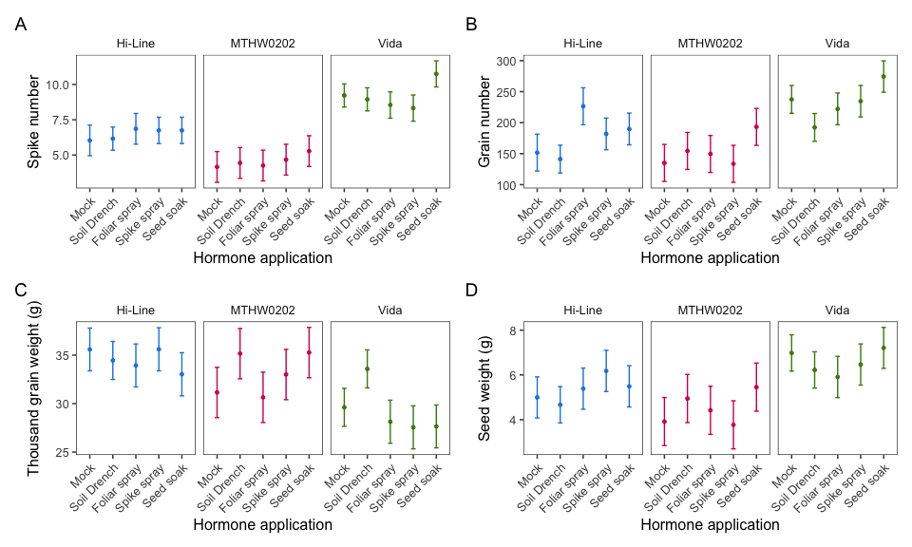
Fig. S1. Vida produces more spikes and more grain.
Three varieties of hard red spring wheat were examined for A) spike number and B) grain number, C) thousand grain weight (g), and D) seed weight per plant, across 3-5 biological replicates. The points indicate the estimated marginal means, and the errors bars are the standard errors of the estimated marginal means. Blue indicates the genotype Hi-Line, magenta indicates MTHW0202, and green indicates Vida.
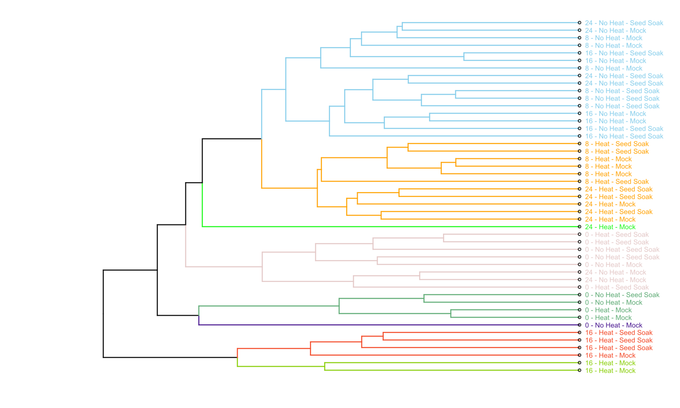
Fig. S2. Hierarchical clustering of different timepoints, stress conditions and BR seek soak treatment. Euclidean distances of counts per million of the expressed genes were used to calculate distances and average linkage hierarchical clustering was performed. Tree was colored according to the division into eight clusters.

Fig. S3. Progression of heat stress dynamically affects specific gene functions. A semantic similarity matrix displays k-means clustered GO terms enriched for downregulated genes at timepoints 8, 16, and 24 hours after heat stress. The word clouds display the words associated with each cluster with word size reflecting the frequency of the word in the cluster. The heatmap displays the significance (p-adjusted) of contribution of each GO term to the cluster with the bar graph displaying the count of GO terms contributing to the cluster from each timepoint.
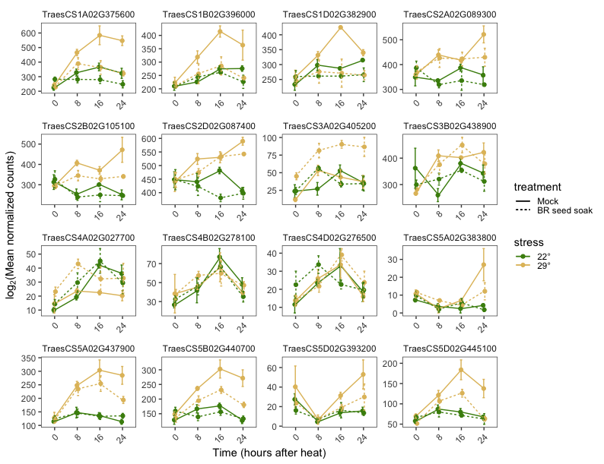
Figure S4. Time, BR and heat gene expression profiles varied across HsfA2 homologs. Normalized, log₂-transformed RNA-seq counts from the developing wheat head are shown for sixteen annotated HsfA2 across mock and BR seed soak treatments hours after plants were subjected to control or heat stress conditions.

