Supplemental Figures
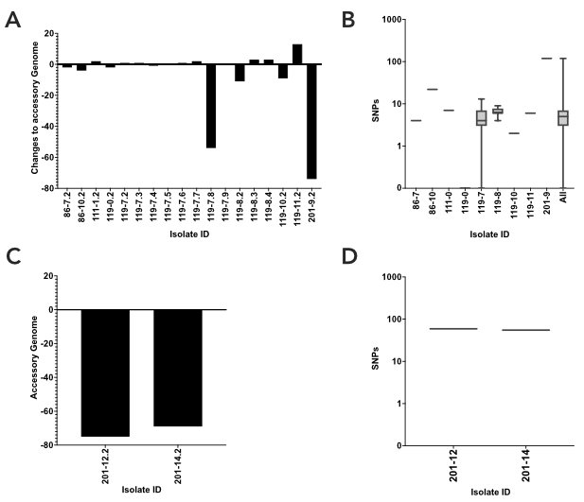
Figure S1. Analyses of accessory genomes and single nucleotide polymorphisms (SNPs) from co-isolated strains. A) Analysis of the changes in the accessory genome of isolates from within a participant collected at the same time point – termed co-isolates. Changes in the accessory genomes are shown as changes from the reference isolates: a positive number indicates a gain of genes, a negative number denotes a loss of genes, and a value of 0 represents no change. Co-isolate accessory genome changes compared to the isolate selected for future analysis include: 86-7 (n=2, 1 comparison), 86-10 (n=2, 1 comparison), 111-0 (n=2, 1 comparison), 119-0 (n=2, 1 comparison), 119-7 (n=9, 8 comparisons), 119-8 (n=4, 3 comparisons), 119-10 (n=2, 1 comparison), 119-11 (n=2, 1 comparison), and 201-9 (n=2, 1 comparison). B) SNP analyses of co-isolates from (A) including: 86-7 (n=2, 1 comparison), 86-10 (n=2, 1 comparison), 111-0 (n=2, 1 comparison), 119-0 (n=2, 1 comparison), 119-7 (n=9, 71 comparisons), 119-8 (n=4, 12 comparisons), 119-10 (n=2, 1 comparison), 119-11 (n=2, 1 comparison), and 201-9 (n=2, 1 comparison). C) Analysis of the changes in the accessory genome of the methicillin susceptible S. aureus (MSSA) co-isolates from NHR 201 – 201-12.2 (n=2, 1 comparison) and 201-14.2 (n=2, 1 comparison) – using the methicillin resistant S. aureus (MRSA) isolate as the reference. D) SNP analyses of MRSA and MSSA co-isolates from NHR 201 collected at the same collection time point from C. Box and whisker plots display the median as a solid bar within the interquartile range (IQR) box, with the whiskers representing the range.
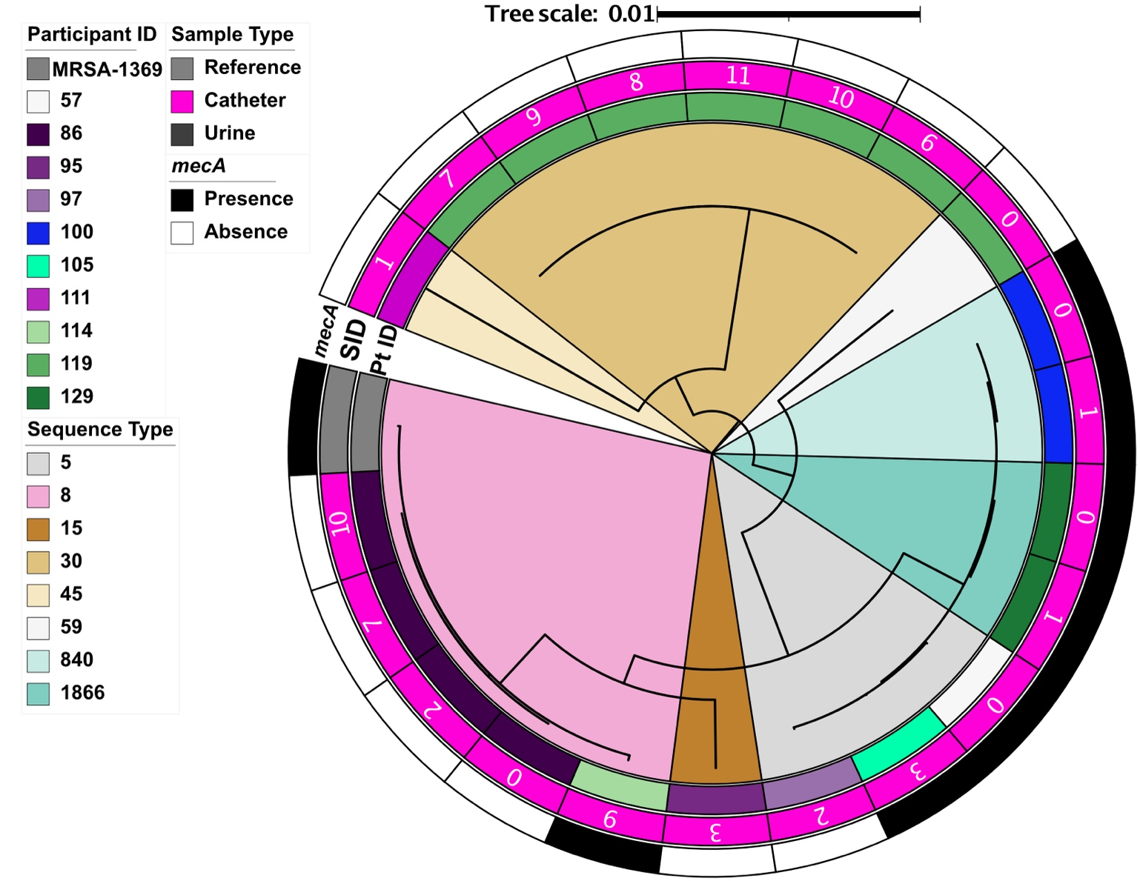
Figure S2. Phylogenetic tree of urology outpatient (UP) isolates with the well characterized MRSA-1369 used to root the tree. The participant ID (PT ID), sample type and collection time point (SID), and the presence or absence of mecA (mecA) are denoted starting from the inner and moving to the outer rings. The multi-locus sequence type (ST) is denoted in the within the branches of the tree.

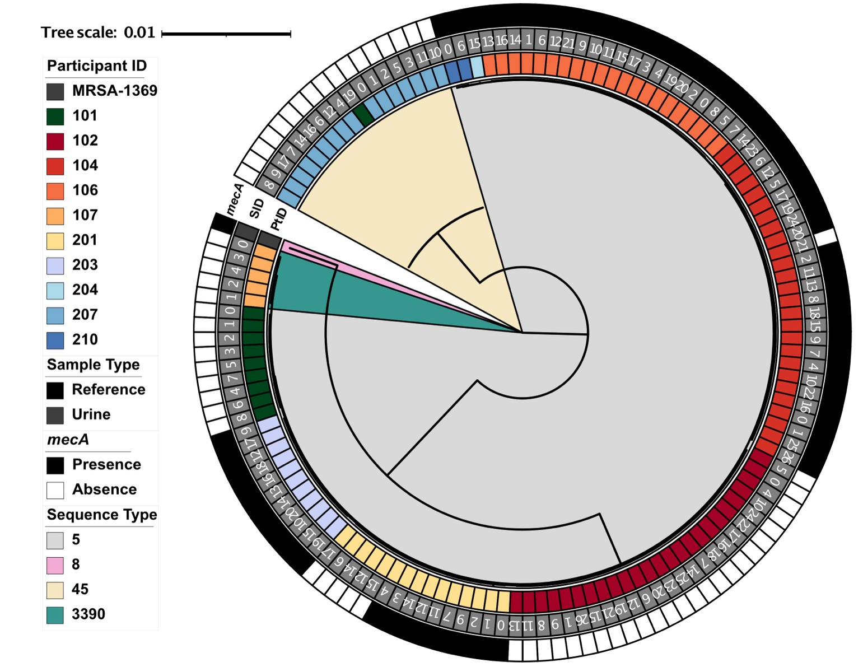
Figure S3. Phylogenetic tree of nursing home resident (NHR) isolates with the well characterized MRSA-1369 used to root the tree. The participant ID (PT ID), sample type and collection time point (SID), and the presence or absence of mecA (mecA) are denoted starting from the inner and moving to the outer rings. The multi-locus sequence type (ST) is denoted in the within the branches of the tree.

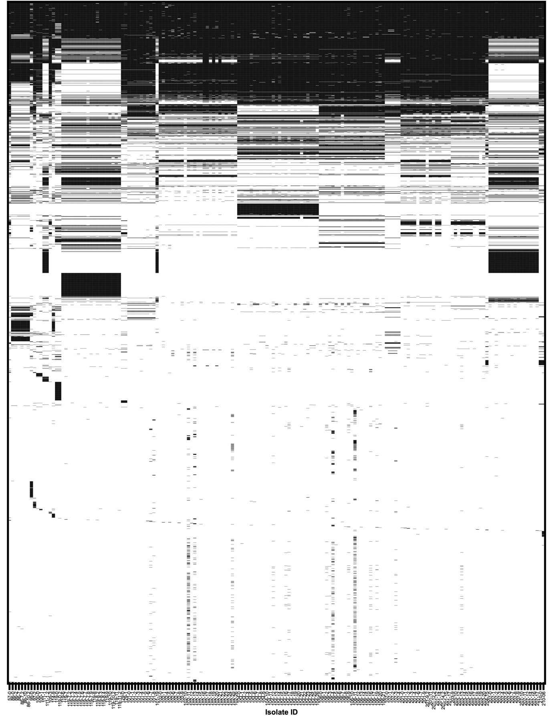

Figure S4. Accessory genomes of longitudinal S. aureus isolates. Strain ID is shown along the x-axis, and accessory gene presence (black) or absence (white) are shown vertically. Full list of genes in the accessory genome can be found in Supplemental Table S4.
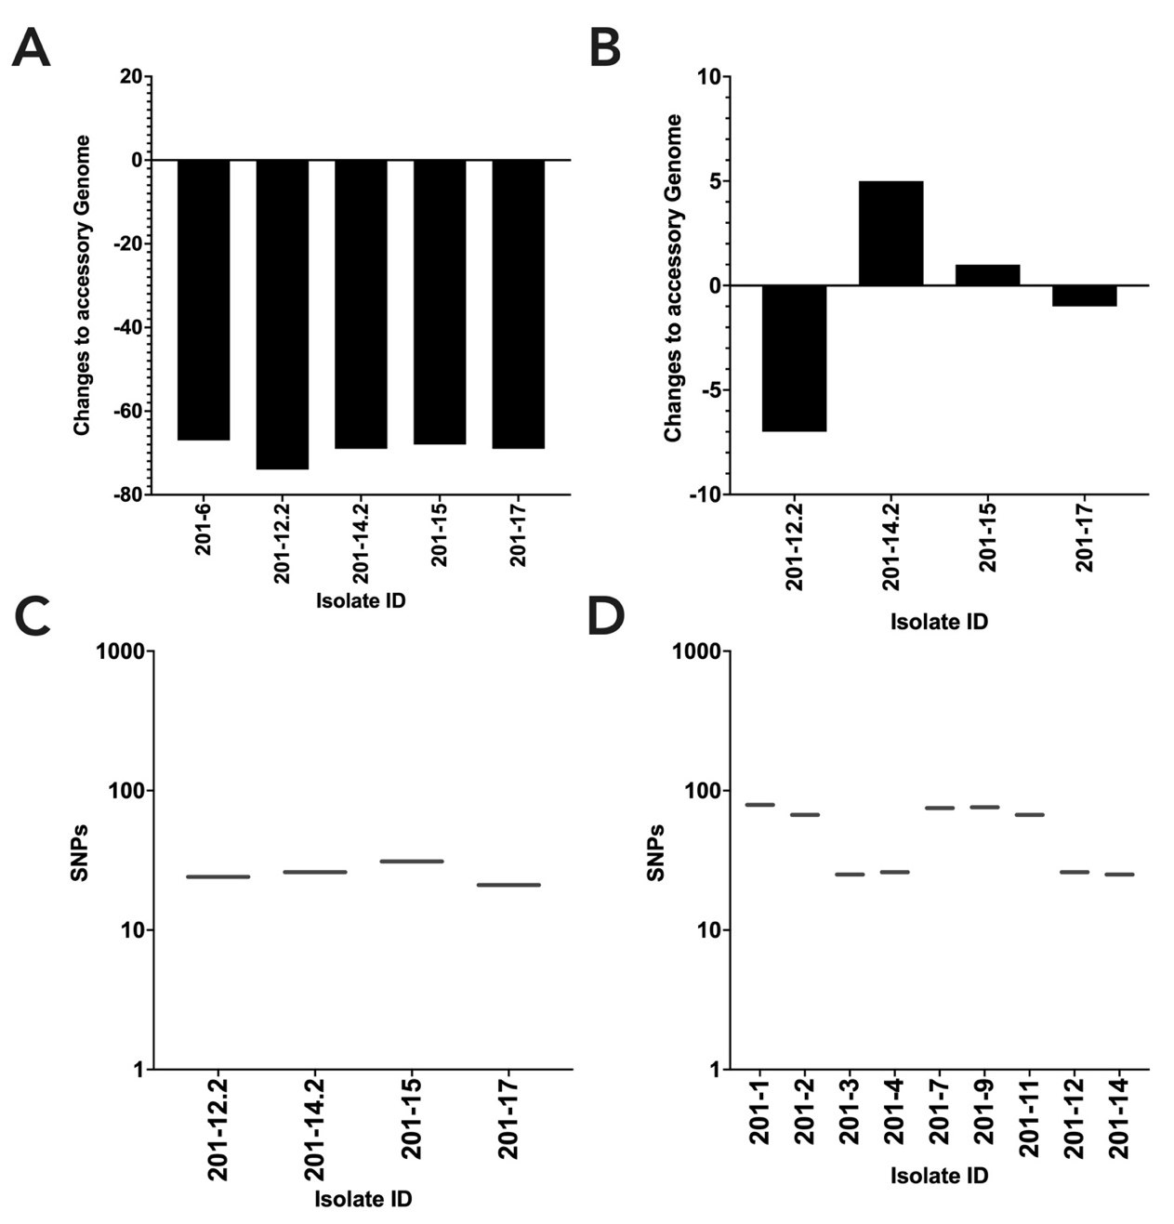
Figure S5. Single nucleotide polymorphism (SNP) and accessory genome analyses of NHR 201 methicillin susceptible S. aureus (MSSA) longitudinal isolates. A) Analysis of the changes in the accessory genome of the MSSA isolates compared to the methicillin resistant S. aureus (MRSA) index isolate 201-0: 201-6, 201-12.2, 201-14.2, 201-15, 201-17. Changes in the accessory genomes are shown as changes from the reference isolates: a positive number indicates a gain of genes, a negative number denotes a loss of genes, and a value of 0 represents no change. B) Analysis of the changes in the accessory genome of the MSSA isolates compared to the MSSA index isolate 201-6: 201-12.2, 201-14.2, 201-15, 201-17. C) SNP analyses of isolates from NHR 201 comparing the index MSSA isolate (201-6) to the rest of the MSSA isolates: 201-12.2 (n=2, 1 comparison), 201-14.2 (n=2, 1 comparison), 201-15 (n=2, 1 comparison), 201-17 (n=2, 1 comparison). D) SNP analyses of isolates from NHR 201 comparing the index MRSA isolate (201-0) to the rest of the MRSA isolates: 201-1 (n=2, 1 comparison), 201-2 (n=2, 1 comparison), 201-3 (n=2, 1 comparison), 201-7 (n=2, 1 comparison), 201-9 (n=2, 1 comparison), 201-11 (n=2, 1 comparison), 201-12 (n=2, 1 comparison), and 201-14 (n=2, 1 comparison. Box and whisker plots display the median as a solid bar within the interquartile range (IQR) box, with the whiskers representing the range.
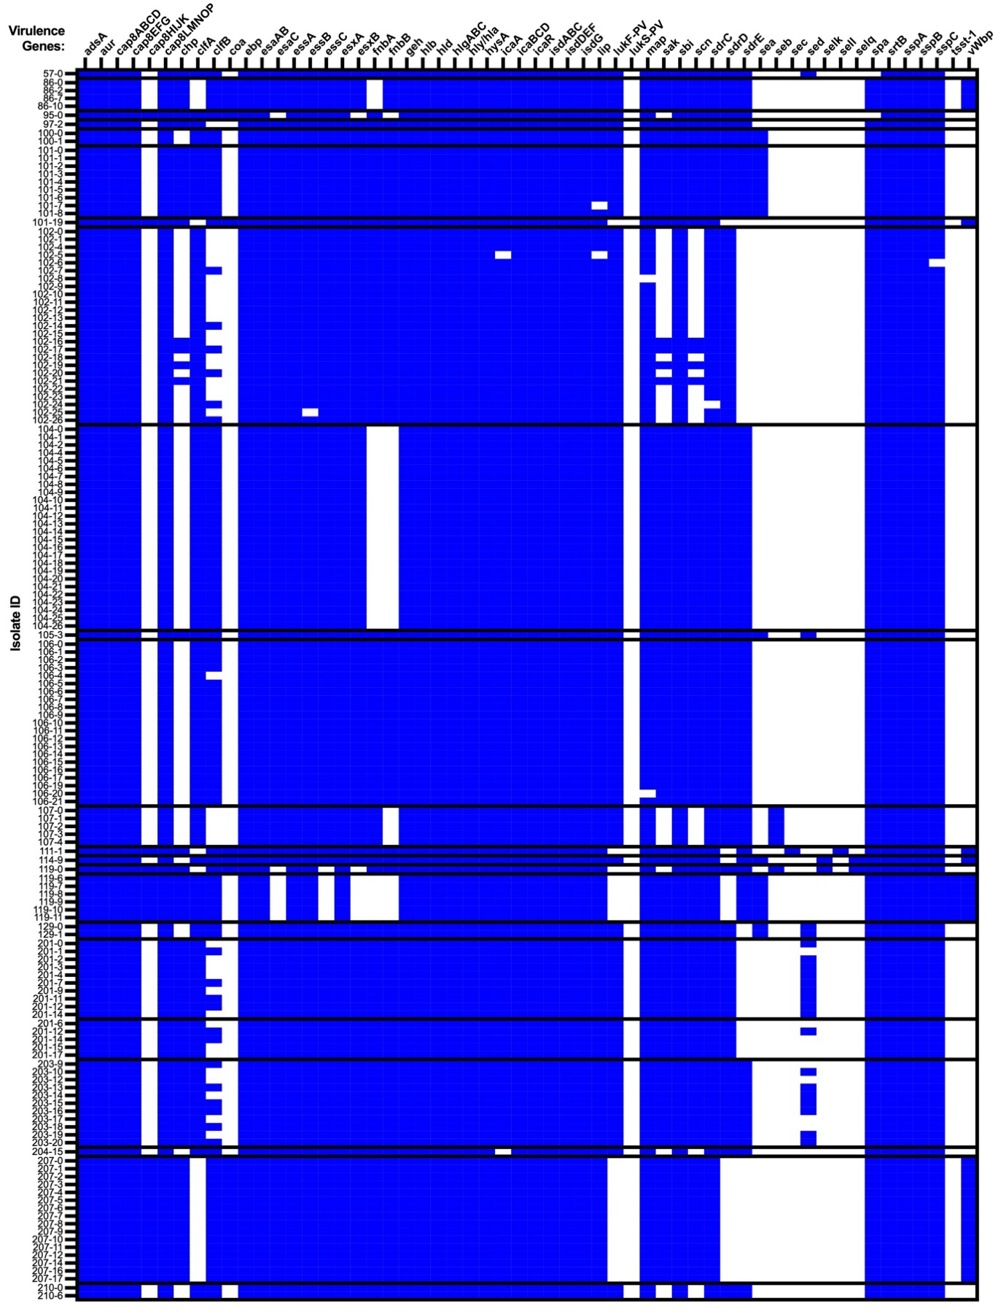
Figure S6. Virulence factor profiles of longitudinal S. aureus isolates. Virulence factors are shown on top x-axis and clinical isolates, organized by participant and chronologically, are shown on the left y-axis. Isolates with ST changes or different methicillin resistance profiles were organized separately.

