Inventory of Supporting Information
- Extended Data Figures and Legends

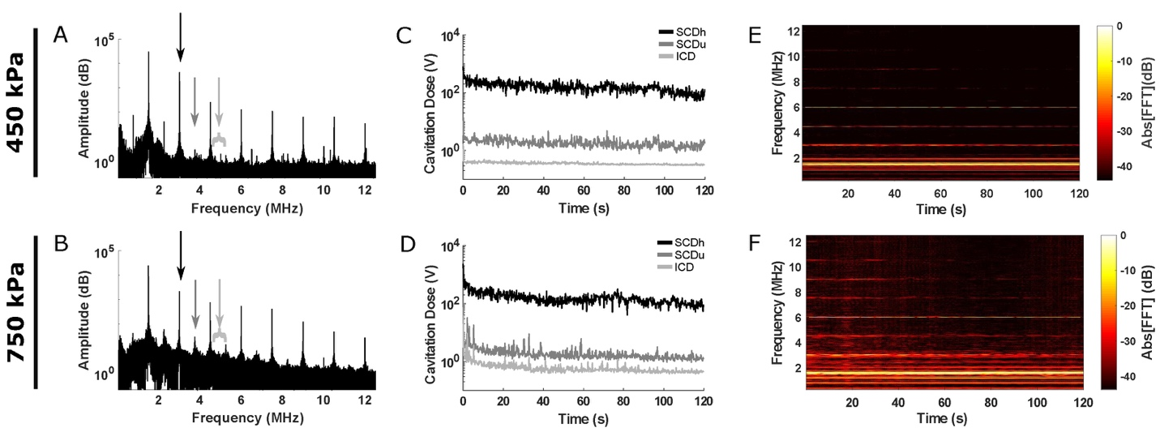

Extended Data Figure 1. Increased ultra-harmonic and inertial cavitation at 750 kPa are confirmed by in vivo monitoring of passive cavitation. (A, B) The spectral amplitude for a single FUS pulse at 450 kPa (A) and 750 kPa (B) with black arrows indicating harmonic peaks (black arrow; nfc, n=1, 2… 6, fc=1.5 MHz), dark gray arrows indicating ultra-harmonic peaks (dark gray arrow; nfc/2, n=3, 5, 7, 9), and inertial cavitation defined as the broadband signal between harmonic and ultra-harmonic peaks (light gray). An increased amplitude of the ultra-harmonic peaks and broadband signal is seen at 750 kPa (B). (C, D) Sample traces of stable harmonic cavitation levels (SCDh, black), stable ultra-harmonic levels (SCDu, dark gray), and inertial cavitation levels (ICD, light gray) throughout the FUS sonication period (120 seconds) at 450 kPa (C) and 750 kPa (D). At 450 kPa, SCDu and ICD levels remain constant over the duration of the sonication, and there is a slight decrease in SCDh cavitation dose over time (C). At 750 kPa, both SCDu and ICD are highest at the beginning of the FUS sonication slowly reaching a plateau, suggesting some microbubble collapse (D). The inertial cavitation dose remains higher throughout the sonication at 750 kPa compared to 450 kPa. (E, F) Spectrograms for the sonication period (120 s) at 450 kPa (E) and 750 kPa (F). Broadband emissions indicated by signal intensity between harmonic and ultra-harmonic values are absent at 450 kPa (E), but present throughout the sonication period at 750 kPa (F).

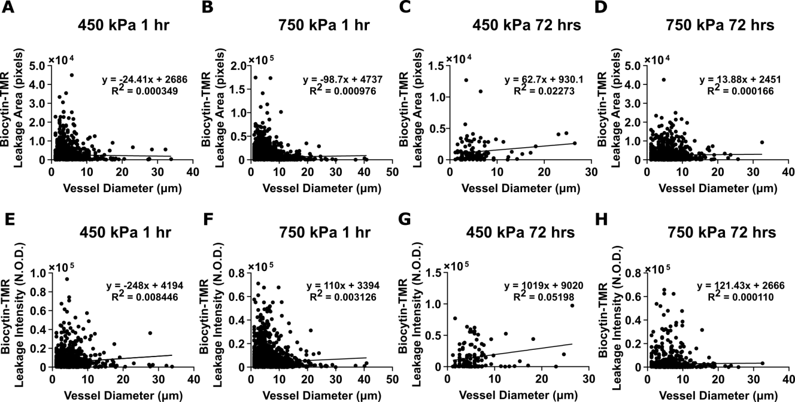

Extended Data Figure 2. The vessel diameter is a poor predictor of the area and the intensity of tracer leakage in either low or high pressures at 1 and 72 hours post-FUS-BBBO with 1.5 MHz frequency. (A-D) Plots of the vessel diameter (X axis; μm) versus the biocytin-TMR tracer leakage area (Y axis) with the linear regression equation (formula and line) after 1 hour at 450 kPa (A; R² = 0.000349) and 750 kPa (B; R² = 0.000976; *p<0.05, one way ANOVA) and 72 hours at 450 kPa (C; R² = 0.02273) and 750 kPa (D; R² =0.000166). (E-H) Plots of the vessel diameter (X axis; μm) versus the biocytin-TMR tracer leakage intensity (Y axis) with linear regression (formula and line) after 1 hour at 450 kPa (E; R² = 0.008446, ***p<0.001, ANOVA) and 750 kPa (F; ****p<0.0001, R² = 0.003126) or 72 hours at 450 kPa (G; *p<0.05, R² = 0.05198) and 750 kPa (H; R² =0.000110). For these dataset, the number of mice at 1 hour is N = 4 (n = 1387 vessels for 450 kPa and n = 4981 vessels for 750 kPa) and at 72 hours is N = 4 (n = 118 vessels for 450 kPa) and N = 5 (n = 940 vessels at 750 kPa). The slope of the linear regression was significantly different from zero for the vessel diameter versus the biocytin-TMR leakage area at 1 hour for 750 kPa (C), the vessel diameter versus the biocytin-TMR leakage intensity at 1 hour for 450 kPa and 750 kPa (E, F), and at 72 hours for 450 kPa. (G). Overall, the low R² values of linear regression for all conditions suggest that vessel diameter is a poor predictor of vessel leakage for both pressures and time points analyzed in this study.

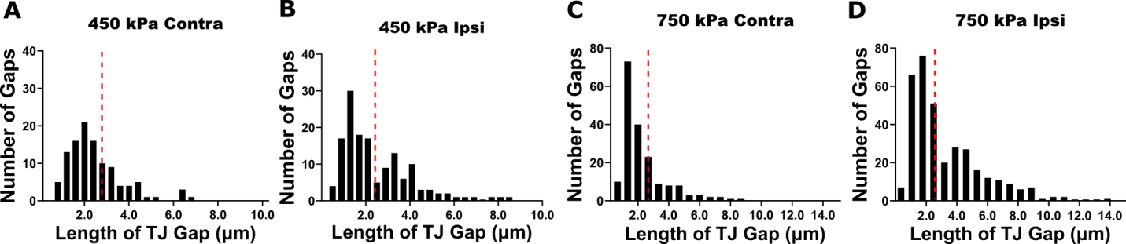

Extended Data Figure 3. Quantification of blood-brain barrier tight junction gap length one hour after FUS-BBBO with 1.5 MHz frequency across blood vessels reveals a significant difference at the unsafe, high pressure. (A-D) Histograms of the number of the blood-brain barrier tight junction strands with gaps (Y axis) plotted over tight junction gap lengths (X axis; µm) across CNS vessel types for all mice for 450 kPa (A, B) and 750 kPa (C, D) in the contralateral (A, C) and ipsilateral (B, D) hemispheres. On the contralateral hemisphere, 75% of the data are clustered below 2.9 μm at 450 kPa (red line) and 2.2 μm at 750 kPa (red line). Tight junction strands with gaps > 2.5 μm in length were chosen as the cutoff for abnormal gap length in both datasets. Both 450 kPa and 750 kPa show a clear bimodal distribution in the length of tight junction gaps. The number of mice is N = 4 (450 kPa) and N = 5 (750 kPa) at 1 hour and the number of vessels is n = 254 (450 kPa) and n = 526 (750 kPa).

Extended Data Figure 4. Persistent structural abnormalities in arteriole tight junctions visualized by confocal microscopy correlate with continuous BBB opening at the unsafe, high pressure. (A-D”; G-J”) Maximum intensity projection images of arteriole tight junctions (green) and biocytin-TMR tracer leakage (red) obtained from 25µm-thick caudate putamen sections of Tg::eGFP-Claudin5^{+/-} mice at 1 hour (A-D”) and 72 hours (G-J”) after 1.5 MHz FUS-BBBO sonication at 450 kPa (A-D”) and 750 kPa (G-J”) pressures in contralateral and ipsilateral hemispheres. eGFP (green) labels BBB tight junctions. Biocytin-TMR tracer leakage (red) is seen exclusively in the brain parenchyma of the FUS-BBBO sonicated hemisphere. TJ strand gaps are shown with white arrowheads. (E-F) Quantification of the fraction of TJ strands containing gaps between 0.4-2.5 µm (E) and > 2.5 µm (F) at 450 kPa and 750 kPa one hour after FUS-BBBO. The fraction of TJ strands with gaps > 2.5 µm is significantly different between the ipsilateral and contralateral hemispheres at 750 kPa (N=4 mice; ∗p < 0.05; one-way ANOVA with Sidak’s multiple comparison test). (K-L) Quantification of the fraction of TJ strands with gaps between 0.4-2.5 µm (E) or > 2.5 µm (F) at 450 kPa (N=4 mice) and 750 kPa (N=5 mice) 72 hours after FUS-BBBO. The fraction of TJ strands with gaps > 2.5 µm is significantly different between the ipsilateral and contralateral hemispheres at 750 kPa (N=4 mice; **p < 0.01; one-way ANOVA with Sidak’s multiple comparison test). All data are presented as mean ± standard deviation. Scale bar=20 µm.

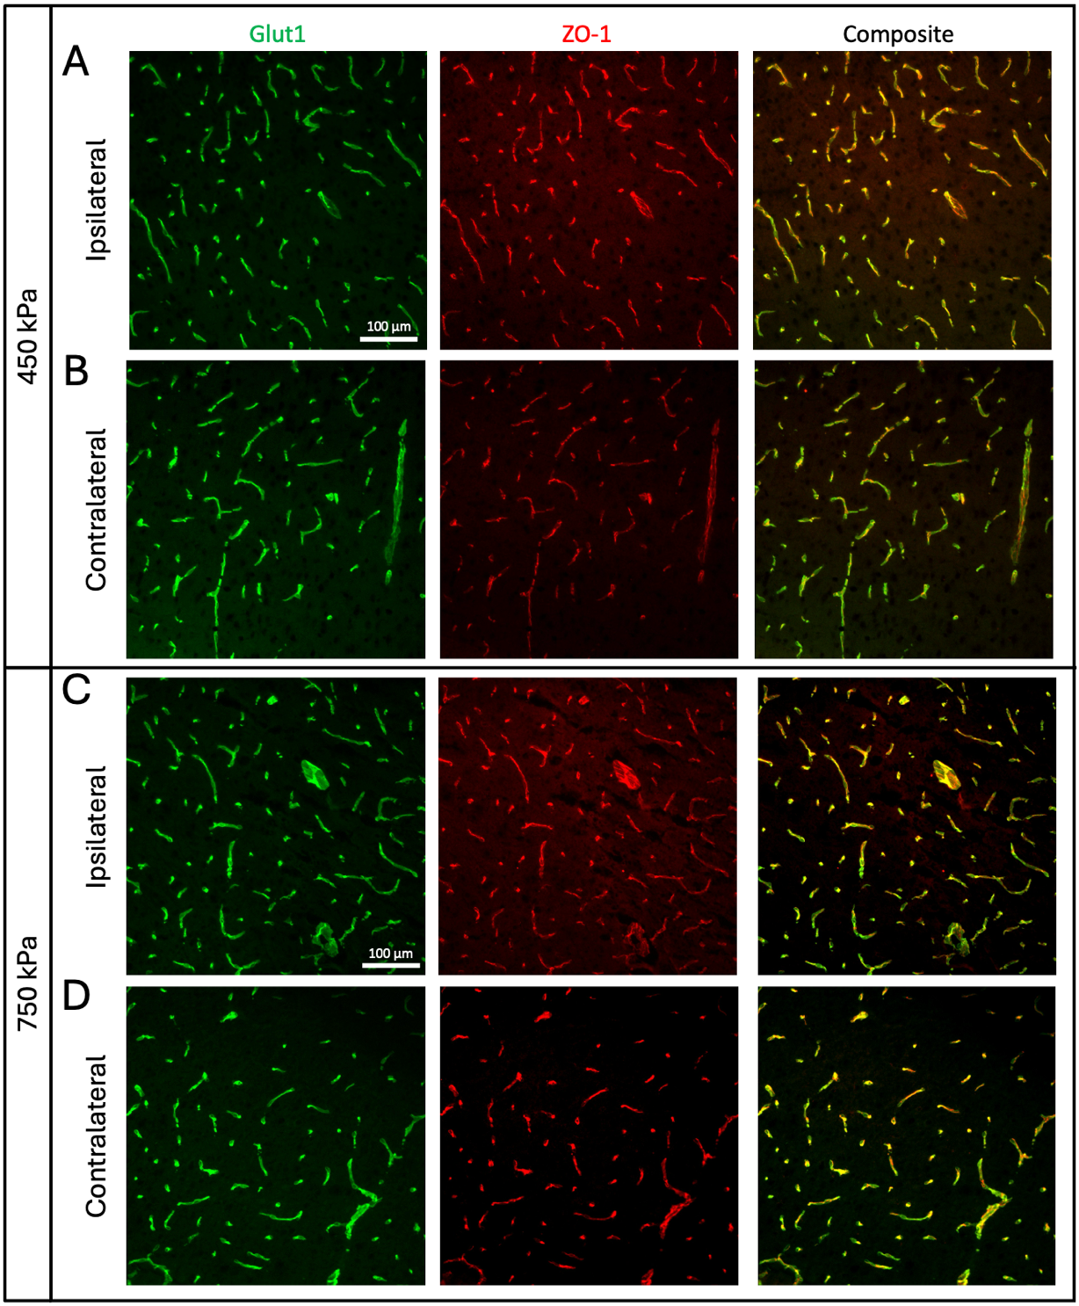

Extended Data Figure 5. ZO-1 expression at the blood-brain barrier is restored after 72 of FUS-BBBO with both low and high pressure. (A, B) Immunofluorescence images show the colocalization of ZO-1 with Glut1+ vessels in the ipsilateral (A) and (B) contralateral hemispheres of mice at 72 hours post FUS-BBBO with low pressure (450 kPa). (C, D) Immunofluorescence images showing the colocalization of ZO-1 with Glut1+ vessels in the ipsilateral (A) and (B) contralateral hemispheres of mice at 72 hours post FUS-BBBO with high pressure (750 kPa). ZO-1 is restored in both pressures.

Extended Data Figure 6. Fibrinogen leaks across capillaries and arterioles only at the acute phase following FUS-BBBO with either safe (low), or unsafe (high) pressures. (A-D”; F-I”) Maximum intensity projection images of 25µm-thick caudate putamen sections from Tg::eGFP-Claudin5+/- mice at 1 (A-D”) and 72 (F-I”) hours following 1.5 MHz FUS-BBBO sonication at 450 kPa (A-B”; F-G”) and 750 kPa (C-D”; H-I”). Biocytin-TMR tracer (red) labels leaky vessels, lectin (white) labels vessels, Iba1 (magenta) labels myeloid cells (microglia or macrophages) and fibrinogen (cyan) labels the deposited serum protein into the CNS. (E, J) Quantification of the area of fibrinogen leakage at 1 (E) and 72 (J) hours following FUS-BBBO sonication at 450 kPa (N=4 mice) and 750 kPa (N=5 mice) (*p<0.05 and **p<0.01; one-way ANOVA with Sidak’s multiple comparison test). All data are presented as mean ± standard deviation. Scale bar=20 µm.

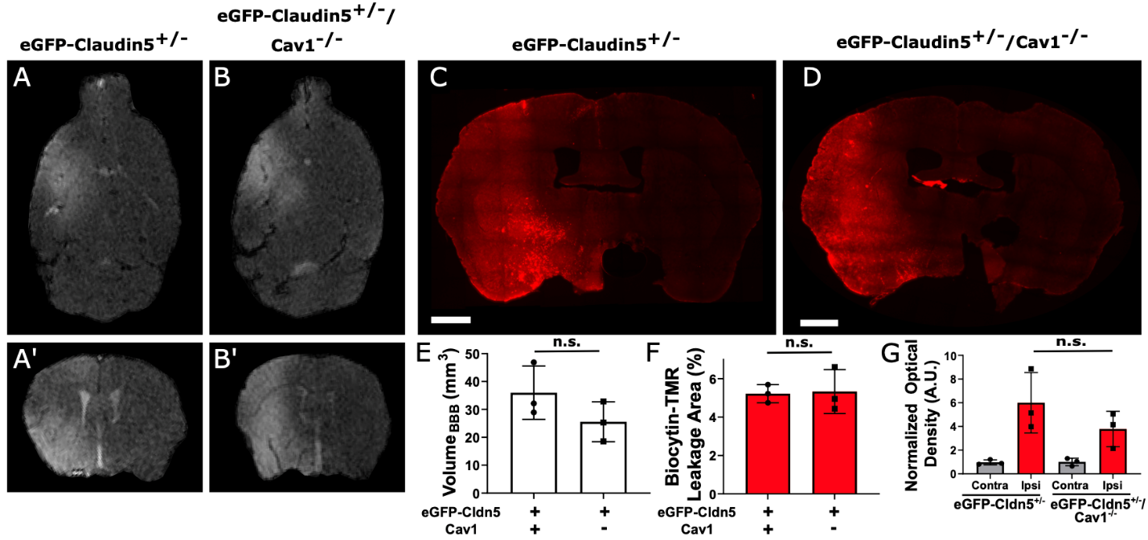

Extended Data Figure 7. Caveolin-1 is not required for the transient increase in BBB permeability following FUS-BBBO with 1.5 MHz frequency at safe, low pressures. (A-B’) Axial (A, B) and coronal (A’, B’) evaluation of changes in BBB permeability 45 minutes-post FUS-BBBO with microbubbles at 450 kPa with contrast-enhanced T1-weighted MRI in the caudate/putamen region of Tg::eGFP-Claudin5+/- mice (labelled as eGFP-Claudin5+/-) (A, A’) and Tg::eGFP-Claudin5+/-; Cav1-/- mice (labelled as eGFP-Claudin5+/- / Cav1-/-) (B, B’). (C, D) eGFP-Claudin5+/- and eGFP-Claudin5+/-; Cav1-/- mice were injected with biocytin-TMR (890 Da) tracer 1 hour after FUS-BBBO to determine changes in BBB permeability. Brain sections from eGFP-Claudin5+/- (C) and eGFP-Claudin5+/- / Cav1-/- (D) mice show a similar pattern of biocytin-TMR tracer leakage from blood vessels into the ipsilateral caudate/putamen region 1 hour following FUS-BBBO at 450 kPa. (E) Quantification of Gd-DPTA-BMA (540 Da) volume 45 min post-FUS-BBBO at 450 kPa with matched VOIs between eGFP-Claudin5+/- and eGFP-Claudin5+/- / Cav1-/- mice (N = 3 mice/group). (F) Quantification of biocytin-TMR leakage area at 450 kPa one hour after FUS-BBBO in eGFP-Claudin5+/- and eGFP-Claudin5+/- / Cav1-/- mice (N = 3 mice/group; n.s. = p>0.05 with Student’s t-test). (G) Quantification of biocytin-TMR fluorescence intensity normalized to optical density between ipsilateral and contralateral matched ROIs 1 hour after FUS-BBBO at low safe pressures (450 kPa) (N = 3 mice/group; n.s. = p>0.05 with Student’s t-test between ipsilateral hemispheres; a.u., arbitrary unit). There is no difference in the area of intensity of tracer leakage between eGFP-Claudin5+/- and eGFP-Claudin5+/-; Cav1-/- mice one hour after FUS with microbubbles at 450 kPa suggesting a caveolar-independent mechanism for FUS-BBBO at safe, low pressures. Scale bars are 1mm.

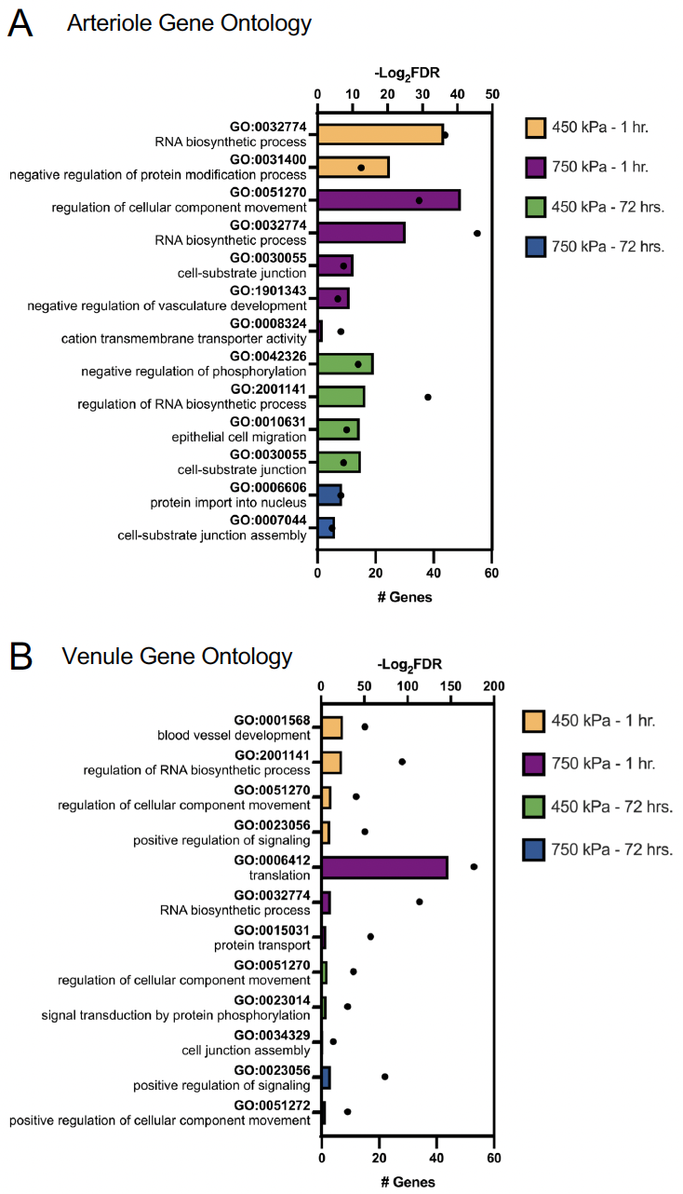
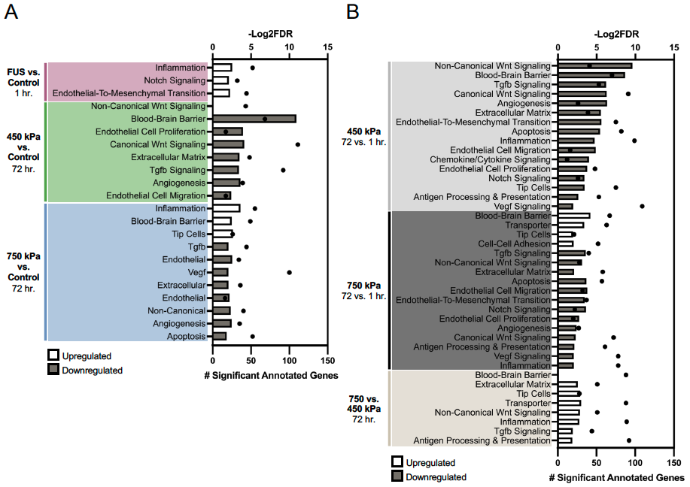
A
B
C
D
Extended Data Figure 8. Gene set enrichment (GSEA) analysis of differentially expressed genes in capillary and GO analysis of arteriole and venous endothelial cells at various times and pressures after FUS-BBBO. (A) GSEA of pathways that are up and downregulated in low (450 kPa) and high (750 kPa) pressures at 1 or 72 hours post FUS-BBBO relative to control (p value cutoff < 0.3) in capillary endothelial cells. (B) GSEA terms that are up and downregulated between 72 and 1 hour within each pressure group, then between 750 and 450 kPa at 72 hours post-FUS-BBBO (P value cutoff < 0.3). (C, D) Upregulated gene ontology (GO) terms of differentially expressed genes from the single cell RNA sequencing data in arteriole (C) and venule (D) ECs for each of the four treatment groups relative to untreated controls. Bars represent -Log₂(FDR) values (top axis), and dots represent the number of significantly differentially expressed genes annotated to each term (bottom axis). See also Extended Data Tables 6-8.

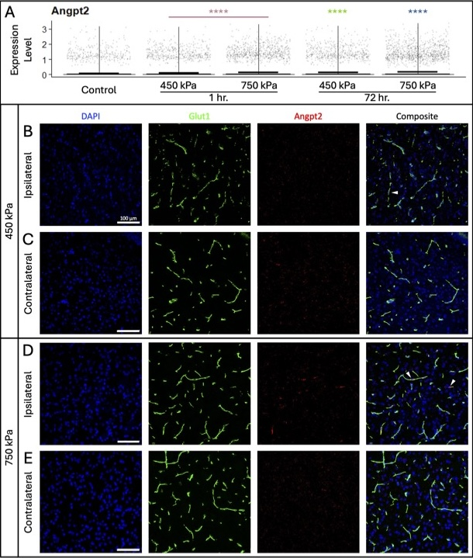

Extended Data Figure 9. Brain endothelial cells exposed to unsafe, high FUS-BBBO pressure show a sustained increase in Angpt2 mRNA expression. (A) Violin plots showing expression of Angpt2, an angiogenesis marker, across each of the treatment groups (pressures and timepoints after FUS-BBBO). Mean expression level is indicated by the bar in each plot. Statistically significant differences between each group and untreated controls are determined by Wilcoxon rank sum test (**** p ≤ 0.0001). B-E) Fluorescent in situ hybridization for Angpt2 mRNA combined with immunofluorescence for Glut-1 (vessel marker) in the striatum after FUS-BBBO. Glut1⁺ brain endothelial cells (green) exposed to 450 kPa (B) exhibit higher levels of Angpt2 mRNA expression compared to the untreated contralateral hemisphere (C). Brain ECs (green) exposed to 750 kPa (D) exhibit increased expression of Angpt2 mRNA relative to the untreated contralateral hemisphere (E). White arrowheads indicate Glut1-positive vessels with higher Angpt2 mRNA expression.

II. Extended Data Tables and Legends

Extended Data Tables 1-8. Results of the single-cell RNA-sequencing analysis of brain endothelial cells from the FUS-BBBO experiments.
Batch structure for the single-cell RNA-sequencing experiments (Extended Data Table 1). Table of differential gene expression between control vs. FUS-BBBO 1 hour at both pressures (Extended Data Table 2); control vs. FUS-BBBO 72 hours at 450 kPa (Extended Data Table 3); control vs. FUS-BBBO 72 hours at 750 kPa (Extended Data Table 4). Negative log2fc values mean that the gene is lower in the FUS-BBBO compared to control, and positive values mean that the gene is higher in FUS-BBBO compared to control. Go analysis generated from the DEGs for the capillary (Extended Data Table 5), arterial (Extended Data Table 6) and vein (Extended Data Table 7) ECs. GSEA analysis results are summarized for each condition (Extended Data Table 8).

- Supplementary Movies

Movie S1. Visualization of microglia and biocytin 1 hour post-FUS-BBBO at 450 kPa. 3D texture-based volume renderings of 25 µm Z stack confocal images on the ipsilateral hemisphere of the caudate putamen one hour after FUS-BBBO at low pressure. Iba1+ cells (magenta) label microglia/macrophages and the fluorescent tracer biocytin-TMR (red) identifies regions of BBB permeability following FUS-BBBO.

Movie S2. Visualization of microglia and biocytin 1 hour post-FUS-BBBO at 750 kPa. 3D texture-based volume renderings of 25 µm Z stack confocal images on the ipsilateral hemisphere of the caudate putamen one hour after FUS-BBBO at high pressure. Iba1+ cells (magenta) label microglia/macrophages and the fluorescent tracer biocytin-TMR (red) identifies regions of BBB permeability following FUS-BBBO.

Movie S3. Visualization of microglia and biocytin 72 hours post-FUS-BBBO at 450 kPa. 3D texture-based volume renderings of 25 µm Z stack confocal images on the ipsilateral hemisphere of the caudate putamen 72 hours after FUS-BBBO at low pressure. Iba1+ cells (magenta) label microglia/macrophages and the fluorescent tracer biocytin-TMR (red) identifies regions of BBB permeability following FUS-BBBO.

Movie S4. Visualization of microglia and biocytin 72 hours post-FUS-BBBO at 750 kPa. 3D texture-based volume renderings of 25 µm Z stack confocal images on the ipsilateral hemisphere of the caudate putamen 72 hours after FUS-BBBO at high pressure. Iba1+ cells (magenta) label microglia/macrophages and the fluorescent tracer biocytin-TMR (red) identifies regions of BBB permeability following FUS-BBBO.

