Supplementary figures for:
Molecular and Physiological Acclimation to Low Light and Iron Scarcity in Globally Abundant Oceanic Pelagophyte
Coale, T. H.¹, Lampe, R. H.^{2,3}, Tan, M²., Rowland, E.⁴, Füssy, Z.^{2,3,5}, Venepally, P.², Zheng, H.², McCrow, J.², Bertrand, E. M.⁴ & Allen, A.E.^{2,3}
¹Ocean Sciences Department, University of California, Santa Cruz, Santa Cruz, CA 95064

²Microbial and Environmental Genomics, J. Craig Venter Institute, 4120 Capricorn Lane, La Jolla, CA, 92037, USA
³Integrative Oceanography Division, Scripps Institution of Oceanography, University of California San Diego, 9500 Gilman Drive, La Jolla, CA, 92093 USA
⁴Department of Biology, Dalhousie University, 1355 Oxford St, Halifax, NS, Canada B3H 4R2
⁵Faculty of Science, Department of Chemistry, University of South Bohemia, 370 05 České Budějovice, CZ

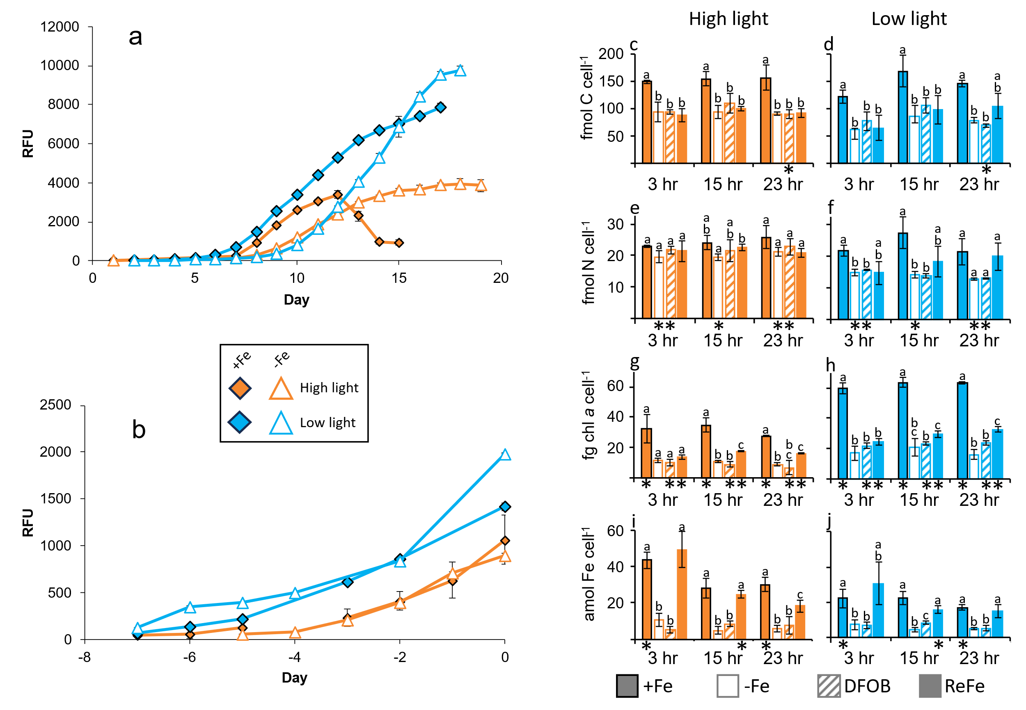
Extended Data Fig.1 a, Growth in pre-experiment cultures used to determine exponential growth phase by fluorescence (relative fluorescence units, RFU). Points represent mean RFU of triplicate cultures with error bars showing ± 1 SD. b, Growth of cells in experimental bottles prior to initiation of the experiment at Day 0. Points represent mean RFU of triplicate cultures with error bars showing ± 1 SD. c-j, Cellular quotas at the three major time points for carbon (c,d), nitrogen (e, f) , chlorophyll a (g, h) , and Fe (i, j) . High light treatments are in orange, low light in blue. Bars show mean of biological triplicate cultures and error bars represent ± 1 SD. Letters indicate groups that are not significantly different from each other, based on pairwise comparisons within the same timepoint and light level, * indicates significant differences between the light levels at a given timepoint and Fe (Welch’s t-test, P<0.05).

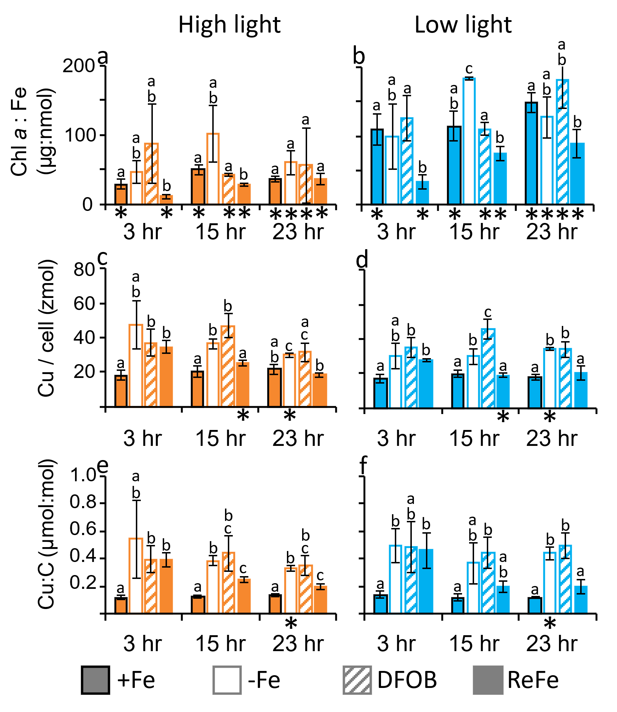
Extended Data Fig.2 Ratios of chlorophyll a to iron (a,b), cellular copper quotas (c,d), and ratios of copper to carbon (e,f) at the three major time points. High light treatments are in orange, low light in blue. Bars show mean of biological triplicate cultures and error bars represent ± 1 SD. Letters indicate groups that are not significantly different from each other, based on pairwise comparisons within the same timepoint and light level, * indicates significant differences between the light levels at a given timepoint and Fe (Welch’s t-test, P<0.05).

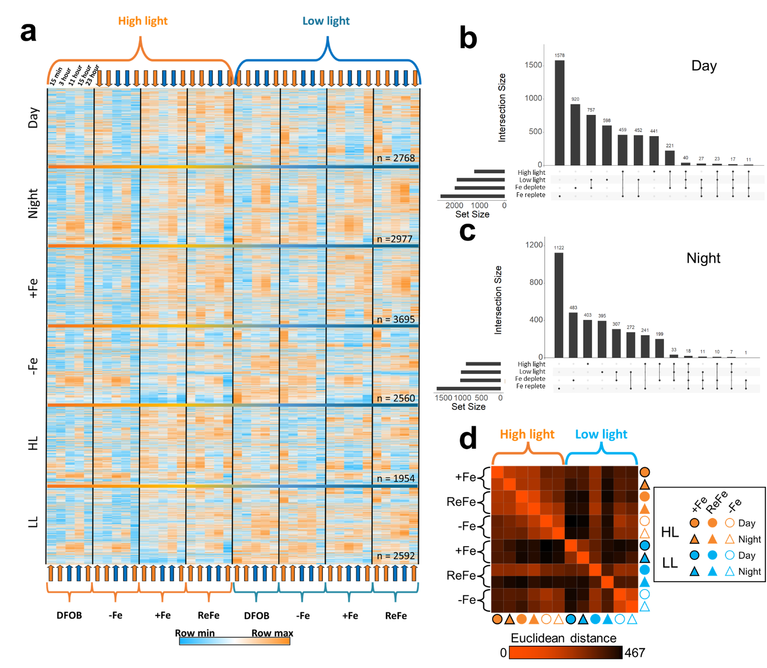
Extended Data Fig.3 a, Heatmap showing average CPM transcript abundance (row-normalized) of differentially expressed genes across the diel cycle, grouped by EdgeR response type. Orange brackets indicate high light treatments and blue brackets show low light. Orange arrows show day time points and blue arrows show night time points. Numbers indicate total number of genes in each response type. b, UpSet plot showing intersections of Fe and light response types from day samples only. c, same as b but for night samples. d, Heatmap showing Euclidean distances between all protein samples. Mean normalized protein quantities for each set of triplicate samples were used to calculate distances.

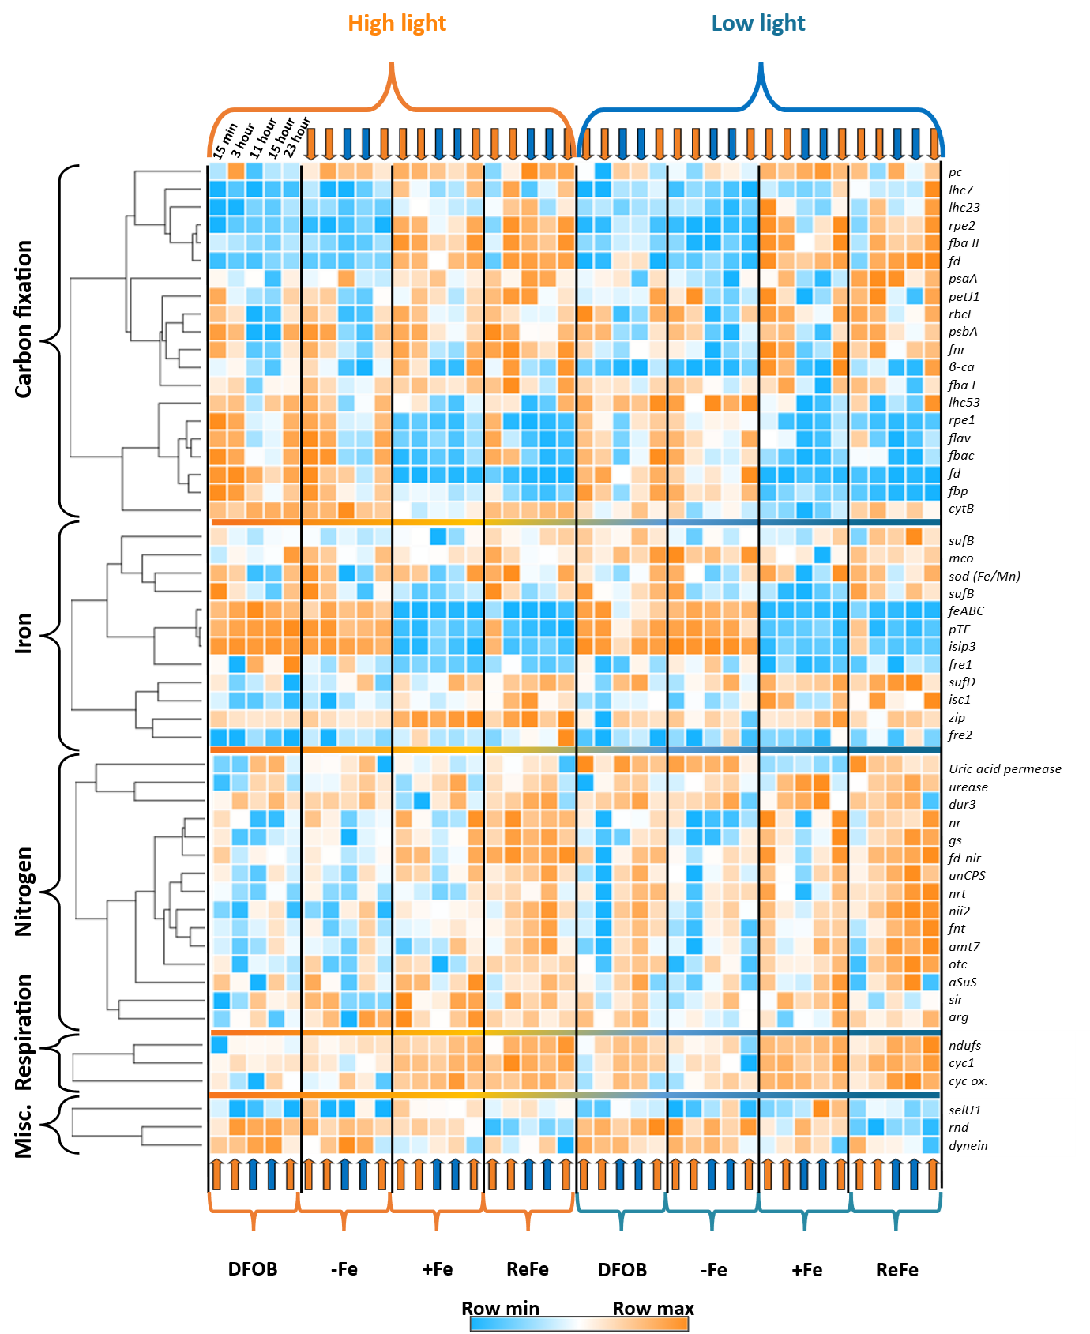
Extended Data Fig.4 Heatmap showing average CPM transcript abundance of selected genes across the diel cycle. Orange brackets indicate high light treatments and blue brackets show low light. Orange arrows show day time points and blue arrows show night time points. amt7, ammonia transporter; arg, arginase; aSuS, argininosuccinate synthase; β-ca, carbonic anhydrase; cyc ox., cytochrome c oxidase; cyc1, cytochrome c; cytB, cytochrome b6; dur3, urea-proton symporter; fba I, fructose bisphosphate aldolase class I; fba II, fructose bisphosphate aldolase class II; fbac, fructose bisphosphate aldolase class I; fbp, fructose bisphosphatase; fd, ferredoxin; fd-nir, nitrite reductase - ferredoxin; sod (Fe/Mn), Fe/Mn superoxide dismutase; feABC, ferrichrome ABC transporter-like protein; flav, flavodoxin; fnr, ferredoxin NADP+ reductase; fnt, formate nitrite transporter; fre, ferric reductase ; gcpE, (E)-4-hydroxy-3-methylbut-2-enyl-diphosphate synthase; gs, glutamate synthetase; isc1, Fe-S assembly protein; isip3, iron starvation induced protein 3; lhc23, putative plastid light harvesting protein isoform 23; lhc53, putative plastid light harvesting protein isoform 53; lhc7, putative plastid light harvesting protein isoform 7; mco, multicopper oxidase ; ndufs, NADH:ubiquinone oxidoreductase; ngit, Neurotransmitter-gated ion-channel; nii2, nitrite reductase - NADH; nr, nitrate reductase; nrt, nitrate/nitrite transporter; otc, ornithine carbamoyltransferase ; pc, plastocyanin; petJ1, cytochrome c6; psaA, photosystem I core protein PsaA; psbA, photosystem II P680 reaction center D1 protein ; pTF, phytotransferrin; rbcL, ribulose-1,5-bisphosphate carboxylase/oxygenase large subunit; rnd, resistance-nodulation-division transporter; rpe, ribulose 5-phosphate 3-epimerase; selU1, selenoprotein; sir, nitrite/sulfite reductase - ferredoxin; suf, Fe-S assembly protein; zip, zinc responsive transporter/iron responsive transporter-like protein

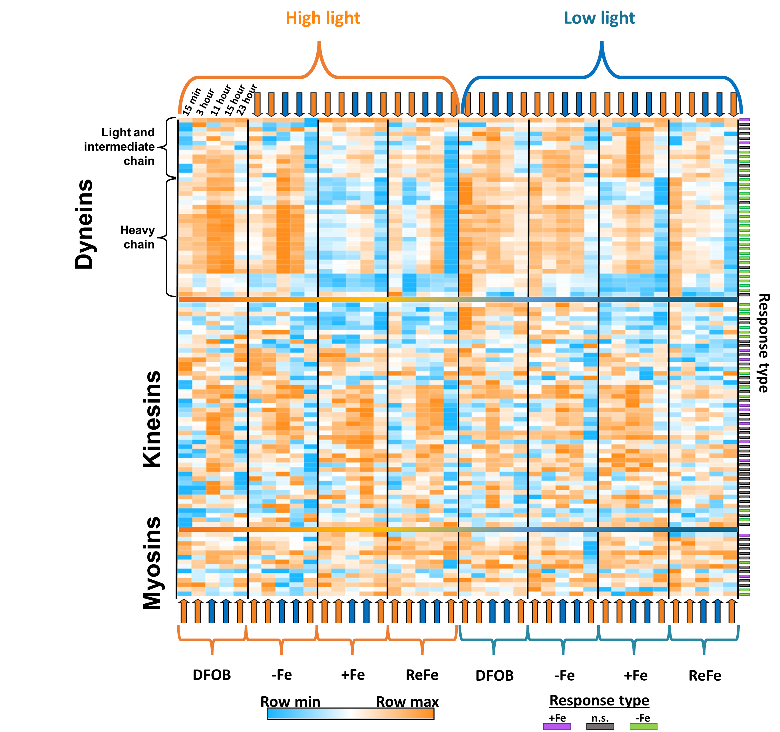
Extended Data Fig.5 Dynein, kinesin and myosin motor protein gene expression across all conditions and time points. Heatmap showing average CPM transcript abundance of genes annotated as dynein, kinesin or myosin across the diel cycle and hierarchically clustered by expression pattern (Pearson correlation). Fe-related response types (edgeR, see online methods) are given by colored bar.

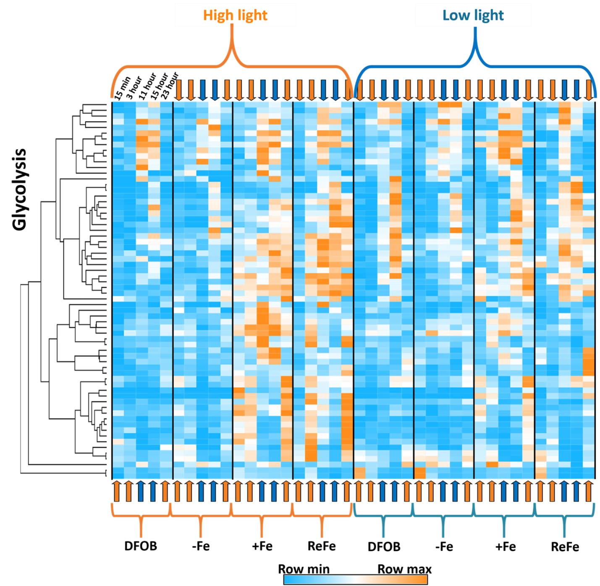
Extended Data Fig.6 Glycolysis gene expression across all conditions and time points. Heatmap showing average CPM transcript abundance of genes annotated as glycolysis by KO pathway, across the diel cycle. Genes are hierarchically clustered by expression pattern (Pearson correlation).

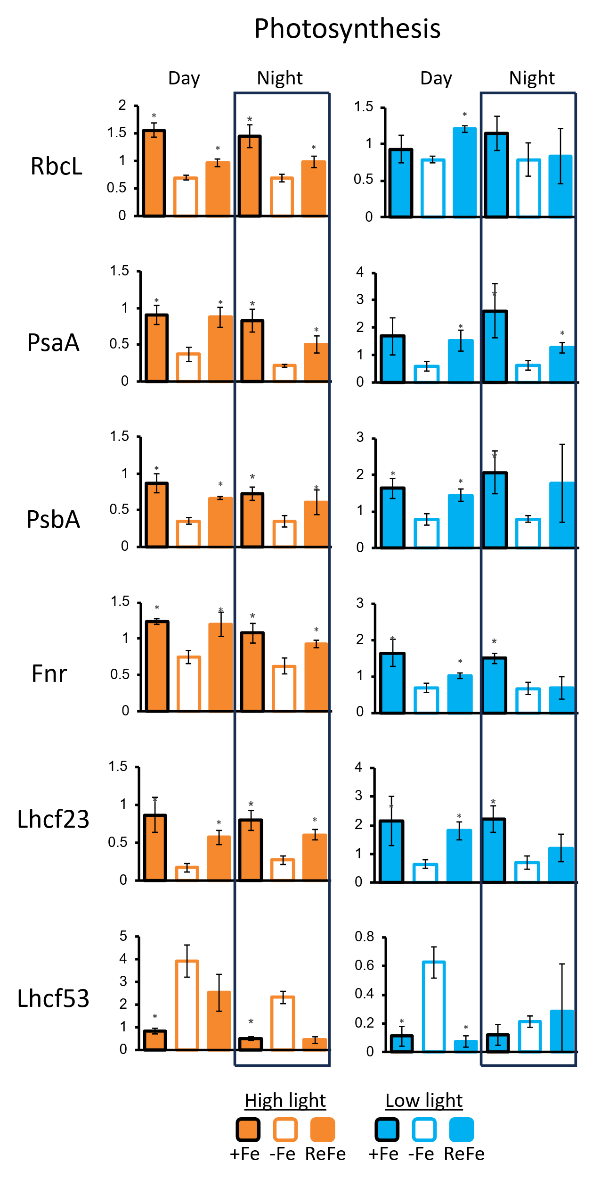
Extended Data Fig.7 Scaled abundance of photosynthetic proteins. Protein expression values (TMM) averaged across biological triplicates, and scaled to average expression by protein. Orange indicated high light cultures; blue shows low light cultures. Error bars show +/- 1 SD and asterisk indicates P < 0.05 (Student unpaired two-tailed t test) difference from -Fe value at same time of day. RbcL = ribulose 1,5 bisphosphate carboxylase large subunit, PsaA = photosystem I reaction center proteins A, PsbA = photosystem II reaction center proteins A, Lhcf = light harvesting complex protein f, Fnr = ferredoxin NADP+ oxidoreductase.

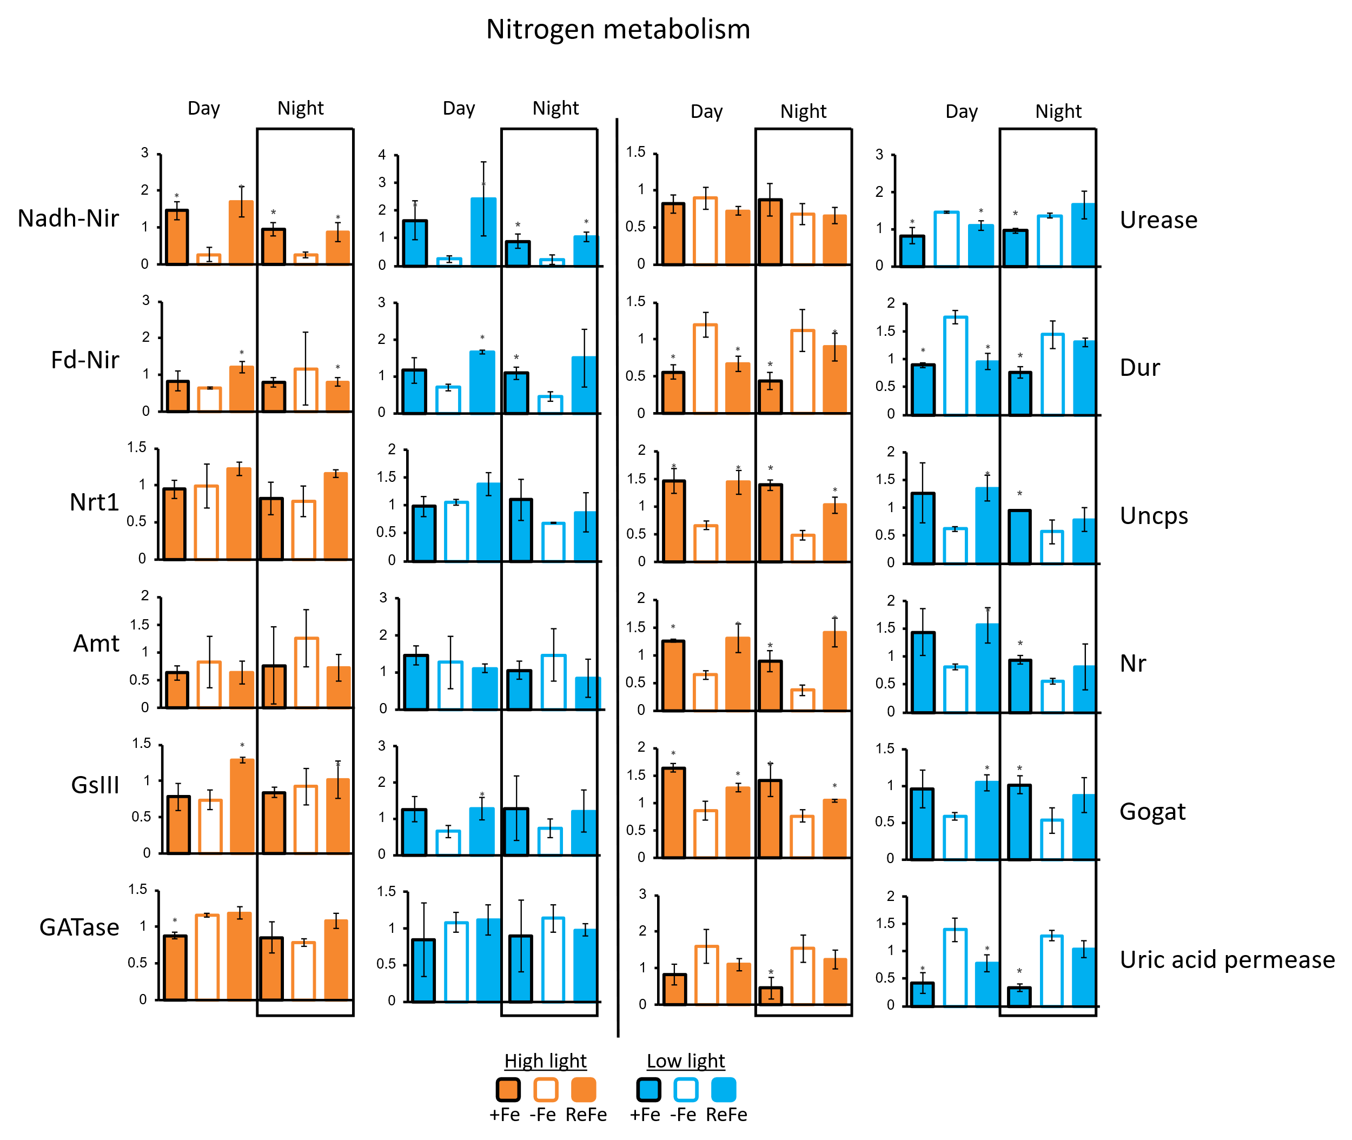
Extended Data Fig.8 Scaled abundance of nitrogen metabolism proteins. Protein expression values (TMM) averaged across biological triplicates, and scaled to average expression by protein. Orange indicated high light cultures; blue shows low light cultures. Error bars show +/- 1 SD and asterisk indicates P < 0.05 (Student unpaired two-tailed t test) difference from -Fe value at same time of day. Nadh-Nir = NADPH nitrite reductase, Fd-Nir = ferredoxin nitrite reductase, Nrt1 = nitrate transporter, Amt = ammonia transporter, GsIII = glutamine synthetase III, GATase = glutamine amidotransferases, Uncps = carbamoyl phosphate synthetase, Nr = nitrate reductase, Gogat = glutamine oxoglutarate aminotransferase.

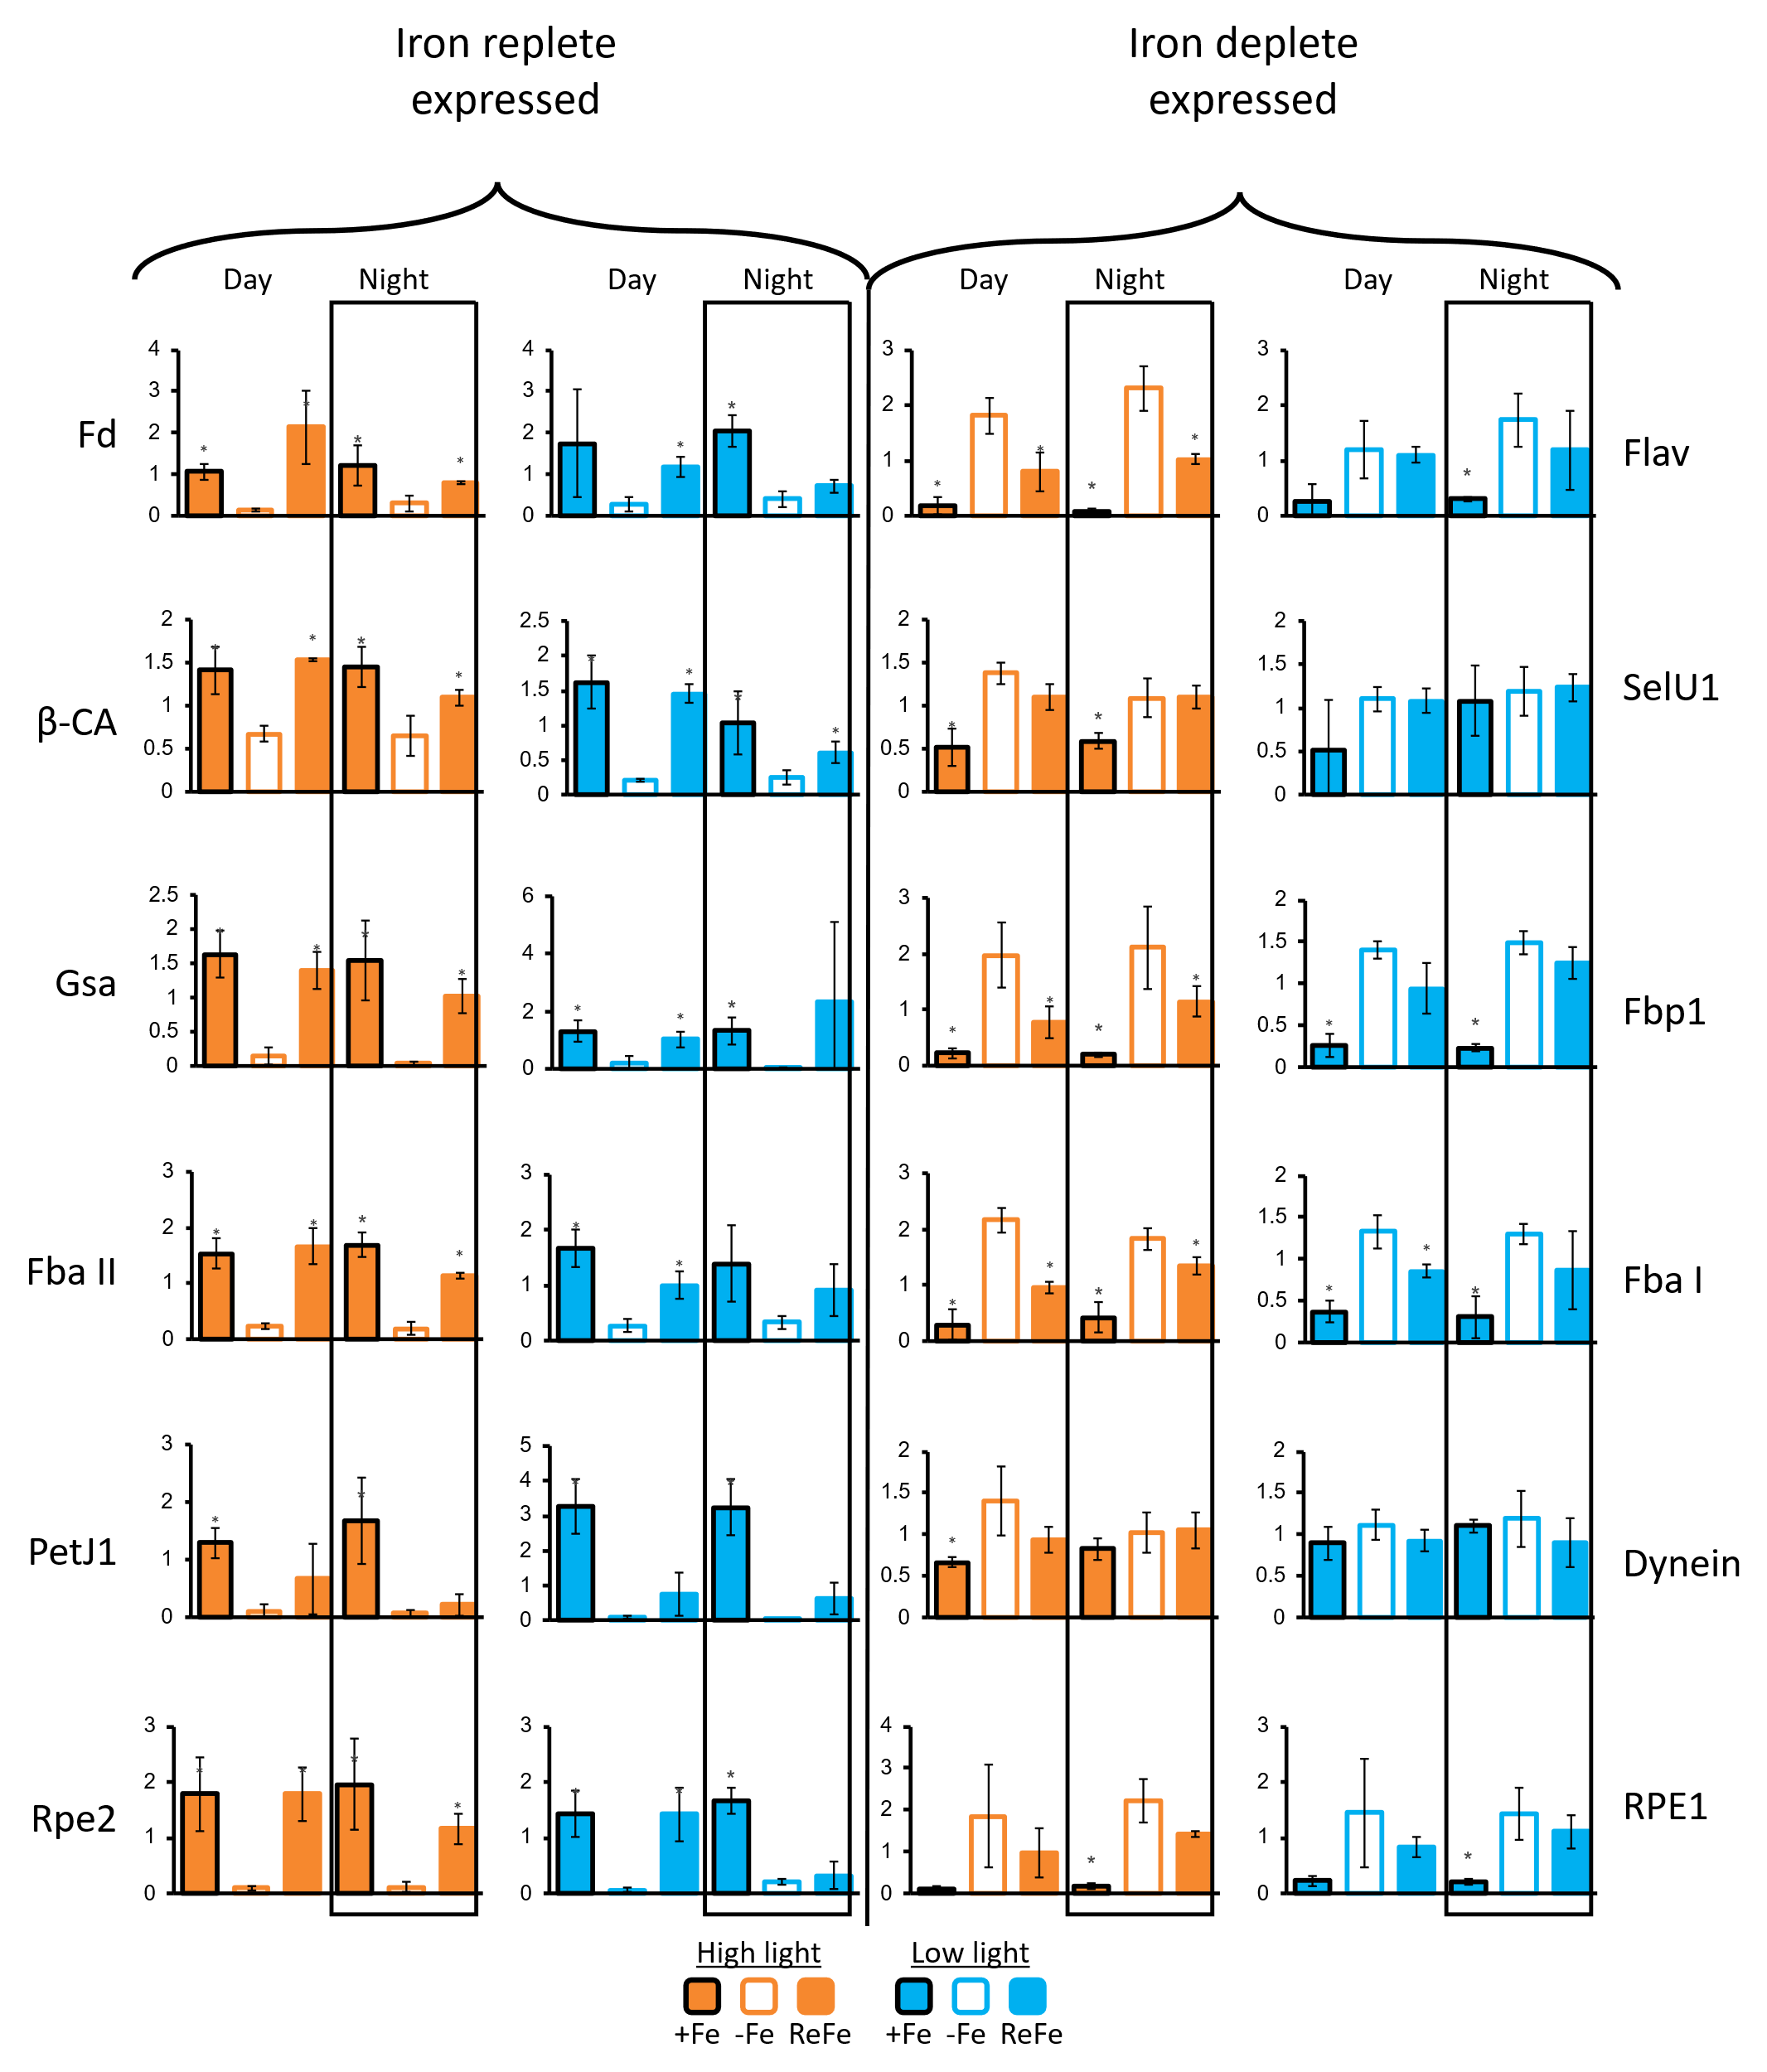
Extended Data Fig.9 Scaled abundance of iron-sensitive proteins. Protein expression values (TMM) averaged across biological triplicates, and scaled to average expression by protein. Orange indicated high light cultures; blue shows low light cultures. Error bars show +/- 1 SD and asterisk indicates P < 0.05 (Student unpaired two-tailed t test) difference from -Fe value at same time of day. Fd = ferredoxin, Fbp1 = fructose 1,6-bisphosphatase, β-CA = β-carbonic anhydrase, SelU1 = selenoprotein U1, Gsa = glutamate-1-semialdehyde aminotransferase, Fbp1 = fructose 1,6-bisphosphatase, Fba = fructose bisphosphate aldolase, PetJ1= cytochrome c₆, Rpe = ribulose 5-phosphate 3-epimerase, Flav = flavodoxin.

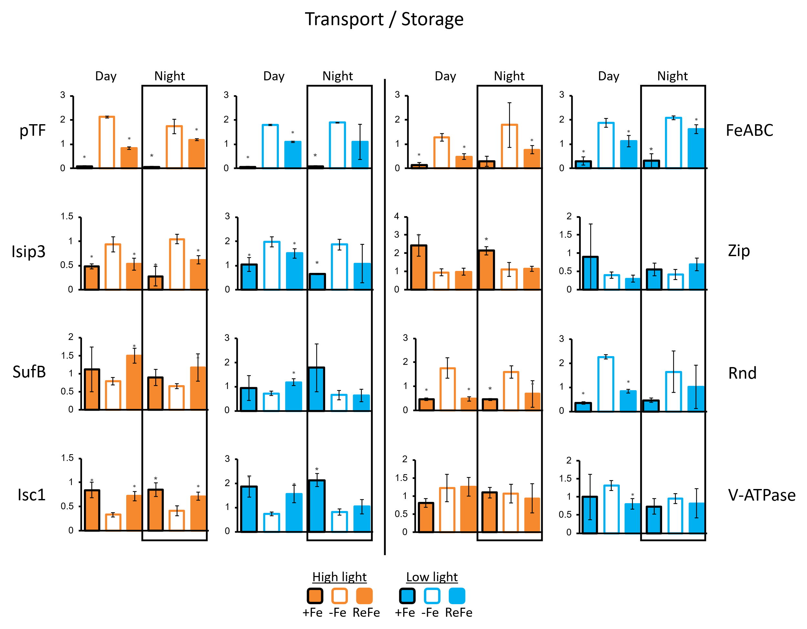
Extended Data Fig.10 Scaled abundance of iron transport and storage related proteins. Protein expression values (TMM) averaged across biological triplicates, and scaled to average expression by protein. Orange indicated high light cultures, blue shows low light cultures. Error bars show +/- 1 SD and asterisk indicates P < 0.05 (Student unpaired two-tailed t test) difference from -Fe value at same time of day. pTF = phytotransferrin, Isip3 = iron starvation induced protein 3, FeABC = ferrichrome ABC transporter protein, Zip = zinc responsive transporter/iron responsive transporter-like protein, Mrp1 = multidrug resistance protein, SufB = chloroplast Fe-S cluster assembly protein, V-ATPase = vacuolar proton pump, Isc1 = Iron sulfur cluster assembly protein, Rnd = resistance-nodulation-division transporter.

