Supplemental Figures
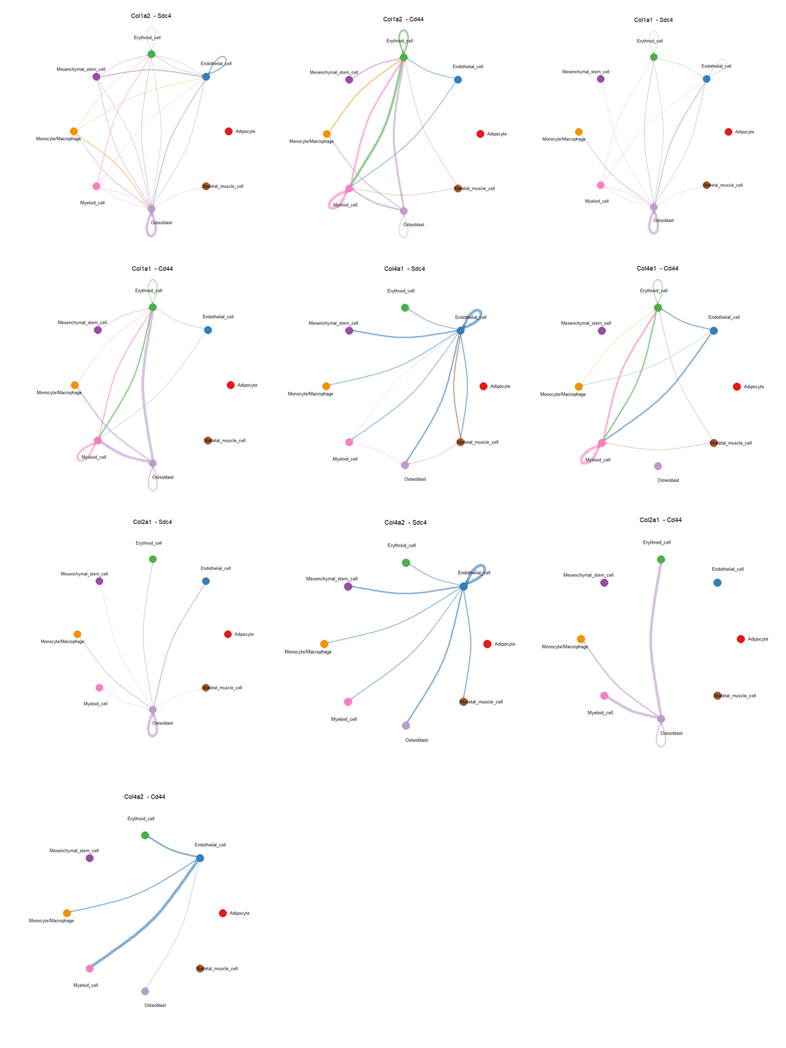
Supplemental Figure 1. Cell-cell communications mediated via 10 L-R pairs within COLLAGEN signaling pathway.
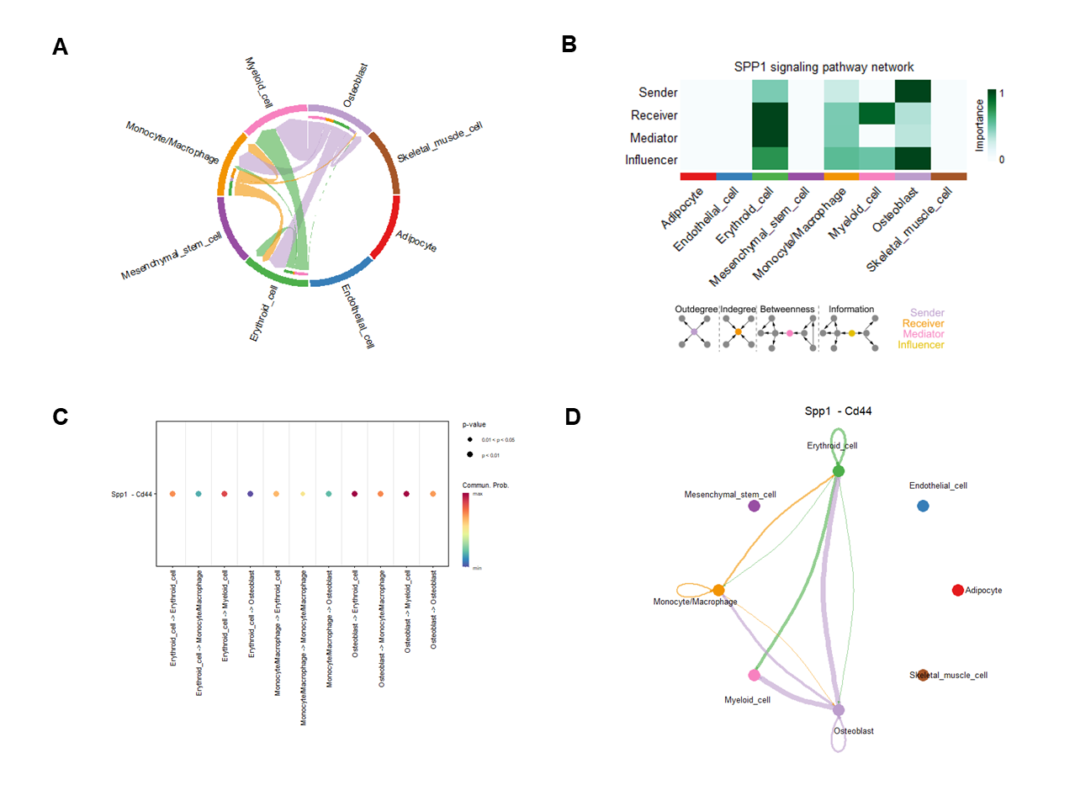
Supplemental Figure 2. Cell-cell communications and their corresponding ligand–receptor interaction pairs in SPP1 pathway. A) A chord diagram shows the cell-cell communications in SPP1 pathway. B) The relative importance of each cell cluster based on the computed network centrality measures of signaling networks. Influencer represents a kind of cell that can control information flow within a signaling network, and a higher value indicates greater control on the information flow. The meaning of importance is the magnitude of the possibility of four roles (sender, receiver, mediator, and influencer) that the cell types play. The darker the color, the greater the role cells play. C) Dot plot shows the significant L-R pairs across various cell types in SPP1 signaling pathway. D) Cell-cell communication mediated by a Spp1-Cd44 L-R pair in SPP1 signaling pathway.
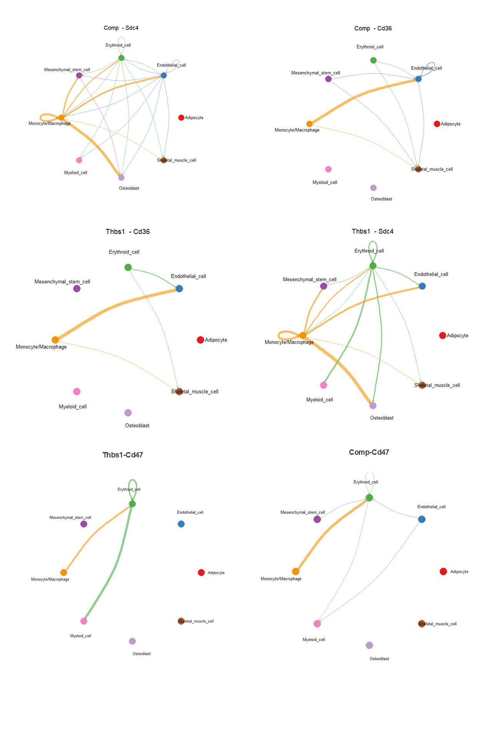

Supplemental Figure 3. Cell-cell communications mediated via 6 L-R pairs within THBS signaling pathway.
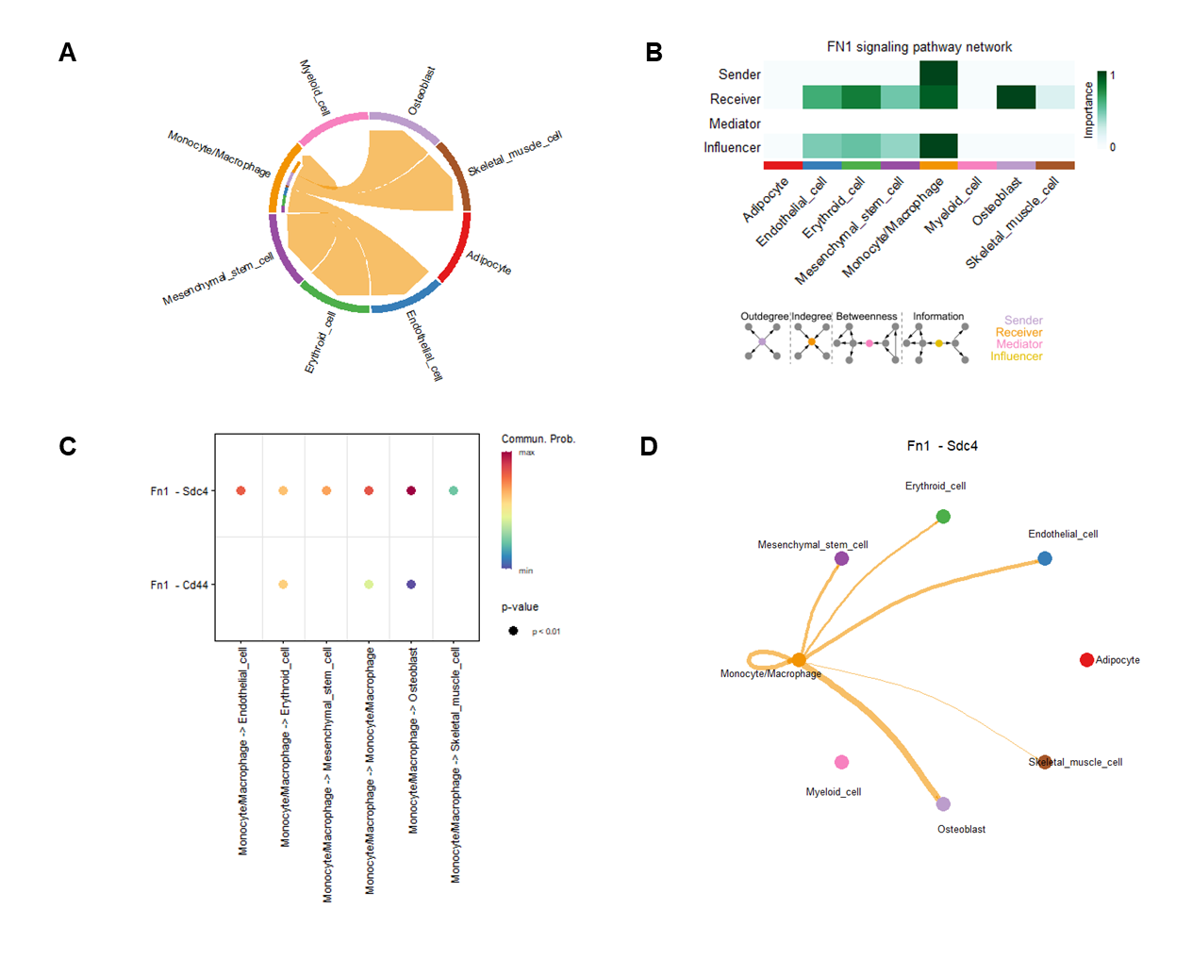
Supplemental Figure 4. Cell-cell communications and their corresponding ligand–receptor interaction pairs in FN1 pathway. A) A chord diagram shows the cell-cell communications in FN1 pathway. B) The relative importance of each cell cluster based on the computed network centrality measures of signaling networks. Influencer represents a kind of cell that can control information flow within a signaling network, and a higher value indicates greater control on the information flow. The meaning of importance is the magnitude of the possibility of four roles (sender, receiver, mediator, and influencer) that the cell types play. The darker the color, the greater the role cells play. C) Dot plot shows the significant L-R pairs across various cell types in FN1 signaling pathway. D) Cell-cell communication mediated by a Fn1-Sdc4 L-R pair in FN1 signaling pathway.

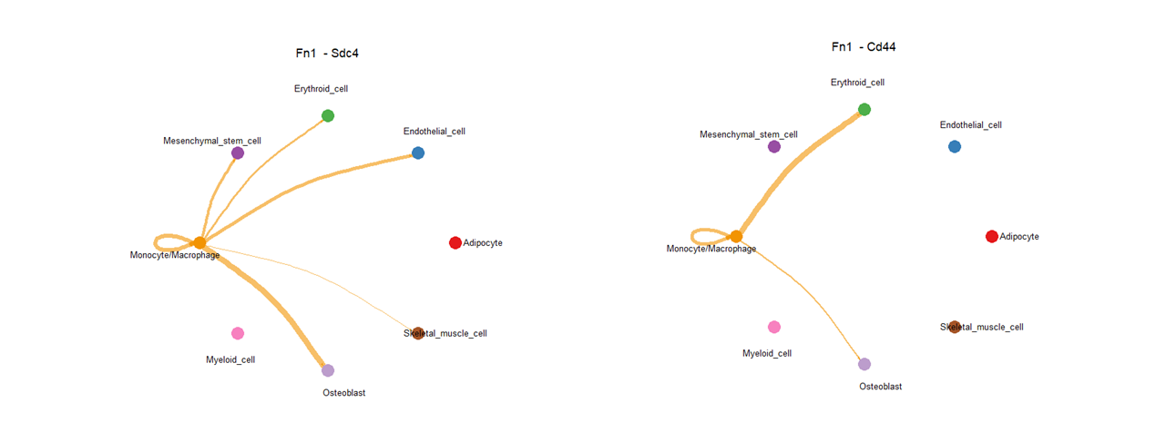
Supplemental Figure 5. Cell-cell communications mediated via 2 L-R pairs within FN1 signaling pathway.
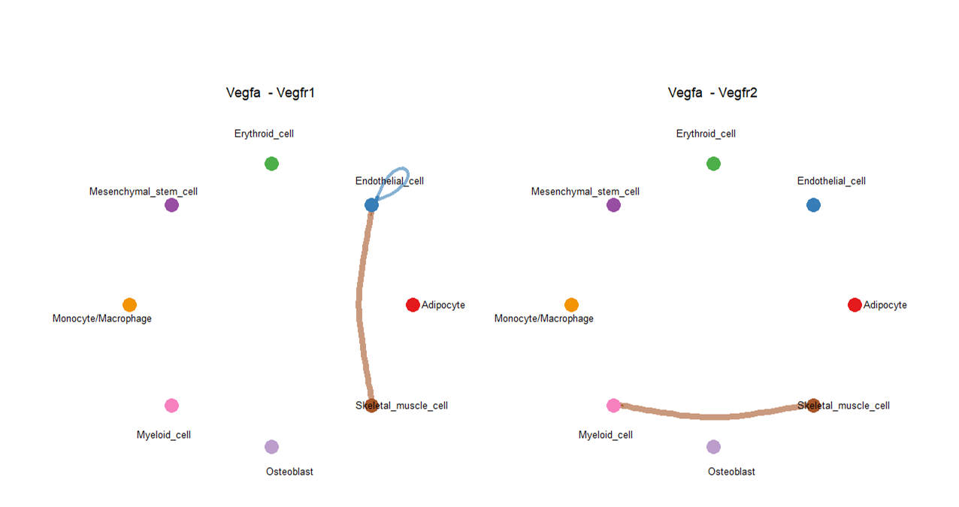
Supplemental Figure 6. Cell-cell communications mediated via 2 L-R pairs within VEGF signaling pathway.
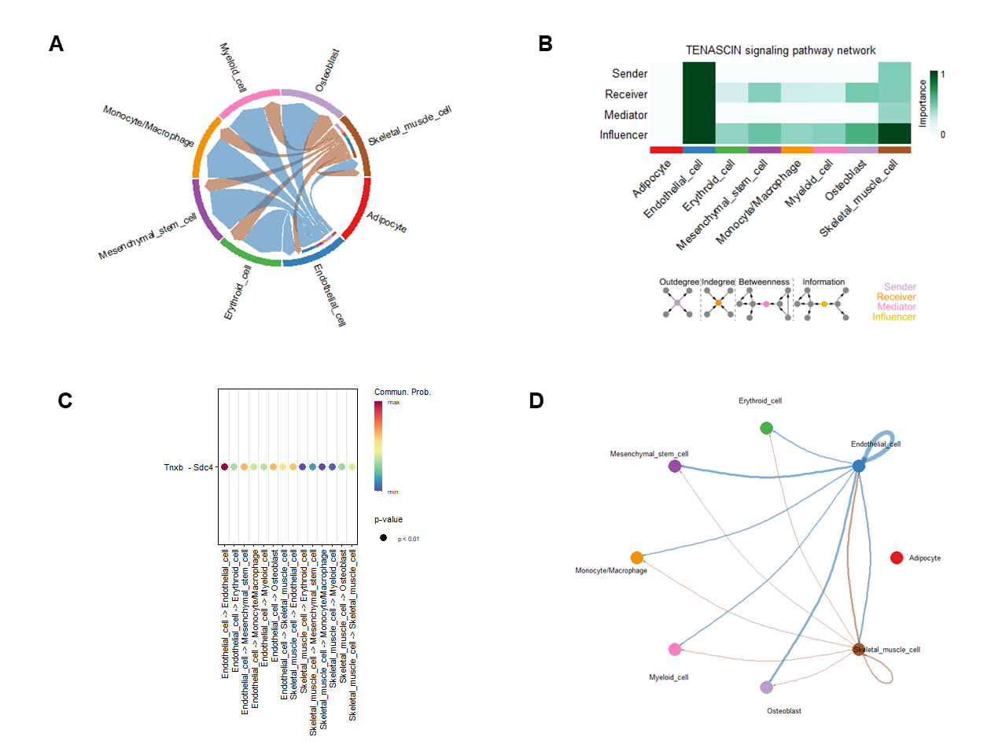
Supplemental Figure 7. Cell-cell communications and their corresponding ligand–receptor interaction pairs in TENASCIN pathway. A) A chord diagram shows the cell-cell communications in TENASCIN pathway. B) The relative importance of each cell cluster based on the computed network centrality measures of signaling networks. Influencer represents a kind of cell that can control information flow within a signaling network, and a higher value indicates greater control on the information flow. The meaning of importance is the magnitude of the possibility of four roles (sender, receiver, mediator, and influencer) that the cell types play. The darker the color, the greater the role cells play. C) Dot plot shows the significant L-R pairs across various cell types in TENASCIN signaling pathway. D) Cell-cell communication mediated by a Tnxb-Sdc4 L-R pair in TENASCIN signaling pathway.

