Immigrant-driven hunting and wildlife decline in an Afrotropical rainforest landscape

Supplementary information

Table S1: Full results of Bayesian regression models fitted on wildlife and hunting in the Ebo forest, Cameroon to investigate differences in hunting and wildlife patterns in the hunting territories of different human communities.
Species | Parameter | Estimate | Est.Error | l-95%CI | u-95%CI | Rhat | Bulk_ESS | Tail_ESS
Chimpanzee | Intercept | -1.89 | 0.26 | -2.41 | -1.40 | 1.00 | 3222 | 5092
Chimpanzee | Area:BassaEast | -0.67 | 0.32 | -1.31 | -0.05 | 1.00 | 3715 | 5026
Chimpanzee | Area:BassaWest | 0.09 | 0.35 | -0.58 | 0.77 | 1.00 | 3214 | 4589
Chimpanzee | Area:Immigrant | -1.39 | 0.34 | -2.06 | -0.72 | 1.00 | 3033 | 4688
Chimpanzee | Area:Yingui | -0.75 | 0.43 | -1.61 | 0.09 | 1.00 | 4388 | 5551
Chimpanzee | Year | -0.28 | 0.11 | -0.51 | -0.06 | 1.00 | 4693 | 6033
Chimpanzee | Village distance | 0.66 | 0.13 | 0.41 | 0.91 | 1.00 | 3673 | 4572
Chimpanzee | Ruggednessedness | 1.12 | 0.13 | 0.87 | 1.38 | 1.00 | 4206 | 5073
Chimpanzee | Elevationation | 0.08 | 0.14 | -0.20 | 0.35 | 1.00 | 3626 | 5117
Chimpanzee | River distance | 0.02 | 0.10 | -0.18 | 0.22 | 1.00 | 4661 | 5429
Chimpanzee | Survey effort | 0.84 | 0.42 | 0.18 | 1.79 | 1.00 | 6657 | 4714
Chimpanzee | Area:BassaEast*Year | 0.27 | 0.18 | -0.08 | 0.64 | 1.00 | 6774 | 5681
Chimpanzee | Area:BassaWest*Year | -0.10 | 0.18 | -0.44 | 0.25 | 1.00 | 6642 | 5985
Chimpanzee | Area:Immigrant*Year | 0.14 | 0.15 | -0.16 | 0.44 | 1.00 | 6022 | 6506
Chimpanzee | Area:Yingui*Year | 0.00 | 0.26 | -0.52 | 0.50 | 1.00 | 9360 | 5976
Elephant | Intercept | -3.23 | 0.33 | -3.92 | -2.63 | 1.00 | 3663 | 5321
Elephant | Area:BassaEast | -1.27 | 0.39 | -2.04 | -0.51 | 1.00 | 6115 | 6434
Elephant | Area:BassaWest | -2.79 | 0.53 | -3.88 | -1.77 | 1.00 | 7500 | 6074
Elephant | Area:Immigrant | -0.90 | 0.39 | -1.67 | -0.15 | 1.00 | 5005 | 6194
Elephant | Area:Yingui | -1.96 | 0.70 | -3.38 | -0.64 | 1.00 | 10434 | 6175
Elephant | Year | 0.46 | 0.14 | 0.19 | 0.74 | 1.00 | 7861 | 6182
Elephant | Village distance | 1.17 | 0.17 | 0.86 | 1.51 | 1.00 | 5292 | 6310
Elephant | Ruggedness | -0.49 | 0.17 | -0.83 | -0.16 | 1.00 | 5992 | 6240
Elephant | Elevation | 1.33 | 0.18 | 0.99 | 1.70 | 1.00 | 4366 | 5347
Elephant | River distance | -0.25 | 0.14 | -0.53 | 0.02 | 1.00 | 5684 | 6113
Elephant | Survey effort | 0.31 | 0.27 | -0.16 | 0.91 | 1.00 | 7994 | 5094
Elephant | Area:BassaEast*Year | 0.18 | 0.28 | -0.36 | 0.75 | 1.00 | 10496 | 6555
Elephant | Area:BassaWest*Year | -0.80 | 0.40 | -1.59 | -0.01 | 1.00 | 12256 | 6508
Elephant | Area:Immigrant*Year | -1.42 | 0.20 | -1.81 | -1.05 | 1.00 | 7608 | 6328
Elephant | Area:Yingui*Year | -0.23 | 0.63 | -1.42 | 1.04 | 1.00 | 14327 | 6046
Putty-nosed monkey | Intercept | -1.86 | 0.16 | -2.19 | -1.55 | 1.00 | 4651 | 5231
Putty-nosed monkey | Area:BassaEast | -0.10 | 0.20 | -0.49 | 0.30 | 1.00 | 6795 | 6668
Putty-nosed monkey | Area:BassaWest | -0.25 | 0.23 | -0.71 | 0.20 | 1.00 | 5805 | 6086
Putty-nosed monkey | Area:Immigrant | -0.59 | 0.22 | -1.01 | -0.17 | 1.00 | 4936 | 5894
Putty-nosed monkey | Area:Yingui | -0.23 | 0.28 | -0.79 | 0.30 | 1.00 | 8135 | 5996
Putty-nosed monkey | Year | 0.04 | 0.11 | -0.17 | 0.26 | 1.00 | 4981 | 5398
Putty-nosed monkey | Village distance | 0.26 | 0.08 | 0.10 | 0.42 | 1.00 | 6825 | 6368
Putty-nosed monkey | Ruggedness | 0.28 | 0.08 | 0.12 | 0.45 | 1.00 | 7996 | 6462
Putty-nosed monkey | Elevation | 0.16 | 0.09 | -0.03 | 0.34 | 1.00 | 5819 | 5915
Putty-nosed monkey | River distance | -0.09 | 0.07 | -0.23 | 0.05 | 1.00 | 10164 | 6422
Putty-nosed monkey | Survey effort | 0.50 | 0.18 | 0.19 | 0.90 | 1.00 | 9741 | 5052
Putty-nosed monkey | Area:BassaEast*Year | -0.06 | 0.18 | -0.40 | 0.29 | 1.00 | 6984 | 5823
Putty-nosed monkey | Area:BassaWest*Year | 0.19 | 0.19 | -0.17 | 0.56 | 1.00 | 7533 | 6412
Putty-nosed monkey | Area:Immigrant*Year | -0.25 | 0.15 | -0.54 | 0.04 | 1.00 | 5832 | 6152
Putty-nosed monkey | Area:Yingui*Year | -0.27 | 0.24 | -0.73 | 0.21 | 1.00 | 8920 | 6053
Red river hog | Intercept | -0.02 | 0.13 | -0.27 | 0.23 | 1.00 | 3800 | 5218
Red river hog | Area:BassaEast | 0.03 | 0.16 | -0.28 | 0.34 | 1.00 | 5435 | 6034
Red river hog | Area:BassaWest | -0.40 | 0.18 | -0.76 | -0.05 | 1.00 | 4188 | 5207
Red river hog | Area:Immigrant | -0.89 | 0.17 | -1.23 | -0.56 | 1.00 | 3987 | 4956
Red river hog | Area:Yingui | -0.92 | 0.23 | -1.38 | -0.47 | 1.00 | 6397 | 6575
Red river hog | Year | 0.49 | 0.09 | 0.31 | 0.68 | 1.00 | 4106 | 5233
Red river hog | Village distance | 0.19 | 0.06 | 0.07 | 0.30 | 1.00 | 6196 | 5936
Red river hog | Ruggedness | -0.23 | 0.06 | -0.35 | -0.11 | 1.00 | 7556 | 5874
Red river hog | Elevation | -0.13 | 0.08 | -0.28 | 0.01 | 1.00 | 4960 | 5459
Red river hog | River distance | 0.02 | 0.05 | -0.08 | 0.12 | 1.00 | 7893 | 5948
Red river hog | Survey effort | 0.51 | 0.07 | 0.38 | 0.66 | 1.00 | 10131 | 6703
Red river hog | Area:BassaEast*Year | 0.18 | 0.15 | -0.10 | 0.46 | 1.00 | 5960 | 5748
Red river hog | Area:BassaWest*Year | 0.14 | 0.14 | -0.13 | 0.42 | 1.00 | 5381 | 5480
Red river hog | Area:Immigrant*Year | 0.03 | 0.12 | -0.21 | 0.25 | 1.00 | 4798 | 6023
Red river hog | Area:Yingui*Year | 0.17 | 0.21 | -0.25 | 0.60 | 1.00 | 7401 | 5806
Crowned monkey | Intercept | -2.83 | 0.22 | -3.28 | -2.41 | 1.00 | 3659 | 4807
Crowned monkey | Area:BassaEast | -0.51 | 0.28 | -1.07 | 0.02 | 1.00 | 6625 | 5854
Crowned monkey | Area:BassaWest | -0.41 | 0.31 | -1.02 | 0.19 | 1.00 | 5899 | 6346
Crowned monkey | Area:Immigrant | -0.63 | 0.29 | -1.20 | -0.06 | 1.00 | 4361 | 4920
Crowned monkey | Area:Yingui | -0.66 | 0.44 | -1.57 | 0.16 | 1.00 | 7461 | 6455
Crowned monkey | Year | 0.05 | 0.15 | -0.25 | 0.36 | 1.00 | 4398 | 5746
Crowned monkey | Village distance | 0.31 | 0.11 | 0.09 | 0.53 | 1.00 | 6541 | 5465
Crowned monkey | Ruggedness | 0.03 | 0.11 | -0.20 | 0.25 | 1.00 | 8732 | 6301
Crowned monkey | Elevation | 0.22 | 0.12 | -0.02 | 0.47 | 1.00 | 4965 | 5992
Crowned monkey | River distance | -0.22 | 0.10 | -0.42 | -0.02 | 1.00 | 8658 | 5910
Crowned monkey | Survey effort | 0.68 | 0.30 | 0.18 | 1.38 | 1.00 | 7635 | 5076
Crowned monkey | Area:BassaEast*Year | 0.11 | 0.27 | -0.41 | 0.65 | 1.00 | 6355 | 6111
Crowned monkey | Area:BassaWest*Year | 0.28 | 0.29 | -0.26 | 0.85 | 1.00 | 6947 | 6318
Crowned monkey | Area:Immigrant*Year | -0.15 | 0.20 | -0.54 | 0.25 | 1.00 | 5000 | 6186
Crowned monkey | Area:Yingui*Year | -0.95 | 0.35 | -1.65 | -0.27 | 1.00 | 6827 | 5939
Red duikers | Intercept | -1.11 | 0.14 | -1.38 | -0.85 | 1.00 | 4208 | 5436
Red duikers | Area:BassaEast | -0.39 | 0.18 | -0.74 | -0.04 | 1.00 | 6229 | 6138
Red duikers | Area:BassaWest | -0.22 | 0.20 | -0.60 | 0.17 | 1.00 | 5190 | 5436
Red duikers | Area:Immigrant | -0.36 | 0.19 | -0.72 | 0.00 | 1.00 | 4064 | 5427
Red duikers | Area:Yingui | -0.25 | 0.23 | -0.71 | 0.20 | 1.00 | 7244 | 5787
Red duikers | Year | -0.05 | 0.10 | -0.24 | 0.15 | 1.00 | 3776 | 4788
Red duikers | Village distance | -0.07 | 0.07 | -0.20 | 0.07 | 1.00 | 5942 | 6224
Red duikers | Ruggedness | 0.01 | 0.07 | -0.12 | 0.15 | 1.00 | 8211 | 6100
Red duikers | Elevation | -0.07 | 0.08 | -0.23 | 0.09 | 1.00 | 4886 | 5728
Red duikers | River distance | -0.01 | 0.06 | -0.12 | 0.11 | 1.00 | 9440 | 6036
Red duikers | Survey effort | -0.03 | 0.06 | -0.14 | 0.08 | 1.00 | 9452 | 6726
Red duikers | Area:BassaEast*Year | 0.10 | 0.16 | -0.20 | 0.42 | 1.00 | 5949 | 5567
Red duikers | Area:BassaWest*Year | -0.05 | 0.15 | -0.35 | 0.24 | 1.00 | 5334 | 5345
Red duikers | Area:Immigrant*Year | -0.01 | 0.12 | -0.25 | 0.22 | 1.00 | 4429 | 5585
Red duikers | Area:Yingui*Year | -0.05 | 0.20 | -0.43 | 0.34 | 1.00 | 6847 | 5662
Blue duiker | Intercept | -2.19 | 0.18 | -2.56 | -1.83 | 1.00 | 3670 | 4844
Blue duiker | Area:BassaEast | -0.42 | 0.24 | -0.90 | 0.06 | 1.00 | 7744 | 6416
Blue duiker | Area:BassaWest | -0.79 | 0.28 | -1.36 | -0.24 | 1.00 | 6391 | 5973
Blue duiker | Area:Immigrant | -0.59 | 0.25 | -1.08 | -0.10 | 1.00 | 4903 | 5945
Blue duiker | Area:Yingui | -0.47 | 0.33 | -1.11 | 0.17 | 1.00 | 8125 | 5915
Blue duiker | Year | 0.22 | 0.14 | -0.06 | 0.50 | 1.00 | 4801 | 5586
Blue duiker | Village distance | -0.10 | 0.09 | -0.29 | 0.08 | 1.00 | 7619 | 6018
Blue duiker | Ruggedness | -0.06 | 0.10 | -0.25 | 0.12 | 1.00 | 9331 | 5638
Blue duiker | Elevation | -0.03 | 0.11 | -0.26 | 0.19 | 1.00 | 5664 | 5741
Blue duiker | River distance | -0.02 | 0.08 | -0.20 | 0.14 | 1.00 | 10270 | 5917
Blue duiker | Survey effort | 0.02 | 0.08 | -0.14 | 0.18 | 1.00 | 9841 | 5566
Blue duiker | Area:BassaEast*Year | -0.05 | 0.23 | -0.50 | 0.41 | 1.00 | 7122 | 6337
Blue duiker | Area:BassaWest*Year | -0.38 | 0.24 | -0.84 | 0.09 | 1.00 | 7371 | 6540
Blue duiker | Area:Immigrant*Year | -0.49 | 0.18 | -0.85 | -0.14 | 1.00 | 5726 | 5831
Blue duiker | Area:Yingui*Year | 0.22 | 0.32 | -0.39 | 0.87 | 1.00 | 8752 | 5965
Hunting intensity | Intercept | 2.03 | 0.18 | 1.69 | 2.37 | 1.00 | 4054 | 5735
Hunting intensity | Area:BassaEast | -0.01 | 0.23 | -0.45 | 0.44 | 1.00 | 5086 | 5609
Hunting intensity | Area:BassaWest | -0.17 | 0.25 | -0.67 | 0.32 | 1.00 | 4382 | 5861
Hunting intensity | Area:Immigrant | 0.58 | 0.24 | 0.11 | 1.05 | 1.00 | 3770 | 5534
Hunting intensity | Area:Yingui | 0.20 | 0.30 | -0.38 | 0.78 | 1.00 | 6004 | 6771
Hunting intensity | Year | 0.07 | 0.10 | -0.13 | 0.27 | 1.00 | 4726 | 5605
Hunting intensity | Village distance | -0.10 | 0.08 | -0.27 | 0.06 | 1.00 | 5020 | 6479
Hunting intensity | Ruggedness | -0.56 | 0.09 | -0.73 | -0.39 | 1.00 | 5430 | 5978
Hunting intensity | Elevation | 0.40 | 0.11 | 0.19 | 0.60 | 1.00 | 4260 | 5734
Hunting intensity | River distance | -0.01 | 0.07 | -0.15 | 0.14 | 1.00 | 5384 | 6532
Hunting intensity | Area:BassaEast*Year | -0.31 | 0.15 | -0.61 | 0.00 | 1.00 | 7234 | 6397
Hunting intensity | Area:BassaWest*Year | 0.06 | 0.15 | -0.25 | 0.36 | 1.00 | 6657 | 5825
Hunting intensity | Area:Immigrant*Year | -0.19 | 0.12 | -0.44 | 0.05 | 1.00 | 5256 | 6590
Hunting intensity | Area:Yingui*Year | -0.28 | 0.20 | -0.68 | 0.11 | 1.00 | 9177 | 6620
Wire snare | Intercept | -1.69 | 0.19 | -2.07 | -1.31 | 1.00 | 6420 | 6663
Wire snare | Area:BassaEast | -0.66 | 0.28 | -1.21 | -0.13 | 1.00 | 8790 | 6472
Wire snare | Area:BassaWest | -0.17 | 0.28 | -0.73 | 0.36 | 1.00 | 7171 | 6908
Wire snare | Area:Immigrant | 0.53 | 0.25 | 0.03 | 1.03 | 1.00 | 6270 | 6250
Wire snare | Area:Yingui | 1.02 | 0.30 | 0.42 | 1.62 | 1.00 | 8140 | 6311
Wire snare | Year | 0.18 | 0.13 | -0.08 | 0.44 | 1.00 | 6438 | 6146
Wire snare | Village distance | -0.15 | 0.09 | -0.33 | 0.03 | 1.00 | 8573 | 6726
Wire snare | Ruggedness | -0.13 | 0.09 | -0.31 | 0.05 | 1.00 | 9385 | 6625
Wire snare | Elevation | -0.12 | 0.11 | -0.35 | 0.11 | 1.00 | 6986 | 6036
Wire snare | River distance | 0.05 | 0.08 | -0.10 | 0.22 | 1.00 | 10567 | 6866
Wire snare | Survey effort | 0.39 | 0.10 | 0.19 | 0.59 | 1.00 | 13282 | 6658
Wire snare | Area:BassaEast*Year | -0.44 | 0.23 | -0.89 | 0.02 | 1.00 | 9521 | 6576
Wire snare | Area:BassaWest*Year | -0.33 | 0.20 | -0.72 | 0.04 | 1.00 | 7676 | 6538
Wire snare | Area:Immigrant*Year | -0.11 | 0.15 | -0.41 | 0.19 | 1.00 | 6669 | 6367
Wire snare | Area:Yingui*Year | -0.43 | 0.23 | -0.88 | 0.01 | 1.00 | 9176 | 6477
Shotgun cartridge | Intercept | -2.11 | 0.21 | -2.54 | -1.71 | 1.00 | 6557 | 6091
Shotgun cartridge | Area:BassaEast | -0.69 | 0.28 | -1.26 | -0.17 | 1.00 | 11521 | 6497
Shotgun cartridge | Area:BassaWest | -0.06 | 0.29 | -0.62 | 0.48 | 1.00 | 9182 | 6904
Shotgun cartridge | Area:Immigrant | -0.04 | 0.26 | -0.58 | 0.47 | 1.00 | 8412 | 6489
Shotgun cartridge | Area:Yingui | -0.46 | 0.37 | -1.20 | 0.23 | 1.00 | 11760 | 6945
Shotgun cartridge | Year | 0.15 | 0.13 | -0.11 | 0.42 | 1.00 | 9025 | 6173
Shotgun cartridge | Village distance | -0.09 | 0.10 | -0.28 | 0.10 | 1.00 | 10148 | 6759
Shotgun cartridge | Ruggedness | -0.22 | 0.10 | -0.42 | -0.03 | 1.00 | 12463 | 6551
Shotgun cartridge | Elevation | 0.36 | 0.12 | 0.14 | 0.60 | 1.00 | 8988 | 6705
Shotgun cartridge | River distance | -0.02 | 0.09 | -0.20 | 0.15 | 1.00 | 13661 | 6382
Shotgun cartridge | Survey effort | 0.38 | 0.14 | 0.12 | 0.68 | 1.00 | 14837 | 6160
Shotgun cartridge | Area:BassaEast*Year | -0.21 | 0.25 | -0.69 | 0.27 | 1.00 | 11470 | 6324
Shotgun cartridge | Area:BassaWest*Year | 0.22 | 0.22 | -0.21 | 0.64 | 1.00 | 11334 | 6989
Shotgun cartridge | Area:Immigrant*Year | 0.22 | 0.17 | -0.11 | 0.55 | 1.00 | 9495 | 6635
Shotgun cartridge | Area:Yingui*Year | 0.42 | 0.32 | -0.18 | 1.06 | 1.00 | 12920 | 6447

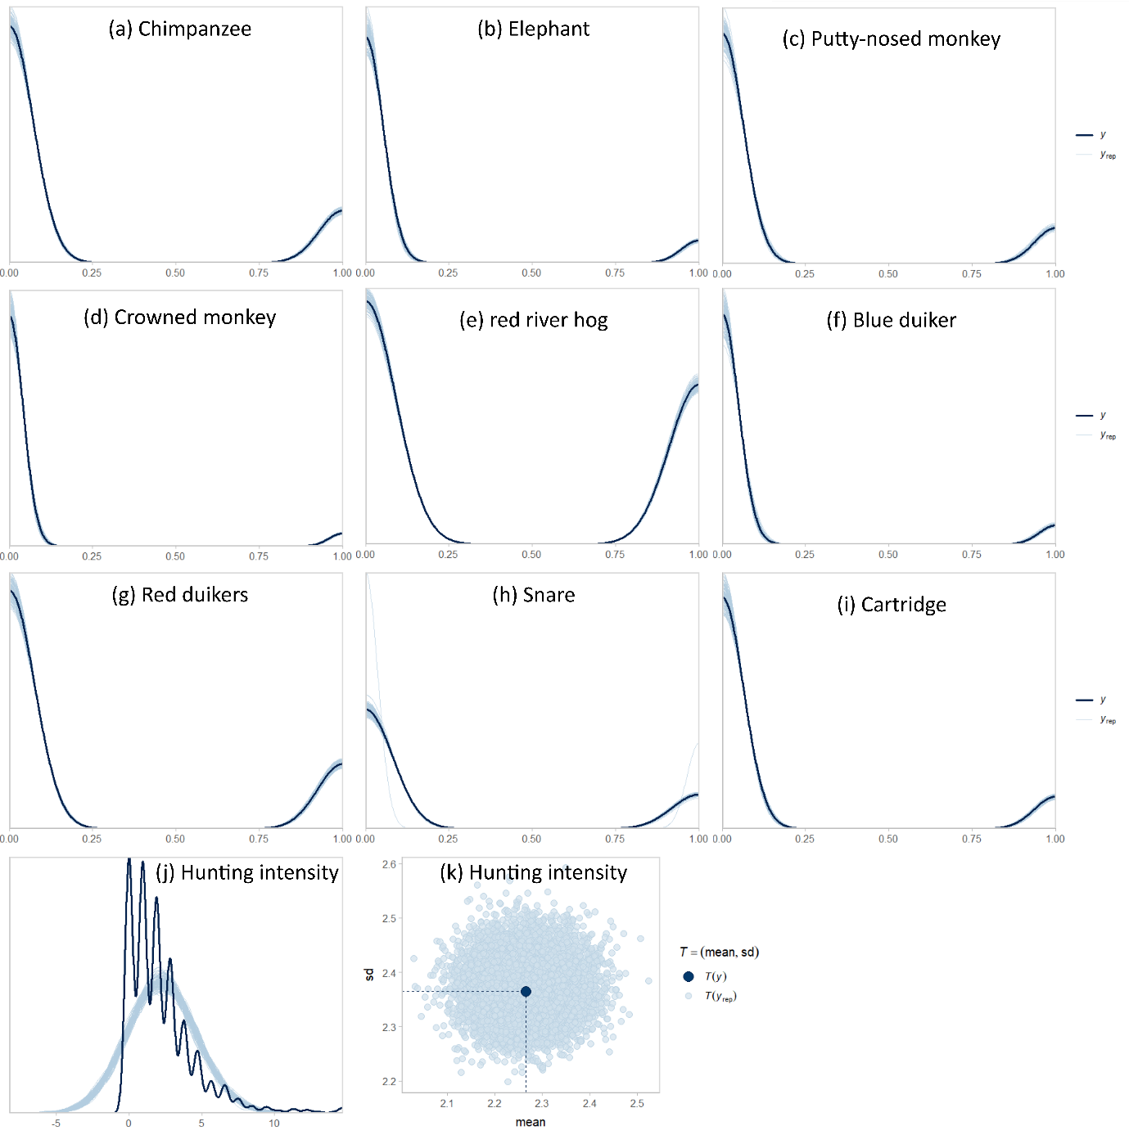
Fig. S1 Posterior predictive check comparing the distribution of the observed data (dark lines) with the distribution of replicated datasets (thin light lines) from Bayesian regression models.

