Supplementary materials

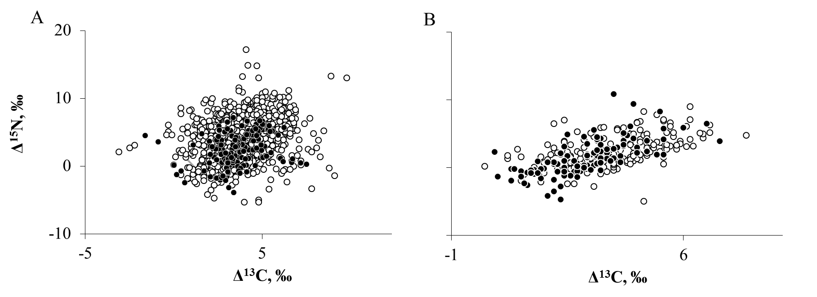
Fig. S1. A. Isotopic composition (litter-normalized δ¹³С and δ¹⁵N values) of soil and litter-dwelling animals collected at Malinky Biological Station during this study (black dots, each point is one animal, n = 165) and those reported in Potapov et al. (2019) (open dots, points represent mean value of species in different ecosystems, n = 1300). B. Isotopic composition of soil-dwelling Collembola. All data are taken from Potapov et al. (2019). Closed dots: Collembolans collected at Malinky Biological Station (n = 114). Open dots: Collembolans collected in other temperate forests (n = 183).
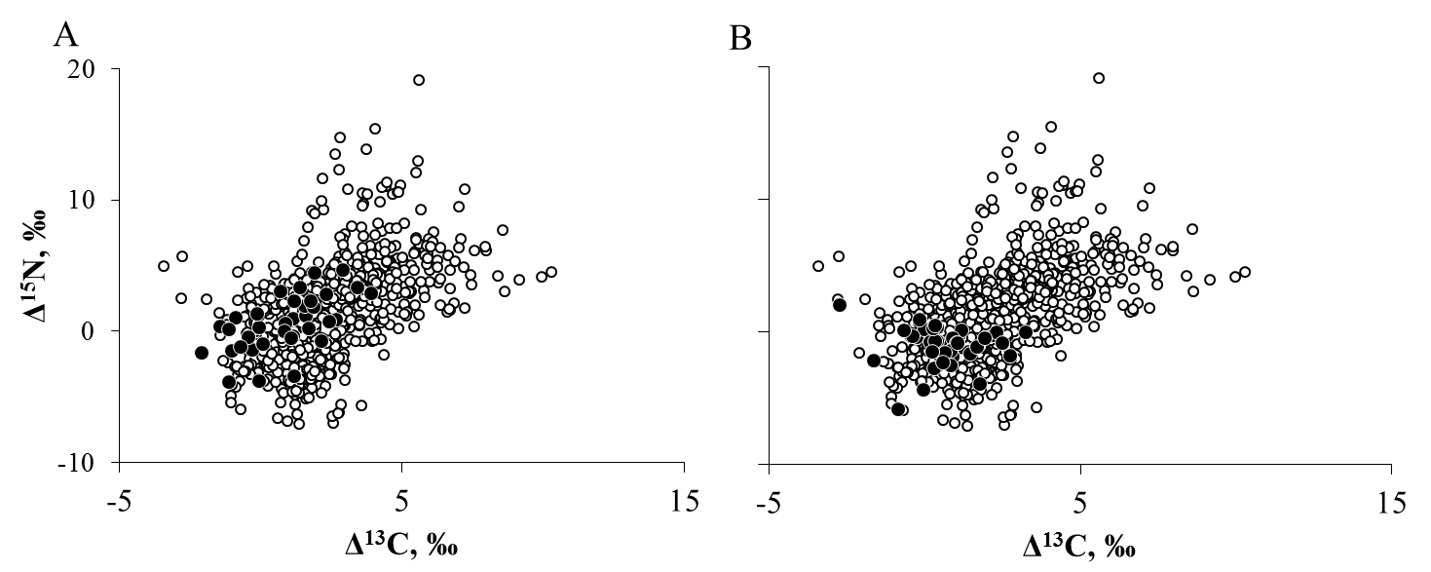
Fig. S2. Isotopic composition (litter-normalized δ¹³C and δ¹⁵N values) of exuviae (A, n = 35), and excrements (B, n = 36) collected in the traps (closed dots). Isotopic composition of arthropods from the arthropod rain is shown as open dots.

Table S1. Stable isotope composition (not normalized δ¹³C and δ¹⁵N values) of soil and plant materials, and of individual taxa of animals forming the arthropod rain. Unweighted mean values ± 1 SE, data are averaged across two forest plots and a whole growing season.

Material |  | Taxa / Order |  |  | Family Stage |  | δ¹³C, ‰ | δ¹⁵N, ‰ | n
Fresh leaf litter from the traps |  |  |  |  |  |  | -28.9±0.1 | -0.4±0.1 | 35
Leaf litter from the soil surface |  |  |  |  |  |  | -29.2±0.3 | -0.2±0.3 | 6
Green needles |  |  |  |  |  |  | -31.2±0.8 | 0.2±0.4 | 9
Green leaves |  |  |  |  |  |  | -31.7±0.5 | -0.9±0.8 | 5
Bark |  |  |  |  |  |  | -28.6±0.2 | -1.1±0.4 | 28
Wood |  |  |  |  |  |  | -31.2±0.5 | -1.0±0.2 | 5
Pollen |  |  |  |  |  |  | -25.5±0.1 | -0.2±0.3 | 7
Lichens |  |  |  |  |  |  | -30.2±0.6 | -5.3±0.6 | 22
Soil |  |  |  |  |  |  | -27.8±0.3 | 1.5±0.8 | 11
Excrements (frass) |  |  |  |  |  |  | -28.3±0.2 | -1.4±0.3 | 36
 | Total Arthropod rain |  |  | mean |  |  | -26.5±0.1 | 1.2±0.1 | 730
 |  | exuviae |  | mean |  |  | -28.0±0.2 | 0.2±0.4 | 35
 |  | Acari |  | mean |  |  | -26.7±0.5 | 2.1±0.6 | 16
 |  |  |  | Astigmatina |  |  | -26.5±0.5 | 4.4±0 | 3
 |  |  |  | Gamasina |  |  | -24.8±2.0 | 3.7±1 | 3
 |  |  |  | Oribatida |  |  | -27.6±0.5 | -0.7±1.1 | 3
 |  |  |  | Trombidiformes |  |  | -27.3±0.5 | 3.0±0.8 | 5
 |  | Araneae |  | mean |  |  | -26.2±0.2 | 3.0±0.3 | 32
 |  |  |  |  | Araneidae | juvenile | -25.9±0.5 | 3.9±0.5 | 7
 |  |  |  |  | Linyphiidae | adult | -26.4±0.3 | 3.6±0.5 | 5
 |  |  |  |  | - | juvenile | -26.4±0.3 | 3.4±1.9 | 2
 |  |  |  |  | Philodromidae | adult | -25.3 | 1.8 | 1
 |  |  |  |  | Salticidae | adult | -26.1 | 4.4 | 1
 |  |  |  |  | Tetragnathidae | adult | -25.3 | 4.3 | 1
 |  |  |  |  | Theridiidae | adult | -26.3±0.5 | 0.4±0.3 | 3
 |  |  |  |  | - | juvenile | -26.9±0.4 | 2.2±0.5 | 6
 |  |  |  |  | Thomisidae | adult | -25.3 | 3.1 | 1
 |  |  |  |  | - | juvenile | -25.8±0.3 | 3.4±0.5 | 3
 |  | Coleoptera |  | mean |  |  | -24.2±0.2 | 4.5±0.2 | 126
 |  |  |  |  | Apionidae | imago | -27.3 | 1.7 | 1
 |  |  |  |  | Cerylonidae | imago | -23.2±0.5 | 4.8±0.1 | 3
 |  |  |  |  | Cholevidae | imago | -23.6±0.3 | 11.6±0.9 | 2
 |  |  |  |  | Chrysomelidae | imago | -28.0±0.5 | 1.1±0.2 | 2
 |  |  |  |  | Ciidae | imago | -22.5 | 1.6 | 1
 |  |  |  |  | Coccinellidae | imago | -28.4 | 3.9 | 1
 |  |  |  |  | Corylophidae | imago | -23.3±0.8 | 5.1±0.6 | 7
 |  |  |  |  | Cryptophagidae | imago | -23.1±0.5 | 2.8±1 | 4
 |  |  |  |  | Curculionidae | imago | -25.9 | 3.5 | 1
 |  |  |  |  | Latridiidae | imago | -23.7±0.3 | 6.2±0.7 | 10
 |  |  |  |  | Leiodidae | imago | -21.8±0.8 | 2.1±0.5 | 4
 |  |  |  |  | Monotomidae | imago | -23.7±0.3 | 2.0±0.5 | 2
 |  |  |  |  | Peltidae | imago | -22.0±1.8 | 2.0±0.6 | 2
 |  |  |  |  | Pselaphidae | imago | -23.4±0.8 | 4.9±0.3 | 3
 |  |  |  |  | Ptiliidae | imago | -23.8±0.8 | 2.4±1.2 | 4
 |  |  |  |  | Pythidae | imago | -25.2±0.6 | 5.9±3.5 | 2
 |  |  |  |  | Scydmaenidae | imago | -24.6 | 7.2 | 1
 |  |  |  |  | Silvanidae | imago | -23.3±0.9 | 3.9±0.7 | 5
 |  |  |  |  | Staphilynidae | imago | -24.2±0.3 | 5.1±0.3 | 51
 |  |  |  |  | Zopheridae | imago | -25.3 | 3.0 | 1
 |  |  |  | mean |  | larva (total) | -25.7±0.4 | 3.4±0.7 | 13
 |  | Collembola |  | mean |  |  | -27.4±0.1 | -2.6±0.1 | 177
 |  |  |  | Symphypleona | Dicyrtomidae |  | -26.9±0.2 | -3.3±0.3 | 20
 |  |  |  |  | Sminthuridae |  | -27.5±0.2 | -3.5±0.3 | 32
 |  |  |  | Entomobryomorpha | Entomobriydae |  | -27.5±0.1 | -2.7±0.1 | 90
 |  |  |  |  | Isotomidae |  | -26.3 | -1.5 | 1
 |  |  |  |  | Tomoceridae |  | -27.0 | -1.7 | 1
 |  |  |  | Poduromorpha |  |  | -27.2±0.3 | -1.3±0.2 | 32
 |  | Diptera |  | mean |  |  | -26.2±0.2 | 3.0±0.3 | 121
 |  |  |  |  | Agromyzidae | larva | -24.5±0.3 | 2.1±0.1 | 2
 |  |  |  |  | Anisopodidae | larva | -30.5±1.8 | 2.8±1.7 | 2
 |  |  |  |  | Calliphoridae | larva | -26.7 | 2.9 | 1
 |  |  |  |  | Cecidomyiidae | imago | -26.0±0.6 | 1.5±0.8 | 9
 |  |  |  |  | - | larva | -27.0±0.3 | 0.3±0.4 | 38
 |  |  |  |  | Ceratopogonidae | imago | -27.3±0.3 | 3.8±2.5 | 3
 |  |  |  |  | Chironomidae | imago | -26.4±0.1 | 2.4±0.8 | 2
 |  |  |  |  | Chloropidae | imago | -24.0 | 10.2 | 1
 |  |  |  |  | Drosophilidae | imago | -25.7 | 1.7 | 1
 |  |  |  |  | Empididae | imago | -25.8±1.1 | 3.7±2.4 | 3
 |  |  |  |  | Limoniidae | imago | -24.6±1.9 | 2.7±0.5 | 4
 |  |  |  |  | Lonchaeidae | imago | -25.5±1.1 | 4.5±0.8 | 5
 |  |  |  |  | - | larva | -24.5±0.2 | 3.7±0.1 | 2
 |  |  |  |  | Muscidae | imago | -26.7 | 2.2 | 1
 |  |  |  |  | Mycetophilidae | imago | -25.2±0.3 | 9.8±1.9 | 6
 |  |  |  |  | Psychodidae | imago | -27.0 | 8.6 | 1
 |  |  |  |  | Scatopsidae | imago | -28.6±3.1 | 3.6±1.6 | 2
 |  |  |  |  | Sciaridae | imago | -25.5±0.2 | 4.9±0.7 | 26
 |  |  |  |  | - | larva | -24.8 | 2.7 | 1
 |  |  |  |  | Syrphidae | larva | -29.0 | 1.3 | 1
 |  | Hemiptera |  | mean |  |  | -27.2±0.2 | 1.1±0.2 | 84
 |  |  |  | Heteroptera | Acanthosomatidae |  | -26.1±0.4 | -0.6±0.3 | 3
 |  |  |  |  | Aradidae |  | -24.5±0.5 | 2.3±0.4 | 15
 |  |  |  |  | Lygaeidae |  | -26.7±0.8 | 0.8±0.1 | 2
 |  |  |  |  | Miridae |  | -27.1 | 2.8 | 1
 |  |  |  |  | Reduviidae |  | -26.1±1.3 | 2.3±4.6 | 2
 |  |  |  |  | Tingidae |  | -27.9 | 2.5 | 1
 |  |  |  | Others | Aphidoidea |  | -28.1±0.2 | 0.7±0.2 | 50
 |  |  |  |  | Cicadellidae |  | -28.7±1 | 1.8±2.2 | 2
 |  |  |  |  | Phylloxeridae |  | -27.3 | 1.8 | 1
 |  |  |  |  | Psyllidae |  | -26.6±1.1 | 1.2±0.8 | 6
 |  | Hymenoptera |  | mean |  |  | -25.8±0.3 | 5.5±0.7 | 27
 |  |  |  |  | Aphelinidae | imago | -27.8 | 2.3 | 1
 |  |  |  |  | Braconidae | imago | -25.3 | 9.1 | 1
 |  |  |  |  | Ceraphronidae | imago | -26.0 | 6.1 | 1
 |  |  |  |  | Diapriidae | imago | -24.0 | 10.1 | 1
 |  |  |  |  | Encyrtidae | imago | -26.0 | 2.1 | 1
 |  |  |  |  | Figitidae | imago | -23.3 | 18.7 | 1
 |  |  |  |  | Formicidae | imago | -26.7±0.1 | 4.5±0.9 | 7
 |  |  |  |  | Ichneumonidae | imago | -26.3±0.7 | 3.7±0.2 | 2
 |  |  |  |  | Megaspilidae | imago | -25.3±0 | 6.4±0.5 | 2
 |  |  |  |  | Mymaridae | imago | -26.3 | 3.6 | 1
 |  |  |  |  | Platygastridae | imago | -25.6±0.5 | 4.5±0.1 | 2
 |  |  |  |  | Pteromalidae | imago | -23.4 | 6.5 | 1
 |  | Lepidoptera |  | mean |  |  | -27.4±0.9 | 1.6±1.1 | 4
 |  |  |  |  | Argyresthidae | larva | -28.2 | 2.2 | 1
 |  |  |  |  | Geometridae | larva | -26.8 | 3.4 | 1
 |  |  |  |  | Lymantriidae | larva | -29.3 | -1.7 | 1
 |  |  |  |  | Tortricidae | larva | -25.4 | 2.3 | 1
 |  | Neuroptera |  | mean |  |  | -28.6±0.3 | -1.7±1.1 | 4
 |  |  |  |  | Chrysopidae |  | -29.1±0 | 0.2±0 | 2
 |  |  |  |  | Coniopterygidae |  | -28.4 | -3.1 | 1
 |  | Opiliones |  | mean |  | adult | -26.7±0.2 | 2±0.2 | 30
 |  | Plecoptera |  |  |  | larva | -29.7 | 1.9 | 1
 |  | Psocoptera |  | mean |  |  | -28.7±0.1 | -3.6±0.3 | 40
 |  | Thysanoptera |  | mean |  |  | -25.7±0.1 | 2.4±0.1 | 33

