Supplementary Information
- PRISMA flow chart showing the process of selecting publications

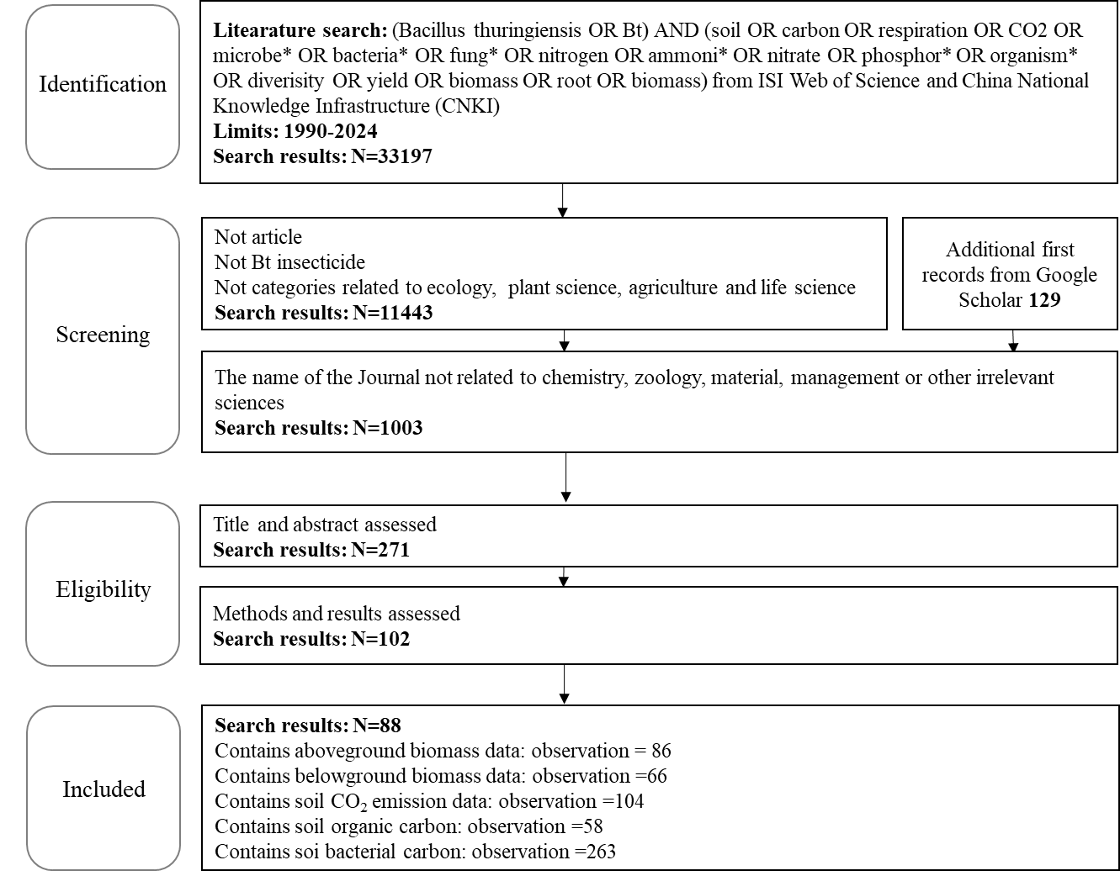

- The list of 88 papers from which the data were extracted for this meta-analysis.
Armada E, Azcon R, Lopez-Castillo OM, Calvo-Polanco M, Manuel Ruiz-Lozano J (2015) Autochthonous arbuscular mycorrhizal fungi and Bacillus thuringiensis from a degraded Mediterranean area can be used to improve physiological traits and performance of a plant of agronomic interest under drought conditions. Plant Physiology and Biochemistry, 90, 64-74.
Becker R, Bubner B, Remus R, Wirth S, Ulrich A (2014) Impact of multi-resistant transgenic Bt maize on straw decomposition and the involved microbial communities. Applied Soil Ecology, 73, 9-18.
Blaise D, Velmourougane K, Santosh S, Manikandan A (2021) Intercrop mulch affects soil biology and microbial diversity in rainfed transgenic Bt cotton hybrids. Science of the Total Environment, 794.
Bumunang EW, Babalola OO, Barros E (2013) Bacterial community profiling in the rhizosphere of field grown GM and Non-GM maize. Journal of Pure and Applied Microbiology, 7, 157-164.
Cerevkova A, Miklisova D, Szoboszlay M, Tebbe CC, Cagan L (2018) The responses of soil nematode communities to Bt maize cultivation at four field sites across Europe. Soil Biology & Biochemistry, 119, 194-202.
Chen J, Chen F, Liu M, Feng Y, Dang Z, Li H, Hu F (2014) Short-term effects of CO₂ concentration elevation, warming and transgenic Bt rice cropping on soil labile organic carbon and nitrogen, and nematode communities. Acta Ecologica Sinica, 34, 1481-1489.
Chen X, Liu T, Li X, Li H, Chen F, Liu M, Whalen JK (2017) Soil nematode community varies between rice cultivars but is not affected by transgenic Bt rice expressing Cry1Ab or Cry1Ab, Cry1Ac. Biology and Fertility of Soils, 53, 501-509.
Chen Y, Ren M, Guan X, Zhu W, Shen Q (2019) Influence of insect-resistant transgenic Bt cotton on Bt protein residue and available nutrient contents in rhizosphere soil. Agricultural Research in the Arid Areas, 37, 123-128.
Cotta SR, Franco Dias AC, Marriel IE, Andreote FD, Seldin L, Van Elsas JD (2014) Different Effects of Transgenic Maize and Nontransgenic Maize on Nitrogen-Transforming Archaea and Bacteria in Tropical Soils. Applied and Environmental Microbiology, 80, 6437-6445.
Cowgill SE, Wright C, Atkinson HJ (2002) Transgenic potatoes with enhanced levels of nematode resistance do not have altered susceptibility to nontarget aphids. Molecular ecology, 11, 821-827.
Coz I, Saxena D, Andow DA, Zwahlen C, Stotzky G (2008) Microbial populations and enzyme activities in soil in situ under transgenic corn expressing Cry proteins from Bacillus thuringiensis. Journal of Environmental Quality, 37, 647-662.
Daudu CK, Muchaonyerwa P, Mnkeni PNS (2009) Litterbag decomposition of genetically modified maize residues and their constituent <i>Bacillus thuringiensis</i> protein (Cry1Ab) under field conditions in the central region of the Eastern Cape, South Africa. Agriculture Ecosystems & Environment, 134, 153-158.
Debruyn JM, Bevard DA, Essington ME et al. (2017) Field-grown transgenic switchgrass (Panicum virgatum L.) with altered lignin does not affect soil chemistry, microbiology, and carbon storage potential. Global Change Biology Bioenergy, 9, 1100-1109.
Devare M, Londono-R LM, Thies JE (2007) Neither transgenic Bt maize (MON863) nor tefluthrin insecticide adversely affect soil microbial activity or biomass: A 3-year field analysis. Soil Biology & Biochemistry, 39, 2038-2047.
Dong L, Meng Y, Wang J (2014) Effects of transgenic Bt + CpTI cotton on rhizosphere bacteria and ammonia oxidizing bacteria population. Acta microbiologica Sinica, 54, 309-318.
Duan Y (2014) Degration of Bt protein and effect on soil microbial activity after residue embedded into soil from transgenic Bt cotton. Shanxi Agricultural University.
Fliessbach A, Messmer M, Nietlispach B, Infante V, Maeder P (2012) Effects of conventionally bred and Bacillus thuringiensis (Bt) maize varieties on soil microbial biomass and activity. Biology and Fertility of Soils, 48, 315-324.
Fu X (2008) Effects of Bt transgenic rice on soil ecosystem. Hunan Normal University
Garcia-Villaraco Velasco A, Kowalchuk GA, Gutierrez Manero FJ, Ramos B, Yergeau E, Lucas Garcia JA (2013) Increased microbial activity and nitrogen mineralization coupled to changes in microbial community structure in the rhizosphere of Bt corn. Applied Soil Ecology, 68, 46-56.
Ge L, Mao C, Wu Y et al. (2024) Soil nutrient cycling and microbiome responses to Bt rice cultivation. Plant and Soil.
Griffiths BS, Heckmann L-H, Caul S, Thompson J, Scrimgeour C, Krogh PH (2007) Varietal effects of eight paired lines of transgenic Bt maize and near-isogenic non-Bt maize on soil microbial and nematode community structure. Plant Biotechnology Journal, 5, 60-68.
Guan X, Wu G, Wang M (2015) Effects of transgenic Bt rice on the structure of soil microbial community. Hubei Agricultural Science, 54, 1046-1058.
Hoess S, Reiff N, Ottermanns R, Pagel-Wieder S, Dohrmann AB, Tebbe CC, Traunspurger W (2015) Risk assessment of the cultivation of a stacked Bt-maize variety (MON89034 x MON88017) for nematode communities. Soil Biology & Biochemistry, 91, 109-118.
Ibrahim M, Ahmad F, Nawaz H, Aslam M, Shad MA (2020) Studies on correlations between soil chemistry and bacterial population in rhizosphere of Bt and non-Bt cotton and characterization of rhizobacteria. Journal of Taibah University for Science, 14, 1463-1474.
Jin J, Mi R, Li Q, Lang J, Lan Y, Huang N, Yang G (2023) Bacillus thuringiensis enhances the ability of ryegrass to remediate cadmium-contaminated soil. Sustainability, 15.
Knox OGG, Gupta VVSR, Lardner R (2014) Field evaluation of the effects of cotton variety and GM status on rhizosphere microbial diversity and function in Australian soils. Soil Research, 52, 203-215.
Kravchenko AN, Hao X, Robertson GP (2009) Seven years of continuously planted Bt corn did not affect mineralizable and total soil C and total N in surface soil. Plant and Soil, 318, 269-274.
Lehman RM, Osborne SL, Rosentrater KA (2008) No differences in decomposition rates observed between Bacillus thuringiensis and non-Bacillus thuringiensis corn residue incubated in the field. Agronomy Journal, 100, 163-168.
Li P, Ye S, Chen J et al. (2023) Combined metagenomic and metabolomic analyses reveal that Bt rice planting alters soil C-N metabolism. ISME communications, 3, 4-4.
Li X-Q, Chen F-J, Liu M-Q, Hu F (2012a) Effects of transgenic Bt rice on soil dissolved organic carbon and nitrogen contents and microbiological properties. The Journal of Applied Ecology, 23, 96-102.
Li X (2011) Soil ecological risk evaluation of transgenic Bt rice through nematode community analysis. Nanjing Agricultural University.
Li Y, Fan Q, Chen G, Zhang D, Chai Y, Li YE (2012b) Effects of consecutive cultivation of Bt transgenic cotton on soil microbial community structure. In: China Cotton Society 2012 Annual Conference. pp Page, Yuncheng, Shanxi Province in China.
Liu L (2011) Effect of transgenic Bt maize on soil microbial diversity. Gansu Agricultural University.
Liu W (2009) Effect of Bt insecticidal gene on rice photosynthetic carbon sequestration and microbial diversity in paddy soil. Zhejiang University.
Liu W, Wang S-T, Chen Y-X, Wu W-X, Wang J (2011) Microbial diversity in rhizosphere soil of transgenic Bt rice based on the characterization of phospholipids fatty acids. The Journal of Applied Ecology, 22, 727-733.
Liu W, Wu W, Lu HH, Chen YX (2014) Carbon flux from decomposing ¹³C-labeled transgenic and nontransgenic parental rice straw in paddy soil. Journal of Soils and Sediments, 14, 1659-1668.
Lu H, Wu W, Chen Y, Zhang X, Devare M, Thies JE (2010) Decomposition of Bt transgenic rice residues and response of soil microbial community in rapeseed-rice cropping system. Plant and Soil, 336, 279-290.
Lv H (2010) Effects of Bt gene transformation in rice on rhizosphere and residue decomposed microbial community. Zhejiang University.
Lv N, Liu Y, Guo T, Liang P, Li R, Liang P, Gao X (2022) The influence of Bt cotton cultivation on the structure and functions of the soil bacterial community by soil metagenomics. Ecotoxicology and Environmental Safety, 236.
Meijun Z, Wude Y (2008) Effect of transgenic Bt cotton planting on biological characteristics and nutrient content in rhizosphere soil. Plant Nutrition and Fertitizer Science, 14, 162-166.
Meijun Z, Wude Y, Yan'e LI (2008) Effects of Bt transgenic cottons planting on rhizosphere soil microorganisms at different growth stages. Acta Phytoecologica Sinica, 32, 197-203.
Meijun Z, Yun D, Wude Y, Meichen F, Lujie X (2013) Effect of ground leaves from transgenic Bt cotton on soil microbial activity. Journal of Shanxi Agricultural University, 33, 93-97,135.
Na B (2011) Effects of transgenic Bt + CpTI cotton on the soil microorganisms and enzyme activities. Inner Mongolia Normal University.
Na R-S, Yu H, Yang D-L, Zhao J-N, Li G, Na B-Q, Liu L (2011) Effect of plantation of transgenic Bt cotton on the amount of rhizospheric soil microorganism and bacterial diversity in the cotton region of Yellow River basin. The Journal of Applied Ecology, 22, 114-120.
Neher DA, Muthumbi AWN, Dively GP (2014) Impact of coleopteran-active Bt corn on non-target nematode communities in soil and decomposing corn roots. Soil Biology & Biochemistry, 76, 127-135.
Niu W (2009) Changes in microbial flora and bacterial physiological group diversity in rhizosphere soil of transgenic Bt cotton Shangdong Agricultural University.
Qi L (2013) Effects of transgenic Bt rice on soil community: Integrating long-term field experiment and hot spots manipulation in greenhouse. Nanjing Agricultural University.
Qi L, Chen F, Liu M, Chen X, Zhu X, Li H, Hu F (2013) Effects of short-term planting of three transgenic Bt rice lines on soil microbial biomass and soil nematode assemblage. Chinese Journal of Ecology, 32, 975-980.
Qi L, Liu M, Jiang L, Zhang J, Li X, Chen F, Hu F (2015) Influences of rhizosphere and detritusphere of Bt rice on soil nematode communities. Acta Ecologica Sinica, 35, 1434-1444.
Raubuch M, Roose K, Warnstorff K, Wichern F, Joergensen RG (2007) Respiration pattern and microbial use of field-grown transgenic Bt-maize residues. Soil Biology & Biochemistry, 39, 2380-2389.
Reisig D, Heiniger R (2024) Yield analysis and corn earworm feeding in Bt and non-Bt corn hybrids across diverse locations. Journal of economic entomology.
Sarkar B, Patra AK, Purakayastha TJ (2008) Transgenic Bt-Cotton affects enzyme activity and nutrient availability in a sub-tropical inceptisol. Journal of Agronomy and Crop Science, 194, 289-296.
Sarkar B, Patra AK, Purakayastha TJ, Megharaj M (2009) Assessment of biological and biochemical indicators in soil under transgenic Bt and non-Bt cotton crop in a sub-tropical environment. Environmental Monitoring and Assessment, 156, 595-604.
Singh AK, Rai GK, Singh M, Dubey SK (2013) Bacterial community structure in the rhizosphere of a Cry1Ac Bt-brinjal crop and comparison to its non-transgenic counterpart in the tropical soil. Microbial Ecology, 66, 927-939.
Song Y-Y, Liu J-W, Li L-K, Liu M-Q, Chen X-Y, Chen F-J (2020a) Evaluating the effects of transgenic Bt rice cultivation on soil stability. Environmental Science and Pollution Research, 27, 17412-17419.
Song Y, Liu J, Chen F (2020b) Elevated CO₂ not increased temperature has specific effects on soil nematode community either with planting of transgenic Bt rice or non-Bt rice. Peerj, 8.
Sun C, Zhang Y, Miao L, Chen L, Wu Z (2006) Changes of nutrients in soil of transgenic Bt crops. The Journal of Applied Ecology, 17, 943-946.
Tan F, Wang J, Feng Y, Chi G, Kong H, Qiu H, Wei S (2010) Bt corn plants and their straw have no apparent impact on soil microbial communities. Plant and Soil, 329, 349-364.
Tao M (2013) Effect of transgenic Bt gene rice on soil nematodes. Hangzhou Normal University.
Wan X (2007) Effect of planting transgenic Bt cotton on soil enzymatic and microbial activities. Nanjing Agricultural University.
Wang B, Fan C, Yin J, Wu F, Wang D, Song X (2019) Effects of planting transgenic insect-resistant maize with cry1Ac gene Bt-799 on the composition structure of soil fauna. Acta Phytophylacica Sinica, 46, 167-174.
Wang B, Yin J, Wu F, Jiang Z, Song X (2021) Field decomposition of Bt-506 maize leaves and its effect on collembola in the black soil region of Northeast China. Global Ecology and Conservation, 26.
Wang B, Yin J, Wu F, Wang D, Jiang Z, Song X (2022) Climate change did not alter the effects of Bt maize on soil Collembola in northeast China. Scientific Reports, 12.
Wang C (2012) Effects of transgenic cotton with Bt and Bt plus CpTI gene on soil microbial community structure. Nanjing Forestry University.
Wang H (2003) Influence of Bt transgenic rice on cultivable microorganisms in soil Zhejiang University.
Wu G, Li J, Xiao N, Ge F, Liu X (2012) Effects of transgenci Bt rice on soil physical and chemical properties Journal of Plant Protection in Hubei, 134, 22-25.
Wu L, Tuya (2012) Effect of trangenic (Bt + CpTI) cotton on rhizosphere soil microbial diversity. Inner Mongolia Agricultural University.
Wu WX, Liu W, Lu HH, Chen YX, Devare M, Thies J (2009) Use of ¹³C labeling to assess carbon partitioning in transgenic and nontransgenic (parental) rice and their rhizosphere soil microbial communities. Fems Microbiology Ecology, 67, 93-102.
Wu Y (2015) Distribution and horizontal gene transfer of exogenous recombinant DNA from transgenic Bt cotton in soil environment. Chinese Academy of Agricultural Sciences.
Xia LI, Quanhong XUE, Junfeng FaN, Yongxue Z, Janshe GaO (2011) Effects of one-year-old Bt transgenic Populus nigra on soil microorganism. Journal of Northwest Forestry College, 26, 123-127.
Xiao M, Dong S, Li Z et al. (2015) Effects of water management practices on residue decomposition and degradation of Cry1Ac protein from crop-wild Bt rice hybrids and parental lines during winter fallow season. Ecotoxicology and Environmental Safety, 122, 275-289.
Xiaogang LI, Biao LIU, Wenhua XU et al. (2011) Effect of transgenic Bt cotton on biodiversity of soil microbial community. Journal of Ecology and Rural Environment, 27, 17-22.
Xiaoyu WaN, Yongchao L, Zhongpei LI, Song A, Yunsheng LOU (2007) Effect of planting transgenic Bt cotton on soil enzymatic and microbial activities. Acta Ecologica Sinica, 27, 5414-5420.
Xu J, Wang X, Han C, Jiang Y, Zhong W, Liu B (2022) Trait-based comparison of transgenic Bt rice and its non-Bt counterpart in response to soil copper pollution. Environmental Science and Pollution Research, 29, 2773-2782.
Yan S (2011) Effects of Bt maize on soil microbial activity and fertility. Shandong Normal University.
Yang Y, Tie S, Shuang Q, Yue R, Han X, Yan S (2012) Effect of transgenic Bt maize on soil culturable microbial flora. In: 2012 Annual conference on Maize Genetics and Breeding. pp Page, Zhenzhou, Henan Province, China.
Yanni SF, Whalen JK, Ma B-L (2011) Field grown Bt and non-Bt corn: Yield, chemical composition, and decomposability. Agronomy Journal, 103, 486-493.
Yasin S, Asghar HN, Ahmad F, Zahir ZA, Waraich EA (2016) Impact of Bt-cotton on soil microbiological and biochemical attributes. Plant Production Science, 19, 458-467.
Yu Z, Xiong J, Zhou Q et al. (2015) The diverse nematicidal properties and biocontrol efficacy of Bacillus thuringiensis Cry6A against the root-knot nematode Meloidogyne hapla. Journal of Invertebrate Pathology, 125, 73-80.
Zaman M, Mirza MS, Irem S, Zafar Y, Mehboob Ur R (2015) A temporal expression of Cry1Ac protein in cotton plant and its impact on soil health. International Journal of Agriculture and Biology, 17, 280-288.
Zhang B, Bai Z, Hoefel D et al. (2008) Assessing the impact of the biological control agent Bacillus thuringiensis on the indigenous microbial community within the pepper plant phyllosphere. Fems Microbiology Letters, 284, 102-108.
Zhang F, Yin Q, Mao J et al. (2020a) Effects of Bacillus thuringiensis transgenic cotton straw returning to field on soil fertility. Chinese Journal of Eco-Agriculture, 28, 734-744.
Zhang F, Yin Q, Wang D et al. (2020b) Effects of returning Bt cotton straw on soil nutrient characteristics. Journal Biosafety, 29, 69-77.
Zhang M, Feng M, Xiao L, Song X, Guangwei D, Yang W (2019) Persistence of Cry1Ac protein from transgenic Bt cotton cultivation and residue returning in fields and its effect on functional diversity of soil microbial communities. Pedosphere, 29, 114-122.
Zhang Y (2010) The effect of Bt transgenic rice on envrionmental microbes. Nanjing Forestry University.
Zhang Y, Guo T, Pan H, Huang M, Wang M, Zhuge Q (2012) Analysis on insecticidal activity of Bt transgenic Populus deltoides * P. euramericana cv Nanlin 895 and its effects on soil microorganism. Forest Research, 25, 346-350.
Zhao Y (2016) Effect and mechanism of root exudates from transgenic Bt cotton on the soil N cycling Huazhong Agricultural University.
Zhou X, Liang J, Luan Y, Song X, Zhang Z (2021) Characterisation of Bt maize IE09S034 in decomposition and response of soil bacterial communities. Plant Soil and Environment, 67, 286-298.

- Supplementary Figures
Figure S1 The response of soil ammoniacal nitrogen, nitrate nitrogen, bacterial diversity and fungal diversity to transgenic Bt crops.
Figure S2 The response of nematode diversity to transgenic Bt crops.

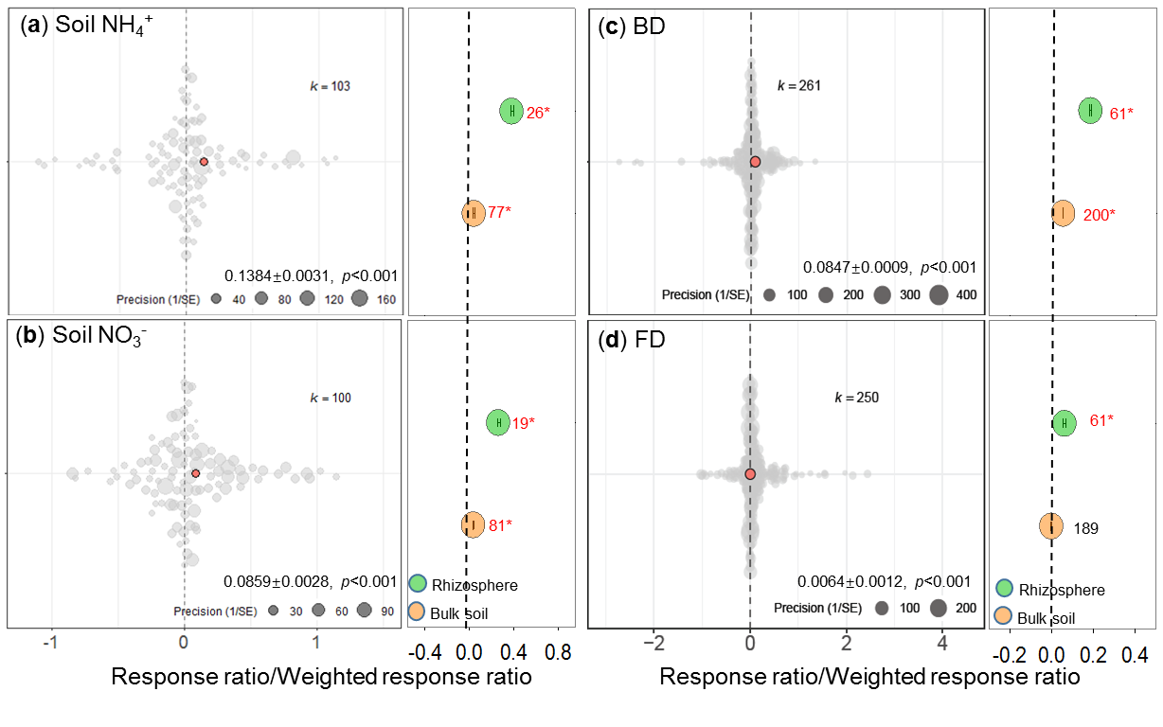
Figure S1 The response of soil ammoniacal nitrogen (Soil NH₄⁺, a), nitrate nitrogen (Soil NO₃^{-,} b), bacterial diversity (BD, c) and fungal diversity (FD, d) to transgenic Bt crops. The center of grey circle was the response ratio of individual study, the red circle was the total weighted response ratio (mean ± se), while the blue and orange circle was the weighted response ratio in rhizosphere and bulk soil, respectively. The error bars of blue and orange circles indicated 95% confidence interval (CI). If the 95% CI of weighted response ratio did not overlap with zero, the effect of transgenic Bt crops was considered to be statistically significant, and the red or blue symbol * indicated statistical significance of increase and decease at p<0.05, respectively, based on two-tailed tests. The number beside of the blue and orange circles were the sample size.

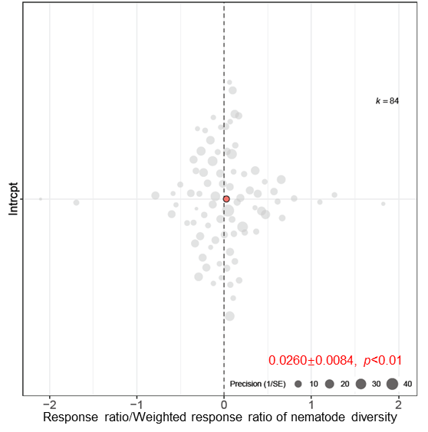

Figure S2 The response of nematode diversity to transgenic Bt crops. The center of grey circle in plot was the response ratio of individual study, the red circle was the total weighted response ratio (mean ± se).

