Supplementary Information for
The Response of the Southern Ocean to Climatological Iceberg Freshwater Forcing
Jingwei Zhang ^{1,2}, Xuebin Zhang², Matt A. King ^{1,3}, Kewei Lyu⁴
¹School of Geography, Planning, and Spatial Sciences, University of Tasmania, Hobart, Australia
²Climate Science Centre, CSIRO Environment, Hobart, Australia
³The Australian Centre for Excellence in Antarctic Science, University of Tasmania, Hobart, Australia
⁴State Key Laboratory of Marine Environmental Science, College of Ocean and Earth Sciences, Xiamen University, Xiamen, China

*Correspondence to: jingwei.zhang@utas.edu.au

Overview
We present here additional information related to model setup, oceanography data, method, and additional analyses.
Contents of this file
1 Text S1-S3
2 Fig. S1
——————————

1. Text
1.1 Model configurations
ACCESS-OM2 is a global model with coupled ocean and sea-ice components driven by prescribed atmosphere forcing. ACCESS-OM2 solves the primitive equations under the hydrostatic and Boussinesq approximations with a free surface and horizontal spatial discretization on an Arakawa B-grid (Arakawa and Lamb 1977; Griffies and Greatbatch 2012). Our model configuration uses 1º nominal resolution in both zonal and meridional directions, but with a meridional refinement of 1/3º between 10ºS and 10ºN, and cosine-dependent resolution ranging from 1/4º at 78ºS and 1º at 30ºS.
Following Bi et al. (2013), the vertical grid comprises 50 vertical levels, with grid spacing from 2.3 m at surface to 219.6 m by the bottom reaching the deepest depth of 5363.5 m in the model domain. ACCESS-OM2 also employs a z* generalized vertical coordinate with partial cells to better represent ocean floor, and includes the boundary layer K-profile parameterization (KPP, (Large et al. 1994) with a constant background vertical viscosity of 10⁻⁴ m²/s. The impacts of mesoscale eddies in our model configuration are parametrized using explicit neutral tracer diffusion (Solomon 1971; Redi 1982) and the advective transport parameterization of Gent and Mcwilliams (1990) and Gent et al. (1995).
The atmospheric forcing derived from JRA55-do (Tsujino et al. 2018), including wind speed, air temperature and humidity, radiation, precipitation, and sea level pressure, are used to diagnose air–sea fluxes (wind stress, heat flux, and freshwater flux) through bulk formulae and interactive coupling between ocean and sea ice. Freshwater flux and heat flux are defined as positive downward (i.e., freshwater/heat gain by the ocean). The Antarctic calving and ice shelf basal meting are prescribed as a climatological runoff (Depoorter et al., 2013) near the Antarctic “coast”.
1.2 Hydrographic data
The observation-based climatological means for temperature and salinity at the resolution of 1º were extracted from the WOA13 v2 ((Locarnini et al. 2013; Zweng et al. 2013); https://www.nodc.noaa.gov/OC5/woa13/). WOA13 v2 is a re-gridded and quality-controlled dataset based on the World Ocean Database. Objectively analyzed climatology of temperature and salinity for 40 years (1971-2010) is used as observation-based climatology in this study.
1.3 Decomposition of ocean density and vertical stratification
The density of seawater $ρ$ is determined by temperature, salinity and the pressure to which a parcel of seawater is exposed. At a given pressure, an approximate equation of state for seawater is:
ρ = ρ_{o} [1-α (ϴ - ϴ_{o}) + β (S - S_{o})] (5)
where $α$and $β$are the expansion and contraction coefficients for temperature$ϴ$ and absolute salinity S, respectively. $ρ$ is density, S₀ is the reference salinity (35psu) and ϴ₀ is the reference temperature (0ºC).
To understand the contributions of temperature and salinity on density, we decomposed the changes in density into thermal component (density change induced by temperature) and halo components (density change induced by salinity):
Δρ = Δρ_{Thermal} (35, ϴ, P) + Δρ_{Halo} (S, 0, P) (6)
where Δρ_{Thermal} is the temperature driven density change and Δρ_{Halo} is salinity driven density change. The above decomposition of ∆$ρ$ into Δρ_{Thermal} and Δρ_{Halo} is approximate since density is a nonlinear function of temperature, salinity and pressure, but ∆$ρ$ is very close to the sum of Δρ_{Thermo} and Δρ_{Halo} in our calculation.
In this study, the vertical stratification is computed as the squared buoyancy frequency. N² is computed according to the equation of state (TEOS-10)(IOC 2010):
N² (ϴ, S) = g (α ϴ_{z} - β S_{z}) (7)
where ϴ_{z} and S_{z} are vertical gradients of temperature and salinity, respectively.

Figure
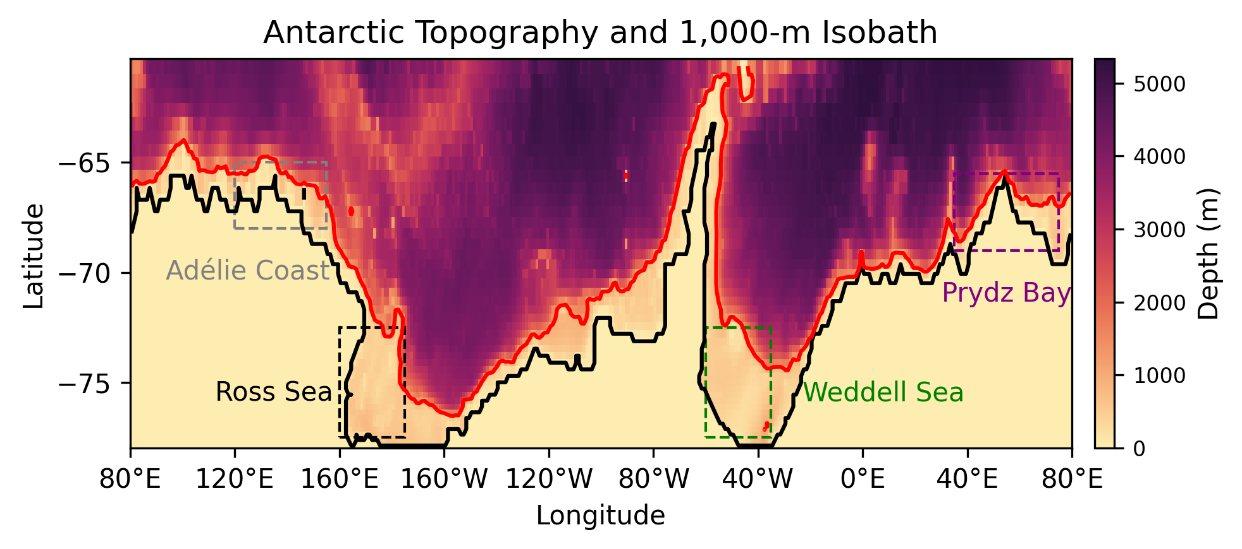 Fig. S1 Antarctic topography with the 1000m isobath (red contour) and key regions of AABW production: Ross Sea, Weddell Sea, Prydz Bay and Adélie Coast.

Reference

Arakawa, A., and V. R. Lamb, 1977: Computational design of the basic dynamical processes of the UCLA general circulation model. General circulation models of the atmosphere, 17, 173-265.
Bi, D., and Coauthors, 2013: ACCESS-OM: the ocean and sea-ice core of the ACCESS coupled model. Aust Meteorol Oceanogr J, 63, 213-232.
Gent, P. R., and J. C. Mcwilliams, 1990: Isopycnal mixing in ocean circulation models. Journal of Physical Oceanography, 20, 150-155.
Gent, P. R., J. Willebrand, T. J. McDougall, and J. C. McWilliams, 1995: Parameterizing eddy-induced tracer transports in ocean circulation models. Journal of Physical Oceanography, 25, 463-474.
Griffies, S. M., and R. J. Greatbatch, 2012: Physical processes that impact the evolution of global mean sea level in ocean climate models. Ocean Modelling, 51, 37-72.
IOC, 2010: The International thermodynamic equation of seawater, 2010: calculation and use of thermodynamic properties.
Large, W. G., J. C. McWilliams, and S. C. Doney, 1994: Oceanic vertical mixing: A review and a model with a nonlocal boundary layer parameterization. Reviews of geophysics, 32, 363-403.
Locarnini, R., and Coauthors, 2013: World Ocean Atlas 2013, Volume 1: Temperature, edited by: Levitus, S. A. Mishonov Technical Ed., NOAA Atlas NESDIS, 73, 40.
Redi, M. H., 1982: Oceanic isopycnal mixing by coordinate rotation. Journal of Physical Oceanography, 12, 1154-1158.
Solomon, H., 1971: On the representation of isentropic mixing in ocean circulation models. Journal of Physical Oceanography, 1, 233-234.
Tsujino, H., and Coauthors, 2018: JRA-55 based surface dataset for driving ocean–sea-ice models (JRA55-do). Ocean Modelling, 130, 79-139.
Zweng, M., and Coauthors, 2013: World Ocean Atlas 2013, Volume 2: Salinity. NOAA Atlas NESDIS 74. Silver Spring MD.

