Supplementary materials
Supplementary tables
Supplementary table 1. Table for Analysis of Intercellular Communication Network

Supplementary figures
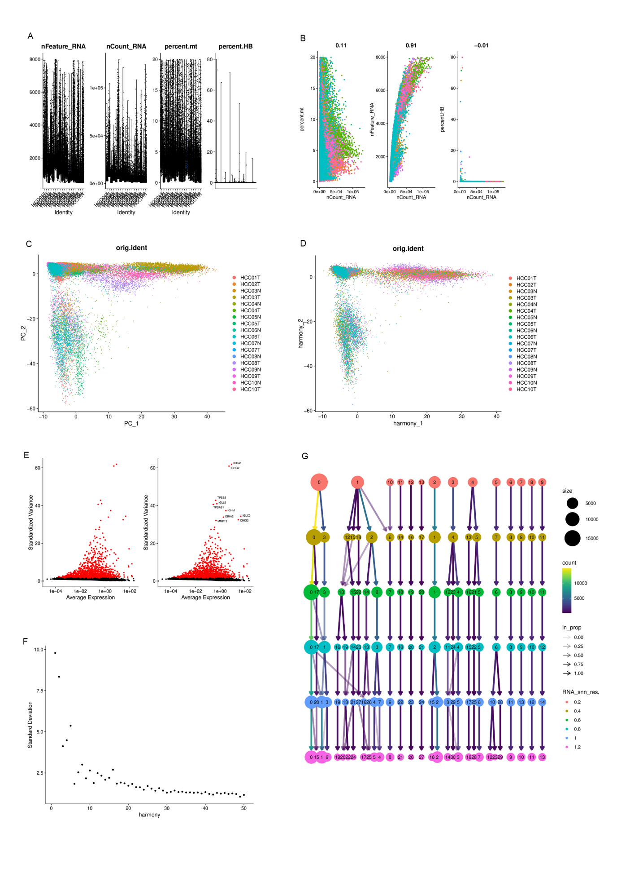

Figure S1 Annotation of Single-Cell Data

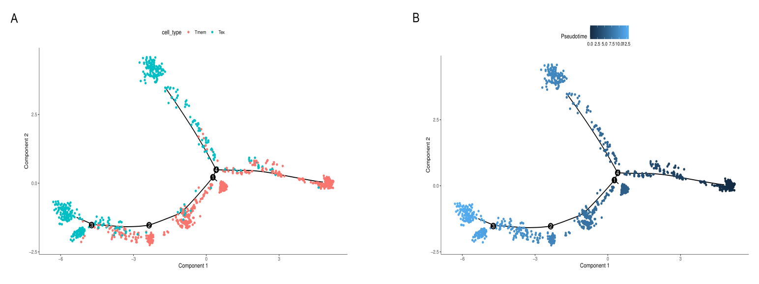

Figure S2 The results of pseudotime analysis of Tmem and Tex cells. (A) UMAP visualization demonstrated the pseudotime distribution pattern of Tmem and Tex cells. (B) UMAP visualized a pseudotime arrangement of Tmem and Tex cells.

